CHEMICAL ENGINEERINGTRANSACTIONS  VOL. | A publication of
The Italian Association
of Chemical Engineering
Online at www.cetjournal.it
Guest Editors:
Copyright © AIDIC Servizi S.r.l.
ISBN 978-88-95608-xx-x ISSN 2283-9216

Lactic Acid Pre-Treatment for Lactide Production – A Techno-Economic Feasibility Study for the Dehydration Step
Nadia Gagliardi Khouri^{a*}, Juliana O. Bahúª, Bruna L. Carvalho Cunha^{b}, Maria Regina Wolf Macielª, Viktor Oswaldo Cárdenas Concha^{b}, Rubens Maciel Filhoª
ªSchool of Chemical Engineering, University of Campinas (UNICAMP), Campinas, São Paulo, Brazil
^{b}School of Chemical Engineering, Federal University of São Paulo (UNIFESP), Diadema, São Paulo, Brazil
khouri.g.nadia@gmail.com
Lactic acid (LA) can be synthesized via carbohydrate microbial fermentation; such acid is a bifunctional compound containing hydroxyl and carboxylic acid as chemical groups, having optical activity due to an asymmetric carbon in its structure. A common application for lactic acid is the synthesis of poly(lactic acid) (PLA) via direct polycondensation. This polymerization route needs a dehydration process of the commercially available LA (aqueous, 85% w/w). It is an important step since the presence of water negatively affects the lactide isomerism, which is crucial for the final PLA properties. Considering this, the present work aims to evaluate this pre-treatment process by establishing two configurations, using COCO® simulator. The first is the association of a heat exchanger and a flash vessel. By applying a temperature of 115 °C and a pressure of 383.8 mmHg, the flash liquid stream has a water content of 2.02% w/w. In such conditions, the Total Annual Cost (TAC) is $ 30,663.80. The second configuration has a heat exchanger and a distillation column. The same water content is achieved (2.02% w/w) when a three-stage column operates at 456.0 mmHg and reflux ratio = 1.0 – with a TAC = $ 67,857.71. Therefore, a flash vessel system is the favourable configuration.

  - Introduction
The poly(lactic acid) (PLA), commonly applied in the medical area (Singhvi et al., 2019), is the principal consumer of lactide, a high-cost cyclic dimer(Sigma Aldrich, 2021). This monomer can be used at two polymerization routes: ring-opening polymerization (ROP) and direct polycondensation (DPC) (Nofar et al. 2019, Mehta et al., 2005). The lactide is directly used in the ROP since a catalyst (usually stannous octoate) promotes the ring-opening and polymeric chain growth (Paul and Virivinti, 2021).
Dehydration of the purified lactic acid (aqueous, ~85% w/w, Komesu et al., 2018) is required in the DPC route, since water is undesirable during the polymerization step because it favours chain transfer, resulting in low molar mass PLA (Shetty, Shetty, 2019). Moreover, as dehydration occurs, the highly reactive LA suffers dimerization, producing high viscous oligomers that consequently difficult water removal (Jem and Tan, 2020; Lopes et al., 2014). Therefore, the polymerization in the presence of a catalyst must occur gradually, because in the esterification, water is produced as a by-product, and it also needs removal (Nofar et al. 2019). Usually, the DPC is the less used polymerization route (Stefaniak and Masek, 2021), however is worth noting that lactic acid is far less expensive than lactide (high value-added monomer), which might increase the interest in the DPC route (Masutani and Kimura, 2015).
In this context, dehydration in the DPC route is a crucial step in the PLA synthesis that can affect the final properties of this polymer. Bearing all this in mind, the present work aimed to evaluate this first step in the PLA chain production, proposing a techno-economical approach to establish the feasibility of this process. Two configurations were evaluated in an open-access process simulator: one employed a flash vessel, and the other used a distillation column.

  - Methodology
COCO simulator (Cape-Open to Cape-Open) was used in this study to evaluate the LA dehydration. COCO does not have lactic acid in its components database (PCD manager) and their parameters had to be manually inserted using literature data (Linstrom et al., 1997). After that, the most suitable thermodynamic model had to be chosen. The proposed simulation has a system composed of LA and water, both being polar substances. Activity coefficient models are recommended for polar systems; therefore, UNIQUAC (universal quasichemical) was selected. The UNIQUAC parameters (B) defined for this system indicates the Lactic Acid-Water interaction (B _{LA-water}) and the Water-Lactic Acid interaction (B _{water-LA}). Both constants were exported from the Aspen Plus ® components database: B _{LA-water}= 630.62 K and B _{water-LA}= -226.23 K. As mentioned before, the LA pre-treatment was analysed comparing two approaches, the first used a flash vessel to dehydrate LA (Figure 1) and the second used a distillation column (Figure 2).

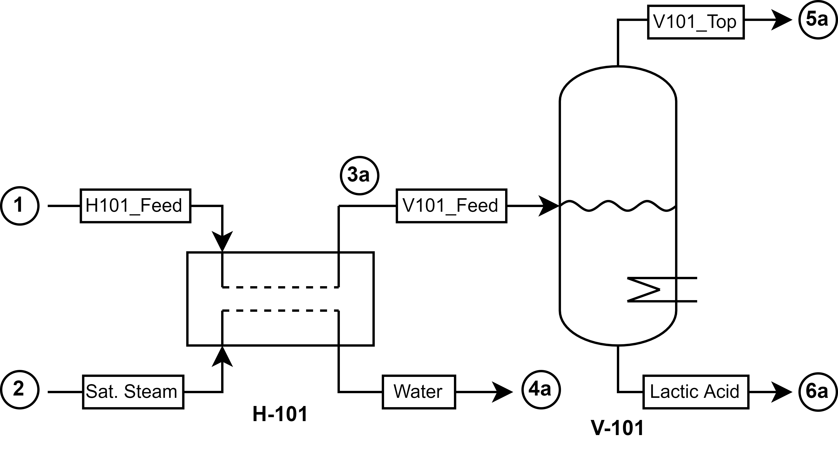
Figure 1: Flowsheet of the LA dehydration using a heat exchanger and a flash vessel.

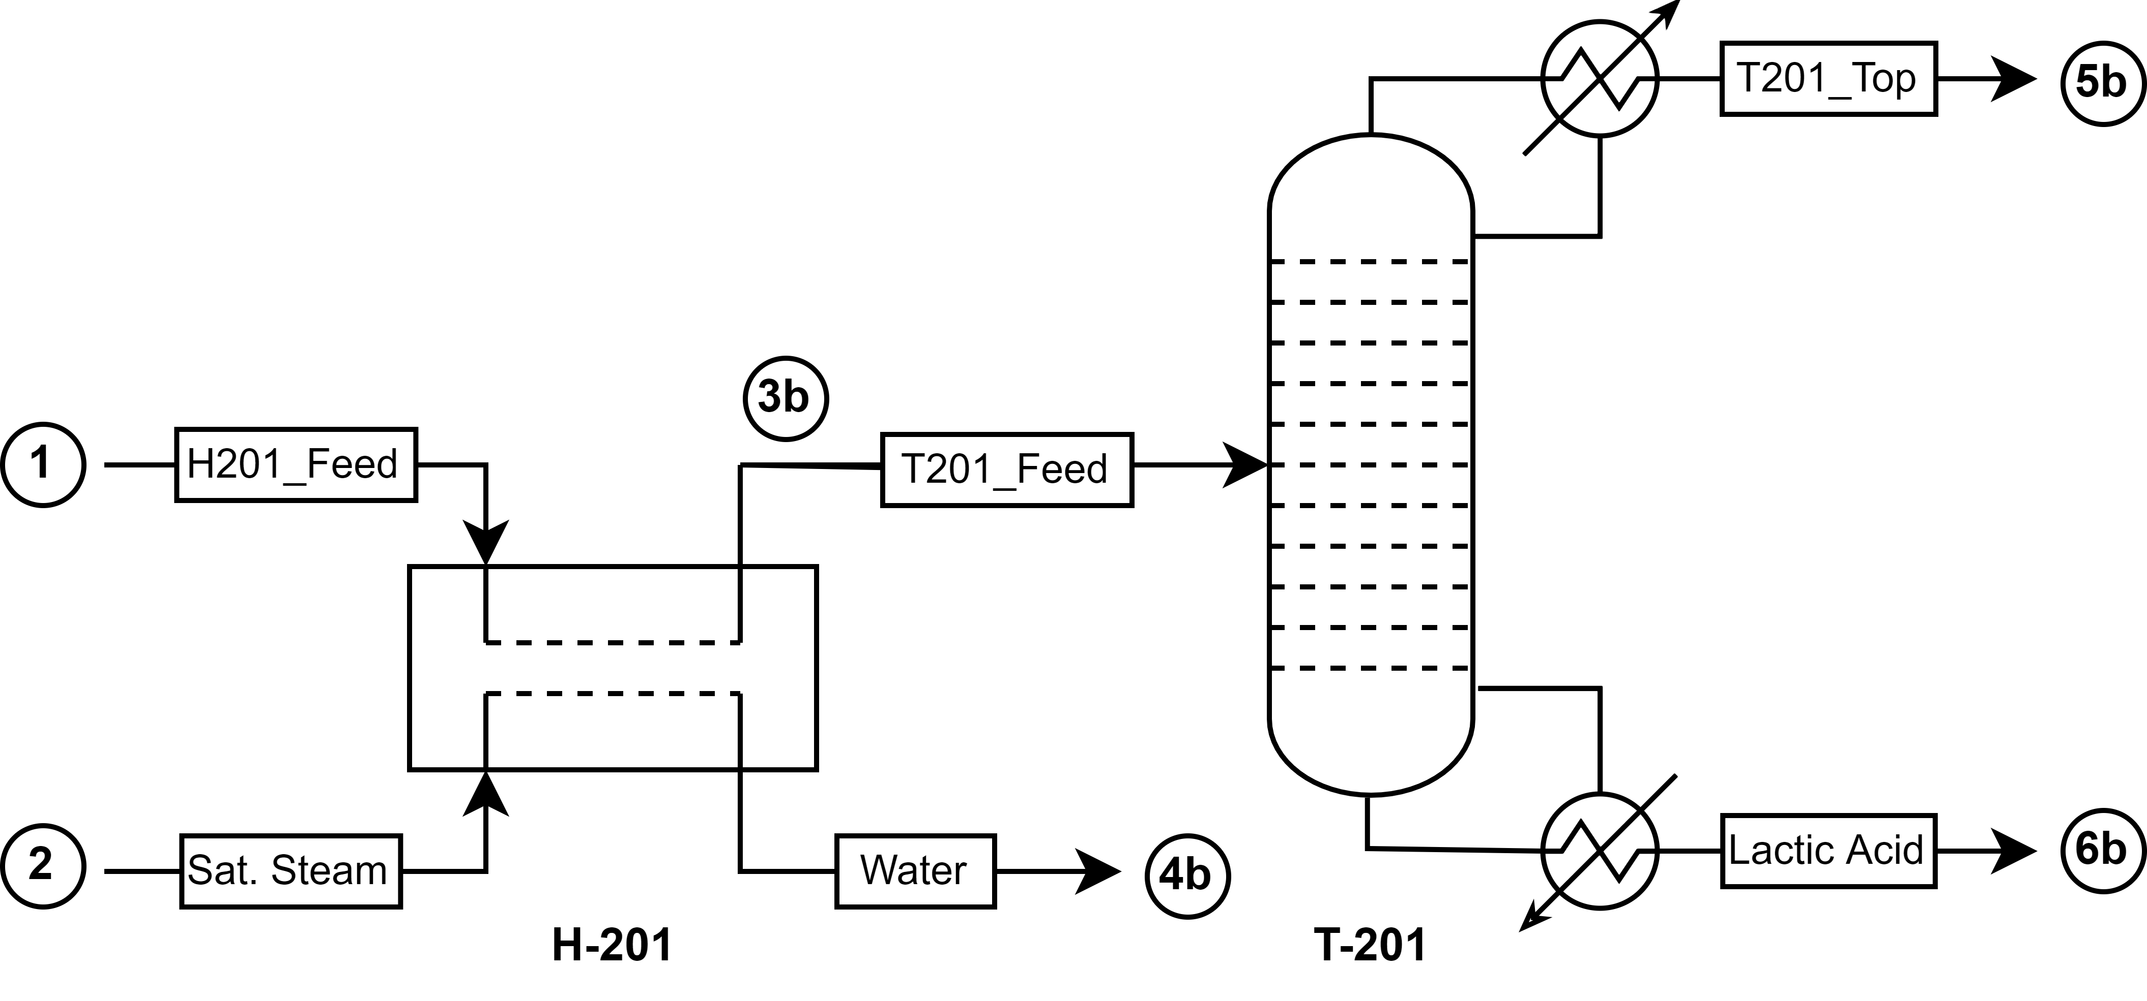
Figure 2: Flowsheet of the LA dehydration using a heat exchanger and a distillation column.
After assembling the flowcharts, the input streams and operating conditions had to be specified. The feed streams (1 and 2) were the same in both configurations (Table 1). Overall, the temperatures applied for both systems did not exceed 120 °C, as the LA decomposes at higher values. In the first configuration, the flash vessel (V-101) pressure was established by a parametric study varying it between 260-760 mmHg with a step size of 4.95 mmHg at 115°C.
Table 1: Specification properties for the feed streams.
Stream | 1 | 2
T [°C] | 27.0 | 160.0
P [mmHg] | 760.0 | 4510.3
Mass Flow [kg/h] | 1000.0 | 500.0
Water Content [% w/w] | 15.0 | 100.0

In the second configuration, three different columns sizes (I, II, and III) were specified at the same conditions (Table 2). The column’s pressure and reflux ratio were fixed to ensure that its temperature profile did not exceed 120 °C and that the final product had a 2.02% w/w water content. In addition, higher towers require less heat but demands more investments in the equipment construction. Therefore, three different heights were considered to analyze the losses and gains in operational and equipment costs.
Table 2: Operating conditions for the distillation columns.
Column | I | II | III
Number of Stages | 3 | 5 | 7
Feed Stage | 2 | 3 | 4
Column Pressure [mmHg] | 456.0
Reflux Ratio | 1.0
Bottom Stream Water Content [% w/w] | 2.02

In addition, a techno-economic feasibility study was realized to decide which configuration is the most adequate for the dehydration process. All the options were compared by using an economic performance parameter, the Total Annual Cost (TAC) – Eq (1), which depends on the operational costs (OPEX), the installed equipment's costs (CAPEX), and the Annual Capital Charge Ratio (ACCR) (Towler and Sinnott, 2013).

$$TAC=OPEX+CAPEX*ACCR$$ | (1)

The OPEX was determined by calculating the process utilities, considering that saturated steam costs $4.54/GJ and water costs $ 0.38/GJ (Turton et al., 2018). The CAPEX was estimated using the correlations developed by Douglas (1988) for carbon steel vessel shells – Eq (2); carbon steel sieve trays – Eq (3); and carbon steel shell and tube heat exchanger – Eq (4). These three equations are dependent of the equipment’s diameter (D), height (H) and area (A). Also, the Marshall and Swift equipment cost index (M&S) was considered equal to 1822.5.

$${TIC}_{shell}= \left(\frac{M\&S}{280}\right)*324.0*D^{1.066}*H^{0.82}$$ | (2)

$${TIC}_{internals}= \left(\frac{M\&S}{280}\right)*4.7*D^{1.55}*H$$ | (3)

$${TIC}_{heat exchanger}= \left(\frac{M\&S}{280}\right)*333.3*A^{0,65}$$ | (4)

The ACCR represents a portion of the investment’s value that must be annually accumulated to repay the investment’s principal + interest (Towler and Sinnott, 2013). Therefore, an ACCR = 0.26 was applied for both configurations, by assuming a 5-year return (n) with a 10% discount rate (i) – Eq (5).

$$ACCR= \frac{i*{\left(1+i\right)}^{n}}{{\left(1+i\right)}^{n}-1}$$ | (5)

Finally, an economical sensitivity analysis was performed to assess the impact of some variables on the TAC of the two configurations (Table 3). The boundaries for the year-return (n) were settled to represent a short- and long-term project. The different discount rates (i) were selected using usual values (Towler and Sinnott, 2013). And the other economic parameters were varied in ± 20%. Tornado graphs were assembled to visualize this influence and organize the parameters by their order of importance.
Table 3: Values of the economic parameters used in the sensitivity analysis.
 | Lower Values | Base Scenario | Higher Values
Year-Return (n) | 3 | 5 | 8
Discount Rate (i) | 0.05 | 0.10 | 0.15
M&S Index | 1458.0 | 1822.5 | 2187
Saturated Steam Cost [$/GJ] | 3.63 | 4.54 | 5.45
Water Cost [$/GJ] | 0.30 | 0.38 | 0.45
  - Results and Discussion
The first configuration (Figure 1) was implemented, and the parametric study determined that the 115 °C flash vessel had to be pressurized at 383.8 mmHg to ensure a lactic acid with a 2.02% w/w water content (Figure 3). The operation was simulated at such conditions and the design results are in Table 4. The second configuration (Figure 2) was simulated using three different heights (Table 5). The condenser and reboiler heat duties decreased in higher towers, indicating that the OPEX will be lower in the seven-stage column (III) despite the higher value in its CAPEX. Therefore, it is necessary to analyze different column sizes to verify if operational gains overcome the capital costs.

Figure 3: Parametric study of the flash vessel (V-101) pressure at a constant temperature of 115°C to analyse the water content in the dehydrated LA.
Table 4: Design results for the LA dehydration using the first configuration (Figure 1).
H-101 Heat Exchange [W] | 31,075.0
H-101 Area [ft²] | 14.4
V-101 Diameter [ft] | 0.984
V-101 Height [ft] | 4.23
V-101 Heat Duty [W] | 83,603.1
V-101 Heat Transfer Area [ft²] | 95.5

Table 5: Design results for the LA dehydration using the second configuration (Figure 2) – data applied in the Techno-Economic Feasibility Study.
Column | I | II | III
H-201 Heat Exchange [W] | 23,403.0
H-201 Area [ft²] | 14.3
T-201 Diameter [ft] | 0.75
T-201 Height [ft] | 7.97 | 17.81 | 29.60
T-201 Condenser Heat Duty [W] | 166,609.0 | 166,587.0 | 165,532.0
T-201 Condenser Area [ft²] | 284.4 | 289.9 | 286.5
T-201 Reboiler Heat Duty [W] | 173,988.0 | 173,967.0 | 172,915.0
T-201 Reboiler Area [ft²] | 123.2 | 123.4 | 122.7

The techno-economic study was realized using the simulations results. For the first configuration, the TAC was equal to $ 30,663.80 (Table 6) and the operational and equipment annual cost (AC) impacted equally in the final value (Figure 4 (a)). The heating system equipment weighted the most, demonstrating its importance in the process design. The second configuration showed that the three-stage column (I) is the most viable size, with a TAC = $ 67,857.71 (Table 7). Therefore, the operational gains of higher columns are not sufficient to cover the CAPEX. In this case, the heat exchangers also contributed strongly to the final cost (Figure 4 (b)). When comparing the two results, the flash vessel system is the most feasible economically with a lower operational and capital cost.
Table 6: Economic parameters for the first configuration (Figure 1).
H-101 Total Installed Cost (TIC) [$] | 12,277.60
V-101 Shell TIC [$] | 6,704.50
V-101 Heater TIC [$] | 42,006.50
CAPEX [$] | 60,982.46
H-101 Utility Costs[$/y] | 4,022.54
V-101 Utility Costs [$/y] | 10,821.96
OPEX[$/y] | 14,844.50
TAC [$/y] | 30,699.94
Table 7: Economic parameters for the second configuration (Figure 2).
 | I | II | III
H-101 TIC [$] | 12,215.70
T-101 Shell TIC [$] | 8,438.58 | 16,316.15 | 24,747.57
T-201 Internals TIC [$] | 156.10 | 348.83 | 579.75
T-201 Condenser TIC [$] | 85,391.65 | 86,450.98 | 85,787.78
T-201 Reboiler TIC [$] | 49,608.89 | 49.592.94 | 49,445.90
CAPEX [$] | 115,810.92 | 164,924.60 | 172,776.69
H-201 Utility Costs [$/y] | 3,029.45
T-201 Utility Costs [$/y] | 24,317.42 | 24,314.47 | 24,166.92
OPEX [$/y] | 27,346.87 | 27,343.91 | 27,196.37
TAC [$/y] | 67,857.71 | 70,224.31 | 72,118.31

 | (a) |  | (b)
Figure 4: Percentage of the operational & equipment costs on the first configuration (a) and on the three-stage column system (b).
The economic sensitivity analysis showed that the year-return (n) is the most important variable in both the studied cases (Figure 5). Thus, a more viable project is achieved with a higher year-return and the flash vessel still is the better option.

 | (a) |  | (b)
Figure 5: Tornado graphs of the flash vessel process (a) and the three-stage column system (b).
In addition, the saturated steam cost has a significant impact on the first system, which can be justified by the OPEX high contribution in the TAC (48.3 %). Therefore, it is recommended to lower the operational costs to benefit the process. The opposite is verified in the distillation columns, in which the operational parameters had the least influence on the final value.
  - Conclusion
Dehydrated lactic acid is required for poly(lactic acid) due to the negative effect of the water on the polymerization process. Here it was found that the dehydration system consisted of a flash vessel is more economical than the one using a distillation column. The flash vessel process had equal investments in equipments and operational costs, showing that that the saturated steam has a substantial contribution. Also, the year-return is an important variable to the economic study, and a long term project is a viable option to the LA pre-treatment.

Acknowledgments
This study had support from grant #2015/20630-4, a Thematic Project of São Paulo Research Foundation (FAPESP)
  - References
*Douglas, J.M. (1988), Conceptual Design of Chemical Processes, 1st ed., McGraw-Hill, New York, US.
*Jem, K.J., Tan, B. (2020) “The development and challenges of poly(lactic acid) and poly(glycolic acid)”, Advanced Industrial and Engineering Polymer Research, Vol. 3, pp. 60-70. DOI: 10.1016/j.aiepr.2020.01.002.
*Komesu, A., Oliveira, J., Martins, L.H.S., Maciel Filho, R., Maciel, M.R.W. (2018) “Effect of operating conditions and split ratio for lactic acid purification by short path evaporation system”, Chemical Engineering Transactions, Vol. 69, pp. 601-606. DOI: 10.3303/CET1869101.
*Linstrom, P.J., Mallard, W.G. (1997), National Institute of Standards and Technology (NIST), Chemistry WebBook, NIST Standard Reference Database 69, L-Lactic Acid. DOI: 10.18434/T4D303.
*Lopes, M.S., Jardini, A.L., Maciel Filho, R. (2014) “Synthesis and characterization of poly(lactic acid) by ring-opening polymerization for biomedical applications”, Chemical Engineering Transactions, Vol. 38, pp. 331-336. DOI: 10.3303/CET1438056.
Masutani, K., Kimura, Y. (2015) “PLA synthesis. from monomer to the polymer”, Chapter 1, Poly(Lactic Acid) Science and Technology: Processing, Properties, Additives and Applications, Ed. The Royal Society Chemistry, pp. 1-36. DOI: 10.1039/9781782624806-00001.
*Mehta, R., Kumar, V., Bhunia, H., Upadhyay, S.N. (2005) “Synthesis of poly(lactic acid): A review”, Journal of Macromolecular Science – Part C: Polymer Reviews, Vol. 45, pp. 325-349. DOI: 10.1080/15321790500304148.
*Nofar, M., Salehiyan, R., Sinha, S. (2019) “Rheology of poly (lactic acid)-based systems, Polymer Reviews, Vol. 59, pp. 465-509. DOI: 10.1080/15583724.2019.1572185.
*Paul, G.P., Virivinti, N. (2022) “An outlook on recent progress in poly(lactic acid): Polymerization, modelling and optimization”, Iranian Polymer Journal, Vol. 31, pp. 59-81, DOI: 10.1007/s13726-021-00993-y.
*Shetty, S. D., Shetty, N. (2019) “Investigation of mechanical properties and applications of polylactic acids – a review”, Materials Research Express, Vol. 6, pp. 112002. DOI:10.1088/2053-1591/ab4648.
*Sigma-Aldrich (2021), “Lactide Price”, available at: <https://www.sigmaaldrich.com/BR/pt/product/aldrich/303143?context=product> (accessed 18 November 2021).
*Singhvi, M.S., Zinjarde, S.S., Gokhale, D.V. (2019) “Polylactic acid: Synthesis and biomedical applications”, Journal of Applied Microbiology, Vol. 127, pp. 1612-1626. DOI: 10.1111/jam.14290.
*Stefaniak, K., Masek, A., (2021) “Green copolymers based on poly(lactic acid) – Short review”, Materials, Vol. 14, pp. 5254. DOI: 10.3390/ma14185254.
*Towler, G.P., Sinnott, R.K. (2013), Chemical Engineering Design Principles, Practice, and Economics of Plant and Process Design, 2nd ed., Butterworth-Heinemann Elsevier Ltd, Oxford, UK.
*Turton, R., Shaeiwitz, J., Bhattacharyya, D., Whiting, W. (2018), , Analysis, Synthesis, and Design of Chemical Processes, 5th ed., Pearson, London, UK.

