|  |  |
| --- | --- |
| cetlogo ***CHEMICAL ENGINEERING TRANSACTIONS***  ***VOL. 92, 2022*** | A publication of  aidiclogo_grande |
| The Italian Association  of Chemical Engineering  Online at www.cetjournal.it |
| Guest Editors: Rubens Maciel Filho, Eliseo Ranzi, Leonardo Tognotti  Copyright © 2022, AIDIC Servizi S.r.l. **ISBN** 978-88-95608-90-7; **ISSN** 2283-9216 | |

Techno-economical analysis of CO2 capture from biomass-derived syngas

Viktória Zsinkaa, Janka Bobek-Nagya, Attila Egedya\*, Norbert Miskolczia, Szabina Tomaseka, Haiping Yangb

1University of Pannonia, Hungary

2Huazhong University of Technolgy, China

egedya@fmt.uni-pannon.hu

The application of renewables is one of the key aspects of the design of sustainable processes. Biomass has a high interest as a feedstock, mostly because of the conversion potential to valuable products, e.g. syngas (containing hydrogen and carbon monoxide). Regarding sustainability and global climate change, carbon dioxide reduction, capture and storage are important tasks of waste-derived syngas production. There are many possibilities for the further handling of syngas to reduce the carbon dioxide concentrations, such as absorption, adsorption etc. The main goal of this study is to optimise the parameters and design the key operating units of different scenarios for carbon dioxide reduction (absorption by monoethanolamine (MEA) solution, cryogenic distillation, Ca-looping) from biomass-derived syngas. Pyrolysis-reforming of the biomass has been performed in a multizone horizontal tubular reactor using different process parameters. Gas fraction has been analysed by gas-chromatography, then based on the result, the key process parameters were identified focusing on the techno-economical approach of the different scenarios. The CO2 removal efficiencies obtained by cryogenic distillation and Ca-looping were nearly the same. Meanwhile, the amine solution absorbed 83.5 % of the CO2 content of the feedstock. The capital expenditures of the absorption, cryogenic distillation and Ca-looping were 1,587,000, 2,633,000 and 1,555,000 USD, respectively. The calculated values of the operating expenditures (OPEX) changed between 42,000 and 529,000 USD/year, while according to the expectations, the highest OPEX was observed in cryogenic distillation. Based on the results, it was found that the best available technology for CO2 removal is absorption using MEA solution.

* 1. Introduction

Nowadays, energy consumption rises steadily as the population increases and the living standard improves. Nowadays, the major sources of energy are attributed to fossil fuels that are strongly responsible for climate change and global warming (Detchusananard et al., 2018). Carbon dioxide (CO2) is a typical greenhouse gas that accounts for 76 % of total greenhouse gas emissions**. It** will cause a temperature increase of 1.8 – 5.8 °C in the average temperature of the planet by the end of the twenty-first century if the current emission level remains stable(Xiang et al., 2019).To relieve the mentioned issues,searching for renewable energy sources and/or carbon capture storage (CCS) or sutilisation (CCU) technologies are needed (Lee et al., 2017).CCU processes consist of various CO2 removal methods such as absorption (Zhang et al., 2019),adsorption (Ahmed et al., 2019),cryogenic distillation (Song et al., 2019) and Ca-looping (Ortiz et al., 2018). Although chemical absorption by alkanol amines – especially by monoethanolamine (MEA) – is considered as the most mature technology (Shi et al., 2014),it has somedisadvantages, such as high energy requirement, corrosiveness, slow kinetics, low absorption capacity and thermal stability (Narku-Tetteh et al., 2017).As a result of the limitations, many studies have been focused on solid adsorbents (e.g. activated carbon, zeolites etc.) (Samanta et al., 2012).However, it was found that adsorption methods are less effective, resulting in low CO2 selectivity and capacity. Moreover, the regeneration and reusability of adsorbents may raise further questions **(**Bamdad et al., 2018).Cryogenic distillation is also a possible way to remove CO2, but its high energy demand commonly contributes to over 50 % of the total plant operating costs **(**Ebrahimzadeh et al., 2016).Besides, from the referred technologies, Ca-looping seems to be the most promising technology for CO2 removal. Due to the high optimal carbonation temperature (650 °C), this process offers a relatively small energy penalty and results in around 80 – 90 % CO2 capture efficiency (Romano et al., 2013).Although the mentioned technologies were widely studied in the purification of flue gases, the knowledge about their applicability in CO2 removal of biomass-based syngases is limited. Based on the available literature, there are no available publications in which these technologies would be compared and soptimised based on efficiency, capital and operating expenditures (CAPEX and OPEX). As a result of it, the best available technology is unknown. In this study, three promising technologies were simulated with applying a flow sheeting simulator (Aspen Plus); the main equipment was designed, sized and the most suitable technology for the purification of this specific stream was determined.

* 1. Material and methods

Based on the typical biomass yields and gasification reactor outlet parameters, a 5000 t/year capacity was chosen. This will result in our case around 58 % of gas (2900 t/year) and about 42 % (2100 t/year) of char yields (which can be varied based on the inlet composition of the biomass). The sutilisation of the solid was not considered; only the purification of the outlet gas was calculated.

The same inlet parameters were applied: 362 kg/hr feedstock at 850 °C and 1 bar. Table 1 shows the inlet gas composition derived from laboratory-scale experiments. The inlet stream of the process was the outlet of the multizone gasification reactor. The contact mediums (adsorbent, absorbent) was cleaned and recirculated as possible.

Table 1: The molar composition of the feed gas

|  |  |  |  |  |  |  |  |  |  |  |
| --- | --- | --- | --- | --- | --- | --- | --- | --- | --- | --- |
|  | CO2 | H2 | CO | CH4 | C2H4 | C2H6 | C3H6 | C3H8 | C4H8 | C4H10 |
| Gas feed molar composition [%] | 16 | 53 | 17 | 6 | 1.7 | 1.45 | 1.1 | 1.0 | 1.3 | 1.45 |

Three different processes were considered:

* absorption using MEA as absorbent,
* cryogenic distillation,
* Ca-looping process using CaO as adsorbent.

All processes were implemented and simulated using Aspen Plus software. The main process equipment was designed sized; besides CAPEX and OPEX were calculated as well. The Aspen Plus Economic analyser was used when applicable; otherwise, nomogram based cost calculation was applied (indicated with \*-s). All the CAPEX and OPEX values were sactualised using CE Plant index from 2018. Based on the different scenarios, the most suitable can be selected for the negative emission gasification technology. In this study, the technologies were compared without energy integration. The applied modules were basic Aspen Plus modules; the application parameters can be accessed in the Aspen Plus built-in guide. There are several versions; one of them can be accessed via the web (Aspen Plus user guide).

* 1. Results
     1. Absorption using MEA as absorbent

The absorption technology with MEA absorbent includes two heat exchangers, one compressor, an 8 trayed absorber and a sorbent regeneration unit (Figure 1). The feed stream is cooled and compressed to 20 °C and 5 bar to provide the adequate temperature for the mechanism of CO2 absorption in the absorber (3 bar), as it was referred in earlier studies (Bihong et al., 2015). The total CO2 removal is 83.5 % which can be improved by increasing the flow rate of the MEA solution. Henceforward, desorption was carried out at 100 °C towards the CO2 removal. The two sensitivity analysis presented shows the effect of MEA and the desorption unit temperature.

The main design parameters are the following:

* HX101 heat duty, 8.8 m2 heat transfer area (simple heat exchanger module).
* CO101: 46.81 kW work required, 80 % efficiency (standard compressor module).
* HX102: -56 kW heat duty, 2.7 m2 heat transfer area (simple heat exchanger module).
* C101: 83.5 % efficiency, with a 0.36 m diameter with Raschig type packing (Radfrac detailed module).
* C102: 53 kW net heat duty required (flash2 phase separator).

The costs are summarised in Table 2.

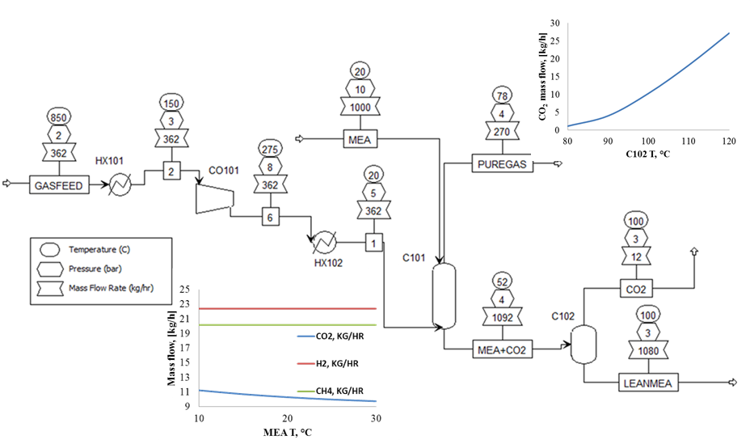

Figure 1: Flowsheet and the process parameters of the designed absorption process

Table 2: Cost evaluation of the designed MEA absorption process

|  |  |  |
| --- | --- | --- |
|  | CAPEX (USD) | OPEX (USD/year) |
| HX101 | 22,000 | 4,000 |
| CO101 | 1,207,000 | 36,000 |
| HX102 | 71,000 | 2,000 |
| C101 | 176,000 | - |
| C102 | 111,000 | - |
| SUM | 1,587,000 | 42,000 |

* + 1. Cryogenic distillation

The cryogenic distillation technology (Figure 2) consists of a cooler (HX101), which serves the cooling from   
850 °C to 35 °C. The distillation column operates at 5 bar and -65 °C (Yousef et al., 2019); thus, a compressor (CO101) and one more cooler (HX102) are needed to reach the operational parameters. Due to the sensitivity analysis, the feed stream is introduced in 3rd stage. The column pressure drop is 0.5 bar, while the CO2 removal efficiency is 75 %. The feed stage position has a minimal effect on the separation, as the results of the sensitivity analysis are shown in Figure 2. The costs are summarised in Table 3.

The main design parameters are the following:

* HX101: -202 kW heat duty, 9.9 m2 heat transfer area (simple heat exchanger module).
* CO101: 46.3 kW work required, 72 % efficiency (standard compressor module).
* HX102: -70.6 kW heat duty, 1.0 m2 heat transfer area (simple heat exchanger module).
* C101: 0.5 m bottom diameter, 9.1 m height, sieves stages, condenser heat duty: -147 kW, reboiler heat duty: 89 kW (radfrac detailed module).

Table 3: Cost evaluation of the designed cryogenic distillation process

|  |  |  |
| --- | --- | --- |
|  | CAPEX (USD) | OPEX (USD/year) |
| HX101 | 717,000 | 4,000 |
| C101 | 647,000 | 490,000 |
| HX102 | 76,000 | 170 |
| CO101 | 1,194,000 | 35,000 |
| SUM | 2,633,000 | 529,000 |

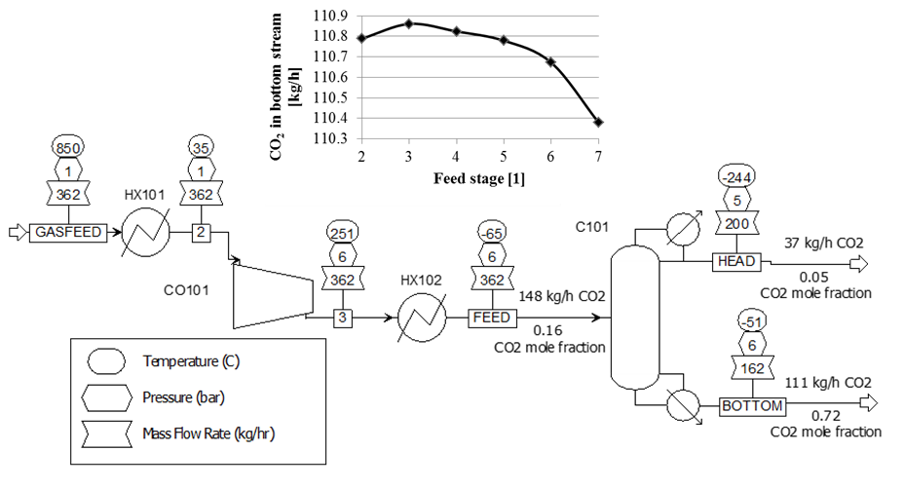

Figure 2: Flowsheet, the process parameters of the designed cryogenic distillation process and the influence of feed’s stage on CO2 mass flowrate in BOTTOM stream

* + 1. Ca looping process

Figure 3 shows the flowsheet of the Ca-looping process and the process parameters. The process contains a compressor (CO101), a heat exchanger (HX101), a carbonator (R101) modelled as a fluidised bed reactor, and a calciner (R102) modelled as a Gibbs reactor. Then the outlet of the R102 reactor was purified with a cyclone (CY101), and the CO2 and CaO streams were obtained. The R101 reactor operates at 650 °C, so the inlet gas feed should be cooled down before entering the reactor. The calciner temperature is 900 °C which is suitable for the complete regeneration of the spent CaO to its original form. Thus a large amount of CaO can be recycled. However, no conveyors or any solid transportation equipment was modelled or sized in this study. The lower diagram shows the molar composition of the GASOUT stream. The conversions were derived from (Cormos and Simon, 2013), and 70 % conversion was approximated in the carbonator. The amount of CO2 decreases through the reactor as the reaction progresses. Besides, the particle size distribution can be seen in Figure 3. The costs are summarised in Table 4.

The main design parameters are the following:

* CO101 – 55.6 kW work required (standard compressor module).
* HX101 – 111.55 kW duty (simple heat exchanger module).
* R101 – with 0.5 m diameter and 10 m height (mostly preventing solid discharge), with 150 kg solids load, and 266 m2 surface area with 2.92e8 Geldart type B particles (Fluidised bed module).
* R102 – calculated as a furnace with 0.131 Gcal/hr duty (Gibbs reactor module)
* CY101 – 99.5 % efficiency, with a 1.35 m diameter and 2.02 m cylinder, and 3.38 m cone section height with 3.35 m vortexes, using 3 Stairmand-HE type cyclones (cyclone module).

Table 4: Cost evaluation of the designed Ca-looping process

|  |  |  |
| --- | --- | --- |
|  | CAPEX (USD) | OPEX (USD/year) |
| CO101 | 76,000 | 35,000 |
| HX101 | 40,000 | 1,000 |
| R101 | 1,265,000\* | 1,000 |
| R102 | 17,000\*\* | 33,000 |
| CY101 | 158,000 | 0 |
| SUM | 1,555,000 | 69,000 |

\*Rules of Thumb in Engineering Practice, \*\*nomogram

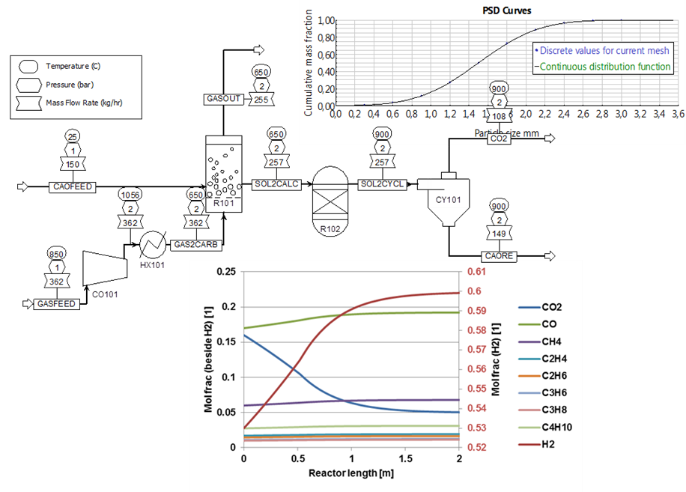

Figure 3: Flowsheet and the process parameters of the designed Ca-looping process

* + 1. Discussion

The cryogenic distillation is not feasible economically from the three examined cases due to the low distillation temperatures. The Ca-looping (mostly used in steel and cement industries) and the absorption have similar performance according to the CAPEX and OPEX. The final application and the decision on which technology should be chosen must include energy integration and also the definition of the inlet stream. If the biomass pyrolysis device is on-site in the removal unit, the Ca-looping would be suitable because it operates at higher temperatures. However, if the medium is transferred before purification, then MEA based absorption is the most appropriate option.

* 1. Conclusion

In this study, three promising CO2 removal technologies (absorption by MEA solvent, cryogenic distillation, Ca-looping) were simulated with the application of Aspen Plus software and compared on the basis of efficiency, capital and operating expenditures (CAPEX and OPEX). In the case of absorption, the feed stream was cooled from 850 °C to 20 °C and compressed from 1 bar to 3 bar to provide the adequate temperature and pressure for the mechanism of CO2 absorption. In cryogenic distillation, a two-step cooling process was used to reach the operating temperature of the column (-65 °C). In contrast, the optimal carbonation temperature of Ca-looping was 650 °C. The CO2 removal efficiencies obtained by cryogenic distillation and Ca-looping were nearly the same (75 and 70 %). Meanwhile, the amine solution absorbed 83.5 % of the CO2 content from the feedstock. CAPEX and OPEX were also the basis of the comparison. The capital expenditures of the designed technologies were 1,587,000, 2,633,000 and 1,555,000 USD, respectively. The calculated values of the operating expenditures changed between 42,000 and 529,000 USD/year, resulting in the expected values. Due to the high energy demand of cooling, the highest OPEX was observed in cryogenic distillation. Based on the results, it was found that the best available technology for CO2 removal of biomass-based syngas is the absorption using MEA sorbent. The two feasible options are the MEA based absorption and Ca-looping, which applications are based on the optimal pyrolysis condition, including temperature and flue gas logistics.

Acknowledgements

The research was supported by EFOP‑3.6.1‑16‑2016‑00015 Smart Specialisation Strategy (S3) -Comprehensive Institutional Development Program at the University of Pannonia to Promote Sensible Individual Education and Career Choices project. This project has received also funding from the European Union's Horizon 2020 research and innovation program under the Marie Skłodowska-Curie grant agreement No 823745.

References

Ahmed M.B., Johir M.A.H., Zhou J.L., Ngo H.H., Nghiem L.D., Richardson C., Moni M.A., Bryant M.R., 2019, Activated carbon preparation from biomass feedstock: Clean production and carbon dioxide adsorption, Journal of Cleaner Production, 225, 405–413.

Aspen Plus User Guide, <https://web.ist.utl.pt/ist11038/acad/Aspen/AspUserGuide10.pdf>, Accessed on. 2022.02.26.

Bamdad H., Hawboldt K., MacQuarrie S., 2018, A review on common adsorbents for acid gases removal: Focus on biochar, Renewable and Sustainable Energy Reviews, 81, 1705–1720.

Bihong Lv., Guo B., Zhou Z., Jing G., 2015, Mechanism of CO2 capture into monoethanolamine solution with different CO2 loading during the absorption/desorption processes, Environmental Science and Technology, 47(17), 10728–10735.

Cormos A-M., Simon A., 2013, Dynamic modelling of CO2 capture by calcium-looping cycle, Chemical Engineering Transactions, 421–426

Detchusananard T., Im-orb K., Ponpesh P., Arpornwichanpo A., 2018, Biomass gasification integrated with CO2 capture processes for high-purity hydrogen production: Process performance and energy analysis, Energy Conversion and Management, 171, 1560–1572.

Ebrahimzadeh E., Matagi J., Fazlollahi F., Baxter L.L., 2016, Alternative extractive distillation system for CO2-ethane azeotrope separation in enhanced oil recovery processes, Applied Thermal Engineering, 96, 39–47.

Lee Y., Yang X., Cho S-H., Kim J-K., Lee S.S., Tsang D.C.W., Ok Y.S., Kwon E.E., 2017, Pyrolysis process of agricultural waste using CO2 for waste management, energy recovery, and biochar fabrication, Applied Energy, 185, 214–222.

Moioli S., Pellegrini L.A., 2013, Regeneration section of CO2 capture plant by MEA scrubbing with a rate-based model, Chemical Engineering Transactions, 32, 1849–1854.

Narku-Tetteh J., Muchan P., Idem R., 2017, Effect of alkanol chain length of primary alkanolamines and alkyl chain lenght of secondary and tertiary alkanolamines on their CO2 capture activities, Separation and Purification Technology, 187, 453–467.

Ortiz C., Valverde J.M., Chacartegui R., Romeo L.M., Perez-Maqueda L.A., 2018, The mOxy-CaL process: Integration of membrane separation, partial oxy-combustion and calcium looping for CO2 capture, Chemical Engineering Transactions, 70, 643–648.

Romano M.C., Martínez I., Murillo R., Arstad B., Blom R., Ozcan D.C., Ahn H., Brandani S., 2013, Process simulation of Ca-looping processes: review and guidelines, Energy Procedia, 37, 142, 142–150.

Samanta A., Zhao A., Shimizu G.K.H., Sarkar P., Gupta R., 2012, Post-combustion CO2 capture using solid sorbents: A review, Industrial&Engineering Chemistry Research, 51, 1438–1463.

Shi H., Naami A., Idem R., Tontiwachwuthikul P., 2014, Catalytic and non-catalytic solvent regeneration during absorption-based CO2 capture with single and blended reactive amine solvents, International Journal of Greenhouse Gas Control, 26, 39–50.

Song C., Liu Q., Deng S., Li H., Kitamura Y., 2019, Cryogenic-based CO2 capture technologies: State-of-the-art developments and current challenges, Renewable and Sustainable Energy Reviews, 101, 265–278.

Xiang Y., Cai L., Guan Y., Liu W., He T., Li J., 2019, Study on the biomass-based integrated gasification combined cycle with negative CO2 emissions under different temperatures and pressures, Energy, 179, 571–580.

Yousef A.M., El-Maghlany W.M., Eldrainy Y.A., Attia A., 2019, Upgrading biogas to biomethane and liquid CO2: A novel cryogenic process, Fuel, 251, 611–628.

Zhang S., Tao R., Liu L., Zhang L., Du J., 2019, Economic and environmental optimisation framework for carbon capture utilisation and storage supply chain, Chemical Engineering Transactions, 76, 1–6.