CHEMICAL ENGINEERING TRANSACTIONS | A publication of
The Italian Association
of Chemical Engineering
Online at www.cetjournal.it

Analysis of hydrogen production from glycerol gasification using supercritical and subcritical water

Jan Galvão Gomesª, Julles Mitoura dos Santos Juniorª, Annamaria Dória Souza Vidotti^{b}, Antonio Carlos Daltro de Freitas^{b}, Reginaldo Guirardelloª
ªSchool of Chemical Engineering, University of Campinas (UNICAMP), Av. Albert Einstein 500, 13083-852, Campinas-SP, Brazil
^{b}Chemical Engineering Department, Exact Sciences and Technology Center, Federal University of Maranhão (UFMA), Av. dos Portugueses, 1966, Bacanga, 65080-805, São Luís-MA
jangalvaog@gmail.com

With the increasing consumption of fossil fuels, two major problems have been worrying the world: energy security and pollution caused by non-renewable fuels. When considering alternative sources of renewable energy, the potential of several biomasses is verified, which have been used in the production of biofuels such as hydrogen (H₂). This work will present an analysis on the conversion of glycerol into H₂ with gasification in supercritical (SCWG) and subcritical (SbCWG) water using the Gibbs energy minimization (MinG) and entropy maximization (MaxS) methods. These methodologies will be implemented in the Gams software and solved using the CONOPT 4 solver. The cubic Peng Robinson (PR) equation of state was used to evaluate the non-idealities of the phases. The SCWG results showed the most suitable regions to operate in adiabatic (below 900 K) or isothermal (above 900 K) conditions according to the endothermic character of the system. The increase in temperature favors the production of hydrogen while the increase in the initial composition of biomass is unfavorable. Pressure has no major influence on the system. The SbCWG did not show significant production of H₂. However, when secondary reactions are inhibited, we observed relevant productions of H₂. This highlights the need to use specific catalysts to favor the hydrogen reaction. With this work, we seek to contribute to a better thermodynamic understanding of the relevant effects by reactional pathways of biomass decomposition and sustainable production of H₂.
  - Introduction
With the high energy consumption and pollution, there was a need to explore alternative energy sources that would solve both adversities. A promising renewable energy source is biomass. Some reports estimate that there are about 1.8 trillion tons of terrestrial biomass and 4 billion tons of aquatic biomass and this represents a total amount of 33,000 total EJ (Tursi, 2019). The good biomass to be studied is glycerol. It is commonly obtained in large quantities as a by-product in the transesterification reaction of vegetable oils for biodiesel production. Therefore, it is of great interest that it has a proper destination. Thus, it becomes an option for conversion into some type of energy (heat, electricity, or some type of biofuel)(He et al., 2017).
The most promising and widely studied biofuel currently is hydrogen (H₂). It has a high energy density and less generation of pollutants. Thus, being both environmentally and energetically favorable. It is considered a fundamental component in the development of a clean and sustainable energy system.
A promising route for the production of H₂ is supercritical and subcritical water gasification. This reaction occurs at temperature and pressure above 647 K and 220 bar, respectively. Under these conditions, there are changes in the dielectric constant of the water facilitating its entry into the organic matrix of biomass and decomposing it. According to Osada et al. (2006), the composition of the gasified biomass depends on the reaction temperature. Three main reactions of wood biomass occur:
 | $C+ H_{2}O→CO+H_{2 }$ Endothermic | (1)
 | $CO+ H_{2}O→CO_{2}+H_{2 }$ Athermic | (2)
 | $CO+ 3H_{2}→CH_{4}+H_{2}O$ Exothermic | (3)
Equations 1, 2, and 3 represent the possible reactions that occur under SCWG and SbCWG conditions. Its thermal characteristics were considered at the reference temperature of 298 K.
Therefore, this work will present a thermodynamic analysis of the supercritical and subcritical gasification reaction of glycerol, evaluating the thermal effect and regions of higher production of H₂. The reactions will be carried out based on the Gibbs energy minimization and entropy maximization methods and using the PR equation of state to represent the non-ideality of the system.
  - Methodology
2.1. Gibbs Energy Minimization
This method was applied to represent reactors under constant temperature and pressure conditions. It tries to find the condition in which the global Gibbs energy is minimal and thereby achieves equilibrium. The objective function to be minimized is described according to Equation 4. The $n_{i}^{k}$and $μ_{i}^{k}$ represents the number of moles and chemical potential of the species i in the phase k (gas, liquid and solid).
$\min{G}=\sum_{i=1}^{NC}{\sum_{k=1}^{NF}{n_{i}^{k}μ_{i}^{k}}}$ (4)
The system in the condition of minimum energy must conform to the conditions of non-negativity of the number of moles (Equation 5) and the conservation of the number of atoms (Equation 6). The parameter $a_{mi}$ represents the number of atoms of species m in molecule i.
$n_{i}^{k}≥0$ (5)
$\sum_{i=1}^{NC}{\sum_{i=1}^{NF}{{a_{mi}(n}_{i}^{k})}}= \sum_{j=1}^{NC}{{a_{mi}(n}_{i}^{0})}$ | (6)
2.2. Entropy Maximization
In this model, reactions occur at constant pressure and enthalpy conditions. Equilibrium is reached when the maximum entropy value is obtained. The objective function of entropy maximization is described according to Equation 7.
$\max{S}=\sum_{i=1}^{NC}{\sum_{k=1}^{NF}{n_{i}^{k}{\overline{S}}_{i}^{k}}}$ (7)
As in Gibbs' minimum energy model, the maximization of entropy must also comply with the restrictions of non-negativity of the number of moles (Equation 5) and the conservation of the number of atoms (Equation 6). In addition, the enthalpy balance must also be taken into account, as shown in equation 8.
$\sum_{i=1}^{NC}{\sum_{k=1}^{NF}{n_{i}^{k}{\overline{H}}_{i}^{k}}}=\sum_{i=1}^{NC}{n_{i}^{o}{\overline{H}}_{i}^{o}=H^{o}}$ (8)
2.3. Representation of the non-ideality of the system
The cubic Peng Robinson (PR) equation of state was used to represent the possible non-ideality of the system. This will determine the compressibility factors (Z), as presented in Equation 9. The values of u and w are tabled for the Peng Robinson equation and are 2 and -1, respectively. A and B are temperature-dependent parameters (Donald B. Robinson, Ding-Yu Peng, 1977).
 | $$f\left(Z\right)=Z^{3}-\left(1+B-uB\right)Z^{2}+\left(A+wB^{2}-uB-uB^{2}\right)Z-AB-wB^{2}-wB^{3}$$ | (9)
Solving this equation produces one or three real roots, in which two will be used to calculate the fugacity coefficients of the liquid and gaseous phases. Subsequently, the fugacity coefficients of the system components will be calculated based on the approach known as phi-phi, as shown in Equation 10. The solid phase will be considered ideal and only with the formation of solid carbon represented as a pure component.
$\ln{\hat{ϕ_{i}}}=\frac{B_{i}}{B\left(Z-1\right)}-\ln\left( Z-B\right)+\frac{A}{2\sqrt{2}B}\left(\frac{B_{i}}{B}-2\frac{\sum_{j}{y_{j}\sqrt{a_{i}a_{j}}}}{a_{m}}\right)\ln\left(\frac{Z+\left(1+\sqrt{2}\right)B}{Z+\left(1-\sqrt{2}\right)B}\right)$ (10)
The detailed methodology to be used to include these state equations in the thermodynamic method proposed throughout the optimization routines to be developed can be found in Kamath et al. (2010) and Dowling et al. (2015).
2.4. Numerical formulation and resolution of the proposed problems
The optimization problem will be implemented in the GAMS software and solved using the CONOPT 4 solver. This approach has demonstrated great accuracy and efficiency and has been used with great results by our research group over the last few years for a wide range of systems in chemical equilibrium and combined phase conditions (Freitas and Guirardello, 2012).
The proposed methods will consider liquid, gaseous and solid phases for SbCWG and solid, gaseous phases for SCWG. Based on the experiments accomplished by Freitas and Guirardello (2012), 12 components will initially be considered as representative of the main compounds possible to form during the SbCWG or SCWG reaction. These components are: H₂O, H₂, CH₄, CO₂, CO, N₂, O₂, CH₃OH, NH₃, C₂H₆, C₂H₄ and C₃H₈. All the necessary properties were obtained from the literature Poling & Prausnitz (2011).
  - Results and Discussion
The analysis was performed using Gibbs energy minimization methodology and will provide data regarding the equilibrium composition of the compounds generated in the evaluated systems. From these results, it was possible to understand and determine the operational ranges that lead to the highest productivity of hydrogen and intermediate compounds in the reaction. Similarly, the results obtained through the entropy maximization methodology provided data on the equilibrium composition and also on the thermal behavior of the process, assisting in understanding the endothermic and exothermic characteristics of the reactions and validating strategies for maintaining autothermic operational conditions.
3.1. Methodology Validation
Initially, a study for supercritical reactions was developed according to the presented methodology. Based on the results of Tang e Kitagawa (2005) (TK) it was possible to validate the method of supercritical reactions and with the help of the work of Dowling et al. (2015) expand it for subcritical reactions.
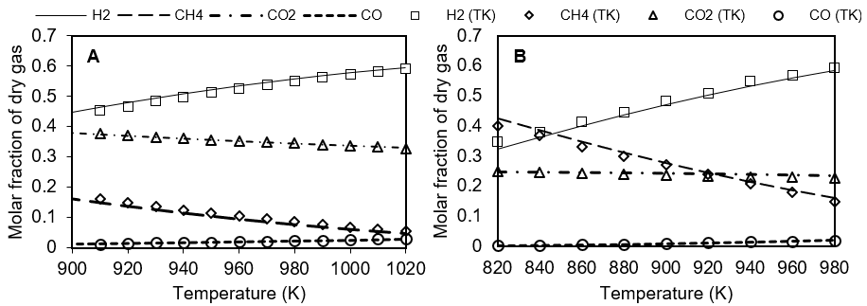
Figure 1: Evaluation of the thermal effect in the comparison between the data calculated by this work and that of Tang and Kitagawa (2005) (TK). A – Using glucose as biomass with an initial concentration of 0.6 M and pressure of 280 bar. B - Using methanol as biomass with an initial concentration of 15% wt and pressure of 276 bar.
The system showed small amounts of methanol, ethane, and ethylene which were ignored in the presentation of the graphical results. Figures 1A and 1B show the 4 compounds formed in relevant quantities: hydrogen (H₂), methane (CH₄), carbon dioxide (CO₂), and carbon monoxide (CO). There was no formation of solids in any of the conditions evaluated. All presented a good agreement with the experimental results. To confirm this, the relative error of the method (MRE) was calculated for both glucose and methanol versus Tang and Kitagawa data, reaching MRE values of 0.05 and 0.03, respectively. Thus, it is observed that this methodology has a good prediction of results, especially in high-temperature conditions. The same analysis was performed for the ideal model of each biomass. An MRE of 0.07 for methanol and 0.08 for glucose was obtained. This reveals the addition of non-ideality to the model contributes to the robustness of the program.
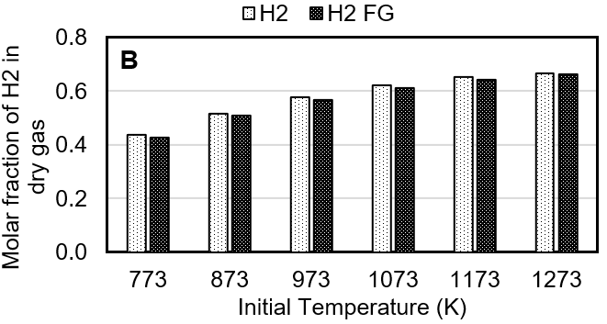
A
Figure 2: Evaluation of the influence of the initial temperature on results of interest the pressure of 250 bar and initial microalgae composition equal to 0.15 wt (Freitas and Guirardello 2015 - FG). A - Effect of the initial temperature on the equilibrium temperature. B - Effect of the initial temperature on the fraction of hydrogen produced.
To validate the entropy maximization methodology, a comparison was made with the data obtained by Freitas and Guirardello (2015) (FG) using a similar methodology. Both methods analyzed the effects of the initial reaction temperature and the initial composition of the microalgae Nannochloropsis sp. about the equilibrium temperature and composition of the products obtained. The system presented small amounts of C₂H₆, C₂H₄, N_{2,} and NH₃ in addition to the main produced compounds (H₂, CH₄, CO_{2,} and CO).

For the conversion of Nannochloropsis sp. good agreement was obtained between the equilibrium and initial temperatures, as shown in Figure 2A, with a relative error (MRE) of 0.008. Figure 2B confirms the result reaching a relative error (MRE) of 0.06 for the H₂ molar fraction. This shows the accuracy of the methodology in predicting the results of these variables.
3.2. Results obtained using Glycerol
The results of this work will be divided into basically 4 steps. The first 3 steps include evaluation of the effect of temperature, pressure, and initial glycerol composition for both Gibbs energy minimization and entropy maximization under supercritical conditions. The fourth step will focus on evaluating reactions under subcritical conditions and their characteristics.
3.2.1. Temperature Assessment
Figures 3A and 3B present the molar composition of products as a function of temperature. It is observed that with increasing temperature there is an increase in H₂ and CO compositions and, consequently, a decrease in the compositions of CH₄ and CO₂.
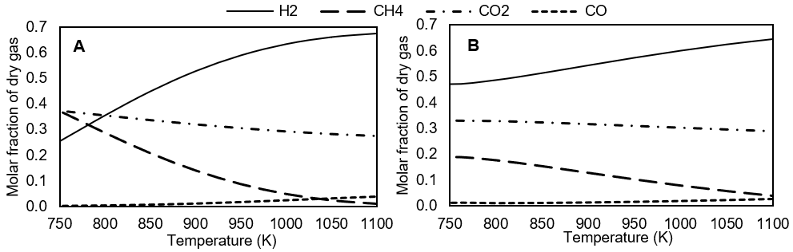
Figure 3: Influence of temperature on the main products at a pressure of 220 bar and initial glycerol composition of 10% wt. A - Result obtained at MinG. B - Result obtained at MaxS.
This behavior is following Equations 1, 2, and 3 that show the thermal character of the reactions. The gasification reaction, being endothermic, is favored, forming more CO and H₂. Meanwhile, the methanation reaction, being exothermic, is disadvantaged by reducing the formation of CH₄. Regarding the water gas shift reaction, as it has a more athermic character, it presents a lower response to the thermal effect, so a less influence on the decrease of CO₂ in the system.
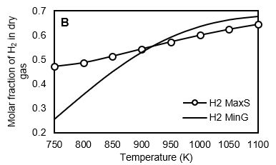
A
Figure 4: Analysis of the thermal character of the reaction at pressure and 220 bar and initial glycerol composition of 10% wt. A - Evaluation of the equilibrium temperature concerning the initial temperature based on entropy maximization. B - H₂ production obtained from MinG and MaxS methods.
Figure 4A presents a better view of the thermal character of the reaction. It is observed that with an increase in temperature, there is an increase in equilibrium temperature. However, at each initial temperature studied there is a lower equilibrium temperature. Analyzing the energetic behavior of the reactions, it is possible to notice that for all initial temperatures there is a predominance of the endothermic character in the system. With increasing temperature, the reaction tends to have an increasingly pronounced endothermic character.
Figure 4B shows a comparison in H₂ production in each of the models used. It is observed that for temperatures lower than 900 K there is a higher hydrogen production using MaxS. This superior behavior is due to the reaction being performed in an adiabatic reactor and can convert all the produced heat in favor of it. However, for temperatures above 900 K, there is higher H₂ production using MinG. This is due to the increasingly pronounced endothermic nature of the reaction, which harms adiabatic operational conditions when it is desired to produce more H₂.
3.2.2. Pressure Assessment
The pressure did not show great relevance for the reactions as shown in Figures 5A and 5B. In MinG and MaxS, the increase in pressure generates a slight decrease in the H₂ fraction and a small increase in the CH₄ fraction. This effect can be attributed to the methanation reaction that is favored with increasing pressure according to Le Chatelier's principle.
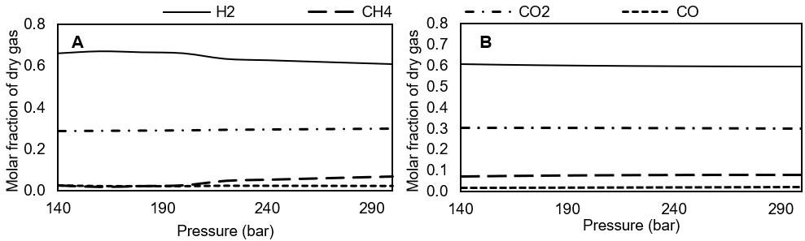
Figure 5: Evaluation of the molar fraction of products as a function of pressure at a temperature of 1000 K and initial composition 10% wt of glycerol. A - Result obtained at MinG. B - Result obtained at MaxS.
Figure 5A showed a greater variation in the molar fraction of H₂ and CH₄ at a pressure close to 220 bar, which is the critical water pressure. This variation is attributed to the shift from subcritical to supercritical region. The MaxS method barely differentiates the phase shift.
3.2.3. Evaluation of glycerol composition
Figures 6A and 6B show the result of the variation in composition about the products formed. With the increase of biomass in the feed, there is a significant decrease in the H₂ fraction, a slight growth of CO, CO₂ fractions, and higher production of CH₄. Thus, it is understood that increased glycerol composition tends to favor the methanation reaction and, consequently, to disfavor the production of H₂.
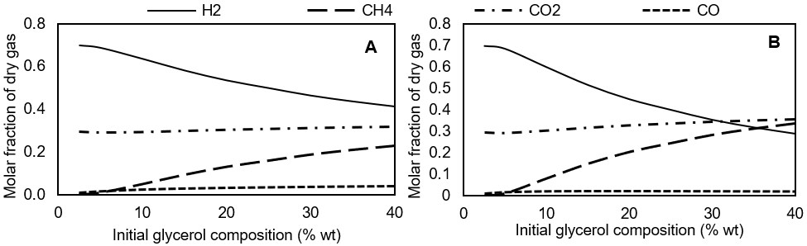
Figure 6: Evaluation of the effect of the glycerol feed composition on the molar fraction of the products at a pressure of 220 bar and a temperature of 1000 K. A - Result obtained at MinG. B - Result obtained at MaxS.
According to previous studies, it is expected that with the increase of the initial composition there will be constancy in the fractions of the products, and all extra biomass will not convert or turn into solid carbon.
3.2.4. Evaluation of the reaction under subcritical conditions
The study under subcritical conditions was conducted in a temperature range of 500 to 600 K, pressures between 180 and 260 bar, and initial glycerol composition between 2.5% and 20% wt. The pressure ranges and glycerol composition were defined based on the maximization of H₂ production through SCWG. For temperatures below 500 K, the reaction practically does not occur.
Figure 7A shows glycerol conversion in products. It is observed that practically does not form H₂. Most biomass converts to solid carbon and a small part generate CO₂ and CH₄. This behavior was expected as the reaction occurs in the liquid phase and hinders the production of H₂. Therefore, a way to increase the production of H₂ in these conditions was sought. Tang and Kitagawa (2005) cite in their work a compact reactor that catalyzed the gas-water reaction and inhibited the methane reaction. Therefore, it was decided to verify this effect in the subcritical reaction of glycerol, as shown in Figure 7B.
There is a significant increase in the production of H₂ reaching a fraction of 10% at a temperature of 600 K. However, the fraction of solid carbon is still very high, which can make the H₂ production process unfeasible. Thus, it is necessary to develop more studies and specific catalysts that can improve the reaction conditions and inhibit solid carbon formation throughout the process.
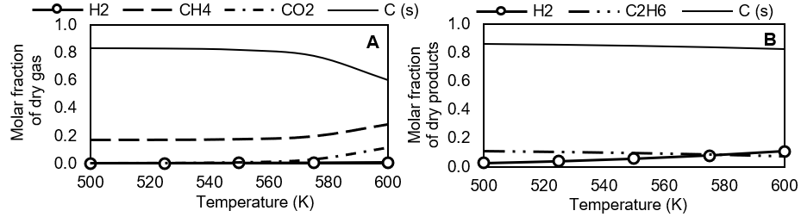
Figure 7: Evaluation of the effect of temperature on the molar fraction of products in subcritical condition at a pressure of 220 bar and initial glycerol composition of 10% wt. A – Gibbs minimization considering all possible products. B - Gibbs minimization disregarding CH₄ formation.

The MaxS model showed no reaction under subcritical conditions for glycerol. This is due to the thermal (endothermic) character and the liquid phase in which the reaction occurs.
  - Conclusion
It is possible to affirm that Gibbs energy minimization and entropy maximization methodologies are very useful and accurate tools in the thermodynamic predictions of reactions with biomass under supercritical and subcritical conditions for H₂ production. Furthermore, it was possible to define, based on the thermal character of the reaction, the best temperature ranges and the best method. The increase in temperature favored the production of H₂ while the increase in the initial composition of biomass was unfavorable. When evaluating the pressure, it was observed that its variation does not have a great influence on the system. The evaluation of the thermal character also contributed to defining the optimal conditions of temperature and H₂ production. The reactions in the subcritical state did not present good results for H₂ production. This reveals that it is necessary to use catalysts for reactions in these conditions. The GAMS software and CONOPT 4 solver were very efficient in solving the problems, completing the simulations in seconds.
Acknowledgment
The authors gratefully acknowledge the financial support from FAPESP – Fundação de Amparo à Pesquisa do Estado de São Paulo (Process 2020/03823-1), CNPq – Conselho Nacional de Desenvolvimento Científico e Tecnológico and CAPES - Coordenação de Aperfeiçoamento de Pessoal de Nível Superior, Brazil.
References
Donald B. Robinson, Ding-Yu Peng, and H.-J. N. (1977). Applications of the Peng-Robinson equation of state. University of Alberta, Edmonton, Alberta, Canada Incorporates.
Dowling, A. W., Balwani, C., Gao, Q., & Biegler, L. T. (2015). Optimization of sub-ambient separation systems with embedded cubic equation of state thermodynamic models and complementarity constraints. Computers and Chemical Engineering, 81, 323–343.
Freitas, A. C. D., & Guirardello, R. (2012). Supercritical water gasification of glucose and cellulose for hydrogen and syngas production. Chemical Engineering Transactions, 27(1), 361–366.
Freitas, A. C. D., & Guirardello, R. (2015). Use of CO2 as a co-reactant to promote syngas production in supercritical water gasification of sugarcane bagasse. Journal of CO2 Utilization, 9, 66–73.
He, Q. (Sophia), McNutt, J., & Yang, J. (2017). Utilization of the residual glycerol from biodiesel production for renewable energy generation. Renewable and Sustainable Energy Reviews, 71(December 2016), 63–76.
Kamath, R. S., Biegler, L. T., & Grossmann, I. E. (2010). An equation-oriented approach for handling thermodynamics based on cubic equation of state in process optimization. Computers and Chemical Engineering, 34(12), 2085–2096.
Osada, M., Sato, T., Watanabe, M., Shirai, M., & Arai, K. (2006). Catalytic gasification of wood biomass in subcritical and supercritical water. Combustion Science and Technology, 178(1–3), 537–552.
Poling, B. E., & Prausnitz, J. M. (2011). Sciencedirect_articles_08Jan2016_02-19-13.101. In Solutions (Issue C).
Tang, H., & Kitagawa, K. (2005). Supercritical water gasification of biomass: Thermodynamic analysis with direct Gibbs free energy minimization. Chemical Engineering Journal, 106(3), 261–267.
Tursi, A. (2019). A review on biomass: Importance, chemistry, classification, and conversion. Biofuel Research Journal, 6(2), 962–979.

