|  |  |
| --- | --- |
| cetlogo ***CHEMICAL ENGINEERING TRANSACTIONS***  ***VOL.*** | A publication of  aidiclogo_grande |
| The Italian Association  of Chemical Engineering  Online at www.cetjournal.it |
| Guest Editors:  Copyright © AIDIC Servizi S.r.l. **ISBN** 978-88-95608-xx-x **ISSN** 2283-9216 | |

Numerical Modelling of a Lab-scale Reactor for Microalgae Growth

Graziano Frungieria,\*, Michele Caroneb, Vincenzo Riggiob, Antonio Buffoa, Marco Vannia, Mariachiara Zanettib

a Dipartimento di Scienza Applicata e Tecnologia, Politecnico di Torino, Corso Duca degli Abruzzi 24, 10129, Torino, Italy

b Dipartimento di Ingegneria dell’Ambiente, del Territorio e delle Infrastrutture, Politecnico di Torino, Corso Duca degli Abruzzi 24, 10129, Torino, Italy

\* graziano.frungieri@polito.it

In this paper we present the results of a numerical modelling work aimed at predicting the kinetics of microalgae production in a lab-scale photobioreactor. The experimental equipment is composed of a flat-plate bioreactor exposed to the light irradiation, and of a tank equipped with a hydraulic pump to secure the culture circulation. The numerical model addresses both the hydrodynamics of the experimental equipment and the kinetics of the relevant bio-chemical reactions. The hydrodynamics of the reactor was modelled as the one of a plug flow with a longitudinal dispersion, whereas the hydrodynamics of the tank was modelled as a cascade of continuous flow stirred tank reactors. The gaseous species transfer from the liquid free surface to the atmosphere was also considered. The relevant bio-chemical processes involved were modelled using common first-order rate expressions for the microalgae growth, and the effect of both thermal and photosynthetic phenomena, as well as the inhibition effects induced by substrate limitation and oxygen excess, have been taken into account. A calibration procedure has been conducted and showed that the model is able to reproduce with a satisfactorily degree of accuracy the experimental results, thus paving the way for its use as a production forecasting tool.

* 1. Introduction

The large number of high-value bio-compounds which can be obtained from microalgae has drawn the attention of a variety of industrial sectors for which microalgae represents a promising feedstock source for the production of more sustainable products (Brennan, Owende, 2010, Molino et al., 2020).

Microalgae have traditionally been cultivated in simple and low-cost open photobioreactors, often referred to as “open raceways ponds”. Open ponds are the cheaper method for the large-scale production of microalgae as they do not require artificial irradiation sources, they have low energy and maintenance requirements, and they do not compete for land, if implemented in areas with limited crop production potential. However, such photobioreactors suffer of poor mixing, light and CO2 utilisation, and moreover the cultures can easily be contaminated, thus precluding their use for the preparation of high-value products by the pharmaceutical and cosmetics industries, for instance.

Closed photobioreactors are designed to overcome some of the major problems associated with the open pond production system (Brennan, Owende, 2010, Fekete et al., 2018). Closed photobioreactors consist of an array of straight glass or plastic tubes which capture irradiation for the microalgae to grow. Microalgae cultures are re-circulated either with a mechanical pump or by an airlift system providing a mechanism for mixing and gas exchange (Eriksen, 2008, Converti et al., 2006, Muharam et al., 2017). Furthermore, closed photobioreactors minimize contamination risks, they offer better control over operative conditions (such as pH, temperature, light, CO2 concentration), they prevent water loss by evaporation, and they permit higher cell concentrations, thus making them the most suitable approach for the largescale production of microalgae (Janssen et al., 2002, Huang et al., 2017).

However, even in closed photobioreactors, production forecasting and optimization is challenging because microalgae growth depends on a number of parameters, including radiation, temperature, nutrients availability as well as on certain inhibitory conditions (e.g. excess of oxygen). In this context, mathematical models offer a great opportunity to study the simultaneous effect of different factors affecting algal growth. The first efforts for modelling microalgae growth kinetics date back to the work by Droop (1974) who predicted algal growth based on the substrate concentration. Since then, a number of researchers have developed models based on single factors such as light intensity (Huisman, 1999, Mazzelli et al., 2018), temperature (Franz et al., 2012), photosynthesis and photoinhibition effects (Wu, Merchuk, 2001), or accounting for multiple phenomena (Sánchez-Zurano et al., 2021)

A detailed biokinetic model that includes the crucial physical and bio-kinetic processes has been recently proposed by Solimeno et al. (2015). This model counts for the carbon-limited algal growth, the transfer of gases to the atmosphere, the photorespiration, photosynthesis and photoinhibition phenomena, and assumes the growth of microalgae to be a function of light intensity and temperature, as well as of the availability of nutrients. In the present work we aim at using such a bio-kinetic model to predict the growth kinetics experimentally observed in a lab-scale flat-plate photobioreactor. The bio-kinetic model has been enriched with a model for addressing the hydrodynamics of the equipment and it has been calibrated with an experimental set of data, with the final aim of developing a predictive and reliable production forecast tool.

* 1. Methods

The microalgae strain selected for the experimental tests is the *Acutodesmus obliquus* strain 276-3b, formally *Scenedesmus obliquus* (Turpin) Kützing, obtained from the SAG Culture Collection of Algae (Göttingen, Germany). The photobioreactor prototype (Figure 1 left) is made up of two flat-panels, a mixing tank and a hydraulic circulator. Between the two hydraulic panels a luminous source system is placed, which is composed by a customizable LED (Light Emitting Diode) matrix and an optical guide for the optimization of the light distribution on the panel surface. The panels are made of transparent polycarbonate with a surface area of 1.5 m2. Each panel is partitioned into 28 channels (alveoli), with a 0.0004 m2 rectangular cross section and a total length of about 40 m. The mixing tank is made up with a HDPE material, with a working volume of 0.026 m3. The experiments were conducted in batch mode, with a flow rate of 20.2 m3/day, a mixed red-blue light spectrum with an average irradiance of 150 µE(m2 s)-1 and a room temperature kept at 25°C.

The biomass concentration was periodically measured by dry weight measurements. A small sample of the culture broth was periodically collected, filtered through a 1.5 µm pore-size glass fiber filter, dried at 105°C and finally weighted. Temperature, pH, dissolved oxygen and carbon dioxide concentrations in the broth were constantly monitored by probes located at the output of the photoreactor.

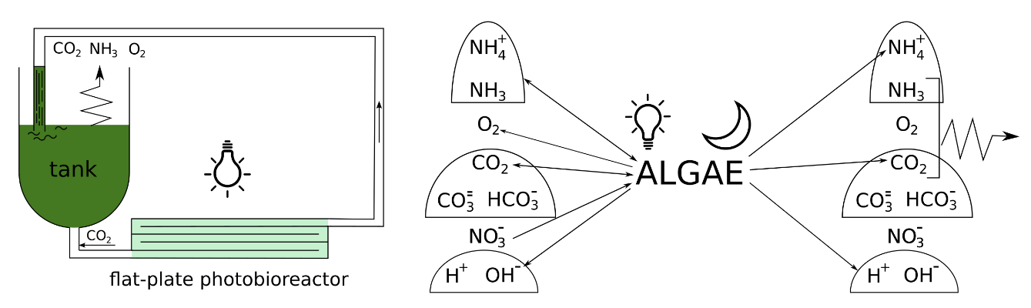

Figure 1: left) Schematization of the lab-plant for microalgae growth. Nutrients are added at the process start-up. CO2 is supplied at the tank exit. Gaseous species are released to the atmosphere from the liquid free surface. Right) Graphical representation of the components considered by the kinetic model. Arrows indicate species that are either consumed or produced, or both, by the microalgae. The bells group species in chemical equilibrium with each other.

2.1 Hydrodynamics modelling

The plant has been modelled addressing both the hydrodynamics and the chemical kinetics of the process. The hydrodynamics of the tank has been modelled as a cascade of equally sized continuous flow stirred tank reactors (CSTRs). In each CSTR it is assumed that the broth is well mixed such that there are no gradients in nutrients, gases or biomass concentrations. The chemical kinetics are taken into account as detailed in the work by Solimeno et al. (2015), and the transfer of the gaseous species to the atmosphere is considered as well. Therefore, the mass balance for an *i-*component in the α-reactor reads as:

$\frac{dC_{α,i}}{dt}= \frac{\dot{V}}{V_{α}}C_{i,in}-\frac{\dot{V}}{V_{α}}C_{i,out}+ {\dot{m}}_{i,atm}+ Σr_{i}$ (1)

where $C_{i}$ is the *i*-component concentration, $\dot{V}$ the flow rate, $V_{α}$ the volume of the reactor, ${\dot{m}}_{i,atm}$ the mass transfer rate of the specie to the atmosphere, and ${Σr}_{i}$ the reaction rate of the *i*-component. The transfer to the atmosphere of the gaseous species was assumed to occur only from the first of the three CSTRs adopted for the hydrodynamic modelling of the tank, and it was computed as ${\dot{m}}_{i,atm}={{(k}_{L}a)}_{i}(C_{i}^{SAT}- C_{i})$ where ${{(k}_{L}a)}_{i}$ is the free surface mass transfer coefficient between the liquid and the ambient atmosphere, and where $C_{i}^{SAT}$ is the saturation concentration of the specie in the liquid phase.

In the flat-plate reactor the flow dynamics was assumed to be the one of a plug flow reactor with an axial dispersion, included in the model to count for the flow non-idealities, and left as a calibration parameter. Thus, neglecting all concentration gradients other than the one in the velocity direction, in such an equipment the mass balance for a *i* component reads as:

$\frac{∂C_{i}}{∂t}=-\frac{∂\left({u_{z}∙C}_{i}\right)}{∂z}+ D\frac{∂^{2}C_{i}}{∂z^{2}}+Σr_{i}$ (2)

where $z$ is the flow direction, $u_{z}$ is the fluid velocity in the flow direction, and $D$ is the longitudinal dispersion.

2.2 Reaction kinetic modelling

Regarding the kinetic modelling of the reactions taking place in the broth, the model by Solimeno et al. (2015) has been used. The basic idea of the model is that with light (i.e., in the radiated flat-panel) microalgae growth, they consume substrate (carbon and nitrogen) and release oxygen. As a result of the microalgal activity, hydroxide ions concentration and pH increase, displacing the equilibrium of the carbon species towards the formation of carbonates. In darkness (i.e., in the tank), endogenous respiration and inactivation of microalgae take place and release carbon dioxide, the concentration of hydrogen ions increases and pH decreases.

The model is conceptually depicted in Figure 1 (right), where all the components of the model are reported together with arrows indicating the main reactions taking place. The model comprises three gaseous species (O2, CO2, NH3), six ion species (NO3-, NH4+, HCO3-, CO32-, H+, OH-) and one particulate component, namely the microalgae biomass $X_{alg}$. A detailed description of the reaction network can be found in the work by Solimeno et al. (2015). Here, for the sake of conciseness we limit ourselves to report the rate expression used for describing the growth of algae on nitrates. This has been expressed as the product of a maximum specific growth rate $μ_{alg}$, multiplied by the local instantaneous concentration $X_{alg}$ and by corrective factors (in the form of Monod functions) that limit or inhibit the growth:

|  |  |
| --- | --- |
| $$r_{i}=μ_{alg}{∙f}_{T,FS}\left(T\right){∙η}_{PS}\left(I,C_{O_{2}}\right)∙\frac{C_{{CO}_{2}+}C_{{HCO}_{3}^{-}}}{K_{C,alg}+C_{{CO}_{2}+}C_{{HCO}_{3}^{-}}+\frac{{C_{{CO}_{2}}}^{2}}{I_{{CO}_{2},alg}}}∙\frac{C_{{NO}_{3}^{-}}}{K_{N,alg}+C_{{NO}_{3}^{-}}}∙\frac{K_{N,alg}}{K_{N,alg}+C_{{NH}_{3}+}C_{{NH}_{4}^{+}}}∙X_{alg}$$ | (3) |

In Eq(3), $f_{T,FS}= exp⁡{\left(-\frac{T-T_{opt}}{s}\right)}^{2}$ is a thermic photosynthetic factor introduced to count for the growth rate decrease due to the deviation from the optimal temperature ($T_{opt}=25°C$, $s=13$), $η_{PS}$ is a photosynthetic factor used to count for the effects of light intensity and excess of oxygen on photosynthesis, $K_{C,alg}$ and $K_{N,alg}$ are affinity constant of microalgae on carbon and nitrogen species, respectively, and is a CO2 inhibition constant. Phosphorous species and their effects on the biological process were not included in the model but assumed to be in large excess in the broth and to not be growth-limiting. The reader is referred to the work by Solimeno et al. (2015) for the full reaction network, which includes the microalgae growth on ammonia, the microalgae endogenous respiration, the microalgae inactivation phenomena, and the relevant chemical equilibria.

2.3 Computational details

The partial differential equations of Eq(2) describing the species transport in the flat-plate reactor have been reduced to a set of ODEs by the method of lines, with 50 nodes used for the domain discretization. Three CSTRs have been used to describe the hydrodynamics of the tank, and 10 components are accounted for by the bio-kinetic model. This results in a total number of linear equations equal to 530 (= $50∙10+3∙10$).

The problem has been coded using Fortran95, resorting to the *lsode* routine of the ODEPACK library for the solution of the linear system of ODEs. The code returned the results of a 4 physical-days batch process in about 4 wall-clock computational hours, when run on a single CPU of a workstation equipped with an Intel(R) Xeon(R) CPU E5-2630 v4 @ 2.20GHz.

* 1. Results and discussion

The experimental tests were conducted in batch mode, thus neither influent nor effluent liquid flows were used. A carbon dioxide flow has been instead insufflated in the broth during the experiment, and adjusted by an on-off control system such as to keep the pH value of the broth around 8.0. In the modelling, for the sake of numerical stability, we opted for introducing a continuous CO2 injection, whose flow rate was set by a trial and error procedure until we observed the pH to be constantly equal to 8 throughout the entire growth process. This was seen to occur for a linearly increasing flow rate following a ramp of equation ${\dot{m}}_{{CO}_{2}}=a+b∙t$, with $a=4$ nL/day and $b=$ 6.4 nL/day2.

The other species initial concentrations were set as experimentally determined. However, the model relies on a number of characteristic parameters whose exact values are unknown. This uncertainty imposed the need for a calibration process. As reported by Solimeno et al. (2015) and as simulation results proved, the model is especially sensitive to the rate of gaseous species release to the atmosphere. This happens because gases participate in a number of processes which have a serious impact on the algal activity. Indeed, high dissolved oxygen levels can inhibit microalgae growth, as well as carbon dioxide does at very high concentrations because of its acidifying effect. For this reason, the transfer coefficient of gases to atmosphere have been adjusted in order to match the data obtained by the experimental run. The main parameters used to calibrate the model are reported in Table 1. The reader is referred to the work by Solimeno et al. (2015) for the complete set of equations and for the value of the parameters not herein reported.

Table 1: Main parameters of the simulated microalgal growth process

|  |  |  |  |  |  |  |
| --- | --- | --- | --- | --- | --- | --- |
| Longitudinal dispersion  [m2 d-1] | Flow rate [m3 d-1] | CO2 mass transfer coefficient [d-1] | O2 mass transfer coefficient [d-1] | CO2 saturation concentration [g m-3] | O2 saturation concentration [g m-3] | Specific growth rate [d-1] |
| 0.1 | 20.16 | 4 | 2 | 6.89 | 9.30 | 1.8 |

Figure 2a reports both the simulated and experimental temporal evolution of the dissolved CO2 in the broth. It can be seen that the two sets of data compare fairly well, with a small deviation appearing only in the late stage of the growth process. In Figure 2b the comparison between the computed and the experimental pH value is shown.

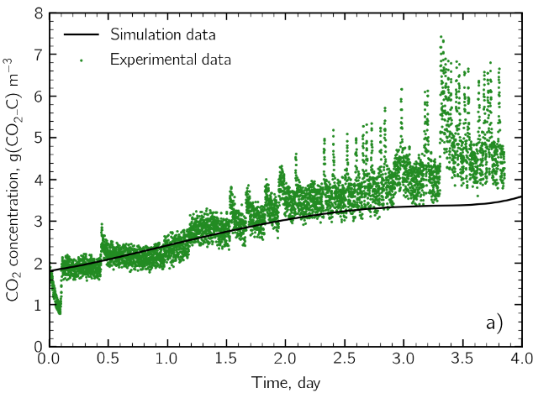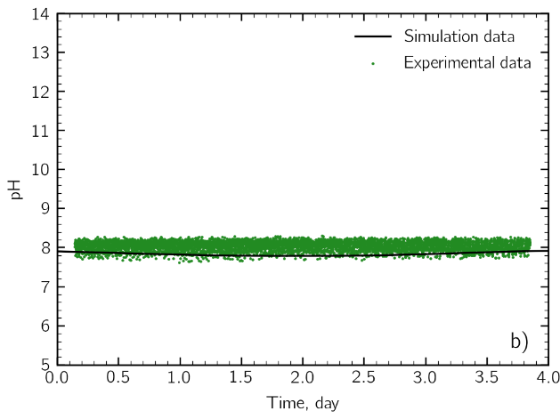

Figure 2: a) Simulated and experimental dynamics of the dissolved CO2 concentration. b) Simulated and experimental pH value of the broth.

It can be seen that a satisfactorily agreement is reached here as well, even though the CO2 supply procedure differs between the two cases, being a continuous injection in the numerical model, and an on-off discontinuous injection controlled by the pH value in the experimental tests. These results prove however that after calibration our numerical method is able to properly model the increased CO2 need determined by the algal biomass growth.

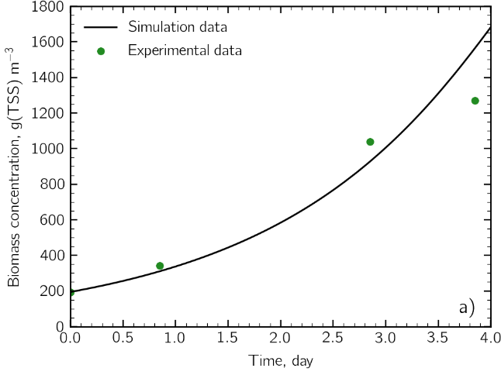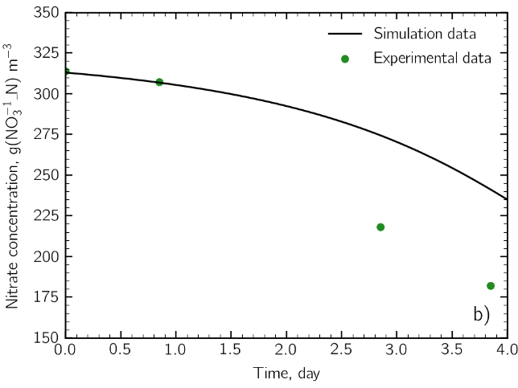

Figure 3: a) Simulated and experimental total suspended solid concentration by dry weight measurements. b) Temporal evolution of the nitrate concentration.

In Figure 3a we report the microalgae concentration in the broth as a function of time. A satisfactory agreement with the experimental data was reached by using a value of the specific growth rate $μ_{alg}$ equal to 1.8 d-1, which well fits within literature ranges (Solimeno et al. 2015). Figure 3b shows the comparison between the experimental and simulated nitrate concentration. Here, the two sets of data agree remarkably well in the initial stage of the process, but a significant discrepancy can be observed at a later stage, with the model evidently underestimating the NO3- consumption. This suggests that growth on other substrates (e.g. ammonia) may have set in during the growth. However, to date, our experimental setup is not able to determine to which extent nitrates are converted to ammonia and used as a substrate for the algal activity.

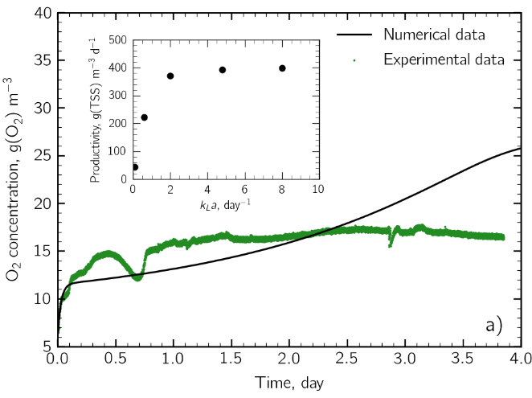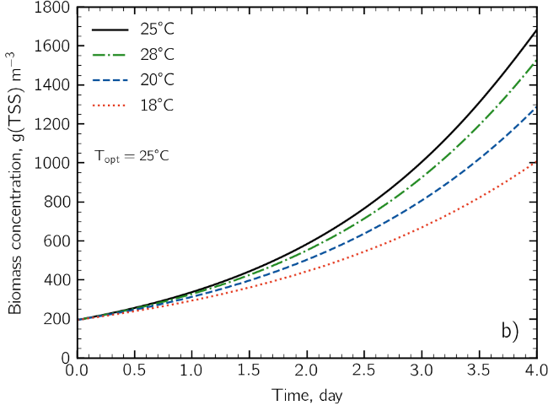

Figure 4: a) Dissolved oxygen concentration as a function of time for =2 d-1. In the inset the result of a sensitivity analysis of the oxygen mass transfer on the process yield is shown. b) Biomass concentration as a function of time for 4 different temperature values.

Figure 4a reports the temporal evolution of the dissolved oxygen concentration. It can be noted that the model correctly predicts the expected increase of the oxygen concentration due to the algae photosynthetic activity, and the simulation data agree quantitively well with the experimental results. However, the apparent qualitative discrepancy suggests the need for a more careful characterization of the features of the tank hydrodynamics in order to obtain more reliable prediction for the oxygen release to the atmosphere. In the inset the dependence of the process productivity (computed as ${(X}_{alg,fin}-X_{alg,in})/(t_{fin}- t_{in})$) on the oxygen mass transfer coefficient is shown, making apparent the substantial detrimental effect of the oxygen accumulation on the process productivity for low mass transfer coefficients. Finally, Figure 4b reports the numerically predicted temperature effect on the microalgae growth kinetics, which shows that even small deviations from the growth optimal temperature are potentially able to induce substantial productivity drops.

* 1. Conclusions

In this work we developed a model addressing both the hydrodynamics and the bio-chemical kinetics of a microalgae growth process. A calibration procedure has been conducted in order to match the simulated results with the one of an experimental growth process conducted in a lab-scale flat-plate photobioreactor.

The preliminary results herein presented show a satisfactorily match with the experimental ones. The model was seen to accurately predict the microalgae production rate, the pH value of the broth as well as the temporal behavior of the dissolved gaseous species concentration. Discrepancies were observed in the nitrate concentration, thus indicating the need for a more careful estimation of the nutrient consumption rate.

Results made apparent that the model is particularly sensitive to the gas release to the atmosphere, therefore future investigations by computational fluid dynamics simulation will be conducted in order to obtain a more accurate characterization of the hydrodynamic regimes in both the tank and the reactor, and in order to obtain estimates for the mass transfer coefficients based on the equipment hydrodynamics.

Finally, it is worth noting that the results herein presented were obtained under specific experimental conditions. Therefore, the model predictions depend on the parameter set at which the model was calibrated. However, results prove our model as a promising tool for a predictive and reliable production forecast of microalgae growth.

References

Brennan L., Owende P., 2010, Biofuels from microalgae - A review of technologies for production, processing, and extractions of biofuels and co-products, Renewable and Sustainable Energy Reviews, 14, 557-577.

Converti A., Lodi A., Del Borghi A., Solisio C., 2006, Cultivation of Spirulina platensis in a combined airlift-tubular reactor system, Biochemical Engineering Journal, 32, 13-18.

Droop M. R., 1974, The nutrient status of algal cells in continuous culture, Journal of the Marine Biological Association of the United Kingdom, 54, 825-855.

Eriksen N.T., 2008, The technology of microalgal culturing, Biotechnology Letters, 30, 1525-1536.

Fekete, R., Žáková, T., Gabrišová, L., Kotora, P., Peciar, P., Gahurová, D., Slaninová, M., 2018, Optimalization of photoreactor geometry for the cultivation of Chlamydomonas Reinhardtii, Acta Polytechnica, 58, 92-103.

Franz A., Lehr F., Posten C., Schaub G., 2012, Modeling microalgae cultivation productivities in different geographic locations–estimation method for idealized photobioreactors, Biotechnology Journal, 7, 546-557.

Huang Q., Jiang F., Wang L., Yang C., 2017, Design of photobioreactors for mass cultivation of photosynthetic organisms, Engineering, 318-329.

Huisman J., 1999, Population dynamics of light‐limited phytoplankton: microcosm experiments, Ecology, 80, 202-210.

Janssen M., de Bresser L., Baijens T., Tramper J., Mur L. R., Snel J. F., Wijffels R. H., 2000, Scale-up aspects of photobioreactors: effects of mixing-induced light/dark cycles, Journal of Applied Phycology, 12, 225-237.

Mazzelli, A., Cicci, A., Sed, G., Bravi, M., 2018, Development of a semi-theoretical light radiation and photosynthetic growth model for the optimal exploitation of wastewaters by microalgae, Chemical Engineering Transactions, 64, 685-690.

Molino, A., Iovine, A., Leone, G., Di Sanzo, G., Palazzo, S., Martino, M., Sangiorgio P., Marino T., Musmarra, D., 2020, Microalgae as alternative source of nutraceutical polyunsaturated fatty acids, Chemical Engineering Transactions, 79, 277-282.

Muharam, Y., Pramadana, A. B., Wirya, A. S., 2017, Modelling and simulation of a bubble column photobioreactor for the cultivation of microalgae Nannochloropsis Salina, Chemical Engineering Transactions, 56, 1555-1560.

Sánchez-Zurano A., Rodríguez-Miranda E., Guzmán J. L., Acién-Fernández F. G., Fernández-Sevilla J. M., Molina Grima E., 2021, ABACO: A new model of microalgae-bacteria consortia for biological treatment of wastewaters, Applied Sciences, 11, 998.

Solimeno A., Samsó R., Uggetti E., Sialve B., Steyer J.P., Gabarró A., García J., 2015, New mechanistic model to simulate microalgae growth, Algal Research, 12, 350-358.

Wu X., Merchuk J. C., 2001, A model integrating fluid dynamics in photosynthesis and photoinhibition processes, Chemical Engineering Science, 56, 3527-3538.