CHEMICAL ENGINEERING TRANSACTIONS  VOL. 92, 2022 | A publication of
The Italian Association
of Chemical Engineering
Online at www.cetjournal.it

Guest Editors: Rubens Maciel Filho, Eliseo Ranzi, Leonardo Tognotti
Copyright © 2022, AIDIC Servizi S.r.l.
ISBN 978-88-95608-90-7; ISSN 2283-9216

Photogrammetry with Remotely Piloted Aircraf System for the Determination of Aerial Biomass in Urban Parks
Jennyfer F. Burgos Ochoa, Alexandra C. Meléndez Jackson, Carlos A. Castañeda-Olivera*, Danny A. Lzarzaburu Aguinaga
Universidad César Vallejo, Campus Los Olivos, Lima, Perú
*caralcaso@gmail.com
The exponential growth of the population is generating the deterioration of ecosystems due to its need to improve the quality of life, so the application of non-invasive methods for the management of natural resources such as trees in urban parks is sought. Therefore, in the present research, photogrammetry with Remotely Piloted Aircraf System (RPAs) was applied for the determination of aerial biomass in the parks of the district of Los Olivos in Lima, Peru. The study was conducted in five parks, which were previously georeferenced by a GPS to capture images with the Phantom 4 Pro drone. The images were processed with Agisoft software to calculate the aerial biomass and carbon sequestration of the trees. The results were given in tons of aerial biomass per hectare (t/ha) and tons of carbon sequestration per hectare (tC/ha); thus, Raimondi Park obtained 1,217 t/ha and 0. 572 tC/ha, Solidaridad Park obtained 1,848 t/ha and 0.868 tC/ha, Cristo Rey Park obtained 9,443 t/ha and 4,438 tC/ha, Juan Pablo II Park obtained 3,694 t/ha and 1,736 and Santa Rosa Park obtained 4,260 t/ha and 2,002 tC/ha. Based on the results, it is concluded that photogrammetry with RPAs is a favorable and efficient methodology that allows determining the aerial biomass and calculating carbon sequestration, helping to preserve green areas according to the number of inhabitants per urban area.
1. Introduction
In recent years, there has been an exponential growth in population generating the deterioration of ecosystems due to their need to improve the quality of life (He et al., 2021), causing an increase in environmental problems such as the greenhouse effect, noise pollution and temperature variation, among others (Zhao and Hu, 2017). The World Health Organization (WHO) recommends that for every inhabitant there should be between 9 and 11 square meters of green areas (Pauchard and Barbosa, 2013); however, in Latin America, not all countries comply with this recommendation, thus depriving the population of having environmental services.
The carbon footprint can be measured in multiple ways, one of the most accurate is by means of forest aboveground biomass (AGB) (Muukkonen and Heiskanen, 2007; Baccini et al., 2017). Aboveground biomass can be calculated by the direct method or the indirect method (Meza, 2015). The direct method consists of felling and selecting trees at different diameters, while the indirect method considers variables that can be measured more easily by leaf drying, diameter measurements, tree height, allometric equations, remote sensing and photogrammetry. The latter uses LIDAR (laser image detection and ranging) and UAV (unmanned aerial vehicles) images (Roik et al., 2020; Heinrich et al., 2021; Su et al., 2020).
Quirós (2014) mentions that photogrammetry is the science that uses photographs that allow measurements to be taken in order to provide precision, dimension and position of an object in space, as well as to generate plans and maps. To achieve better results, photogrammetry has implemented RPAs (Remotely Piloted Aircraft System) that provide detailed information through remotely managed controls, obtaining better panoramas of inaccessible and vulnerable areas (Sánchez et al., 2016; Jimenez and Mulero, 2019). In addition, this methodology reduces the environmental impacts caused by conventional methods used to calculate aerial biomass (Petris, Sarvia and Borgogno, 2020; Marcos et al., 2016).
The determination of tree aboveground biomass is a preliminary step to perform the calculation of carbon sequestration (carbon sequestration capacity of trees) because trees are a large carbon reservoir in cities and have an air-purifying function, improving the climate and ecological environment (Zhao and Hu, 2017). Aboveground biomass (AGB) is the amount of organic matter located above the ground that includes leaves, branches, trunk and bark (FAO, 2010). There are studies estimating aboveground biomass using UAV images to compare their results with other methods and equipment in the field that were competitive in reaffirming their accuracy and effectiveness (Bendig et al., 2014).
Therefore, this research determined the aerial biomass and estimated carbon sequestration in trees in the parks of Los Olivos district in Lima - Peru, using photogrammetry with RPAs. This was done in order to improve the management of urban trees and consequently improve the quality of life of the population.
2. Materials and methods
2.1 Study area
The study area consisted of five urban parks located in the district of Los Olivos in Lima, Peru (Figure 1). These parks include Antonio Raimondi, Solidaridad, Cristo Rey, Juan Pablo II and Santa Rosa, which are intended for recreational use by the population.
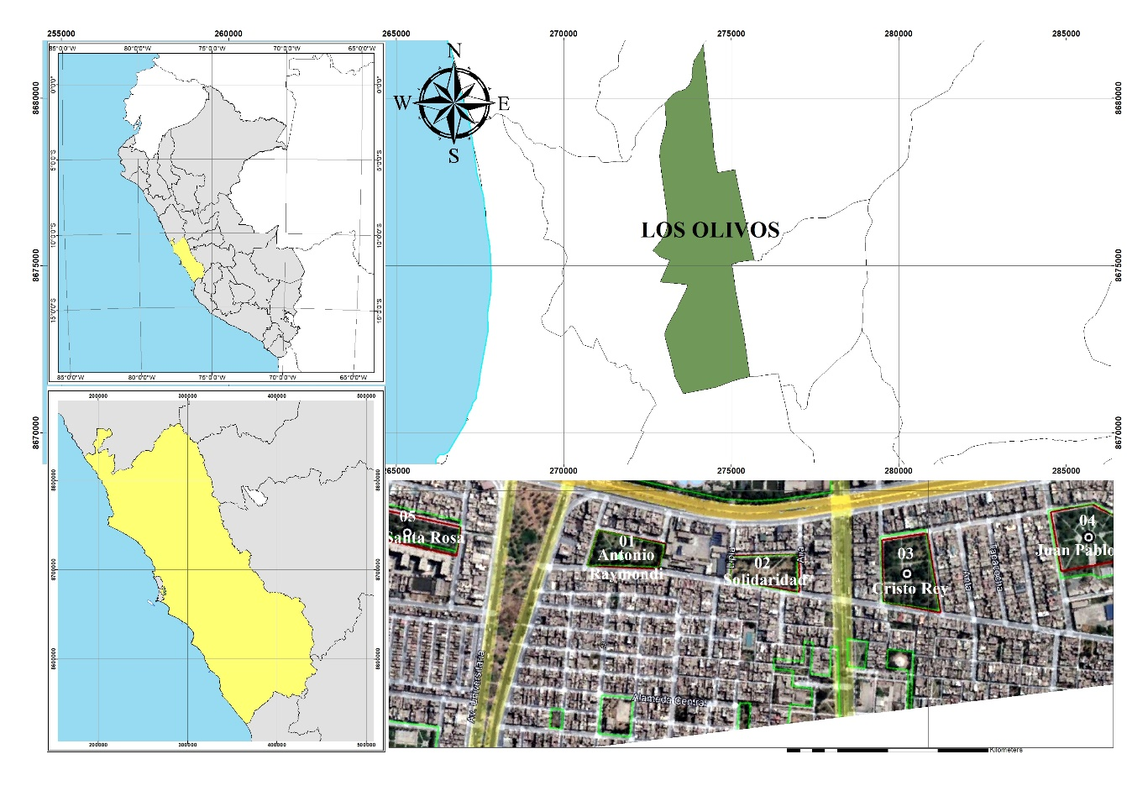
Figure 1: Map of the study area
2.2 Field stage
Five control points were established in each park, which were marked at the ends and center with enamel paint. The marks were approximately 1m x 1m long, and the RTK (Real Time Kinematic) method was used to georeference the points with Rolavi GPS equipment and the SW MAPS application. In addition, the base point for georeferencing is certified by the National Geographic Institute (IGN). On the other hand, to perform the flight with the RPAs, parameters such as area, time, height, ground sample distance (GSD), overlap photogram and camera angle were considered.
2.3 Cabinet stage
The data obtained from the control points were exported in shapefile format and then processed in ArcGis software to obtain the UTM coordinates for georeferencing each park.
The images obtained during the flight were processed in Agisoft Metashape software, which generated a point cloud. This point cloud with X, Y, and Z coordinates were georeferenced and adjusted millimetrically with the coordinates obtained by the RTK method.
2.4 Calculation of aboveground biomass and carbon estimation
To calculate the aerial biomass, the data were processed in Excel considering the height of each tree (greater than 2.5m) to determine its diameter of breast height (DBH). Equation 1 established by Isibue and Pingel (2020) was used to determine DBH. Meanwhile, for the calculation of biomass in trees, Equation 2 was used, which is applied for the Coast and Highlands regions established by the Peruvian Ministry of Environment (MINAM, 2019).

$BH =\left(0.0128×{Heigth}^{1.3797}\right)$ (1)
$AGB =0,112 ×{\left(ρ×{dap}^{2}×ht\right)}^{0.916}$ (2)

With the results obtained from the AGB, carbon sequestration was calculated using Equation 3, which consists of multiplying the constant "0.47" established by the Peruvian Ministry of the Environment.

$C =\left(AGB ×0.47\right)$ (3)
3. Results and discussion
3.1 Flight plan
Table 1 shows the parameters established in the flight plan for each urban park studied, considering also camera angle (90º) and overlap photogram (70% and 80%).
Table 1: Flight plan
Park name | overflown area (m²) | Flight height (m) | Flight time (min) | GSD (cm/px) | Frame count (u)
Antonio Raimondi | 11 620 | 51.9 | 3 min 11 s | 1.95 | 44
Solidaridad | 14 112 | 51.9 | 3 min 32 s | 1.95 | 55
Cristo Rey | 25 900 | 51.9 | 5 min 10 s | 1.95 | 126
Juan Pablo II | 22 379 | 51.9 | 4 min 38 s | 1.95 | 60
Santa Rosa | 14 534 | 65.5 | 2 min 59 s | 2.36 | 39

Table 1 shows that the flight height of the RPAs in Antonio Raimondi, Solidaridad, Cristo Rey and Juan Pablo II parks was 50 meters with a GSD of 1.95 cm/px and in Santa Rosa park at 60 meters with a GSD of 2.36 cm/px, because this park is adjacent to a multi-family building and to avoid accidents it was considered to increase the flight height by 13.6 meters.
In the same sense, Isibue and Pingel (2020) considered for an urban forest a flight height of 50 and 80 meters, with a camera angle of 70° and an overlap of 80% for a better coincidence of points. On the other hand, Huerta et al. (2018) performed the flight in an urban forest area at a height of 40 meters with a camera angle of 90° and an overlap of 70%, obtaining reliable results. In summary, Alonzo et al. (2020) mention that the camera angle serves to improve the geometry of images and the overlapping of images reduces systematic errors in the point cloud.
3.2 Aboveground biomass
For the calculation of aerial biomass, tree height, number of trees and diameter of breast height were considered. Table 2 shows the amount of aboveground biomass determined in each urban park as well as the number of trees and area.

Table 2: Calculation of aboveground biomass
Park name | area (m²) | number of trees | aboveground biomass (t/ha)
Antonio Raimondi | 6,591.468 | 46 | 1.217
Solidaridad | 6,260.493 | 85 | 1.848
Cristo Rey | 11,570.092 | 129 | 9.443
Juan Pablo II | 12,135.281 | 95 | 3.694
Santa Rosa | 6894.629 | 71 | 4.260

Table 2 shows that Cristo Rey Park has the highest amount of aboveground biomass, with a value of 9,443 t/ha. This is because it contains a greater number of trees compared to the rest of the urban parks studied. On the other hand, the park with the lowest amount of aboveground biomass is Antonio Raimondi, with a value of 1,217 t/ha and a smaller number of trees.
In another research conducted in three agricultural plots they obtained aerial biomass values of 2,971 kg/ha, 1,714 kg/ha and 2,923 kg/ha, with areas of 2.16 ha, 5.07 ha of and 15.8 ha, respectively (Marcos et al., 2016). In the same way, Huerta et al. (2018) calculated the aboveground biomass of an urban forest having as a result 379.35 tons in an area of 3 500 m2 with 48 trees of two different species. The results show that there is a difference in biomass estimation because it depends on the methodology used, the study area and number of trees. To this, Alonzo et al. (2020) and Cunliffe et al. (2021) mention that the use of photogrammetry with RPAs provides accurate estimates of aboveground biomass in different types and sizes of ecosystems, with adjustments to existing information from forest inventories.
3.3 Carbon sequestration
Figure 2 shows the amount of carbon sequestration of each park based on aboveground biomass content.
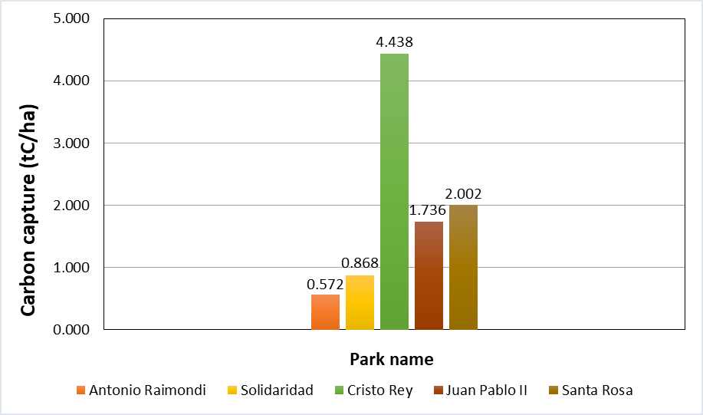
Figure 1: Calculation of aboveground biomass
Cristo Rey Park has a higher carbon sequestration of 4,438 tC/ha than the other parks because it contains more aboveground biomass. Antonio Raimondi Park has the lowest level with 0.572 tC/ha and less aboveground biomass, showing that aboveground biomass is directly proportional to carbon sequestration.
The estimation of carbon sequestration may vary according to the conversion factor used, which depends on the characteristics of the species evaluated and on the researcher's criteria. In the present research, the factor "0.47" was used for the conversion of biomass to carbon, according to the report of the Forest and Wildlife National Inventory of Peru (MINAM, 2019). This factor was also applied in the work of Abdullah et al. (2021), using the Intergovernmental Panel on Climate Change (IPCC) as a reference.
Thus, Zhao and Hu (2017) used the constant 0.4937 due to the fact that in their research they worked with different broadleaved tree species that could use coefficients in the range between 0.45 and 0.55. On the other hand, Fernandes et al. (2020) and Tak and Kakde (2020) used the conversion factor 0.5 because they considered 50% of the calculated biomass, indicating that the conversion factor depends on the species evaluated.
4. Conclusions
Photogrammetry with RPAs is a favorable and efficient methodology that allows determining the aerial biomass and calculating carbon sequestration, helping to preserve green areas according to the number of inhabitants per urban area. The results were given in tons of aerial biomass per hectare (t/ha) and tons of carbon sequestration per hectare (tC/ha); thus, Raimondi Park obtained 1,217 t/ha and 0. 572 tC/ha, Solidaridad Park obtained 1,848 t/ha and 0.868 tC/ha, Cristo Rey Park obtained 9,443 t/ha and 4,438 tC/ha, Juan Pablo II Park obtained 3,694 t/ha and 1,736 tC/ha, and Santa Rosa Park obtained 4,260 t/ha and 2,002 tC/ha, demonstrating a direct correlation between biomass and carbon.
Acknowledgments
The authors would like to thank "Investiga UCV" of the Universidad César Vallejo for financial support for the publication of this research.
References
Abdullah M. M., Al-Ali Z. M., Abdullah M. M., Srinivasan S., Assi A. T., Al Atiqi S., 2021, Investigating the applicability of UAVs in characterizing desert shrub biomass and developing biological indicators for the selection of suitable revegetation sites, Journal of Environmental Management, 288, 112416.
Alonzo M., Dial R. J., Schulz B. K., Andersen H. E., Lewis-Clark E., Cook B. D., Morton D. C., 2020, Mapping tall shrub biomass in Alaska at landscape scale using structure-from-motion photogrammetry and lidar, Remote Sensing of Environment, 245, 111841.
Baccini A., Walker W., Carvalho L., Farina M., Houghton R. A., 2019, Response to Comment on “Tropical forests are a net carbon source based on aboveground measurements of gain and loss”, Science, 363 (6423), 1–11.
Bendig J., Bolten A., Bennertz S., Broscheit J., Eichfuss S., Bareth G., 2014, Estimating biomass of barley using crop surface models (CSMs) derived from UAV-based RGB imaging, Remote Sensing, 6 (11), 10395–10412.
Cunliffe A. M., Anderson K., Boschetti F., Brazier R. E., Graham H. A., Myers-Smith I. H., ..., Wojcikiewicz R., 2022, Global application of an unoccupied aerial vehicle photogrammetry protocol for predicting aboveground biomass in non-forest ecosystems, Remote Sensing in Ecology and Conservation, 8 (1), 57–71.
Fernandes M. R., Aguiar F. C., Martins M. J., Rico N., Ferreira M. T., Correia A. C., 2020, Carbon stock estimations in a mediterranean riparian forest: A case study combining field data and UAV imagery, Forests, 11 (4).
He Y., Wang W., Chen Y, Yan H., 2021, Assessing spatio-temporal patterns and driving force of ecosystem service value in the main urban area of Guangzhou, Scientific Reports, 11 (1), 1–18.
Heinrich V., Dalagnol R., Cassol H., Rosan T., De Almeida C., Silva Junior C., Campanharo W., House J., Sitch S., Hales T., Adami M., Anderson L., Aragão L., 2021, Large carbon sink potential of secondary forests in the Brazilian Amazon to mitigate climate change, Nature Communications ,12, 1-11.
Huerta-García R. E., Ramírez-Serrato N. L., Yépez-Rincón F. D., Lozano-García D. F., 2018, Precisión de los sensores remotos para la estimación de parámetros de biomasa aérea: LIDAR portátil y sensores ópticos. Revista Chapingo, Serie Ciencias Forestales y del Ambiente, 24 (2), 219–235.
Isibue E., Pingel T., 2020, Unmanned aerial vehicle based measurement of urban forests, Urban Forestry & Urban Greening, 48.
Jiménez J., Mulero M., 2019, Drones for Conservation in Protected Areas: Present and Future. Drones, 3 (1), 1–23.
Marcos J., Sánchez L., Gil M., Ortiz J., Martínez S., 2016, Empleo de la fotogrametría de rango cercano y RPAs para la determinación de biomasa en parcelas agrícolas, Revista lbérica de Sistemas y Tecnologías de Información RISTI,19 (9), 118-130.
Meza Chavez, L. P., 2015, Biomasa aerea y contenido de carbono de los bosques del aerea de influencia de la carretera Iquitos- Nauta. Perú. Tesis de grado, Universidad Nacional de la Amazonía Peruana, Iquitos, Perú.
Ministerio del Ambiente - MINAM, 2019, Informe del Inventario Nacional Forestal y de Fauna Silvestre del Perú <www.serfor.gob.pe/portal/wp-content/uploads/2020/03/INFORME-DEL-INFFS-PANEL-1.pdf> accessed 29.09.2021
Muukkonen P., Heiskanen, J., 2007, Biomass estimation over a large area based on standwise forest inventory data and ASTER and MODIS satellite data: A possibility to verify carbon inventories, Remote Sensing of Environment, 107 (4), 617–624.
Organización de las Naciones Unidas para la Alimentación y la Agricultura - FAO, 2010, Términos y Definiciones <www.fao.org/3/am665s/am665s00.pdf> accessed 10.06.2021
Pauchard A., Barbosa O., 2013, Regional Assessment of Latin America: Rapid Urban Development and Social Economic Inequity Threaten Biodiversity Hotspots. In: Elmqvist T. et al. (eds) Urbanization, Biodiversity and Ecosystem Services: Challenges and Opportunities, Springer, Dordrecht, 589-608.
Petris S., Sarvia F., Borgogno E., 2020, RPAS-based photogrammetry to support tree stability assessment: Longing for precision arboriculture, Urban Forestry & Urban Greening, 55, 126862.
Quirós E., 2014, Introducción a la Fotogrametría y Cartografía aplicadas a la Ingeniería Civil 1ª edición. España.
Roik M., Carlos E., Ruiz Z., 2020, Aboveground Biomass and Organic Carbon of Native Araucaria Angustifolia (Bertol.) Kuntze, Floresta e Ambiente Review, 27 (3).
Sánchez L., Marcos J., LLorente E., Hernández S., Carrión P., 2016, Aplicación de tecnologías de teledetección al estudio de biomasa forestal, Revista lbérica de Sistemas y Tecnologías de Información RISTI, 1646-9895.
Su H., Shen W., Wang J., Ali A., Li M., 2020, Machine learning and geostatistical approaches for estimating aboveground biomass in Chinese subtropical forests, Forest Ecosystems, 7 (1).
Tak A.A., Kakde U.B., 2020, Analysis of carbon sequestration by dominant trees in urban areas of Thane city, International Journal of Global Warming, 20 (1), 1-11.
Zhao Y., Hu Q., 2017, Carbon Sequestration Estimation of Street Trees Based On Point Cloud From Vehicle-Borne Laser Scanning System. The International Archives of the Photogrammetry, Remote Sensing and Spatial Information Sciences, XLII-2/W7, 18–22.

