|  |  |
| --- | --- |
| cetlogo ***CHEMICAL ENGINEERING TRANSACTIONS***  ***VOL. 92, 2022*** | A publication of  aidiclogo_grande |
| The Italian Association  of Chemical Engineering  Online at www.cetjournal.it |
| Guest Editors: Rubens Maciel Filho, Eliseo Ranzi, Leonardo Tognotti  Copyright © 2022, AIDIC Servizi S.r.l. **ISBN** 978-88-95608-90-7; **ISSN** 2283-9216 | |

Production of ecological roofing calamines from pineapple bud and sugarcane bagasse residues

Jaqueline Y. Morales Avila, Carlos A. Castañeda-Olivera\*, Juan J. Ordoñez Galván, Elmer G. Benites Alfaro

Universidad César Vallejo, Campus Los Olivos, Lima, Perú

\*caralcaso@gmail.com

The greatest challenge in the world is to deal with the waste generated by different anthropic activities. Many of these wastes are not sent to sanitary landfills or are not reused, causing pollution, bad odors and can even affect people's health. Thus, the main purpose of this research was to produce ecological roofing calamines from pineapple buds and sugarcane bagasse in order to reduce the large amount of organic waste from fruit markets. Three types of calamine were produced with different proportions of pineapple bud and sugarcane bagasse mixture (1:1, 1:2 and 1:3), following the Peruvian technical standard NTP-ISO 9933:1997, and their physical-mechanical properties were determined. The results showed that the fibers of pineapple bud and sugarcane bagasse had humidity percentages of 17.08 and 23.7%, respectively. On the other hand, the ideal proportion of mixture for the elaboration of ecological calamines was 1:2 because it did not show holes and presented less thickness compared to the other proportions. In addition, the physical-mechanical characteristics such as dimensions (width, length, thickness, wave height and wavelength), traction and bending were viable. Finally, it is concluded that organic wastes such as pineapple bud and sugarcane bagasse are a favorable alternative for the production of calamine and could be used as an industrial material.

1. Introduction

Globally, the population continues to experience a continuous growth over time and at the same time the strong anthropic pressures on the environment makes the population, food, energy and productive demands increase, generating a greater amount of organic waste that needs to be treated in order to be reincorporated into the social market economy, such as agricultural waste that was treated to generate fibers for pulp and paper (Majid et al., 2018). Another alternative in the energy field is the production of briquettes from Durian seeds that have starch as a binding agent (Cahyono et al., 2017). In addition to the leaves of pineapple residues, ecological aerogels have been obtained that are characterized by low densities and high porosities (Luu et al., 2020). It has also been possible to implement in the treatment of solid waste the use of the system analysis approach, by using an optimization model to minimize costs in the treatment of its reduction in the landfill (Hoang et al., 2020).

Among the multiple actions used for the reduction of organic solid waste generated, in relation to the topic developed in the research, the manufacture of biocomposite materials based on polypropylene and pineapple leaf fiber is mentioned, which were subjected to compression processes and a series of tests to measure their elasticity, deformation and maximum effort (Betancur, 2017). Also, from cellulose from sugarcane bagasse it was possible to obtain biodegradable containers (Ross-Aclaudia et al., 2017). Along the same line, it can be indicated that the organic residues of *Ananas comosus* were reused in the production of handmade paper, evaluating physical characteristics such as grammage, resistance and humidity (Velásquez, 2018).

With the pineapple bud residue, cellulose, hemicellulose and lignin were obtained to generate fibers that were used to make an ecological food container, after a 95% relative humidity reduction treatment (Mamani et al., 2020). In addition, pineapple leaf pulp was used to make paper sheets, measuring their physical and mechanical properties; they were also subjected to biological coatings that increased their grammage and thickness, thus allowing for a biodegradable product (Lewkittayakorn et al., 2020). It was also possible to make a one-centimeter thick biodegradable pot with fresh pineapple waste (Jirapornvaree et al., 2017).

The waste from pineapple production and processing has multiple applications ranging from biogas production, organic amendment, livestock feed, paper making due to the fiber and cellulose content, which allows the by-products of the production of this fruit to have a high value within the circular economy chain (Baidhe et al., 2021). Therefore, the research aimed to produce ecological roofing calamines from pineapple bud and sugarcane bagasse in order to reduce the large amount of organic waste from fruit markets.

2. Experimental

2.1 Raw material

The input for the research was obtained from the organic solid waste generated by the Caqueta Market in Lima-Peru, where fruits such as pineapple and sugar cane are sold. A total sample of 61.4 kilograms was obtained between pineapple bud (40.4 kg) and sugarcane bagasse (21 kg).

2.2 Elaboration of the ecological calamines

With the samples of solid organic residues from the pineapple and sugarcane bagasse, they were cut into basic elements of 1 to 2 cm for the pineapple and 2 to 4 cm for the sugarcane. Then they were washed to remove impurities, and then soaked for 12 hours to soften the fibers and extract the remaining liquid, as shown in Figure 1.

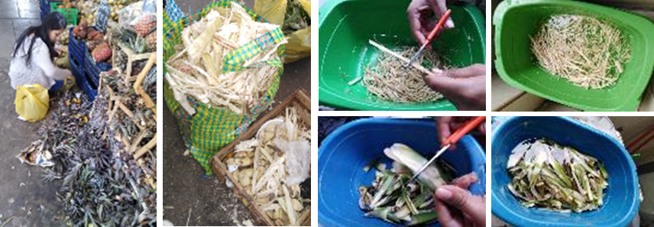

*Figure 1: Sequence of collection, washing and soaking of pineapple and sugar cane residues*

In the pineapple cooking phase, 10% sodium hydroxide (NaOH) had to be added for each kilo of samples treated, in order to remove the lignin and obtain the fiber, while for sugarcane the process was carried out using only water. In both cases, the time was two hours and at an average temperature of 90ºC. Then, the fibers with the longest length were extracted for liquefaction, in the case of bagasse; while for the pineapple heart, a cellulosic fiber (pasty mass) was obtained. The whole process ended with the weighing and drying of both fibers for 24 hours, as shown in Figure 2.

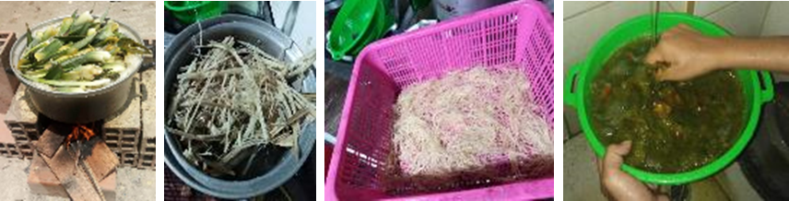

*Figure 2: Washing and cooking process of pineapple bud and sugarcane bagasse fibers*

Three types of mixtures were obtained with the fibers of pineapple bud and sugarcane bagasse, in the proportions of 1:1, 1:2 and 1:3, being necessary for them the incorporation of a natural binder. The base quantity of pineapple bud was 80 g to generate a sheet of 70 cm x 70 cm, which was left to dry for two days at room temperature (23 ºC). Table 1 shows the components and proportions used in the preparation of the ecological calamine.

Table 1: Components and proportions of the elements for the production of ecological calamine

|  |  |  |  |  |  |  |  |  |  |  |  |  |
| --- | --- | --- | --- | --- | --- | --- | --- | --- | --- | --- | --- | --- |
| Fiber calamine | Samples | Residues (kg) | NaOH (g) | Cooking time (h) | Volume of water in calamine processing | | | | | Fiber (g) | Binder (g) | Resin (g) |
| Washing and soaking (L) | Cooking (L) | Milling (L) | Washing (L) | Total (L) |
| Bagasse | M1 | 1 | - | 2 | 5 | 4 | 2 | 2 | 13 | 140 | 800 | 300 |
| M2 | 1 | - | 2 | 5 | 4 | 2 | 2 | 13 | 20 | 300 | 50 |
| M3 | 1 | - | 2 | 5 | 4 | 2 | 2 | 13 | 20 | 320 | 45 |
| Pineapple | M4 | 10 | 1000 | 4 | 7 | 8 | - | 8 | 23 | 410 | 3500 | 400 |
| M5 | 4 | 400 | 2 | 3 | 4 | - | 4 | 11 | 160 | 850 | 40 |
| M6 | 4 | 400 | 2 | 3 | 4 | - | 4 | 11 | 163 | 850 | 40 |
| Bagasse and pineapple | M7 | 3 | 200 | 3 | 5 | 5 | 2 | 4 | 19 | 240 | 1500 | 300 |
| M8 | 2 | 100 | 3 | 3 | 4 | 2 | 4 | 16 | 24 | 400 | 50 |
| M9 | 2 | 100 | 3 | 3 | 4 | 2 | 4 | 16 | 24 | 400 | 50 |

2.3 Physical characteristics of ecological calamines

The elaboration of nine samples whose dimensions were 20 cm wide, according to the guide in Table 1. Three sheets were prepared for each of the selected proportions, which were tested to determine their tensile and flexural strength and dimensions (thickness, width, length, wavelength, wave length, wave height and weight). These tests were performed in a Tenius Olsen universal press, taking into consideration NTP ISO 993, as detailed in Figure 3.

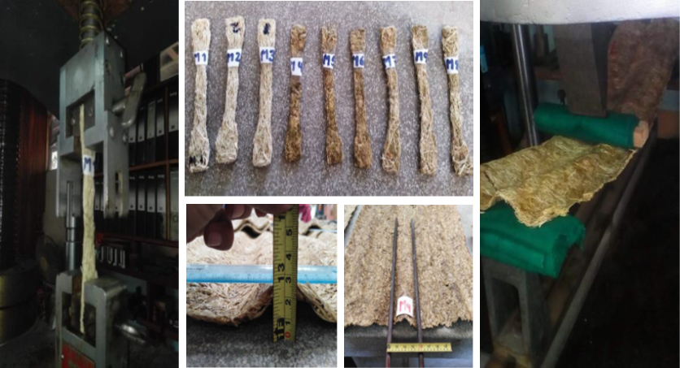

*Figure 3: Sequence of tests on calamine samples and calamine sheets*

3. Results and discussion

3.1 Residue characteristics

Figure 4 shows the pH values of the sugarcane bagasse and pineapple bud residues, during and after the cooking process. In the same, it is observed that in both fibers there was a decrease in their initial values, going from alkaline to slightly alkaline and from slightly alkaline to neutral, as found by Velásquez (2018) who had reduction in pH values (from 12 to 7) after treatment process.

Figure 5 shows the humidity percentage values of the wet and dry fiber, for the six sheets generated from sugarcane bagasse and pineapple bud, obtaining that samples two and five (M2 and M5) present a decrease of 90% and 80% of the weight in humidity.

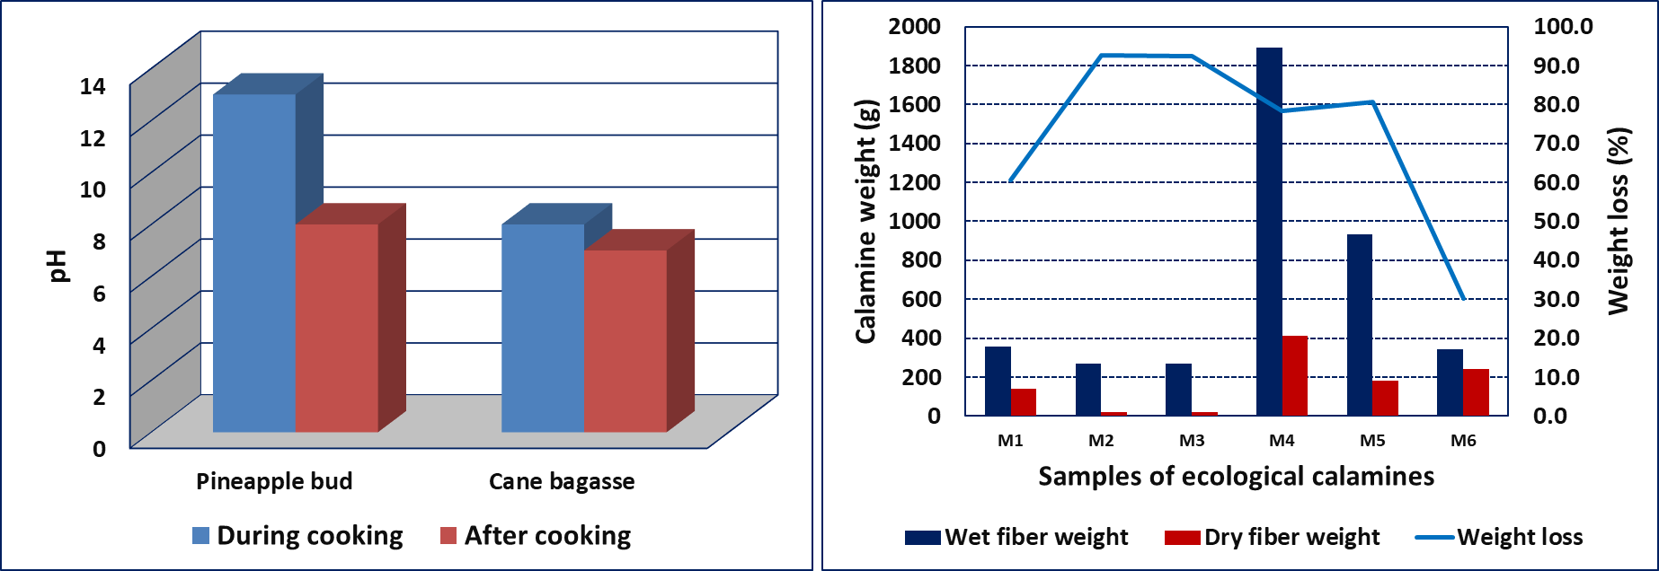

*Figure 4: Comparison of pH in the fibers Figure 5: Weight loss comparison*

3.2 Physical characteristics of the ecological calamines

Each of the ecological calamines prepared with the 1:1 ratio (six in total) were tested to determine the tensile properties in relation to deformation and stress, as shown in Figure 6. It shows that sample M2 of sugar cane bagasse shows less deformation (50%) in relation to samples M1 and M3. For pineapple bud, the M5 sample shows the lowest levels of deformation (80%) compared to the M4 and M6 samples (Figure 6b), which corroborates with the results obtained by Lewkittayakorn et al. (2020) in relation to the maximum tensile strength of pineapple leaf paper.

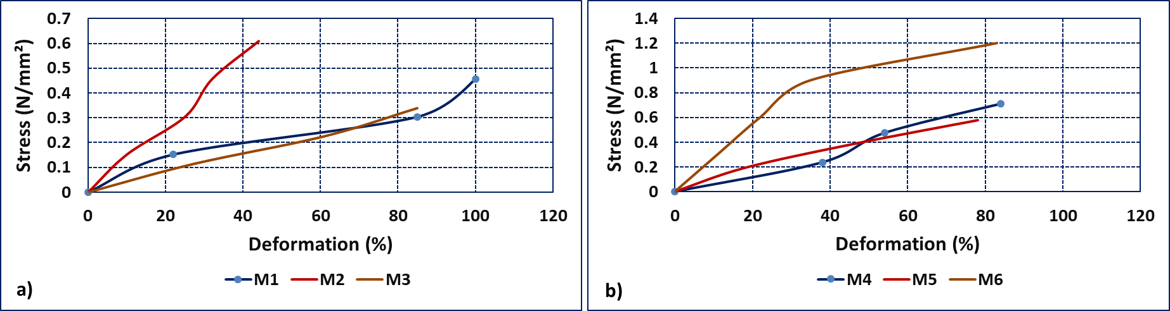

*Figure 6: Relationship between deformation and stress for bagasse and pineapple samples*

For the mixture of sugarcane bagasse and pineapple bud components, a 1:2 ratio was used, whose test generated the results of the relationship between deformation and stress shown in Figure 7a, showing that for sample M9 there is a deformation of 35%. Figure 7b shows the behavior of the breaking load levels for each of the ecological calamine samples generated from sugar cane bagasse (blue color), pineapple bud (green color) and the mixture of both (red color). It is observed that samples M2, M5 and M7 are the ones that withstood the highest breaking load, but in spite of this, they did not comply with Peruvian technical standard NTP-ISO 9933:1997.

In relation to the physical aspects of the dimensions achieved in each of the ecological calamines, for the different treated wastes, the following has been observed: the thicknesses fluctuate between 5.06 mm (M1, for sugarcane bagasse) and 4.59 mm (M9, for the mixture) (Figure 8a), the wave height fluctuates between 23. 2 mm (for bagasse) and 25.3 mm (for bagasse and mixture) (Figure 8b) and the wavelength varies between 101.6 mm (for bagasse) and 100.5 mm (for mixture) (Figure 8c); which comply with Peruvian technical standard NTP-ISO 9933:1997, used in the production of cement with fiber reinforcement.

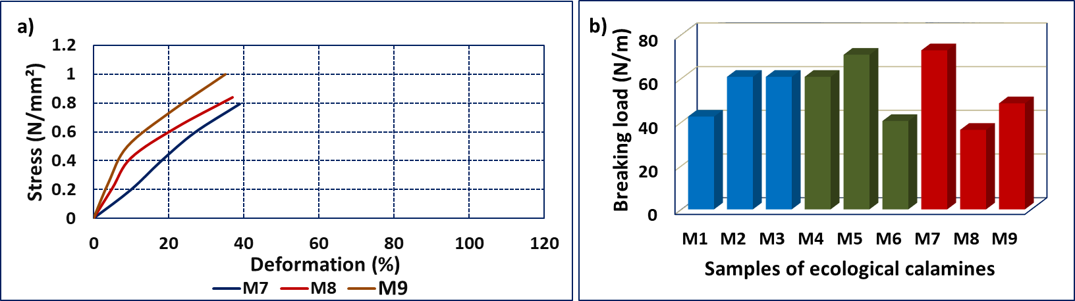

*Figure 7: Deformation and stress ratio for the mixture and breaking load level for the nine ecological calamine samples*

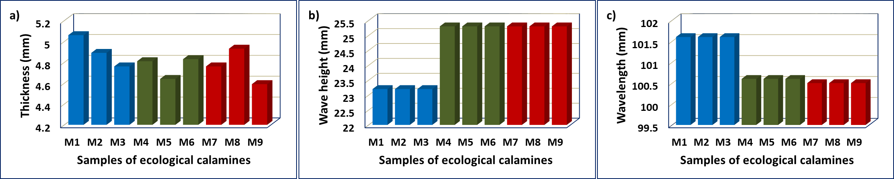

*Figure 8: Physical aspects of cane bagasse, pineapple bud and mixture ecological calamines*

Based on the results obtained in the research, some concerns arise in relation to the durability of the calamine related to its biodegradation, to avoid it we suggest adding a layer of waterproofing such as natural resin obtained from various plant sources, which will help to have a greater resistance to heat and fire. It is also important to perform adequate technical analysis to corroborate its resistance and durability.

4. Conclusions

It was determined that the sheet with the best tensile strength was sample M6 (pineapple bud), while sample M7 (mixture) presented the best breaking load with 72.87 N/m, a value very close to NTP ISO 9933. Regarding the dimensions of the sheets produced, they comply with the same standard; therefore, they are viable for the production of ecological calamines with these organic solid wastes.

Acknowledgments

The authors would like to thank the Universidad Cesar Vallejo, Campus Los Olivos for their support in the completion of this research.

References

Baidhe E., Kigozi J., Mukisa I., Muyanja C., Namubiru L., Kitarikawe B., 2021, Unearthing the potential of solid waste generated along the pineapple drying process line in Uganda: A review, Environmental Challenges, 2, 100012.

Betancourt Sánchez, Carlos, 2017, Utilización de fibras de hoja de piña como refuerzo para biocompuestos fabricados por moldeo de compresión. Universidad Autónoma de Occidente, Santiago de Cali. 2017, 84 p.

Bolio-López G., 2018, Planta piloto para obtención de celulosa de residuos de caña de azúcar (saccharum spp.) y elaboración de recipientes biodegradables, agro productividad, 10 (11).

Cahyono R. B., Santoso J., Miliati R., 2017, Biomass briquettes using indonesia durian seeds as binder agent: the effect of binder concentration on the briquette’s properties, Chemical Engineering Transactions, 56, 1663-1668.

Hoang G. M., Pham P. S. T., Fujiwara T., Pham D. V., 2020, Waste-to-Landfill Reduction: Assessment of CostEffective Solutions using an Optimisation Model, Chemical Engineering Transactions, 78, 511-516.

Jirapornvaree I., Suppadit T., Popan A., 2017, Uso de desechos de piña para la producción de macetas descomponibles. Int J Recycl Org Waste Agricult 6, 345–350.

Lewkittayakorn J., Khunthongkaew P., Wongnoipla Y., Kaewtatip K., Suybangdum P., Sopajarn A., 2020, Biodegradable plates made of pineapple leaf pulp with biocoatings to improve water resistance, Elservier, 9 (3), 5056-5066.

Luu T. P., Do N. H. N., Chau N. D. Q., Lai D. Q., Nguyen S. T., Le D. K., Thai Q. B., Le P. T. K., Duong H. M., 2020, Morphology Control and Advanced Properties of Bio-Aerogels from Pineapple Leaf Waste, Chemical Engineering Transactions, 78, 433-438.

Majid R. A., Mohamad Z., Rusman R., Zulkornain A. A., Abdul N., Abdul M., Hor J., 2018, Development of tea waste/kapok fiber composite paper, Chemical Engineering Transactions, 63, 457-462.

Mamani D. C., Nole K. S., Montoya E. C., Mayta D. A., Pastrana R. Y., Aguilar H., 2020, Minimizing Organic Waste Generated by Pineapple Crown: A Simple Process to Obtain Cellulose for the Preparation of Recyclable Containers, Recycling 2020, 5:24.

Ross-Alcudia R. E., Bolio-López G. I., Veleva, L., Azamar-Barrios, J.A., Hernández-Villegas, M.M., Pérez-Romero, J., Pérez-Romero, C.A., Correa-Durán, M.S., Córdova-Sánchez, S., 2017, Planta piloto para obtención de celulosa de residuos de caña de azúcar (saccharum spp.) y elaboración de recipientes biodegradables, Universidad Popular de la Chontalpa, México. AGRO Productividad, 61-65.

Velásquez D., 2018, Producción de papel artesanal a partir de los residuos de la corona de la piña (ananás comosus) generados en el Mercado Unicachi – Comas, 2018, Universidad Cesar Vallejo, Lima, Perú, 102 p.