CHEMICAL ENGINEERING TRANSACTIONS  VOL. 92, 2022 | A publication of
The Italian Association
of Chemical Engineering
Online at www.cetjournal.it

Guest Editors: Rubens Maciel Filho, Eliseo Ranzi, Leonardo Tognotti
Copyright © 2022, AIDIC Servizi S.r.l.
ISBN 978-88-95608-90-7; ISSN 2283-9216

Lycopene-Containing Tablets Production from Tomato Peels by Environment-friendly Extraction:
Simulation and Discussion
Marcello Casa^{a,b}, Michele Miccioª
ªDipartimento di Ingegneria Industriale, Università degli Studi di Salerno, Via Giovanni Paolo II, 132 - 84084 Fisciano (SA)
^{b}eLoop Srl, Naples, Italy
mcasa@unisa.it
This work aims to model the extraction process of lycopene from tomato peels using a conventional or a "green" solvent, which could be more environment-friendly, and its subsequent encapsulation. The Aspen Plus® software is used to this end. Different cases considering alternative extracting solvents, as well as the recycling of recovered solvent streams and water are evaluated and compared. The raw materials to be considered in an inventory analysis are tomato peels from local industries, solvents, drying agents and soft capsules. Based on literature data and using MS Excel® worksheets, the process mass and energy balances are set up and, hence, the extraction yield is evaluated, while the solvent recovery stage is simulated and optimized in Aspen Plus®. The economic potential of these cases is calculated by considering the cost of utilities, product and by-product sales, wastewater treatment, and raw material costs.
Results show that tomato peels can be appealing for lycopene extraction and valorization. The productivity of lycopene-containing tablets is appreciably large: 12000 pz/h of lycopene-containing tablets after extraction with ethyl acetate and 3500 pz/h in the case of limonene were obtained. Moreover, the predicted gross profit is reasonably attractive, with 39 M€/year for the conventional process and 11 M€/year for the "green" alternative.
  - Introduction
Lycopene (from the neo-Latin Lycopersicum, the tomato species) is a bright red carotenoid found in tomatoes and other red fruits, vegetables, and photosynthetic algae. Due to the strong color and its solubility in organic matters, lycopene is useful as a food coloring (registered as E160d) and is approved for use in the USA by the US Food and Drug Administration since 26 July 2005. Lycopene has also been studied concerning its potential health effects. Promising data from epidemiological, as well as cell culture and animal, studies suggest that lycopene and the consumption of lycopene-containing foods may positively affect human health (Mordente et al., 2011; Rao and Agarwal, 1999; Story et al., 2010). In the last years, tomato peels have been proposed as a cheap source of lycopene and many works have been published regarding different methods of extraction. Similarly, to the extraction of carotenoids from other plant materials, solvent extraction is the most studied and optimized technique for lycopene extraction from tomato residues (Fritsch et al., 2017). Numerous variables can influence the yield of lycopene extraction, but the solvent type is considered the most important one to be optimized by many researchers (Kaur et al., 2008). Due to their affinity with lycopene, organic solvents and their mixtures are the most studied (Periago et al., 2004). Anyway, given lycopene utilization in the food industry, the UE allows the use of only the following ones: Propane-2-ol, Hexane, Acetone, Ethanol, Methanol, and Ethyl acetate. In all cases, the solvent residue should not exceed 50 mg/kg, singly or in combination (Commission Directive 2011/3/EU, 2011). Recently, environmentally friendly solvents have been proposed as an alternative, and among these the most interesting and promising is limonene, which is the major component of the organic oil contained in citrus fruit peels (Shakir and Salih, 2015), used in the food industry (Kim and Ryu, 2011; Ravichandran et al., 2018), and a viable alternative to conventional solvents (Chemat-Djenni et al., 2010). The solvent extraction process produces a fat-soluble oleoresin, containing a high concentration of lycopene and all the hydrophobic extractives contained in pomace; it accounts for around 5% of tomato peels on dry weight (Brachi et al., 2016). The oleoresin is already available on the market, with nutraceutical properties, and can be sold as produced or in pills (Bombardelli et al., 1999). Therefore, this work concerns the development, simulation and optimization of a plant section producing tomato oleoresin containing lycopene (about 10% by weight) with nutraceutical application as a food supplement to be sold in capsules. The use of two different solvents is proposed: a conventional organic solvent and a “green” alternative. Namely, ethyl acetate is the well-established solvent with the best extraction performance; limonene is a natural liquid coming from lemon processing by-products and the best eco-friendly solvent alternative for carotenoid extraction.
Also, in the case of tomato processing residues, the development of a biorefinery plant aimed at valorization and exploitation of agro-industrial wastes (Adiletta et al., 2020) is a very promising target. The present work represents a follow-up to a previous study (Casa and Miccio, 2021) published by the authors.
  - Materials and methods
    - Feedstock characteristics
The feedstock characteristics are dictated by the upstream processing in the proposed biorefinery (Casa and Miccio, 2021). Therefore, the basis for the present calculations is provided by the output of the upstream drying section, i.e., the feed rate of dried peels (DP) is 91.7 kg/h, with a moisture content of 8% wt. This corresponds to the amount of DP contained in tomato by-products produced by 5 medium-size companies located in Campania in a small area with a diameter of 10 km, during the two-month working season.
    - Extraction process: parameters and yields
Two different scenarios for the extraction process were considered: ethyl acetate is used as the extraction solvent in the first case, d-limonene in the second one. The key process parameters were inferred by experimental research on the extraction of lycopene from ground tomato peels reported in the literature. The conditions for the first scenario were gathered by the experimental research of Calvo et al. (2007). A process temperature of 50°C, a solid to liquid ratio of 1/80, and a residence time of 30 min were considered; in these conditions, an extraction yield of 1.64 g of oleoresin per 100 g of dried tomato peels was granted. The extracted oleoresin was reported to contain 8.23 % wt. of lycopene (Calvo et al., 2007).
In the second scenario, an extraction temperature of 25°C, a solid to liquid ratio of 1/6.25 and a residence time of 30 min were considered; in these conditions, a reaction yield of 0.39 g of oleoresin per 100 g of tomato peels was ensured, with a lycopene content of 10% wt. (Chemat-Djenni et al., 2010).
    - Process simulation
Process flowsheeting was carried out to assess the technical feasibility of the lycopene oleoresin production from dried tomato peels, with a purity meeting European standard for nutraceutical application, and then, to allow the comparison of the scenarios. The simulation was performed with Aspen Plus®. The method selected to describe a liquid solution was NRTL (Non-Random Two Liquid Model), which correlates the activity coefficients of a compound with its molar fractions. This is the most used model in the chemical engineering field for the calculation phase equilibria. The oleoresin composition was considered as the one reported by Rath and Olempska-Beer (2009), by using triglycerides included in the database of Aspen Plus®. The ALL-T-01 component is the one adopted to represent the lycopene, due to the higher concentration of trans-lycopene in oleoresin (Ho et al., 2015). The DEXTR-1 (C₆H₁₂O₆) was used for representing the solid portion of the feed. The compounds’ properties were imported in the simulation from APV88 PURE32 and BIODIESEL, primary component databanks from Aspen Tech, allowing the simulation in the absence of experimental data.
Both scenarios can be divided into 4 main sections (see Figure 1):
- Extraction: in this section, the dried tomato peels are mixed with solvent, then the reaction mixture is brought to selected condition and sent to the extraction vessel.
- Centrifugation: in this section, the spent solid remaining after the lycopene extraction is removed from solvent media by centrifugation.
- Solvent recovery: in this section, the lycopene oleoresin contained in the solvent is purified by flash evaporation, removing the solvent. The recovered solvent is sent back to the extraction section.
- Encapsulation: the purified lycopene oleoresin is encapsulated in tablets in this section.
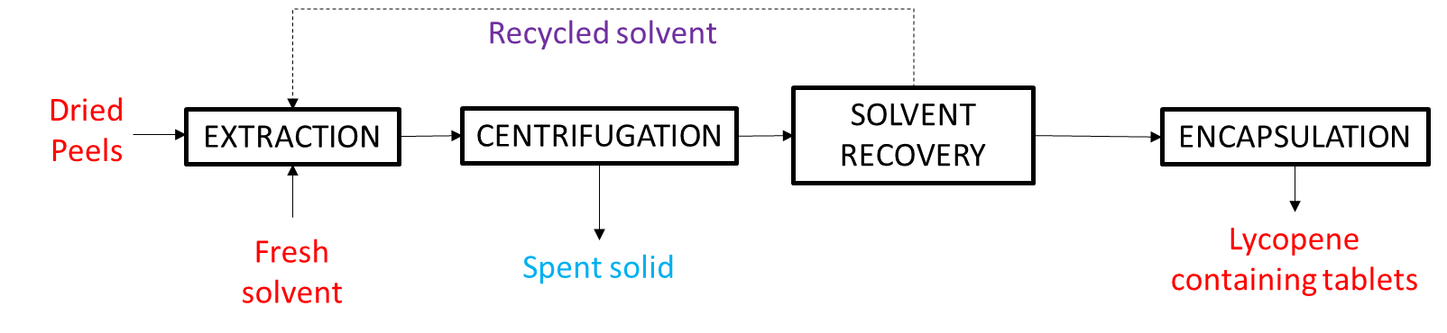
Figure 1 Simplified block diagram for lycopene-containing tablets production from tomato peels
The two developed flowsheets in the Aspen Plus® software are not reported in the text because of readability and easiness. Anyway, the block diagrams and some highlights of the crucial sections are shown and discussed.
    - Economic Analysis
To assess the economic feasibility of the plant for lycopene extraction, operating cost, revenue, and gross profit of the plant were evaluated.
Operating costs included the costs of methane for heating, electricity, refrigeration, raw materials, and waste streams treatment. The gross profit of the plant was evaluated as the revenues coming from the selling of the produced lycopene-containing tablets (nutraceutical grade) minus the operating costs (Seider et al., 2008). Considering that boxes of 60 tablets are the final product of the plant, with an economic value of 36 €/box, (as found as an average prize found on selling platform as Amazon® and Pharmacosmo®), it is:
$$Gross Profit=Revenue-Operating costs$$ | (1)
  - Results and discussion
Solvent extraction is a batch process; for this reason, the extraction step is designed with 4 agitated vessels working in parallel. For the 1st scenario, each vessel has a volume of 4000 L, to keep loading/unloading step and extraction step of the same duration, and undergoes 4 different operations alternatively: charging, extraction, discharge and washing. The following figure shows the extraction setup.
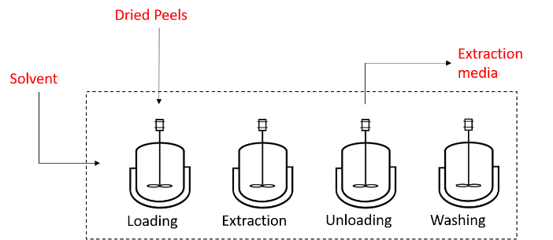
Figure 2 Extraction vessels configuration
Due to the lower L/S ratio for the extraction with limonene, the vessels size is much smaller, i.e., each vessel has a volume of 300 L in this case. After leaching, the extraction media is mainly made of the solvent, in which oleoresin and the solid residue are dispersed. For the separation of the spent peels from the extraction media a Flottweg centrifugal decanter Model C2E-4 was considered. In particular, the technical datasheet reports that for a feed inlet of 1-10 m³/h, 5.5-7.5 kW are needed for the drum drive motor, while 2.2 kW are needed for the auger drive motor. Among all the unit operations involved in this plant, the most important and energy-consuming is solvent recollection/oleoresin purification, due to technology and purification issues. Indeed, the organic solvent removal is a hard task because of the high evaporation temperature of the solvent: ethyl acetate boils at 77°C, while the binary mixture limonene-water boils at 117°C; on the other hand, lycopene oleoresin cannot undergo high-temperature processing, due to its easy degradation. Moreover, as stated by the European commission the solvent amount in the final oleoresin cannot be higher than 50 mg/kg of oleoresin (Commission Directive 2011/3/EU, 2011). For this reason, the evaporation process must be carried out in vacuum conditions (Rath and Olempska-Beer, 2009) that are generally more energy consuming than mild solvent evaporation. With this background, the flash evaporation for extraction with ethyl acetate was first modelled and then optimized by using Aspen Plus® (Figure 3). The optimization was carried out with the Sensitivity tool of the software. For the calculation, the feed stream was considered the reaction media coming out of the extraction and centrifugation steps.
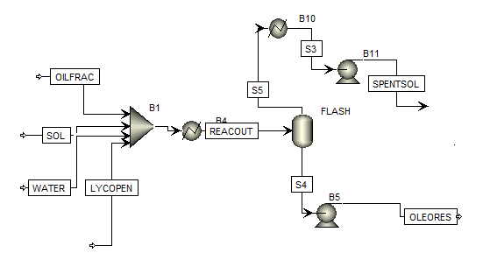
Figure 3 Flowsheet for solvent recovery section in Aspen Plus® software
The liquid stream (REACOUT), coming from the centrifugation section and composed of the solvent (SOL) and the extractives, i.e., the residual water in the peels (WATER), the lycopene (LYCOPEN), and the oily fraction (OILFRAC), enter the flash evaporator and two different streams come out, i.e., a liquid stream rich in oleoresin (OLEORES) and a gaseous stream rich in the organic solvent and water (SPENTSOL). The OLEORES stream is brought to ambient pressure by a pump (B5), while the SPENTSOL stream reaches ambient pressure thanks to a cooler that turns it into a liquid stream (B6) to be pumped (B11). The Flash evaporator is optimized by a Sensitivity in which pressure and temperature are studied. Pressure ranges between 0.05 mbar and 1 mbar while the temperature is between 30°C and 70°C. The optimized parameters were the amount of ethyl acetate in OLEORES (<50 mg/kg) and the lycopene recovery factor (>0.9995). The outcome of the sensitivity is reported in Figure 4 where the feasibility areas are in light and dark green.
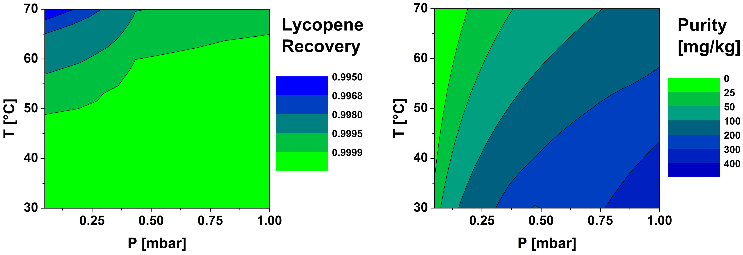
Figure 4 Feasibility areas of flash evaporator regarding the two design constraints
Then, the feasibility zones for these two parameters were plotted together to find the operating zone where both constraints are satisfied. The result is reported in Figure 5, where the red crosses represent the points in which the lycopene recovery is higher than 0.9995, while the blue dots represent the points in which the solvent content in the oleoresin is lower than 50 mg/kg.
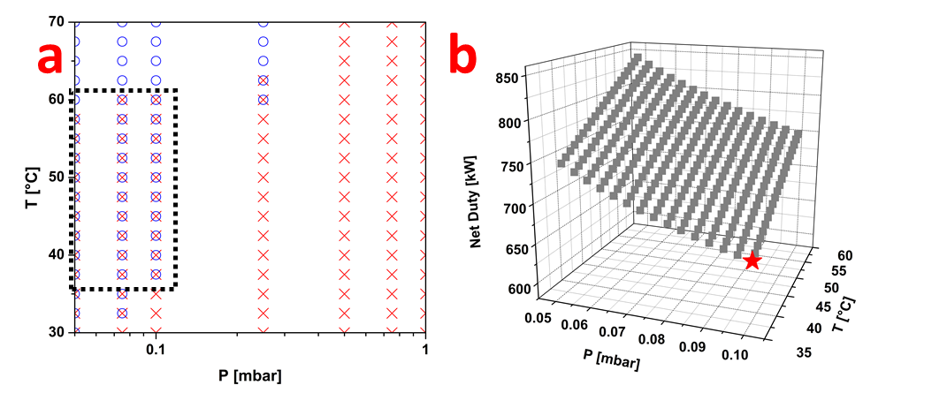
Figure 5 a) Operating points for the flash evaporator, b) Net duty optimization for the flash operation.
The black dotted line highlights the operating range, namely P comprised between 0.05 and 0.1 mbar and T in the range 37.5-57.5°C. Then, in the operating range, another sensitivity was carried out to optimize the total net duty of the separation: heat duty at the flash and network at the pumps. The pump efficiency was taken 0.9. The result of the second sensitivity is reported in Figure 5b. The optimum operating condition for flash evaporation, i.e., the one that satisfies the constraints and minimizes the duty (red star), is given by P = 0.1 mbar and T = 37.5°C, with a total duty of 656.84 kW. The same methodology was used to optimize the separation of the extracted oleoresin from the solvent mixture limonene-water, for the alternative extraction scheme. The optimization results for both schemes are reported in Table 1.
Table 1: Optimized parameters for solvent removal in the lycopene extraction process
 | Pressure at flash [mbar] | Flash temperature [°C] | Flash operation total duty [kW]
1st scenario | 0.1 | 37.5 | 656.84
2nd scenario | 0.05 | 52.5 | 237.94

As reported in the table, the removal of limonene-water requires heavier conditions due to the higher boiling point, but the total duty is lower due to the lower L/S ratio.
For the encapsulation section, a liquid capsule filling sealing machine from Upmack® Model LCFS 300 was considered. It is a fully automatic machine that fills and seals up to 18,000 capsules per hour with oily liquid, solution, mixed suspensions or paste formulations, with a power demand of 9 kW. These results were used for the evaluation of the mass and energy balances involved in the two alternative schemes for the extraction of lycopene from tomato peels. The most interesting results are reported in Table 2
Table 2: Main results from mass and energy balances
 | Dried peels | Fresh solvent [kg/h] | Lycopene tablets [pz/h] | Power Demand [kW]
1st scenario | 91.7 | 248.69 | 12000 | 1134
2nd scenario | 91.7 | 19.26 | 3500 | 337

As reported in the table, when 91.7 kg/h of dried peels are fed to the extraction section, a vessel volume of 4000 L and 248.69 kg/h of fresh ethyl acetate are needed in the 1st scenario, while only 300 L extractor and 19.26 kg/h of limonene are fed to the extractor in the second alternative scheme. Anyway, the product output for the two scenarios is quite different due to the lower extraction in yield for limonene. An extraction plant based on ethyl acetate produces 12000 lycopene-containing capsules per hour, corresponding to 120 boxes/h, while only 3500 capsules per hour are produced in the 2nd scenario, corresponding to 35 boxes/h. Regarding the energy demand of the extraction with ethyl acetate, the power allocation is 1134 kW, with the heating system as the most energy-demanding part, indeed 58% of the power demand is due to the flash operation and 35% is due to the solvent and peels heating. For the 2nd scenario, the total power demand is 337 kW, with flash evaporation as the most energy-demanding part (70% allocation). Finally, considering that, in the first analysis, the costs for working the two separation systems are those due to methane for heating, electricity, refrigeration, raw materials, and waste streams treatment, an operating cost comparison was carried out. To obtain lycopene tablets by using ethyl acetate as the solvent, a total operating cost of 5.79 M€/y is predicted. This is mainly due to the raw materials (54%) and reagent heating (38%). For the limonene extraction, the operating cost is 2.29 M€/y. Again, most of the cost is due to materials (69%) and heating (25%). On the other hand, due to the higher extraction yield and tablets output, the revenue for the 1st scenario is 41 M M€/y, while it is only 13.3 M€/y in the 2nd scenario. Considering the above Eq.1, the gross profit for a plant that uses ethyl acetate as the extraction solvent is 39 M€/y, whereas it is almost 11 M€/y when the limonene-water solution is used as the solvent.
  - Conclusions
This work demonstrates the technical-economic feasibility of the production of lycopene-containing tablets for nutraceutical purposes from dried tomato peels by two alternative process schemes, mainly differing as far as the crucial choice of the extraction medium: the first one uses an organic solvent, i.e., ethyl acetate, and the second one a “green” one, i.e., limonene. AspenPlus® was used to implement the process flowsheeting and generate the results, except for the solid-liquid extraction reactor, for which the lycopene yield was calculated using the MS Excel® spreadsheet. The developed process schemes were composed of a lycopene extraction section, centrifugation, a solvent recovery unit and an encapsulation machine. Literature data provided the basis for materials description and solvent extraction yield and conditions.
The results show that tomato peels may be technically and economically valorized through lycopene extraction, with productivity of 12000 and 3500 pz/h of lycopene-containing tablets with ethyl acetate and limonene as the extracting solvent, respectively. Correspondingly, the economic potential in terms of gross profit is 39 M€/year for the conventional process and 11 M€/year in the "green" one.
The present work represents a further cornerstone added to the work for the development and design of a multi-product biorefinery, based on tomato by-products from the canning industries located in a reasonable small territorial area, in the frame of a circular economy approach.
Acknowledgements
This work has been carried out in the frame of the “Training on-the-job” initiative (Dottorati di ricerca con caratterizzazione industriale) funded by Regione Campania (DGR No. 156 21/03/2017 - POR Campania FSE 2014/2020 - obiettivo specifico 14 - azione 10.4.5)
References
Adiletta G., Brachi P., Riianova E., Crescitelli A., Miccio M., Kostryukova N., 2020. A Simplified Biorefinery Concept for the Valorization of Sugar Beet Pulp: Ecofriendly Isolation of Pectin as a Step Preceding Torrefaction, Waste Biomass Valor., 11(6), 2721–2733. https://doi.org/10.1007/s12649-019-00582-4
Bombardelli E., Morazzoni P., Seghizzi R., 1999. Process for the extraction of lycopene using phospholipid in the extraction medium. US5897866A. https://patents.google.com/patent/US5897866A/en.
Brachi P., Miccio F., Miccio M., Ruoppolo G., 2016. Pseudo-component thermal decomposition kinetics of tomato peels via isoconversional methods. Fuel Process. Technol. 154, 243–250. https://doi.org/10.1016/j.fuproc.2016.09.001
Calvo M.M., Dado D., Santa-María G., 2007. Influence of extraction with ethanol or ethyl acetate on the yield of lycopene, β-carotene, phytoene and phytofluene from tomato peel powder. Eur. Food Res. Technol. 224, 567–571. https://doi.org/10.1007/s00217-006-0335-8
Casa M., Miccio M., 2021. Thinking, Modeling and Assessing Costs of Extracting Added-value Components from Tomato Industrial By-products on a Regional Basis. Chem. Eng. Trans. 87, 163–168. https://doi.org/10.3303/CET2187028
Chemat-Djenni Z., Ferhat M.A., Tomao V., Chemat F., 2010. Carotenoid Extraction from Tomato Using a Green Solvent Resulting from Orange Processing Waste. J. Essent. Oil-Bear. Plants 13, 139–147. https://doi.org/10.1080/0972060X.2010.10643803
Commission Directive 2011/3/EU of 17 January 2011 amending Directive 2008/128/EC laying down specific purity criteria on colours for use in foodstuffs.
Fritsch C., Staebler A., Happel A., Cubero Márquez M.A., Aguiló-Aguayo I., Abadias M., Gallur M., Cigognini I.M., Montanari A., López M.J., Suárez-Estrella F., Brunton N., Luengo E., Sisti L., Ferri M., Belotti G., 2017. Processing, Valorization and Application of Bio-Waste Derived Compounds from Potato, Tomato, Olive and Cereals: A Review. Sustainability 9, 1492. https://doi.org/10.3390/su9081492
Ho K.K.H.Y., Ferruzzi M.G., Liceaga A.M., San Martín-González M.F., 2015. Microwave-assisted extraction of lycopene in tomato peels: Effect of extraction conditions on all-trans and cis-isomer yields. LWT - Food Sci. Technol. 62, 160–168. https://doi.org/10.1016/j.lwt.2014.12.061
Kaur D., Wani A.A., Oberoi D.P.S., Sogi D.S., 2008. Effect of extraction conditions on lycopene extractions from tomato processing waste skin using response surface methodology. Food Chem. 108, 711–718. https://doi.org/10.1016/j.foodchem.2007.11.002
Kim S.C., Ryu J.Y., 2011. Properties and performance of silver-based catalysts on the catalytic oxidation of toluene. Environ. Technol. 32, 561–568. https://doi.org/10.1080/09593330.2010.505612
Mordente A., Guantario B., Meucci E., Silvestrini A., Lombardi E., Martorana G.E., Giardina B., Böhm V., 2011. Lycopene and cardiovascular diseases: an update. Curr. Med. Chem. 18, 1146–1163. https://doi.org/10.2174/092986711795029717
Periago M.J., Rincón F., Agüera M.D., Ros G., 2004. Mixture approach for optimizing lycopene extraction from tomato and tomato products. J. Agric. Food Chem. 52, 5796–5802. https://doi.org/10.1021/jf049345h
Rao A.V., Agarwal S., 1999. Role of lycopene as antioxidant carotenoid in the prevention of chronic diseases: A review. Nutr. Res. 19, 305–323. https://doi.org/10.1016/S0271-5317(98)00193-6
Rath S., Olempska-Beer Z.S., 2009. Lycopene Extract from Tomato - 71st Joint FAO/WHO Expert Committee on Food Additives (JECFA) Meeting - Chemical and Technical Assessment.
Ravichandran C., Badgujar P.C., Gundev P., Upadhyay A., 2018. Review of toxicological assessment of d-limonene, a food and cosmetics additive. Food Chem. Toxicol. 120, 668–680. https://doi.org/10.1016/j.fct.2018.07.052
Seider W.D., Seader J.D., Lewin D.R., Widagdo S., 2008. Product and Process Design Principles: Synthesis, Analysis and Design, 3° edizione. ed. John Wiley & Sons Inc, Hoboken, NJ.
Shakir I.K., Salih S.J., 2015. Extraction of Essential Oils from Citrus By-Products Using Microwave Steam Distillation. Iraqi J. Chem. Pet. Eng. 16, 11–22.
Story E.N., Kopec R.E., Schwartz S.J., Harris G.K., 2010. An update on the health effects of tomato lycopene. Annu. Rev. Food Sci. Technol. 1, 189–210.

