CHEMICAL ENGINEERING TRANSACTIONS  VOL. 92, 2022 | A publication of
The Italian Association
of Chemical Engineering
Online at www.cetjournal.it

Guest Editors: Rubens Maciel Filho, Eliseo Ranzi, Leonardo Tognotti
Copyright © 2022, AIDIC Servizi S.r.l.
ISBN 978-88-95608-90-7; ISSN 2283-9216

“Zero Waste” and “Green” Approaches towards Valorisation of Vegetable Residues
Stefania Marzorati^{a,}*, Alessio Massironiª, Rita Nastiª, Amparo Jiménez-Quero^{b}, Luisella Verottaª
ª Department of Environmental Science and Policy, Università degli Studi di Milano, Via Celoria 2, 20133, Milano, Italy
^{b} Division of Glycoscience, Department of Chemistry, CBH School, KTH Royal Institute of Technology, AlbaNova University Centre, SE-106 91, Stockholm, Sweden
stefania.marzorati@unimi.it

Among the waste valorisation strategies, particular attention is given to plant and agri-food biomasses. They are particularly valuable since they are produced in large amounts worldwide and have been widely studied since ancient times for the richness in secondary metabolites, displaying strong bioactive properties.
Within this context, the following biomasses have been selected and processed for the present study:
- Residues from medicinal plants (Cucurbita pepo L. seeds and Serenoa repens L. fruits). Given the selectivity of the method employed from the company processing the commercial oils, the residual biomasses are expected to still contain a significant amount of valuable natural products.
- Coffee silverskin, the only by-product of coffee roasting process. Silverskin has already been investigated as combustible, fertilizer and animal feed, but our work points out the relevance of its phytochemical profile in terms of polar compounds dealing with its antioxidant properties.
The aim of the study was to set up a green methodology minimizing the use of organic solvents, employing a green extraction technique, supercritical CO₂, selectively enriching the extracts of target high value compounds. Plant biomasses were chosen in order to assess different methodologies, based on the same supercritical fluid technique, able to demonstrate the feasibility to target separately narrow windows of compounds, differentiated by their polarities.
  - Introduction
Plant biomass represent an unlimited source of bioactive molecules directly usable as phytotherapic drugs or combined as ingredients in specific pharmaceutical preparations (Uwineza and Waśkiewicz, 2020). Accordingly, it has been estimated that the global plant extracts market size (USD 27.1 billion in 2016) may reach USD 44.6 billion by 2024 (www.hexaresearch.com/research-report/global-herbal-medicine-market).
The valorisation of industrial waste biomasses is considered therefore an opportunity to provide new higher-value products with a concomitant solution to waste accumulation issues. In this way, ethical issues come to the stage and, pointing to circularity, the final products added value increases (Guo et al., 2021; Mou et al., 2020).
Bioactive compounds can be extracted from biomasses by various traditional extraction techniques. Most of these techniques are based on the use of organic solvents. These “conventional” techniques however urge to be replaced by “greener” extraction approaches that decrease the environmental fingerprint by minimizing the use of organic solvents and applying milder conditions, thus also protecting the stability of the extractables (Panzella et al., 2020).
In this work, we selected supercritical CO₂ as extractor fluid targeting specific classes of compounds. Supercritical CO₂ provides a series of advantages, first being characterized by low environmental impacts, ensuring a safe and selective extraction strategy, easily scalable to industrial plants with the possibility to recycle the employed CO₂ (De Melo et al., 2014). Here, two different case studies are presented.
In the first one, plants residues are obtained after supercritical fluid industrial extraction of active natural compounds from Serenoa repens Small (saw palmetto) fruits and Cucurbita pepo L. (pumpkin) seeds. The extracted oils, obtained by a company under specific set of pressure and temperature in supercritical conditions, are commercialized for the treatment of genito-urinary tract pathologies (Kulczynski and Gramza-Michałowska, 2019; Wilt et al., 2007). Although the mechanism of action is not completely understood yet, it has been reported that the therapeutic agents could exert an inhibitory activity towards 5α-reductase (De Monte et al., 2014). It is suggested that the fatty acids and their combination with sterols are the responsible for this effect. In order to define the structural richness still available in the biomass wastes, the strategy was set on the potential selectivity achievable by tuning the supercritical CO₂ parameters, namely pressure and temperature, to enrich the extracts in different classes of compounds, still present in the wastes.
The second case study addresses coffee silverskin, a tegument of coffee beans that constitutes the byproduct of the roasting procedure. Since different studies have shown the healthy properties of coffee brews, it is conceivable that some of the properties described for coffee brews are maintained also in this waste (Narita and Inouye, 2014). Its lipidic content was already studied in a previous work (Nasti et al., 2021), so the goal now was to shift the extractable compounds towards higher polarities, targeting caffeine and, mostly, the phenolic chlorogenic acids.
For these reasons, both caffeine and 5-caffeoylquinic acid (5-CQA), were considered the main added-value compounds from coffee silverskin. 5-CQA in particular is known as a polar molecule, hence non easily extractable by means of pure supercritical CO₂, whose polarity index is similar to the n-hexane one. In order to facilitate the extraction, a polarity modifier was necessary in the planned strategy. A mixture water and ethanol was identified as the best choice of co-solvent, in terms of environmental sustainability and safety issues.
  - Materials and methods
    - Analytical methods
Ultrahigh Performance Liquid Chromatography (UPLC)
The extracts composition was analysed with Waters ACQUITY UPLC system equipped with a quaternary solvent manager system, autosampler, thermostated column compartment and a UV-Vis detector. The analytical separation was performed using an ACQUITY UPLC® BEH C18 column (1.7 μm x 2.1 mm × 50 mm).
Extracts from coffee silverskin were analysed using a mobile phase composed by water (+ 0.1% of formic acid) (A) and acetonitrile (+ 0.1% of formic acid) (B). The flow rate was set at 0.25 mL min⁻¹ and the linear gradient elution was: 0 min, 95% A; 3 min, 93% A; 7 min, 90% A; 13 min, 82% A; with a re-equilibration time of 3 min before the next injection. The column temperature was maintained at 34 °C and the wavelengths set at 275 nm and 324 nm, corresponding to the maximum of absorption of caffeine and 5-O-caffeoylquinic acid, respectively. Aqueous solutions of samples were filtered (0.2 μm nylon filters) and injected (2 μl) in the system.
The analysis of medicinal plants extracts was conducted using a mobile phase composed of isopropanol (A) and acetonitrile (+ 0.1% of formic acid) (B). The flow rate was set at 0.20 mL min⁻¹ and the elution was conducted in isocratic conditions with a mixture of 20% A and 80% B. The column temperature was maintained at 34 °C and the wavelength set at 210 nm, corresponding to the maximum of absorption of sterols and polyprenols.
Methanolic solutions of samples were filtered (0.2 μm PTFE filters) and injected (2 μl) in the system.
Gas Chromatography-Mass Spectrometry (GC-MS)
Before the GC-MS analyses, samples were subjected to a derivatization process. A modification of a literature method was used (Tripodi et al., 2020). Briefly, 5 mg of each sample were suspended in 100 µl of anhydrous pyridine, and silylated using 100 µl of N,O-Bis (trimethylsilyl)trifluoroacetamide containing 1% of Trimethylsilyl chloride. The samples were incubated under stirring at 60°C for 2 h. At the end of the reaction, 0.8 ml of ethyl acetate was added. The samples were then filtered (0.22 µm PTFE syringe filters) and analyzed by using an ISQTM QD Single Quadrupole GC-MS (Thermo Fisher) equipped with a VF-5 ms column (30 m × 0.25 mm i.d. × 0.25 µm; Agilent Technology). Injection volume: 1 µl, split mode; Oven program: 120°C for 5 min; then 10°C min⁻¹ to 200°C; 5 min holding time; then 20°C min⁻¹ to 300°C; 20 min holding time; total run time: 38 min. Helium was used as a gas carrier. Ionization mode: electron impact: −70 eV. Acquisition mode: full scan. To identify the chemical structures, the fragmentation pattern of each peak was compared to NIST 2014 database.
    - Valorisation of Cucurbita pepo and Serenoa repens residues
Biomass collection and processing
After industrial selective extraction of commercial oils by means of supercritical fluids, Cucurbita pepo exhausted seeds (CP) and Serenoa repens exhausted fruits (SR) were gently donated by Indena S.p.A. (Italy). CP was partially composed by a fine powder mixed with small fragments of few millimeters in diameter. SR was provided as pressed and extruded powder, in the form of fragile pellets, easily crushable. Samples were stored at room temperature.
Supercritical fluid extraction
Supercritical fluid extractions (sc-CO₂) were performed using a pilot unit SFT110XW System (Supercritical Fluid Technologies, Inc.; DE, USA). It consisted of a 100 cm³ stainless steel extraction vessel inserted in an oven, a constant pressure piston pump (SFT-Nex10 SCF Pump; DE, USA) with a Peltier Cooler, a 515 HPLC pump (Waters, Milford, MA, USA) for the co-solvent addition, and a collection vial. The extraction vessel was filled with an exactly weighted amount of the biomass (20-40 g of sample was used in each trial).
CP and SR extraction: for each biomass, consecutive extractions were performed with alternation of static (15 min) and dynamic (30 min) cycles in supercritical conditions, changing the set temperature and pressure only when no further extract was obtained. Starting from mild conditions, pressure and temperature were increased step by step, in order to achieve a selective and consecutive extraction of targeted compounds. In details, three extraction conditions were performed from mild, then medium, to strong, corresponding to CO₂ densities of 700, 830 and 920 kg m⁻³. Extracts were analysed by GC-MS and UPLC.
Acid and neutral fractions separation
Amberlite IRA-400 was activated before use with sodium hydroxide solution and then flushing methanol. The CP and SR extracts were dissolved in methanol and stirred overnight in the presence of the resin, in order to favor the adsorption of free fatty acids. The resin was poured in a column and the eluate, containing the neutral fraction, was collected. Acids were recovered washing the resins with acetic acid methanolic solution (1:1 v/v). The solvent was evaporated under vacuum from the acidic and neutral fraction, then they were weighted and analysed by GC-MS and UPLC.
    - Valorisation of coffee silverskin
Biomass collection and processing
Micronized Coffee Silverskin (CS) was provided by an Italian roasting company. The CS powder was characterized by a particle size ranging from 10 to 50 µm. Sample was stored at ambient temperature.
Solvent-based extraction of caffeine and chlorogenic acid
In order to study the maximum extractable yield in terms of chlorogenic acids and caffeine, CS was first defatted by Soxhlet method as in previous work (Nasti et al., 2021). Then, 1 gram of defatted CS biomass was mixed with 10 ml of an acidic hydroalcoholic solution of water:ethanol=7:3 v/v (+1% formic acid). The suspension was magnetically stirred at room temperature for 4 hours, centrifuged at 6000 rpm for 5 min and then filtered. The solvent was evaporated and the extract was analysed by UPLC (Rai et al., 2018; Shan et al., 2017; Suárez-Quiroz et al., 2014). Quantities of caffeine and 5-O-caffeoylquinic acid extracted by this solvent-based method were considered in the calculations as the maximum extractable yields (set as the reference 100% yield), in order to make comparisons with extraction from sc-CO₂ method.
Supercritical fluid extraction
The supercritical CO₂ apparatus was the same described before.
CS extraction: following the results from a previous work on CS (Nasti et al., 2021), the biomass was first exhausted in its lipidic content setting a combination of pressure (300 bar) and vessel temperature (60°C) to get a CO₂ density of 830 kg m⁻³. An alternation of static (30 min of maceration period in supercritical condition) and dynamic (valves were open for 10 min) cycles was conducted until no evident extract mass was further gained. The same equipment was then connected to the co-solvent pump targeting phenols and caffeine. Defatted CS was loaded inside the vessel and 10% v/w (with respect to the loaded biomass) of a mixture water:ethanol (8:2 v:v) was injected. The operative supercritical conditions were the same as the previous extraction. Many cycles, comprising 15 min of maceration time in static conditions and 1 hour of dynamic conditions with co-solvent addition, were performed. The extraction was interrupted when the total pumped solvent was about five times the weight of the biomass. This threshold was chosen considering that the biomass-to-solvent-ratio is conventionally set as 1:10 in solvent-based extraction methods. By employing a greener strategy such as sc-CO₂, it was assessed reasonable not to exceed half of the previous ratio. The extract solutions were collected and the solvent was evaporated. Extracts were analysed by UPLC.
  - Results and Discussion
    - Lipids from CP and SR
Both Serenoa repens and Cucurbita pepo L. wastes were carefully selected as promising case studies considering some aspects. In fact, in terms of classes of compounds, they share a similar chemical profile, and they have been treated industrially under a specific set of pressure and temperature (confidential data) in sc-CO₂ extraction conditions that assure to leave some unextracted material that can be further processed. The presence of further compounds of interest left in the industrial waste was therefore expectable.
The maximum extractable yields obtained over time is displayed in Figure 1, changing the pressure and temperature (and therefore the density) of the supercritical CO₂. In the extraction process it was decided on purpose to start from low density (mild conditions) and to progressively shift to stronger conditions (higher density) in order to achieve the highest possible selectivity towards classes of compounds.
When the extraction was run on CP biomass waste, the first extraction (with a d_{CO2}= 700 kg m⁻³) gave a yield of about 1.2%. The second extraction (with a d_{CO2}= 830 kg m⁻³) was able to increase the cumulative extraction yield up to 8.7%; finally, in the last extraction (with a d_{CO2}= 920 kg m⁻³) 11.5% total yield was achieved. The second set of parameters was hence the most effective in terms of mass extraction of compounds. Each extract was then subject to anion exchange resin, to separate the free fatty acids from the neutral fraction. In Table 1 the results of separation are expressed in terms of relative percentages of free fatty acids and neutral fraction. From these results it is worth noting that milder extraction conditions are able to provide extracts with a higher % of free fatty acids compared to the stronger ones, characterized by an increasing quantity of neutral compounds. Fatty acids obtained from CP extracts in mild conditions were mainly composed by oleic and linoleic acids with traces of palmitic and stearic acids. The last fraction, 95% by weight composed of neutral compounds, was obtained in stronger supercritical conditions, presented high percentages of ∆7 sterols.
On the other hand, when the extraction was run on SR biomass waste, worse results were obtained in terms of selectivity, since the first two sets of supercritical extraction (with a d_{CO2}= 700 kg m⁻³ and d_{CO2}= 700 kg m⁻³) were not able to yield any extract. Only the last condition, (with a d_{CO2}= 920 kg m⁻³) provided a yield of 1.7%. This extraction yield is anyway still rewarding in terms of quantitative presence of extractables from a biomass residue. Interestingly, the extract was mainly composed of long and middle chain free fatty acids such as oleic and lauric acids in the presence of terpenoids such as β-sitosterol. The quantitative identification of other high value compounds, such as a mixture of oligomeric isoprenoid alcohols, namely polyprenols, is still under investigations, but preliminary experiments confirmed their presence in the extracts, pointing again to the high interest in this biomass residue (G. Jommi et al., 1988).
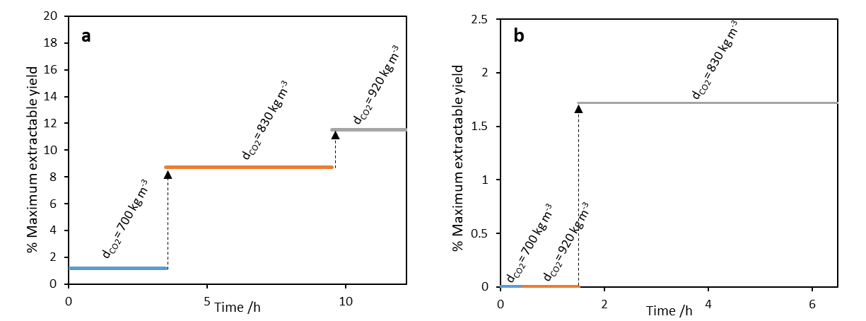
Figure 1: Maximum extractable yields obtained changing the supercritical CO₂ density for CP biomass (a) and SR biomass (b).
Table 1: relative % w/w of acid and neutral fractions.
Sample | CO₂ density | % free fatty acids | % neutral fraction
CP waste | 700 kg m⁻³ | 71 | 29
 | 830 kg m⁻³ | 29 | 71
 | 920 kg m⁻³ | 4 | 96
SR waste | 700 kg m⁻³ | n.d. | n.d.
 | 830 kg m⁻³ | n.d. | n.d.
 | 920 kg m⁻³ | 82 | 18

    - Chlorogenic acids and caffeine from CS
After co-solvent evaporation, sc-CO₂ extracts from coffee siverskin were weighted and analyzed by liquid chromatography. By comparison with reference standards, it was assessed that the main peak recorded at retention time (t_{R}) of 3.5 min at 324 nm, corresponded to 5-O-caffeoylquinic acid, while the main peak recorded at 275 nm at t_{R} of 3.8 min corresponded to caffeine, as displayed in Figure 2a. A calibration line was built and 5-CQA and caffeine were quantified in extracts from each sc-CO₂ extraction cycle. Figure 2b shows the % of caffeine and chlorogenic acid in terms of cumulative extraction yield over time, setting as 100% the extraction yield obtained by solvent-based method. As shown in Figure 2b, even if in supercritical conditions it was impossible to reach the extractable yields obtained by conventional solvent-based methods, it is worth to comment on another important parameter that is the content of target compounds in the extracts, displayed in Table 2. Many of the sc-CO₂ extracts resulted enriched in caffeine and 5-CQA by at least the double, if compared to the conventional extract content. Caffeine content in the extract was maximum in the first cycle, 10.1% was obtained, representing a 5-fold increase compared to the conventional extraction. In this case the extraction yield decreased over the sequential cycles. This trend is justified by the solubility of caffeine also in pure supercritical CO₂, hence exhausting caffeine content of the biomass even from the beginning of sc-CO₂ cycles. On the other hand, the % of 5-CQA is sequentially increased from cycle 1 to cycle 5, reaching 0.55% (compared to 0.26% of conventional extraction), however at this point the extraction was interrupted due to the amount of co-solvent employed. A further use of organic solvent would not be reasonable to be employed when applying a “green technique” such as supercritical fluid extraction.
Overall, these results confirm the higher selectivity of supercritical CO₂ extraction technique, able to yield purer extracts in terms of targeted compounds of interest.
Table 2: % by weight of 5-CQA and caffeine in each extract
CS sample | % 5-CQA in the extract |  | % caffeine in the extract
CONVENTIONAL EXTRACTION | 0.26 |  | 2.40
sc-CO₂ cycle 1 | 0.00 |  | 10.00
sc-CO₂ cycle 2 | 0.40 |  | 7.12
sc-CO₂ cycle 3 | 0.32 |  | 4.14
sc-CO₂ cycle 4 | 0.54 |  | 4.82
sc-CO₂ cycle 5 | 0.55 |  | 3.31
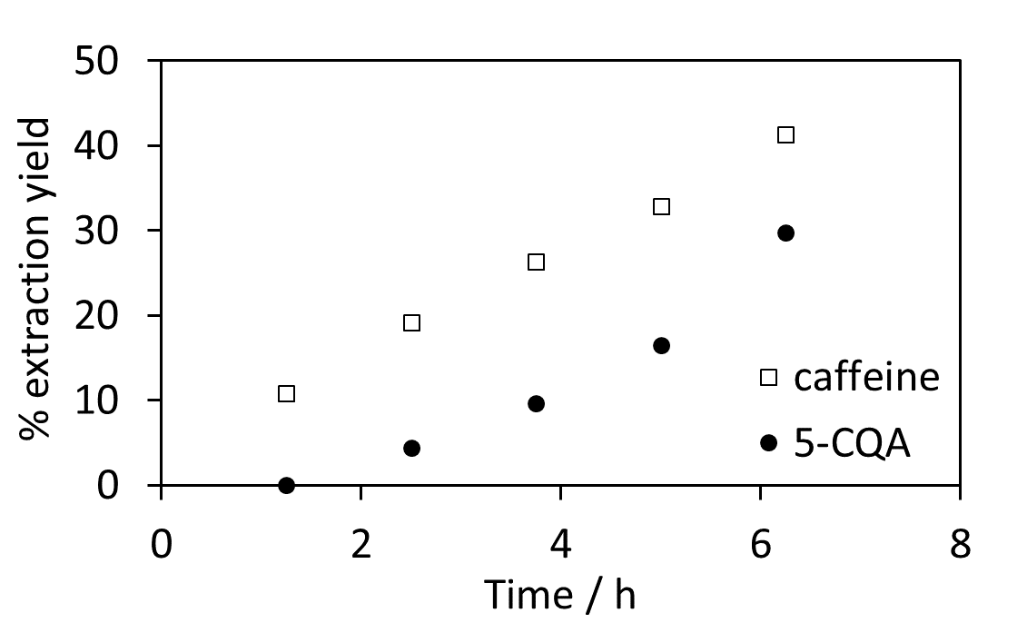
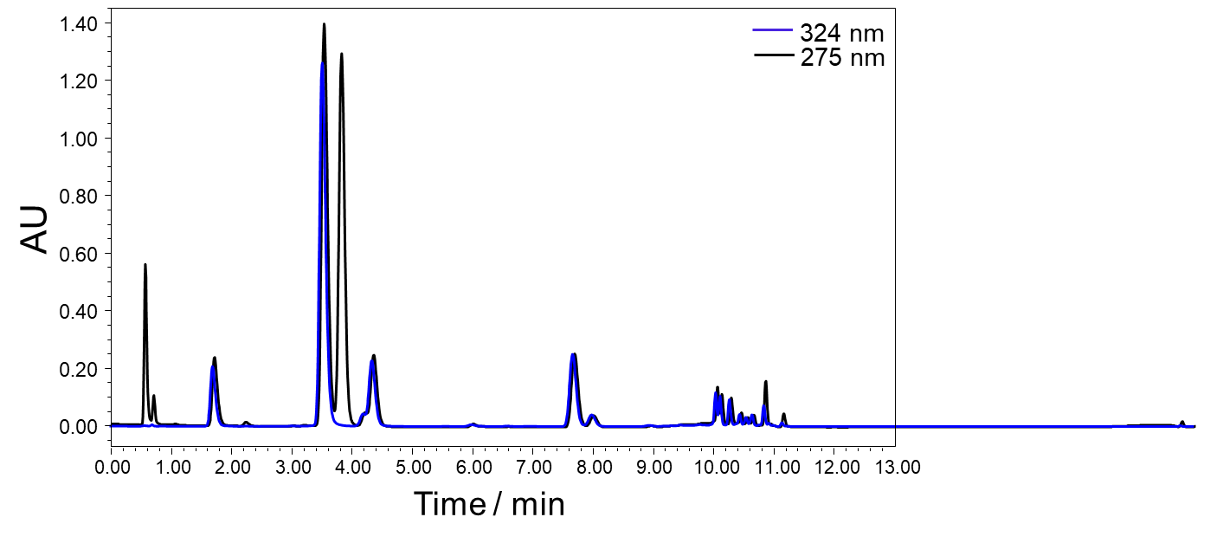
b
a
5-CQA
caffeine

Figure 2: a) UPLC chromatogram of CS supercritical CO₂ extract. b) caffeine and 5-CQA extraction yield over time.
Conclusions
This works points out the relevance of biomass waste streams valorisation by their conversion to high added value products. Focusing on two case studies, it was first demonstrated the presence of relevant percentages of unextracted compounds from medicinal plants residues. The presence of fatty acids, sterols and polyprenols was confirmed, yielding different extracts in terms of mass and composition, depending on the physico-chemical parameters of the extraction.
Second, the presence of non-negligible percentages of 5-O-caffeoylquinic acid and caffeine in coffee silverskin was assessed and quantified, pointing even more to the use of this still underexplored biomass.
With this aim, the use of a green strategy such as supercritical CO₂ confirms the feasibility of the technique not only for lipids extraction, but even when the targets are more polar compounds, proving a fully environmentally sustainable approach, from the biomass choice to the employed methodology.
Acknowledgments
CP and SR biomass wastes were kindly donated by Indena S.p.A. The authors thank Dr. Paolo Spontoni and Dr. Marco Schiavoni for GC-MS analysis. The present research was financed by Cariplo Foundation (STAIRWAy project−2019-2122)
References
De Melo M.M.R., Silvestre A.J.D., Silva C.M., 2014, Supercritical fluid extraction of vegetable matrices: Applications, trends and future perspectives of a convincing green technology, Journal of Supercritical Fluids, 92, 115–176.
De Monte C., Carradori S., Granese A., Di Pierro G.B., Leonardo C., De Nunzio C., 2014, Modern extraction techniques and their impact on the pharmacological profile of Serenoa repens extracts for the treatment of lower urinary tract symptoms, BMC Urology, 14, 1-11.
Hexa Research, 2017, Herbal Medicine Market Size and Forecast, By Product (Tablets & Capsules, Powders, Extracts), By Indication (Digestive Disorders, Respiratory Disorders, Blood Disorders), And Trend Analysis, 2014 - 2024, www.hexaresearch.com/research-report/global-herbal-medicine-market [WWW Document], n.d. URL www.hexaresearch.com/research-report/global-herbal-medicine-market (accessed 12.16.21).
Jommi G., Verotta L., Gariboldi P., 1988, Constituents of the Lipophilic Extract of the Fruits of Serenoa repens (Bart.) Small, Gazzetta Chimica Italiana, 118, 823-830.
Guo Z., Wang A., Wang W.Y., Zhao Y.L., Chiang P.C., 2021, Implementing Green Chemistry Principles for Circular Economy towards Sustainable Development Goals, Chemical Engineering Transactions, 88, 955–960.
Kulczynski B., Gramza-Michałowska A., 2019, The profile of secondary metabolites and other bioactive compounds in cucurbita Pepo L. And cucurbita moschata pumpkin cultivars, Molecules, 24, 1-22.
Mou J., Li C., Yang X., Kaur G., Sze Ki Lin C., 2020, Overview of Waste Valorisation Concepts from a Circular Economy Perspective, Chapter In: Lin C.S.K., Kaur G., Li C., Yang X. (Ed.), Waste Valorisation: Waste Streams in a Circular Economy, Chapter 2, Wiley Online Library, 1–11.
Narita Y., Inouye, K., 2014, Review on utilization and composition of coffee Silverskin, Food Research International, 61, 16-22.
Nasti R., Galeazzi A., Marzorati S., Zaccheria F., Ravasio N., Giulia L.B., Manenti F., Verotta L., 2021, Valorisation of Coffee Roasting By‑products: Recovery of Silverskin Fat by Supercritical CO₂ Extraction, Waste and Biomass Valorization, 12, 6021-6033.
Panzella L., Moccia F., Nasti R., Marzorati S., Verotta L., Napolitano A., 2020, Bioactive Phenolic Compounds from Agri-Food Wastes: an Update on Green and Sustainable Extraction Methodologies, Frontiers in Nutrition, 7, 1-27.
Rai A., Shukla R., Sawant S., Shetye R., Bopte D., Gavandi H., 2018, Extraction of Chlorogenic Acid from Green Coffee Beans for Preservation against Extraction of Chlorogenic Acid from Green Coffee Beans for Preservation against Bread Spoilage, NCIFEH Conference Proceeding, 263-269.
Shan Y., Jin X., Cheng Y., Yan W., 2017, Simultaneous determination of chlorogenic acids in green coffee bean extracts with effective relative response factors, International Journal of Food Properties, 20, 2028-2040.
Suárez-Quiroz M.L., Alonso Campos A., Valerio Alfaro G., González-Ríos O., Villeneuve P., Figueroa-Espinoza M.C., 2014, Isolation of green coffee chlorogenic acids using activated carbon, Journal of Food Composition and Analysis, 33, 55-58.
Tripodi F., Lombardi L., Guzzetti L., Panzeri D., Milanesi R., Leri M., Bucciantini M., Angeloni C., Beghelli D., Hrelia S., Onorato G., Di Schiavi E., Falletta E., Nonnis S., Tedeschi G., Labra M., Coccetti P., 2020, Protective effect of Vigna unguiculata extract against aging and neurodegeneration, Aging, 12, 19785-19803.
Uwineza P.A., Waśkiewicz A., 2020, Recent advances in supercritical fluid extraction of natural bioactive compounds from natural plant materials, Molecules, 25, 3847.
Wilt T., Ishani A., Mac Donald R., 2002, Serenoa repens for benign prostatic hyperplasia (Review), The Cochrane Collaboration, published by John Wiley & Sons, Ltd.Library, Wiley.

