 CHEMICAL ENGINEERING TRANSACTIONS  VOL. 92, 2022 | A publication of  
The Italian Association
of Chemical Engineering
Online at www.cetjournal.it

Guest Editors: Rubens Maciel Filho, Eliseo Ranzi, Leonardo Tognotti
Copyright © 2022, AIDIC Servizi S.r.l.
ISBN 978-88-95608-90-7; ISSN 2283-9216

Biodiesel Production by Hydrodynamic Cavitation Through an Orifice Plate
James R. Vera-Rozo, José M. Riesco-Ávila*, Marlon Y. Poveda-Pachon, Alejandro Zaleta-Aguilar
Mechanical Engineering Department, University of Guanajuato. Salamanca, Guanajuato. Mexico
riesco@ugto.mx
The traditional biodiesel production process consumes a large amount of energy by maintaining a reaction mixture of oil and alcohol for extended periods of up to 120 min at average temperatures of 60 °C. To reduce biodiesel production costs, alternatives have emerged that reduce reaction time and consequently the production costs. One of these alternatives is hydrodynamic cavitation, which through the contribution of sensitive heat, because of the phase change, allows to provide a large amount of energy to the fluids in reaction. Some elements that cause low pressures, which allows the presence of cavitation, are orifice plates. This paper presents the results obtained from the production of biodiesel by hydrodynamic cavitation caused by an orifice plate. These results are compared with those obtained by the traditional method of stirring and heating. For both processes soybean oil was used as raw material, a molar ratio of methanol oil 6:1 and 12:1, sodium hydroxide as catalyst at 0.5 % w/w and a reaction temperature of 60 °C. The biodiesel obtained was characterized by the standard EN14214 which establishes a minimum of 96.5% of FAME. The results show that this minimum value is exceeded at 17 min with the orifice plate, while with the traditional method the time was 120 min, demonstrating that hydrodynamic cavitation reduces the time and energy cost in biodiesel production.
  - Introduction
Biodiesel is defined as the mixture of mono alkyl esters of long-chain fatty acids derived from natural lipids, obtained from the transesterification reaction, this carried out by mixing triglycerides (vegetable or animal) with short-chain alcohols such as ethanol or methanol, and provide sufficient energy to allow contact between the two non-miscible reagents with the aid of a typically basic catalyst (Aghbashlo et al., 2021). Industrial biodiesel production is generally developed in bach reactors of stirring and heating, which allow constant contact of the reagents during elevated times of around 60 to 120 min, and temperatures of 60 °C to achieve good yields, resulting in high energy consumption (Vera-Rozo et al., 2022). To improve the process of obtaining biodiesel, technologies have been developed that allow to intensify the reaction of transesterification, managing to reduce the time of obtaining and, in some cases, the energy cost. Some of these technologies are cavitation, microwave, plug-flow reactors, and others. Specifically, cavitation can be subclassified in hydrodynamic and ultrasonic reactors, with hydrodynamic reactors having the highest capacity and lowest cost (Tabatabaei et al., 2019). Hydrodynamic cavitation can be produced by passing the fluid through a constriction, for example, a strangulation valve, a hole plate or a venturi, or by a rotor-stator-type reactor.

Orifice plates are classified as indirect measurement obstruction flow meters because they quantify the pressure in the suction and discharge of the plate, to subsequently apply the energy and continuity equation by estimating the flow, with errors up to 20 % (Ghayal et al., 2013). Each orifice plate has particular characteristics that seek to avoid the presence of cavitation, which affects the measurement of pressures and alters the integrity of materials; the two main delimiters for an orifice plate are the orifice diameter ratio to the diameter of the pipe ($β$ > 0.1) and the Reynolds number (Re > 5 000) as they directly affect the flow measurement through the plate (Angele et al., 2021). Failure to comply with these limitations can generate cavities in the areas after the discharge of the plate, which generates alterations in the fluid causing vapor interstices, which subsequently evolve through a flow of liquid of higher pressure, causing the bubbles generated to implode and release a significant amount of energy into the fluid (Tang et al., 2019).

In the particular application of technologies that benefit the production of biodiesel, various studies have been developed where methyl esters are obtained by making oil and alcohol flow through a orifice plate, such as that presented by Ghayal et al., (2013), who optimized the production of biodiesel by hydrodynamic cavitation by comparing four plates of different geometrics for a used cooking oil and methanol at a molar ratio of 12:1, using potassium hydroxide (KOH) as catalyst at 1.5 % w/w, reaching a maximum FAME of 95.0 % in 10 min. Subsequently, Maddikeri et al. (2014), compares the obtaining of biodiesel through a orifice plate with straight and circular venturi tubes, finding that the straight venturi tube obtains the highest FAME of 90.0 % at 30 min of reaction of methanol with used cooking oil at a molar ratio of 6:1 and sodium hydroxide (NaOH) of 1.0% w/w. In turn, Bargole et al. (2019), obtained biodiesel by hydrodynamic cavitation by comparing three plates, using methanol and used cooking oil to a molar ratio of 6.8:1 and NaOH at 1.0 % w/w, achieving a FAME of 99.0% w/w. All these results are developed for used cooking oil as a general alternative to a waste revaluation but, about 28 % of the biodiesel generated in the world is from soybean oil, which is obtained in a traditional way and only some researchers like Gogate et al. (2006), showed results related to hydrodynamic cavitation using methanol with a molar ratio of 6:1 and NaOH at 1.0 % w/w finding in 30 min a FAME of 95 % w/w.

In this work, the obtaining of biodiesel from refined soybean oil is presents, this raw material is used in order to evaluate the hydrodynamic cavitation without the difficulties that may have the presence of free acids, gums, or impurities. Experimentally, the reaction mixture (methanol and oil) is circulated through an orifice plate of diameter ratio β = 0.15, under two methanol-oil molar ratios of 6:1 and 12:1, with flow rate of 3. 56 LPM along the orifice plate; having as objective to evaluate the rate of the conversion reaction of triglycerides to fatty acid methyl esters (FAME) of soybean oil, and relate it to the pressures generated along the hydraulic system used, demonstrating the presence of cavitation and energy contribution to the fluid.
  - Materials and Methods
The materials and the experimental model developed in this study are described below, comparing the traditional process with respect to the hydrodynamic cavitation process. The variables important evaluate is its reaction rate, density, kinematic viscosity, heating value and cetane number.
    - Materials and experiment
To produce biodiesel, refined soybean oil for food use, Merck brand purchased at a local supermarket in Salamanca, Guanajuato, Mexico, was used. The oil characterization is developed according to ISO and ASTM standards, that is, ISO 6883-2017 is used to obtain the density, ASTM D445 is used to obtain the viscosity and NMX-F101-SCFI-2012 to obtain the acidity percentage. The reaction conditions were selected considering two molar ratios from 6:1 to 12:1 and a fixed percentage of catalyst according to what is available in the literature, as shown in Table 1 (Silva et al., 2010). Methanol with purity of 99.5% and purchased in Fermont (at Toronto, Canada), analytical sodium hydroxide was acquired in Meyer (at Mexico City, Mexico). Once biodiesel was produced by the traditional method and hydrodynamic cavitation, it was washed with distilled water and dried with anhydrous sodium sulfate from Panreac (Monterrey, Mexico). The variant conditions in the experiment were the molar ratio and the type of reactor used to obtain biodiesel as indicated in Table 1.
Table 1: Parameters of experiment
Fixed parameters |  | Variable parameters
Type of alcohol | Methanol | Type of reaction | Traditional
Type of catalyst | NaOH |  | Cavitation hydrodynamic
Amount of catalyst [% w/w] | 0.5 | Molar ratio Methanol:oil | 6:1
Temperature of reaction [°C] | 60 |  | 12:1
    - Traditional process
Traditional transesterification took place in a 200 mL coated batch-heated glass reactor, equipped with a condenser to prevent the loss of methanol. Magnetic stirring at 700 rpm was used, allowing the 150 g of oil with the corresponding methanol to be properly mixed along the reactor. Heating of the thermal layer ensures a uniform temperature of 60°C inside the shirt. The equipment described above is presented in Figure 1.
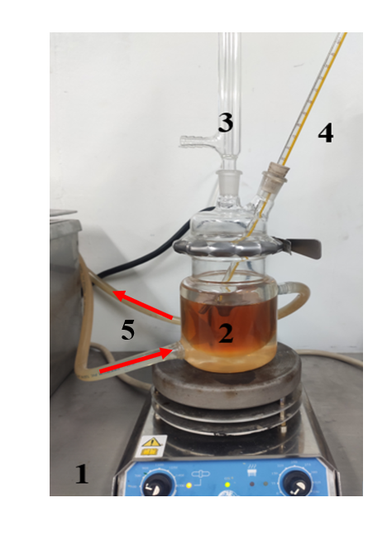
Figure 1: Scheme of the test facility of traditional process (1. Magnetic plate stirrer, 2. Reactor, 3. Condenser, 4. Thermometer, 5. Inlet and outlet of water hot).
    - Cavitation hydrodynamics process
The alternative transesterification took place in a system with a fixed bed reactor for the storage of the 150 g oil mixture with the corresponding methanol coupled to the suction of a gear pump, On the discharge line, a self-designed orifice plate is coupled to finally return to the reactor. The system described above is shown in Figure 2. It indicates where pressure and temperature measurements are taken throughout the system, such as samples of fluid reacting to the discharge of the pump and the discharge of the orifice plate.
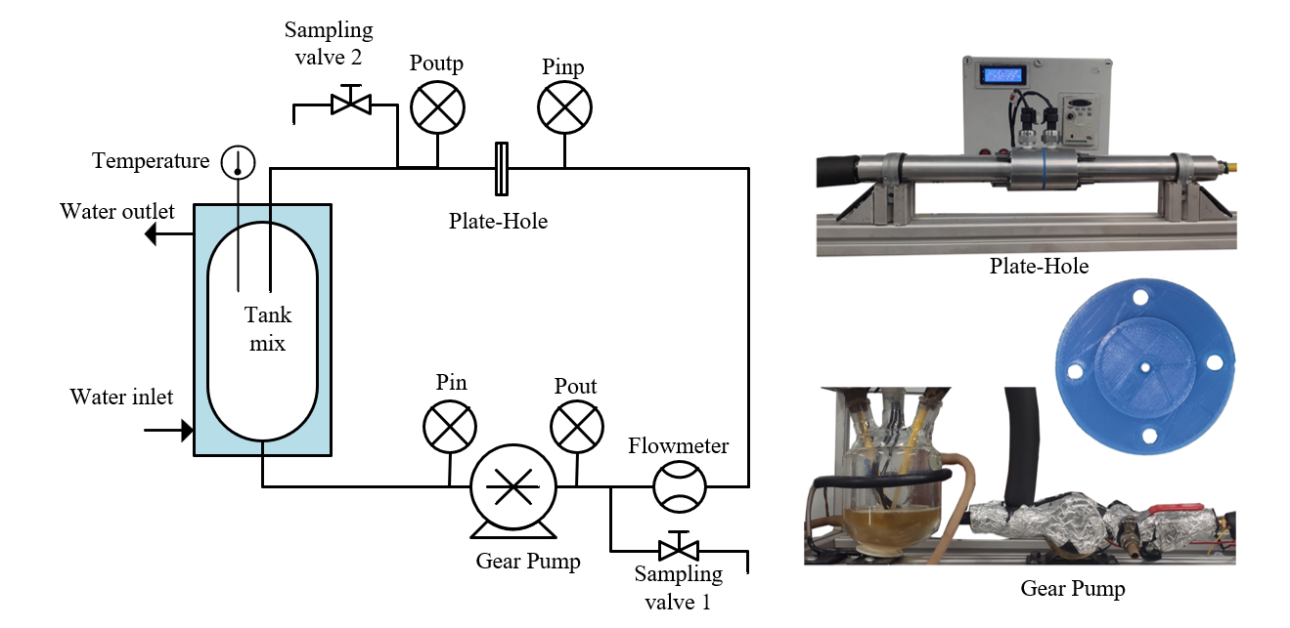
Figure 2: Scheme of the test facility of cavitation hydrodynamics process (P_{in}: Pressure of inlet in gear pump, P_{out}: Pressure of outlet in gear pump, P_{inp}: Pressure of inlet in plate hole, P_{outp}: Pressure of outlet in plate hole).
    - Reaction speed
To make the comparison of the biodiesel produced by the two methods at different times, a sample of 15 mL was extracted from both systems described in section 2.2 and 2.3, a centrifuge process was subsequently carried out, followed by micropipette separation of the glycerin methyl esters, followed by washing with distilled water the biodiesel and drying with anhydrous sodium sulphate. Finally, the amount of fatty acid methyl esters (FAME) present in the sample is analyzed by gas chromatography.
    - Biodiesel characterization
For the determination of FAME the standard EN 14103: 2011 was followed, using methyl nonadecanoate as standard, supplied by Sigma-Aldrich (Steinheim, Germany). A gas chromatograph with a flame ionization detector from VARIAN (Waltham, MA, U.S. was used. The kinematic viscosity of biodiesel was measured with a Cannon Fenske 9721-B59 (Ontario, Canada) and the density with a Robsan TDM1121 (Mexico, Mexico) aerometer applying ASTM 445 and ASTM 1298, respectively. The calorific values were determined with a calorimetric pump IKA C 3000 (Staufen, Germany), with the application of the isoperibolic method, following the ASTM 240 standard. Distillation temperatures were obtained for samples of 100 mL at atmospheric pressure, under the ASTM D86 standard.
  - Results
Next, the results of the Soybean Oil properties, a comparison of the reaction rate, biodiesel characterization, and the results of the cavitation method are shown.
    - Properties of the soybean oil
One of the main characteristics for a complete transesterification of the oil is the low presence of free fatty acids, maximum 1% w/w (Vera-Rozo et al., 2022). In addition, knowing properties such as density and viscosity are paramount for a correct evaluation of biodiesel. For this reason, these properties and the traceability of fatty acid compounds of soybean oil have been determined, which are presented in Table 2 (Aboelazayem et al., 2021). The results show a density, viscosity and traceability behavior of the compounds very similar to those reported by some characterizations available in the literature (Knothe et al., 1985; Sahasrabudhe , 2017; Yongphet, 2021).
Table 2: Physical and chemical properties of soybean oil
Properties | Soybean | Standard
Acidity percentage (%) | 0.136 ± 0.001 | NMX-F-101-SCFI-2012
Kinematic viscosity (mm²/s) | 51.32 ± 0.01 | ASTM 445
Density (kg/m³) | 920.3 ± 0.1 | ASTM D1298
Fatty acid composition | Molar weight*(g/mol) | (% w/w)
Palmitic (C16:0) | 256.4 ± 0.1 | 10.74
Palmitoleic (C16:1) | 254.1 ± 0.1 | 0.10
Stearic (C18:0) | 284.5 ± 0.1 | 4.05
Oleic (C18:1) | 282.5 ± 0.1 | 24.05
Linoleic (C18:2) | 280.4 ± 0.1 | 53.36
Linolenic (C18:3) | 272.4 ± 0.1 | 7.48
Arachidic (C20:0) | 312.5 ± 0.1 | 0.17
*The average triglyceride molar weight is 928.4 g/mol
    - Comparative of reaction speed
The obtaining of biodiesel by both methods was developed up to 45 min, being a time apart sufficient for the stabilization of the reaction intensified by cavitation, as is observed in Figure 3. In turn, the reaction kinetics for both 6:1 and 12:1 molar ratios have a much higher slope in the process intensified by cavitation compared to the traditional stirring and heating, requiring 90 to 120 min to achieve good performance of at least 95 % (Yongphet et al., 2021). Other hand, the only configuration that reaches the standard EN 14214 of 96.5 % w/w in FAME is under a molar methanol:oil ratio of 12:1. The kinetic curves obtained show a trend similar to that reported by other works that obtain biodiesel with more than 10 L allowing to consider that the behavior of this process would be scalable for large volumes (Maddikeri et al., 2014).

    - Other characteristics of biodiesel obtains
To make a comparison more interesting than the time of obtaining, other properties are presented for the best results in FAME of biodiesel obtained by both methods. For hydrodynamic cavitation intensification, biodiesel obtained in 20 min at a molar ratio of 12:1, on the other hand, in the case of traditional biodiesel, there is a reaction that was carried out over 120 min with the same molar ratio conditions. As shown in Table 3, the biodiesel obtained for both cases exceed the 96.5 % w/w FAME limit, the calorific values, density, viscosity and distillation temperatures are approximately constant and within the permissive range of EN 14214. The energy consumed by the process intensified by cavitation is noticeably lower, because despite requiring greater demand for instantaneous energy, the operating time is only 16 % of the traditional process, causing an energy saving of one third.

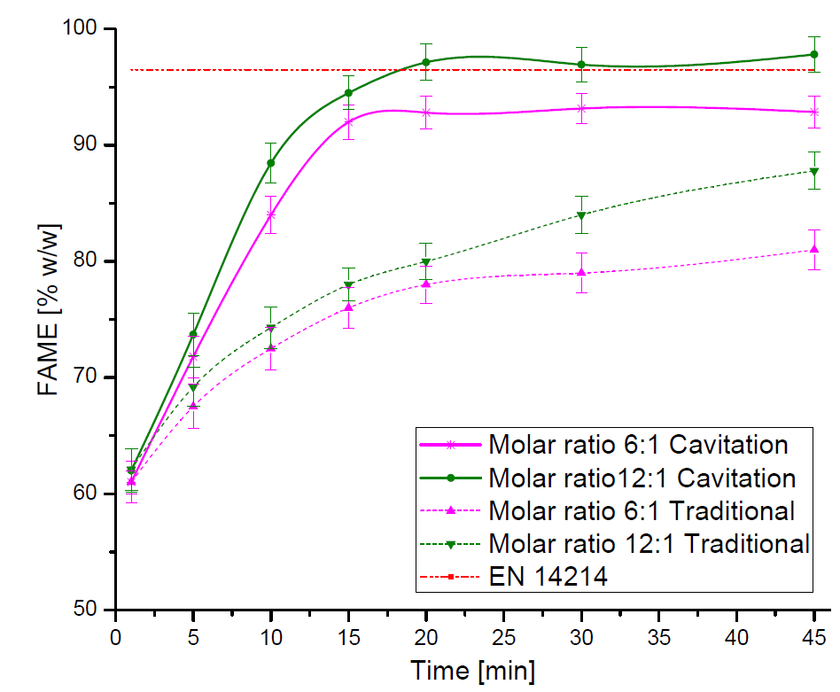
Figure 3: Reaction speed of four experiment.
Table 3: Physical and chemical properties of biodiesel.
Properties | Cavitation system | Traditional system | Standard
FAME (% w/w) | 97.20 ± 1.20 | 98.58 ± 1.40 | EN 14214 (Min 96.5)
Kinematic viscosity (mm²/s) | 4.074 ± 0.01 | 4.141 ± 0.01 | ASTM 445 (Min 3.5 – Max 5.0)
Density (kg/m³) | 882.1 ± 0.1 | 883.4 ± 0.1 | ASTM D1298 (Min 860 – Max 900)
Distillation ª |  |  | ASTM D86*
T₁₀ (°C) | 331.3 ± 0.1 | 333.1 ± 0.1
T₅₀ (°C) | 335.4 ± 0.1 | 336.7 ± 0.1
T₉₀ (°C) | 338.1 ± 0.1 | 338.2 ± 0.1
Heating value (kJ/kg) | 39 845 ± 25 | 39 749 ± 18 | ASTM D240*
Cetane number | 51.8 ± 0.1 | 51.7 ± 0.1 | ASTM D 613 (Min 51) ^{b}
Operation characteristics
Time reaction (min) | 20 | 120
Energy consumption (kWh) | 0.74 | 2.04
ª The local barometric pressure is 88.26 kPa. The value is verified by using a barometric sensor Bme280 registered
^{b} It is estimated with the equation presented by Giakoumis (Giakoumis and Sarakatsanis, 2018)
* The standard only report.
    - Cavitation demonstration
The presence of cavitation in the orifice plate system can be demonstrated in a practical way by the pressures measured along the system, because for there to be formation of bubbles the vapor pressure of one of the two reagents (methanol and oil) must be reached. Since the methanol in the system is easily evaporated, the vapor pressure of the methanol at 60°C is considered as the pressure limit to reach the imminent cavitation, this being 82.94 kPa (Marcus et al., 2018) and the local atmospheric pressure is 88.26 kPa, so achieving vacuum pressures of just -5.32 kPa would have the presence of methanol vapor interstices through the reaction fluid. The pressures in the discharge of the plate reach measurements of up to -8.00 kPa which shows the presence of cavitation after the discharge of the plate and bubbles along the system.
  - Conclusions
The use of cavitation, despite being a phenomenon that is avoided in many processes, can be an alternative to the intensification of chemical reactions. This work has shown that the controlled use of hydrodynamic cavitation generated through an orifice plate produces an intensification in the transesterification reaction, managing to reduce the reaction time from 120 to 20 minutes, and consequently an energy saving of the production process of up to 66%. The properties such as the content of methyl esters is greater than 96.5 % w/w, density, viscosity, calorific value and cetane number comply with the regulatory restrictions stipulated by the independent EN 14214 method used for its production.
Nomenclature
FAME – Fatty Acid Methyl Esters, % w/w
Re – Number Reynolds, $\frac{VD}{ν}$
V – Flow velocity, m/s
D – Flow Diameter, m
$ν$ – Kinematic Viscosity, m²/s -
NaOH – Sodium hydroxide
KOH – Potassium hydroxide
rpm – revolution per minute

References
Aboelazayem O.,Gadalla M.,Alhajri I.,Saha B., 2021. Advanced process integration for supercritical production of biodiesel: Residual waste heat recovery via organic Rankine cycle (ORC). Renew. Energy 164, 433–443.
Aghbashlo M.,Peng W.,Tabatabaei M.,Kalogirou S.A.,Soltanian S.,Hosseinzadeh-Bandbafha H.,Mahian O.,Lam S.S., 2021. Machine learning technology in biodiesel research: A review. Prog. Energy Combust. Sci. 85, 100904.
Angele K., 2021. Prediction of cavitation in orifice plates—A novel and simple rule-of-thumb. Exp. Comput. Multiph. Flow 3, 68–76.
Bargole S.,George S.,Kumar Saharan V., 2019. Improved rate of transesterification reaction in biodiesel synthesis using hydrodynamic cavitating devices of high throat perimeter to flow area ratios. Chem. Eng. Process. - Process Intensif. 139, 1–13.
Ghayal D.,Pandit A.B.,Rathod V.K., 2013a. Optimization of biodiesel production in a hydrodynamic cavitation reactor using used frying oil. Ultrason. Sonochem. 20, 322–328.
Ghayal D.,Pandit A.B.,Rathod V.K., 2013b. Optimization of biodiesel production in a hydrodynamic cavitation reactor using used frying oil. Ultrason. Sonochem. 20, 322–328.
Giakoumis E.G.,Sarakatsanis C.K., 2018. Estimation of biodiesel cetane number, density, kinematic viscosity and heating values from its fatty acid weight composition. Fuel 222, 574–585.
Gogate P.R.,Tayal R.K.,Pandit A.B., 2006. Cavitation: A technology on the horizon. Curr. Sci. 91, 35–46.
Knothe G., 1985. Transesterification Kinetics of Soybean Oil. Biodiesel Handb. Second Ed. 63, 1375–1380.
Maddikeri G.L.,Gogate P.R.,Pandit A.B., 2014. Intensified synthesis of biodiesel using hydrodynamic cavitation reactors based on the interesterification of waste cooking oil. Fuel 137, 285–292.
Marcus Y., 2018. Extraction by subcritical and supercriticalwater, methanol, ethanol and their mixtures. Separations 5.
Sahasrabudhe S.N.,Rodriguez-Martinez V.,O’Meara M.,Farkas B.E., 2017. Density, viscosity, and surface tension of five vegetable oils at elevated temperatures: Measurement and modeling. Int. J. Food Prop. 20, 1965–1981.
Silva C.C.C.M.,Ribeiro N.F.P.,Souza M.M.V.M.,Aranda D.A.G., 2010. Biodiesel production from soybean oil and methanol using hydrotalcites as catalyst. Fuel Process. Technol. 91, 205–210.
Tabatabaei M.,Aghbashlo M.,Dehhaghi M.,Panahi H.K.S.,Mollahosseini A.,Hosseini M.,Soufiyan M.M., 2019. Reactor technologies for biodiesel production and processing: A review. Prog. Energy Combust. Sci.
Tang T.,Gao L.,Li B.,Liao L.,Xi Y.,Yang G., 2019. Cavitation optimization of a throttle orifice plate based on three-dimensional genetic algorithm and topology optimization. Struct. Multidiscip. Optim. 60, 1227–1244.
Vera-Rozo J.R.,Riesco-Avila J.M.,Elizalde-Blanca F.,Cano-Andrade S., 2021. OPTIMIZATION OF THE REAL CONVERSION EFFICIENCY OF WASTE COOKING OIL. Therm. Sci. 1–14.
Yongphet P.,Wang J.,Wang D.,Mulbah C.,Fan Z.,Zhang W.,Amaral P.C.S., 2021. Optimization of operation conditions for biodiesel preparation from soybean oil using an electric field. Biomass Convers. Biorefinery 11, 2041–2051.

