 CHEMICAL ENGINEERING TRANSACTIONS  VOL. 92, 2022 | A publication of  
The Italian Association
of Chemical Engineering
Online at www.cetjournal.it

Guest Editors: Rubens Maciel Filho, Eliseo Ranzi, Leonardo Tognotti
Copyright © 2022, AIDIC Servizi S.r.l.
ISBN 978-88-95608-90-7; ISSN 2283-9216

PHYTOREMEDIATION TO REMOVE POLLUTANTS FROM WATER, LEACHATES AND SOILS
Lesly Patricia Tejeda Benítez^{a, b}, Liset Mallarino Miranda^{b*}, Carlos Alfredo Castellon Castro^{b}

ª Process Design and Biomass Utilization Research Group (IDAB), Chemical Engineering Department, Faculty of Engineering, Universidad de Cartagena, Cl 30 No. 48-152, Cartagena, Colombia.
^{b} Biomedical, Toxicological, and Environmental Sciences Research Group (BIOTOXAM). Zaragocilla Campus. Faculty of Medicine, Universidad de Cartagena, Cra. 50 No. 29 - 11, Cartagena, Colombia.
*lmallarinom@unicartagena.edu.co

Phytoremediation is a technique that uses various types of plants to remove, treat, translate, or destroy pollutants from soil and water. We used Sorghum vulgare to remediate soils contaminated by hydrocarbons, Chrysopogon zizanioides to treat landfill leachates, and Lemna minor to remove nickel from mining water. The phytoremediation process was performed using hydroponic crops for water and planters for soils. The soil samples were contaminated with diesel (10%). Phytoremediation process using Sorghum vulgare was performed for 30 days in planters. Soil with the same concentration of diesel without plants was used as a control (natural attenuation). The efficiency of diesel removal was 92% while natural attenuation reached a removal rate of 49%. A sample of leachate from a landfill in Cartagena (Colombia) was submitted to the remediation process using hydroponic crops of Chrysopogon zizanioides for 10 days. The metal uptake of cadmium was up to 98.4% nickel 98.7% and lead 98%. Additionally, synthetic water prepared with nickel (10%) was remediated through a hydroponic crop of Lemna minor for 10 days. This plant reached a removal efficiency of nickel of 68%. All above suggests that phytoremediation is a suitable technique to clean waters and soils.
  - Introduction
The environmental damage in aquatic ecosystems by pollutants such as heavy metals and petroleum hydrocarbons comes mainly from anthropogenic activities related to energy and mineral consumption, including mining, steam generation, power plants, and waste treatment (Chen et al., 2016; Sun et al., 2016). In this sense, the need to innovate in methods that improve water quality and, simultaneously, remove substances that are not easily degradable or removable is growing.
Phytoremediation is a very suitable technique for stabilizing organic and inorganic compounds and improving water and soil quality since some plants can easily accumulate pollutants through different physical and biochemical mechanisms (Manoj et al., 2020; Shah and Daverey, 2020). Plants retain and store nutrients in their roots or shoots for subsistence. This principle also applies to heavy metals and other toxics substances, which they accumulate in other tissues, making them useful for bioremediation of sediments and water bodies (Eid et al., 2020).
Recently, this methodology has been increasingly explored in soils, so evaluating its performance in water is a promising option, as it is suitable for applications in countless field sites where other remediation methods are not cost-effective or practicable, it improves landscape quality, and its costs are mostly associated with process maintenance. However, the presence of these metals or petroleum hydrocarbons can also have toxic effects on other species, so animal access to these plants or their sale for consumption should be restricted. This strategy applies to most heavy metals (Saavedra et al., 2018). In fact, phytoremediation can be considered inexpensive compared to other techniques such as adsorption and filtration (Wan et al., 2016; Willscher et al., 2017).
In this study, it observed the changes in their morphological characteristics and analyze their pollutant removal and adsorption capacity of Sorghum vulgare to remediate soils contaminated by hydrocarbons, Chrysopogon zizanioides to treat landfill leachates, and Lemna minor to remove nickel from water was used.
- Materials and Methods
  - Phytoremediation of soils contaminated with hydrocarbons
S. vulgare seedlings were planted in soils previously contaminated with diesel (1000 and 6000 mg/Kg). The toxic effects on the plant were evaluated and the presence of hydrocarbons was analyzed after 30 days by gas chromatography. As controls, the plant was planted in soil without hydrocarbons and additionally a sample of soil with hydrocarbons was analyzed after 30 days without planting plants to compare the phytoremediation versus natural attenuation. Three replicates were conducted for each treatment.
  - Phytoremediation of a landfill leachate
A synthetic leachate was prepared based on Charki et a. (2021). C. zizanioides seedlings were planted in water contaminated with leachate using two concentrations (50% and 100%vol) using hydroponic growths. The toxic effects on the plant and removal of cadmium, lead and nickel at 7 days were evaluated. The experiment was conducted in triplicate.
  - Phytoremediation of nickel from water
Synthetic solutions were prepared with nickel sulfate at concentrations of 0.5, 1.5, and 2.5 mg/L of Nickel (II) ion. L. minor were taken from nature and planted in the solutions. The toxic effects on the plant and removal of nickel at 10 days were evaluated Six experimental combinations and their respective replicates were conducted. Figure 1 shows the setup of the experiments.

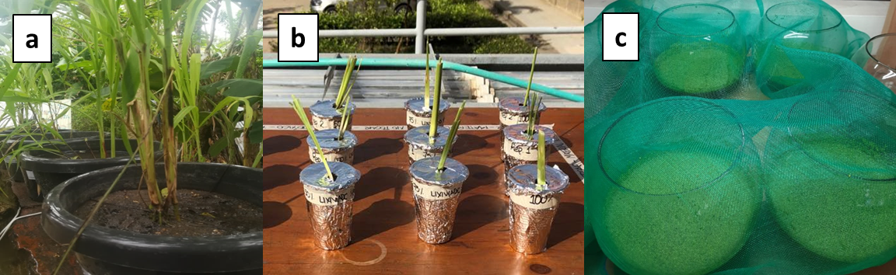
Figure 1. Setup of phytoremediation tests. (a) S. vulgare planted in soil. (b) C. zizanioides in synthetic leachates. (c) L. minor planted in nickel-contaminated water

Results
Figure 2 displays the toxic ​​​​​​​effects of diesel in S. vulgare. The presence of diesel at 6000 mg/Kg in soil affected the number of leaves and the height of the plant (p<0.05). However, plants planted in soil with 1000 mg/Kg of diesel showed discoloration on their leaves. Generally, the presence of diesel caused damage in leaves. This has been reported by several authors who report that petroleum hydrocarbons reduce seed germination and nutrient translocation, induce oxidative stress, alter plant metabolic activity, inhibit plant physiology and morphology, leading to plant tissue and cell necrosis (Bao et al., 2020; Haider et al., 2021; Hung et al., 2020).
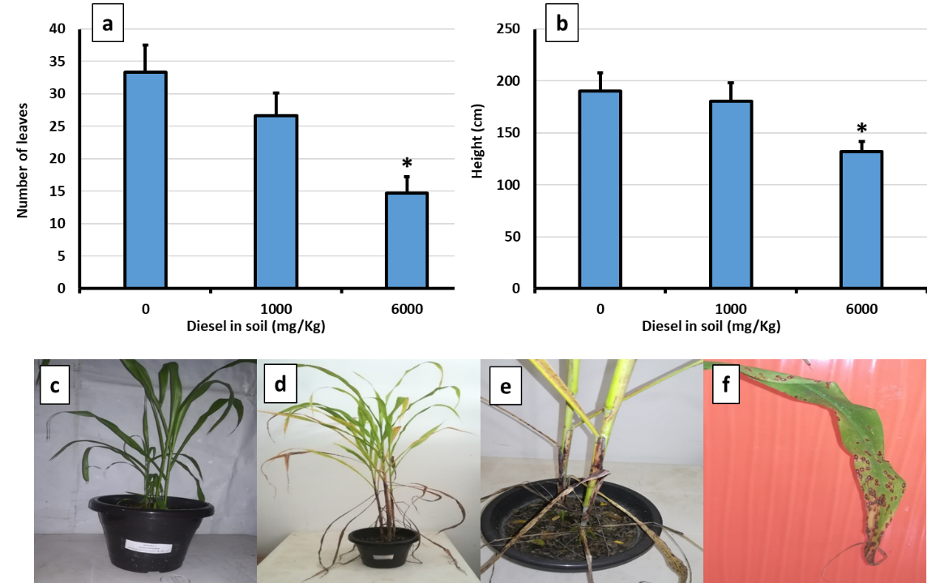
Figure 2. Toxicological effects on S. vulgare. (a) Number of leaves. (b) Height of the plant. (c) Plant in control soil. (d) Plant in soil with 1000 mg/Kg of diesel (e) Plant in soil with 6000 mg/Kg of diesel. f. Damage in leaves.

According to the GC-MS analysis, the diesel sample used to contaminate the soil samples contained aliphatic and aromatic hydrocarbons between 8 and 28 carbons, with heptadecane and octadecane as priority components. Figure 3 shows the removal of hydrocarbons. The phytoremediation of soils contaminated with diesel led to the removal of hydrocarbons measured from day 10 to 30. The removal of hydrocarbons in soils contaminated with 1000 mg/kg of diesel was greater than in those with 6000 mg/kg, probably due to the toxic effects suffered by the plant at high concentrations. It is evident that phytoremediation allows a greater removal of hydrocarbons than natural attenuation.

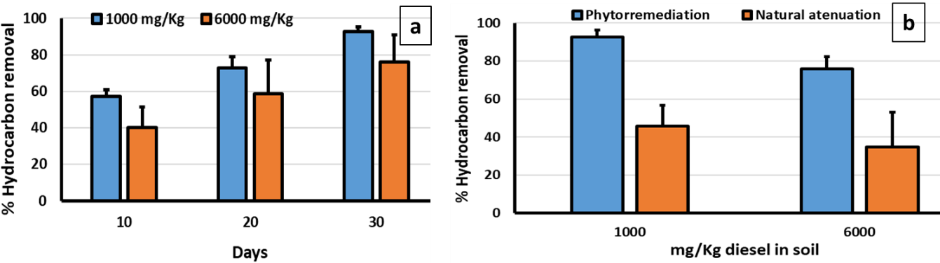
Figure 3. Phytoremediation of soils with S. vulgare. (a) Removal at different days. (b) Comparison with natural attenuation.

However, the toxicological effect of leachate on C. zizanioidesas can be seen in figure 4a, the samples most affected in terms of growth were those with a 100% concentration, which only managed to grow 0.154 cm/day on average throughout the exposure, in addition, a decrease in tonality is observed. green characteristic of the plant and even dry stems and/or parts of the stem throughout the exposure. This is also evidenced in the Figure 4b, where it can be observed that the green hue of the plant was preserved and even some new stems are observed. Roongtanakiat et al. (2007) showed similar results where C. zizanioides was used for the bioremediation of industrial wastewater containing heavy metals. In this research, the best stem growth obtained was in a sample with 50% leachate. The sample with 100% leachate showed growth detriment. This could be that the amount of leachate present was unable to meet the plant's nutritional need.

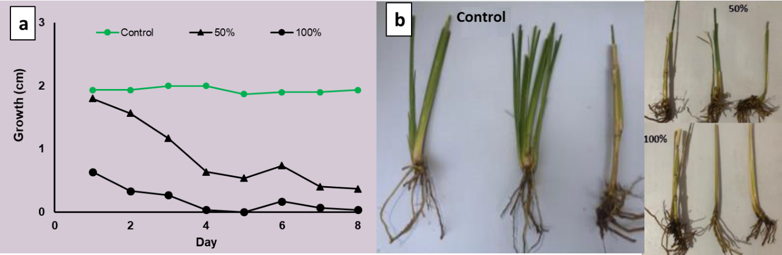
Figure 4. Efects of leachate on C. zizanioides (a) Changes in growth (b) Morphological changes

Figure 5 displays the results of removal of COD, Cd, Pb and Ni from synthetic leachates. The removal of pollutants was satisfactory, obtaining reduction percentages ranging between 48% and 98%. ​​​​​​​COD removal was low (48 – 57%) compared with heavy metals. suggesting a high accumulation capacity of heavy metals of C. zizanioides. For instance, Pb and Ni achieved removal between 95 and 98%. Furthermore, no significant differences were found (p <0.05) between the concentrations evaluated, therefore, it is concluded that the percentage of pollutant removal is independent of the dilution leachate used. Madera-Parra et al. (2015) performed a similar work using three species to remove Chromium and COD from a 100% leachate sample.
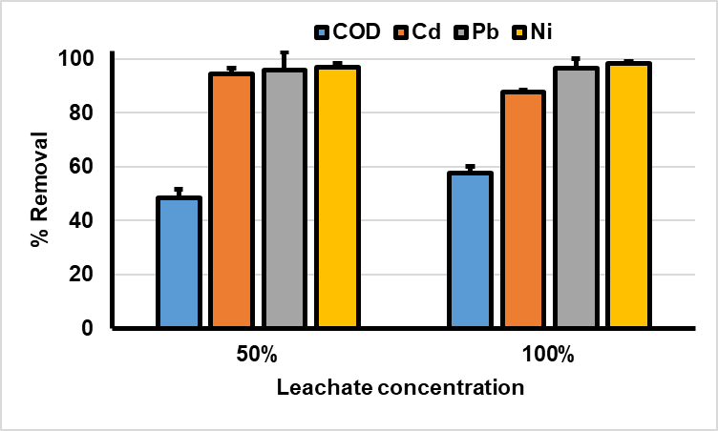

Figure 5. Effects of leachate on C. zizanioides (a) Changes in growth (b) Morphological changes

Finally, the toxic effects of nickel in L. minor at the concentrations evaluated are shown in Figure 6. Signs of necrosis and chlorosis can be seen in Figures 6b and 6c. This is because nickel enters cells, induces various toxic effects for plants at morphological, physiological, and biochemical levels. The impact related to the presence of this metal in the plants can result from direct action and indirect factors, including the alteration of the water status of the plant, the deterioration of the photosynthesis, and the alteration or imbalance of mineral/nitrogen nutrition (Kiiskila et al., 2019). As shown in Figure 4d, the most noticeable effect of L. minor is the loss of photosynthetic pigments.
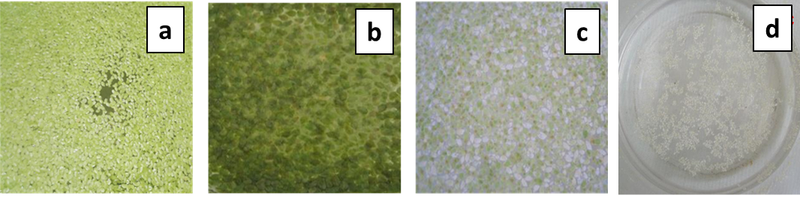
Figure 6. Physical changes in L. minor (a) without contamination, (b) necrosis at 1.5 mg/L Ni, (c) irreversible damage at 2.5 mg/L Ni, (d) chlorosis at 2.5 mg/L Ni

For the removal of Nickel by L. minor, though the plants did not show signs of growth or significant biomass production in the tests at different values of nickel concentrations, it was possible to evidence the removal of the heavy metal from the water. Figure 7 shows that L. minor were removed between 25% and 68% of Ni. L. minor, even at the lowest concentration, showed signs of irreversible deterioration. However, this did not impede it from conducting the phytoremediation process. Therefore, it is assumed that from the second day, the dead plant material acted as a bio-adsorbent, that the pH increased, and so did the conductivity proportional to the concentrations of nickel studied, which suggests that when the plant died, the waste made the medium alkaline. Nevertheless, the metal was still in the bioavailability range (Verschoor et al., 2017), so adsorption continued to occur.

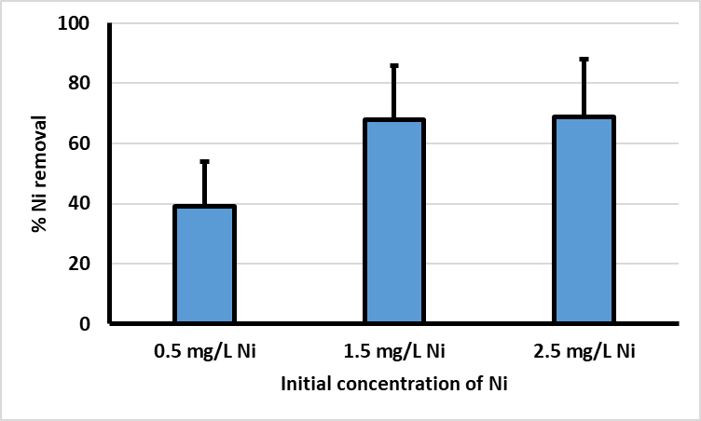
Figure 7. Nickel removal after ten days
- CONCLUSIONS
In this work, we found that despite the toxicity caused by contaminants, S. vulgare can remove hydrocarbons from the soil, C. zizanioides could reduce COD and heavy metals such as Cd, Pb and Ni from leachates, and L. minor can reduce the concentration of nickel in the water. In conclusion, S. vulgare, C. zizanioides and L. minor are plants that can be used for phytoremediation efficiently. Phytoremediation is a promising technique to recover terrestrial and aquatic ecosystems contaminated by anthropogenic activities.
This research aims to raise awareness and contribute to the development of this promising technology that has become an important area of research in the last 15 years due to its low cost, easy maintenance and installation in open fields and high removal efficiency (Vigliotta et al., 2016), setting a baseline for future studies on the removal of aromatic hydrocarbons or others compounds from soils, recovery, and reuse of valuable metals, as well as inspiring new work focused on the application of this technology on a larger scale such as artificial wetlands.
- REFERENCES

Bao, H., Wang, J., Zhang, H., Li, J., Li, H., Wu, F. 2020. Effects of biochar and organic substrates on biodegradation of polycyclic aromatic hydrocarbons and microbial community structure in PAHs-contaminated soils. J. Hazard Mater, 385,121595. https://doi.org/10.1016/j.jhazmat.2019.121595
Charki, A., El Ouarghi, H., Ahari, M. 2021. Treatability tests of synthetic leachate from the AlHoceima city controlled landfill. E3S Web of Conferences 314, 07007.
Chen, J., Wang, L., Wang, M., Hung, Y., Shammas, N. 2016. Remediation of heavy metals in the environment. 1st ed. CRC Press, Boca Raton. https://doi.org/10.1201/9781315374536
Eid, E. M., Galal, T. M., Sewelam, N. A., Talha, N. I., & Abdallah, S. M. 2020. Phytoremediation of heavy metals by four aquatic macrophytes and their potential use as contamination indicators: a comparative assessment. Environmental Science and Pollution Research, 27(11), 12138-12151. https://doi.org/10.1007/s11356-020-07839-9
Haider, F., Ejaz, M., Alam Cheema, S., Khan, M., Zhao, B., Liqun, C., Salim, M., Naveed, M., Khan, N., Núñez-Delgado, A., Mustafa, A. 2021. Phytotoxicity of petroleum hydrocarbons: Sources, impacts and remediation strategies, Environmental Research, 197, 111031. https://doi.org/10.1016/j.envres.2021.111031
Hung, C., Huang, C., Chen, C., Wu, C., Lin, Y., Dong, C. 2020. Activation of percarbonate by water treatment sludge–derived biochar for the remediation of PAH contaminated sediments. Environmental Pollution, 265, 114914. https://doi.org/10.1016/j.envpol.2020.114914
Kiiskila, J., Sarkar,D., Panja, S., Sahi, S., Datta, R. 2019. Remediation of acid mine drainage-impacted water by vetiver grass (Chrysopogon zizanioides): A multiscale long-term study. Ecological Engineering, 129, 97-108. https://doi.org/10.1016/j.ecoleng.2019.01.018
Manoj, S., Karthik, C., Kadirvelu, K., Arulselvi, P., Shanmugasundaram, T., Bruno, B., Rajkumar, M. 2020. Understanding the molecular mechanisms for the enhanced phytoremediation of heavy metals through plant growth promoting rhizobacteria: A review. Journal of Environmental Management., 254, 109779. https://doi.org/10.1016/j.jenvman.2019.109779
Roongtanakiat, N., Tangruangkiat, S., Meesat, R. 2007. Utilization of vetiver grass (Vetiveria zizanioides) for removal of heavy metals from industrial wastewaters, ScienceAsia 33, 397–403. 10.2306/scienceasia1513-1874.2007.33.397
Saavedra, A. S., PARRA, C., Salamanca, E. J. P., Cerón, V. A., & Mosquera, J. 2018. Grupos funcionales fitoplanctónicos en una laguna algal de alta tasa usada para la biorremediación de lixiviados de rellenos sanitarios. Acta Biológica Colombiana, 23(3), 295-303. https://doi.org/10.15446/abc.v23n3.69537
Shah, V., Daverey, A. 2020. Phytoremediation: A multidisciplinary approach to clean up heavy metal contaminated soil. Environmental Technology & Innovation, 18, 100774. https://doi.org/10.1016/j.eti.2020.100774
Sun, Z., Chen, J., Wang, X., Lv, C. 2016. Heavy metal accumulation in native plants at a metallurgy waste site in rural areas of Northern China. Ecological Engineering, 86, 60-68. https://doi.org/10.1016/j.ecoleng.2015.10.023
Verschoor, A., Vijver, M., Vink, J. 2017. Refinement and cross-validation of nickel bioavailability in PNEC-Pro, a regulatory tool for site-specific risk assessment of metals in surface water. Environmental Toxicology and Chemistry, 36(9), 2367-2376. https://doi.org/10.1002/etc.3772
Vigliotta, G., Matrella, S., Cicatelli, A., Guarino, F., & Castiglione, S. 2016. Effects of heavy metals and chelants on phytoremediation capacity and on rhizobacterial communities of maize. Journal of Environmental Management, 179, 93–102. https://doi.org/10.1016/j.jenvman.2016.04.055
Wan, X., Lei, M., & Chen, T. 2016. Cost–benefit calculation of phytoremediation technology for heavy-metal-contaminated soil. Science of the Total Environment, 563–564, 796–802. https://doi.org/10.1016/j.scitotenv.2015.12.080
Willscher, S., Jablonski, L., Fona, Z., Rahmi, R., & Wittig, J. 2017. Phytoremediation experiments with Helianthus tuberosus under different pH and heavy metal soil concentrations. Hydrometallurgy, 168, 153–158. https://doi.org/10.1016/j.hydromet.2016.10.016

