|  |  |
| --- | --- |
| cetlogo ***CHEMICAL ENGINEERING TRANSACTIONS***  ***VOL. 92, 2022*** | A publication of  aidiclogo_grande |
| The Italian Association  of Chemical Engineering  Online at www.cetjournal.it |
| Guest Editors: Rubens Maciel Filho, Eliseo Ranzi, Leonardo Tognotti  Copyright © 2022, AIDIC Servizi S.r.l. **ISBN** 978-88-95608-90-7; **ISSN** 2283-9216 | |

Biomes of Mangifera indica and Vitis vinifera for the Production of Biodegradable Sorbets

Celeste V. Gallardo Bravo, Xiomara A. Velasquez Ruiz\*, Jorge Jave Nakayo, Veronica Tello Mendívil, Carlos Castañeda Olivera, Elmer Benites-Alfaro

Cesar Vallejo University, Av. Alfredo Mendiola 6232 Los Olivos Lima 15314, Peru

\*corresponding: velasquezalessandra4@gmail.com

The use of plastic straws (straw) has become a habit under the pretext of being a way of caring for health in the face of the lack of hygiene of the containers that serve food (drinks, juices, etc.), accentuated even more as a way to avoid contagion of diseases such as COVID 19; This has resulted in the generation of abundant solid plastic waste that has a negative impact on the contamination of soil and water. Faced with this problem, the objective was to produce sorbets with biodegradability characteristics from Mangifera indica and Vitis vinifera shell biomass, taking advantage of their rich content of starch and cellulose. The production method consisted of testing various doses of shell biomass of the aforementioned species, analysing their physical and mechanical characteristics, as well as biodegradability, to corroborate it later with a survey of the level of satisfaction of the elaborated product that obtained the best properties. The results indicated that the Mangifera indica shells had higher starch content compared to the Vitis vinifera shells; On the contrary, regarding the cellulose content, the Vitis vinifera husks had a higher quantity, resulting in a harder and more resistant bioplastic. Finally, it is concluded that biodegradable straws from biomass of Mangifera indica and Vitis vinifera are a significant solution compared to conventional ones, with the important advantage of being biodegradable in a short time and their characteristics are similar to plastic straws, to the time they turned out to have a good level of acceptance by the respondents.

* 1. Introduction

Over the years, environmental pollution has increased and has a detrimental impact on the quality of soil, air and water. And one of the most polluting elements is presented through the use of oil in industry, since it generates various by-products such as plastic, and that in the last 10 years has become one of the environmental problems to which various international organizations, Oceanographic institutes and world authorities have become aware, and that during past decades no policies and/or action have been taken to minimize, avoid or reduce the accumulation of plastic waste in bodies of water such as rivers, seas, oceans, lakes, wetlands; these volumes of plastic, regardless of size, are deposited, broken down and degraded in the oceans, representing a risk for marine species, which can ingest them casually and cause choking, cause entrapment, strangulation, increases mortality and negatively impacts the conservation and reproduction of organisms, on the other hand through the consumption of fish and shellfish is a danger to humans (Ita et al., 2022). Plastic waste in the form of straws or bottle rings constitutes a risk and can physically harm the different species residing in the oceans, being able to ingest it or enter the nostrils of marine fauna.

About 5 billion bags a year are used throughout the world, that is, almost 10 million per minute, of 8 million are disposed of in the sea (MINAM, 2021). Projections affirm that by the year 2030 about 53 million tons will be discarded into the ocean, that is, three times what was emitted in 2016 (Ita et al., 2022), and with the same pattern of generation and use, by 2050. the amount of plastic will be greater than that of fish in the ocean (Ellen Macrthur Foundation, sf), 99% of fish will have ingested plastic particles, 15% of species harmed by ingestion, entrapment or strangulation with plastic garbage will be in danger of extinction. Plastic has been dispersed in many places, plastic bags have been found on Everest peak, in the polar ice caps and deeper places in the sea, in 2017, a "Plastic Island" of about 2.6 million km2 (almost twice the Peruvian territory) was discovered in the middle of the ocean off the coasts of Peru and Chile. In Peru, the average use of plastic is of 30 kg/person and in the city of metropolitan Lima and Callao, 886 tons of plastic waste are produced daily, which means 46% of the total waste in the entire country (MINAM, 2021). To counteract this situation, the world's leading authorities have given greater impetus to laws and regulations related to the disposal of solid waste and prevent it from being disposed of in bodies of water. In Peru, the reason why plastic waste ends up in rivers, lakes, Knoch and Mihalyi (2018) in their article mention that the use of bioplastics is a great start for improvement to mitigate global warming, in addition to using plastics based on renewable sources that do not generate large-scale environmental impacts unlike conventional plastics.

Alarcón and Barrantes (2019) carried out a study on the perception of consumers of the use of biodegradable materials, finding that the purchasing power of consumers was not decisive when choosing the use of these biodegradable products, so that consumers if they are aware of the harmful impact generated by the use of common polyethylene plastic.

Research proposes alternatives for the manufacture of degradable bioplastic bags from banana peel, with more resistant physical and mechanical characteristics than conventional bags, with a degradation time of 8 weeks (Huzaisham & Marsi, 2020). The manufacture of bioplastic from common domestic fruit peels (banana, orange, avocado and lemon) mixed with glycerine (plasticizer), cornstarch, vinegar and water as solvent has also been tested, the result was a more resistant and more biodegradable material. than common plastics (Del campo et al., 2020). Siti et al. (2020) elaborated bioplastic from residues of cocoa pod husks and sugar cane bagasse, with efficacy characteristic in food preservation, promotes sustainable economic development due to the added value of the different materials through by-products. In an investigation carried out by Sernaqué et al. (2020) analyze the biodegradability of bioplastics made from Mangifera indica (mango) and Musa paradisiaca (banana) peels, based on the assumption that for degradation to occur, the molecules have to break their crystalline structures, and this is influenced by exposure to environmental factors, for this specific case, earthworm humus was used as a degradation medium, 93.06% and 73.16% reduction in its initial weight in 4 weeks, determining that glycerol has a direct relationship with the biodegradability of bioplastic sheets.

Huang (2020), elaborated biodegradable sorbets using vegetable fibers and a polymer as raw material, verifying that they biodegraded much more easily, indicating as advantages not containing petrochemical substances or any silica, it can be eliminated in the subsoil and form part of the environment without any damage. In this panorama, the enormous amounts of food waste that come from different sources, and that can constitute a danger if not disposed of properly, can be used and add value with the production of biodegradable plastics with environmental advantages and lower cost (Tan et al., 2019). Taking into account the high volumes of plastic as waste and the negative impact that it already has and worsens as time goes by, it is necessary to develop and improve techniques and methods for the production of biodegradable products, including straws that are widely used for considerations. of hygiene and that can replace the use of plastics whose origin is petroleum, for which the objective of the research was the elaboration of sorbets from bioplastic sheets obtained from organic fruit waste, specifically from the peel of *Mangifera indica* (mango) and *Vitis vinifera* (grape), determining the biodegradation time, physical and mechanical properties of these biodegradable straws.

* 1. Materials and methodology

The procedure for obtaining bioplastic from the shell of Mangifera indica and Vitis vinifera was carried out in four stages. The organic residues used as inputs were obtained in the amount of 2 kg that corresponded to Mangifera indica and Vitis vinifera shells.

**Stage No. 1: Obtaining the biomass from the shell of *Mangifera indica* and *Vitis vinifera***

The peel of *Mangifera indica* (mango) has bioactives such as carotenoids, flavonoids, pectin, polyphenols, anthocyanins, mangiferin, dietary fiber, polyunsaturated fatty acids (Garcia-Mendoza et al., 2015), the peel of *Vitis vinifera* (grape) contains phenols and flavonoids (Tsang et al., 2019). The pretreatment to obtain the biomass to be used in the preparation of the sorbets is detailed in figure 1.

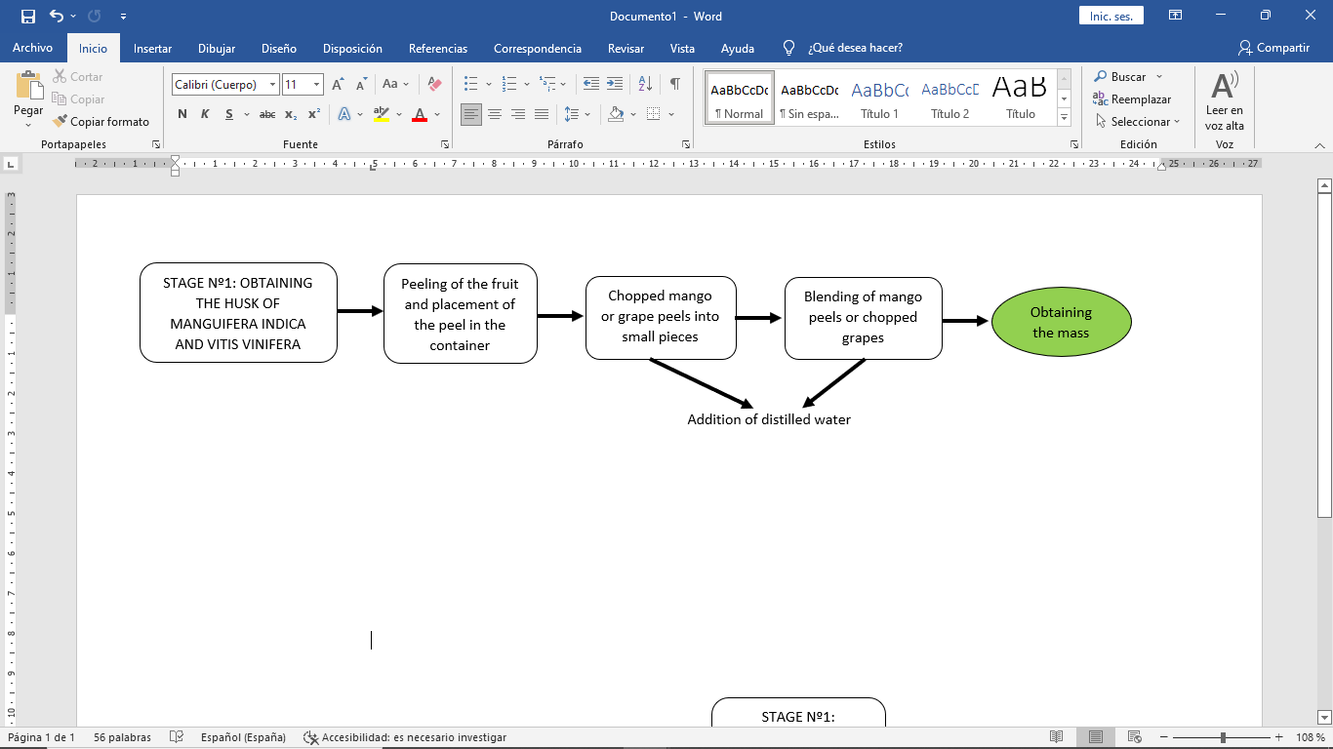

*Figure 1: Obtaining shell from Mangifera indica and Vitis vinifera.*

**Stage No. 2: Manufacture of bioplastic sheets from *Mangifera indica* and *vitis vinifera* shell biomass**

The bioplastic sheets were made, following the details indicated in Figure 2. The grinding process (liquefied) is done for 2 minutes. The bioplastic sheets were prepared and dried at room temperature for 3 days. See Figure 3

|  |  |
| --- | --- |
|  | a    b |
| *Figure 2: Elaboration of the bioplastic from the shell of Mangifera indica and Vitis vinifera* | *Figure 3: a) Mangifera indica and b) Vitis vinifera bioplastic sheets* |

**Stage No. 3: Elaboration of *Mangifera indica* and *Vitis vinifera* shell sorbets**

In the elaboration of the sorbets, cornstarch dissolved in water was used as a natural glue to join the bioplastic sheets using a mold. See Figures 4 and 5.

|  |  |
| --- | --- |
|  |  |
| *Figure 4: Production of Mangifera indica and Vitis vinifera shell sorbets* | *Figure 5: Biodegradable Straws* |

**Stage No. 4: Physical and mechanical analysis of *Mangifera indica* and *Vitis vinifera* shell sorbets**

The biodegradable straws were subjected to physical, mechanical and biodegradation analyses, while a questionnaire on the perception of the use of the straws was carried out. See figure 6.

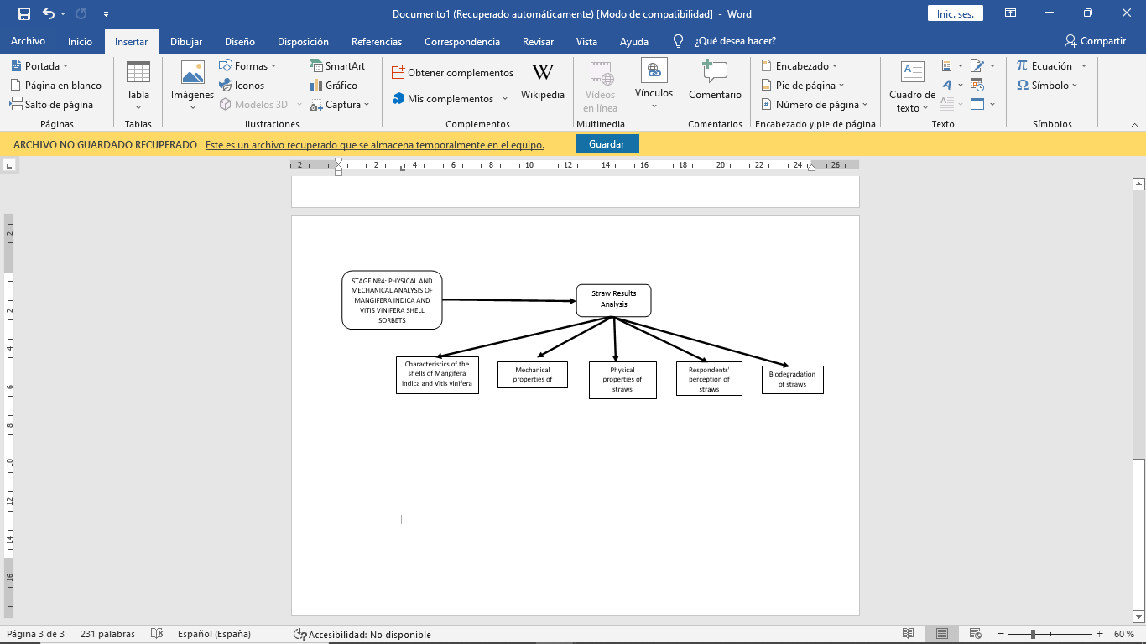

*Figure 6: Physical and mechanical analysis of Mangifera indica and Vitis vinifera shell sorbets.*

* 1. Results and discussions
     1. Characteristics of the peel of *Mangifera indica* and *Vitis vinifera*

Table 1 shows the percentage of starch and cellulose, which are the basic components of the plasticity property, the result indicates that Mangifera indica has a higher percentage of starch than *Vitis vinifera*. Starch is a polysaccharide, it is one of the main polysaccharides for the production of bioplastics, cellulose is a biopolymer present in all plants that needs an element to give it plasticity Katrin and Rajeev (2020).

*Table 1: Percentage of starch and cellulose*

|  |  |  |  |
| --- | --- | --- | --- |
|  | Starch (%) | Cellulose (%) | Reference methods |
| *Mangifera indica* | 4.87A | 12.77 | Starch: AOAC Official Method 948.02 Starch in Plants  Cellulose: Songlklanakarin J. Sci. Technol.  33 (4), 397-404, Jul.-Aug.2011 |
| *Vitis vinifera* | 1.58 | 9.67 |

* + 1. Composition of Mangifera indica and Vitis vinifera biodegradable sorbets

After the tests with repetitions in the quantities of components for the elaboration of the sorbets, in Table 2, the three best compositions are presented for the case of *Mangifera indica* sorbets, the same proportions were used for *Vitis vinifera* sorbets, with the end of comparison.

*Table 2: Components for the production of biodegradable straws from Mangifera indica*

|  |  |  |  |  |  |  |  |
| --- | --- | --- | --- | --- | --- | --- | --- |
| repetitions | shell (g) | Cornstarch (g) | White vinegar (ml) | Glycerin (ml) | Lemon juice (ml) | Distilled Water (ml) | Ground Cinnamon (g) |
| First | 200 | 20 | 15 | 30 | 0 | 200 | 0 |
| Second | 150 | 40 | 10 | 20 | 0 | 350 | 2.5 |
| Third | 150 | 40 | 10 | 20 | two | 350 | 2.5 |

* + 1. Mechanical properties of Mangifera Indica shell sorbets

Table 3 shows the average of the mechanical properties of traction, elongation and hardness of 5 samples of straws made, following the reference method ASTM D882 Traction and elongation) and ASTM D2240 (shore A hardness for soft plastics such as straws). It is observed that the Vitis vinifera sorbets had the highest hardness due to the low presence of cellulose, which provides greater rigidity (Siti et al., 2020). Figure 7 and Figure 8 show the results of the traction and elongation force tests, which were 5 repetitions represented in different colors.

*Table 3: Mechanical characteristics of Mangifera Indica shell-based sherbets.*

|  |  |  |  |
| --- | --- | --- | --- |
| Type of straws | Pulling force (N) | Elongation (%) | Hardness (kg/mm2) |
| Sherbet based on *Mangifera Indica* peel | 8,862 | 10.2 | 10.7 |
| Sherbets based on *Vitis vinifera* peel | 12.04 | 8.8 | 43.4 |

|  |  |
| --- | --- |
|  |  |
| *Figure 7. Tensile strength and elongation of sorbets based on Mangifera indica shell* | *Figure 8: Tensile strength and elongation of sorbets based on Vitis vinifera peel* |

* + 1. **Physical properties of *Mangifera indica* and *Vitis vinifera* sorbets**.

Table 4 shows the density, color and humidity of the elaborated sorbets. Regarding humidity, Siti et al. (2020) maintains that a bioplastic tends to be harder and drier when the cellulose composition is low, because humidity is linked to the concentration of cellulose in the material, and this is verified through the results obtained.

*Table 4: Physical properties of Mangifera indica and Vitis vinifera sorbets*

|  |  |  |  |  |
| --- | --- | --- | --- | --- |
| Sorbet Type | Weight (g) | Density (kg/m3) | Colour | Humidity (%) |
| *Mangifera indica* | 5 | 10000 | Dark yellow | 66.67 |
| *Vitis vinifera* | 5 | 10000 | reddish purple | 60.00 |

* + 1. Biodegradation of *Mangifera indica* shell sorbets

The biodegradation test was done by burying the straws in fertile soil using glass containers at room temperature conditions. The sherbet samples were 5 g and it was possible to degrade in approximately 3 weeks, in the percentages indicated in Table 5. It is observed that the biodegradation time of the *Mangifera indica* shell sherbet is less than that of the shell sherbet of Vitis vinifera, the reason is due to the lower presence of starch that, as Alarcón & Barrantes (2019) states, starch is the component that facilitates degradation because it is a soluble element. In the case of Mangifera indica sorbets, in the evaluation made at 7 days, the degradation reached between 60 and 70%, reaching 100% at 13 days, and in the case of *Vitis vinifera* sorbets at 7 days it was between 60 and 80% and at 18 days the degradation also reached 100%, these results are similar to those found by Sernaqué et al. (2020) that achieved between 93.06% and 73.16% biodegradability for bioplastics from Mangifera indica (mango) and Musa paradisiaca (banana) in 4 weeks.

*Table 5: Biodegradation of Mangifera indica and Vitis vinifera shell sorbets*

|  |  |  |  |  |  |  |
| --- | --- | --- | --- | --- | --- | --- |
| Biodegradation process weights | | | | | | |
| Sample | Guy | 0 days (04/01/2021) | 7 days (04/07/2021) | 13 days (04/13/2021) | 18 days (04/18/2021) | Biodegradation % |
| Initial Weight (g) | Weight 2 (g) | Weight 3 (g) | Weight 4 (g) |  |
| *1* | *Mangifera indica* | 5 | 1 | *-* | *-* | 80 (in 7 days) |
| *2* | 5 | 2 | *-* | *-* | 60 (in 7 days) |
| *1* | *Vitis vinifera* | 5 | 3 | 1.5 | - | 70(in 13 days) |
| *2* | 5 | 4 | 2 | - | 60(in 13 days) |
| *3* | 5 | 3.5 | 1 | - | 80(in 13 days) |

* 1. Conclusion

It has been shown that one of the alternatives for the manufacture of bioplastic straws is the use of biomass based on mango (Mangifera indica) and grape (Vitis vinifera) peels, since the results show the potential of using of this raw material, which is usually an organic waste generated in domestic and commercial places, resulting in mango sorbets (Mangifera indica) degrading in less time. But, as evidenced by the results and the literature, it is practical and economical to prepare. The biodegradation time of the straws will depend on the dimensions in thickness, amounts of starch and cellulose used for its preparation, being able to obtain a degradation up to 100% in a short time. It was also evidenced that the presence of organic components provides plasticity-biodegradation and firmness-hardness, respectively. It was also determined that lower percentages of cellulose provide strength to the sorbet manufacturing material. The results of the investigation allow us to corroborate that it is possible to use biomass from certain fruits that are discarded, taking advantage of them in the elaboration of products with plastic properties, and at the same time contributing to reduce the pollution that the latter produce in a negative and accelerated way; therefore, bioplastics is an opportunity to improve and protect the environment.

**Acknowledgments**

To the César Vallejo University for the academic support in conducting the research and preparing this scientific report.

References

Alarcon G., & Barrantes S., 2019. Influence of consumer perception on the intention to consume biodegradable products in North Lima, 2019 [Bachelor's Thesis, Universidad San Ignacio de Loyola]. Virtual institutional repository, Lima. repository.usil.edu.pe/handle/usil/8849.

Bisho G., Styles D., & Lens P., 2021. Environmental performance comparison of bioplastics and petrochemical plastics: A review of life cycle assessment (LCA) methodological decisions. Sciencedirect, 168(105451).

Koch D. & Mihalyi B., 2018. Assessing the Change in Environmental Impact Categories when Replacing Conventional Plastic with Bioplastic in Chosen Application Fields. Engineering Transactions, 70, pp. 853-858. Available in: https://doi.or Acknowledgmentsg/10.3303/CET1870143 [Consulted 03-27-2022]

Campo M. d., Garrido I., Morales C., & Perucha C., 2020. Bioplastic from organic waste [Bachelor's thesis, Polytechnic University of Madrid]. Virtual institutional repository, Madrid. Polired.upm.es/index.php/ingenia\_materiales/article/view/4429.

Ellen Macrthur Fundation, sf The New Plastics Economy: Rethinking the future of plastics & catalysing action [WWW Document]. The new circular economy of plastics. URL https://ellenmacarthurfoundation.org/the-new-plastics-economy-rethinking-the-future-of-plastics-and-catalysing (accessed 1.12.22).

Garcia-Mendoza MP, Paula JT, Paviani LC, Cabral FA, Martinez-Correa HA, 2015. Extracts from mango peel by-product obtained by supercritical CO2 and pressurized solvent processes. LWT - Food Science and Technology 1 Part 1, 131–137. https://doi.org/10.1016/j.lwt.2015.01.026

Tsang YF, Kumar V, Samadar P, Yang Y, Lee J, Ok YS, Song H, Kim K-H, Kwon EE, Jeon YJ, 2019. Production of bioplastic through food waste valorization. Environment International 127, 625–644.

Huang C., 2020. Biodegradable drinking straw. United States Patent Application. worldwide.espacenet.com/publicationDetails/originalDocument?CC=US&NR=2020015612A1&KC=A1&FT=D&ND=4&date=20200116&DB=EPODOC&locale=en\_EP.

Huzaisham, N., & Marsi, N., 2020. Utilization of banana (musa paradisiaca) peel as bioplastic for planting bag application. Papers.ssrn, 11(4). ssrn.com/abstract=3598064.

Ita D., Vasquez I., & Kahhat R., 2022. Prevalence of microplastics in the ocean in Latin America and the Caribbean. ScienceDirect, 5(100037), doi.org/10.1016/j.hazadv.2021.100037.

Katrin J., & Rajeev B., 2020. Valorization of food processing wastes and by-products for bioplastic production. ScienceDirect, 11(4), 108-118. doi.org/10.1016/j.scp.2020.100326

MINAN, 2021. Figures of the World and Peru. www.minam.gob.pe/menos-plastico-mas-vida/cifras-del-mundo-y-el-peru/.

Sernaqué F., Huamán L., Chest H., & Chacón M., 2020. Biodegradability of bioplastics made from shells of Mangifera indica and Musa paradisiaca. Agricultural Center - Agricultural Research Center of the Central University Marta Abreu de Las Villas, 47(4), 22-31. scielo.sld.cu/pdf/cag/v47n4/0253-5785-cag-47-04-22.pdf

Siti A., Najah H., & Mohd N., 2020). Development and characterization of food packaging bioplastic film from cocoa pod husk cellulose incorporated with sugarcane bagasse fiber. ScienceDirect, 5(4), 248-255.

Tsang Y, Kumar V, Samadar P, Yang Y, Lee J, Ok Y, Jeon Y, 2019. Production of bioplastic through food waste valorization. ScienceDirect, 127(1), 625-644. doi.org/10.1016/j.envint.2019.03.076.