 CHEMICAL ENGINEERING TRANSACTIONS  VOL. 92, 2022 | A publication of  
The Italian Association
of Chemical Engineering
Online at www.cetjournal.it

Guest Editors: Rubens Maciel Filho, Eliseo Ranzi, Leonardo Tognotti
Copyright © 2022, AIDIC Servizi S.r.l.
ISBN 978-88-95608-90-7; ISSN 2283-9216

Depolymerization of Sugarcane Bagasse by Microwave-Assisted Pyrolysis

João C. S. Leiteª, Maria J. Suota^{b}, Luiz P. Ramosª, Marcelo K. Lenzi ª Luiz F. de Lima Luz Jr^{a*}
ªDepartment of Chemical Engeneering, Federal University of Paraná – Curitiba, Paraná 81531-980 – Brazil
^{b}Department of Chemistry, Federal University of Paraná, P.O. Box 19081 – Curitiba, Paraná 81531-980 – Brazil
*luzjr@ufpr.br

Technologies and processes that minimize the dependence on petroleum products are among the most significant challenges of our time. Lignocellulosic biomass, such as sugarcane bagasse, is a promising alternative for obtaining a wide range of products, such as value-added chemicals and fuels. Pyrolysis is one of the most efficient ways to convert biomass into products with high calorific power, such as pyrolysis gas, bio-oil, and biochar. In this work, sugarcane bagasse with different moisture content (3.1 and 13.2%) was pyrolyzed using a microwave-assisted pyrolysis (MAP) system with silicon carbide (SiC) as a microwave absorber. The temperature profiles and fractions analysis helped to defining the best pyrolysis parameters: 23 min reaction time, 100% microwave power (644.70 Watts), 60 g of SiC, over setpoint temperature of 450 °C, and inert gas flow rate of 3 L/h. Analysis of the liquid fraction by GC-MS identified alcohols, aldehydes, carboxylic acids, and lignin derivatives in bio-oil composition. A slightly different bio-oil composition showed up for the sample with higher moisture content. Likewise, the solid fractions (biochar) were characterized by microscopy, showing a different surface morphology acording to the moisture content. In conclusion, MAP can be a promising alternative for achieving valuable magerials and small molecular mass compounds from sugarcane bagasse.
  - Introduction
Numerous technologies have been evaluated and implemented in recent decades to add value to biomass, enhancing its use as biofuels and as source of chemicals. Technologies to obtain products from biomass can be organized into two main families: the biochemical and the thermochemical.
The biochemical-based technologies involve the application of biological catalysts such as enzymes and microorganisms to transform biomass into fuels, chemicals, and advanced biomaterials (Luque et al., 2012). By contrast, the thermochemical based technologies use heat and sometimes conventional chemical catalysts to convert biomass to the same. Widely known thermochemical processes are combustion, gasification, pyrolysis, reforming, and hydrothermal conversion. Among these, pyrolysis is one of the most studied due to its potential to produce value-added products such as vanillin, phenols, antioxidants, and renewable hydrocarbons (Zhang et al., 2017). In general, thermochemical technologies are more energy-efficient and flexible concerning the raw materials to be used for conversion.
There is evidence that pyrolysis use dates from thousands of years ago. In ancient Egypt, pyrolytic oils were used as waterproof coating for wooden ship hulls (Garcia-Nunez et al., 2017). In the 19th century, technologies were developed to recover products from pyrolysis reactions, such as methanol and acetic acid. This type of industrial process is considered the precursor to petroleum refining technology.
A typical pyrolysis process involves heating the feedstock without oxygen up to high temperatures leading to liquid, solid and gaseous products, such as bio-oil, biochar, and pyrolysis gases, respectively. All fractions obtained have great potential as alternative sources of energy. However, although some upgrading is still necessary, bio-oil has attracted more significant interest in recent decades due to its low cost and potential to replace transportation fuels (Wang et al., 2013). As an emerging technology, microwave-assisted pyrolysis is efficient and promising because of its unique features of dielectric heating caused by microwave electromagnetic irradiation. In addition, higher quality pyrolysis products and higher energetic efficiencies are expected compared to conventional heating (Kappe, 2004).
The literature reveals several studies on MAP of many materials, including organic wastes and agricultural solid residues (Abdul Aziz et al., 2013). After pyrolysis, these depolymerized materials can be suitable for replacing some fossil feedstocks for polymer synthesis and platform chemicals. Given this scenario, the present work used an experimental setup of a microwave-assisted pyrolysis system to produce bio-oil from sugarcane bagasse with different moisture content.
  - Materials and methods
2.1 Materials

Sugarcane bagasse with moisture contents of 13.2 ± 1.5 % and 3.1 ± 1.5 % and particle size distribution between 28 and 48 Tyler Mesh were used in this study. Silicon carbide (SiC) used as a microwave absorber was supplied by Saint-Gobain with a particle size of 40 Tyler Mesh and degree of purity of 98.85%. Nitrogen (99.998% N₂, White Martins) was used to promote an inert atmosphere.

2.2 Experimental apparatus

The pyrolysis experiments were carried out in a laboratorial-scale MAP system (Figure 1) built in a Panasonic domestic microwave oven model NN-S52BH with a nominal power of 900 W and frequency of 2.45 GHz. The inert gas was suplied by a N₂ cylinder, and the gas flow rate was controlled using a rotameter. The pyrolysis temperature in the reacting media was measured using a K-type thermocouple and recorded by the Arduino MEGA 2560 microcontroller. Also, this Arduino-based system controled the relay in “on” and “off” positions to process the thermocouple acquisition data. The logic for sending data to the OLED display and the spreadsheet in Microsoft Excel® were programmed via the PLX-DAQ interface provided by Parallax Inc.
Sugarcane bagasse was pyrolyzed in a 500 mL borosilicate glass round-bottom flask. The liquid-phase pyrolysis product was collected in a three-neck round bottom flask after condensation using three condensers cooled down by a thermostatic bath at 0 °C.

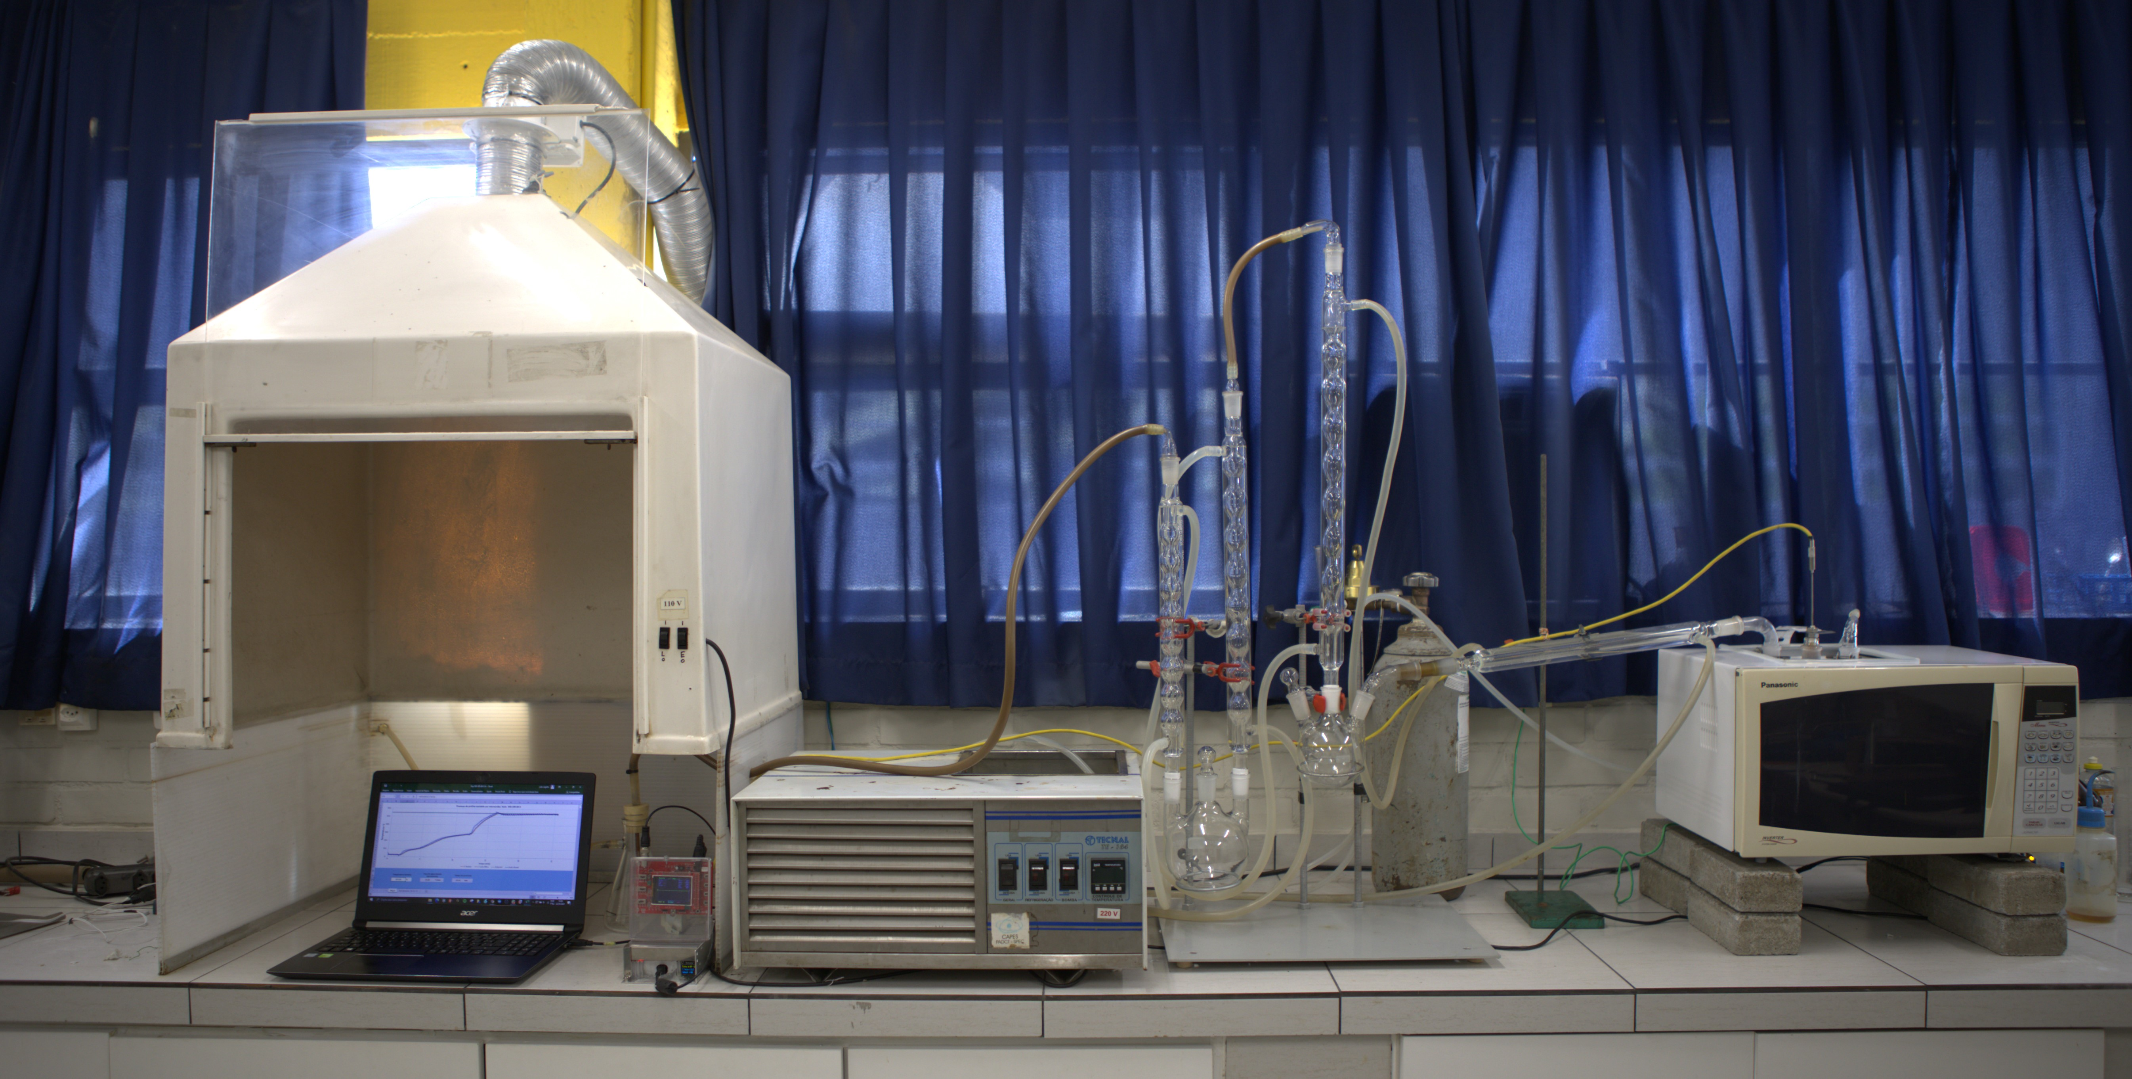
Figure 1: Overview of the microwave pyrolysis unit components.
2.3 Experimental procedure of MAP process
Pyrolysis was carried out using biomass with different moisture contents (13.2 ± 1.5 % and 3.1 ± 1.5 %). The process conditions were microwave power level of 100% (644.70 W), 60 g of SiC, and N₂ flow rate of 3 L/h. The applied pyrolysis time and sugarcane bagasse mass were 23 min and 30 g, respectively.
After the reaction vessel reached 450 °C, the microwave power was reduced to 20% by manually setting on the equipment control panel.

2.4 Fractions and analysis of the pyrolysis products
Fractions of the solid (biochar) products were determined by weighing the reactor before and after pyrolysis. The liquid fraction (bio-oil) collected in the round-bottom flask and adhered to condenser walls and pipes during the experiment was recovered by washing with dichloromethane. Afterward, the dichloromethane was removed by vacuum rotary evaporation, and the solvent masses were discounted from the liquid fractions. Finally, the gaseous fraction was determined by difference to 100 %.
The bio-oil compounds extracted with dichloromethane were identified using a QP-2010 GC-MS chromatograph (Shimadzu), equipped with a VF-5MS (95 % methyl- 5 % phenyl) polydimethyl siloxane capillary column (30 m, 0.25 mm i.d., 0.25 μm film thickness). Samples (1 µL) were injected in split mode (1:10) and run at 50 °C for 2 min. Then, the temperature was raised up to 280 °C at 5 °C min⁻¹, where it remained for additional 2 min. The ion source was kept at 200 °C and the interface at 280 °C. The components were analyzed by automatic peak integration using the GC-MS Solution software. A total of 60 major peaks, with a percentage abundance higher than 1 %, were integrated. Components with a similarity index lower than 80 % (“Mass Spectrometry Data Center, NIST 11”, n.d.) were not identified, but their percentage areas were considered for semiquantitative analysis.
The morphology of the solid fraction was characterized by Scanning Electron Microscopy (SEM), applying an accelerating potential in the 5 kV range for imaging. The solid fractions were metallized by Au/Pd sputtering and analyzed in a JEOL JSM-6010LA Scanning Electron Microscope available in the Laboratory for the Analysis of Rocks and Minerals (LAMIR) at Federal University of Paraná.

  - Results and Discussion
3.1 Temperature profile and fractions obtained from sugarcane bagasse with different moisture contents
Sugarcane bagasse with higher moisture content presented a lower heating rate. The profile observed in Figure 2 can be explained by the interaction of the electromagnetic field will all reaction components, including sugarcane bagasse fibers, moisture (water present in fibers) and the absorber. Indeed, the sample with a lower moisture content absorbed less microwave energy, which was mostly directed to the absorber. Thus, the heating time was longer, although the setpoint temperature was quickly reached. Other factors that led to differences in the biomass heating profile and pyrolysis performance were the latent heat of the water and the phase extension in the system, which may partially explain the differences in temperature profiles.

Figure 2: Temperature profiles under different biomass moisture conditions.
Figure 2 shows the temperature profiles for sugarcane bagasse with different moisture contents. The biomass with higher moisture had a heating rate to the setpoint (450 °C) of 30.14 °C/min and maximum temperature of 455.4 °C, while the lower moisture condition showed a heating rate of 32.50 °C/min, about 7.8 % higher, and maximum temperature at 458.9 °C.
The fractions obtained in this study are presented in Table 1. The solid fraction showed the lowest difference among them all. The liquid fraction, as expected, was lower for the lowest moisture condition, while the gaseous fraction was higher under this same condition. In the liquid fractions, a 10.1 p. p. (points percent) higher amount was observed for the sample which was higher in moisture. This amout is equivalent to the mass of water that was eliminated from the original sample.
Table 1: Pyrolysis fractions on a wet basis
Moisture (%) | Biomass input (g) | Solid fraction (%) | Liquid fraction (%) | Gas fraction (%)
13.2 | 30.0 | 28.8 | 47.7 | 23.5
3.1 | 30.0 | 25. | 37.6 | 36.5

To account for the presence of water, the pyrolysis data was recalculated and expressed on a dry basis (Table 2) and, by doing so, the difference reported above raised from 10.1 to 16.1 p. p.. The liquid fractions presented in Tables 1 and 2 yielded 47.7 % to 54.9 % for the higher moisture condition, while for the lower moisture condition, the variation was from 37.6 % to 38.8 %. This difference was solely due to the proper accounting of sample initial moisture content in our yield calculations.
Table 2: Pyrolysis fractions on a dry basis
Moisture (%) | Biomass input (g) | Biomass discounting moisture content (g) | Fraction
 |  |  | Solid (%) | Liquid (%) | Gas (%)
13.2 | 30.0 | 26.0 | 33.2 | 54.9 | 11.9
3.1 | 30.0 | 29.0 | 26.7 | 38.8 | 34.5

3.2 Characterization of the liquid fraction by GC-MS
In the characterization performed by GC-MS, there was a slight change in the distribution of pyrolysis products with a similarity index equal or above 80 % for experiments carried out with sugarcane bagasse with different moisture contents.
Table 3 shows the likely compounds present in the pyrolysis oil for each moisture condition. Compounds that are not identified in both moisture conditions are highlighted in green. Nearly 20% more compounds were identified under the highest moisture condition. Yet, the presence of moisture proved more influential over the heating profile and bio-oil yield than over the formation of different organic compounds.

Table 3: Relevant compounds identified in the pyrolysis bio-oil.
Moisture of 13.2 % |  |  | Moisture of 3.1 %
Retention time | Compound name |  | Retention time |  | Compound name
8.991 | Butanoic acid |  | 6.471 | 1,2-Dioxetane,3,4,4-trimethyl-3-methyl
9.911 | 2-Furanylmethoxy |  | 9.009 | 2,2-Dimethylpropoxy)
11.699 | Trimethylphenoxy |  | 9.919 | 2-Furanylmethoxy
14.819 | 3-Methylphenoxy |  | 11.699 | Trimethylphenoxy
17.123 | 2-Methoxyphenol |  | 14.823 | 3-Methylphenoxy
17.464 | 3-Ethylphenol |  | 16.660 | 2-Hexenoic acid
19.641 | 1,2-Benzenediol |  | 17.124 | 2-Methoxyphenol
19.790 | 2-Methoxy-5-methylphenol |  | 17.468 | 3-Ethylphenol
21.698 | 4-Methylcatechol |  | 19.644 | 1,2-Benzenediol
21.979 | 1,4-Cyclohexadiene |  | 19.790 | 2-Methoxy-5-methylphenol
22.159 | 2,6-Dimethoxyphenol |  | 21.704 | 4-Methylcatechol
26.042 | Benzaldehyde |  | 22.161 | 2,6-Dimethoxyphenol
26.616 | 2-Methoxy-4-(1-propenyl) phenoxy) |  | 23.594 | 2-Hydroxyphenethyl alcohol
 |  |  | 26.049 | Benzaldehyde
3.3 Surface analysis of the solid fraction
The solid fraction present in Figure 3 preserved the original features of sugarcane bagasse, presenting pores and an imprint of a fiber network on its surface. In the 13.2 % moisture condition, eruptions occurred that are represented by the red circle, which would enlarge if the process were carried out at a higher temperature than the one used in this study.
In the lower moisture condition (3.1 %), these eruptions are not visually observed. Therefore, higher moisture contents lead to eruptions that increase the biochar porosity; however, the way in which microwaves interact with water is determinant in generating pathways for the release of volatile components. Therefore, materials with a higher carbon content are formed, freeing up pore spaces and forming macro, meso, and micropores that contribute to the increased specific surface area of the resulting biochar (Yorgun and Yildiz, 2015).

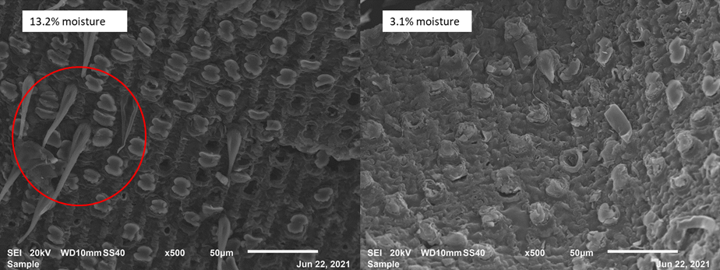
Figure 3: SEM at different moisture conditions and 500 x magnification
  - Conclusion
The influence of moisture on the microwave-assisted pyrolysis of sugarcane bagasse was demonstrated. The interaction of microwaves with water was evidenced by its effect on the reaction heating rate. Moisture did not cause a major influence in the formation of organic compounds that make up the liquid fraction; comparing the two conditions, this difference was around 20 % between the number of compounds in each moisture condition. When comparing the composition of liquid fractions derived from different moisture contents, the difference was 54.9 % and 38.8 % for the highest and lowest moisture conditions, respectively.
Microscopic analysis of the solid fraction (biochar) showed that the interaction of moisture with microwaves and its subsequent eruption from the internal part of the fibers collaborated with the increase material porosity and surface area.
Acknowledgments
This work has been supported by the following Brazilian research agency: CAPES and CNPq. The authors are also grateful to the support of the Laboratory for the Analysis of Rocks and Minerals (LAMIR/UFPR).
References
Abdul Aziz, S.M., Wahi, R., Ngaini, Z., Hamdan, S., 2013. Bio-oils from microwave pyrolysis of agricultural wastes. Fuel Processing Technology 106, 744–750. https://doi.org/10.1016/j.fuproc.2012.10.011
Garcia-Nunez, J.A., Pelaez-Samaniego, M.R., Garcia-Perez, M.E., Fonts, I., Abrego, J., Westerhof, R.J.M., Garcia-Perez, M., 2017. Historical Developments of Pyrolysis Reactors: A Review. Energy and Fuels. https://doi.org/10.1021/acs.energyfuels.7b00641
Kappe, C.O., 2004. Synthetic Methods Controlled Microwave Heating in Modern Organic Synthesis. Angew. Chem. Int. Ed 43, 6250–6284. https://doi.org/10.1002/anie.200400655
Luque, R., Menéndez, J.A., Arenillas, A., Cot, J., 2012. Microwave-assisted pyrolysis of biomass feedstocks: The way forward? Energy and Environmental Science. https://doi.org/10.1039/c1ee02450g
Mass Spectrometry Data Center, NIST [www Document], n.d. URL https://chemdata.nist.gov/ (accessed 3.19.22).
Wang, H., Male, J., Wang, Y., 2013. Recent advances in hydrotreating of pyrolysis bio-oil and its oxygen-containing model compounds. ACS Catalysis. https://doi.org/10.1021/cs400069z
Yorgun, S., Yildiz, D., 2015. Slow pyrolysis of paulownia wood: Effects of pyrolysis parameters on product yields and bio-oil characterization. Journal of Analytical and Applied Pyrolysis 114, 68–78. https://doi.org/10.1016/j.jaap.2015.05.003
Zhang, Y., Chen, P., Liu, S., Fan, L., Zhou, N., Min Min, M., Cheng, Y., Peng, P., Anderson, E., Wang, Y., Yiqin Wan, Y., Liu, Y., Li, B., Ruan, R., 2017. Microwave‐Assisted Pyrolysis of Biomass for Bio‐Oil Production. In (Ed.), Pyrolysis. IntechOpen. https://doi.org/10.5772/67442

