 CHEMICAL ENGINEERING TRANSACTIONS  VOL. 92, 2022 | A publication of  
The Italian Association
of Chemical Engineering
Online at www.cetjournal.it

Guest Editors: Rubens Maciel Filho, Eliseo Ranzi, Leonardo Tognotti
Copyright © 2022, AIDIC Servizi S.r.l.
ISBN 978-88-95608-90-7; ISSN 2283-9216

Bio compound to replace wood agglomerates produced with brewery malt waste
Danyele A Nakamura^{b}, Leonardo M Machado^{c}, Ghiovani Z Raniero^{c}, Antonio R G Monteiro^{c}, Fernando M da Silvaª, Claudia C F Monteiro^{ab}*
ª CIAUD, Research Centre for Architecture, Urbanism and Design, Lisbon School of Architecture, Universidade de Lisboa, Rua Sá Nogueira, Polo Universitário do Alto da Ajuda, 1349-063 Lisboa, Portugal
^{b} Department of Design, Universidade Estadual de Maringa, R Afonso Pena, 130, Cianorte, PR, Brazil
^{c} Post graduation program in Food Science, Universidade Estadual de Maringa, Av Colombo, 5790, Maringa, PR, Brazil
* ccfmonteiro@uem.br
The brewing industry annually produces nearly 200 billion litres, generating more than 15 million tons of malt residue. Most of this residue is used to generate energy for the industries' operation. However, a still significant part, estimated at more than 1.5 million tons, coming mainly from small and medium breweries, does not have a good destination. Given this context, this research aimed to develop a bio compound to replace conventional wood agglomerates made from brewing malt residue with pre-gelatinised corn and PVA glue. Bio compound with brewer's residue was made by following steps: pre-gelatinised corn was initially driven by extrusion in an IMBRA RX50, single screw extruder (INBRAMAQ, Ribeirão Preto, SP). Soon after extrusion, extruded was ground in a hammer mill with a smaller than 0.7 mm particle size. The pre-gelatinised was mixed with the brewer's residue, PVA glue, and water in proportions established in the experimental design and pressed in a hydraulic press at 40 kg/cm². Each sample was dried in an oven with air circulation at 70 °C for 24 hours. After the oven, the material was placed in a desiccator until the analysis. All treatments established in the experimental design were subjected to characterisation analyses: Mechanical resistance by Texture Analyzer TAXT2 Plus (Stable Micro Systems, England), density, moisture by AOAC methods, and Colour by Minolta Chroma Meter CR-400 colourimeter. With the analysis of the results, it was possible to identify that the material formed with the proportion 65:35 (residue / pre-gelatinised corn) plus 10 % of PVA presented better results in terms of mechanical resistance. The analysis of Colour and appearance of the material does not show significant variation in the results, and it was impossible to establish a better treatment for these characteristics. The data presented could conclude that the bio compound developed could be a good destination for this waste since it showed physical characteristics like conventional agglomerates, with the additional advantages of low cost and lower environmental impact due to no use of chemical components in its composition.

  - Introduction
Most particle boards are composed of recycled wood and urea-formaldehyde. It is currently used on a large scale for different applications in the market, such as furniture, construction materials and others. However, the emission of formaldehyde presents itself as a health risk and can lead to respiratory infections, irritation in the eyes and even cancer (Mirindi et al., 2021).
From problems such as these, there was a growing need to study new methods of material developments that would maintain the quality of what is commonly used, in an economically beneficial way, linked to the constant concern to reduce impacts on nature and society.
A new possibility that has been highlighted today is agro-industrial residues, mainly cereals. In addition to meeting different demands, this process was seen as valuing that by-product (Donner et al., 2020) that would be dropped.
Beer is popularly known and consumed in large quantities in the most diverse countries, presenting itself as the fifth most consumed beverage globally (Rachwal et al., 2020). In 2020, its world production reached approximately 1.82 billion hectoliters, where China, the United States, and Brazil stood out among the leading brewing countries (STATISTA, 2021). However, this high demand increased the generation of industrial waste.
The brewing process goes through malting, grinding, mashing, boiling, cooling, and fermentation (Kao, 2018). For every 100 litres of beer, about 20 kg of by-products are produced, in which malt bagasse stands out, equivalent to 85 % (Rachwal et al., 2020) of all solid waste generated during production, thus the primary residue of the brewing industry.
Most of this waste is currently used to generate energy for the industries' operation or animal feed (Amoriello and Ciccoritti, 2021). However, a significant part of by-products such as draff, yeast sediment, pot ale, and spent hops (NetRegs UK, 2019), coming mainly from small and medium-sized breweries, does not have a good destination, resulting in a tremendous environmental impact.
A small brewery can generate up to 453.5 kg of grain spent in its production process; this amount is enough to fill up to 20 barrels. In this context, according to Rachwal et al., 2020, the brewery industry generates enormous amounts of waste, the management of which is economically troublesome. However, their accumulation in the environment is an ecological issue as well. The increasing public concerns about environmental pollution have prompted the search for ways to reduce the production of industrial waste.
This problem instigated the development of reasonable solutions such as replacing conventional materials with bio compounds to collaborate with the environment through the reuse and recovery of industrial waste. The bio compound developed in its composition, binding agents that considered the environmental appeal through the pressing process. This method is recurrently used by industries and consists of filling the mass/powder homogeneously in a given mould, which then undergoes compaction through pressure, resulting in a part ready for extraction (Amorós, 2000).
Many studies on materials use binding agents that are harmful to nature or, when beneficial, at a high price. For example, polyvinyl acetate (PVA), with the formula C₄H6O₂, is used in various fields, whether for artisanal or industrial purposes. Its versatility, resistance quality, odourless ness and low environmental or health impact are factors that contribute to its high applicability. This binder provides high performance with an excellent cost-benefit and improves the material's properties, either in terms of aesthetics or increased water resistance (Kaboorani et al., 2015).
Another binding agent that also stands out for sustainable materials is pre-gelatinised corn. Starch has received significant attention due to its environmental benignity, easy fabrication, relative abundance, non-toxicity, and biodegradability. It is also used in various applications, including food, polymer, paper, textile, and biofuel productions (Amaraweera et al., 2021). Its primary raw material is corn, and this tends to grow significantly over time due to the diversity of benefits it provides to society.
According to Monteiro et al. (2021), to obtain a material using starch, it is necessary to use techniques to destroy the original semicrystalline structure of its granules, which can be done by a combination of mechanical energy and thermal energy. The resulting material is biodegradable and fully decomposes into non-toxic waste (Schlemmer et al., 2014). Thus, maise must undergo an extrusion process for its pre-gelatinisation and therefore act as a binding agent in the material. Pregelatinized corn starch has properties that favour homogenisation and thus its application.
From the analysis of the properties of the agglomerates, it is expected that the material developed present similar results. According to ANSI A208.1 (2009), Moisture content reaches a maximum of 10 %, Density range between 620-670 kg/m³, modulus of rupture (MOR) of 13.0 N/mm², modulus of elasticity (MOE) of 2,000 N /mm², Internal bond of 0.40 N/mm², Screw holding in the face with 900 N and 800 N in core and length-width ± 2.0 mm. Thickness swelling proves to be decisive for the dimensional stability of the material, in which the more significant the application of adhesive (resin), the greater the values ​​of the modulus of rupture (MOR) (Astari et al., 2018).
In the studies by Monteiro et al. (2021), biomaterials were developed with brewer's residue; however, the main limitation of the material was the mechanical resistance. In this context, this research aimed to create a biocomposite to replace conventional wood agglomerates made from wood residues. Brewing malt, PVA glue, and pre-gelatinised corn seek to obtain a material with good mechanical resistance while contributing to sustainable development applied to the most varied fields of industry.
  - Material and methods
This chapter present the methodologies used for material development and physical characterisation.
2.1 Materials
For obtaining ground and standardised beer residue, the used malt residue was supplied by a small local brewery (Maringa, PR, Brazil). After the mashing process of a pure malt lager, the resulting residue was dried in an oven with air circulation at 70 °C with air circulation for 48 hours. The grinding was done in a mill and separated into three different granulometry (3.5-6, 6-14, 14-28) and later stored in polypropylene bags until the moment of use.
To obtain the milled corn extrudate, corn grits provided by Nutrimilho (Maringa, PR, Brazil) was extruded according to Nakagawa et al. (2021) using IMBRA RX50 single screw equipment (INBRAMAQ, Ribeirão Preto, SP, Brazil) - 50 mm diameter and 200 mm length. The die plate had two holes of 3 mm diameter, and extrusion parameters were 20 A of motor amperage, the feed rate of 12 g/s and a screw speed of 90 rpm. Afterwards, the extrudates were ground, and the 60-80 mesh fraction was separated and later stored in polypropylene bags until use.

2.2 Bio compound production
The bio compound was made according to Monteiro et al. (2021), where beer residues, extruded ground corn, PVA glue, water in the proportions and granulometric shown in 2³ experimental design with three repetitions in central point. Extruded corn, beer residues, water and PVA glue, were manually stirred until a homogeneous mixture was obtained.
Subsequently, the mixed material added in a metallic cylinder with 15 cm in diameter and pressed by a hydraulic press at 7 tons for 300 seconds results in a 40 kg/cm² pressure. The materials were then transferred to an oven with air circulation at 70 °C for 24 hours. In the end, the samples were conditioned in a desiccator for 48 hours before analysis.

2.2.1 Experimental Design
The proportions of components (extruded corn, beer residue, water, and PVA glue) and Particle size of residue malt grounded were variated in eight treatments and a central point in triplicate. Table 1 shows the experimental design of bio compound production.
Table 1. Experimental design of the bio compound production
Treatment | Malt waste  (g) | Extruded maise (g) | PVA glue  (g) | Water  (g) | The particle size of malt waste (mash)
T1 | 85 | 15 | 0 | 30 | 14-28
T2 | 85 | 15 | 0 | 30 | 3.5 - 6
T3 | 85 | 15 | 10 | 20 | 14-28
T4 | 85 | 15 | 10 | 20 | 3.5 - 6
T5 | 65 | 35 | 0 | 30 | 14-28
T6 | 65 | 35 | 0 | 30 | 3.5 - 6
T7 | 65 | 35 | 10 | 20 | 14-28
T8 | 65 | 35 | 10 | 20 | 3.5 - 6
CP | 75 | 25 | 5 | 25 | Mixed 14-28 / 3.5 -6

2.3 Material characterisation
The sample was cut in specimens with 30 x 80 mm to material characterisation.

2.3.1 Density
Samples thickness was determined using a digital micrometre (0.001 mm resolution, Mitutoyo, Japan). Five points of each sample area were evaluated, and the volume was calculated with the average thickness with sample dimension. The mass of the sample was evaluated in an analytical balance.

2.3.2 Moisture content
Moisture content determination of the samples was carried out by AOAC (2005) methodology, in triplicate, using oven-dry at 105 °C.
2.3.3 Mechanical resistance
Tensile strength analysis was performed on Texture Analyzer TAXT2 Plus (Stable Micro Systems, England), according to Covino et al. (2015), where the samples were arranged horizontally on the platform using the 12 x 7 cm Probe Warner Bratzler (HDP / BS), at 50 kg maximum load, which breaks the sample like a guillotine. Ten repetitions were used with a pre-test and a test speed of 2.0 mm.s⁻¹ and a test speed of 1.0 mm.s⁻¹.

2.3.4 Colour
The Colour was evaluated using a Minolta Chroma Meter CR‐400 colourimeter with D65 illuminate as the reference, with readings in three-point each sample for each treatment. The CIELAB system expressed results with values of L *, a * and b * whose L * values. Values of L* vary from black (0) to white (100), values of a* range from green (-60) to red (+60) and b* values, from blue (-60) to yellow (+60).

2.3.5. Statistical Analysis
All data were treated statistically from the analysis of variance (ANOVA) with subsequent analysis of the Tukey tests' means at 5 % probability and correlation test. The statistical tests were made by software Sisvar 5.6 (Monteiro, 2021).
3. Results and discussion
The results obtained from the physical characteristics of the bio compounds developed are shown in Table 2. There was no significant difference between all treatments in the moisture analysis, which was expected since all were dried to constant weight in the process and later stored in the same conditions in a desiccator.
It was possible to observe that treatments with larger granulometry (T2, T4, T6, and T8) had a significantly higher performance than samples with finer granulometry (T1, T3, T5, and T7) concerning mechanical strength. Moreover, the central point treatment (CP) was in the middle. This behaviour was also observed concerning the density of these samples. These results are in line with the results found by Monteiro et al. (2021), highlighting that the resistance values ​​in the PVA glue treatments were significantly higher. This is since larger fibres form a more intertwined network, providing more excellent compaction and greater resistance to the set. Furthermore, the PVA glue could increase the resistance of this net. The values ​​found are compatible with Astari et al. (2018) for clusters.
The use of PVA glue increased mechanical strength in samples with larger granulometry, not being identified the same impact in samples with finer granulometry. This is mainly because the PVA glue helps join the long fibres of the high-grained material.
Table 2. Physical properties of the bio compound
Treatment | Density  (kg/m³) * 10⁻⁶ | Moisture  (%) | Mechanical resistance  (N)
T1 | 0.85c | 2.66a | 57.31d
T2 | 0.93a | 2.45a | 204.76c
T3 | 0.85c | 2.51a | 57.31d
T4 | 0.92a | 3.14a | 313.71bc
T5 | 0.86bc | 2.51a | 83.88d
T6 | 0.94a | 2.8a | 429.48ab
T7 | 0.79d | 2.77a | 56.31d
T8 | 0.93a | 3.10a | 549.69a
CP | 0.91ab | 2.62a | 324.06b

Means with different letters in the same column are significantly different (P ≤ 0.05).

Table 3 presents the results of the colour analysis of the biomaterials developed. It was possible to observe that both the composition and granulometry difference did not significantly change the colour parameters of the developed material.
Figure 1 shows photos of materials T1, T8, and CP made with fine, coarse and mixed granulometry, respectively. No pictures of the other materials were presented since only the granulometry affected the visual aspect of the samples.

Table 3. Colour of bio compound
Treatment |  | Heading 3
 | L | a | b
T1 | 47.58 (0.12) | -0.82 (0.03) | 27.31 (0.56)
T2 | 48.01 (0.35) | 0.04 (0.03) | 26.73 (0.47)
T3 | 48.35 (0.32) | -0.72 (0.12) | 27.09 (0.57)
T4 | 49.25 (0.16) | 1.3 (0.08) | 26.89 (0.54)
T5 | 47.92 (0.43) | 1.79 (0.11) | 26.9 (0.87)
T6 | 50.67 (1.03) | 0.9 (0.20) | 27.16 (0.34)
T7 | 49.29 (0.27) | -0.44 (0.06) | 27.15 (0.09)
CP | 49.01 (0.18) | -0.51 (0.02) | 26.8 (0.37)
Mean (standard deviation)

Given the colour results and the images of the materials obtained, as in Monteiro et al. (2019), it was impossible to establish materials with a better appearance, so the mechanical strength factor can effectively be the differential between them the treatments.

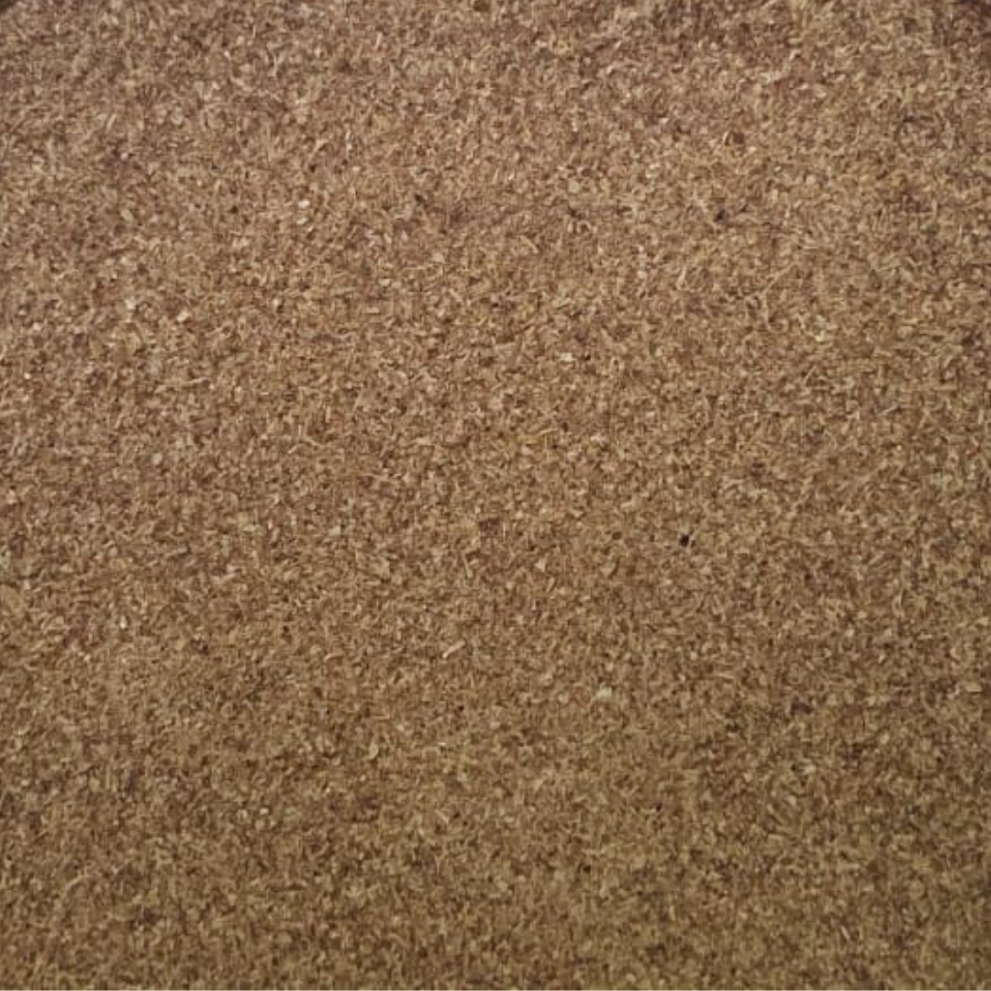 | 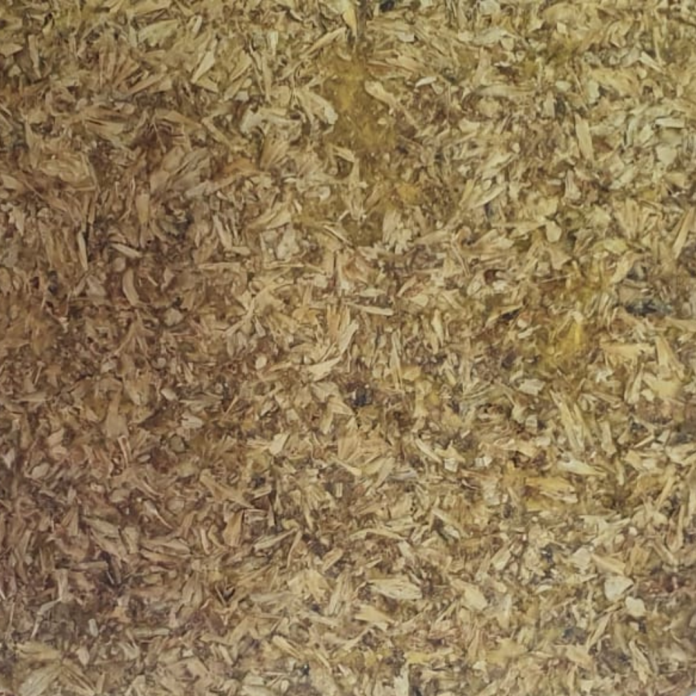 | 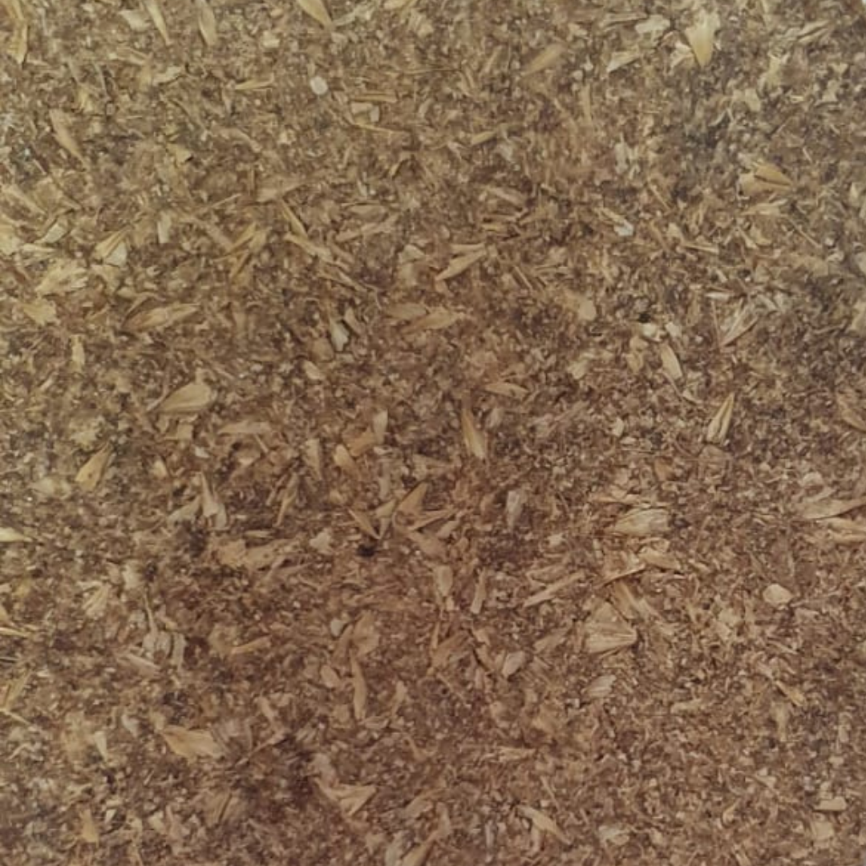
T1 | T8 | CP
Figure 1: Photos of the bio compounds
4. Conclusions
Given the results found, it was possible to conclude that the sample with the highest proportion of corn extrudate and PVA glue showed better resistance. However, when comparing the treatment with the highest ratio of the extrudate and without PVA glue, the one with the lowest proportion and with PVA glue achieved similar performance.
In this context, it was possible to affirm that the treatment with 35 g of corn extrudate, 65 g of malt residue, and 10 g of PVA glue had the best performance. Still, future research should optimise these two factors that presented a synergistic effect, aiming to obtain results even more expressive with the least amount of resources possible.
Acknowledgements
This work is financed by national funds through FCT - Fundação para a Ciência e a Tecnologia, I.P., under the Strategic Project with the references UIDB/04008/2020; and UIDP/04008/2020 and by Conselho Nacional de Desenvolvimento Científico e Tecnológico. Brazil (CNPq project n 303597/2018-6), CAPES and Fundação Araucária / Paraná.

References
Amaraweera SM., Gunathilake C., Gunawardene OHP., 2021, Development of Starch-Based Materials Using Current Modification Techniques and Their Applications: A Review. Molecules. 26(22):6880. DOI: 10.3390/molecules26226880.
Amoriello, T., Ciccoritti, R., 2021, Sustainability: Recovery and Reuse of Brewing-Derived By-Products. Sustainability, 13, 2355. DOI: 10.3390/su13042355.
Amorós, J. L., 2000, A Operação de prensagem: considerações técnicas e sua aplicação industrial parte I : o preenchimento das cavidades do molde. Cerâmica Industrial, v. 5, n. 5, p. 23–28 (in Portuguese)
ANSI - American National Standard. A208.1, 2009, Particleboard. Gaithersburg.
Astari, L., Prasetiyo, K., Suryanegara, L., 2018, Properties of Particleboard Made from Wood Waste with Various Size. IOP Conference Series: Earth and Environmental Science. 166. 012004. DOI: 10.1088/1755-1315/166/1/012004.
Covino, R., Monteiro, A. R. G., Scapim, M. R. S., Marques, D. R., Benossi, L., Monteiro, C. C. F. (2015). Manufacturing cereal bars with high nutritional value through experimental design. Acta Scientiarum. Technology, 37(1), 149-154. <doi.org/10.4025/actascitechnol.v37i1.20732>
Donner, M., Gohier, R., de Vries, H., 2020, A new circular business model typology for creating value from agro-waste, Science of The Total Environment, Vol 716, Montpellier, FR. DOI: 10.1016/j.scitotenv.2020.137065.
Kaboorani A. Riedl B, 2015, Mechanical performance of polyvinyl acetate (PVA)-based biocomposites. Biocomposites, Woodhead Publishing Series in Composites Science and Engineering, Québec, CA, 347-364. DOI: 10.1016/B978-1-78242-373-7.00009-3.
Kao, T., 2018, Health Potential for Beer Brewing Byproducts. Current Topics on Superfoods, Naofumi Shiomi, IntechOpen. DOI: 10.5772/intechopen.76126.
Mirindi, D., Onchiri, R.O., Thuo, J., 2021, Physico-Mechanical Properties of Particleboards Produced from Macadamia Nutshell and Gum Arabic. Applied sciences, 11, 23, 11138. DOI: 10.3390/app112311138.
Monteiro C.C.F., Malavazi B., Mendes M.P., Paschoarelli L.C., Clifford M., 2019, Biomaterial based on brewing waste and vegetable resin: Characterization and application in product design, Chemical Engineering Transactions, 75, pp. 475–480.
Monteiro C.C.F., Monteiro A.R.G., da Silva F.M., 2020, Product Development with Biopolymers Made from Brewers' Spent Grain (BSG) and Carboxymethylcellulose (CMC), Using 3D Food Printer. In: Mrugalska B., Trzcielinski S., Karwowski W., Di Nicolantonio M., Rossi E. (eds) Advances in Manufacturing, Production Management and Process Control. AHFE 2020. Advances in Intelligent Systems and Computing, vol 1216. Springer, Cham. DOI: 10.1007/978-3-030-51981-0_17
Nakagawa A., Raniero G.Z., Berwig K.P., Monteiro C.C., Sousa I., Monteiro A.R., 2021, Waxy Starch to Replace Vegetable Fat in Extruded Snack Aromatisation and Different Salt Delivery Way to Decrease Sodium Intake, Chemical Engineering Transactions, 87, 271-276 DOI:10.3303/CET2187046.
Rachwał, K., Waśko, A., Gustaw, K., Polak-Berecka, M., 2020, Utilization of brewery wastes in food industry. PeerJ, 8, p.e 9427. DOI: 10.7717/peerj.9427.
Schlemmer, D. A., Andreani, L. Valadares, L. F., 2014, Biomateriais: Polímeros e Compósitos, Comun. Técnico, vol. 10, pp. 1–9. (in Portuguese)
STATISTA, 2021, Beer production worldwide from 1998 to 2020: in billion hectoliters. www.statista.com/statistics/270275/worldwide-beer-production/ accessed 27.10.2021.

