CHEMICAL ENGINEERING TRANSACTIONS  VOL. 92, 2022 | A publication of
The Italian Association
of Chemical Engineering
Online at www.cetjournal.it

Guest Editors: Rubens Maciel Filho, Eliseo Ranzi, Leonardo Tognotti
Copyright © 2022, AIDIC Servizi S.r.l.
ISBN 978-88-95608-90-7; ISSN 2283-9216

Strategies to Improve Quality and Yield of Pyrolysis Bio-oils
Paola Brachiª, Renata Migliaccio^{a*}, Elvis T. Ganda^{b}, Massimo Urciuoloª, Giovanna Ruoppoloª, Antonio Coppolaª, Fabrizio Scala^{b}, Piero Salatino^{b}
ªIstituto di Scienze e Tecnologie per l’Energia e la Mobilità Sostenibili – Consiglio Nazionale delle Ricerche, Piazzale V. Tecchio 80, 80125 Napoli, Italy
^{b}Dipartimento di Ingegneria Chimica, dei Materiali e della Produzione Industriale - Università degli Studi di Napoli Federico II, Piazzale V. Tecchio 80, 80125 Napoli, Italy
* renata.migliaccio@stems.cnr.it
Crude bio-oil obtained from fast pyrolysis of biomass and wastes is typically characterised by the presence of high levels of oxygenated compounds, which are mainly responsible for its unfavourable characteristics (e.g., low heating value, high acidity, and poor storage stability). In order to overcome this drawback and favourably produce drop-in fuels, the fast pyrolysis of olive stone (OS), has been studied by giving particular attention to the exploration of operating conditions (i.e. pyrolysis temperature) and strategies (i.e. catalytic pyrolysis and co-pyrolysis) suitable to promote efficient de-oxygenation of bio-oils and improve the quality of the product streams. Steady state fast pyrolysis tests were performed in a bench scale fluidized bed reactor (gas residence time ~1s). Pyrolysis tests were carried out at 500 °C and 600 °C by using either inert sand or γ-alumina catalyst as bed material. Outcomes from the non-catalytic and the catalytic co-pyrolysis of low-density polyethylene (LDPE) and OS (plastic-to-biomass ratio of 20/80) at two different temperatures (500 and 600 °C) are also presented. Preliminary findings highlight that the co-processing of LDPE and OS under non-catalytic conditions stands out for the formation of long-chain aliphatic hydrocarbons in the form of both liquid paraffins and wax deposits, which are well-known to be the primary products evolved from the pyrolysis of polyolefins. The addition of γ-alumina catalyst significantly affects both the distribution and the quality of the pyrolytic products (char, bio-oils, and gas). Under catalytic co-pyrolysis conditions, a marked reduction in the yield of bio-liquid is observed, compensated by a remarkable improvement in its quality, particularly in terms of the formation of light mono-aromatics and a marked decrease in the total amount of the oxygenated compounds. On the downside, however, a significant increase in the production of polycyclic aromatic hydrocarbons (PAHs) is detected. Remarkable benefits are also detected by increasing the co-pyrolysis temperature to 600 °C, particularly in terms of content of oxygenated compounds in the bio-oils, as well as in terms of PAHs and water formation, which decreased considerably. Altogether, preliminary findings of this study suggest that further research efforts are required in order to improve the process performance, for example by optimizing the operating conditions as well as the physicochemical properties of catalysts.

  - Introduction
The rapid increase in waste production coupled with the continuous growth in demand for sustainable carbon-based fuels and chemicals has fostered renewed interest in resources recovery through waste processing (Uzoejinwa et al, 2018). In this context, residual biomass as a renewable resource is expected to play a central role in the decarbonization path, in line with sustainability goals (Hassan S. S.et al., 2019). Among the currently available thermochemical conversion processes, fast pyrolysis offers a suitable option for the production of liquid fuels (bio-oils) and chemicals as well as energy from biomass (Huber et al., 2006). On the downside, however, the bio-crude recovered from biomass valorization is of poor quality, due to high acidity, low thermal stability, low calorific value, high viscosity, mostly related to large oxygen content in the form of acids, ketones, alcohols, and aldehydes, which are mainly responsible for its unfavorable characteristics (Agblevor et al., 2016). Accordingly, significant research efforts have been conducted over the past decades, pursuing the objective of finding operating conditions (i.e., pyrolysis temperature) and strategies (i.e., catalytic pyrolysis and co-pyrolysis) suitable to produce fuels and chemicals that are functionally equivalent to petroleum fuels, hence fully compatible with existing petroleum infrastructure (Agblevor et al., 2010). Catalytic pyrolysis relies on use of different catalytic materials (i.e., γ-alumina, zeolites, metal oxides, etc.) and reactor configurations (i.e., in-situ vs. ex-situ) to upgrade the quality of bio-oil. The presence of catalyst promotes dehydration, decarboxylation, decarbonylation reactions, which consequently improves the quality of bio-oil (Xue and Bai, 2018). The success of catalytic pyrolysis is, however, partly hampered by the intrinsic biomass properties, in particular the high oxygen content and the hydrogen deficiency, which typically results in low hydrocarbon yields and catalytic coke formation (Xue and Bai, 2018). In addition, the hydrogen-deficient nature of biomass can promote the hydrogen transfer reactions, resulting in the serious coking of catalysts during catalytic fast pyrolysis of biomass (Zheng et al., 2017). In order to maximize aromatic yield while minimizing coke formation, co-catalytic fast pyrolysis of biomass with hydrogen-rich plastic materials has been explored by several researchers (Ahmed et al., 2020), even though further research is required to provide evidence of its effectiveness and feasibility (Pinto et al, 2018), particularly when the fluidized bed technology is adopted. This approach is more economical than other conventional upgrading methods for pyrolysis oil (e.g., hydrotreatment and esterification, etc.) as they do not require any solvent or addition of hydrogen. During co-pyrolysis, the mutual interactions of the two feedstocks result in beneficial synergistic effects that are ascribed to reactions taking place during both the devolatilization and condensation phases as reported in the literature (Gunasee et al., 2017). Even though the interpretation of detailed mechanism underlying co-pyrolysis is still controversial, the following statements are generally agreed upon: (i) interaction among volatile species is essentially of radical nature; (ii) lignocellulosic-derived char catalyzes the decomposition of plastics; (iii) plastics donate hydrogen and stabilize some of the biomass-derived intermediates; and (iv) pyrolytic water may catalyze the cracking of heavy volatiles (H. Hassan et al., 2019). Catalytic co-pyrolysis of biomass and plastic feedstock has gained increased popularity in the last decades as a promising route to enhance hydrocarbon-rich bio-liquid production (Zhang et al., 2014). Improved quality of bio-oils by reduction of oxygenated compounds may effectively be accomplished by optimal choice of catalysts and of process temperature. In the present study, the potential for production of high quality bio-oil from olive stone (OS), a residual biomass characteristic of the Mediterranean regions, has been preliminary assessed in experiments carried out with a bench scale fluidized bed reactor under different process conditions. Fast pyrolysis has been carried out at 500 °C and 600 °C by using either inert sand or a γ-alumina catalyst as bed material. The purely thermal (non-catalytic) and catalytic co-pyrolysis of OS with low-density polyethylene (LDPE) at two different temperatures (500 °C and 600 °C) were also investigated at a plastic-to-biomass ratio of 20/80. LDPE was selected as a representative surrogate of the plastics materials commonly found in municipal solid wastes (MSW).

  - Experimental section
    - Materials and pre-treatment
The OS samples used in the present study were provided by an Italian olive oil producer as residual waste material in the form of a granular solid with a diameter of 5 mm. The LDPE was instead purchased from Sigma-Aldrich. Both the OS and LDPE samples were ground using a batch rotor mill (IKA MF 10 Basic mill using a 1 mm mesh sieve) to obtain a particle size less than 1mm. Liquid nitrogen was used for plastic milling to reduce the possibility of overheating and/or melting. Finally, the commercial γ-alumina spheres catalysts of 1mm in size were kindly provided by from SASOL chemical ltd.
Raw OS was characterized in terms of cellulose, hemicellulose, and lignin content according to the procedure described in (Sluiter et al., 2012) yielding the following macro-component fractional content: hemicellulose ~18.8 %, cellulose ~ 28.4 %, lignin ~ 40.11 %. Ultimate analysis was performed on both olive stone and LDPE samples using a CHN 628 LECO analyzer and a TGA 701 LECO thermogravimetric analyzer, respectively. An isoperibolic oxygen bomb calorimeter (Parr 6200 Calorimeter) was instead used to measure the calorific values of samples. All the tests were performed in triplicates at least with the data reported as averaged values in Table 1.

    - Experimental apparatus and analytical methods
Steady state pyrolysis tests were performed in a bench scale fluidized bed reactor with a gas residence time of ~1 s and fluidization velocity of 0.7 m/s. The schematic representation of the experimental apparatus used for tests is shown in Figure 1. In more details, the fluidized bed reactor consists of an electrically heated tubular reactor (41 mm inner diameter, 700 mm height) resulting from the assembly of a windbox/pre-heater, a gas distributor, and the fluidization column. The gas flow leaving the reactor pass through a stainless steel filter (hot filtration at 300 °C) and then is split into three sub-streams. The first one is sent to a set of on-line ABB gas analyzers to continuously monitor the concentration of O₂, CO, CO₂, CH_{4,} and H₂. The second sub-stream passes through a chilled impinger train (1 flask at room temperature, and 6 refrigerated flasks at a temperature of ‐12 °C) in order to condense the vapours to liquid pyrolysis oils. The third sub-stream is sent to the vent. Permanent gases leaving the condensation train were analyzed by means of a micro gas chromatograph (micro-GC) to measure the concentration of light hydrocarbons (C₁–C₆), in addition to CO, CO₂, CH_{4,} and H₂. The collected pyrolytic liquids were characterized offline using an Agilent 7890A GC equipped with MS 5975C-VLMSD (GC-MS). Chromatographic peaks were identified using the NIST 11 mass spectral data library, whereas a semi-quantitative approach was adopted to determine the relative content of each bio-oil component. Water concentration in bio-oil was measured by using a Mettler Toledo V20 Karl Fischer volumetric titrator. Proximate and ultimate analyses of residual char and elutriated fine particles were also carried out.

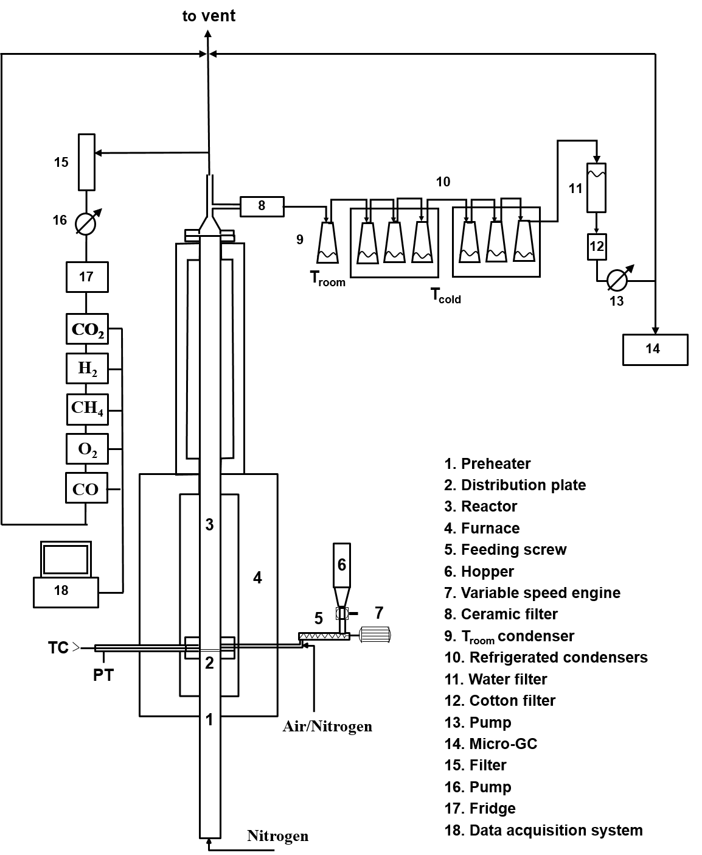
Figure 1: Schematic of the experimental apparatus
3. Results and discussion
3.1 Feedstock characterization
Ultimate and proximate analyses as well as calorific values of the feedstocks used in this study are reported in Table 1.
Table 1: Ultimate and proximate analyses of biomass and plastics.
 |  | OS | LDPE
Moisture (%wt., ar) |  | 14.0 | -
Proximate Analysis (%wt., db) | Ash | 0.1 | -
 | Fixed Carbon | 21.4 | -
 | Volatile matter | 78.5 | 100.0
Ultimate Analysis (%wt., daf) | C | 48.4 | 85.7
 | H | 5.9 | 14.3
 | N | 0.3 | -
 | O* | 45.4 | -
* oxygen content calculated by difference
HHV(MJ/kg, db) |  | 20.2 | 46.1

3.2 Product yields
Table 2 reports the distribution of products generated in pyrolysis and co-pyrolysis experiments performed at 500 and 600 °C under catalytic and non-catalytic conditions. Results from thermal pyrolysis of pure OS at 500 °C and 600 °C are also shown for comparison. Compared with results of the reference case (Test 1), co-processing with a hydrogen-rich plastic material (Test 2), addition of γ-alumina catalyst (Test 4), and increase of pyrolysis temperature (Test 5), all result in a decrease of the oil yield. Only in Test 2 (co-pyrolysis) the decrease of bio-oil yield is associated with a significant decrease in the water content. Water yield in the presence of the catalyst (Test 4) and for purely thermal pyrolysis performed at the higher temperature of 600 °C (Test 5) is almost twice the yield observed in the base case (Test 1). When the intended measures for improved bio-oil are used jointly, as is the case of Test 3 (catalytic co-pyrolysis) and Test 6 (co-pyrolysis at 600 °C), it appears that better performances are obtained when co-pyrolysis is performed at high temperature under non-catalytic conditions. In fact, while in the presence of the catalyst (Test 6) there was a remarkable decrease in the yield of bio-oils (by 87 %) and an equally remarkable increase in the yield of water (by 175 %), operation at a higher temperature without catalyst (Test 6) brought about a remarkable decrease in the water yield (by 89 %) with only a slight reduction in the oil yield (by 16 %). As regards the solid and gaseous pyrolytic by-products, no noteworthy phenomena are observed. When analyzing alternative operating conditions with respect to the base-case Test 1, the following statements hold: i) co-processing of OS with hydrogen-rich plastic material (Test 2) favorably lead to the decrease in both the solid (by 17 %) and the gaseous (by 42 %) yields; ii) catalyst addition (Test 4) results in an undesirable increase in the yield of both solid (by 40 %) and gaseous (by 13 %) by-products; and iii) the rise of the operating temperature (Test 5) results in a significant reduction of the solid yield (by 38 %), which is unfavorably coupled with the rise of the yield of pyrolytic gases (by 18 %). When the intended measures for improved bio-oil are used jointly (Test 3 and 6), increased formation of the pyrolysis by-products is observed, except for a slight decrease in the solid yield in the case of co-pyrolysis at 600 °C (Test 6). It is worth noting that only a few studies are available on co-pyrolysis of waste plastic and solid biomass in fluidized-bed reactors (Wang et al., 2021), most of which provide preliminary test results under non-optimized operating conditions. Careful analysis of results in the light of chemical reaction engineering and industrial catalysis principles and criteria indicate that there is ample space for improvement by optimizing the physicochemical properties of the catalysts, as well as the operating conditions (e.g., pyrolysis temperature, biomass to LDPE ratio, feedstock to catalyst ratio, volatiles residence time, gas-solid contact time, gas flow pattern) of the pyrolytic converter, so as to take full advantage of the superior performance of fluidized bed reactors for the specific purpose. The upgrading of the condensation system is also required to ensure more effective recovery of the liquid products and, hence, to improve mass balance closures.
Table 2: Product yield distribution
Test No. | Test operating conditions:  feedstock/bed material/temperature (°C) | Gas yield (%wt.) | Oil yield (%wt.) | Solid yield (%wt.) | Water yield (%wt.)
Test 1 | OS/sand/500 | 18.3 | 41.0 | 12.8 | 10.4
Test 2 | OS-LDPE/sand/500 | 10.6 | 37.9 | 10.6 | 2.2
Test 3 | OS-LDPE/γ-alumina/500 | 22.6 | 5.4 | 22.7 | 28.6
Test 4 | OS/γ-alumina/500 | 20.8 | 16.4 | 17.9 | 20.7
Test 5 | OS/sand/600 | 21.7 | 24.6 | 8.0 | 20.9
Test 6 | OS-LDPE/sand/600 | 25.8 | 34.4 | 7.3 | 1.2

3.3 Product characterization
The semi-quantitative chemical composition of the collected bio-liquids as determined using GC-MS is reported in Figure 2. It is worth noting that the formation of wax deposits in the collection flasks took place during co-pyrolysis tests (Test 2, 3, and 6), to a greater extent in the test performed under non-catalytic conditions at the lower temperature level (Test 2). The more severe operating condition of Test 6, instead, resulted in a liquid product characterized by the presence of a smaller amount of wax deposits but which apparently looked oilier, most likely due to catalytic cracking of waxes into lighter aliphatic hydrocarbons. Dichloromethane was used to solubilize the condensed materials for subsequent analyses. However, they were only partly solubilized by the solvent. For this reason, the oily liquid fraction was further separated from the residual waxy solid fraction by filtration using hydrophobic PTFE Millipore filters (0.45 µm pore size and 47 mm diameter membrane).
Results indicate that, under the selected operating conditions and with the present design of the fluidized bed converter, both the addition of the catalyst (Test 4) and the temperature rise to 600 °C (Test 5) are not effective in accomplishing de-oxygenation of bio-liquids from fast pyrolysis of OS. In fact, almost all the characteristic decomposition products found in bio-liquids collected from Test 1 (reference case) were also detected in the liquids from Test 4 and Test 5, with the exception of guaiacols which are degraded to alkyl phenols at 600 °C (Test 5).
Improvements in terms of smaller content of oxygenated compounds are not detected even when co-processing LDPE with OS under non-catalytic conditions at 500 °C (Test 2). The bio-liquids obtained in Test 2, in fact, exhibit the presence of both aliphatic hydrocarbons, which are characteristic of the pyrolysis of plastics, and oxygenated compounds, including phenolic compounds (guaiacols, syringols, and alkyl phenols), furans, organic acid, aldehydes, and ketones, derived from the decomposition of pure OS (Test 1). Bio-liquids collected during non-catalytic pyrolysis of OS (Test 1) and non-catalytic co-pyrolysis of OS and LDPE (Test 2) display similar compositions and almost the same content of oxygenated compounds. On the other hand, the complexity of bio-liquids from co-pyrolysis experiments is appreciably reduced by the addition of γ-alumina (Tests 3), which contributed to drastically reducing oxygenated species derived from OS decomposition. When shifting from non-catalytic to catalytic co-pyrolysis conditions, the content of the oxygenated compounds in bio-liquids was effectively reduced from 60.5 % to 14.3 %, as a consequence of complete degradation of aldehydes, furans and sugars coupled and of a net reduction in the content of ketones, organic acids and guaiacols compared to the non-catalytic tests. A slight increase in the content of alkyl phenols is also detected. This finding can be attributed to the mesoporous nature of γ-alumina, which allows also much bulkier oxygenated lignin derivatives to be deoxygenated. In addition, it results that pyrolytic oils produced in the presence of the γ-alumina catalyst (Tests 3 and 4) are highly aromatized, in the form of both mono- and polyaromatics, such as o-xylene (in trace), benzene derivatives, and biphenyl. The presence of a high concentration of polycyclic aromatic hydrocarbons (PAHs), mostly naphthalene derivatives, was detected especially in the case of catalytic co-pyrolysis tests (Test 3), and to a lesser extent when OS is processed alone in the presence of the catalyst (Test 4).

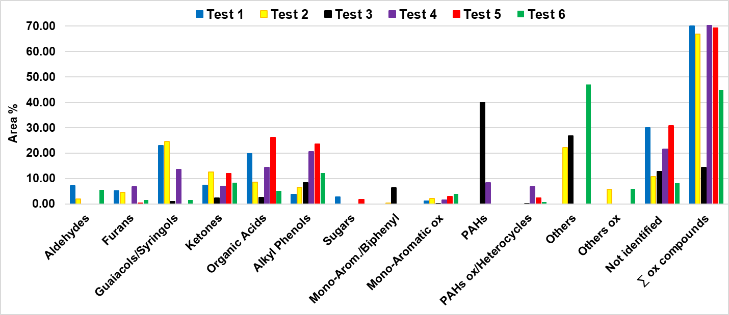
Figure 2: Semi-quantitative composition by GC-MS analysis of bio-liquids
Excessive PAHs content in the pyrolysis oils resulting from deoxygenation of primary pyrolysis products calls for careful optimization of conversion conditions, so as to favour conversion to the far more valuable mono-aromatic hydrocarbons (Li et al., 2015). In that regard, it is worth noting that significant, albeit preliminary, benefits were obtained by rising co-pyrolysis temperature to 600 °C. In this case, in addition to favorable reduction in the content of oxygenated compounds, from 60.5 % in the case of non-catalytic co-pyrolysis test at 500 °C (Test 2) to 44.8 % in the case of non-catalytic co-pyrolysis test at 600 °C (Test 6), a small production of PAHs (0.8 %) was detected. Indeed, the higher operating temperature of 600 °C favored a reduction in the content of furans, guaiacols/syringols, ketones, and organic acids, compared to the co-pyrolysis treatment performed at 500 °C with a vanishingly small production of PAHs.
When considering pyrolysis by-products, it is found that char collected during the non-catalytic co-pyrolysis of OS and LDPE (Test 2) exhibits a larger H/C ratio as compared with that generated by non-catalytic pyrolysis of OS alone (Test 1). This finding suggests the occurrence of some beneficial synergetic effect during the co-processing of biomass and plastics also as regard in the formation of char. The same beneficial synergy, however, could not be found when co-processing OS and LDPE in the presence of the catalyst (Test 3). In fact, in the last case, ultimate analysis (not reported) shows that the char is characterized by a H/C ratio similar to that of the char produced in Test 1 (reference case), hence smaller than that in Test 2 (non-catalytic co-pyrolysis).

Conclusions
The present study reports the results of preliminary pyrolysis and co-pyrolysis tests (80% Olive Stone and 20% LDPE) performed under both catalytic (γ-alumina catalyst) and non-catalytic conditions at two different temperature levels (i.e., 500 and 600 °C). Specifically, the positive effects and the drawbacks that the above alternative processing conditions, aimed at improving the quality of the bio-oil by reducing the content of oxygenated compounds, exert on the yield and composition of produced bio-liquids are discussed.
The experimental results indicate that neither the addition of an acidic catalyst (γ-alumina) nor increasing the temperature to 600 °C favourably affect the distribution and the quality of pyrolytic products from fast pyrolysis of OS. In fact, poor de-oxygenation of the bio-oil is observed, together with a substantial reduction in the bio-oil yield. Likewise, no remarkable benefits are detected following the addition of LDPE to OS under non catalytic conditions. Indeed, the bio-oils produced through non-catalytic co-pyrolysis have approximately the same content of oxygenates as those from fast pyrolysis of OS alone. Instead, an interesting improvement in the quality of bio-liquid is achieved during co-pyrolysis tests performed in the presence of the γ-alumina catalysts, particularly in terms of trace formation of mono-aromatic compounds (such as benzene derivatives and o-xylene) as well as a marked decrease in formation of the oxygenated compounds, by a factor of nearly 80 % when shifting from non-catalytic to catalytic co-pyrolysis. On the downside, however, a significant increase in the production of PAHs was detected. This drawback could be overcome by co-processing OS and LDPE at a higher temperature level (600 °C). A significant reduction in the production of PAHs (by 98 % moving from Test 3 to Test 6), together with a satisfactory decrease in the yield of oxygenated compounds (by 33 %) and a decrease in the water content of bio-liquids (by 44 %) was recorded in this case, compared to co-pyrolysis tests carried out at 500 °C (Test 2). Altogether, these preliminary findings show the track along which careful application of chemical reaction engineering and industrial catalysis principles and criteria must be applied in order to improve the performance of pyrolysis/co-pyrolysis processes. Optimization of pyrolysis temperature, biomass to LDPE ratio, feedstock to catalyst ratio, volatiles residence time, solid-gas contact time, physicochemical properties of catalysts (specifically, pore size distribution and acidic site strength) as well as reconsideration of design and operational conditions of the fluidized bed converter and the condensation system, will be undertaken as further steps of the investigation.
Acknowledgments
This study has been carried out in the frame of the project PON ARS01_00985: Biofeedstock: Development of Integrated Technological Platforms for Residual Biomass Exploitation, funded by the Italian Ministry for University and Research. E.T.G. acknowledges a grant from ENI for a PhD position at Università degli Studi di Napoli Federico II as recipient of the ENI Award Young Talents from Africa 2018.
References
Agblevor F. A., Elliott D. C., Santosa D. M., Olarte M. V., Burton S. D., Swita M., Beis S. H., Christian K., and Sargent B., 2016, Red Mud Catalytic Pyrolysis of Pinyon Juniper and Single-Stage Hydrotreatment of Oils, Energy & Fuels, 30, 7947-7958.
Agblevor F. A., Mante O., Abdoulmoumine N., and McClung R., 2010, Production of Stable Biomass Pyrolysis Oils Using Fractional Catalytic Pyrolysis, Energy & Fuels, 24, 4087-4089.
Ahmed M.H.M., Batalha N., Mahmudul H.M.D., Perkins G., and Konarova M., 2020, A review on advanced catalytic co-pyrolysis of biomass and hydrogen-rich feedstock: Insights into synergistic effect, catalyst development and reaction mechanism, Bioresource Technology, 310, 123457.
Gunasee S. D., Danon B., Görgens J. F., and Mohee R., 2017, Co-pyrolysis of LDPE and cellulose: Synergies during devolatilization and condensation, Journal of Analytical and Applied Pyrolysis, 126, 307-314.
Hassan S. S., Williams G. A., and Jaiswal A. K., 2019, Lignocellulosic Biorefineries in Europe: Current State and Prospects, Trends in Biotechnology, 37, 231-234.
Hassan H., Lim J. K., and Hameed B. H., 2019, Catalytic co-pyrolysis of sugarcane bagasse and waste high-density polyethylene over faujasite-type zeolite, Bioresource Technology, 284, 406-414.
Huber G. W., Iborra S., and Corma A., 2006, Synthesis of Transportation Fuels from Biomass: Chemistry, Catalysts, and Engineering, Chemical Reviews, 106 (9), 4044-4098.
Li J., Yu Y., Li X., Wang W., Yu G., Deng S., Huang J., Wang B., Wang Y., 2015, Maximizing carbon efficiency of petrochemical production from catalytic co-pyrolysis of biomass and plastics using gallium-containing MFI zeolites, Applied Catalysis B: Environmental, 172-173, 154-164.
Pinto F., Paradela F., Carvalheiro F., Duarte L. C., Costa P., André R., 2018, Effect of Experimental Conditions on Co-Pyrolysis of Pre-Treated Eucalyptus Blended with Plastic Was, Chemical Engineering Transactions, 70, DOI: 10.3303/CET1870133.
Sluiter A., Hames B., Ruiz R., Scarlata C., Sluiter J., Templeton D., and Crocker D., 2012, Determination of structural carbohydrates and lignin in biomass, Laboratory analytical procedure, vol. (Version 08-03-2012), no. TP-510-42618.
Uzoejinwa B. B., He X., Wang S., Abomohra A. E.-F., Hu Y., and Wang Q., 2018, Co-pyrolysis of biomass and waste plastics as a thermochemical conversion technology for high-grade biofuel production: Recent progress and future directions elsewhere worldwide, Energy Conversion and Management, 163, 468-492.
Wang Z., Burra K. G., Lei T., and Gupta A. K., 2021, Co-pyrolysis of waste plastic and solid biomass for synergistic production of biofuels and chemicals-A review, Progress in Energy and Combustion Science, 84, 100899.
Xue Y. and Bai X., 2018, Synergistic enhancement of product quality through fast co-pyrolysis of acid pretreated biomass and waste plastic, Energy Conversion and Management, 164, 629-638.
Zhang H., Nie J., Xiao R., Jin B., Dong C., and Xiao G., 2014, Catalytic co-pyrolysis of biomass and different plastics (polyethylene, polypropylene, and polystyrene) to improve hydrocarbon yield in a fluidized-bed reactor, Energy & Fuels, 28, 1940-1947.
Zheng A., Jiang L., Zhao Z., Huang Z., Zhao K., Wei G., Li H., 2017, Catalytic fast pyrolysis of lignocellulosic biomass for aromatic production: chemistry, catalyst and process, WIREs Energy & Environment, 6, 234.

