CHEMICAL ENGINEERING TRANSACTIONS  VOL. 92, 2022 | A publication of
The Italian Association
of Chemical Engineering
Online at www.cetjournal.it

Guest Editors: Rubens Maciel Filho, Eliseo Ranzi, Leonardo Tognotti
Copyright © 2022, AIDIC Servizi S.r.l.
ISBN 978-88-95608-90-7; ISSN 2283-9216

Acid and Alkali Pre-treatment Studies on Brewer’s Spent Grains (BSG)
Reshma Babu^{a,*}, Mateusz Jackowski^{b}, Gustavo Capannelliª, Antonio Comite^{a,*}, Anna Trusek^{b}
ªDepartment of Chemistry and Industrial Chemistry, University of Genoa, via Dodecaneso 31,16146, Genoa, Italy
^{b}Department of Micro, Nano and Bioprocess Engineering, Faculty of Chemistry, Wroclaw University of Science and Technology, C. K. Norwida 4/6, 50-373, Wroclaw, Poland
* reshma.babu@edu.unige.it, antonio.comite@unige.it
One of the main by product obtained during beer production in the brewing industry is brewer’s spent grains (BSG). They are rich in cellulose, hemicellulose, lignin, and proteins. The aim of the work is to explore the effect of acid and alkali pre-treatments on BSG by studying the solubilisation behaviour of the organic molecules. BSG is chemically pre-treated using (alkali addition using NaOH, acid addition- HCl) by varying the concentration. After the pre-treatments, analyses such as pH measurements, total sugars using refractometer, reducing sugars using 3,5-Dinitrosalicylic acid (DNS) Miller’s method, total polyphenols using Folin–Ciocalteu method, proteins using Lowry method are carried out on the liquid phase. The results obtained could provide better insights into efficient chemical pre-treatment studies of BSG and further valorisation.
  - Introduction
Europe is the world’s second largest producer of beer after China with more than 8490 breweries producing about 400million hectolitres of beer as per reports in 2016 (Hassan et al., 2020). One of the main by product obtained during beer production in the brewing industry is brewer’s spent grains (BSG). It is the most abundant agro-industrial waste created and accounts to over 3.4 million tons of BSG generated yearly in Europe (Mendez et al., 2018). BSG is the insoluble part of the malted barley grain that is separated during the mashing process before fermentation of the soluble liquid wort (Jackowski et al., 2019). About 30% of the initial malted barley end up as BSG at the end of brewing (Ravindran et al., 2018). European legislation ‘New Waste Framework Directive- 2008/09’ was introduced for the management of food wastes like BSG and to define methods for their reuse and recycle (Ravindran et al., 2018). BSG is rich in cellulose, hemicellulose, lignin, and proteins and are generally used as animal feed (Jackowski et al., 2020). The composition of BSG including its high fibre content make them a suitable raw material for biotechnological processes, enzyme production, renewable energy, production of bread, ethanol, activated carbon among others (Ravindran and Jaiswal, 2016a). For effectively valorising BSG, it is necessary to destroy its lignocellulosic structure. Pre-treating BSG can help to facilitate this objective by making the organic molecules readily available. Thus, pre-treatment strategies like chemical, physical, thermal methods are important for improving the valorisation process of BSG (Ravindran and Jaiswal, 2016b). The effect of several pre-treatments like microwave (Alonso-Riaño et al., 2020), thermal (Macheiner et al., 2003), acid hydrolysis (Wolters et al., 2016) and alkali hydrolysis (Liguori et al., 2015) have been studied in the past.
Till to date to the best of our knowledge, other pre-treatment studies on BSG could not be found where individual acid and alkali hydrolysis were performed by varying the acid and alkali concentrations in a single study. So, the aim of the work is to pre-treat BSG using chemical pre-treatments to understand and compare the effect of pre-treatments on the solubilisation of organics. These results would also aid in valorisation of BSG for the future similar to valorisation of sludge as done in previous studies (Babu et al., 2021) firstly by pre-treating them and then by examining suitability of the liquid for obtaining molecules as feedstock and solid for fuel properties after pre-treatments.
  - Materials & methods
BSG were obtained as a by-product from the brewery located at the premises of the Wroclaw University of Science and Technology (Poland). The grains were dried at 50 ºC for 48 h and ground and then stored at room temperature in a dry place for further experiments.
    - Pretreatments
Different chemical BSG pre-treatments were done with acid and alkali as the medium. For acid medium, 0.01N and 0.5N hydrochloric acid (HCl) were used while for alkaline ones, 0.01N and 0.5N sodium hydroxide (NaOH) solutions were utilized. The pre-treatments were done by adding 5 g of BSG in 100 ml of aqueous medium in a 230 ml Erlenmeyer flask and stirred in a water bath shaker (Elpin+ type 357) at 100 rpm for 1 h at room temperature. In addition to acid and alkali samples, one Erlenmeyer flask was shaken with 100 ml of Milli-Q water and 5 g of BSG as reference sample. After the experiments, samples were separated into solid and liquid fractions by vacuum filtration. Solid was dried at 50 ºC in an oven for 24 h and stored while liquid was stored at 4 ºC until further analyses.
    - Total sugars
On the liquid part, total sugars are measured using refractometer (Kerbl 14640-32 °BRIX). Results are given in Brix degrees, 1 ºBrix is equal to 1 g of sucrose in 100 g of solution.
    - Total reducing sugars
Measuring the concentrations of total reducing sugars were done using 3,5-Dinitrosalicylic acid (DNS) by Miller’s test (Miller, 2002). 0.5 mL of sample was put in a boiling tube and 1.5 mL of DNS was added and boiled at 100 ºC for 5 min. Then the tubes were rapidly cooled, and 8 mL of distilled water was added to the mixture. The solution was mixed and allowed to stay at room temperature for 25 min. After this period, the absorbances values were measured at 550 nm using UV-1800 Spectrophotometer (Shimadzu, Kyoto, Japan) and concentration was determined according to the standard calibration curve. A control sample was prepared similarly with distilled water instead of 0.5 mL sample.
    - Total polyphenols
Total polyphenols were done by Folin–Ciocalteu method and concentration of polyphenols is calculated as a gallic acid equivalent (Makkar, 2003). In a test tube, 20 µL of sample was added followed by 100 µL Folin reagent. The reactants were mixed and left to stay at room temperature for 3 min. Then, 300 µL of sodium carbonate solution (20%) and 1580 µL of distilled water was added to the test tube and mixed. Control sample was prepared with distilled water instead of sample. The solution mixture was incubated in a dark place at room temperature for 2 h. The absorbance values were measured at 765 nm using UV-1800 Spectrophotometer (Shimadzu, Kyoto, Japan).
    - Total proteins
The total protein measurements were performed by Lowry method using Lowry and Folin reagents. Calibration curve was prepared using albumin as a reference protein (Lowry et al, 1951). 0.5 mL of sample was prepared and added to 0.5 mL of Lowry reagent in a test tube. The solution was mixed and allowed to stay for 20 min at room temperature. This was followed by the addition of 250 µL of Folin reagent and the resultant mixture was agitated and left for 30 min at room temperature. The sample absorbance was measured at 750 nm in UV-1800 Spectrophotometer (Shimadzu, Kyoto, Japan).
  - Results & discussions
The visual morphology of the BSG samples before and after different pre-treatments are shown in Figure 1. The color of the aqueous solutions changed after all the pre-treatments. The color for water and acid pre-treated samples were quite similar and changed from light brown to slightly darker brown after 1 h of reaction. However, for both alkali pre-treated samples the color of the solution turned to red/brown before pre-treatment and after the reaction time the color turned to a darker red/brown. This darker red/brown color could be attributed to the presence of proteins, lignin, and disintegration of hemicellulose. Even in previous works, the color change from light yellow/brown to dark brown of lignocelluloses’ materials in alkaline medium (Chen et al., 2016) was due to the degradation of lignocellulosic fibers and existence of materials like proteins, some sugars, and lignin (Mishra et al., 2017).

Before
pre-treatments
After
pre-treatments
 | Water | 0.01N HCl | 0.5N HCl | 0.01N NaOH | 0.5N NaOH

Figure 1: Physical observation of BSG samples before and after different pre-treatments

    - Reducing sugars and ºBrix
Figure 2 shows the results obtained from DNS-reducing sugars and refractometer ºBrix measurements on the liquid fraction after pre-treatments. Degrees Brix or ºBrix is a measure of the total soluble solids (TSS) present in the sample and is mostly used in food processing industries. TSS is mainly made up of sugars but also includes other compounds like organic acids, fats, minerals, alcohols, or flavonoids. Sugar content is highest in comparison to other soluble solids. So ºBrix is taken as a measure of total sugar contents and does not differentiate between the different sugars.

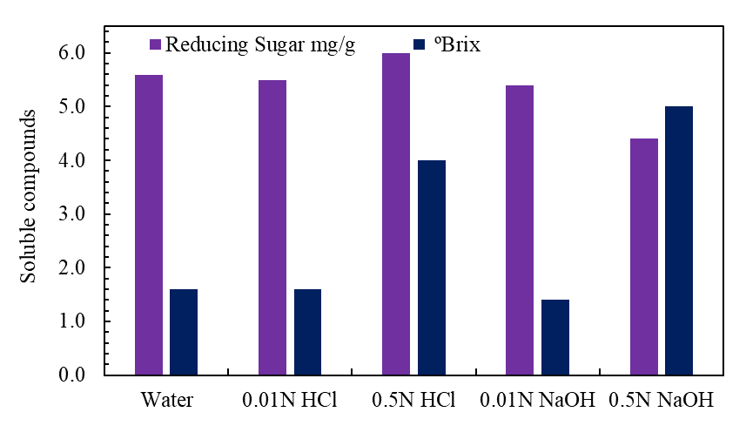
Figure 2: Graph showing concentration of reducing sugars (mg/g) and ºBrix after different pre-treatments

From Figure 2 it was seen that in general, among the different pre-treatments there is quite comparable concentration of reducing sugars 4.4- 6.0 mg/g that is being released into the liquid phase with the highest solubilisation in 0.5N HCl medium. However, on comparing the effect of different media, it can be seen that there was lower release of reducing sugars in alkaline solutions. During acid pre-treatment conditions, there is degradation of polysaccharides to monomers and subsequent breakdown of simple sugars to 5-hydroxymethyfurfural (HMF), levulinic acid or formic acid (Macheiner et al., 2003).
ºBrix was highest in 0.5N NaOH sample followed by 0.5N HCl while in 0.01N HCl, 0.01N NaOH and water the ºBrix values were almost constant. This large ºBrix in 0.5N alkali solution could be because alkaline pH is good for solubilisation of not only sugars but also other molecules from pre-treated BSG but did not favour the release of reducing sugars. An alkaline medium is responsible for the inter-crystalline swelling of cellulose by the breakup hydrogen bonding of adjacent glucose molecules to produce material of low bulk density. Also, hydrolysis of hemicellulose takes place. Additionally, it was observed that the results obtained from 0.01N acid and alkali media was similar to the control sample in water as aqueous phase. So, the lower concentrations of acid and alkali did not significantly impact the solubilisation of total and reducing sugars. While a higher concentration of 0.5N of HCl and NaOH was found to improve the concentrations of reducing sugars and ºBrix respectively.
    - Proteins and polyphenols
Figure 3 shows the concentrations of proteins and polyphenols measured on the liquid fraction after all pre-treatments.

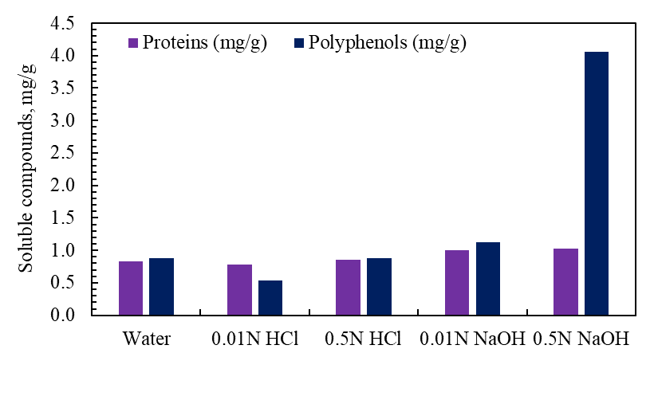

Figure 3: Graph showing concentration of proteins and polyphenols after pre-treatments

It can be observed that the highest solubilisation of polyphenols was in alkaline medium with 0.5N NaOH solution. The solubilisation of proteins was quite comparable and within the range of 0.7- 1.0 mg/g. Higher solubilisation of the organics like proteins and polyphenols were reported by previous works at operating conditions of 120 ºC, 90 min (Sibhatu et al., 2021) and alkaline environment (Mussatto et al., 2007). The concentrations of proteins and polyphenols are also quite comparable for the pre-treatments in water and acidic media and 0.01N NaOH solution. The contents of proteins and polyphenols solubilised were quite similar or lower than the control sample in case of acidic conditions and 0.01N NaOH solutions. This trend was also observed in case of reducing sugars and ºBrix except for 0.5N HCl which could suggest that at these conditions used they did not significantly improve the values in terms of hydrolysis. Higher concentrations of acid and alkali at 0.5N seems to be the most feasible option among others. However, further analyses for instance determination of ferulic acid in the solubilised liquid is necessary to have a better understanding of the results obtained.
  - Conclusions
BSG is pre-treated by 0.01N and 0.5N solutions of HCl and NaOH for a reaction time of 1 h using water as a control sample. The effect of pre-treatments was investigated by the extent of solubilisation of molecules into aqueous phase after pre-treatments.
Highest release of reducing sugars among all the different pre-treatments was found to be 6.0 mg/g in 0.5N HCl sample while ºBrix which could be used to estimate total sugar contents was largest in alkaline medium of 0.5N NaOH. Also, the concentration of polyphenols solubilised were highest in alkaline solution of 0.5N NaOH whereas the concentration of proteins after all the pre-treatments were quite similar. These results could provide preliminary knowledge for valorisation of pre-treated BSG liquid and solid and also further insights on the additional analyses that need to be performed on both pre-treated fractions.
Acknowledgments
This research was supported by grant ARGE17-992/5/2 for a PhD funded by the European Social Fund within the Liguria Regional operational program 2014–2020- thematic objective “Education and Training”. The authors acknowledge the financial support received from the European Social Fund—Liguria Regional operational program 2014–2020. They thank Ticass Scrl, Iren Spa, Micamo, and Active Cells for supporting this project. They would also like to thank Prof. Anna Trusek and her group Micro, Nano, and Bioprocess engineering group at Wroclaw University of Science & Technology, Poland for allowing to carry out this research work there.
References
Alonso-Riaño P., Diez M.T.S., Blanco B., Beltrán S., Trigueros E., Benito-Román O., 2020, Water Ultrasound-Assisted Extraction of Polyphenol Compounds from Brewer’s Spent Grain: Kinetic Study, Extract Characterization, and Concentration, Antioxidants, 9, 265.
Babu R., Capannelli G., Comite A., 2021, Effect of Different Pretreatments on Sludge Solubilization and Estimation of Bioenergy Potential, Process, 9, 1382.
Chen J.H., Xu J.K., Huang P.L., Sun R.C., 2016, Effect of alkaline pretreatment on the preparation of regenerated lignocellulose fibers from bamboo stem, Cellulose, 23, 2727–2739.
Hassan S.S., Ravindran R., Jaiswal S., Tiwari B.K., Williams G.A., Jaiswal A.K., 2020, An evaluation of sonication pretreatment for enhancing saccharification of brewers’ spent grain, Waste Management, 105, 240–247.
Jackowski M., Niedźwiecki L., Jagiełło K., Uchańska O., Trusek A., 2020, Brewer’s Spent Grains—Valuable Beer Industry By-Product, Biomolecules, 10, 1669.
Jackowski M., Semba D., Trusek A., Wnukowski M., Niedzwiecki L., Baranowski M., Krochmalny K., Pawlak-Kruczek H., 2019, Hydrothermal Carbonization of Brewery’s Spent Grains for the Production of Solid Biofuels, Beverages, 5, 12.
Liguori R., Soccol C.R., de Souza Vandenberghe L.P., Woiciechowski A.L., Faraco V., 2015, Second Generation Ethanol Production from Brewers’ Spent Grain, Energies, 8, 2575-2586.
Lowry O.H., Rosebrough N.J., Farr A.L., Randall R.J., 1951, Protein measurement with the Folin phenol reagent, Journal of Biological Chemistry, 193, 265–275.
Macheiner D., Adamitsch B.F., Karner F., Hampel W.A., 2003, Pretreatment and Hydrolysis of Brewer’s Spent Grains, Engineering Life Sciences, 3, 401–405.
Makkar H.P.S., 2003, Measurement of Total Phenolics and Tannins Using Folin-Ciocalteu Method, Quantification of Tannins in Tree and Shrub Foliage, Vienna, Austria, 49–51.
Mendez D.A., Marti E., Puyuelo B., Colon J., Ponsa S., 2018, Evaluation of pre-treatments of brewery’s spent grain for growing bacteria in the production of Polyhydroxyalkanoates, Chemical Engineering Transactions, 65, 403-408.
Miller G.L., 2002, Use of Dinitrosalicylic Acid Reagent for Determination of Reducing Sugar, Analytical Chemistry, 31, 426–428.
Mishra P.K., Gregor T., Wimmer R., 2017, Utlising brewer’s spent grain as a source of cellulose nanofibers following separation of protein-based biomass, BioResources, 12, 107-116.
Mussatto S.I., Dragone G., Roberto I.C., 2007, Ferulic and p-coumaric acids extraction by alkaline hydrolysis of brewer’s spent grain, Industrial Crops and Products, 25, 231–237.
Ravindran R., Jaiswal A.K., 2016a, Microbial Enzyme Production Using Lignocellulosic Food Industry Wastes as Feedstock: A Review, Bioengineering, 3, 30.
Ravindran R., Jaiswal A.K., 2016b, A comprehensive review on pre-treatment strategy for lignocellulosic food industry waste: Challenges and opportunities, Bioresource Technology, 199, 92–102.
Ravindran R., Jaiswal S., Abu-Ghannam N., Jaiswal A.K., 2018, A comparative analysis of pretreatment strategies on the properties and hydrolysis of brewers’ spent grain, Bioresource Technolnology, 248, 272–279.
Sibhatu H.K., Jabasingh S.A., Yimam A., Ahmed S., 2021, Ferulic acid production from brewery spent grains, an agro-industrial waste, LWT - Food Science and Technology, 135, 110009.
Wolters N., Schabronath C., Schembecker G., Merz J., 2016, Efficient conversion of pretreated brewer’s spent grain and wheat bran by submerged cultivation of Hericium erinaceus, Bioresource Technology, 222, 123–129.

