CHEMICAL ENGINEERING TRANSACTIONS  VOL. 92, 2022 | A publication of
The Italian Association
of Chemical Engineering
Online at www.cetjournal.it

Guest Editors: Rubens Maciel Filho, Eliseo Ranzi, Leonardo Tognotti
Copyright © 2022, AIDIC Servizi S.r.l.
ISBN 978-88-95608-90-7; ISSN 2283-9216

Reutilization of Crude Glycerol in a Circular Biodiesel Production Process
Bruna R. Margarida*, Luiz F.L. Luz Jr
Federal University of Parana, Polytechnic Center, Department of Chemical Engineering, Avenida Coronel Francisco Heraclito dos Santos, 100, 81531-980, Brazil
*bruna.margarida18@gmail.com
The biodiesel production process has been widely studied and had many improvements regarding reaction conversion and cost reduction. However, most processes in this field share a common problem, the formation of glycerol as the side product. There are still many concerns involving glycerol use and demand, as the growth in biodiesel production inevitably raises glycerol formation as well. Nevertheless, the rapid growth in glycerol availability has led to price fluctuations, and, sometimes, the crude glycerol formed is even discarded as a waste product. Considering this constant problem, one option would be to indirectly use glycerol inside the biodiesel production process. One way to achieve this proposal is to convert this product to mainly hydrogen, carbon monoxide, and carbon dioxide and then convert these gases to methanol. In this study, a biodiesel production process from residual oil is proposed as well as glycerol processing to convert this side product to methanol, using it as a reactant in the same unit. The proposed process will minimize waste production by recycling the raw materials in excess from the biodiesel reaction and also the converted side product. Here, the biodiesel and glycerol processing units are thoroughly analyzed and optimized. Energy integration is also considered to reduce utility usage. A final economic evaluation is made to verify if the conversion of glycerol to methanol is economically feasible and compare the economic aspects of glycerol processing instead of selling or disposing it. The use of a circular biodiesel industry is a promising reality that could help reduce waste disposal and encourage new findings and alternatives to improve the conversion of such wastes into value-added products.

  - Introduction
The biodiesel industry is rapidly evolving, and thus, the processes to obtain this product are constantly being improved and optimized. Biomass is an essential source for this biofuel production, as shown by Casa et al. (2021), where tomato seed was used as the oil source. The traditional route for biodiesel production includes the use of acid or base catalysts and reactions with temperatures near the alcohol’s (usually methanol or ethanol) boiling point. The supercritical route for biodiesel production is an interesting alternative, enabling a high production efficiency (Sawangkeaw et al., 2010) and a high conversion of the oil source, even without any catalyst. In addition, regardless of the fatty acid presence, the supercritical route allows both esterification and transesterification to happen simultaneously (Farobie and Matsumura, 2017). Another critical issue related to the biodiesel process is the formation of glycerol, as for each m³ of biodiesel produced, 0.1 m³ of glycerol is also obtained (Knothe et al., 2005). The high expectations for biodiesel production also increase concerns to find alternatives for glycerol utilization. As the biodiesel industries focus on this biofuel production, it is common for such sectors to sell this side product as crude glycerin, so it may be used to obtain other products, mainly in the pharmaceutical, personal care, and polymer sectors (Monteiro et al., 2018). However, the uncertainty regarding the price fluctuation of this product implies that having less dependency on its price fluctuation would benefit the biodiesel industry. To overcome this problem, some studies on glycerol conversion to other valuable compounds have been developed and optimized (Santos et al., 2021). Considering the possibilities, converting glycerol to the same alcohol used in the biodiesel production process could help reduce both glycerol and alcohol price dependence. In this study, considering methanol as the alcohol used to obtain the biodiesel, the glycerol formed is first converted to synthesis gas, which is then reacted to form methanol (Gutiérrez Ortiz et al., 2013). Finally, the obtained methanol is recycled, and the overall circular biodiesel production process is evaluated.

  - Methodology

Two simulation processes were developed, one for glycerol processing and another for crude glycerol selling. The simulation processes and economic evaluation were entirely developed in Aspen Plus V10, and Aspen Energy Analyzer was used for heat integration analysis. When available, the reaction kinetics data were obtained from published articles using the same thermodynamic models. Tests to verify the reproducibility of the data extracted were developed using the same reaction conditions and inlet flows, verifying the final conversion and system behavior for further comparison with the literature before using the data in the actual system. The main thermodynamic models used were RK-SOAVE when working with light gases and mildly polar mixtures, and PSRK when working with polar compounds. Both methods enable a good prediction when working at high temperatures and pressures, including in the supercritical region.
After the base simulations were completed, an energy analysis was developed, where heat integration systems were included to minimize utility usage. Finally, the economic evaluation was made to verify the economic feasibility of the process proposed for glycerol processing and compare the economic aspects of both units.

  - Results and Discussion
3.1. Processes Simulation and Energy Analysis

Initially, residual oil (15 wt% FFA) was converted to biodiesel under a supercritical route using methanol in a 40:1 alcohol/oil proportion. Triolein was used to represent the triglycerides and oleic acid to represent the FFA. In this route, no catalyst was added in order to minimize environmental issues and costs; instead, Minami and Saka (2006) showed that the fatty acid also acts as an acid catalyst in the reaction. The kinetics for the esterification (Jin et al., 2015) and transesterification (parameters regressed from Varma and Madras (2007)) reactions were obtained separately as no article with both kinetics and in the same conditions was found. The reaction conditions used were the same as Varma and Madras (2007) used (320 ºC and 200 bar), which presented higher temperature and pressure in relation to the esterification reaction proposed. However, considering that higher temperatures and pressures benefit the esterification reaction (Cho et al., 2012), and the conditions chosen are out of the kinetics range for the proposed esterification reaction, it is important to keep in mind that the results obtained here underestimate the actual esterification reaction behavior.
The kinetic model proposed by Guo et al. (2013) was used for the glycerol conversion to synthesis gas. The reaction conditions were 567 ºC and 250 bar. Acetaldehyde was considered the intermediate product in this reaction as it was the main liquid product obtained, and molecules with two carbons were more commonly present in the liquid phase (Guo et al., 2013). Finally, an equilibrium reactor was used to obtain methanol from the synthesis gas reaction. This choice was due to the lack of reproducibility between the kinetic equation and experimental data available in different articles under similar conditions. The equilibrium reactor, however, presented very close results compared to the behavior obtained by Mäyrä and Leiviskä (2018). The reaction conditions were 220 ºC and 50 bar, and ZnO/Cr₂O₃ was used as the catalyst. Other literature data have shown that the activity of this catalyst is very stable in the reverse-water-gas-shift reaction without coke formation (Park et al., 2000). However, no tests regarding catalyst activity have been done for the entire reaction proposed.
The final simulation for the biodiesel production unit with glycerol processing to obtain methanol is presented in Figure 1. The solid lines represent the process streams, while the dotted lines represent the energy integration.
As can be seen, the process starts with the addition of the residual oil and methanol in the supercritical reactor, followed by methanol recycling and glycerol separation. The biodiesel from the oil phase is then purified and separated as the final product. In contrast, the glycerol present in the water phase is directed to the synthesis gas formation reactor. These gases then proceed to the final reactor for methanol production. An excess of hydrogen is added to improve reaction conversion. The unreacted gases are recycled to this reactor while methanol is directed to the methanol recycling stream. Three energy integration systems were used in this unit.
It is important to remember that the simulation with glycerol selling (Figure 2) was almost the same as the one present in Figure 1 up to the second distillation column, where all other equipment after this column was removed. The conditions after the supercritical reactor were also milder, as no other supercritical reaction would occur. Another difference between the simulated plants was regarding energy integration, where for the glycerol selling plant, only one integration was necessary for a considerable energy saving.
In both simulations, biodiesel within specification from the European biodiesel standard (EN 14214) was obtained, and in the glycerin selling unit, crude glycerin with low methanol (<0.2 wt%) and water (<2.5 wt%) content was obtained. For the total glyceride specification, the unreacted triglyceride was considered the mixture among the mono, di, and triglycerides, as the kinetics used did not consider intermediate products. Therefore, the sum of mono, di, and triglyceride from the standard limits was used as the maximum unreacted triglyceride composition possible in the simulation, achieving a value of <1 wt% in the model.

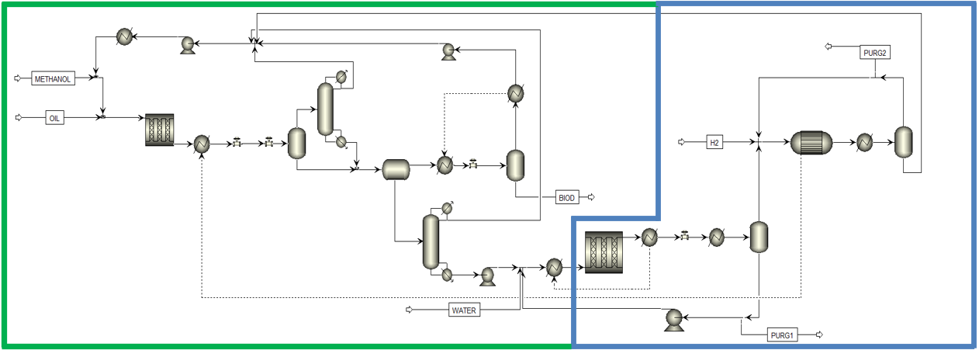
Figure 1: Biodiesel production (green box) and glycerol processing (blue box) simulation

The simulation process proposed considering glycerol selling is presented in Figure 2.

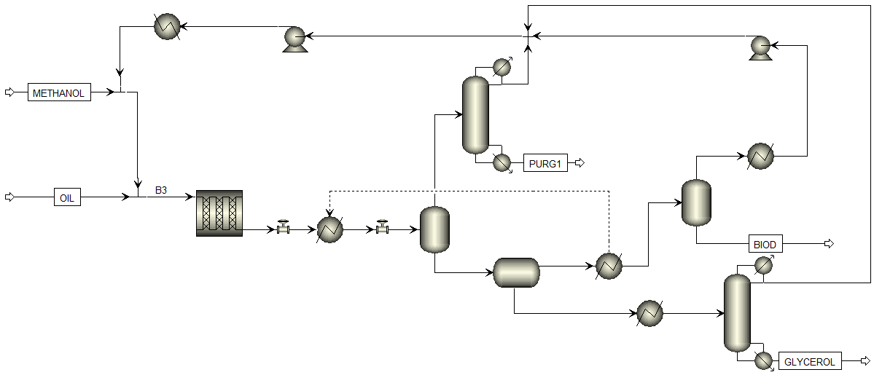
Figure 2: Biodiesel production unit with glycerol selling

After the three energy-saving systems were included in the glycerol processing simulation, energy consumption was reduced from 25,238 kW to 13,381 kW, a 47% reduction. In the glycerol selling unit, energy consumption was reduced from 15,139 kW to 13,519 kW, a 17% reduction. Although the final energy consumption is very similar in both units, the utility cost in the glycerol processing unit is more than double of the glycerol selling unit, as the types of utilities used are not the same.
In summary, the energy integration included in the simulation (especially the glycerol processing unit) significantly reduced energy consumption, utility usage, and, consequently, the OPEX.

3.2. Economic Evaluation

The two simulations were evaluated to analyze if both units were economically feasible and if there are advantages to glycerol processing. Table 1 shows the average price for each raw material and product present in the simulation. The utility prices used were Aspen’s default values, and the catalyst was not included due to the lack of information in the literature about pricing and reuse. However, Park et al. (2000) has shown that little to no coke formation was observed in similar reactions, which indicates that this catalyst may have high reusability. Thus, its price might have small participation in the process costs.
Table 1: Raw material and product prices used in the simulation
Component | Price (USD/ton)
Biodiesel (Neste, 2022) | 1630.0
Glycerol (Oleoline, 2022) | 514.6
Methanol (Methanex, 2022) | 577.5
Residual oil (USDA, 2022) | 970.0
Hydrogen (Ammonia Energy, 2022) | 795.5

As can be seen, glycerol’s price is about 10 % lower than methanol’s. Therefore, the possibility to use glycerol as raw material for methanol production is justified, and an optimized glycerol processing unit could help reduce raw material costs. It is also observed that raw material costs have the most significant influence on the operating cost in both units (90 %), another reason to propose new ways to minimize its participation in such costs.
Although the glycerol processing unit uses hydrogen, an expensive material compared to methanol and glycerol, only a small amount is used as makeup, contributing to only 0.7 % of the unit’s raw material costs. Most hydrogen used in the last reaction comes from the previous reaction with synthesis gas formation, which already produces large amounts of this component. The unreacted hydrogen is also recycled to the methanol production reactor.
From the economic analysis results, the glycerol processing in a circular biodiesel production process is economically feasible with a payback period of 3.86 years for annual biodiesel production of 70,000 m³. The glycerol processing unit reduced methanol costs by 28 % compared to the glycerol selling unit, a considerable cost reduction that can help minimize the impact of possible methanol price fluctuations.
Comparing the results obtained from the glycerol processing unit to the selling unit, the second one still showed more favorable results with a lower payback period (2.68 years). However, one should keep in mind that this advantage is present if the glycerol selling price remains high, and there are enough purchasers to meet the demand. As mentioned before, the high expectations for the fast growth of biodiesel industries can rapidly saturate the glycerol market. Thus, finding new alternatives for glycerol reutilization in the biodiesel industry may ensure economic stability and reduce possible environmental issues.
Table 2 shows some of the previously cited economic aspects of each process for a more detailed comparison.
Table 2: Economic analysis of the simulated units
Property | Glycerol processing unit | Glycerol selling unit
Installed Equipment Cost (USD) | 8,253,600 | 3,051,300
Total Capital Cost (USD) | 15,946,200 | 8,161,900
Utilities Cost (USD/year) | 1,933,120 | 886,006
Raw Material Cost (USD/year) | 60,142,400 | 60,809,000
Operating Cost (USD/year) | 69,036,200 | 67,990,700
Product Sales (USD/year) | 95,758,600 | 99,536,400
Payback Period (year) | 3.86 | 2.68

Apart from the overall economic evaluation obtained, four analyses were made to verify the behavior of both units to different components’ price fluctuation; varying biodiesel price by 10 %; varying methanol price by 10 %; varying glycerol price by 10 %, and varying acid oil price by 10 %. Table 3 shows the payback period difference to a 10 % variation in biodiesel price.
Table 3: Payback period for a variation of 10 % in biodiesel cost
Unit simulated | 10 % below original biodiesel price | Original biodiesel price | 10 % above original biodiesel price
Payback period of the glycerol processing unit | 5.61 | 3.86 | 3.03
Payback period of the glycerol selling unit | 3.59 | 2.68 | 2.20

It can be seen that a 10 % variation above the final biodiesel price would decrease the payback period by 22 % in the glycerol processing unit and by 18 % in the glycerol selling unit. Moreover, a 10 % variation below the biodiesel price would increase the payback period by 45 % and 34 % in the glycerol processing and selling units, respectively. These results show that the biodiesel price strongly influences the glycerol processing unit, as biodiesel is the only product that is actually marketable in this unit. In contrast, the glycerol selling unit has two products, and thus, it slightly decreases the biodiesel influence in the payback period.
Variations in the methanol price were also verified, and the results can be seen in Table 4.
Table 4: Payback period for a variation of 10 % in methanol cost
Unit simulated | 10 % below original methanol price | Original methanol price | 10 % above original methanol price
Payback period of the glycerol processing unit | 3.82 | 3.86 | 3.90
Payback period of the glycerol selling unit | 2.65 | 2.68 | 2.72

It is possible to observe that a 10 % variation in methanol price (above or below the original price) would vary the payback period by 1 % and 1.5% in the glycerol processing and selling units, respectively. This small impact is mainly due to the high residual oil price, as methanol cost only represents 6 % of the raw material cost, while the residual oil is responsible for the other 94%. However, these numbers already show the lower impact of methanol price fluctuation in the glycerol processing unit. Moreover, considering the acid oil price participation in the raw material cost, the use of cheaper oil sources may increase methanol participation in this cost and provide more expressive results for the comparisons regarding methanol price fluctuations.
The payback period analysis regarding glycerol price fluctuation was also made, as shown in Table 5.
Table 5: Payback period for a variation of 10 % in glycerol cost
Unit simulated | 10 % below original glycerol price | Original glycerol price | 10 % above original glycerol price
Payback period of the glycerol processing unit | 3.86 | 3.86 | 3.86
Payback period of the glycerol selling unit | 2.70 | 2.68 | 2.67

Similar to what happened with the methanol and residual oil price, the variation of glycerol will slightly impact the glycerol selling unit, as the income from glycerol price represents only 2.7 % of the total income from the unit. At lower biodiesel prices, however, the participation of glycerol in the product sale will increase.
Finally, the payback period analysis for the acid oil price fluctuation (10 %) was made, as shown in Table 6.
Table 6: Payback period for a variation of 10 % in acid oil cost
Unit simulated | 10 % below original acid oil price | Original acid oil price | 10 % above original acid oil price
Payback period of the glycerol processing unit | 3.20 | 3.86 | 5.11
Payback period of the glycerol selling unit | 2.24 | 2.68 | 3.35

This analysis showed that the residual oil price has an important impact on the units’ operating costs, as an increase of 10 % of its price increased the payback period by 32 % and 25% for the glycerol processing and selling units, respectively. This difference is minimized when decreasing the residual oil price by 10 %, where the payback period decreased by 17 % and 16 % for the glycerol processing and selling units, respectively.
The results obtained from the previous tables showed that the glycerol processing to obtain methanol improves economic stability regarding methanol price fluctuations and, as expected, has no influence on glycerol price fluctuations. Nevertheless, this unit presented less stability to biodiesel and acid oil price fluctuations.
Despite the satisfactory results from the economic analysis, it was observed that the second part of the process (for methanol production from glycerol) might be further improved, as the glycerol conversion obtained in the synthesis gas reactor was around 80 % and at the end, for each mol of glycerol consumed, only 1.4 mols of methanol are produced. Therefore, technological improvements for glycerol conversion are necessary to obtain a higher methanol yield and to be economically competitive, even though it was already shown that this process is economically feasible.
  - Conclusions
The reutilization of crude glycerol in the biodiesel production process to form methanol is a potential issue to be further studied and discussed, as it may significantly improve the stability of methanol price fluctuations in the biodiesel industry. To verify the possibility of this reutilization, a simulation process using a supercritical route for biodiesel production and two reactors for the glycerol conversion, one to convert glycerol to synthesis gas and another one to produce methanol from this synthesis gas, was proposed. Acid oil was chosen as the oil source for biodiesel production, and the reactions kinetics and system behavior were obtained and compared with the literature. It was observed that the price of the oil source had a significate impact on the economic aspects of the project, justifying the use of residual sources to reduce raw material costs. Subsequently, the energy analysis developed showed the possibility to reduce energy consumption by 47 %. Considering a 70,000 m³/year of biodiesel production, the payback period obtained for this process was 3.86 years, a very positive result for biofuels production. Therefore, the biodiesel production process with glycerol conversion to methanol is economically feasible and helped reduce methanol costs by 28%. It also improved process stability regarding methanol price fluctuations. Nevertheless, by comparing this simulation with another one built considering only biodiesel production and selling the obtained glycerol, it was seen that the glycerol processing unit was not as competitive. It shows, therefore, the need for further technological improvements to meet future demand for glycerol use, as rapid growth in biodiesel production is expected. Despite the better results obtained from the unit with glycerol selling, one must bear in mind that this route is advantageous as long as methanol and glycerol have an easy transportation route and market demand. Otherwise, costs associated with raw material and products transportation and storage could overcome the costs for the glycerol conversion to methanol.
Acknowledgments
To Programa de Recursos Humanos da ANP (PRH-ANP) for providing financial support and scholarships.
References
Ammonia Energy Association, 2019, The cost of hydrogen: Platts launches Hydrogen Price Assessment, Ammonia Energy Association, <https://www.ammoniaenergy.org/articles/the-cost-of-hydrogen-platts-launches-hydrogen-price-assessment/> accessed 10.01.2022.
Casa M., Prizio C., Miccio M., 2021, Biodiesel production from tomato seed by transesterification with Alkaline and ‘Green’ catalysts: Simulation and discussion, Chemical Engineering Transactions, 87, 451–456.
Cho H. J., Kim S. H., Hong S. W., Yeo Y. K., 2012, A single step non-catalytic esterification of palm fatty acid distillate (PFAD) for biodiesel production, Fuel, 93, 373–380.
Farobie O., Matsumura Y., 2017, State of the art of biodiesel production under supercritical conditions, Progress in Energy and Combustion Science, 63, 173–203.
Guo S., Guo L., Yin J., Jin H., 2013, Supercritical water gasification of glycerol: Intermediates and kinetics, Journal of Supercritical Fluids, 78, 95–102.
Ortiz F. J. G., Serrera A., Galera S., Ollero P., 2013, Methanol Synthesis from Syngas Obtained by Supercritical Water Reforming of Glycerol, Fuel ,105, 739–51.
Jin T., Wang B., Zeng J., Yang C., Wang Y., Fang T., 2015, Esterification of free fatty acids with supercritical methanol for biodiesel production and related kinetic stud, RSC Advances, 5, 1–8.
Knothe G., Gerpen J. V., Krahl J., 2005, The biodiesel handbook. 2nd ed. Champaing: AOCS Press.
Mäyrä O., Leiviskä K., 2018, Modeling in Methanol Synthesis, Methanol: Science and Engineering, 475–492.
Methanex, 2022, <methanex.com/our-business/pricing> accessed 10.01.2022.
Minami E., Saka S., 2006, Kinetics of hydrolysis and methyl esterification for biodiesel production in two-step supercritical methanol process, Fuel, 85, 2479–2483.
Monteiro M. R., Kugelmeier C. L., Pinheiro R. S., Batalha M. O., César A. S., 2018, Glycerol from biodiesel production: Technological paths for sustainability, Renewable and Sustainable Energy Reviews, 88, 109–122.
Neste, 2022, <neste.com/investors/market-data/biodiesel-prices-sme-fame#c52ae609> accessed 10.01.2022
Oleoline, 2022, Glycerine Market Report <hbint.com/datas/media/6058c0f45e3e8833fb39340b/sample-quarterly-glycerine-2.pdf> accessed 10.01.2022.
Park S. W., Joo O. S., Jung K. D., Kim H., Han S. H., 2000, ZnO/Cr2O3 Catalyst for Reverse-Water-Gas-Shift Reaction of CAMERE Process, Korean Journal of Chemical Engineering, 17, 719–722.
Santos J. M., De Sousa G. F. B., Vidotti A. D. S., De Freitas A. C. D., Guirardello R., 2021, Optimization of glycerol gasification process in supercritical water using thermodynamic approach, Chemical Engineering Transactions, 86, 847–852.
Sawangkeaw R., Bunyakiat K., Ngamprasertsith S., 2010, A review of laboratory-scale research on lipid conversion to biodiesel with supercritical methanol (2001-2009), Journal of Supercritical Fluids, 55, 1–13.
USDA Livestock, Poultry & Grain Market News, 2022, National Weekly Ag Energy Round-Up, <ams.usda.gov/mnreports/lswagenergy.pdf> accessed 10.01.2022.
Varma M. N., Madras G., 2007, Synthesis of biodiesel from castor oil and linseed oil in supercritical fluids, Industrial and Engineering Chemistry Research, 46, 1–6.

