|  |  |
| --- | --- |
| cetlogo ***CHEMICAL ENGINEERING TRANSACTIONS***  ***VOL. 92, 2022*** | A publication of  aidiclogo_grande |
| The Italian Association  of Chemical Engineering  Online at www.cetjournal.it |
| Guest Editors: Rubens Maciel Filho, Eliseo Ranzi, Leonardo Tognotti  Copyright © 2022, AIDIC Servizi S.r.l. **ISBN** 978-88-95608-90-7; **ISSN** 2283-9216 | |

Effect of Corn Starch on the Biodegradability and Absorbency of Superabsorbent Polymer

Ariel V. Melendresa,b\*, Christian Jake A. Manacobb and Rolan P. Vera Cruza

aSolvo Inspectis, Inc., 69 Greenview Ave., Sauyo, Quezon City 1116, Philippines

bTechnological Institute of the Philippines, 363 P Casal, Quiapo Manila 1001 Philippines

\*arvmelen@yahoo.com

Corn starch, a biodegradable material, was used to modify the properties of a hydrogel, also commonly called superabsorbent polymer, SAP. The starch was used to enhance the gel strength while providing an improved polymer biodegradability. The starch suspension was prepared by agitating the starch in deionized water and was used for treating the SAP particles. The treatment process was done by mixing the starch particle suspension with the SAP allowing the starch to adhere at the SAP surface and the water to diffuse into the inner SAP structure for a volumetric swelling degree of more than 2. The resulting mixture was then heat treated at a temperature of 150oC until the SAP moisture is less than 5% by weight. The gel strength was determined in terms of the permeability of the gel particles when formed in a layer or bed. The permeability of SAP samples was determined using Gel Layer Permeability (GLP) after the dry SAP particles were allowed to swell at 0.9% sodium chloride solution for one hour. SAP gel strength increased after treatment of starch as shown by the results of GLP tests. To evaluate the biodegradability of the SAP, samples were subjected to high relative humidity environment of 90-95% RH and temperature of 30-35oC for more than one month where discoloration of the SAP particles were checked regularly. The SAP samples treated with corn starch biodegrades faster as shown by the changes in the color compared with other samples without corn starch treatment.

* 1. Introduction

Environmental concern on the use of Superabsorbent Polymer (SAP) triggers the adoption of biobased materials as substitute for the traditional petroleum-based materials. The continued popularity on the use of SAP for the established application such as baby diapers and the increase perception and awareness toward usage in other applications such as agriculture, medical, construction, anti-corrosion, etc. are driving the growth of the market. However, the growth of the industry may be hampered by this environmental issue as SAPs used in the above-mentioned applications are not very biodegradable (Shibly et al., 2021). Efforts on producing more biodegradable products had been the focus of researches recently (Yoo Jin Kim et al., 2019 Melendres and Carrillo, 2019). Ideas that support on using renewable resources as raw materials to improve SAP’s biodegradability have been put forward in developing new superabsorbent polymer structures (Sannino et al., 2009, Nnadi and Brave, 2011, Wang et al., 2009). A study on the evaluation of the biodegradability of two types of superabsorbent polymers such as crosslinked polyacrylate and crosslinked copolymers of polyacrylate and polyacrylamide had been conducted where the findings showed that the solubilization and mineralization rates of the polyacrylate in soil were less than that of the copolymer (Stahl et al., 2000). Thermal and microbial degradation properties through Thermogravimetric Analysis (TGA), and soil supernatant test of alginate based superabsorbent polymer were investigated (Phang et al, 2011). In another study, acrylate-based SAP in different agricultural soils gave different rates of biodegradability evaluated from the results of mineralisation (Wilske et al, 2014). The use of crosslinking agents allow the SAP to form a network of polymer chains affecting not only the various absorption properties but the biodegradability as well. Uncrosslinked types of polymer are easy to degrade according to the report of Ye et al., 2002, but they are not the type of SAP structures that are normally used in the industry. The most commonly used SAP are those of lightly crosslinked, partially neutralized hydrophilic three-dimensional networks that expand during water absorption. These types of SAP are commonly applied but not limited to hygienic products (Bachra et al., 2020, Kosemund et al, 2009, Melendres et al, 2019.).

Crosslinking is an established method of working out the elasticity of the polymer chains for various SAP applications. This is accomplished both on the core and on the surface of the polymers. Particularly, the surface crosslinkers had been reported to improve absorption under load and the permeability of SAP (Venkatachalam, et al., 2013, Jokushch et al., 2009) due to its improved gel rigidity giving higher strength that prevents loosening. While the core crosslinkers are incorporated during the polymerization process, the surface crosslinkers are made to treat the SAP surface in its dry and pulverized form at the downstream step of the manufacturing process. Such surface treatment is typically applied to counterbalance the effect of core crosslinkers on unnecessary reduction of absorption capacity. Most of these surface modifiers or crosslinkers are petroleum base which could result to SAP structure with poor biodegradability. For our study, corn starch, a biodegradable, naturally occurring and eco-friendly material, is used as a surface crosslinker. Starch, a carbohydrate polymer, consists of anhydroglucose units linked by α-d-(1, 4) glucosidic bonds. It is used in a variety of industries including plastics, adhesives, paper, and pharmaceuticals (Yoshimura et al., 2006). Several studies on the use of chemically modified starch have been published (Kono et al., 2012, Lee et al. 2018), however, SAP performance and properties with corn starch in native form as surface modifier for crosslinking has yet to be thoroughly investigated in terms of biodegradability, absorption and permeability performances. Thus, this paper has focused on these studies. The methodology by which the starch was applied on the surface of SAP, and the biodegradability examination methodologies had been explored.

* 1. Materials and Methods
     1. Materials

The SAPs were imported from China, Shandong Tongli Co., Ltd, tightly sealed to maintain moisture below 5%. Analytical grade sodium chloride obtained from Avantor Performance Materials, Inc. was used for preparing the sodium chloride solution. Deionized water with conductivity of <5 µS/cm was used for the tests. Corn starch was obtained from Alyson’s Chemicals. Ethylene carbonate was obtained from Sigma-Aldrich.

* + 1. Methods

Absorption Test for SAP

A tea bag method is used to measure the free swell capacity (FSC) using a heat sealable non-woven bag with dimension of 60 mm length x 40 mm width. The absorption capacity is evaluated by determining the weight before and after absorption of the test solution of 0.9% NaCl (Bachara et al., 2019).

**Gel Layer Permeability**

The GLP (Gel Layer Permeability) is measured using a GLP apparatus which is composed of cylindrical acrylic cylinder with 300 mesh stainless screen at the bottom where the dry SAP particles are spread evenly. After allowing the SAP to swell at 0.9% NaCl for 1 hr and the gel height measured, the cylinder apparatus, under the load of 21g/cm2, is placed on the frame support connected to the water reservoir adjusted to maintain the NaCl solution in the acrylic cylinder at height of 4 cm. The amount of water solution passing through the SAP gel layer is recorded. The permeability *K* in unit of cm2 is calculated based on the Darcy equation below,

$K=\frac{QHμ}{AρP}$ (1)

where Q is flow rate in g/s, *H* is height of gel layer sample in cm, *μ* is the liquid viscosity in MPa.s, *A* is the cross-sectional area in cm2 perpendicular to liquid flow, *ρ* is the liquid density in g/cm3, and *P* is hydrostatic pressure in dynes/cm2. The GLP, expressed in unit of Darcy, is obtained by dividing *K* with 9.87x10-9.

SAP Surface Treatment Method

Starch is mixed with deoinized water to produce a starch suspension of 2%. The starch suspension is poured in a container containing a predetermined amount of SAP while being agitated mechanically. The agitation is continued until a homogenous mixture is obtained and all the water had been absorbed by the SAP. The resulting mixture is then heat treated in the oven at temperature of 150-180oC until the SAP moisture content reaches $≥$ 5%. It is then cooled in a desiccator after which sizes between 300-800 microns were obtained by screening. The product is then used for evaluation of the properties. For comparison of biodegradability, SAP was treated with crosslinker Ethylene carbonate (EC) and subjected to the same biodegradability performance together with the corn starch treated and untreated SAP.

Evaluation of Biodegradability

The biodegradability of SAP was determined by exposing the samples at environment of high relative humidity (RH) and high temperature inside a cabinet made of HDPLE material. The relative humidity inside the cabinet is maintained at 90-95% RH during the duration of the test and at temperature of 30-35oC. The relative humidity is monitored using a data logger HE17X from Huato Electronic Co., Ltd. The samples are placed in small petri dish and is monitored for its color change. After six weeks of exposure, the samples were then subjected to free swell absorption and permeability (GLP) tests (Melendres et al. , 2019).

FTIR and SEM Characterizations.

FTIR spectra of SAP were obtained on Perkin Elmer FTIR Spectrometer Frontier. Samples were analyzed in the solid state as small grains.

3. Results and Discussion

3.1 FTIR Spectra

The results of FTIR spectra of SAP before and after treatment is shown in Figure 1. Test results were obtained in the range of 4000-600 cm-1. For untreated SAP, the spectrum showed a broad band with peak at 3313 cm-1 due to the stretching of –OH group. Peaks at 2930 cm-1 and 1685 cm-1 are because of C-H and C=O stretching. The long band with peak at 1553 cm-1 is due to C-O stretching vibrations. For the treated SAP represented by sample at starch loading of 0.04g/g, the broad band of -OH still appears but this is more intense which could be due to the presence of starch hydroxy groups. Stronger alkane peak is also observed at 2930 and 1050 cm-1 and lower intensity of C=O being masked by the presence of starch component such as -OH.

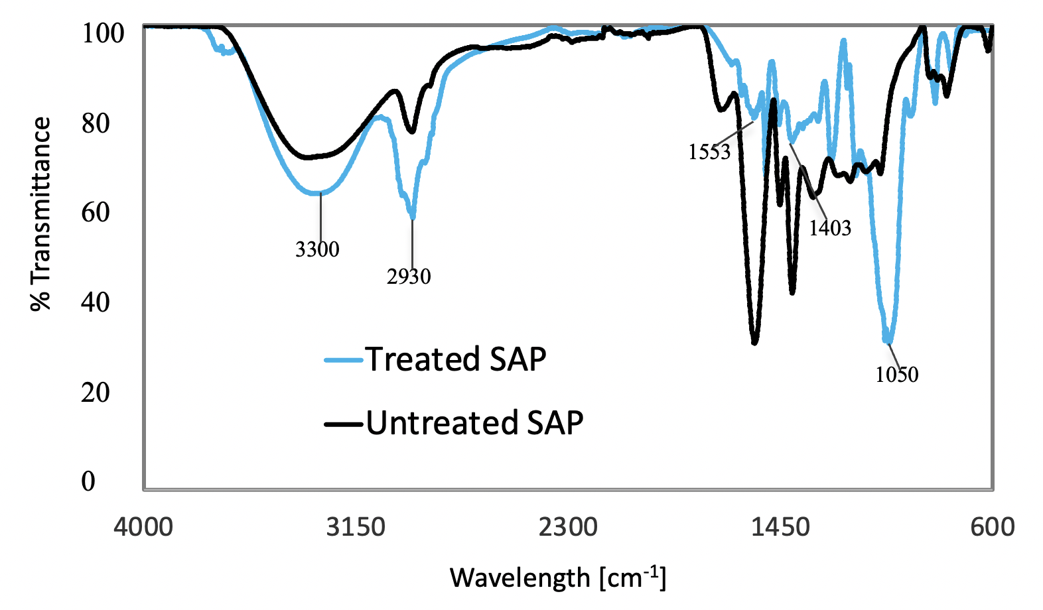

Figure 1. FTIR Results for untreated SAP and corn starch treated SAP

3.2 Absorption Capacities and Permeability of SAP

Free swell capacity (FSC) of SAP measures the absorption capacity of SAP where SAP is allowed to swell without a restraining load using a test solution such as 0.9% solution (Melendres et al., 2020). Besides FSC, SAP performance is also evaluated in terms of permeability of the polymer’s partially swollen gel. The Gel Layer Permeability (GLP) measures the permeability of partially swollen SAP particle layer under a confining pressure. SAP treated by the corn starch at different starch loading were subjected to these tests. SAP treatment of corn starch was done at different starch loading using 2% starch aqueous mixture to give a partially swelled SAP with volumetric degree of swelling found in Table 1 at corresponding starch loading. The volumetric degree of swelling, *q*, is calculated based on equation 2 below as,

$q=\frac{[(w_{1}{-w_{s})/ρ_{1}+(w}_{o}/ρ_{o})] }{ (w_{o}/ρ_{o)} }$ (2)

In this equation, *wo* is the dry polymer weight, *r*o is the polymer density, *r*1 is the liquid weight in solution, *ws* is the liquid weight absorb by starch and *r*1 is the liquid density. The volumetric degree of swelling increases with starch loading due to increased amount of starch suspension as the starch loading is increased which required longer time of heat treatment.

Table 1. Starch loading and SAP Degree of Swelling

|  |  |
| --- | --- |
| Starch Loading (g/g) | Degree of Swelling (*q*) |
| 0.02 | 2.60 |
| 0.04 | 4.21 |
| 0.06 | 5.81 |
| 0.08 | 7.42 |

Figure 2 describes the result of FSC and GLP tests right after the treatment at different starch loading using test solution of 0.9% NaCl. For comparison, the chart also shows the results for untreated SAP. While the graph for FSC decreases with increasing starch loading, an inverse relation is obtained with GLP, i.e., GLP increases with increasing starch loading. The decrease in FSC with increasing starch loading and the increase in permeability with increasing starch loading indicate that the corn starch had increased the rigidity of the gel

Figure 2. Free Swell Capacity and GLP of Untreated and Corn Starch treated SAP

and thus behaved as crosslinker on the surface of SAP thereby providing higher permeability due to a more porous gel layer.

3.3 Biodegradability of SAP

Figure 3 shows photos of SAP exposed to biodegradability test where the samples were subjected at high humidity at 30-35oC. Sample of corn starch treated SAP at the start of the biodegradability test shown in the first photo as a) is also included in the figure to benchmark the SAP’s discoloration during the test period of six weeks. Samples b), c) and d) are SAP samples of EC treated, untreated and corn starch treated samples, respectively. As shown in the photos, samples of starch treated SAP gave more intense brownish color compared with other photos. The corn starch treated sample in the photo has starch loading of 0.04 g/g. Other starch loadings done in this test also experienced more brownish color appearance. The test revealed the biodegradable characteristic of corn starch treated samples compared with EC treated and untreated samples. The corn starch treated sample gave more biodegradable property due to the ability of the SAP that was structurally incorporated with corn starch leading to a biodegradation at a faster pace. Moisture and temperature affect material surface and could lead to decay or biodegradation (Moncmanová A., 2007).

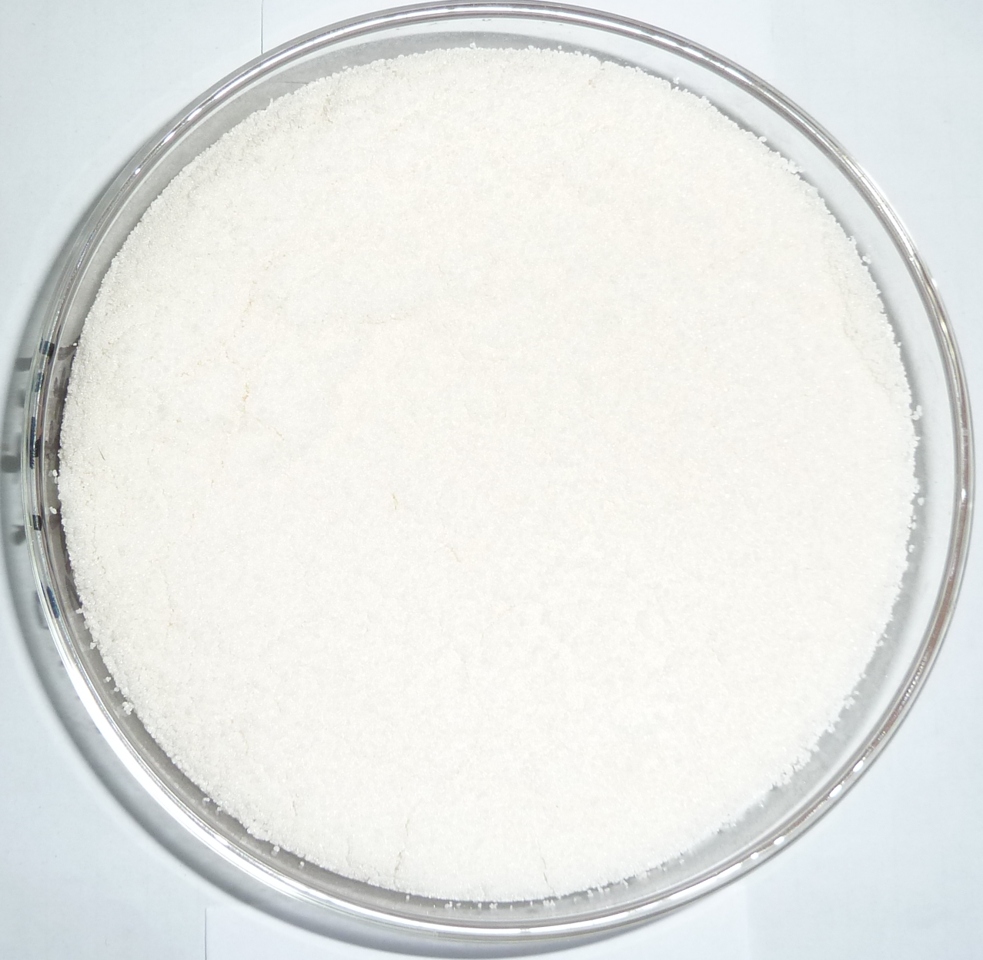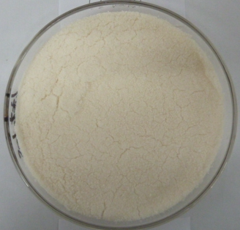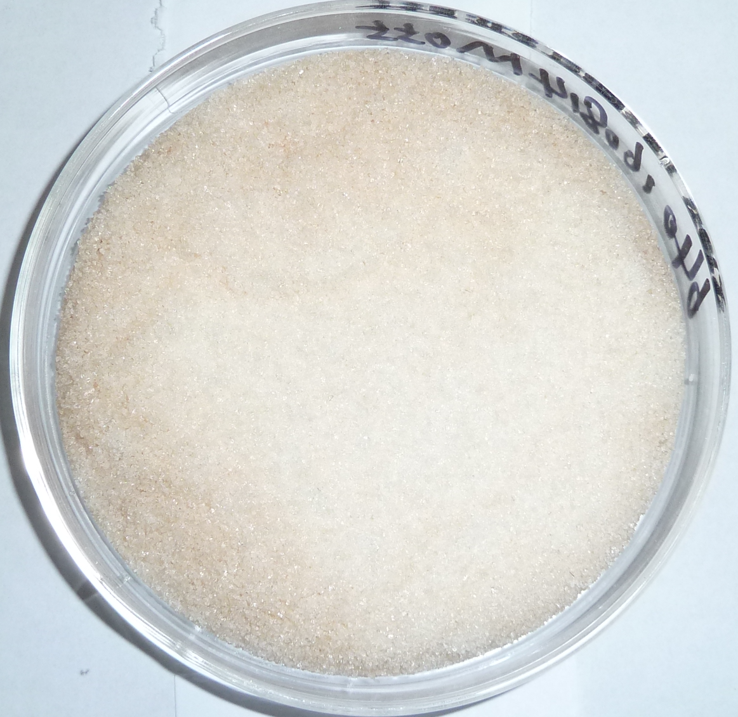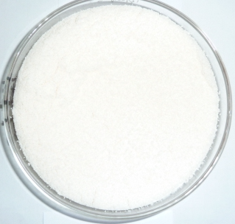

c)

d)

a)

b)

Figure 3. Photos of SAP. a) corn starch treated SAP before biodegradation test, b), c) and d) are photos of SAP for Ethylene Carbonate, untreated, and corn starch treated, respectively, after 6 weeks of biodegradability test.

The formation of moisture layer on the SAP granules leads to the biodegradation as shown by the changes in the texture and color. These changes in the color is normally triggered by the growth of microorganisms on SAP surface specially on the starch treated as observed also in other research (Nissa et al., 2009).

In Figure 4 and Figure 5, the results of the absorption and permeability tests for SAP samples subjected to biodegradability test are shown. All the samples used in this test were dried to its original dry state and particles were screened between 300-800 microns. In these charts, samples show loss of absorption capacity and permeability after the samples had been subjected to biodegradability tests at high humidity environment at about 33oC.

Figure 4. Free Swell Capacity Before and After Biodegradability Test

Figure 5. GLP Before and After Biodegradability Test

Figure 4 shows that the corn starch treated sample has the highest loss in free swell capacity among the three samples tested. The EC treated gave the lowest loss in free swell capacity while untreated SAP gave lower loss in capacity than corn starch treated, but higher than EC treated SAP. The same trend is observed in Figure 5 for GLP test. Corn starch treated sample gave the highest loss in permeability while the untreated and EC treated SAP gave lower loss in permeability. Note that an addition of non-biodegradable crosslinkers rendered the SAP to be more structurally stable and thus has less tendency to experience biodegradation as compared with the addition of corn starch in the structure of SAP. Another research showed more than 50% loss in absorption capacity after subjecting the SAP to biodegradability tests for ten weeks (Benkeerre, et al., 2021). The cornstarch could have acted as a crosslinker between the polymer chains of sodium polyacrylate SAP. The negatively fixed charges along the SAP polymer chains formed bonds with the hydroxyl group of the starch chains forming networks of crosslinked polymerchains which could be easily degraded biologically compared with the current petrochemical based SAP.

* 1. Conclusions

Samples of SAP were surface-treated with corn starch, a biodegradable, naturally occurring polysaccharide made from corn, at different concentrations of starch suspensions. The free swell capacity (FSC), was determined at 0.9% NaCl. Gel Layer Permeability (GLP) test was used to evaluate the permeability of SAP where samples were allowed to partially swell at 0.9% sodium chloride for one hour. Results of FSC and GLP tests showed corn starch was able to modify the absorption and permeability properties of SAP due to increased gel strength after the treatment. The results on biodegradability tests showed that corn starch surface treated SAP has better biodegradability than SAP made from entirely petrochemicals as shown in the discoloration test. The corn starch treated samples also shows a more biodegraded structure base on the results of the free swell capacity and permeability tests.

Acknowledgments

The authors would like to acknowledge the support from ITDI-ADMATEL and PCIEERD of the Department of Science and Technology, Philippines.

References

Bachra Y., Grouli A., Damiri F., Bennamara A., Berrada M.,2020, A new approach for assessing the absorption of disposable baby diapers and superabsorbent polymers: A comparative study, Results in Materials, 8, 100156.

Bankeeree W., Samathayanon C., Prasongsuk S., Lotrakul P., Kiatkamjornwong S., 2021, Rapid Degradation of Superabsorbent Poly(Potassium Acrylate) and its Acrylamide Copolymer Via Thermo-Oxidation by Hydrogen Peroxide, Journal of Polymers and the Environment,  29, 3964–3976.

Jockusch S., Turro N.J., Mitsukami Y., Matsumoto M., Iwamura T., Lindner T., Flohr A., Massimo G., 2009, Photoinduced surface crosslinking of superabsorbent polymer particles, 111,5,2163-2170.

Kim Y.J., Hong S.J, Shin W. S., Kwon Y. R., Lim S.H., Kim H. C., Kim J.S., Kim J.W., Kim D. H., 2019, Preparation of a Biodegradable Superabsorbent Polymer and Measurements of Changes in Absorption Properties depending on the type of Surface-Crosslinker, Polymer Advance Technologies, 31, 2, 273-283.

Kono, H., Fujita, S., 2012, Biodegradable superabsorbent hydrogels derived from cellulose by esterification crosslinking with 1,2,3,4-butanetetracarboxylic dianhydride. Carbohydr. Polym., 87,4, 2582–2588.

Kosemund K., Schlatter H., Ochsenhirt J.L., Krause E.L., Marsman D.S., Erasala G.N., 2009, Safety evaluation of superabsorbent baby diapers, Regul. Toxicol. Pharmacol. 53, 81–89.

Lee J., Park S., Roh H., Oh S., Kim S., Kim M., Kim D., Park J., 2018, Preparation and Characterization of Superabsorbent Polymers Based on Starch Aldehydes and Carboxymethyl Cellulose, Polymers, 10,605.

Melendres A., Antang J.A. and Manacob J., 2019, Investigation of Superabsorbent Polymer Absorbency at Reduced Chemical Potential of Water, MATEC Web of Conferences, 268, 04010.

Melendres A. V., Carrillo L. A., 2019, Surface Treatment of Superabsorbent Polymer with Corn Starch for Improved Properties, Asean J. Chemical Engineering, 19, 66-73.

Melendres A.V., Vera Cruz R.P., 2020, Absorption of Water Vapor Using Superabsorbent Polymer Composite Material, Key Engineering Materials, 858, 129-139.

Moncmanová A., 2007, Environmental factors that influence the deterioration of materials, Environmental Deterioration of Materials , Vol. 21, WIT Press.

Nissa R.C., Fikriyyah A.K., Abdullah A.H.D., Pudjiraharti S.,2019, Preliminary study of biodegradability of starch-based bioplastics using ASTM G21-70, dip-hanging, and Soil Burial Test methods IOP Conf. Ser.: Earth Environ. Sci. 277 012007.

Nnadi F, Brave C., 2011, Environmentally friendly superabsorbent polymers for water conservation in agricultural lands, Journal of Soil Science and Environmental Management, 2, 7, 206-211.

Phang Y., Chee S., Lee C., The Y., 2001, Thermal and microbial degradation of alginate-based superabsorbent polymer, Polymer Degradation and Stability, 96,9, 1653-1661.

Sannino A., Christian Demitri C., Madaghiele M., 2009, Biodegradable Cellulose-based Hydrogels: Design and Applications, Materials, 2, 2, 353-373.

Shibly M.M.H., Hossain M.A., Hossain M.F., Nur M.G., Hossain M.B., 2021, Development of Biopolymer-based Menstrual Pad and Quality Analysis Against Commercial Merchandise, Bull Natl Res Cent,  45, 50, https://doi.org/10.1186/s42269-021-00504-2.

Stahl J.D., Cameron M.D., Haselbach J., Aust S.D.,2000, Biodegradation of Superabsorbent Polymers, ESPR - Environ. Sci. & Pollut. Res. 7, 2, 83 – 88.

Venkatachalam D., Vediappan V., Kaliappa Gounder S., 2013, Synthesis and evaluation of trimethylolpropane triacrylate crosslinked superabsorbent polymers for conserving water and fertilizers, Journal of Applied Polymer Science, 129, 1350–1361.

Wang W., Zhang J., Wang A., 2009, Preparation and swelling properties of superabsorbent nanocomposites based on natural guar gum and organo-vermiculite, Appl. Clay Sci.46, 1, 21–26.

Wilske B., Bai M., Lindenstruth B., Bach M., Rezaie Z., Frede H., Breuer L., 2014, Biodegradability of a polyacrylate superabsorbent in agricultural soil, Environmental Science and Pollution Research volume  21, 9453-9460.

Ye H., Zhao J.Q., Zhang Y.H., 2004, Novel degradable superabsorbent materials of silicate/acrylic-based polymer hybrids. J Appl Polym Sci 91, 936–940.

Yoshimura T., Yoshimura R., Seki C., Fujioka, R., 2006, Synthesis and characterization of biodegradable hydrogels based on starch and succinic anhydride. Carbohydr. Polym., 64, 345–349.