CHEMICAL ENGINEERING TRANSACTIONS  VOL. 92, 2022 | A publication of
The Italian Association
of Chemical Engineering
Online at www.cetjournal.it

Guest Editors: Rubens Maciel Filho, Eliseo Ranzi, Leonardo Tognotti
Copyright © 2022, AIDIC Servizi S.r.l.
ISBN 978-88-95608-90-7; ISSN 2283-9216

Development of a bubbling circulating fluidized-bed reactor for biomass and waste gasification
Esa Kurkela, Minna Kurkela & Sanna Tuomi
VTT Technical Research Centre of Finland Ltd, P.O. Box 1000, FI-02044 VTT, Finland
esa.kurkela@vtt.fi
The Bubbling Circulating Fluidized-Bed (BCFB) gasifier described in this paper is based on a combination of the two fluidized-bed reactor types: a bubbling and a circulating fluidized-bed. The BCFB gasifier was originally developed in the early 2000s and designed for air-blown gasification of waste-derived feedstocks that have very high volatile matter content resulting in high tar concentration in the raw product gas. In an ongoing EU project FlexSNG, the BCFB gasification technology is now adapted for the co-production of biochar and synthesis-quality gas, using steam and oxygen as fluidizing gases. In this paper, the pilot-scale development of the BCFB gasifier in air-blown operation with wood residues and a waste-derived feedstock is firstly presented. Then, the use of this gasifier design for the co-production of biochar and synthesis gas is described and the results from preliminary process simulations are presented. Estimated process performances are shown for two operation modes. In the maximized synthesis gas mode, the gasifier is operated at 900 °C resulting in a similar performance to a conventional CFB gasifier. In co-production operation mode, the bottom section of the BCFB gasifier acts as the carbonization zone producing good-quality biochar, which is recovered from the bottom of the gasifier.
  - Introduction
A fluidized-bed reactor is one of the leading reactor types applied for biomass and waste gasification. It is especially suitable for inhomogeneous feedstocks that have high volatile matter content and high char reactivity. The massive bed stabilizes the pyrolysis, gasification and combustion reactions and helps to maintain good mixing of the reacting feedstock particles and gasification agents. Often the temperature distribution throughout the gasifier is also rather uniform, which is not the case in fixed-bed or entrained flow gasifiers. The two basic types of the fluidized-bed gasifier and the third modified version used in the tests of this paper are illustrated in Figure 1. The circulating fluidized-bed (CFB) is nowadays commonly used in air-blown biomass and waste gasification applications (Isaksson, 2015), while the bubbling fluidized-bed (BFB) was commercialized already in the 1920s for coal gasification and has later been used also for biomass gasification (Hofbauer, 2019). In the CFB design of Figure 1, a high-volatile-matter feedstock, such as biomass or waste, is pyrolyzed in the upper part of the gasifier and the charcoal is recycled back to the bottom of the gasifier together with the recycling bed material, sand and/or dolomite. This principle leads to high carbon conversion as the oxygen of the fluidization gas is reacting primarily with the charcoal instead of burning gases and tars released from the volatile matter. High fluidizing velocities together with the presence of bed particles throughout the reactor help in avoiding ash-related problems such as bed sintering and deposit formation in the upper part of the reactor. In the BFB design, the feedstock is fed into the massive bubbling bed where the pyrolysis and secondary tar decomposition reactions also take place. In this process, the released volatile matter may also react with oxygen, which usually leads to lower tar contents than in CFB gasifiers. However, the carbon conversion is more dependent on steam and CO₂ gasification reactions which are known to be significantly slower than combustion reactions. Consequently, the carbon conversion usually is lower in the BFB gasifiers, and recycling the cyclone fines is rather inefficient. In addition, the recycling line tends to get blocked as the biomass-derived charcoal has a very low bulk density and small particle size, and the recycling mass flow is rather small (Koljonen et al, 1993). BFB gasifiers are also more sensitive to feedstock particle size distribution than CFBs. Fines escape from the dense bed and are pyrolyzed in the practically empty freeboard, while in the CFB, the recycling bed particles offer catalyzing surfaces for tar decomposition also in the upper part of the reactor.
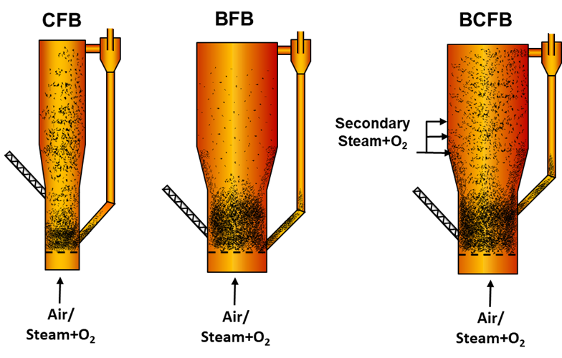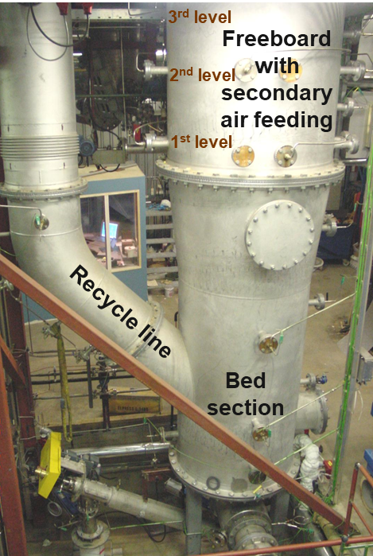
Figure 1: Basic fluidized-bed gasifier types and a photograph of the BCFB pilot gasifier.
The BCFB gasifier applied in this study is essentially a combination of a bubbling fluidized-bed (BFB) bottom and a circulating fluidized-bed (CFB) top thus coupling the benefits of both reactor technologies. In this process, the feeding of gasification agents (air or a mixture of steam and oxygen) is divided into primary and secondary feeds. A mixture of coarse and finer bed material, sand and dolomite, is used to achieve a stable bubbling bed at the bottom of the reactor and a circulating fluidized bed above the dense bed. The upper part of the reactor operates in circulating fluidized-bed mode with the purpose of partially decomposing tars before subsequent clean-up steps and thus preventing tar-related issues downstream the gasifier, e.g. tar deposition, filter blinding, or catalyst coking. This is achieved by introducing a catalytically active bed material (e.g. limestone or dolomite) in the top section and elevating the temperature to 850-900 °C through secondary air or steam and oxygen injection. The presence of fine particles provides the required active surfaces for tar decomposition reactions.
  - Experimental
    - BCFB pilot plant
The gasification tests were carried out with the atmospheric pressure Bubbling Fluidized-Bed (BFB) gasification pilot plant facility, which had a maximum feedstock capacity corresponding to 1 MW. The gasification reactor was constructed according to the BCFB configuration presented in Figure 1. Air and a small amount of steam were used as the primary fluidization gas. In addition, secondary air was introduced to the upper part of the reactor through 12 nozzles, which were located at three vertical levels, 3.0, 3.6, and 4.2 meters above the primary air distributor. The diameter and height of the lower dense bed section were 450 mm and 2200 mm respectively. The total effective gasifier height (from the air distributor to the gas outlet pipe) was 7.3 m and the diameter in the upper part was 650 mm. The center of the fuel feeding port was located 490 mm and the recycling line 690 mm above the distributor plate. The amount of bed material in the gasifier was controlled based on the pressure measurements so that the level of the dense bed was kept ca. 10 cm above the connection for the recycling pipe. After the recycling cyclone, the product gas was led through two heat exchangers, in which the gas was cooled to the target filtration temperature. The first gas cooler was equipped with vertical cooling tubes and the raw gas flew from top to bottom. Pressurized water at 140-160 °C was used as a cooling medium. The secondary gas cooler was equipped with five horizontal cooling tube blocks. Steam with an inlet temperature of 170 °C was used as a cooling media. The cooled product gas was filtered with a bag filter unit including 36 bags of FB900 supplied by 3M company. In the tests of this paper, the filter was operated at 350-400 °C.
    - Gasifier feedstocks
The first test week of this paper was realized with rather clean waste wood and the second week with two solid recovered fuel (SRF) qualities. Table 1 below presents the averaged results for the analyses of the feedstocks used in the test campaigns. SRF2 was in the form of pellets and it had low moisture and high plastic content and a very high volatile matter content. SRF1 originated from municipal solid waste (MSW) and it was not pelletized but had been just crushed to below 20 mm sieve. SRF1 had higher moisture and ash contents and a lower heating value than SRF2. Waste wood chips were crushed below 10 mm sieve before use. Mixtures of silica sand with a wide particle size distribution of 0.1-0.8 mm and limestone Parfil P3 (of 0.1-0.9 mm) were used as the bed material.

Table 1: Feedstock analyses as used in the gasification campaigns.
 | Moisture  wt% | Volatiles  wt% d.b. | C | H | N | wt% d.b.  Cl | S | O | Ash | LHV  MJ/kg d.b
Wood waste  SRF1  SRF2 | 25.2  18.7  1.9 | 80.7  74.6  80.4 | 49.9  51.3  53.9 | 6.1  7.2  7.8 | 0.4  1.0  0.7 | nd  0.84  0.64 | 0.01  0.32  0.14 | 41.7  24.6  26.7 | 2.0  14.7  10.1 | 18.8  21.3  22.6
  - Results from air-blown gasification tests with wood and solid recovered fuel
The results presented in this paper are from two one-week-long test runs during which the plant was operated continuously. Typically, a test week included a preheating period, 2-4 steady-state set point periods, and a shutdown and cooling period. Applied operation methods, analytical procedures, and the methods for calculating mass balances and performance indicators were similar as described in (Kurkela et al, 2021) and (Laatikainen-Luntama et al, 2015). Measurements were carried out in five 6-24-hour-long periods (set points), during which the mass flow rates of the input streams were kept as constant as possible. Elemental mass balances and performance indicators of the gasification process were calculated for the set point periods based on average measuring results. The main operating conditions and calculated performances for selected steady-state set points are summarized in Table 2.
Table 2: Main operating conditions of the gasifier at set points.
Set point  Feedstock | A  Wood waste | B  Wood waste | C  SRF1 | D  SRF1 | E  SRF2
Fuel moisture content (ar), % | 25.2 | 25.2 | 18.7 | 18.7 | 1.9
Fuel feed rate, g/s | 38 | 34 | 35 | 31 | 27
Bed additivesª  Sand +limestone feed, g/s  Primary air feed, g/s  Secondary air feed, g/s  Steam feed, g/s  T bed, °C  T freeboard, °C  Air ratio of gasification  Bed pressure drop, mbar  Fluidization velocity, m/s  Wet gas flow rate, m³/h (STP^{b}) | ⅔S+⅓P3  3.4  56  3.4  4.1  892  908  0.36  47  1.2  335 | ⅓S+⅔P3  2.7  56  3.1  4.3  893  887  0.37  49  1.2  324 | ½S+½P3  3.7  57.1  6.8  6.2  847  855  0.32  48  1.3  318 | ½S+½P3  4.3  57.2  5.0  5.3  870  873  0.33  51  1.3  302 | ½S+½P3  3.3  55.0  4.8  6.1  870  873  0.29  51  1.2  285
Dry gas composition, vol%  CO  CO₂  H₂  N₂ (as difference)  CH₄  C₂H_{y}  C₃-C₅Hy  NH₃  H₂O in wet gas, vol% | 10.5  17.3  11.3  56.6  3.3  0.82  -  0.16  22.8 | 10.4  17.7  12.4  55.7  3.2  0.66  -  nm  20.4 | 5.0  17.8  7.0  62.3  4.6  2.8  0.05  0.51  23.7 | 5.5  17.3  7.7  62.2  4.5  2.3  0.03  0.51  21.7 | 7.4  16.3  9.0  59.3  5.0  2.6  0.04  0.38  16.4
Tars + benzene, g/m³_{STP} | 9.7 | 7.3 | 30.6 | 32.3 | 31.9
Filter temperature, °C  Dust content in filter inlet, g/m³_{STP}  Filter pressure drop, mbar  Filter face velocity, cm/s | 372  8.4  13.1  0.91 | 373  6.2  12.5  0.88 | 359  40.8  13.8  0.84 | 376  43.0  14.0  0.82 | 392  25.3  14.0  0.79
C-conversion, wt%  to dry gas and tars | 97.7 | 98.1 | 99.3 | 99.4 | 98.8
Mass balance closures (out/in)  C-balance  O-balance  Ash balance | 1.00  1.01  0.78 | 0.99  1.01  1.02 | 1.00  1.02  1.04 | 1.00  1.03  1.08 | 0.99  1.03  1.03
ª S + P3: The mixture of sand and Parfil3 limestone, ^{b} STP: at 273.15 K and 101,325 kPa, nm: not measured

In the gasification of SRF, the tar contents were more than three times higher than in wood gasification. Bed material calcium is not actively catalyzing tar decomposition reactions evidently due to higher chlorine and sulfur contents, which may react with the CaO particles and make them inactive. In wood gasification, tar decomposition is effectively catalyzed by bed material calcium. The lowest tar contents were measured in set point B, where the share of limestone in the bed material was higher than in set point A. The tar results obtained at this BCFB gasifier are in a good agreement with those reported for the ordinary CFB gasifier (Kurkela et al, 2021). In wood gasification, 86 % of the feedstock nitrogen was converted to ammonia and in the test with SRF, the conversion was in the range of 65-70 %. These results are also similar to those determined for CFB gasification (Kurkela et al, 2021).
The operation of the bag filter unit was stable and the pressure drop remained at a constant level after the initial increase as illustrated in Figure 3. The 36 filter bags were located in six rows and each of them was equipped with a nitrogen pulse cleaning tube. In the SRF test run, the interval between pulsing of individual filter clusters was 12 min, the pulse valve opening time was 0.25 s, and the pulsing pressure was 3.5 bar. This test run was started by a short period of wood gasification and the pressure drop started to increase immediately when the feedstock was changed to SRF. A rather thick dust cake was formed around the filter bags and this residual cake could not be removed by pulse cleaning. This is illustrated in the photograph of the used filter elements taken after the test run. This is a typical challenge of SRF gasification where the contents of heavy tars are high and part of these tars are captured by the filter cake. The high dust content, however, seemed to protect the filter from severe tar blinding and thus enabled stable operation.
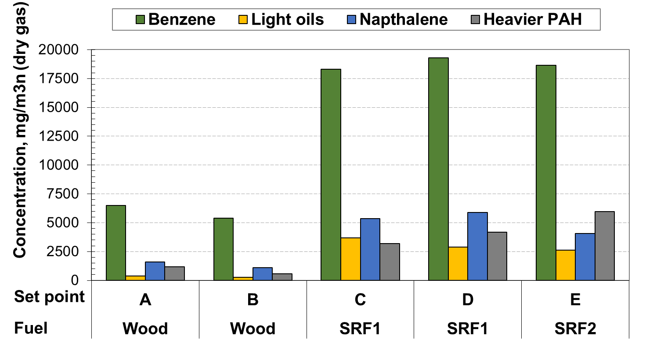
Figure 2: Concentration of tars at selected set points.
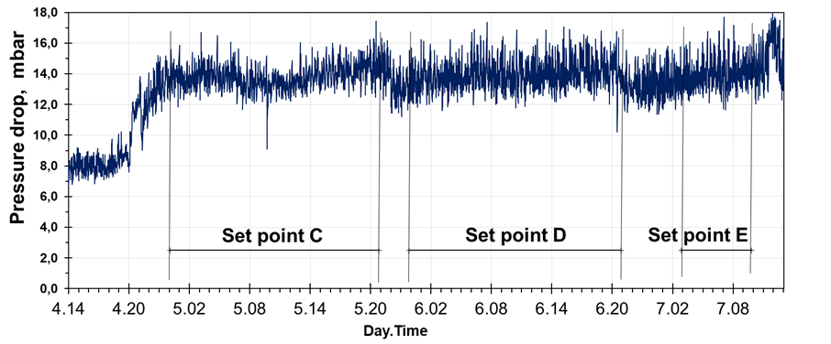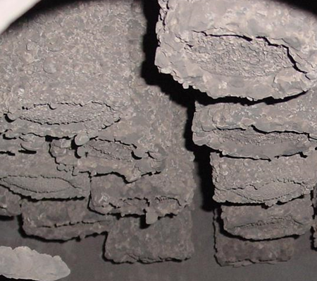
Figure 3: Pressure drop across the filter in the test run with SRF and a photograph of filters after the test.
  - Estimated performance of co-producing biochar and synthesis gas
Both BFB and CFB gasifiers can also be operated as steam-oxygen blown synthesis gas production units. In this chapter, the plant performances in an ordinary BTL (Biomass-to-Liquids) mode and co-production mode are evaluated. In co-production, biochar is produced in addition to the Fischer-Tropsch (FT) hydrocarbons. The two intermediate bioenergy carriers, FT-hydrocarbons and biochar, produced at the plant can be used widely in the energy system in transport and energy production and industries. Biochar is a solid and easily storable bioenergy carrier that can be used to displace fossil feedstock in energy production (e.g. dispatchable thermal generation, co-firing, district heating) and industry (e.g. cement, iron and steel making). Pelletized biochar has about 5-6 times higher energy density than wood chips and 1.5 times higher than wood pellets. In addition to energy use or substitution of coal in industrial operations, biochar can be used in e.g. agriculture for soil amendment, wastewater treatment, and various material applications, such as activated carbon. Biochar also has potential in carbon sequestration enabling the production of renewable transport fuels with negative CO₂ emissions.
The production concept illustrated in Figure 4 is similar to the one used in previous studies described in (McKeough and Kurkela, 2007) and (Hannula, 2015). An excel-based simulation model was used to estimate the mass and energy balances for the plant operated in BTL alone and co-production. In the BTL case, gasification is carried out at 900 °C and with a high carbon conversion efficiency of 98.5 %. In the co-operation mode, the gasifier operates at 820 °C and 20 % of biomass carbon is assumed to be recovered as biochar from the bottom and fly ash streams. In both cases, the raw gas is cooled to 600 °C, filtered, and led to the catalytic reformer similarly as in the studies described in (Hannula, 2015). The reformer is operated with an outlet temperature of 900 °C and the conversion efficiencies for methane, C₂-hydrocarbon gases and tars are 70%, 100%, and 99.5 %, respectively. The final gas cleaning and FT-processes are calculated using the models described in (McKeough and Kurkela, 2007). A short recycle loop for the FT tail gas is applied. The CO-conversion and C5+ selectivity of the FT process are 85% and 91 %, respectively. In both studied cases, biomass is assumed to arrive in the plant at 50 % moisture content and it is dried in a belt-dryer to the final moisture of 15 %. The energy efficiency of the dryer is assumed to be 55 % and hot water and steam are used to provide heat for drying. Elemental and proximate analysis and lower heating value of dry matter are from Table 1.

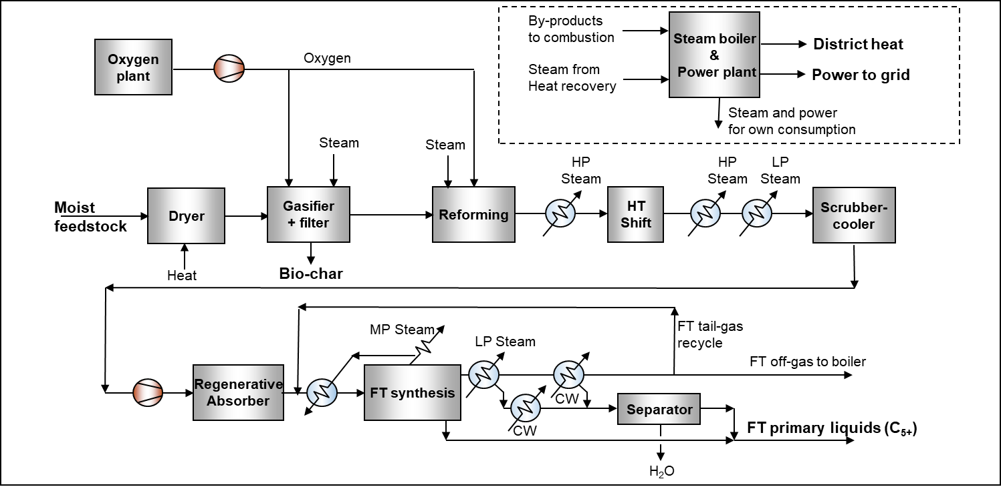
Figure 4: Schematic of the studied biomass-to-liquids plant configurations
The results presented in Figure 5 are scaled for a 100 MW biomass input so that it is easy to compare the energy conversion efficiencies to different products. In reality, however, this type of process concept requires at least a 150-300 MW scale to reach positive economics (Hannula, 2015). In the first case, 48.2 % of biomass energy is converted to FT liquids. In addition, the net production of heat and electricity corresponds to 21.9 % and 4.6 %, respectively. Total energy conversion efficiency to usable products is 74.6 %. In this basic process, 30.3 % of biomass carbon is converted into the final FT products, while the rest is released to the atmosphere as CO₂. In the second case, the total energy conversion efficiency is almost the same as in the first case, but now roughly 20 % of biomass energy is retained in the biochar. Consequently, the efficiencies to heat, power and FT-products are lower. Even in this case, the plant is self-sufficient for electricity. The carbon efficiency to FT-products and biochar is 45.1 %, which is higher than achieved in the basic BTL case.
The BCFB gasifier design offers several potential advantages in realizing a flexible process, which can be operated both with a maximized syngas yield as well as in co-production of syngas and biochar. In the maximized syngas production mode, the gasifier is operated with uniform temperature distribution and higher oxygen-to-fuel ratio resulting in ca. 900 °C and almost complete carbon conversion. In the co-operation mode, the primary oxygen feed is decreased and bed temperature is reduced to 750-800 °C. Secondary oxygen can be fed to the upper part of the gasifier if necessary for reducing the tar content before the filter and catalytic reformer. In an ordinary CFB gasifier, the unconverted charcoal is elutriating from the bed and in the course of recycling is attrited into very fine particles, which finally pass through the recycling cyclone and are captured as filter fines. In principle, the BFB gasifier offers possibilities to recover a larger part of the biochar directly from the bed. This bed charcoal has a larger particle size and may be of better quality than the biochar collected by the hot filter.

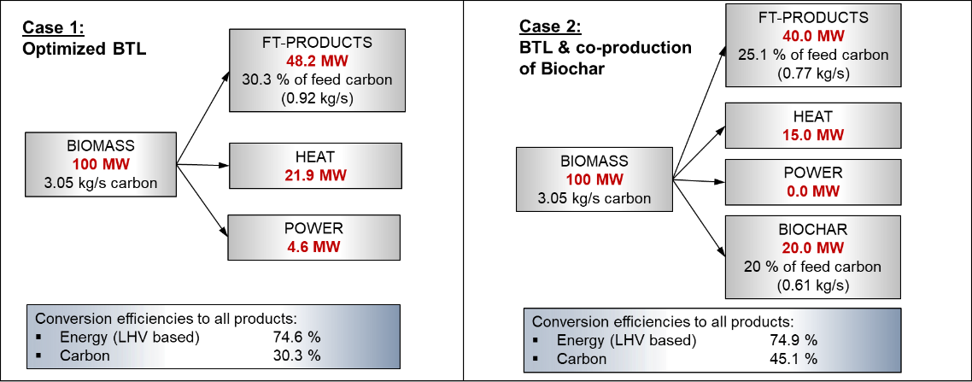
Figure 5: Energy and carbon mass flows and conversion efficiencies for the two studied operation modes
  - Conclusions and further R&D
A modified version of the bubbling fluidized-bed gasifier was developed and tested at a 1 MW pilot plant. This gasifier could be smoothly operated with wood wastes as well as with low-quality MSW-based feedstock. A secondary circulating bed could be created to increase the particle density in the upper part of the gasifier. This contributed to improved tar decomposition by providing catalyzing surfaces and helped in maintaining a stable recycle flow from the cyclone separator back to the upper part of the bottom bed. This system also requires a significantly lower pressure drop for the recycle loop compared to the ordinary design where the recycle line is connected to the bottom of the dense bed. This gasifier design also is considered to have a great potential in realizing a flexible synthesis gas production plant, which can be operated with a target for complete carbon conversion as well as with a target of producing biochar as a valuable by-product.
This flexible production concept is presently developed in an EU-Canada collaboration project “FlexSNG”. In this project, the targeted products are synthetic natural gas (SNG) and biochar. One of the general advantages of the gasification-based biomass conversion route is the variety of potential final products, as the syngas is suitable for various alternative synthesis processes.
Acknowledgments
The process evaluation work and the preparation of this paper have been made within the FlexSNG project, which has received funding from the European Union’s Horizon 2020 Research and Innovation Programme under Grant Agreement No 101022432 and the Government of Canada’s New Frontiers in Research Fund (NFRF) and the Fonds de recherche du Québec (FRQ). Pilot tests were realized in previous VTT projects.
References
Hannula, I. (2015). Synthetic fuels and light olefins from biomass residues, carbon dioxide and electricity: Performance and cost analysis: Dissertation. VTT Technical Research Centre of Finland.
Hofbauer H., 2019, Large Scale Biomass Gasification for Electricity and Fuels, In: Kaltschmitt M., (Ed.), Energy from Organic Materials, Encyclopedia of Sustainability Science and Tech., Springer, New York.
Isaksson J., 2015, Commercial CFB gasification of waste and biofuels - Operational experiences in large scale, presentation at the Gasification Tech. Conf., October 11–14, 2015, Colorado Springs, USA.
Koljonen J., Kurkela E., Wilén, C., 1993, Peat-based HTW-plant at Oulu, Bioresource Technology, 46, 95 – 102.
Kurkela E., Kurkela M., Nieminen, M., Laatikainen-Luntama J., 2021, Circulating fluidized bed gasification of solid recovered fuels - Results from gasification and gas filtration tests. Chemical Engineering Transactions, 86, 19-24.
Laatikainen-Luntama J., Kurkela E., 2015, Air-blown CFB gasification of forest residues, demolition wood and crushed wheat straw pellets, In: Bankiewicz D., Mäkinen M., Yrjas P. (Ed.), Proceedings of the 22nd International Conference on Fluidized Bed Conversion, 14-17 June 2015, Turku, Finland, 476–486.
McKeough, P., Kurkela, E., 2007, Detailed comparison of efficiencies and costs of producing FT liquids, methanol, SNG and hydrogen from biomass, 15th European Biomass Conference, Berlin, Germany.

