CHEMICAL ENGINEERING TRANSACTIONS  VOL. 92, 2022 | A publication of
The Italian Association
of Chemical Engineering
Online at www.cetjournal.it

Guest Editors: Rubens Maciel Filho, Eliseo Ranzi, Leonardo Tognotti
Copyright © 2022, AIDIC Servizi S.r.l.
ISBN 978-88-95608-90-7; ISSN 2283-9216

Thermodynamic Calculation for the Formation of Methane and Carbon Dioxide Hydrates
Isabela T. Bicalho, Reginaldo Guirardello*
School of Chemical Engineering, University of Campinas (UNICAMP), Av. Albert Einstein 500, 13083-852, Campinas – SP, Brazil.
guira@feq.unicamp.br
The development of carbon capture and storage (CCS) methods has attracted the scientific community’s interest, mainly because it is a technology that can act in the control of greenhouse gas (GHG) emissions with the global permanence of the use of fuels fossils. In this sense, the application of hydrates as a CCS method has become a promising alternative compared to other strategies to reduce carbon dioxide emissions in the atmosphere, mainly due to the large capacity of gas storage, in addition to the possibility of recovery of methane from natural gas hydrate reserves (NGHs) while carbon dioxide is stored in these reservoirs. Therefore, this work studied the thermodynamic equilibrium of hydrate considering a ternary system composed of CO₂, CH₄ and H₂O, in order to contribute to its application as a CCS method. For this, the isofugacity criterion was used to determine the three-phase equilibrium curve of the system and the methodology referring to the minimization of the Gibbs energy was chosen to complement the study since this method allows to determine the compositions of a multiphase and multicomponent system robustly and stably. The Soave-Redlich-Kwong cubic (SRK) equation was used to calculate the liquid and gas phases and the Van Der Waals and Platteeuw models were used to describe the solid-phase of the hydrate. The thermodynamic calculus was developed as an optimization problem, using the General Algebraic Modeling System (GAMS) software and the CONOPT4 solver. The results of this research were compared with experimental data available in the literature, allowing to conclude the satisfactory prediction of the behavior of the phase equilibrium of the studied system.
  - Introduction
Hydrates are non-stoichiometric crystalline structures composed of water molecules and low molecular weight compounds, being generally formed under conditions of high pressure and low temperatures. The molecules of one or more gases are trapped in cavities formed by water molecules, joined by hydrogen bonds, stabilizing the hydrate structure due to Van Der Waals interactions (Sloan and Koh, 2008).
The development of Carbon Capture and Storage (CCS) methods has attracted scientific interest, mainly because it is a technology that can act in the control of greenhouse gas emissions with the global permanence of the use of fossil fuels. This is an important factor because, according to a projection made by the International Energy Agency (IEA, 2017) through the World Energy Outlook (2017) report, fossil fuels (oil, natural gas and coal) will continue to be the main energy sources until of the year 2040.
In this sense, the use of hydrates in CCS technologies has become a promising alternative when compared to other strategies to reduce carbon dioxide (CO₂) emissions in the atmosphere due to the large gas storage capacity (1m³ of hydrate can contain about 156 m³ of pure CO₂) (Takeya et al., 2016), low environmental damage, lower adaptation costs for industries and the possibility of recovering methane (CH₄) from natural gas hydrate reserves (NGHs) while CO₂ is stored in these reservoirs, performing CO₂ sequestration and CH₄ recovery simultaneously (Wang et al., 2020).
From this, it is possible to perceive the importance of deepening studies on hydrates in order to expand the knowledge of these systems as a whole, collaborating with the development of more efficient, safe and applicable technologies on an industrial scale.
Therefore, the motivation of this work was to study the thermodynamic equilibrium of hydrates considering a
ternary system composed of CO₂, CH₄ and H₂O and to contribute to its application as a CCS method. For this, the isofugacity criterion was used to determine the three-phase equilibrium curve of this system and the methodology referring to the minimization of the Gibbs energy was used to complete this study. This methodology, combined with an adequate algorithm and the use of robust software, can guarantee that a global optimum is reached if sufficient and necessary conditions for the minimization of Gibbs energy are met. As a convexity analysis was not carried out in this study, the General Algebraic Modeling System (GAMS) software and the CONOPT4 solver only guarantee a local optimum in the study of hydrate formation, which, however, is adequate for this work.
  - Methodology
The methodology used in this research was based on the work of Matragrano and Guirardello (2020), who studied the phase equilibrium for the CH₄ + H₂O and CO₂ + H₂O systems. It is important to highlight that the present work studied the thermodynamic equilibrium for the multicomponent system CH₄ + CO₂ + H₂O.
    - Isofugacity
The Soave-Redlich-Kwong cubic equation (SRK), presented explicitly by Eq(1), was the methodology used to describe the behavior of the liquid and vapor phases of the systems in this study.
$$P=\frac{RT}{V-b}-\frac{a\left(T\right)}{V\left(V+b\right)}$$ | (1)
The fugacity coefficients of i-component in the liquid and vapor phases of the mixture were determined with the aid of Eq(2), represented in its generalized form (Prausnitz et al., 1999).
$$ln{\hat{φ}}_{i}=\frac{1}{RT}\int_{V}^{∞}{\left[{\left(\frac{∂P}{∂n_{i}}\right)}_{T,V,n_{j≠i}}-\frac{RT}{V}\right]}dV-lnZ i=1,2, … ,NC$$ | (2)
In this work, a phi-phi approach was used to determine the fugacity of the i-component in the liquid and vapor phases of the mixture, according to Eq(3).
$${\hat{f}}_{i}={\hat{φ}}_{i}∙x_{i}∙P$$ | (3)
The methodology used for solid-phase modeling was based on equations developed by Waals and Platteeuw (1959). Therefore, the fugacity of water in the crystal structure of the hydrate can be calculated using Eq(4).
$${\hat{f}}_{w}^{H}=f_{w}^{0}∙exp\left[\sum_{m=1}^{NCAV}{ϑ_{m}∙ln\left(1-\sum_{i=1}^{NC-1}{θ_{i}^{H,m}}\right)+\frac{∆μ_{0}}{RT_{0}}+\frac{∆H_{0}}{R}}\left(\frac{1}{T}-\frac{1}{T_{0}}\right)-\frac{∆c_{P}}{R}\left[ln\left(\frac{T}{T_{0}}\right)+\frac{T_{0}}{T}-1\right]+\frac{P∆V_{0}}{R\overline{T}}\right]$$ | (4)
In this equation, the different types of cavities (NCAV) that can be formed by the non-aqueous components of the system are considered. The values of the parameters of the state transition properties of water ($∆μ_{0}, ∆V_{0}, ∆H_{0}$ and $∆c_{P}$) in the aggregation state of pure liquid water or as ice up to structures I and II, possible to be formed by the system, still corresponding to an intermediate metastable phase, were obtained using the studies by Pedersen et al. (2014) and Parrish and Prausnitz (1972). Term $\overline{T}$ is responsible for accounting for the temperature dependence on the PV/T term and can be calculated from the average between the system temperature and the reference temperature $T_{0}$, equivalent to 273.15 K. Furthermore, the term $ϑ_{m}$, which corresponds to the number of cavities of type m per water molecule, was also obtained by Pedersen et al. (2014), whereas $θ_{i}^{H,m}$which represents the fraction of occupation of molecule i in cavity m, was calculated with Eq(5).
$$θ_{i_{m}}=\frac{C_{i_{m}}{\hat{f}}_{i}}{1+\sum_{j=1}^{NC}{C_{j_{m}}}{\hat{f}}_{j}} i=1, …, NC-1$$ | (5)
From Eq(6), based on the Langmuir model of gas adsorption, was determined the constant for i-component in a cavity of type m, in which the simplification was proposed by Munck et al. (1988).
$$C_{i_{m}}=\frac{A_{i_{m}}}{T}∙exp\left(\frac{B_{i_{m}}}{T}\right) i=1, …, NC-1$$ | (6)
The values of parameters A and B were obtained from the studies by Pedersen et al. (2014) and Parrish and Prausnitz (1972). The iterative numerical procedure used to equal the fugacity between the same components under different conditions (liquid, vapor and solid) to consolidate the isofugacity criterion was carried out with
the help of Microsoft Office Excel 2019.
    - Gibbs Energy Minimization
Eq(7) is the result of integrating the partial molar Gibbs energy equation over the entire gas or vapor phase (V), liquid phase (L) and stable crystalline phase for solid hydrate (H) and also overall NC components of the system, considering isothermal and isobaric conditions.
$$G=\sum_{i=1}^{NC}{\left(n_{i}^{V}μ_{i}^{V}+n_{i}^{L}μ_{i}^{L}\right)+\sum_{i=1}^{NC-1}{\sum_{m=1}^{NCAV}{\left(n_{i}^{H,m}μ_{i}^{H,m}\right)+\left(n_{w}^{H}μ_{w}^{H}\right)}}}$$ | (7)
For all phases (liquid and vapor), the chemical potential for the i-component in the mixture can be calculated from a convenient reference state (ideal gas at 1 atm and T) to the chemical potential under system conditions T and P, as presented by Eq(8).
$$μ_{i}\left(T,P\right)- μ_{i}^{0}\left(T,P_{0}\right)=RTln\left(\frac{{\hat{φ}}_{i}∙x_{i}∙P}{P_{0}}\right)$$ | (8)
With $P_{0}$ it is 1 atm (1.013 bar). The calculation of the chemical potential for guest molecules in the crystal structure of the hydrate was calculated by Eq(9) for each i-component hosted in each cavity of type m in the crystal structure.
$$μ_{i}^{H,m}=μ_{i}^{0}+{∆G}_{i}^{m^{0}}+RTln\left(\frac{θ_{i}^{H,m}}{1-\sum_{i=1}^{NC-1}{θ_{i}^{H,m}}}\right)$$ | (9)
The chemical potentials of the species in the standard state ($μ_{i}^{0}$), at $T$ and $P_{0}$, were calculated from Atkins and Paula (2006), considering the pure state at 298.15 K and 1.013 bar. Term ${∆G}_{i}^{m^{0}}$ was calculated using Eq10.
$${∆G}_{i}^{m^{0}}=-RT\left[ln\left(\frac{A_{i_{m}}}{T}\right)+\frac{B_{i_{m}}}{T}\right]$$ | (10)
The occupation fraction of i-molecule in cavity m was defined by Eq(11), in which 1 corresponds to the number of moles of the i-component in the crystal structure of the hydrate.
$$θ_{i}^{H,m}=\frac{n_{i}^{H,m}}{ϑ_{m}∙n_{w}^{H}} i=1,…, NC-1$$ | (11)
The calculation of the chemical potential of water in the crystal structure of the hydrate was based on the equation of Waals and Platteeuw (1959), according to Eq(12).
$$μ_{w}^{H}=μ_{w}^{β}+RT\sum_{m=1}^{NCAV}{ϑ_{m}\ln\left(1-\sum_{i}{θ_{i}^{H,m}}\right)}$$ | (12)
The chemical potential for water in the metastable intermediate crystalline phase ($μ_{w}^{β}$) was determined using Eq(13).
$$μ_{w}^{β}=μ_{w}^{L}+∆μ_{0}\left(\frac{T}{T_{0}}\right)+{∆H}_{0}\left(1-\frac{T}{T_{0}}\right)-T{∆c}_{P}\left[ln\left(\frac{T}{T_{0}}\right)+\frac{T_{0}}{T}-1\right]+\frac{PT∆V_{0}}{R\overline{T}}$$ | (13)
Where $μ_{w}^{L}$ is the chemical potential of pure liquid water at T. By replacing Eq(8), Eq(9) and Eq(12) in Eq(7), it is possible to obtain the non-linear objective function of the minimization problem Eq(14).
$$G\left(T, P,n_{i}^{K}\right)=\sum_{i=1}^{NC}{n_{i}^{L}\left[μ_{i}^{0}+RTln\left(\frac{{\hat{φ}}_{i}^{L}∙x_{i}∙P}{P_{0}}\right)\right]}+\sum_{i=1}^{NC}{n_{i}^{V}\left[μ_{i}^{0}+RTln\left(\frac{{\hat{φ}}_{i}^{V}∙y_{i}∙P}{P_{0}}\right)\right]+}\sum_{i=1}^{NC-1}{\sum_{m=1}^{NCAV}{n_{i}^{H,m}}}\left[μ_{i}^{0}+{∆G}_{i}^{m^{0}}+RTln\left(\frac{θ_{i}^{H,m}}{1-\sum_{i=1}^{NC-1}{θ_{i}^{H,m}}}\right)\right]+n_{w}^{H}\left[μ_{w}^{β}+RT\sum_{m=1}^{NCAV}{ϑ_{m}\ln\left(1-\sum_{i}{θ_{i}^{H,m}}\right)}\right]$$ | (14)
The Gibbs energy minimization problem is subject to the molar balance constraints for water in all phases of the
system, the molar balance constraints for the non-aqueous i-components also in all phases of the system and the non-negativity of the number of moles of any component in any phase. These conditions are represented by the equations Eq(15), Eq(16) and Eq(17), respectively.
$$n_{w}^{V}+n_{w}^{L}+n_{w}^{H}=n_{w}^{T}$$ | (15)
$$n_{i}^{V}+n_{i}^{L}+n_{i}^{H,s}+n_{i}^{H,l}=n_{i}^{T} i=1,2,…,NC-1$$ | (16)
$$n_{i}^{k}≥0$$ | (17)
The resolution of the nonlinear problem of this work was carried out using version 23.9.5 of the GAMS software, through the CONOPT4 solver, one of the most robust packages for solving nonlinear programming problems, with the help of the Reduced Gradient algorithm Generalized (GRG) for convergence of the programming problem.
  - Results and Discussion
Figures 1a, 1b and 1c show the phase equilibrium curves obtained by isofugacity and the geometric points defined in the Gibbs Energy minimization criterion, for the ternary system CH₄-CO₂-H₂O as a function of temperature, pressure and molar fraction of CO₂ in the vapor phase of 25 mol%, 50 mol% and 75 mol% in dry basis, respectively.

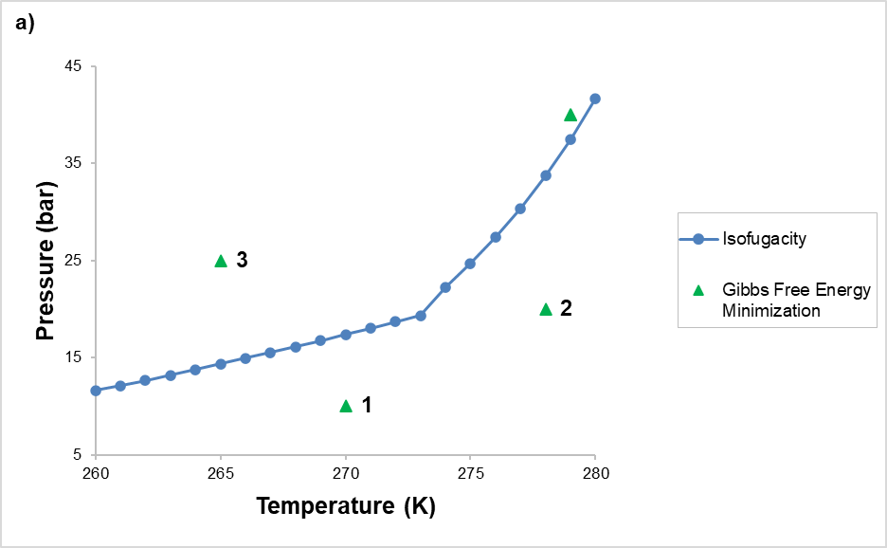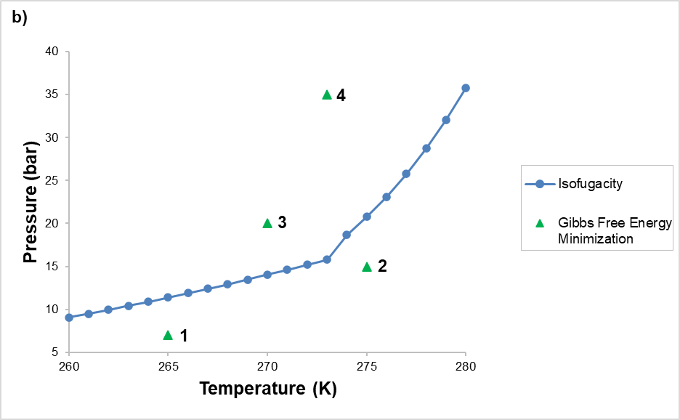
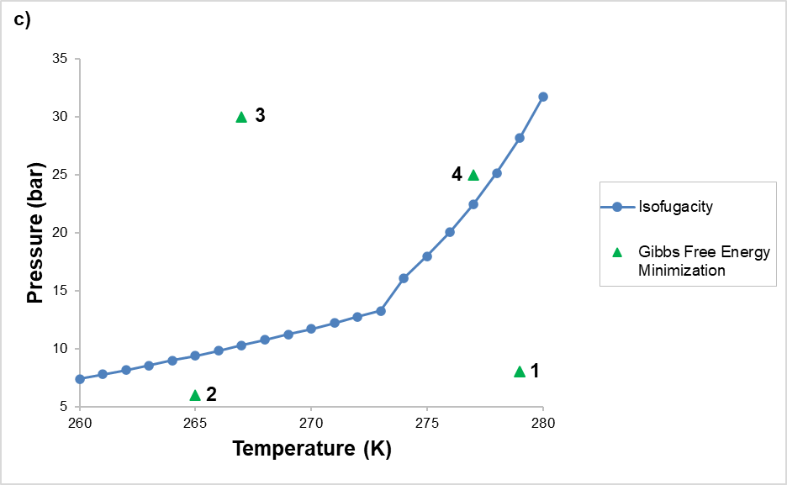
Figure 1: Results obtained for the CH₄ + CO₂ + H₂O system with a CO₂ molar fraction of a) 25 mol% b) 50 mol% and c) 75 mol% in the gas phase on a dry basis.

The geometric representations, calculated by the isofugacity criterion, present the coexistence of three phases, among them the solid hydrate phase. The upper part of the three-phase equilibrium curves corresponds to the biphasic region of hydrate stability, while the lower region of the curves does not form hydrate crystals, only non-aqueous components and water in equilibrium. The validation of the results was performed by comparing the results obtained in this work with experimental studies of phase equilibrium available in the literature. Using the work of Adisasmito et al. (1991), Seo and Lee (2001), Wang et al. (2014) and Dholabhai and Bishnoi (1994), the largest deviation from the experimental values found was 3.036 % for the study by Seo and Lee (2001).
For the Gibbs energy minimization criterion, randomly, 4 geometric points of temperature and pressure outside the previously calculated three-phase equilibrium regions were considered. At each geometric point, numbered from 1 to 4 in the phase diagrams, the molar amounts of the components in all equilibrium phases were obtained,
as well as the fractions of occupation of the gaseous components in the small and large structures of the hydrate.
In tables 1, 2 and 3, the results obtained by the Gibbs Energy minimization criterion are available, considering
an initial equimolar composition equivalent to 10 moles for each component of the system. The results allow us to conclude that at points 1 and 2, for the three conditions studied, the number of moles of the respective non-aqueous components and water in the hydrate structure is equal to zero. Therefore, the solid-phase representing the hydrate existence is not formed, being in equilibrium only CH₄ and CO₂ in the vapor phase and H₂O in the liquid phase. This result was expected, since this region is located outside the region of hydrate stability, that is, below the three-phase equilibrium curve previously calculated by isofugacity.

Table 1: Molar quantities and occupancy fractions in the hydrate structures, at the geometric points, for the
CH₄ + CO₂ + H₂O system with a CO₂ molar fraction of 25 mol% in the gas phase on a dry basis.
N. | Comp. | T (K) | P(bar) | Gas | Liquid | n  sI – small | n  sI – large | n  sI – structural | θ  sI – small | θ  sI – large
1 | CH₄ | 270.0 | 10 | 10.000 | 0 | 0 | 0 | - | 0 | 0
 | CO₂ |  |  | 10.000 | 0 | 0 | 0 | - | 0 | 0
 | H₂O |  |  | 0 | 10.000 | - | - | 0 | - | -
2 | CH₄ | 278.0 | 20 | 10.000 | 0 | 0 | 0 | - | 0 | 0
 | CO₂ |  |  | 10.000 | 0 | 0 | 0 | - | 0 | 0
 | H₂O |  |  | 0 | 10.000 | - | - | 0 | - | -
3 | CH₄ | 265.0 | 25 | 9.455 | 0 | 0.112 | 0.432 | - | 0.258 | 0.331
 | CO₂ |  |  | 8.948 | 0 | 0.192 | 0.860 | - | 0.409 | 0.660
 | H₂O |  |  | 0 | 0 | - | - | 10.000 | - | -
4 | CH₄ | 279.0 | 40 | 9.408 | 0 | 0.167 | 0.424 | - | 0.385 | 0.325
 | CO₂ |  |  | 9.043 | 0 | 0.090 | 0.867 | - | 0.208 | 0.665
 | H₂O |  |  | 0 | 0 | - | - | 10.000 | - | -

Table 2: Molar quantities and occupancy fractions in the hydrate structures, at the geometric points, for the
CH₄ + CO₂ + H₂O system with a CO₂ molar fraction of 50 mol% in the gas phase on a dry basis.
N. | Comp. | T (K) | P(bar) | Gas | Liquid | n  sI – small | n  sI – large | n  sI – structural | θ  sI – small | θ  sI – large
1 | CH₄ | 265 | 7 | 10.000 | 0 | 0 | 0 | - | 0 | 0
 | CO₂ |  |  | 10.000 | 0 | 0 | 0 | - | 0 | 0
 | H₂O |  |  | 0 | 10.000 | - | - | 0 | - | -
2 | CH₄ | 275 | 15 | 10.000 | 0 | 0 | 0 | - | 0 | 0
 | CO₂ |  |  | 10.000 | 0 | 0 | 0 | - | 0 | 0
 | H₂O |  |  | 0 | 10.000 | - | - | 0 | - | -
3 | CH₄ | 270 | 20 | 9.460 | 0 | 0.116 | 0.424 | - | 0.267 | 0.325
 | CO₂ |  |  | 9.006 | 0 | 0.131 | 0.863 | - | 0.302 | 0.662
 | H₂O |  |  | 0 | 0 | - | - | 10.000 | - | -
4 | CH₄ | 273 | 35 | 9.404 | 0 | 0.153 | 0.443 | - | 0.351 | 0.340
 | CO₂ |  |  | 9.024 | 0 | 0.126 | 0.849 | - | 0.290 | 0.651
 | H₂O |  |  | 0 | 0 | - | - | 10.000 | - | -

Table 3: Molar quantities and occupancy fractions in the hydrate structures, at the geometric points, for the
CH₄ + CO₂ + H₂O system with a CO₂ molar fraction of 75 mol% in the gas phase on a dry basis.
N. | Comp. | T (K) | P(bar) | Gas | Liquid | n  sI – small | n  sI – large | n  sI – structural | θ  sI – small | θ  sI – large
1 | CH₄ | 279 | 8 | 10.000 | 0 | 0 | 0 | - | 0 | 0
 | CO₂ |  |  | 10.000 | 0 | 0 | 0 | - | 0 | 0
 | H₂O |  |  | 0 | 10.000 | - | - | 0 | - | -
2 | CH₄ | 265 | 6 | 10.000 | 0 | 0 | 0 | - | 0 | 0
 | CO₂ |  |  | 10.000 | 0 | 0 | 0 | - | 0 | 0
 | H₂O |  |  | 0 | 10.000 | - | - | 0 | - | -
3 | CH₄ | 267 | 30 | 9.406 | 0 | 0.132 | 0.461 | - | 0.305 | 0.354
 | CO₂ |  |  | 8.996 | 0 | 0.172 | 0.832 | - | 0.395 | 0.638
 | H₂O |  |  | 0 | 0 | - | - | 10.000 | - | -
4 | CH₄ | 277 | 25 | 9.433 | 0 | 0.139 | 0.428 | - | 0.319 | 0.328
 | CO₂ |  |  | 9.057 | 0 | 0.086 | 0.857 | - | 0.198 | 0.657
 | H₂O |  |  | 0 | 0 | - | - | 10.000 | - | -
On the other hand, the geometric points 3 and 4, also for the three conditions studied, indicate the existence of the solid-phase (hydrate), non-aqueous components in the vapor phase and absence of water in the liquid phase, reiterating the fact that this region corresponds to the biphasic region of hydrate stability, situated above the three-phase equilibrium curve previously calculated by the isofugacity criterion.
As shown in Tables 1, 2 and 3, the occupation fractions at geometric points 1 and 2 are equivalent to zero, since hydrate formation does not occur in this region. The opposite happens at geometric points 3 and 4, which, because they are located in the region of stability of the hydrates, enable the occupation of CH₄ and CO₂ in the respective cavities of the hydrate.
Lastly, the results also reproduce the non-stoichiometric property of the hydrates, since all the water was used for the hydrate formation and the excess of the non-aqueous components remained in the vapor phase.
  - Conclusions
An evaluation of the thermodynamic equilibrium was developed for the ternary system CH₄ + CO₂ + H₂O as a function of temperature, pressure and molar fraction of CO₂ in the vapor phase of 25 mol%, 50 mol% and 75 mol%, on a dry basis. Stable equilibrium was described based on isofugacity and Gibbs energy minimization criteria, with a solid description of all equations used. The validation of the results showed that intrinsic limitations related to the equation of state and the statistical models used did not interfere with the results of this work, with the highest deviation obtained being equal to 3,036 %. Therefore, it can be concluded that the thermodynamic modeling of the vapor and liquid phases using the cubic SRK equation of state and the thermodynamic modeling of the hydrate based on the Van Der Waals and Platteeuw equations were accurate to describe the thermodynamic equilibrium using the isofugacity criterion for the studied system.
References
Adisasmito S., Frank R.J., Sloan E.D., 1991, Hydrates of Carbon Dioxide and Methane Mixtures, Journal of
Chemical & Engineering Data, 36, 68 – 71.
Atkins P.W., Paula J. (Eds), 2006, Physical Chemistry, W.H. Freeman and Company, New York, NY.
Dholabhai P. D., Bishnoi P. R., 1994, Hydrate Equilibrium Conditions in Aqueous Electrolyte Solutions Mixtures of Methane and Carbon Dioxide, Journal of Chemical and Engineering Data, 39, 191-194.
International Energy Agency, 2017, World Energy Outlook 2017 <iea.blob.core.windows.net/assets/4a 50d774-5e8c-457e-bcc9-513357f9b2fb/World_Energy_Outlook_2017.pdf> accessed 12.09.2021.
Matragrano H. B. C., Guirardello R., 2020, Phase Equilibria in the Formation of Hydrates in Methane or Carbon Dioxide + Water Systems Using Isofugacity and Gibbs Energy Minimization, Chemical Engineering Transactions, 80, 169-174.
Munck J., Jorgensen S.S., Rasmussen P., 1988, Computations of the Formation of Gas Hydrates, Chemical
Engineering Science, 43, 2661 – 2672.
Parrish W.R., Prausnitz J.M., 1972, Dissociation Pressures of Gas Hydrates Formed by Gas Mixtures,
Industrial & Engineering Chemistry Process Design and Development, 11, 26 – 35.
Pedersen K.S., Christensen P.L., Shaikh J.A. (Eds), 2014, Phase Behavior of Petroleum Reservoir Fluids,
Taylor & Francis Group, Boca Raton, FL.
Prausnitz J.M., Lichtenthaler R.N., Azevedo E.G. (Eds), 1999, Molecular Thermodynamics of Fluid-Phase
Equilibria, Prentice Hall PTR, Upper Saddle River, NJ.
Seo Y. T., LEE H., 2001, Multiple-Phase Hydrate Equilibria of the Ternary Carbon Dioxide, Methane and Water, The Journal of Physical Chemistry, 105, 10084 – 10090.
Sloan E.D., Koh C.A. (Eds), 2008, Clathrate Hydrates of Natural Gases, CRC Press, New York, NY.
Takeya S., Muromachi S., Yamamoto Y., Umeda H., Matsuo S., 2016, Preservation of CO₂ hydrate under different atmospheric conditions, Fluid Phase Equilibria, 413, 137 – 141.
Waals J.H.V., Platteeuw, J.C., 1959, Clathrate Solutions, In: I. Prigogine (Ed), Advances in Chemical Physics,
Vol 2, Interscience Publishers, New York, NY, 1 – 58.
Wang X., Dennis M., Hou L., 2014, Clathrate Hydrate Technology for Cold Storage in Air Conditioning Systems, Renewable and Sustainable Energy Reviews, 36, 34-51.
Wang X., Zhang F., Lipinski W., 2020, Research progress and challenges in hydrate-based carbon dioxide capture applications, Applied Energy, 269.

