CHEMICAL ENGINEERING TRANSACTIONS  VOL. 92, 2022 | A publication of
The Italian Association
of Chemical Engineering
Online at www.cetjournal.it

Guest Editors: Rubens Maciel Filho, Eliseo Ranzi, Leonardo Tognotti
Copyright © 2022, AIDIC Servizi S.r.l.
ISBN 978-88-95608-90-7; ISSN 2283-9216

Electromagnetic Energy Irradiation Equipment, an Alternative that Increases the Production of Biomass
Suárez-Rivero D.*^{ab}, Marin-Mahecha O.^{b}, Ortiz-Aguilar J.^{c}, Héctor Ardisana E. F.^{d}; Guzman-Hernandez T. de J.^{e}
ª Doctorado en Ciencias Naturales para el Desarrollo (DOCINADE), Instituto Tecnológico de Costa Rica, Universidad Nacional, Universidad Estatal a Distancia, Costa Rica
^{b} Grupo de Investigación e Innovación Agroindustrial – GINNA, Fundación Universitaria Agraria de Colombia – UNIAGRARIA, Colombia
^{c} Universidad Cooperativa de Colombia – UCC, Colombia.
^{d} Universidad Técnica de Manabí, Ecuador
^{e} Doctorado en Ciencias Naturales para el Desarrollo (DOCINADE). Instituto Tecnológico de Costa Rica, Sede Regional San Carlos, Costa Rica
*deivissr2000@hotmail.com

In agriculture, dormancy (also known as dormition) is identified as the period in the biological cycle of an organism in which growth, development and physical activity is temporarily suppressed, with the purpose of efficiently reducing metabolic activity contributing to the conservation of energy. In this sense, the objective of this work is to present to the international scientific community, an electromagnetic irradiation equipment, which, by means of the treatment of botanical seeds, has allowed an increase in productivity in biomass of annual crops. For its construction, pre-experimental and validation tests were carried out, sketches and design of plans of the team. Thus, it is that, by means of a touch screen and an electronic operation controller, the gearmotors are regulated and the operation of variables can be programmed, such as: the speed of the conveyor belt and the exposure time. In this way, the invention equipment is made up of mechanical, electronics and electromagnetic devices. The mechanical part fulfills the functions of support, reception of botanical seeds, dosing and transport, this last, made of insulating and / or dielectric material; the electronic components used to control the current, voltage and power of the equipment; whereas, the electromagnetic part is constituted by electrical circuits, power source and coils generating electromagnetic waves, connected and manipulated through an interface that has a variable control system from a programmable digital board. With the above, a patent was obtained (NC2019/0002674), being a functional equipment that allows to treat botanical seeds and eliminate dormancy, as well as increase productivity in biomass, especially by stimulating the synthesis of photosynthetic pigments in leaves.
Keywords: biomass, patent, pigments, control system.
  - Introduction
A reality in current times is the adverse effects of climate change, which beyond what we can see in terms of changes in temperature and precipitation in the various regions of the planet, projected to affect biotic systems (Yoon et al., 2021). It is not only about the reduction in biomass production per surface unit, but also about its quality for different uses, whether industrial or direct use by humans (Zhao et al., 2020). Thus, it is imperative for current and future society to have technologies that help mitigate the effects, visible or not, of climate change. On the other hand, it should be noted that over a long period of time the negative effects mentioned above have been minimized, with respect to climate change on biological systems, through the use of genetic crosses, obtaining hybrid cultures, cloning processes, as well chemical and phytohormonal treatments on plant material (Sánchez-Soto et al., 2017). Today, other studies that have become relevant correspond to the determination of the effects of electromagnetic fields on orthodox seeds (Anaya et al., 2015). For this reason, the objective of these studies was to investigate how the effects could vary according to two exposure parameters: the intensity of the field (electromagnetic induction) and time. Among the first studies on the effects of this physical agent on plant tissues is the work of Sawostin in 1930, which investigated the incidence of 700 mT magnetic fields on physiological parameters and certain physiology at the cellular level in Nitella flexilis L. (Ortiz-Aguilar et al., 2015, cited by Suárez-Rivero D. et al., 2018). This is how, with the development of previous research, the creation of a machine was achieved that allowed treating orthodox seeds with electromagnetic fields and thus enhancing variables of growth, development and productivity, with low environmental impact, but with a high positive impact on production.

  - Material and methods
Based on preliminary studies aimed at characterizing the effect of electromagnetic fields on growth, development and productivity processes in cultivable plants, a functional equipment was designed for the generation of electromagnetic waves with their respective application in agriculture and linkage to biomass production. This invention relates to an electromagnetic energy irradiation equipment assembly for the treatment of botanical seeds in general and those in a state of dormancy. The designs were made in AutoCAD®, software that was used for Computer Aided Design (CAD) obtaining plans precise 2D as a result. For the construction of the equipment, the use of non-magnetic materials was considered, such as aluminum, acrylic and polymeric materials.

  - Results and discussion
The invention reported in this article (Patent granted by the Superintendence of Industry and Commerce of Colombia (SIC) with File Reference N° NC2019/0002674) consists of a novel device that allows the application of electromagnetic fields on botanical seeds, which they interact with the lines of force of these fields, cutting them so that the collapse of the fields generates electromagnetic lines, providing control mechanisms and feedback sensors in the device; in addition, an oscillation frequency of the electromagnetic fields with a specific time and intensity appropriate to their applications according to each plant species to be treated. Additionally, the invention is constituted as a piece of equipment capable of generating positive changes in the physiology of the seed, which allow accelerating the germination, growth, and development of cultivated plants. This equipment is made up of a mechanical part and an electromagnetic part. The mechanical part has the function of supporting, receiving, dosing and transporting the seeds, made of insulating and/or dielectric material; while the electromagnetic part is made up of electrical circuits, a power source, generating coils of the electromagnetic field and a programmable control board. It should be noted that this equipment is easy to operate and mobile.
Next, the equipment is described with its different parts, understanding that the numbers observed designate the parts in the different figures of the drawings, in which:

Figure 1 shows a general perspective view of the apparatus as well as its dimensions expressed in meters (m).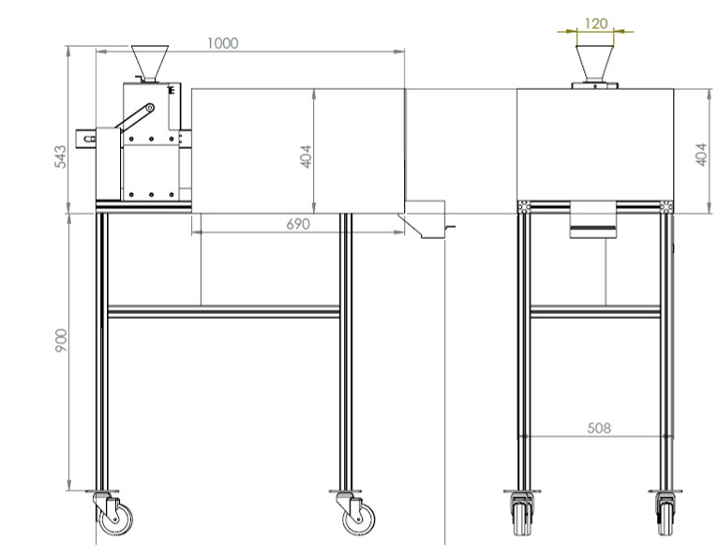
Figure 1: Front and side view of the machine
In the same way, each of the parts of the invention with its function within the machine is detailed by means of figures:
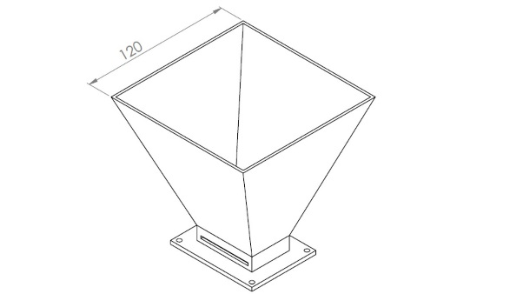
Figure 2: Seed reception hopper with discharge flow regulation
Figure 2 shows the seed reception hopper built in stainless steel. This one has 120 mm per each side at the top and 60 mm at the bottom. Right at the bottom there is a gate to regulate the flow of seed that enters the next component.
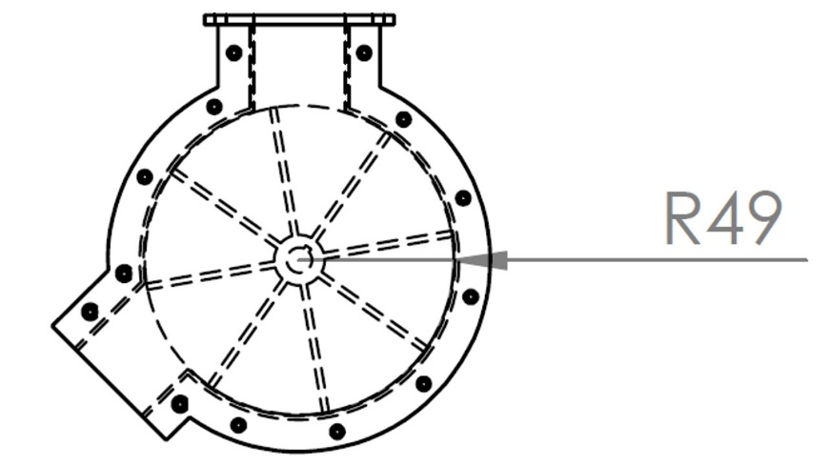
Figure 3: Adjustable seed dispenser according to their size
Figure 3, right part, illustrates the seed dispenser (dispenser adjustable according to the type of seed to avoid jamming and universality of use of the machine) that feeds the third component, this allows feeding according to the programmed speed (on the touch screen) and according to the blades of the built-in reel. Additionally, the left part of the figure shows the dispenser jacket, made of stainless steel and which, in addition to protecting the dispenser, has the function of homogenizing the quantity of seeds to be served on the conveyor element.
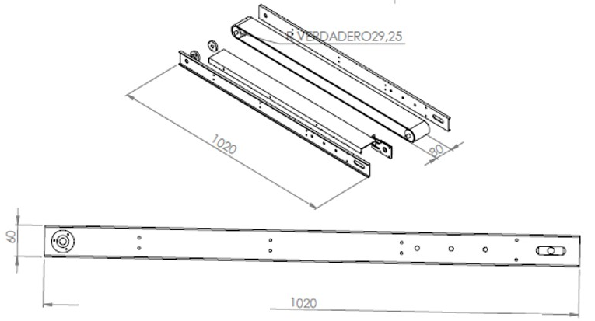

Figure 4: Seed transport system

The seed transport system seen in Figure 4 is made up of a conveyor belt made of polystyrene. Additionally, it has a controllable geared motor and a non-magnetic aluminium frame. The speed of the band is adjustable by means of a touch screen in a range that goes from 0.01 mm/s to 60 mm/s. That is to say, as an example, for a length of 600 mm (60 cm), with the minimum speed value, this route will be achieved in a time of 16.66 h, on the contrary, if the maximum speed of 60 mm/s, this same path (60 cm) will do it in 10 s (the invention has intermediate speeds that can be typed on the touch screen).

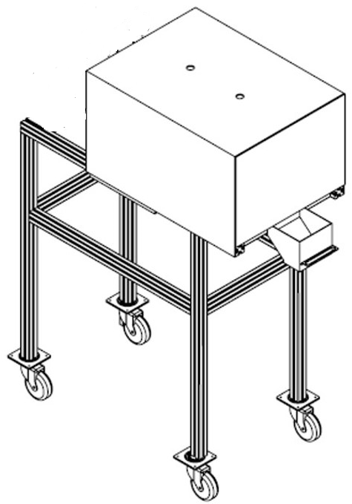

Figure 5: Adjustable seed dispenser according to their size
As a complement to the elements described in Figure 4, Figure 5 shows an acrylic frame (non-magnetic material) as an insulator of the internal body of the machine where the electromagnetic field is generated, supported on four aluminium posts (with wheels) that support the whole invention. Additionally, on the right side of the illustration you can see a small hopper, which has the function of receiving the electromagnetically treated material. The two holes that can be seen in the upper part of the acrylic frame are used to introduce sensors for electromagnetic and temperature monitoring inside the device.
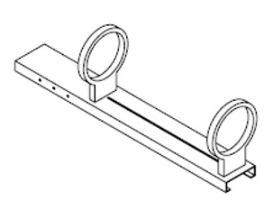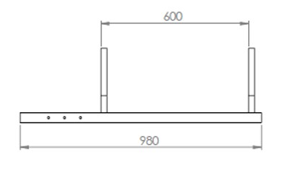
Figure 6: Electromagnetic field generating coils
For its part, Figure 6 shows the two circular coils (front and side view) that generate the electromagnetic field, although it is noteworthy that this has also been generated by means of coils or solenoids regardless of their type. The functional characteristics of the EMF generator circuit are described below.
In this sense, the artificially created electromagnetic fields from electronic circuits (interconnection of voltage sources, capacitors, resistors, coils, switches and semiconductors) interconnected, allowing the generation of electromagnetic waves, whose theoretical foundation is Maxwell's Laws, with the purpose of macroscopically describing the interaction of static or time-invariant loads and dynamic or time-varying loads. Said component arrangements create from one conductive loop to many of them, an intensity of electrostatic force, field and lines of force. As well as, the arrangement of sheets in parallel (similar to a capacitor) separated by an insulator, generating an electric dipole. The generation of electric dipoles, either from coils or sheets, creates a central field.
As a result of studies, the magnetic field has a mathematical basis carried out by authors such as Charles-Augustin de Coulomb (1736-1806), Carl Friedrich Gauss (1777-1855), André-Marie Ampère (1775-1836) and Michael Faraday (1791-1867) among others, which have allowed the work and application in the different study areas, which are used to determine the flux density and intensity of the field that is required. The magnetic flux density B in free space is related to the field strength from Eq 1.
$B=μ_{0}H$ (1)
Where $μ_{0}$ is known as the permeability constant in free space and equal to a $4π ×{10}^{-7}H/m$.
Additionally, H is defined as the magnetic field intensity Eq 2.
$\oint{H ∙dl}= I_{enc}$ (2)
Eq 3. The following equation is used to find the magnetic field in the arrangement of coils proposed in the prototype:
$B=\frac{μ_{0}iN}{2a}(T)$ (3)
Where:
$μ_{0}=4π ×{10}^{-7}H/m$. Permeability in free space
$i$Current applied to the electronic device
$N$ Number of turns
$a$ coil height

With the above, we have the two basic models of coils used and shown in Figures 7 and 8, highlighting in both cases the direction of the lines of force of the electromagnetic field.
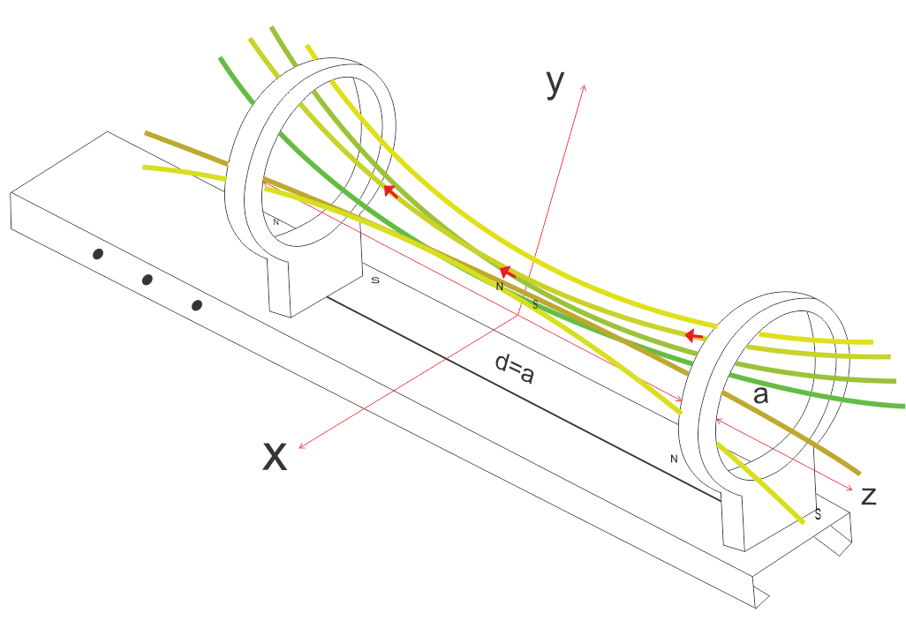
Figure 7: Behaviour of the electromagnetic field of the technological prototype
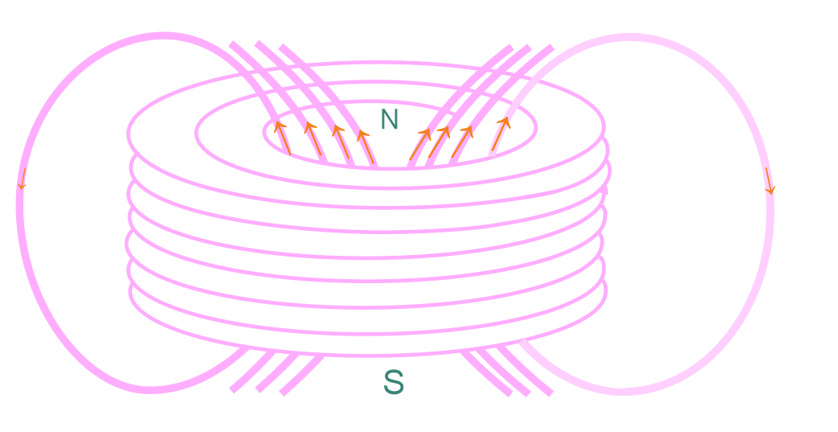
Figure 8: Behaviour of the electromagnetic field of a coil
It is important to highlight that the intensity of the electromagnetic field is controlled from a power source that can be seen in Figure 9. The distance between the two coils is adjustable and the conveyor belt passes through their center, from the point of reception (delivery by the dispenser) to the discharge point (reception hopper).
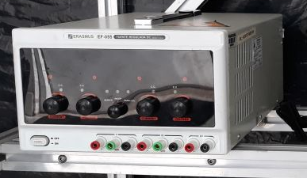
Figure 9: Power source
Figure 10 shows the control panel of the device. From this, the functionality of the dispenser and the speed of the conveyor belt are controlled (see description of the speed of the belt in the description of Figure 4).
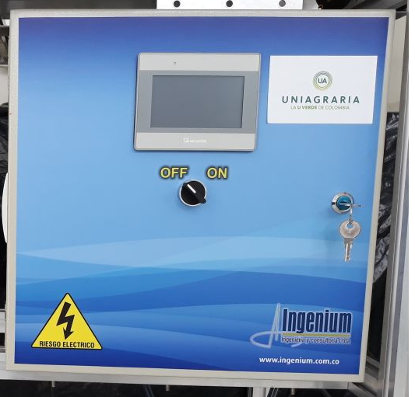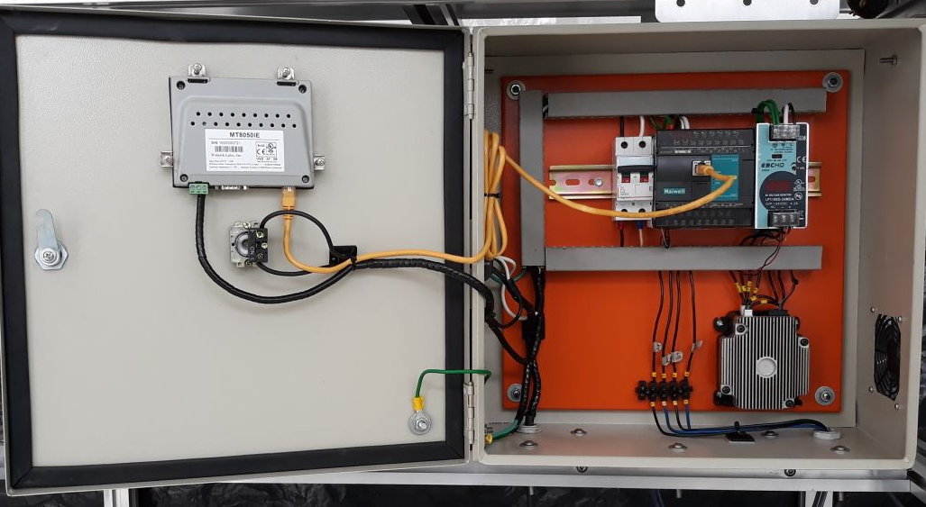
Figure 10: Touch control panel (image on the left) and electrical system (image on the right)
On the other hand, Figure 11 shows the electrical plan of the device, which guarantees all the functionality and concordance between the different phases of the electromagnetic induction process.
Figure 11: Electrical system of the device
In this way and by means provided by the invention, in the described operation, the electromagnetic fields are obtained, which are induced, and which allow reaching a useful intensity for the objects of the invention. With this induced electromagnetic energy, the volume of seeds in translation on a conveyor belt is influenced, finding that it positively affects growth and development patterns. The invention that has been described, for one of its forms, is applied in the treatment of seeds used in agriculture and gardening, since it is possible with the device subject of the invention, to have electromagnetic fields necessary in intensity and duration, to obtain seeds with a higher germination potential, as well as higher growth and development indicators (see Physiological indices evaluated in previous articles such as those described by Ortiz-Aguilar et al. (2015) cited by Suárez-Rivero et al. (2017 and 2018).
  - Conclusions
Although the present invention is described in relation to particular embodiments thereof, it will be understood that numerous modifications may be made by those skilled in the art without actually departing from the scope of the invention. Therefore, modifications and equivalents can be resorted to that fall within the scope of the invention. Having sufficiently described the nature of the invention, as well as the way of operating it in practice, it should be noted that the provisions indicated above are susceptible to detailed modifications as long as they do not alter their fundamental principle. The speed is adjustable through the touch screen in a range that goes from 0.01 mm/s to 60 mm/s. This means that, for example, for a length path of 600 mm (60 cm), with the minimum speed value, this path will be achieved in a time of 16.66 hours, on the contrary, if the maximum speed of 60 mm/s is taken, this same route (60 cm) will do it in 10 s. Therefore, the exposure time of the seed to electromagnetic fields will depend on the type of seed and its morphological and physiological characteristics.

Acknowledgments
In particular, to the Fundación Universitaria Agraria de Colombia – UNIAGRARIA for sponsoring all the research that gave rise to the creation of this invention and co-financing the utility model patent achieved, together with the Ministry of Science, Technology and Innovation – MINCIENCIAS from Colombia. Likewise, a special thanks to other institutions and scientific, technical and administrative support staff.

Reference
Anaya, M., Barbará, E., Padrón, J., Borrego, S., Valdés, O. y Molina, A. (2015). Influencia del campo magnético sobre el crecimiento de microorganismos patógenos ambientales aislados en el Archivo Nacional de la República de Cuba. Biomédica, 35, 325-236. doi:http://dx.doi.org/10.7705/biomedica.v35i3.2569
Sánchez-Soto, B. H., Pacheco-Aispuro, E., Lugo-García, G. A., Reyes-Olivas, Á. y García-Moya, E. (2017). Métodos de escarificación en semillas de Guaiacum coulteri, especie amenazada del bosque tropical caducifolio del norte de Sinaloa, México. Gayana Botanical, 74(2), 262-268.
Suárez-Rivero D., Marin-Mahecha O., Gonzalez A.J., Suarez-Rivero M., Puentes A.E., Ortiz-Aguilar J. (2018). Composition and behavior of sunflower seeds (Helianthus annuus L.) from plants treated with magnetic fields for energy potential use of biomass. Chemical Engineering Transactions, 65, 679-684. DOI: 10.3303/CET1865114.
Suárez-Rivero, D., Marín-Mahecha, O., Salazar Torres, V., Real, X., Ortiz Aguilar, J., y Suárez Rivero, M. (2017). Biomass Production and Morpho‐Phsysiological Effects On Sunflower Plants (Helianthus Annuss L.) Under Induced Magnetic Fiels. Chemical Engineering Transactions, 57, 115-120. doi:10.3303/CET1757020
Yoon, H. I., Kim, H. Y., Kim, J., & Son, J. E. (2021). Quantitative Analysis of UV-B Radiation Interception and Bioactive Compound Contents in Kale by Leaf Position According to Growth Progress. Frontiers in plant science, 12, 667456. https://doi.org/10.3389/fpls.2021.667456
Zhao B., Wang L., Pang S., Jia Z., Wang L., Li W., Jin B. (2020). UV-B promotes flavonoid synthesis in Ginkgo biloba leaves. Industrial Crops and Products. 151:112 - 483. doi:http://dx.doi.org/10.1016/j.indcrop.2020.112483.

