 CHEMICAL ENGINEERING TRANSACTIONS  VOL. | A publication of  
The Italian Association
of Chemical Engineering
Online at www.cetjournal.it
Guest Editors:
Copyright © AIDIC Servizi S.r.l.
ISBN 978-88-95608-xx-x ISSN 2283-9216

Coffee Waste Biochar: A Widely Available and Low-cost Biomass for Producing Carbonaceous Water Treatment Adsorbents
Yousuf M. Al-Awadhi, Snigdhendubala Pradhan, Gordon McKay, Tareq Al-Ansari, Hamish R. Mackey*
Division of Sustainable Development, College of Science and Engineering, Qatar Foundation, Doha, Qatar
*Corresponding author: hmackey@hbku.edu.qa

Coffee is one of the world’s most traded commodities grown in about 80 countries and widely consumed. Accordingly, a high quantity of spent coffee grounds (SCGs) produced from coffee beverage preparation is generated and disposed globally. The high availability and low cost of SCG allow its valorization to obtain a valuable product that could be used as an alternative adsorbent for water treatment applications. This study used dried SCG to produce biochar by pyrolyzing the biomass at three different temperatures: 300, 450, and 600 °C. Pyrolysis was conducted at a slow heating rate of 5 °C.min⁻¹ for 30 min. SCG biomass and biochar were characterized for various properties that would describe the biomass changes during pyrolysis and the effectiveness of biochar for water treatment applications. The SCG biomass was acidic in nature with a pH of 5.54, whereas biochar was mildly alkaline with a pH of 7.5 to 10.6, increasing with pyrolysis temperature. The electrical conductivity of SCG biochar at 600 °C (2,278 µS.cm⁻¹) was higher than that of biomass (550 µS.cm⁻¹). This indicates SCG biochar could have promising ion-exchange capacity. SCG biochar produced at 450 °C has the most negative zeta potential of -57.33 mV, compared to the least negative measure of -30.73 mV for SCG biomass. A negative zeta potential has a strong affinity for positively charged cations and this was confirmed through cation exchange capacity (CEC) measurements. The highest CEC was 29 cmol_{c}.kg⁻¹ for 450 °C SCG biochar, a 58 % increase over that for the SCG biomass. SCG biochar contained 63 % to 88 % of C content for pyrolysis temperatures of 300 to 600 °C, respectively, whereas the SCG biomass had a C content of 43 %. With increasing temperature, the fixed carbon (FC) content of biochar increases and reached 69 % at 600 °C, while in biomass, the FC content was only 13 %. The large change in C content as SCG biomass is pyrolysed indicates large changes in structure and therefore tunability. SCG could be a promising carbonaceous adsorbent to remove organic and inorganic pollutants from polluted water.
  - Introduction
Household, agricultural, and industrial activities produce wastewaters containing high levels of various types of contaminants that can negatively affect the natural environment if discharged untreated. Due to the continual growth in global population and urban concentration, there are increased stresses on local water resources and environment promoting a need for greater levels of wastewater treatment and reuse. Different conventional methods are used to remove organics, inorganics, metals, heavy metals, and pathogens; unfortunately, most of the conventional techniques have large operational and initial expenses. Adsorption has been demonstrated as a highly effective and sustainable treatment process amongst various options (Vlasopoulos et al., 2006). Low-cost carbonaceous adsorbents, in particular, are effective and can be produced from agricultural, industrial, forest, and food waste, providing resource recovery and valorization (Huong et al., 2021). Biochar is a simple carbonaceous adsorbent formed through pyrolysis. It has received much attention as an adsorbent due to its desirable physicochemical properties, which provide high-rate adsorption. Biochar's adsorption capacity for removing wastewater pollutants is due to the presence of various functional groups on the surface of biochar. As a result, the removal efficiency of pollutants from wastewater is because of the surface polarity of various carbon compounds (Huong et al., 2021).

Coffee is one of the world’s most traded commodities with over 9.2 million tons produced in 2021 (Huong et al., 2021). To prepare the beverage from 1 ton of coffee beans, about 0.65 tons of coffee grounds are discarded, in addition to roughly 0.5 tons of coffee husks (Liza et al., 2021). As a result, there is a need to utilize the by-products from the coffee beverage industry. While coffee husks are limited to areas of coffee cultivation, spent coffee grounds (SCG) is a waste biomass source available globally and with a high potential for segregation and collection. SCG is an excellent organic matter to produce biochar, as it is composed of 10 to 13 % of cellulose, 32 to 42 % of hemicellulose, and up to 25 % of lignin. It also contains 10 to 18 % of protein, 2 to 24% lipids, 1 to 2 % of ash, 0 to 0.4 % of caffeine, and 1 to 3 % of chlorogenic acids (Pereira et al., 2019). Coffee biochar has previously been found efficient to remove a maximum of 51.52 mg.g⁻¹ NH₄⁺, and 12.1 mg.g⁻¹ of nitrate (NO₃⁻) (Konneh et al., 2021; Nguyen et al., 2021). Kim et al. (2014) achieved a very high removal efficiency of 99 % for Cd, 88 % for Cu, >99 % for Pb, and 99 % for Zn from acid mining drainage by using SCG biochar adsorbent produced at 400 °C for 16 h. In another study, Oladipo et al. (2016) reported SCG biochar produced at 300 °C for 2 h adsorbed 184.5 mg.g⁻¹ tetracycline compound while Fe₃O₄⁻ coated SCG biochar adsorbed maximum 285.6 mg.g⁻¹ of tetracycline compound. Nguyen et al. (2021) reported the alkaline modified SCG biochar at 500 °C for 2 h could be able to adsorb 113.6 mg.g⁻¹ tetracycline at a pH 7.45. Untreated SCG has also been used as an adsorbent to reasonable effect. Lavecchia et al. (2016) studied the performance of SCG to remove lead, achieving a moderate equilibrium capacity of 2.46 mg.g⁻¹, while Pradhan et al. (2020) found SCG to be one of the most effective materials amongst various possible plant growth media for removal of organics from greywater.

However, there is a lack of detailed comparative study of various properties of SCG and SCG biochar produced at different pyrolysis temperatures towards the application of the adsorbent to remove pollutants. Therefore, this study aims to compare different properties of SCG biomass and biochar produced at varying temperatures to identify their characteristics and potential.
  - Material and Method
    - Collection of SCG biomass and biochar production
SCG was collected from a university canteen at Hamad Bin Khalifa University and oven dried (Fisher Scientific Isotemp oven) at a temperature of 105 °C for twenty-four hours. After drying, 50 g of SCG biomass was used to produce biochar by slow pyrolysis at three different temperatures: 300, 450, and 600 °C. A heating rate of 5 °C.min⁻¹ was applied with a residence time at the set temperature of 30 min. After biochar production, the yield of biochar was determined by following the below Eq (1) (Abdelaal et al., 2021).

$Yield of biochar$=$\frac{Weight of biochar (g)}{Weight of biosolid (g)}×100$ | (1)
    - Physico-chemical characterization of SCG biomass and biochar
The detailed characterization of various physicochemical properties of SCG and SCG biochar were determined by following various standard procedures reported by Abdelaal et al. (2021). The carbon (C), nitrogen (N), and hydrogen (H) content of SCG, as well as SCG derived biochar was determined using a combustion-type elemental analyzer (EA 3000, Eurovector). Proximate analysis was conducted to measure volatile matter (VM), fixed carbon (FC), and ash content of biomass and biochar following the American Society for Testing and Materials (ASTM) D7582-15 method (ASTM, 2013). Fixed carbon content was calculated by the following Eq (2).

$$FC \left(\%\right)=100-[Ash \left(\%\right)+VM \left(\%\right)+MC \left(\%\right)]$$ | (2)

The oxygen (O) % was calculated by following Eq (3)

$$O \left(\%\right)=100-[C \left(\%\right)+H \left(\%\right)+N \left(\%\right)+Ash \left(\%\right)]$$ | (3)

The pH and electrical conductivity of the extract (ECE) of biochar were measured by using a calibrated pH meter and conductivity meter (Orion Star A121 and A329, Thermo Scientific). Media and water were mixed at a ratio of 1:10 in a shaker for 1 h at 150 rpm before measuring pH and ECE (Dai et al., 2013). The cation exchange capacity (CEC) of biochar was determined by measuring the degree of ammonium exchange (NH₄⁺), following ASTM D7503-10 (2010). The concentration of ammonia was measured by segmented flow analyzer (Sans+, Skalar). The ζ-potential of SCG biomass and biochar was measured by Zetasizer Nano-ZS (Malvern Panalytical) following the procedure reported by Abdelaal et al. (2021). The oil holding capacity of the biomass and biochar samples were measured by following the procedure reported by Nguyen (2021). Nutrient content of the biomass and biochar samples were measured by inductively coupled plasma optical emission spectroscopy (ICP-OES) using an Agilent 5110 ICP-OES that enables synchronous radial and axial measurement. Before analysis, 500 mg of sample was digested with 8 mL nitric acid and 2 mL hydrogen peroxide with a microwave digestion system (Ethos UP, Milestone). After digestion, samples were diluted with deionized water and filtered with 0.45 µm filter paper.
  - Results and Discussion
    - Impact of pyrolysis temperature on yield and bulk density of biochar
Temperature is one of the most important factors that affect the process of biomass pyrolysis and biochar yield (Figure 1a). With increasing temperature the yield of biochar decreased. A reduction of 70 % in yield was noticed from 300 to 600 ˚C. This was due to greater primary decomposition of the biomass samples or through the secondary decomposition of the biochar itself, since more volatile materials were being forced out of the char at higher temperatures (Abdelaal et al., 2021). Conversion of biochar at 300 ˚C reduced the bulk density of the material by 62 % compared to the SCG biomass, with only a minor reduction at the higher temperatures. This indicates any form of pyrolysis is highly influential on the physical form of the material and decomposition of SCG biomass (Figure 1b). Bulk density is an indicator of porosity, which plays a major role in absorption of pollutants, as well as aeration of the packed media, microbial movement and colonization. All these factors influence bioremediation potential for biofilter applications.
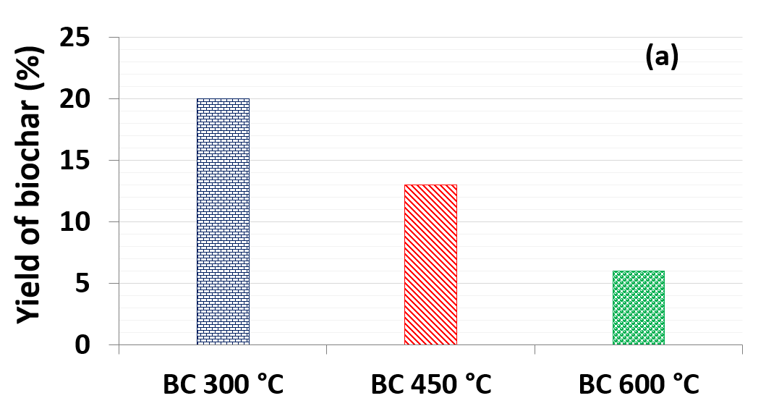 | 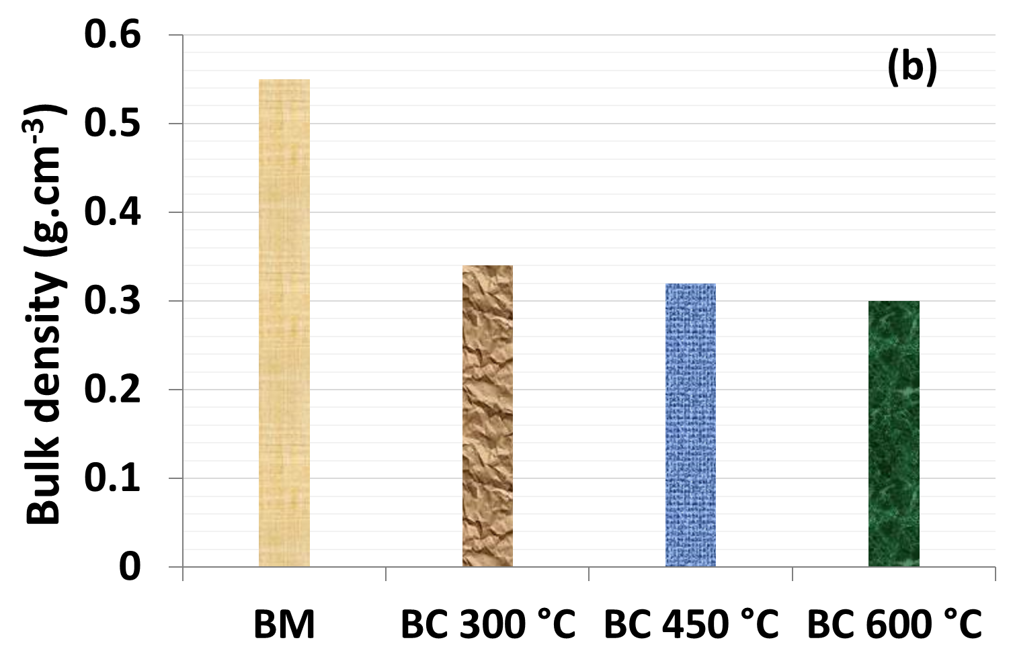
Figure 1: Impact of pyrolysis temperature on (a) yield and (b) bulk density of biochar. BM: biomass; BC: biochar
    - Impact of pyrolysis temperature on elemental and proximate analysis
Pyrolysis of SCG biomass to biochar at 300 °C increased C from 45 % to 67 % and N from 1.77 % N to 1.83 %. O reduced from 46 % to 23 % and H from 6 % to 5 %, signifying loss of certain oxygen rich functional groups and compounds. An increase of 67 % to 78 % of C, 2 % to 3 % of N, a reduction of 5 % to 2 % of H, and 23 % to 10 % of O, was observed when comparing the composition of the biochar produced at the pyrolysis temperature of 300 °C and 600 °C (Figure 2a). The biochar production from SCG biomass at 300 °C increased FC by 35 %, ash by 1 % ash, and VM by 29 %. The increase in pyrolysis temperature from 300 to 450 °C caused a further increase in FC of 21 % FC, ash of 5 %, and reduction of VM by 25 % (Figure 2c). Wang et al. (2020) reported biochar produced from various feedstocks such as bamboo, lotus stalk, orange peel, peanut shell, potato stem, leaf, etc. by pyrolysis with a temperature range of 300 to 900 °C. These materials were capable of removing 15 to 325 mg.g⁻¹ of heavy metals, 130 to 1218 mg.g⁻¹ of dyes, 82 to 1066 mg.g⁻¹ of phenolic compounds and PAHs, 243 to 1158 mg.g⁻¹ of pesticides, and 8.4 to 11.5 mg.g⁻¹ of antibiotics. These adsorbents had C contents from 58 to 85 %, where higher C content was generally beneficial. Therefore, the higher C and FC value of SCG biochar produced at these temperatures could create a more efficient carbonaceous adsorbent to treat wastewater. The increasing ash content at higher temperatures indicates the increasing mineral content, such as potassium, calcium, magnesium, and phosphorus in the biochar.

A van Krevelen plot was constructed with reference to atomic ratios of H/C and O/C to show the changes as SCG biomass is transformed to biochar (Figure 2c). The O/C ratio varies with temperature and gives a reliable indicator of biochar stability (Rangabhashiyam and Balasubramanian, 2019). The H/C ratio of all biochars displayed a decreasing trend with increasing temperature. The reduction of the H/C ratio indicates an increase of condensed aromatic structure of biochars, implying that the release of volatile matter and pore development are enhanced and the stability is improved (Rangabhashiyam and Balasubramanian, 2019). The lower atomic ratio of H/C and O/C at the higher pyrolysis temperature is attributed to demethanation, decarboxylation, decarbonylation, dehydration, and depolymerisation, leading to a decrease in functional groups like hydroxyl, amino, and carboxylic groups, respectively. The low value of the atomic ratio O/C at the higher temperature corresponds to biochar with more aromatic and lesser hydrophilic surfaces because of the loss of polar functional groups and increased carbonization. As the pyrolysis temperature increased the ECE also increased due to the concentration of minerals in the remaining carbonaceous material. The initial drop in ECE may have been due to a loss of hydroxyl and acidic functional groups that act in an ion exchange (Figure 2d).

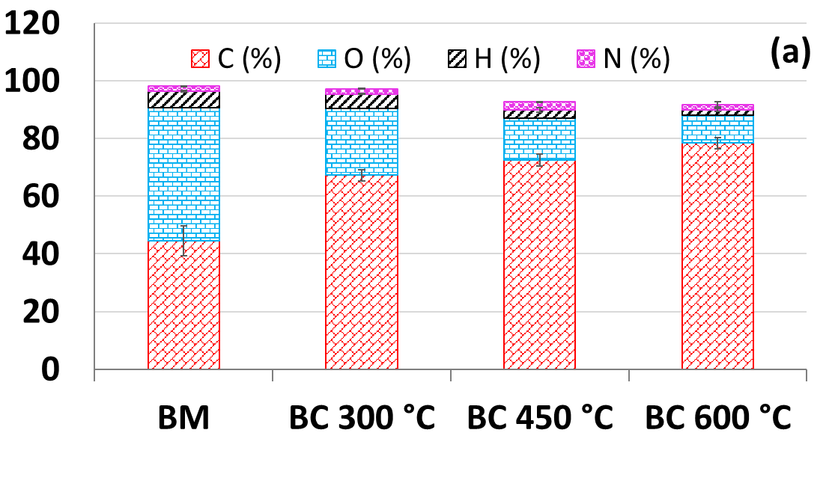 | 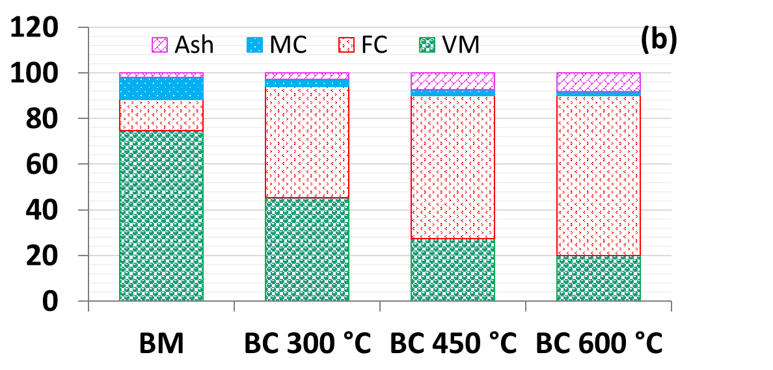
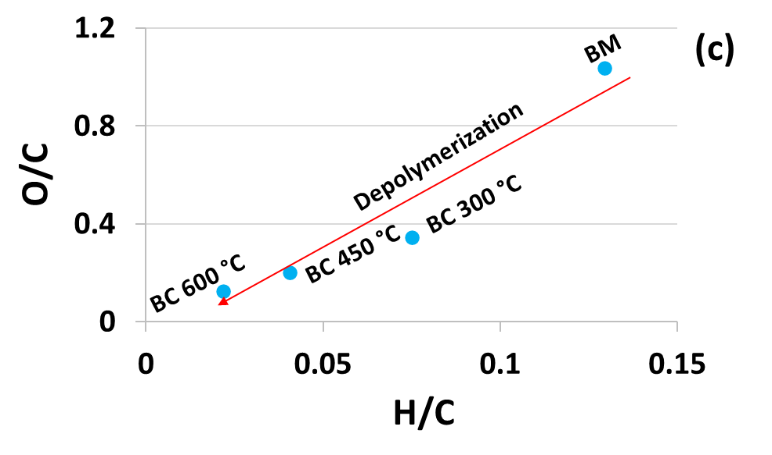 | 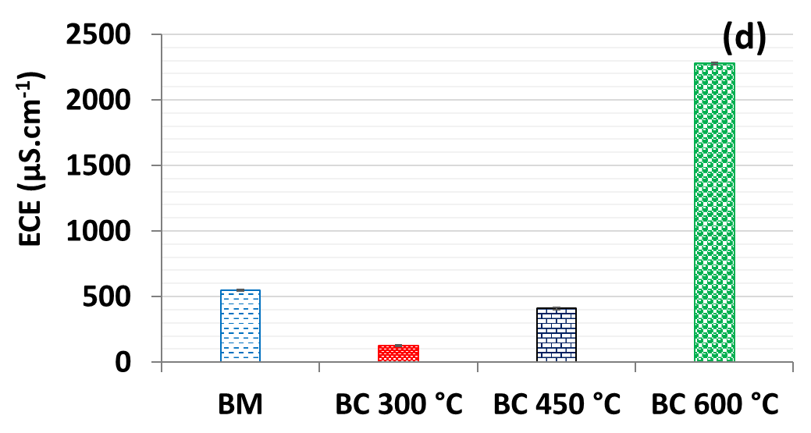
Figure 2: (a) Elemental analysis, (b) proximate analysis, (c) van Krevelen plot of the correlation between H/C to O/C ratio, and (d) ECE of SCG biochar and biomass. BM: biomass; BC: biochar
    - Impact of pyrolysis temperature on chemical properties
The SCG biochar formed at all three pyrolysis temperatures was alkaline in nature while the native SCG biomass was acidic (Figure 3a). The pH plays a critical role in controlling the charge on the adsorbent surface, the magnitude of adsorbate ionization and dissociation of different functional groups on the adsorbent (Konneh et al., 2021). The alkaline biochar maintains negatively charged surface sites across a wide range of acidic and neutral aqueous conditions making it particularly effective for cation removal. Meiirkhanuly et al. (2019) reported the biochar produced from maple wood, food waste, bark, pine wood chip, etc. with a pH ranges from 6.7 to 10.6 has a good adsorption capacity of NH₄⁺ (solution pH of 3.7 to 8.13), phenols (solution pH of 2 to 12), and heavy metals (solution pH of 6.7 to 9.93). In contrast, the acidic SCG biomass contains a majority of positively charged surface groups and may be more effective for anion removal. At 300 °C, the biochar produced was relatively neutral and may show all round capabilities, which also correlated with its lower ECE.

CEC is an important property of biochar indicating the capacity of a biochar to adsorb organic and inorganic pollutants with positive charge (Nguyen et al., 2021). Biochar produced at 300 °C had a CEC value similar to SCG biomass, concomitant with the relatively neutral biochar pH. In contrast, biochar at 450 °C had the highest CEC of the tested conditions (Figure 3b). In another study, biochar produced at 450 °C from chicken manure, eucalyptus sawdust, coffee husk, and sugarcane bagasse showed maximum CEC which reduced at higher temperature (Domingues et al., 2020). The highest ζ-potential was also recorded in this study for 450 °C, though 600 °C was very similar (Figure 3c). Higher ζ-potential of biochar is found efficient for adsorbed maximum removal of heavy metals (Samsuri et al., 2014). Biochar produced at 450 °C also showed higher oil holding capacity which indicates potential as an adsorbent to remove oil products from various industrial wastewater (Figure 3d). Oil pollution is a major issue due to large quantities of crude oil and petroleum product discharges to waterbodies via spills and stormwater runoff (Kponee et al., 2015). Based on these results, 450 °C biochar has the most promise as a water treatment material due to its better suitability for dissolved inorganic salts, positive cations and hydrocarbons.
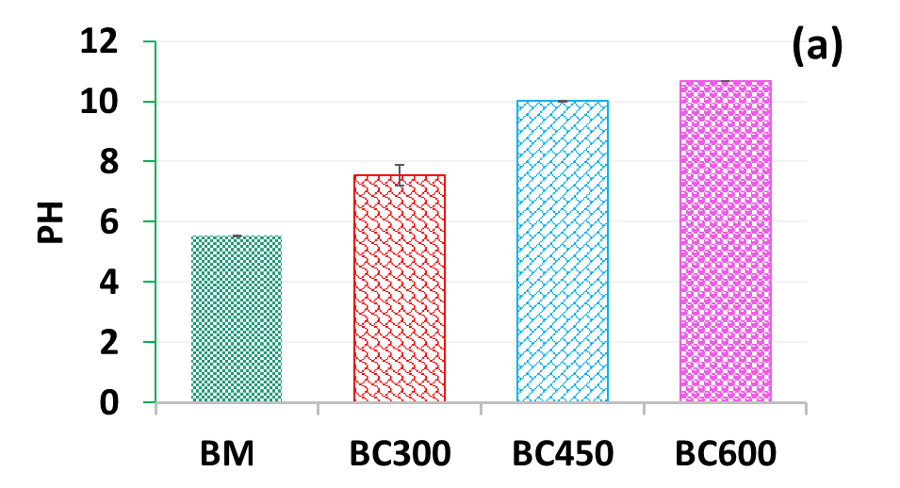 | 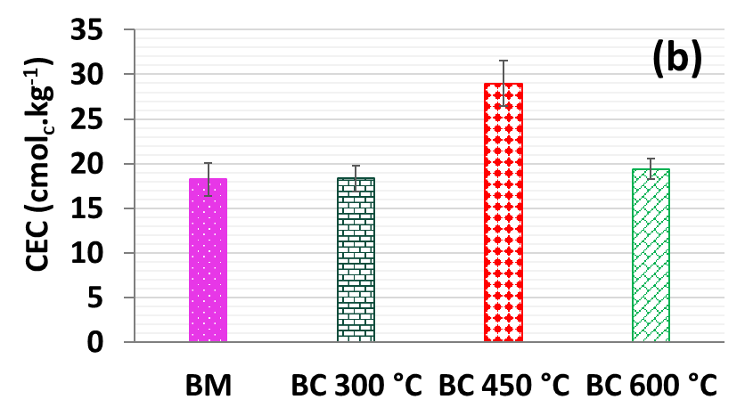
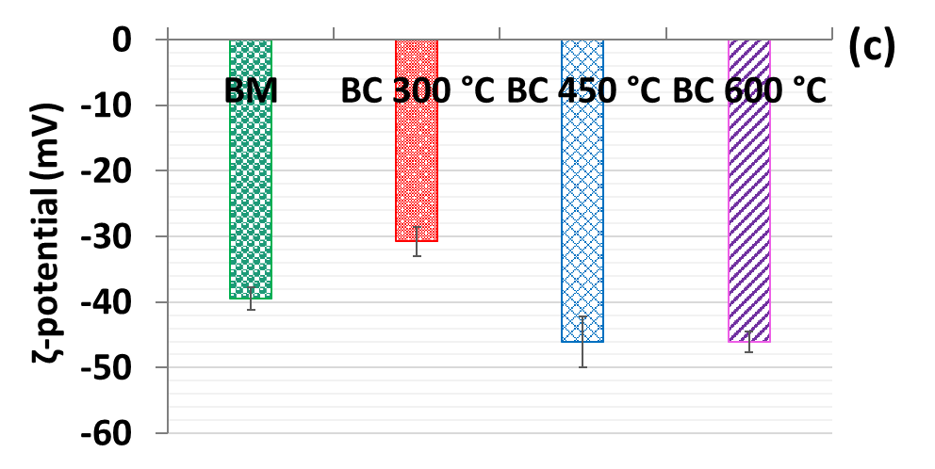 | 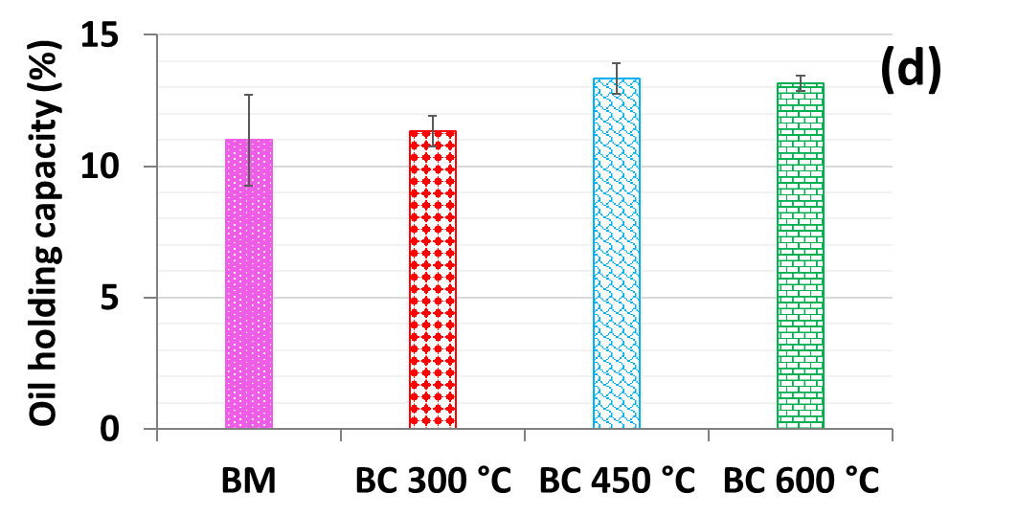
Figure 3: (a) pH, (b) CEC, (c) ζ- potential, and (d) oil holding capacity of SCG biochar and biomass. BM: biomass; BC: biochar
    - Impact of pyrolysis temperature on metals and salts
Pyrolysis temperature strongly influenced the metal and salt concentration present in biochar (Table 1). With increasing temperature, the metal and salt concentrations increased. The most notable changes were observed for potassium, manganese, and iron concentration between 300 and 450 °C. While this is not preferential in most water treatment systems, it may be beneficial for nature based treatment systems that must support plant growth (Pradhan et al., 2018). A small variation was noticed for copper and zinc concentration between biomass and biochar, which suggests a reduced chance of leaching from biochar during the wastewater treatment process.
Table 1: Analysis of various metals present in SCG biomass and biochar

 | BM | BC 300 °C | BC 450 °C | BC 600 °C
K (mg/g) | 0.345±0.016 | 0.464±0.029 | 0.646±0.046 | 0.791±0.008
Fe (mg/g) | 0.25±0.002 | 0.38±0.02 | 1.05±0.07 | 1.08±0.02
Mn (mg/g) | 0.010±0.001 | 0.018±0.002 | 0.031±0.001 | 0.035±0.002
Zn (mg/g) | 0.01±0.003 | 0.015±0.002 | 0.02±0.002 | 0.014±0.004
Al (mg/g) | 0.023±0.0009 | 0.020±0.003 | 0.017±0.014 | 0.116±0.007
Cu (mg/g) | 0.009±0.002 | 0.010±0.002 | 0.015±0.0009 | 0.017±0.0009
K: potassium; Fe: iron; Mn: manganese; Zn: zinc; Al: aluminium; Cu: cupper
  - Conclusion
Biochar has received a lot of attention due to its unique structure and properties, coupled with its cost-effectiveness and environmentally friendly attributes. This study characterized biochar produced from SCG biomass at three different temperatures and analysed its potential of use as an adsorbent. The high availability and low cost of SCG allow its valorization to obtain a carbonaceous adsorbent that can be applied for water and wastewater treatment. Desirable adsorbent properties of biochar demonstrate the potential for slow pyrolysis as a sustainable approach in waste valorization. The high C content, optimal CEC, and ζ-potential in biochar produced at 450 °C signifies a suitable carbonaceous adsorbent to treat water and wastewater. At the same time, the biochar produced at 600 °C also showed comparable properties with biochar at 450 °C. Based on the outcomes, this study plans to evaluate biochars produced at 450 and 600 °C on wastewater treatment performance in the future in comparison with SCG biomass.
  - Acknowledgement
The authors would like to acknowledge the Qatar National Research Fund for supporting this research on materials suitable for nature-based greywater treatment through the National Priorities Research Program (grant NPRP12S-0226-190160).
  - Reference
Abdelaal, A., Pradhan, S., AlNouss, A., Tong, Y., Al-Ansari, T., McKay, G., Mackey, H.R., 2021. The impact of pyrolysis conditions on orange peel biochar physicochemical properties for sandy soil. Waste Management Research, 39, 995–1004. doi:10.1177/0734242X20978456
ASTM, 2013. Standard test methods for proximate analysis of coal and coke by macro thermogravimetric analysis D 7582-15.
ASTM, 2010. Standard test method for measuring the exchange complex and cation exchange capacity of inorganic fine-grained soils D7503-10.
Dai, Z., Meng, J., Muhammad, N., Liu, X., Wang, H., He, Y., Brookes, P., Xu, J., 2013. The potential feasibility for soil improvement, based on the properties of biochars pyrolyzed from different feedstocks. Journal of Soils and Sediments, 13, 989–1000. doi:10.1007/s11368-013-0698-y
Domingues, R., Sánchez-Monedero, M., Spokas, K., Melo, L., Trugilho, P., Valenciano, M., Silva, C., 2020. Enhancing Cation Exchange Capacity of Weathered Soils Using Biochar: Feedstock, Pyrolysis Conditions and Addition Rate. Agronomy 10, 824. doi:10.3390/agronomy10060824
Huong, T.T.T., Van Hoang, N., Toan, V.N., Tong, N.X., Quan, T.A., Thu, V.K., 2021. Initial Results of Using Biochar Derived from Spent Coffee Grounds to Remove Pollutants from Livestock Wastewater in Vietnam, in: Proceedings of the International Conference on Innovations for Sustainable and Responsible Mining. Springer, 305–325.
Kim, M.-S., Min, H.-G., Koo, N., Park, J., Lee, S.-H., Bak, G.-I., Kim, J.-G., 2014. The effectiveness of spent coffee grounds and its biochar on the amelioration of heavy metals-contaminated water and soil using chemical and biological assessments. Journal of environmental management, 146, 124–130.
Konneh, M., Wandera, S.M., Murunga, S.I., Raude, J.M., 2021. Adsorption and desorption of nutrients from abattoir wastewater: modelling and comparison of rice, coconut and coffee husk biochar. Heliyon, 7, 11, e08458. doi:10.1016/j.heliyon.2021.e08458
Kponee, K.Z., Chiger, A., Kakulu, I.I., Vorhees, D., Heiger-Bernays, W., 2015. Petroleum contaminated water and health symptoms: a cross-sectional pilot study in a rural Nigerian community. Environmental Health, 14, 86. doi:10.1186/s12940-015-0073-0
Lavecchia, R., Medici, F., Patterer, S., Zuorro, A., 2016. Lead removal from water by adsorption on spent coffee grounds. Chemical engineering transactions, 47, 295–300.
Liza, Y.F.A., Tapia, F.C., Espinoza, R.F.R., Urquiza, R.J., Castaneda, R.R.L., Canta, J.J.P., Morales, L.K.Q., Burga, B.L.Q., 2021. Study of Coffee Husk (coffea Arabica L.) Activated Carbon in the Treatment of Aquifer Water: Adsorption of Turbidity, Colour and Metals (iron-manganese). Chemical engineering transactions, 89, 655–660. doi:10.3303/CET2189110
Meiirkhanuly, Z., Koziel, J.A., Bia\lowiec, A., Banik, C., Brown, R.C., 2019. The-proof-of-concept of biochar floating cover influence on water pH. Water, 11, 1802.
Nguyen, V.-T., Vo, T.-D.-H., Tran, T., Nguyen, T.-N., Le, T.-N.-C., Bui, X.-T., Bach, L.-G., 2021. Biochar derived from the spent coffee ground for ammonium adsorption from aqueous solution. Case Studies in Chemical and Environmental Engineering 4, 100141. doi:10.1016/j.cscee.2021.100141
Oladipo, A.A., Abureesh, M.A., Gazi, M., 2016. Bifunctional composite from spent “Cyprus coffee” for tetracycline removal and phenol degradation: Solar-Fenton process and artificial neural network. International journal of biological macromolecules, 90, 89–99.
Pradhan, S., Al-Ghamdi, S.G., Mackey, H.R., 2018. Greywater recycling in buildings using living walls and green roofs: A review of the applicability and challenges. Science of Total Environment 652, 330–344.
Pradhan, S., Helal, M.I., Al-Ghamdi, S.G., Mackey, H.R., 2020. Performance evaluation of various individual and mixed media for greywater treatment in vertical nature-based systems. Chemosphere 245, 125564. doi:10.1016/j.chemosphere. 2019.125564
Rangabhashiyam, S., Balasubramanian, P., 2019. The potential of lignocellulosic biomass precursors for biochar production: Performance, mechanism and wastewater application—A review. Industrial Crops Production, 128, 405–423. doi:10.1016/j.indcrop.2018.11.041
Samsuri, A.W., Sadegh-Zadeh, F., Seh-Bardan, B.J., 2014. Characterization of biochars produced from oil palm and rice husks and their adsorption capacities for heavy metals. International Journal of Environmental Science and Technology 11, 967–976. doi:10.1007/s13762-013-0291-3
Vlasopoulos, N., Memon, F.A., Butler, D., Murphy, R., 2006. Life cycle assessment of wastewater treatment technologies treating petroleum process waters. Science of Total Environment 367, 58–70. doi:10.1016/j.scitotenv.2006.03.007
Wang, X., Guo, Z., Hu, Z., Zhang, J., 2020. Recent advances in biochar application for water and wastewater treatment: a review. Peer Journal 8. e9164. doi:10.7717/peerj.9164

