|  |  |
| --- | --- |
| cetlogo ***CHEMICAL ENGINEERING TRANSACTIONS***  ***VOL.*** | A publication of  aidiclogo_grande |
| The Italian Association  of Chemical Engineering  Online at www.cetjournal.it |
| Guest Editors:  Copyright © AIDIC Servizi S.r.l. **ISBN** 978-88-95608-xx-x **ISSN** 2283-9216 | |

**Synthesis of L-Lactide through Reactive Distillation and production of Poly (L-lactic acid) (PLLA)**

\*Sara Crivellin a, \*Samuel D. A. de Souzaa, André L. Jardinia, Maria I. R. B. Schiavona, Viktor O. C. Conchab, Rubens Maciel Filhoa

aNational Institute of Science and Technology in Biofabrication (BIOFABRIS), School of Chemical Engineering, UNICAMP- Campinas, Sao Paulo, Brazil

bChemical Engineering, Federal University of Sao Paulo, Diadema, Sao Paulo, Brazil

The aim of this work is focused on the L-lactide (LLT), a cyclic ester, an intermediate product in the synthesis of Poly(L-lactic acid) (PLLA) by polycondensation reaction from L-lactic acid; a monomer that allows synthesizing PLLA with high molar mass. The great potential of this material has been noted, as the achievement of great purity and good control of its physic-chemical characteristics allows polymeric synthesis under favorable conditions in terms of biodegradability and biocompatibility. The lack of technologies and knowledge for the synthesis of LLT has led to the study of the monomer and in particular synthesis through the way of direct polycondensation and reactive distillation, which have PLLA as a final product. The L-lactide obtained by polycondensation reaction was characterized by Fourier transform infrared spectroscopy (FTIR) and scanning electron microscopy (SEM). It is planned to continue studying a viable LLT production route, taking into account the increased interest in the market, in a single step to increase process productivity, selectivity for the product of interest, and optimization of the synthesis process of this product, completing the polymerization and processing path of the PLLA to validate the quality of the product obtained.

1. Introduction

The synthesis of PLLA, an aliphatic polyester commonly obtained from α-hydroxy acids, is usually a multistep process that begins with the production of lactic acid (LA, 2-hydroxy propionic acid) and ends with its polymerization. An intermediate stage may be the production of the cyclic dimer, L-lactide. PLLA can be produced through different synthesis routes, the main ones are direct polycondensation and ring-opening polymerization (ROP). The synthesis of the polymer by direct polycondensation has as a final product a polymer with low molar mass compared with the ROP (Lasprilla *et al.*, 2012; Wouve *et al.*, 2016). The latter for the production of PLLA needs to go through the production of the cyclic dimer, LLT. The main goal is to control the optical purity of the LLT since it affects the properties of the final polymer to be formed. Consequently, it is necessary to synthesize LLT with a high optical purity to produce PLLA with desirable properties (Heo *et al.*, 2019). LLT is a chiral molecule, as it is shown in Figure 1, that has different stereoisomers being able to classify the enantiomer as levorotatory (L-), dextrorotatory (D-), and the meso (D,L-)~~,~~ leading to the formation of poly(L-lactic acid) (PLLA), poly(D-lactic acid) (PDLA), and poly(D,L-lactic acid) polymers (Neumann, 2016). In this work, the priority is to investigate the PLLA since this polymer offers the best mechanical properties when compared to other stereoisomers. Taking this into consideration, it is important to control the production of LLT because it allows the synthesis of the polymer and in particular the levorotatory stereoisomer, PLLA (Neumann, 2016). Furthermore, PLLA can be formed starting from a lactic acid produced by a fermentation process. Sugarcane bagasse is used with the production of lactic acid adding *Rhizopus oryzae* and *Lactobacillus* in solid-state fermentation (SSF) by supplementing sugars or starch hydrolysates as carbon source (Rojan *et al.*, 2005). Sugarcane is a raw material that is very abundant in Brazil according to FAO Statistics Division (2010), for this reason, there is an interest and incentive for the production of lactic acid and its polymer (Lasprilla *et al.*, 2012). Normally sugar cane is used for the production of bioethanol and the waste material of the process is used for the production of the polymer, so it can be defined as a sustainable process (Kwan *et al.*, 2018).



Figure 1: Chemical structure respectively of L-lactide, D-lactide, D, L-lactide, Source: Produced in ChemSketch based on (Groot *et al.*, 2010).

In the literature it is reported that the reversible formation of LT from the polycondensation reaction of LA was first explored by Carothers (Carothers *et al.*, 1932), demonstrating that temperature and pressure could be used to push the equilibrium towards the lactic product of interest. , and subsequently for the preparation of LT. However, the presence of other species during syntheses, such as lactic acid, water, higher oligomers, and other impurities, requires a purification process (solvent-assisted purification, melt crystallization, or gas phase purification) of the LT crude to make it useful for ROP reactions (Inkinen *et al.*, 2011). For this reason that it is important to control also the catalyst of the reaction, for medical applications according to Food and Drug Administration (FDA), could use tin octanoate II (OctStII) with the quantity of 2% of the polymer mass ratio, it was also studied, thanks to Bukhari *et al.* (2017), how biocatalysis (immobilized *Candida antarctica* Lipase B) accompanied by the use of microwaves can increase the efficiency of the reaction for the production of L-lactide , but as toluene is often used. (Bukhari et al. 2017) In this work the aim is to study a process without toxic solvents, focusing on the develop of ‘green’ process.

Normally the synthesis of PLLA through ROP allows obtaining a polymer with a high molar mass, above 100,000. In the first phase of the polymerization process, a pre-polymerization takes place for the synthesis of the oligomer in which the water is removed without the use of solvents; then this pre-polymer comes depolymerized with a catalyst to form an LT mixture which is purified through distillation. When the reaction is complete, as depicted in Figure 2, all residues and remaining monomers are removed by vacuum and recirculated at the beginning of the process (Park *et al.*, 2018; Heo *et al.*, 2019).

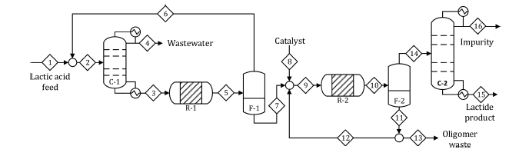

Figure 2: Process flow diagram of L- lactide synthesis process (Heo *et al.*, 2019).

Reactive distillation is being studied as it can be an efficient technology for the production of L-lactide in a single step. This promotes the possibility of chemical reactions and separation in a one-step and therefore increasing the efficiency of the process and decreasing production costs. In this type of distillation, chemical reactions often occur from the introduction of a reactive solvent promoting selective reaction with one of the components inside the column and accompany the fractional distillation in some or all stages of the distillation column, forming the products of interest which should be removed from the column well. The study with this new type of technology for L-lactide synthesis is possible as the production reaction starting from L-lactic acid is reversible but considering that the integration between reaction and separation makes the process more complex, with particularities regarding liquid-vapor equilibrium, liquid-vapor mass transfer, liquid-solid mass transfer, intra-particle diffusion (heterogeneous catalysis), adsorption on the catalyst, and reaction kinetics (Komesu, 2015; Kiss *et al.*, 2006; Lunelli *et al.*, 2011; Perry and Chilton, 1999). For this reason, before continuing the experimental part for the knowledge of all the process parameters, a simulation is being carried out in Aspen Plus software, which with the help of the extension of the latter, Polymer Plus, can be precisely calculated the kinetics and thermodynamics, for the production of L-lactide with the focus about the controlling of temperature of process’s temperature to try to skip the oligopolymerization step and immediately produce the dimer. The residence time in the column will be a very important parameter that can control the conversion of the reaction under examination (Martinez, 2011).

2. Materials and Methods

* 1. Materials

The materials used in this research are: L-lactic acid 85% (Synth), PLLA produced by direct polycondensation, L-lactide obtained during PLLA synthesis and Tin octanoate II (Sigma Aldrich), 1-Dodecanol (Synth).

* 1. Reaction for producing L-lactide

The experiment for obtaining the polymer and consequently L-lactide was carried out in the INCT-Biofabris laboratory, at the University of Campinas. A jacketed reactor was built-up, connected to a water bath and a condenser to allow the collection of the polymer formed, PLLA, to take place. Before starting the polymerization, the dehydration step was carried out because the L-lactic acid used had 15% water, the reactor was heated up to 130 ºC for 3 h, to eliminate the water completely. The second step consisted in starting the actual synthesis, and in this stage SnOct2 and 1-dodecanol were added, respectively, at 1% and 0.0025%, according to the FDA, at a temperature of 160º C, for about 72 h, always maintaining constant agitation (Auras *et al.*, 2010).

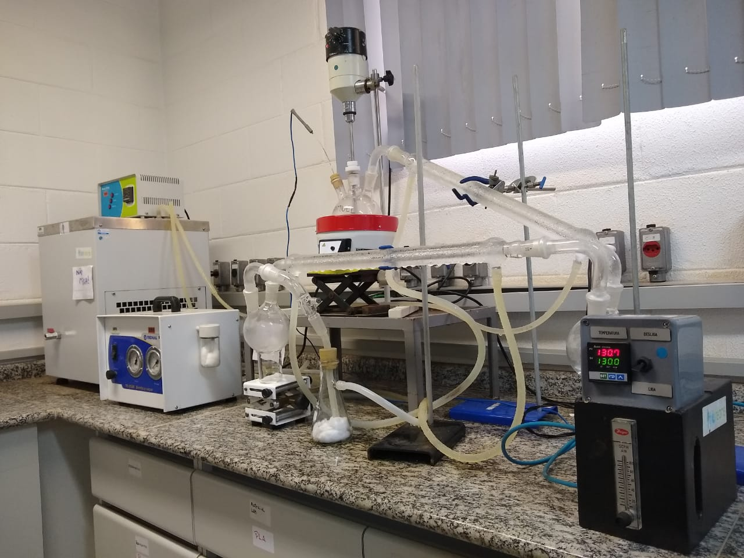

Figure 3: Experimental rig at INCT-Biofabris laboratory, University of Campinas.

During the progress of the synthesis, some encrustations, as shown in Figure 4, were visualized between the exit of the reactor and the beginning of the condenser due to the thermal shock, as the temperature of the condenser was 5 ºC. The material causing the fouling was L-lactide, a by-product of the reaction. The synthesis process was stopped after 8 h and even 12 h to collect the reaction by-product. According to the literature it is found that the formation temperature of L-lactide occurs between 160 ºC and 240 ºC; the thermal shock with the temperature used in the condenser allowed the solidification of the L-lactide (Lasprilla 2011; Lasprilla *et al.*, 2012; Dong *et al.*, 2006).

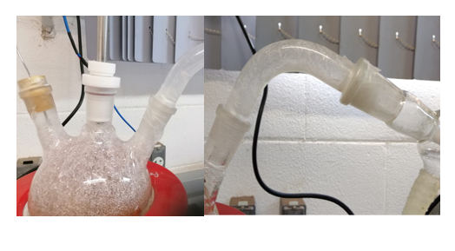

Figure 4: Encrustation obtained in 12 h and 8 h respectively.

2.3 Fourier-transform infrared spectroscopy (FTIR)

The L-lactide collected was analysed with Fourier-transform infrared spectroscopy (FTIR). This analysis studies the transition of normal molecular vibrations so their vibrations can be of the type angular deformation, torsion, and bonding stretch (Pattaro, 2016). FTIR measurements were done on a Bruker VERTEX 70v spectrometer from the AES group of Carbon Sci Tech Labs, located at the Faculty of Electrical and Computer Engineering (FEEC/UNICAMP), in a 633 nm wavelength laser radiation transmission mode.

The sample was prepared by placing 0.2 mg of active material in a Kbr pellet.  
The region under study was 500 to 4000 cm-1 so the determination of absorption vibrational bands for LLT was performed. For the characterization of LLT, the spectrum, shown as result in Figure 7, was generated and for the control, it was taken the table showing the characteristic absorbance band at L-lactide, Table 1, which represents the characteristic absorbance band of the dimer according to the literature (Pattaro, 2016; Gupta *et. al.*, 2007).

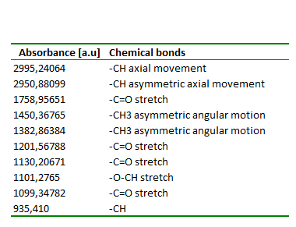

Table 1: Absorption bands of functional groups in the infrared region of L-lactide (Pattaro, 2016).

2.4 Scanning electron microscopy (SEM)

The final polymer recovered after the reaction, Poly (L-lactic acid) was analysed with scanning electron microscopy (SEM), to see the morphology of the polymer in the superficial part.

The surface morphology of PLLA obtained, as presented in Figure 5, was analysed by scanning electron microscopy (SEM) of the AES group of Carbon Sci-Tech Labs, located at the Faculty of Electrical and Computer Engineering (FEEC/UNICAMP), using a Quattro ESEM model microscope from Thermo Scientific™. The same apparatus was used to analyse the atomic composition to verify the exact composition of the polymer obtained from the direct polycondensation system, as shown in Figure 6. The sample was coated with a thin layer of iridium for metallization effects with a focus on acquiring better image resolution.

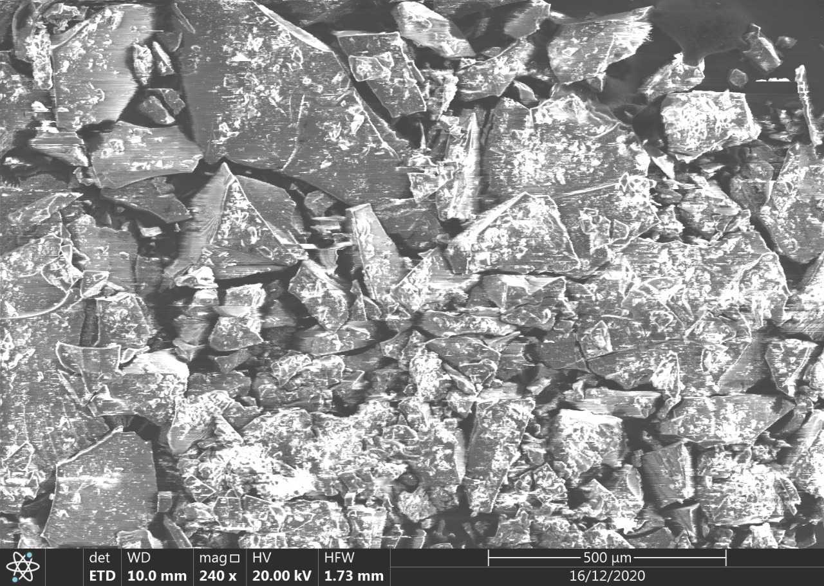

Figure 5: SEM analysis about PLLA obtained

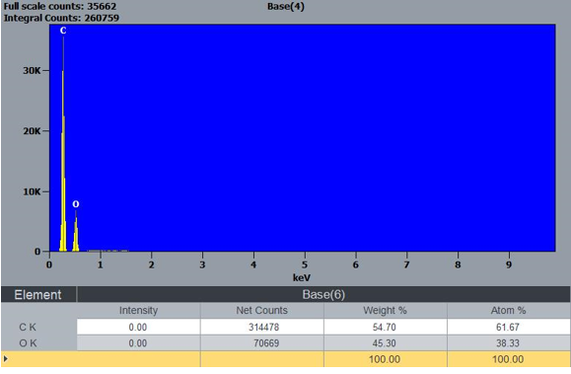

Figure 6: Analysis of the chemical composition of PLLA

1. Results and discussions

Figure 7, related to FTIR spectrum shows that the material obtained as a by-product is L-lactide since the absorbance band corresponds to the atoms that make up the dimer, according to Table 1; There is a correspondence between the spectrum obtained and the table and this confirms that the material is precisely L-lactide

Figure 7: FTIR of L-lactide collected during the experiment.

The analysis carried out, in particular the SEM analysis, Figure 5, allows for verifying the surface of the polymer produced in the laboratory and its composition. The evaluation of information from literature and the experiments allows to saying that it is preferable to use the ROP synthesis route because it leads to a polymer with a larger molecular mass and decreases the reaction time (Pattaro, 2016). Furthermore, the material obtained with this type of route, has adequate mechanical characteristics for prostheses and scaffolds, as the molecular mass interferes with the viscosity and therefore it becomes easier to use a 3D printer or obtain membranes with the electrospinning technique (Pattaro, 2016). Further investigations to improve the synthesis process in the polycondensation reaction, shown in Figure 3, is to automate it and reduce the reaction times in order to directly collect the lactide, avoiding blocking the process and also the encrustations at the reactor outlet, increasing the temperature of the condenser and reducing the thermal shock.

1. Conclusion

The interest in this dimer is growing a lot in the market so studies towards an efficient technology for producing L-lactide such as reactive distillation is very much welcome. The aim is to produce the dimer with the route of ROP with the purpose of using the material for medical applications.

The Aspen PLUS software allows for simulating the process and investigating the variables that control the process, reproducing the processes already known from the literature (Heo *et al.*, 2019) as a first step to validated the adopted simulation hypothesis and then propose strategies with the main objective to increase the process efficiency.

Acknowledgments

The authors are grateful to the financial support of grants #2015/20630-4 and #2021/05719-0 São Paulo Research Foundation (FAPESP), and CAPES, Project n° 88887.461593/2019-00.

References

Bukhari A., Atta M., Idris A. 2017. " Synthesis of poly(L-) lactide under simultaneous cooling and microwave

heating by using immobilised candida antarctica lipase." *Chemical Engineering Transactions* 56:1447-

1452.

Carothers, Wallace H., G. L. Borough, and F. J. Natta. n.d. 1932 “Studies of Polymerization and Ring

Formation. X. The Reversible Polymerization of Six-Membered Cyclic Esters.” *Journal of the American*

*Chemical Society* 54(2):761–72.

Dong, Keun Yoo, Dukjoon Kim, and Sung Lee Doo. 2006. “Synthesis of Lactide from Oligomeric PLA: Effects of Temperature, Pressure, and Catalyst.” *Macromolecular Research* 14(5):510–16.

Groot, Wim, Jan Van Krieken, Olav Sliekersl, and Sicco De Vos. 2010. “Production and Purification of Lactic Acid and Lactide.” *Poly(Lactic Acid): Synthesis, Structures, Properties, Processing, and Applications* 3–18.

Gupta, B.; Revagade, N.; HilbornI, J.,2007. Poly(lactic acid) fiber: An overview. Progress in Polymer Science (Oxford), [s. l.], v. 32, n. 4, p. 455–482.

Heo, Seongmin, Hyun Woo Park, Jay H. Lee, and Yong Keun Chang. 2019. “Design and Evaluation of Sustainable Lactide Production Process with an One-Step Gas Phase Synthesis Route.” *ACS Sustainable Chemistry and Engineering* 7(6):6178–84.

Inkinen, Saara, Minna Hakkarainen, Ann Christine Albertsson, and Anders Södergård. 2011. “From Lactic Acid to Poly(Lactic Acid) (PLA): Characterization and Analysis of PLA and Its Precursors.” *Biomacromolecules* 12(3):523–32.

Kiss, Anton A., Florin Omota, Alexandre C. Dimian, and Gadi Rothenberg. 2006. “The Heterogeneous Advantage: Biodiesel by Catalytic Reactive Distillation.” *Topics in Catalysis* 40(1–4):141–50.

Komesu, Andrea. 2015. “Estratégias de Separação e Purificação Do Ácido Láctico Produzido Por via Fermentativa.” 325.

Kwan Tsz H., Yunzi Hu, Carol S. K. Li. 2018. "Techno-economic analysis of a food waste valorisation process for lactic acid, lactide and poly(lactic-acid) production." *Journal of Cleaner Production* 181: 72-87

Lasprilla Astrid J. R. 2011. " “Síntese Do Poli ( Ácido Láctico ) A Partir Do Ácido Láctico Para Aplicação Em Dispositivos Biomédicos.” *Tese de Mestrado - Universidade Estadual de Campinas, Faculdade de Engenharia Química.* 291.

Lasprilla, Astrid J. R., Guillermo A. R. Martinez, Betânia H. Lunelli, André L. Jardini, and Rubens Maciel Filho.

2012. “Poly-Lactic Acid Synthesis for Application in Biomedical Devices - A Review.” *Biotechnology*

*Advances* 30(1):321–28.

Martinez Guillermo A. R. 2011." Modelagem e simulação do processo de produção de PLA (Poli-acido lactìco) obtido a partir de fontes renovaveis." *Tese de Mestrado - Universidade Estadual de Campinas, Faculdade de Engenharia Química.* 172.

Neumann, I. A.. 2016. “Obtenção De Parâmetros De Síntese Para O Poli(Ácido-L-Lático) (Plla) Para

Estruturação De Blendas Poliméricas Biodegradáveis De Plla E Plla-Estrela.” 93.

Park, Jinwoo, Hyungtae Cho, Dongwon Hwang, Seungnam Kim, Il Moon, and Myungjun Kim. 2018. “Design of a Novel Process for Continuous Lactide Synthesis from Lactic Acid.” *Industrial and Engineering Chemistry Research* 57(35):11955–62.

Pattaro, Ana Flavia. 2016. “Síntese , Caracterização e Processamento de Polímeros Biorreabsorvíveis Para Uso Na Engenharia de Tecidos (Tissue Engineering).” *Tese de Doutorado - Universidade Estadual de Campinas, Faculdadia Química.* 291.

Rojan, Kesavan M. Nampoothiri, Athira S. Nair, Ashok Pandey. 2017. " L(+)-Lactic acid production using

Lactobacillus casei in solid-state fermentation." *e de EngenharChemical Engineering Transaction* 56:

1447-1452.

Wouve, P.; Dusselier, M.;Vanlleeuw, E.; Sels, B. 2016. Lactide Synthesis and Chirality Control for Polylactic Acid Production, Chem Inform, 10.1002/chin.201627260, 47, 27.