CHEMICAL ENGINEERING TRANSACTIONS  VOL. 92, 2022 | A publication of
The Italian Association
of Chemical Engineering
Online at www.cetjournal.it
Guest Editors: Rubens Maciel Filho, Eliseo Ranzi, Leonardo Tognotti
Copyright © 2022, AIDIC Servizi S.r.l.
ISBN 978-88-95608-90-7; ISSN 2283-9216

Hydrothermal carbonization of sludge residues via Carborem C700 industrial scale continuous operating plant

Michela Lucian*ª , Fabio Merzariª, Antonio Messineo^{b} and Maurizio Volpe^{a,b}
ªCARBOREM, piazza Manifattura 1 – 38068 Rovereto (TN), Italy
^{b}Università di Enna, KORE, Facoltà di Ingegneria e Architettura, viale delle Olimpiadi snc, 94100 Enna, Italy
michela.lucian@carborem.com
This study describes the main features of a novel industrial-scale continuous operating hydrothermal carbonization (HTC) developed by Carborem srl named C700. The C700 industrial-scale HTC plant is a highly compact, modular and containerized system capable of treating more than 5 kton per year of sludge. The results of HTC operated with C700 plant at 190 °C and 1 h of residence time of three different high moisture content residues (sewage sludge, agro-industrial sludge, and organic fraction of municipal solid waste digestate) demonstrate the efficiency and versatility of the process. C700 system is capable of promoting dewaterability of sludge residues, producing solid residues (hydrochars) upon centrifugation of HTC slurries with improved phosphorus content. Results show that the system allows concentrating P into the solid residue up to 3.6 wt% on a dry basis and leads to hydrochars with a total solid content, upon centrifugation of 34.6, 38.6 and 41.0 wt% for sewage and agro-industrial sludge and organic fraction of municipal solid waste digestate, respectively. Moreover, while hydrochars show good potential as soil fertilizers, when excess heavy metals like copper and zinc are removed, recirculation of the high carbon content liquid residue to the anaerobic digestion system offers the opportunity to enhance biogas production in the waste management plant thus lowering the total external energy demand of the process.
  - Introduction
Due to the growing attention to the environmental risks associated with the use of digested sludge in agriculture practices and the corresponding more stringent legislations, sludge managements operation are facing increasing costs for sludge treatments and disposal (Wang et al., 2019). Moreover, the global increase in anthropogenic pressure causing a rapid increase in sludge production is pushing the development of new strategies and technologies, in full agreement with a circular economy approach, for the reduction and the safe treatment of such residues. Between the new technologies for the treatments of such as high moisture residues as sewage sludge (Merzari et al., 2020; Volpe et al., 2020), organic fraction of municipal solid waste (Pawlak-Kruczek et al., 2019), agro-waste (Lin et al., 2021) and agro-industrial residues (Benavente et al., 2015), hydrothermal carbonization (HTC) demonstrated to be one of the most promising. HTC is a wet thermochemical process carried out at sub-critical water conditions where high moisture organic residues are treated at temperatures between 180-250 °C and corresponding saturated water pressure of 10-50 bars. During HTC, water acts as a catalyst promoting hydrolyzation, dehydration, and decarboxylation reactions (Kruse and Dahmen, 2015) leading to a solid residue showing an enhanced degree of carbonization (Miliotti et al., 2017), high energy density, hydrophobicity (Sharma et al., 2020) and adsorption properties toward organic water contaminants (Saha et al., 2020). HTC process produces also a considerable amount of an aqueous liquid residue, with increased organic carbon content, suitable for biogas production when recirculated in an anaerobic digestion plant (Villamil et al., 2019).
Despite the high and growing attention for HTC technology and its recognized efficiency and economic viability for upgrading wet waste biomass effluents (Miliotti et al., 2020), just few studies have focused on up-scaling of the process (Child, 2014; Kruse et al., 2013) and even less are the reported industrial scale applications for forestry residues (Hitzl et al., 2015) and agro-industrial digested sludge (Lucian et al., 2021).
The aim of the present study is to report the main features of a novel continuous operating HTC industrial scale developed by Carborem srl named C700 capable of treating up to 5 kton/year (corresponding to 0.7 ton/h) of biomass waste effluents with a solid content ranging between 2-10 wt% at temperature as high as 220 °C and pressure up to 25 bars. Main properties of HTC solid and liquid residues produced by C700 demonstrate its high performance and versatility enhancing dewatering properties of hydrochars. HTC thus reduces the volumes of waste to dispose while also offering the opportunity of producing a valuable product such as an organic fertilizer with high P content.
  - Materials and methods
    - Materials
Three different waste effluents were treated in the continuous HTC plant: sewage sludge digestate (SSD), organic fraction of municipal solid waste digestate (OFD) and agro-industrial digestate (AWD). All the substrates investigated in this study were treated as soon as received at the waste management plant for at least a 48 h in continuously operating mode. The produced HTC residues (slurries) were collected in a 11.3 m³ tank before centrifugation and/or analytical characterization. A portion of each feedstock and corresponding slurry were carefully sampled and stored in sealed plastic containers kept at 4 °C before analytical characterizations.
    - Feedstock and HTC residues analytical characterization
The total solid content of the feedstock and corresponding slurries were measured by the moisture analyzer DAB 100-3 60. The total nitrogen was determined following the CNR IRSA 6 Q64 Vol.3 1985 method. The pH of hydrochars was measured according to the CNR IRSA 1 Q 64 Vol 3 1985 + APAT CNR IRSA 2060 Man 29 2003 method, while the pH value of the liquid/slurry samples was measured with a portable LLG-pH meter 5. The total chemical oxygen demand (COD) of the HTC liquids was determined following the ISO 15705:2002 standard method. The heavy metal (Cd, Hg, Ni, Pb, Cu, Zn) and phosphorus concentrations of all samples (raw materials and HTC residues) were evaluated by means of an ICP 8300 DV Optima Perkin Elmer spectrometer equipped with a high-performance SCD detector using EPA 6010D: 2018 + EPA 3051A: 2007 standard methods. Leaching of the samples was carried out via microwave-assisted digestion using a 10 wt% nitric and hydrochloric solution in water at a temperature of 175 °C. All analyses were performed at least in duplicate, obtaining a maximum deviation less than 5%. Total organic carbon (TOC) determination of the samples was carried out by a TOC analyzer (model PRIMACS SNC-100) following the UNI EN 15936:2012 standard method.

    - C700 Continuous operating Industrial plant: main design features and operation
Figure 1 reports a schematic representation of the C700 HTC plant. The digestate collected from a storage tank is fed into the system via a pump soon after a first mechanical removal of coarse material. The raw digestate is preheated through a heat exchanger that exchanges with the hot HTC slurry coming from the reactor. The preheated feedstock, continuously fed into the reactor, is warmed up to reaction temperature by means of hot diathermic oil flowing through the outer jacket of the reactor. The valve on the HTC slurry pipe regulates the flow rate leaving the reactor, while maintaining the pressure into the HTC reactor. The produced liquid solid mixture, called HTC slurry (SL), is sent into a centrifuge that separates a liquid aqueous phase rich in carbon that is recirculated to the anaerobic digestion system of the plant, and a residue high in solid content (about 40 wt%) named hydrochar (HC).
C700 plant is composed of a feedstock storage tank of about 10.0 m³, a 11.3 m³ HTC slurry storage tank, a diathermic oil boiler fed with provided by the municipal network and / or biogas produced by the anaerobic digester of the waste management plant, and the reactor system located into a container (Figure 2a-b). The diathermic oil boiler, when continuously operated at 190 °C with a residence time of 1 h, consumes about 8.5 ±0.3 Nm³ of methane per ton of digested sludge treated while the overall electricity consumption, for the same amount of treated sludge, is about 4.6 ±0.1 kWh. Figure 2b shows the 0.7 ton/h jacketed C700 HTC reactor.

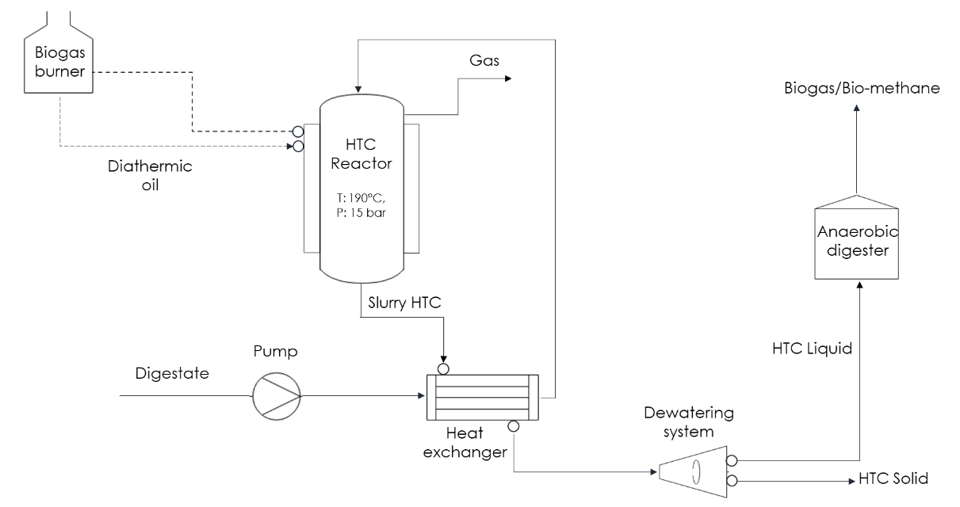
Figure 1: Schematic representation of the continuously operating C700 HTC plant.

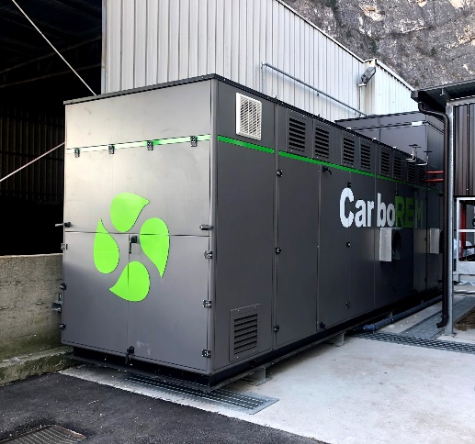

Figure 2: (a) C700 plant container; (b) C700 HTC jacketed reactor vessel

The customized reaction system container, 8.0 m long, 2.0 m large and a maximum height of 3.5 m houses the reactor vessel, the pumping and heating exchanging system and the PLC control system. The PLC can be also operated remotely. A dedicated software, developed for the plant, allows real-time monitoring and recording of all process parameters and data regarding energy consumption and productivity. The diathermic oil boiler and its piping are located in a separate cabinet close to the reactor container.

    - C700 HTC experiments and slurries recovery
In this study SSD, OFD and AWD feedstock were carbonized at 190 °C and 1 hour using C700 plant operating in a continuous mode at 0.7 ton/h reaction rate. The produced HTC slurries (SL) were centrifuged at 2800 rpm by a CBB Decanter model CD 50 SIV industrial centrifuge (Figure 3) working at a flow of 7 ton/h of SL. The HTC slurry materials were named SSD-SL, OFD-SL and AID-SL while centrifuged materials (hydrochars) were named SSD-HC, OFD-HC and AID-HC respectively. A sample of at least 5 kg of each hydrochar was stored in sealed plastic containers and kept at 4 °C before further treatments and characterization.
During the HTC process, a portion of the solid fraction of the starting biomass is converted into a gas that is mainly composed of CO₂ and a liquid aqueous phase. As a consequence, the amount of total solid (TS) found in the HTC slurries, before centrifugation, was lower than solid in the starting sludge. Eq. (1) and (2) are used to compute the solid (MY_{S}) and the liquid (MY_{l}) mass yields obtained during HTC:

$$MYs(\%)=\frac{M_{S-SL }}{M_{S-DS }} ∙100$$ | (1)
$$MYl(\%)=\frac{M_{l-SL db}}{M_{S-DS db}} ∙100$$ | (2)
where M_{S-SL} and M_{l-SL} are the dry basis masses of the solid and liquid phase in the slurries obtained during the HTC process respectively and the M_{S-DS} is the mass of the solid in the digestate on a dry basis.
The mass yield of the gas phase M_{g-HC} is computed by the difference:
$$MYg\left(\%\right)=100-MYl-MYs$$ | (3)

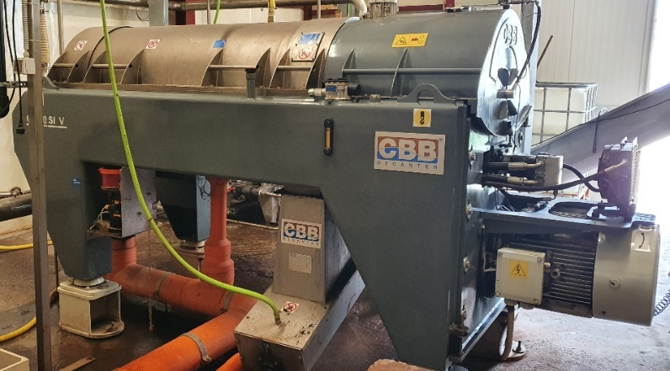

Figure 3: industrial centrifuge at Mezzocorona waste management plant for HTC slurry treatment
  - Results and discussion
    - Feedstock properties and characterization
Table 1 shows the properties in terms of pH, total solids (TS), total organic carbon (TOC), total nitrogen (TKN), phosphorus (P) and heavy metals concentration of the feedstock before HTC. SSD and AWD raw materials show similar characteristics in terms of pH, TOC and P content except for the TS, the OFD sample shows a significantly higher pH, TS and TOC but a considerably lower, as expected, P and heavy metals content.
Table 1: Raw materials properties, pH, total solids TS, total organic carbon TOC, total nitrogen TKN, phosphorus P, and heavy metal concentrations (all values are determined on dry basis)
Sample | pH (U.pH) | TS (wt%) | TOC (wt%) | TKN (wt%) | P (wt%) | Cd (ppm) | Cu (ppm) | Hg (ppm) | Ni (ppm) | Pb (ppm) | Zn (ppm)
SSD | 7.5  (±0.1) | 1.5  (±0.1) | 22.1 (±0.3) | 4.3 (±0.2) | 2.7 (±0.1) | 2.24 (±0.1) | 257 (±4.0) | 0.36 (±0.02) | 44.0 (±2.0) | 28.1 (±0.1) | 810 (±4.0)
OFD | 8.5  (±0.1) | 7.8  (±0.2) | 38.5 (±0.6) | 5.1 (±0.2) | 0.07 (±0.01) | 0.26 (±0.1) | 4.0 (±0.1) | < 0.20 (±0.0) | 3.2 (±0.1) | 0.2 (±0.05) | 71.0 (±1.0)
AWD | 7.0  (±0.1) | 5.1  (±0.1) | 26.0 (±0.4) | 3.6 (±0.1) | 2.3 (±0.1) | < 0.12 (±0.01) | 440 (±0.5) | < 0.20 (±0.0) | 17.2 (±0.1) | 6.4 (±0.1) | 232 (±1.5)
Table 2 reports the pH of HTC slurries and mass yields. The pH values of slurries are similar to the pH of the raw biomass for all the samples investigated, dropping of about 0.5 units maximum. Mass yields data show that between 54.8 and 63 wt% of solid mass is retained in the slurries after HTC, a lesser amount of mass yield is obtained in the gas phase (averagely between 4.4 and 5.6 wt%) while the remaining is moved into the liquid phase (averagely between 31.8 and 40.8 wt%).
Table 2: pH, solid, gas and liquid mass yields, of SSD, OFD and AWD slurries
Sample | pH | MY_{S} (wt%) | MY_{g}* (wt%) | MY_{L} (wt%)
SSD-SL | 7.0 (±0.1) | 63.1 (±2.0) | 5.1 (±0.4) | 31.8 (±1.6)
OFD-SL | 8.0 (±0.1) | 54.8 (±1.1) | 4.4 (±0.2) | 40.8 (±0.9)
AWD-SL | 7.0 (±0.1) | 57.6 (±1.3) | 5.6 (±0.1) | 36.8 (±1.2)
(* computed by difference)
Table 3 reports the data of TS, TOC, TKN, P and heavy metals concentration. The results demonstrate that HTC is capable of substantially increase the dewaterability of the sludge leading to TS values, upon centrifugation of 34.6, 42.0 and 38.6 wt% for SSD, OFD and AWD hydrochars. Notably the P recovery into hydrochars was 75, 78 and 85 wt% for SSD, OFD and AWD samples respectively when compared to the corresponding starting materials. P segregation into hydrochar during HTC has been already reported for sewage sludge (Volpe et al., 2020) and food waste (Idowu et al., 2017).
Table 3: TS, TOC, TKN, P and Heavy metal concentration in SSD, OFD and AWD hydrochars obtained after centrifugation of the corresponding slurries (all data computed on a dry basis).
Sample | TS (wt%) | TOC (wt%) | TKN (wt%) | P (wt%) | Cd (ppm) | Cu (ppm) | Hg (ppm) | Ni (ppm) | Pb (ppm) | Zn (ppm)
SSD-HC | 34.6  (±0.1) | 23.0 (±0.5) | 3.3 (±0.2) | 3.2 (±0.1) | 1.25 (±0.1) | 340 (±5.0) | 0.36 (±0.02) | 49.0 (±2.5) | 44.1 (±1.0) | 1050 (±4.0)
OFD-HC | 41.0  (±0.1) | 29.6 (±0.2) | 4.4 (±0.2) | 0.10 (±0.1) | 1.05 (±0.1) | 19 (±0.1) | < 0.20 (±0.0) | 14.7 (±0.1) | 1.0 (±0.05) | 265 (±3.0)
AWD-HC | 38.6  (±0.2) | 23.6 (±0.3) | 1.9 (±0.1) | 3.4 (±0.1) | < 0.12 (±0.0) | 630 (±5.0) | 0.32 (±0.1) | 10.3 (±0.1) | 19.4 (±0.2) | 450 (±3.5)

Together with P concentration, hydrochars show a considerable increase in heavy metals (in particular Cu and Zn for SSD-HC and AWD-HC residues). Hydrochars containing high levels of heavy metal need to be adequately treated before their possible use as soil amendment (Lucian et al., 2021). HTC liquid residues showed a chemical oxygen demand of 9550, 15560 and 9880 mgO₂/L for SSD, OFD and AWD respectively. TOC values of starting materials and hydrochars demonstrate that relevant amount of organic carbon is moved into the aqueous liquid residues that can be recirculated into the anaerobic digestion system of the plant to produce biogas to cover part of C700 energy needs.
  - Conclusions
This study reports the main feature of a novel continuous operating industrial scale HTC plant developed by Carborem srl. C700 is a compact containerized HTC system that can be easily integrated in existing waste management plant capable of treating up to 5 kton/year (0.7 ton/h) of sludge with a TS between 2 and 10 wt%.
C700 system, even at relatively mild condition, 190 °C and 1 h of residence time, promotes dewaterability of sludge residues, producing hydrochars with improved phosphorus content. Results show that the system is able to segregate up to 85 wt% of the initial P content into the HTC solid residues. The process enhances dewaterability of the slurry obtaining hydrochars with a total solid content, upon centrifugation, of 34.6, 38.6 and 41.0 wt% for sewage sludge, agro-industrial sludge and organic fraction of municipal solid waste digestate, respectively. HTC liquid aqueous residues can be recirculated into the anaerobic digestion system of the waste management increasing biogas production to be used for the energy needs of C700.

Acknowledgments
This research has been carried out under the research industrial project “Upfield-HTC”, funded by the Autonomous Province of Trento (L.P. 6/99).
Authors gratefully acknowledge Ecoopera Soc. Coop. and Consorzio Lavoro Ambiente Soc. Coop. for the technical support at the waste water treatment plant, where the C-700 is located. In particular, authors acknowledge Maurizio and Antonio Schönsberg, Roberto Munter for their needful help in plant management.
References
Benavente, V., Calabuig, E., Fullana, A., 2015. Upgrading of moist agro-industrial wastes by hydrothermal carbonization. J. Anal. Appl. Pyrolysis 113, 89–98. https://doi.org/10.1016/j.jaap.2014.11.004
Child, M., 2014. INDUSTRIAL-SCALE HYDROTHERMAL CARBONIZATION OF WASTE SLUDGE MATERIALS FOR FUEL PRODUCTION. Lappeenranta – Lahti University of Technology LU.
Hitzl, M., Corma, A., Pomares, F., Renz, M., 2015. The hydrothermal carbonization (HTC) plant as a decentral biorefinery for wet biomass. Catal. Today 257, 154–159. https://doi.org/10.1016/j.cattod.2014.09.024
Idowu, I., Li, L., Flora, J.R.V., Pellechia, P.J., Darko, S.A., Ro, K.S., Berge, N.D., 2017. Hydrothermal carbonization of food waste for nutrient recovery and reuse. Waste Manag. 69, 480–491. https://doi.org/10.1016/j.wasman.2017.08.051
Kruse, A., Baris, D., Tröger, N., Wieczorek, P., 2013. Scale-Up in Hydrothermal Carbonization, in: Sustainable Carbon Materials from Hydrothermal Processes. pp. 341–353. https://doi.org/10.1002/9781118622179.ch9
Kruse, A., Dahmen, N., 2015. Water - A magic solvent for biomass conversion. J. Supercrit. Fluids 96, 36–45. https://doi.org/10.1016/j.supflu.2014.09.038
Lin, J., Mariuzza, D., Volpe, M., Fiori, L., Ceylan, S., Goldfarb, L., 2021. Integrated thermochemical conversion process for valorizing mixed agricultural and dairy waste to nutrient-enriched biochars and biofuels. Bioresour. Technol. 328, 124765. https://doi.org/10.1016/j.biortech.2021.124765
Lucian, M., Merzari, F., Gubert, M., Messineo, A., Volpe, M., 2021. Industrial-Scale Hydrothermal Carbonization of Agro-Industrial Digested Sludge: Filterability Enhancement and Phosphorus Recovery. Sustainability 13, 9343. https://doi.org/10.3390/su13169343
Merzari, F., Goldfarb, J., Andreottola, G., Mimmo, T., Volpe, M., Fiori, L., 2020. Hydrothermal carbonization as a strategy for sewage sludge management: Influence of process withdrawal point on hydrochar properties. Energies 13. https://doi.org/10.3390/en13112890
Miliotti, E., Casini, D., Lotti, G., Bettucci, L., Pennazzi, S., Rizzo, A.M., Chiaramonti, D., 2017. Valorization of solid residues from anaerobic digestion through thermal and hydrothermal carbonization process. 25th Eur. Biomass Conf. Exhib. 1063–1069. https://doi.org/10.5071/25thEUBCE2017-3DO.3.4
Miliotti, E., Casini, D., Rosi, L., Lotti, G., Rizzo, A.M., Chiaramonti, D., 2020. Lab-scale pyrolysis and hydrothermal carbonization of biomass digestate: Characterization of solid products and compliance with biochar standards. Biomass and Bioenergy 139, 105593. https://doi.org/10.1016/j.biombioe.2020.105593
Pawlak-Kruczek, H., Sieradzka, M., Mlonka-Mędrala, A., Baranowski, M., Serafin-Tkaczuk, M., Magdziarz, A., Niedźwiecki, Ł., 2019. Structural and energetic properties of hydrochars obtained from agricultural and municipal solid waste digestates, in: ECOS 2019 - Proceedings of the 32nd International Conference on Efficiency, Cost, Optimization, Simulation and Environmental Impact of Energy Systems.
Saha, N., Volpe, M., Fiori, L., Volpe, R., Messineo, A., Reza, M.T., 2020. Cationic dye adsorption on hydrochars of winery and citrus juice industries residues: Performance, mechanism, and thermodynamics. Energies 13, 1–16. https://doi.org/10.3390/en13184686
Sharma, H.B., Sarmah, A.K., Dubey, B., 2020. Hydrothermal carbonization of renewable waste biomass for solid biofuel production: A discussion on process mechanism, the influence of process parameters, environmental performance and fuel properties of hydrochar. Renew. Sustain. Energy Rev. 123, 109761. https://doi.org/https://doi.org/10.1016/j.rser.2020.109761
Villamil, J.A., Mohedano, A.F., Rodriguez, J.J., De la Rubia, M.A., 2019. Anaerobic co-digestion of the aqueous phase from hydrothermally treated waste activated sludge with primary sewage sludge. A kinetic study. J. Environ. Manage. 231, 726–733. https://doi.org/10.1016/j.jenvman.2018.10.031
Volpe, M., Fiori, L., Merzari, F., Messineo, A., Andreottola, G., 2020. Hydrothermal carbonization as an efficient tool for sewage sludge valorization and phosphorous recovery. Chem. Eng. Trans. 80, 199–204. https://doi.org/10.3303/CET2080034
Wang, L., Chang, Y., Li, A., 2019. Hydrothermal carbonization for energy-efficient processing of sewage sludge: A review. Renew. Sustain. Energy Rev. 108, 423–440. https://doi.org/10.1016/j.rser.2019.04.011

