|  |  |
| --- | --- |
| cetlogo ***CHEMICAL ENGINEERING TRANSACTIONS***  ***VOL. xxx, 2025*** | A publication of  aidiclogo_grande |
| The Italian Association  of Chemical Engineering  Online at www.cetjournal.it |
| Guest Editors: Fabrizio Bezzo, Flavio Manenti, Gabriele Pannocchia, Almerinda di Benedetto  Copyright © 2025, AIDIC Servizi S.r.l. **ISBN** 979-12-81206-17-5; **ISSN** 2283-9216 | |

Impact of Adverse Events on Urban Air Quality: The Example of the Rome Fire

Nicoletta Lotrecchianoa, Daniele Sofiab,c\*

aDepartment of Environmental Assessment, Controls and Sustainability Service for Risks and Environmental Sustainability of Technologies, Chemical Substances, Production Cycles and Water Services and for Inspection Activities,

ISPRA - Institute for Environmental Protection and Research, Via V. Brancati 48, 00144 Rome, Italy

bDepartment of Computer Engineering, Modeling, Electronics and Systems, University of Calabria,   
Via P. Bucci, Cubo 44/a Rende, 87036 Arcavacata, Italy

cResearch Department, Sense Square Srl, 84084 Salerno, Italy

daniele.sofia@unical.it or danielesofia@sensesquare.eu

Adverse events such as fires pose a significant threat to air quality in urban areas, with both immediate and long-term impacts on public health and the environment. This study examines the effects of a major fire that occurred in Rome in 2024, affecting an industrial area and resulting in a substantial release of atmospheric pollutants. Using monitoring sensors and dispersion models, we measured the increase in fine particulate matter (PM2.5 and PM10) during and after the incident. The collected data were compared with standard air quality levels, highlighting a critical exceedance of safety thresholds. Furthermore, the study evaluates the effectiveness of the measures taken to contain pollution and reduce public exposure, proposing preventive and management solutions to minimize the impact of future events. The results emphasize the need to improve response strategies to such phenomena and to strengthen the alert system to ensure better protection of air quality and urban health.

* 1. Introduction

The problem of summer wildfires has become increasingly severe in recent years, affecting various regions around the world. Several factors contribute to the rise in the frequency and intensity of these fires. The climate change plays a significant role. Rising temperatures, prolonged droughts, and changing precipitation patterns create optimal conditions for wildfires. Hotter summers and drier landscapes make vegetation more susceptible to ignition, resulting in larger and more destructive fires. Also, human activities are a major contributor to the increase in wildfires. Land use changes, such as deforestation and urban expansion into wildland areas, heighten the risk of fires (Mocellin et al., 2020). Additionally, careless behaviors, such as improper disposal of cigarettes, campfires left unattended, or the use of fireworks, can easily trigger wildfires. Moreover, the growing frequency of extreme weather events, such as heatwaves and strong winds, exacerbates the situation, allowing fires to spread rapidly and making them more difficult to control. In many regions, wildfires have become a recurring summer event, leading to devastating impacts on ecosystems, air quality, and human health, as well as significant economic costs related to firefighting efforts and property damage.

According to the report of the latest forest fire campaign by the Italian Civil Protection (AIB, 2024), in 2024 - in over four months, from June 15 to October 30 - 760 fires occurred in Rome. The highest number since 2017, when there were 868. Over 50 fires in municipalities III, IV, IX, XI, XV. A total of 156 in municipality VI. A so high number of wildfires it has not been seen since 2017, when there were 868. Comparing the past, an equally high number of data back to 2016 (790) while the lowest in 2013 (178). More generally, in 2014 there were 562, in 2015 instead 377, 278 in 2018, 458 in 2019, 488 in 2020, 484 in 2021, 589 in 2022, 363 in 2023. (AIB, 2024)

Citizen science plays a crucial role in monitoring air quality, especially during incidental events such as wildfires (AIB, 2024). This approach involves the active participation of the public in collecting, analyzing, and sharing data related to environmental conditions. During incidents like wildfires, air quality can deteriorate rapidly. Citizen scientists can help gather real-time data from various locations, providing a more comprehensive picture of the air quality across different areas (Sofia et al. 2019). This grassroots data collection can supplement official measurements and fill in gaps in monitoring networks that is usually solved using dispersion models (Lotrecchiano et al., 2021a). Engaging citizens in air quality monitoring raises public awareness about environmental issues and the impact of pollution on health. When individuals participate in such initiatives, they become more informed about air quality and its implications, fostering a community-oriented approach to environmental stewardship. In the event of an incident, having a network of citizen scientists can facilitate a quicker response (Sideri et al., 2024). Local individuals can report changes in air quality, enabling authorities to act more swiftly to protect public health and safety. Citizen science encourages communities to collaborate and share knowledge about air quality, leading to improved resilience against environmental hazards (Takao, 2015). By understanding local air quality trends and potential risks, communities can better prepare for and respond to incidents like wildfires.

Data collected by citizen scientists can contribute to scientific research and policymaking. Researchers can analyze this vast array of data to better understand the effects of wildfires on air quality and develop strategies for mitigation and response (Holmes et al., 2018). Data collected can serve as a valuable tool for validating official air quality measurements. By comparing community-collected data with data from regulatory agencies, discrepancies can be identified and addressed, leading to more accurate assessments of air quality.

PM10 and PM2.5 concentrations can vary considerably during hours, and substantial differences between these two particulate matter levels often suggest the occurrence of specific environmental events. For instance, a notable increase in PM10 levels might suggest the arrival of Saharan dust (Lotrecchiano et al., 2021b), while elevated PM2.5 concentrations could be indicative of smoke from wildfires or other localized sources of pollution. Analyzing these variations not only enhances our understanding of the origins of particulate matter but also reveals how certain environmental phenomena can significantly influence air quality. This knowledge is crucial for developing effective air quality management strategies and addressing public health concerns associated with air pollution (Lotrecchiano et al., 2022).

* 1. Materials and methods

The general style guidelines are first given, followed by specific cases. Avoid lower-level heading immediately following the higher-level one. It is recommended to have at least one sentence in-between.

* + 1. Data

The environmental data collection device considered is the Sensy air quality device (patented) reported in Figure 1. It specializes in capturing temperature, humidity, and particulate matter with high accuracy. Featuring Sensirion sensors with Bandgap and Capacitive technologies, it provides temperature and humidity. The Plantower laser scattering sensors ensure precise measurement of PM1, PM2.5, and PM10 with a time resolution of 1 minute. Sensor’s characteristics are reported in Table 1.

Figure 1. Air quality monitoring device - Sensy.

Table 1. Air quality monitoring device characteristics.

|  |  |  |  |  |
| --- | --- | --- | --- | --- |
| Heading1 | Parameters | [] | Technology | Supplier |
| Microclimate | Temperature | ±0.3°C | Sensore Bandgap | Sensirion |
| Relative humidity | ±2% | Capacitive Sensor | Sensirion |
| Particulate Matter | PM10 | ±5 μg/m3 | Laser Scattering | Plantower |
| PM2.5 | ±5 μg/m3 | Laser Scattering | Plantower |
| PM1 | ±5 μg/m3 | Laser Scattering | Plantower |

For data analysis, the hourly, daily and monthly averages obtained from the measurement station (M) considered were considered.

To evaluate the effect of the fire, the contribution of the monthly pollution Cm was subtracted from each measured daily Cg value as described by Equation 1. D represents the deviation of the daily value from the background from which the presence of an event considered anomalous can be highlighted.

|  |  |
| --- | --- |
|  | (1) |

* + 1. Wildfire Events

Among the numerous fires that occurred during the period June-September 2024, three significant events were selected, whose effects are visible from the measurements of the air quality monitoring site considered. The three events considered involved the western area of Rome as defined in Figure 2.

Abandoned plastic, brushwood and uncultivated greenery are among the main causes of the fires which, combined with the high temperatures that characterised the period June-August 2024 and the prolonged absence of rain, have created a very fertile environment for the rapid spread of the flames.

20 June 2024 (wildfire event 1)

In the Rome western area, a fire broke out around 1:00 p.m. on Thursday, June 20. The flames started near an illegal settlement and involved waste and plastic and a large area of scrub. A huge black cloud was visible from various areas of Rome.

7July 2024 (wildfire event 2)

The fire broke out near a public park involving dry grass and abandoned garbage and lasted several hours.

17 July 2024 (wildfire event 3

The fire, which broke out shortly after 2:00 p.m. on July 17, 2024, in the Rome western area, affected dry brushwood and waste abandoned on the ground, also causing a column of black smoke. Two warehouses were also affected by the flames, including a factory that was heavily damaged.

From an analysis conducted by the Institute for Environmental Protection and Research (ISPRA), the pollutant dispersion is visible until approximately 17:00 on 17/07/2024. The results of the analyses outline the extension of a cloud of smoke arising from the fire that spreads in a westerly direction, affecting the center of the city of Rome.

28-29 August 2024 (wildfire event 4)

On August 28 and 29, 2024, several fires, basically from brushwood, broke out in some of the neighborhoods in the western quadrant. The smoke and flames forced Fiumicino “*Leonardo Da Vinci”* airport to temporarily close some runways.

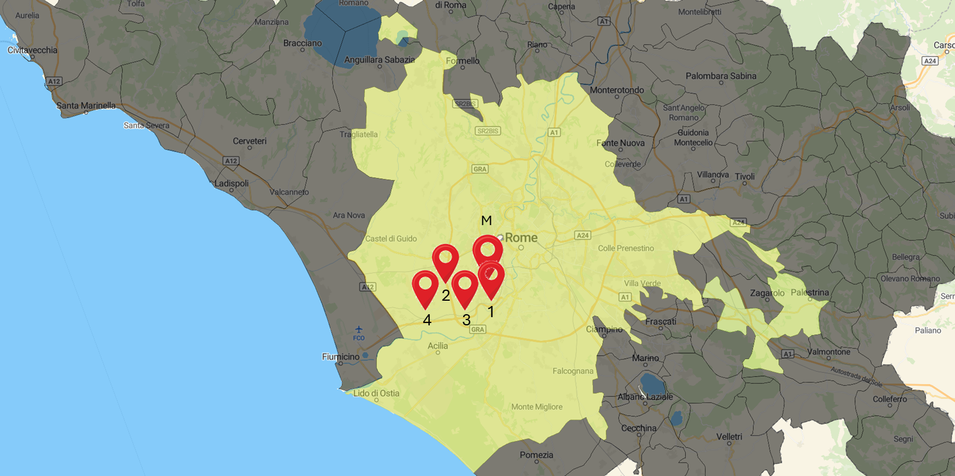

Figure 2. Location of the monitoring station (M) and wildfire events considered (1-4).

* 1. Results and Discussion
     1. Daily variation

From the analysis of the daily average concentrations measured, reported in Table 2, the value of the concentrations of PM10, PM2. 5 and PM1 are increasing from June to August. Analyzing the monthly concentrations of particulate matter in July and August, they appear to be slightly higher than the monthly average values measured in March and April. In general, the concentrations of particulate matter are higher in the winter period due to the massive contribution of domestic heating. In this case, however, it is clear that in the months of July and August there was the contribution of an anomalous source of particulate matter.

Table 2. Monthly average PM1, PM2.5 and PM10 concentration.

|  |  |  |  |
| --- | --- | --- | --- |
|  | **Concentration, μg/m3** | | |
| **Month, 2024** | **PM1** | **PM2.5** | **PM10** |
| **January** | 24.8 | 39.8 | 62.8 |
| **February** | 20.3 | 32.8 | 55.2 |
| **March** | 11.2 | 18.8 | 39.4 |
| **April** | 8.9 | 14.8 | 33.7 |
| **May** |  |  |  |
| **June** | 6.8 | 11.5 | 30.0 |
| **July** | 13.4 | 20.4 | 39.6 |
| **August** | 16.4 | 24.0 | 42.8 |

Figure 3 also shows the exceeding of the daily limit threshold for PM10 defined by Legislative Decree 155/2010 of 50 μg/m3, for 5 times in the period considered. Relative to PM2.5, the concentration values follow proportionally the measured PM10 values, highlighting the absence of Saharan phenomena.

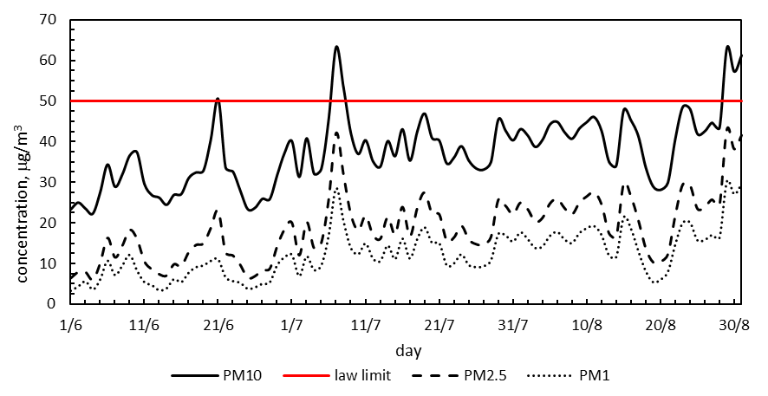

Figure 3. Daily PM10, PM2.5 and PM1 concentrations.

Analyzing the delta values obtained as described in paragraph 2.1 and reported in Figure 4, it is noted that on some days there is a high deviation. These days correspond to the fire events considered and described in chapter 2.2. The event of July 17, 2024, although not clearly visible in Figure 4, was nevertheless of significant intensity as shown by the hourly data in Figure 5.

* + 1. Fire events analysis

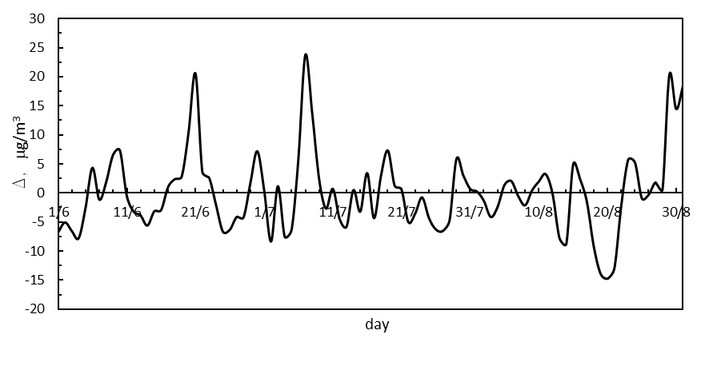

Figure 4. Deviation of the daily value from the background calculated according to Eq.1.

Considering the hourly average values measured on the days in which the four fire events considered occurred, it can be seen, in Figure 5, that the concentration values reach a maximum peak around 120-140 μg/m3 and that in the following hours, however, these values tend to remain high. From an analysis of the wind speed and intensity recorded in the meteorological stations located in the immediate vicinity of the air quality station, the station was under the wind direction and therefore was able to detect the dispersed plume.

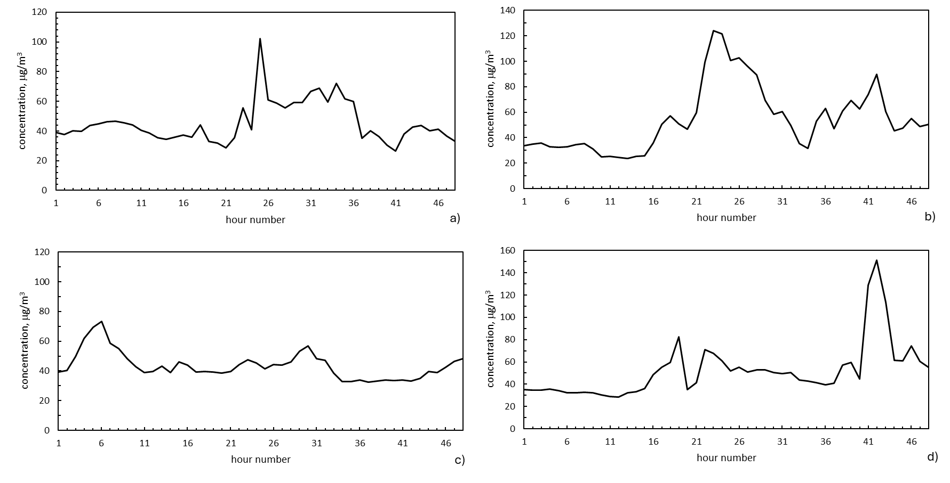

Figure 5. Fire events: a) 20-21 June 2024, b) 06-07 July 2024 c) 16-17 July 2024, d) 28-29 August 2024.

* 1. Conclusions

The analysis of particulate matter concentrations from June to August reveals a notable increase in PM10, PM2.5, and PM1 levels, with July and August exhibiting higher monthly averages compared to March and April. Typically, winter months see elevated concentrations due to domestic heating; however, the summer months in question experienced contributions from an anomalous source of particulate matter. Additionally, significant deviations in particulate matter levels were observed on certain days correlating with fire events, particularly on July 17, 2024. Hourly data indicated that during these fire events, particulate concentrations peaked between 120-140 µg/m3 and remained elevated in subsequent hours. Analysis of local wind conditions confirmed that the air quality station was positioned to detect the dispersed plume from these events, further emphasizing the impact of fire-related emissions on air quality during the summer months. Citizen science is a vital component in monitoring air quality during incidental events such as wildfires. It empowers individuals, enhances data collection, fosters community resilience, and contributes to scientific understanding and effective policymaking. The problem of summer wildfires is escalating due to a combination of climate change, human activities, and extreme weather conditions. Addressing this issue requires comprehensive strategies focused on prevention, preparedness, and effective response measures to mitigate the risks associated with wildfires.

References

Holmes J. and Clark R., 2008, Enhancing the use of science in environmental policy-making and regulation, Environmental Science & Policy, 11, 8, 702-711, https://doi.org/10.1016/j.envsci.2008.08.004.

Institute for Environmental Protection and Research - ISPRA, Rilevazione del plume associato all’incendio di Roma in località Casal Lumbroso del 17 luglio 2024, available at: https://www.isprambiente.gov.it/it/news/rilevazione-del-plume-associato-all-incendio-di-roma-in-localita-casal-lumbroso-del-17-luglio-2024.

Italian Civil Protection, Resoconto Campagna AIB 2024.

Lotrecchiano N., Sofia d., Capozzi V., 2021a, An Innovative Approach to Determining the Contribution of Saharan Dust to Pollution, International Journal of Environmental Research and Public Health, 18, 11, 6100; https://doi.org/10.3390/ijerph18116100.

Lotrecchiano N., Sofia D., Giuliano A., Barletta D., Poletto M., 2021b, Spatial Interpolation Techniques For innovative Air Quality Monitoring Systems, Chemical Engineering Transactions, 86, 391-396 DOI:10.3303/CET2186066.

Lotrecchiano N., Montano L., Bonapace M.I., Tenore G., Trucillo P., Sofia D., 2022, Comparison Process of Blood Heavy Metals Absorption Linked to Measured Air Quality Data in Areas with High and Low Environmental Impact, Processes, 10, 7, 1409; https://doi.org/10.3390/pr10071409.

Mocellin P., Taccaliti F., Maschio G., Lingua E., Vianello C., 2020, Interface Fires in Built-up Areas. a Real-case Study on the Risk Assessment of Fires Interacting with Urban Domains., Chemical Engineering Transactions, 82, 259-264, DOI:10.3303/CET2082044

Sideri V., Karakosta C., Vlachos S., 2024, A Citizen Science Approach to Address Odour Pollution in Greece, Chemical Engineering Transactions, 112, 85-90, DOI:10.3303/CET24112015

Sofia D. et al. Optimization of number and location of sampling points of an air quality monitoring network in an urban contest. DOI 10.3303/CET1974047 (2019).

Takao Y., 2015, Making environmental policy work with civic science: the intermediary role of expert citizens at the Japanese local level, Local Environment, 21, 9, 1100–1117 https://doi.org/10.1080/13549839.2015.1070335.