 CHEMICAL ENGINEERING TRANSACTIONS  VOL. , 2025 | A publication of  
The Italian Association
of Chemical Engineering
Online at www.cetjournal.it

Guest Editors: Fabrizio Bezzo, Flavio Manenti, Gabriele Pannocchia, Almerinda di Benedetto
Copyright © 2025, AIDIC Servizi S.r.l.
ISBN 979-12-81206-17-5; ISSN 2283-9216

Worm-Filter in the recovery of wastewater from the commercial activity of hydrobiological products
Mery N. Carhuallanqui-Torres ª, Elmer Benites-Alfaroª*, Danny Lizarzaburu-Aguinaga ^{b}, Carlos Cabrera Carranza^{c}, Jorge Jave Nakayo ^{c}, Guido Rene Suca-Apaza^{d}, Jose Freddy Atuncar Yrribari^{c}, Jorge López Bulnes ^{c}

ª Universidad César Vallejo, Av. Alfredo Mendiola 6232, Los Olivos, Lima – Perú
^{b} Universidad César Vallejo, Av. Argentina 1795, Callao – Perú
^{c} Universidad Nacional Mayor de San Marcos, Ciudad Universitaria, Lima – Perú
^{d} Universidad César Vallejo, Carretera Central Km 8.2, Ate – Perú,
*ebenitesa@ucv.edu.pe
The wastewater generated in the commercialization activity in specific markets for the sale of hydrobiological products has the characteristic of having a high content of organic matter from fish, shellfish and other marine products that are handled there. The wastewater generated in these places has a high potential for contamination, which, if not properly treated, would have negative environmental impacts on the receiving body. The objective of the research was to evaluate the treatment of wastewater generated in a fish market using the worm filter technology. We sought to determine the amount of substrate and earthworm (Eisenia foetida) in the biofilter to make the treatment more efficient; 5, 10 and 15 days of retention in the biofilter were considered. As a result, the chemical oxygen demand was reduced by 90 %, turbidity by 82 %, total suspended solids by 96 %, total coliforms by 100 %, fecal coliforms by 56 % and organic matter by 91 %. Thus, it is established that the worm filter of this type is efficient to recover wastewater from commercial fishing activity, for its probable reuse and avoiding environmental damage.
  - Introduction
The commercialization of hydrobiological products, such as fish, shellfish, algae and others, is an important economic activity in many countries of the world; however, this activity also produces an important environmental impact, associated with the wastewater produced during the capture, transport and commercialization process. It is in the commercialization stage where organic matter is mainly generated from the remains of hydrobiological products, nutrients such as nitrogen and phosphorus and toxic substances such as heavy metals and organic chemicals, all generated by the body fluids of the species and the cleaning and disinfection products used, which constitute the main pollutants in wastewater (Amin and Akter, 2022).
The negative impacts of pollutants can be on human health (gastrointestinal, respiratory diseases and cancer), as well as on ecosystems, such as eutrophication and contamination by toxic substances in aquatic environments, affecting fauna, flora and other ecosystem services.
Given this reality, the concern is to implement measures to reduce wastewater production and improve the efficiency of processes where water is used; other ways will be to look for control and treatment measures for wastewater to reduce the pollutant load, implement biological treatments or physicochemical treatments (Sánchez-Muñoz, et al., 2020); for this, it is estimated that biological processes are the most convenient from the environmental point of view, whether they are aerobic such as activated sludge, filters, rotary biological contactor to eliminate the organic load, even anaerobic processes are also used that eliminate up to 90% of organic matter and produce gas that can be used as energy (Parvathy, et l., 2017). In other cases, plant products such as palm kernel treated with NaOH are also used as a natural adsorbent to reduce turbidity by up to 85% (Al-Dawey, et al., 2023). Biofilters are also applicable for odor removal with good results (Vela-Aparicio, et al., 2022).
The application of worm-based biofilters has been used in the treatment of domestic wastewater with good efficiency (Singh, et al., 2019) and with good results (Vela-Aparicio, et al., 2022). In some cases, macrophyte plants can be incorporated into these biofilters with worms to improve the process (Samal, et al., 2017). In this context, although biofilters are efficient for the treatment of domestic wastewater, there is not much information regarding the treatment of industrial and/or commercial wastewater, so the objective of the research was to evaluate the result of the treatment of water from the handling and cleaning of hydrobiological products (fish and others) in a large-scale fishing market.
In this context, the research sought to find the efficiency of worms to improve the physicochemical and microbiological parameters of the wastewater of a fishing market, constructing 3 biofilters that differed in the number of worms in the filtration bed, proving that the waters residuals improved the quality of their parameters such as: total suspended solids, biochemical oxygen demand, Chemical Oxygen Demand, Oils and fats, Total Coliforms and organic matter in the range from 85 to 91 %, as detailed in the results.
  - Methodology
For the research, three biofilters were designed and constructed to carry out the tests in triplicate. Then, worms of the Eisenia foetida species were obtained and conditioned and incorporated into the biofilters. Finally, the treatment of effluent water from the industry and commercialization of hydrobiological products generated in a wholesale market was carried out.
    - Design and construction of the biofilter
Three biofilters were constructed according to the design shown in Figure 1. The system was then set up for treatment according to Figure 2.
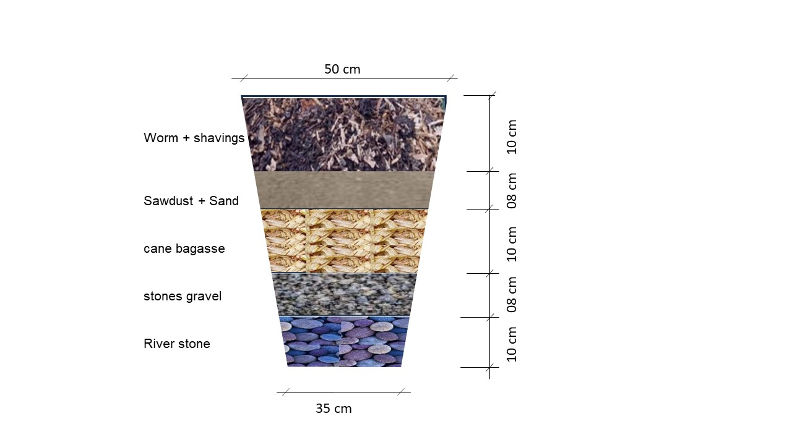 | 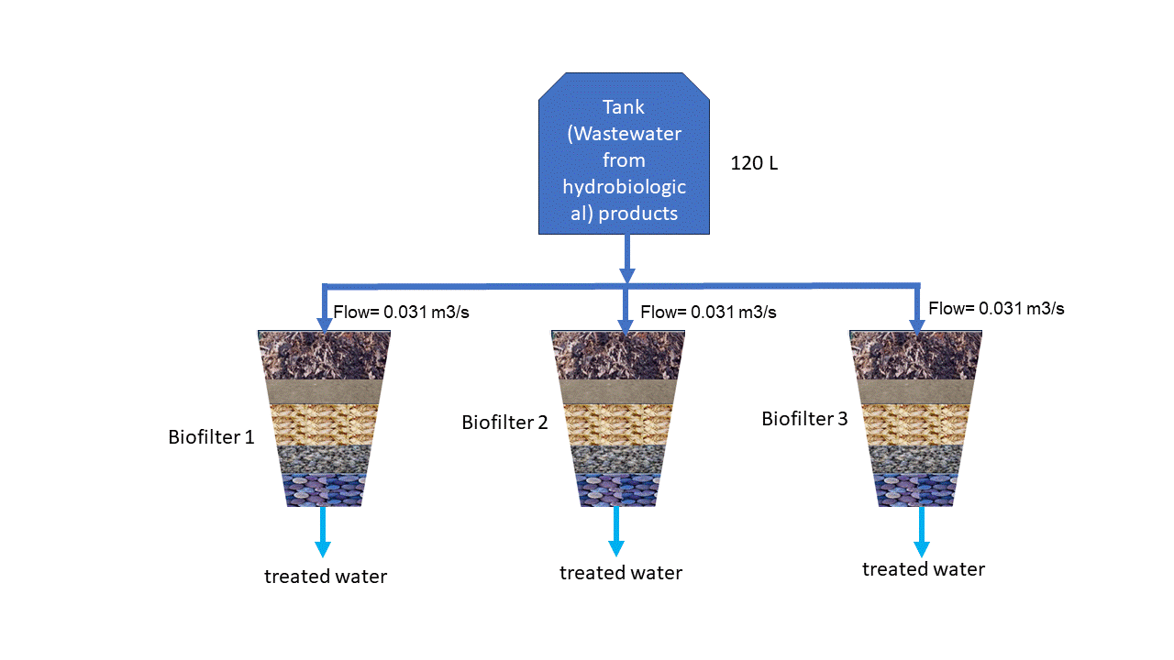
Figure 1: Biofilter design | Figure 2: Biofilter system
    - Worm conditioning
The worms were acquired from the company LombriWasi, certifying the species called red worms Eisenia foetida. They were conditioned in an environment (habitat) at a temperature (between 20 to 25 °C), humidity (between 70 - 80 %) and pH (between 6.8 to 7.2), in order to habituate them before incorporating them into the biofilters.
    - Treatment of wastewater from hydrobiological products
The treatment was carried out by uniformly passing 120 liters of wastewater through the biofilter system, with a flow rate of 0.031 m³/s for each biofilter, the retention time was 15 days, carrying out control and sampling every 5 days. The biofilters were of similar design, except for the layer of worm next to the wood chips. The composition of this layer is indicated in the Table 1.
Table 1: Composition of worm layer
Composition | Filter 1 | Filter 2 | Filter 3
Earthworm Eisenia foetida (g) | 250 | 500 | 1000
Shavings (g) | 3000 | 3000 | 3000

  - Results and discussion
    - Environmental conditions for redworms Eisenia foetida
The conditioning of the worms was carried out under the parameters indicated in Table 2, carrying out monitoring and control at 0, 15, 31 and 46 days, to then be incorporated into the biofilters. This conditioning is important so that the worms adapt to the environmental conditions of the biofilter, such as temperature, humidity and composition of the substrate (so that they do not suffer stress and die), it helps the worms develop a healthy intestinal microbiota and have the ability to degrade organic matter, reproduce and form a stable, population essential for the optimal functioning of the biofilter, acclimatization of 2 to 4 weeks is recommended (Sánchez-Muñoz, et al., 2020). The earthworm species Eisenia foetida requires a temperature between 15 to 25 °C and a humidity level of the substrate between 60 to 80% (Barbado, 2003, cited by Paco et al., 2012)
Table 2: Parameters of earthworm habitability conditions
Control(days) | Temperature (°C) | Humidity (%) | Hydrogen potential (pH)
0 (initial) | 18 | 57.5 | 6.5
15 | 18 | 80.0 | 7.0
31 | 18 | 77.5 | 7.0
46 | 20 | 70.0 | 7.0

    - Physicochemical and microbiological parameters of treated wastewater in biofilter 1
The wastewater from the management and marketing of hydrobiological products after treatment in biofilter 1, which contained 250 g of Eisenia foetida worms, presented the levels of physicochemical and microbiological parameters shown in Table 3. Biofilter 1 (also biofilters 2 and 3) was designed and built on the theoretical basis of the Tohá treatment (created by Dr. José Thoá) (Paico, 2017), considering the filter bed made up of five strata: Worms Eisenia foetida + Shavings, Sawdust + Sand, Cane Bagasse, Gravel stones and river stones; (Castillo and Chimbo, 2021). This design is very versatile and applicable to different urban waters and lately to industrial wastewater (Esquivel and Castañeda, 2022).
The level of reduction of physicochemical and microbiological parameters was evident and important, reaching a level very similar to the use of Moringa oleifera and activated carbon packaging biofilters (Bertolotti and Benites, 2020), it can be observed that the greatest reduction occurred from of the 15 days of treatment.
Table 3: Characteristics of the wastewater after treatment with Filter 1 (250 g de Eisenia foetida)
Parameters | No treatment | Treatment time (days)
 |  | 5 | 10 | 15
Electrical conductivity (μmho/cm) | 8.43 | 7.44 | 7.9 | 3.46
Temperature (°C) | 16.5 | 19.1 | 21.3 | 22.5
TSS (mg/L) | 345 | 64.52 | 17.21 | 15.18
Color (PCU) | 285 | 125 | 63.23 | 47.23
Turbidity (NTU) | 146 | 140.67 | 104.67 | 36.07
pH | 7.43 | 7.01 | 7.15 | 7.75
BOD5 (mg/L) | 744 | 453 | 87.22 | 75.07
COD (mg/L) | 1118 | 580 | 141.5 | 124.37
Oils and fats (mg/L) | 87 | 21.05 | 15.14 | 11.06
Total Coliforms (NMP/100mL) | 240000 | 1200 | 1200 | 1100
Thermotolerant coliforms (NMP/100 mL) | 2500 | 1200 | 1100 | 1100
Organic matter (mg/L) | 631 | 87.03 | 63.22 | 56.09

    - Physicochemical and microbiological parameters of treated wastewater in biofilter 2
Filter 2, with 500 g of worms, showed a level of reduction similar to filter 1, according to the results shown in Table 4, indicating that the efficiency does not depend relatively on the number of worms in the biofilter, the most important thing is the good habitability of the biofilter related to humidity (Loro, 2018), temperature (De Lima Rodríguez et al., 2013) and pH (Paico, 2017).
Table 4: Characteristics of the wastewater after treatment with Filter 2 (500 g de Eisenia foetida)
Parameters | No treatment | Treatment time (days)
 |  | 5 | 10 | 15
Electrical conductivity (μmho/cm) | 8.43 | 8.69 | 8.9 | 4.67
Temperature (°C) | 16.5 | 19.33 | 22.17 | 22.3
TSS (mg/L) | 345 | 58.49 | 17.42 | 16.14
Color (PCU) | 285 | 131.67 | 78.5 | 41.37
Turbidity (NTU) | 146 | 143 | 141.33 | 26.27
pH | 7.43 | 6.74 | 7.05 | 7.62
BOD₅ (mg/L) | 744 | 317 | 83.05 | 78.18
COD (mg/L) | 1118 | 483 | 139.27 | 128.77
Oils and fats (mg/L) | 87.03 | 17.22 | 13.73 | 13.04
Total Coliforms (NMP/100mL) | 240000 | 4400 | 1100 | 1100
Thermotolerant coliforms (NMP/100 mL) | 2500 | 1100 | 1100 | 1100
Organic matter (mg/L) | 631 | 89.14 | 65.16 | 56.36

    - Physicochemical and microbiological parameters of treated wastewater in biofilter 3
In biofilter 3, with 1000 g of worms, after retention of wastewater for 5, 10 and 15 days, the control samples presented levels of physicochemical and microbiological parameters very similar to biofilters 1 and 2 as shown in Table 5, despite the fact that a greater number of worms were loaded in this biofilter; Therefore, the results corroborate the scientific theory that indicates that the efficiency in improving the physicochemical parameters of the treated water does not depend on the number of lorrices, but on the conditions of their habitat to be able to act.
Comparing the three biofilters, it can be deduced that the longer the hydraulic retention time, the better the physicochemical and microbiological properties of the treated water, according to Mamyuchi, et al. (2019) indicate that the longer the hydraulic retention time, the greater the activity of the worms for the degradation and transformation of the matter, obtaining better results. Another aspect to analyse is the flow rate in the biofilter, but this was not evaluated because the flow rates in the three biofilters were the same.
A significant decrease in BOD₅ and COD was obtained, this corroborates that the use of this type of biofilters is also applicable for waters from the fishing industry with removal values ​​similar to those achieved by Saboya (2018); It also significantly decreased the total suspended solids due to its conversion to vermicompost (Xing et al, 2015). The solids that are retained in the sawdust filter bed are consumed by the worms and are not sludge as in other cases, and can be used as fertilizer.
Table 5: Characteristics of the wastewater after treatment with Filter 3 (1000 g de Eisenia foetida)
Parameters | No treatment | Treatment time (days)
 |  | 5 | 10 | 15
Electrical conductivity (μmho/cm) | 8.43 | 5.31 | 8.09 | 4.18
Temperature (°C) | 16.5 | 19.33 | 21.93 | 35
TSS (mg/L) | 345 | 52.82 | 17.64 | 17.12
Color (PCU) | 285 | 143 | 66.67 | 49.6
Turbidity (NTU) | 146 | 138.67 | 135.67 | 65
pH | 7.43 | 6.35 | 6.82 | 7.57
BOD₅ (mg/L) | 744 | 443 | 89.66 | 76.86
COD (mg/L) | 1118 | 543.33 | 143.57 | 131
Oils and fats (mg/L) | 87 | 23.05 | 13.65 | 11.66
Total Coliforms (NMP/100mL) | 240000 | 1300 | 1200 | 1100
Thermotolerant coliforms (NMP/100 mL) | 2500 | 1200 | 1200 | 1166.67
Organic matter (mg/L) | 631 | 87.03 | 63.22 | 56.09

By decomposing organic matter and recycling nutrients, worms can cause the release of basic cations (calcium, magnesium, potassium), as well as the activity itself of increasing microbial populations, which can neutralize the acidity of the water and increase the pH (Aishwarya et al., 2025). The same happens with the temperature, which will increase due to the energy released by the microbial processes involved in the decomposition of organic waste (Ma et al., 2020).
    - Percentage improvement in the improvement of physicochemical parameters of treated water in the filters
From the results obtained, in Table 6 shows the percentage improvement of water parameters. Significant improvement was achieved in TSS (95 %), BOD₅ /89.5-89.7 %), COD (88.3-88.5 %), oils and fats (85-86.6 %), total coliforms (95.5 %) and organic matter (91.1 %), values that were even within the maximum permissible limits of Peruvian regulations (D.S. N° 003-2010-MINAM, 2010).
Figure 3: Percentage of variation in the physicochemical and microbiological parameters of the water after treatment, in the three filters (F1, F2, F3)

Parameters | Filter 1  (250 g of worms) | Filter 2  (500 g of worms) | Filter 3  (1000 g of worms) | Standard deviation
Electrical conductivity (%) | 50.4 | 44.6 | 50.4 | 3.3559
Temperature (%) | 112.1 | 35.2 | 112.1 | 44.4385
TSS (%) | 95.0 | 95.3 | 95.0 | 0.1640
Color (%) | 82.6 | 85.5 | 82.6 | 1.6672
Turbidity (%) | 55.5 | 82.0 | 55.5 | 15.3156
pH (%) | 1.9 | 2.6 | 1.9 | 0.3885
BOD5 (%) | 89.7 | 89.5 | 89.7 | 0.1024
COD (%) | 88.3 | 88.5 | 88.3 | 0.1152
Oils and fats (%) | 86.6 | 85.0 | 86.6 | 0.9128
Total Coliforms (%) | 99.5 | 99.5 | 99.5 | 0.0000
Thermotolerant coliforms (%) | 53.3 | 56.0 | 53.3 | 1.5397
Organic matter (%) | 91.1 | 91.1 | 91.1 | 0.0247

  - Conclusion
It was established that the biofilters, having as a filter bed one with a main layer of Eisenia foetida worms, were efficient in improving the physicochemical and microbiological parameters in wastewater from the commercialization of hydrobiological products, reaching a percentage of 95% for TSS, 90% for BOD₅ , 89% for COD, and 100% for total coliforms as the most important improvement; Therefore, it is also an efficient and environmentally sustainable method for the treatment of industrial waters where further research is still pending, considering the diversity of industrial effluents..
Acknowledgments
The authors and the GITA Group would like to thank the Vice-Rectorate of Research of the Universidad César Vallejo for the financial support for the dissemination and publication of this scientific work.
References
Al-Dawery S., AL-Yaqoubi G., Al-Musharrafi A., Harharah H., Amari A., and Harharah R., 2023, Treatment of Fish-Processing Wastewater Using Polyelectrolyte and Palm Anguish, Processes 11(7), 2124, <doi.org/10.3390/pr11072124>.
Amin M. A. and Akter M., 2022, Impact of fish processing wastewater on aquatic environment: A review, Environmental Science and Pollution Research, 29(28), 33097-33112.
Bertolotti A., and Benites E., 2021, Biological Filter in Water Treatment Using "Moringa Oleifera" and Activated Carbon in Marginal Sectors of Metropolitan Lima [in Spanish], Zenodo, Municipalidad de Lima: A Look at Research and Social Responsibility. MML, <doi.org/10.5281/zenodo.5176851>
Castillo J., Chimbo J., 2021, Efficiency in the removal of organic matter by worm filters (Eisenia foetida) in domestic wastewater for rural areas, Enfoque UTE, 12, 2, 80-99, [in Spanish], <doi.org/10.29019/enfoqueute.746>
De Lima Rodrigues A., Mesak C., Silva M., Silva G., Leandro W., and Malafaia G., 2017, Organic Waste Vermicomposting through The Addition of Rock Dust Inoculated with Domestic Sewage Wastewater, Journal of Environmental Management, 196, 651–658, <doi.org/10.1016/j.jenvman.2017.03.072>
Esquivel Rafaele F.A., Castaneda-Olivera C.A., 2022, Efficiency of a Biofilter Based on Human Hair and Cariniana Decandra Sawdust for the Treatment of Laundry Water, Chemical Engineering Transactions, 92, 589-594, <www.cetjournal.it/index.php/cet/article/view/CET2292099>
Li M., Shao M., Li T., 2020, Characteristics of soil moisture and evaporation under the activities of earthworms in typical anthrosols in China, Sustainability, Volume 12, Issue 16, 6603, DOI <10.3390/su12166603>
Loro A., 2018, Evaluation of the efficiency of secondary treatment of domestic wastewater using a biofilter with Eisenia foetida and a conventional biofilter, [in Spanish], Undergraduate thesis, Scientific University of the South, < hdl.handle.net/20.500.12805/567>
Manyuchi M. M., Mupoperi N., Mbohwa C., and Muzenda E., 2019, Treatment of Wastewater Using Vermifiltration Technology, Water Conservation, Recycling and Reuse: Issues and Challenges, 215–230, <doi.org/10.1007/978-981-13-3179-4_12>
Paco G., Mamani F., Sainz H., 2012, Effect of the Californian red worm (Eisenia foetida) during the composted and vermicompost in properties of the Experimental Station of the Academic Rural Unit Carmen Pampa, [in Spanish] Journal of the Selva Andina Research Society, 2(2):24-39
Paico D., 2017, Tohá System, for the treatment of wastewater from the Cesar Vallejo University. [Undergraduate thesis, Cesar Vallejo University]. Institutional Repository UCV, <hdl.handle.net/20.500.12692/10890>
Parvathy U., Rao K.H., Jeyakumari A. and Zynudheen A., 2017, Biological Treatment Systems for Fish Processing Wastewater - A Review, Nature Environment and Pollution Technology, 16 (2), 447-454
Saboya X., 2018, Efficiency of the vermifilter method in removing contaminants from domestic wastewater in the Chachapoyas-Amazonas District. [Undergraduate thesis, Universidad Peruana Unión]. UPU Repository, <repositorio.upeu.edu.pe/handle/UPEU/1123>
Samal K., Dash R., Bhunia P., 2017, Treatment of wastewater by vermifiltration integrated with macrophyte filter: A review, Journal of Environmental Chemical Engineering, 5, 3, 95-103.
Sánchez-Muñoz M., Pérez-Hernández M., and González-Muñoz M., 2020, Treatment of fish processing wastewater: A review, Journal of Environmental Management, 266, 110610.
Sharma A., Kumari Sh., Chauhan S. Sangal R. Kumar V., Naik B.S., Sai S. Pramanick B., Sharma S., Reddy K., Reddy G., Yadav S., Medida S., 2025, Bacterial community present in the earthworm’s gut and its role in soil biology and health, Plant Science Today, Volume 12, Issue 12025, doi: <10.14719/pst.3356>.
Singh R., Samal K., Dash R., Bhunia P, 2019, Vermifiltration as a sustainable natural treatment technology for the treatment and reuse of wastewater: A review, Journal of Environmental Management, 247, 140-151, ISSN 0301-4797, <doi.org/10.1016/j.jenvman.2019.06.075>.
Vela-Aparicio D., Bautista C.J., Forero D., Acevedo P., Brandao P., Cabeza I., 2022, Inoculation of Compost Biofilter for the Simultaneous Removal of H2S and NH3 under Transient Conditions of Gas Concentration, Chemical Engineering Transactions, 93, 157-162, <www.cetjournal.it/index.php/cet/article/view/CET2293027>
Xing M., Li X., and Yang J., 2015, Treatment Performance of Small-Scale Vermifilter for Domestic Wastewater and Its Relationship to Earthworm Growth, Reproduction and Enzymatic Activity, African Journal of Biotechnology, 9(44), 7513–7520, <doi.org/10.5897/AJB10.811>

