|  |  |
| --- | --- |
| cetlogo ***CHEMICAL ENGINEERING TRANSACTIONS***  ***VOL. xxx, 2025*** | A publication of  aidiclogo_grande |
| The Italian Association  of Chemical Engineering  Online at www.cetjournal.it |
| Guest Editors: Fabrizio Bezzo, Flavio Manenti, Gabriele Pannocchia, Almerinda di Benedetto  Copyright © 2025, AIDIC Servizi S.r.l. **ISBN** 979-12-81206-17-5; **ISSN** 2283-9216 | |

On-purpose Propylene Production from Light Naphtha over Zeolite-based Composite with Low Energy Consumption

Shinya Hodoshima\*

Research & Development Center, Chiyoda Corporation, 3-13 Moriya-cho, Kanagawa-ku, Yokohama, Kanagawa 221-0022, Japan

[hodoshima.shinya@chiyodacorp.com](mailto:hodoshima.shinya@chiyodacorp.com)

Catalytic cracking of light-naphtha feed over zeolite-based composite, consisting of MFI-zeolite containing Fe, Ga and Al species (Fe-Ga-Al-MFI) and silicon-oxide binder (SiO2), was investigated to establish an efficient method for on-purpose propylene production with low energy consumption. The Fe-Ga-Al-MFI zeolite as matrix component, containing each heteroatom at adequate ratio in the zeolite framework, exhibited both acid strength suitable for generating light olefins selectively and enhanced activity for dehydrogenation of light alkanes to alkenes, so that high overall yields of light olefins (ethylene, propylene and butenes) were attained by suppressing aromatics formation compared to light-naphtha cracking over conventional Al-MFI zeolite (ZSM-5). The unique acidity of the Fe-Ga-Al-MFI-zeolite was maintained in the extruded form by using neutral and inactive SiO2 binder, which was selected to enhance mechanical strength and reduce pressure drop during reaction. The zeolite-based composite (Fe-Ga-Al-MFI/SiO2) selectively converted light-naphtha into light olefins including propylene with catalytic lifetime for longer than 700 h, being suitable for fixed-bed operation, due to its excellent resistance to coke formation. Furthermore, the cracking reactions proceeded in the absence of steam at moderate temperatures (< 650oC), so that the catalytic cracking improved overall energy efficiency and both amount of naphtha feed required for producing valuable chemicals (light olefins and BTX) and CO2 emitted in cracking process were reduced by ca. 15%, compared to conventional thermal cracking at 850oC.

* 1. Introduction

Light olefins (ethylene and propylene) are important basic chemicals for producing polymers and chemicals. The demand for light olefins grows at annual rates of 3-4% (Tanium et al., 2022). The thermal cracking of light-naphtha is widely adopted for producing ethylene, propylene, butenes, butadiene and BTX (benzene, toluene and xylenes) (Sadrameli, 2015) and a majority of propylene is currently obtained as a byproduct from thermal light-naphtha cracking with weight ratio of propylene to ethylene in the range of 0.5-0.6. However, ethylene production through thermal cracking of ethane feed, which generates little propylene, is becoming common, especially in the United States where a large amount of ethane is available from shale gas economically (Douri et al., 2017). For these reasons, it is difficult to meet the increasing propylene demand based on the conventional thermal-cracking processes. As well as the potential shortage of propylene, it is important to save energy consumption and reduce CO2 emissions in chemical processes (Amghizar et al., 2017). The thermal cracking of light-naphtha proceeds at temperatures higher than 800oC in the presence of steam, so that this cracking technology is the most energy-consuming process in the chemical industry (Ren et al., 2006). Any alternative technologies for producing propylene efficiently from light-naphtha, a widely available feed, should be thus developed to meet the increasing propylene demand and reduce energy consumption simultaneously.

Catalytic cracking of light-naphtha feed as an alternative method for on-purpose propylene production to conventional thermal cracking is strongly desired to meet increasing propylene demand. Though catalytic cracking of light-naphtha fraction over zeolites have been actively investigated, processes using fixed-bed reactor haven’t been established due to lack of stable catalysts. It is necessary to develop zeolite catalysts with high selectivity and stability to commercialize this technology. In this study, unique zeolite-based catalysts (Hodoshima et al., 2015, 2016, 2019, 2021), consisting of Fe-Ga-Al-MFI zeolite and SiO2 binder, have been developed to produce propylene from light-naphtha feed efficiently at moderate temperatures (< 650oC). This paper presents excellent properties of the cracking catalyst from the viewpoints of catalytic chemistry and chemical process engineering.

* 1. Experimental procedure
     1. Preparation of zeolite-based composites

The MFI-type zeolite containing Fe, Ga and Al species (Fe-Ga-Al-MFI) were synthesized by the conventional hydrothermal method (Hodoshima, 2021). Aqueous solution containing Si, Fe, Ga and Al sources and an organic structure-directing agent (tetrapropylammonium bromide) were prepared as the mother gel with the following molar composition: Si/T = 200, Fe/T = 0.4, Ga/T = 0.2, Al/T = 0.4, T = Fe + Ga + Al. The mother gel was charged into autoclave and then heated at 115oC for 72 h under specific stirring conditions. The obtained sodium-type zeolite was converted into the proton-type zeolite by ion-exchange with ammonium nitrate aqueous solution, dried at 120oC for 3 h and finally calcined at 550oC for 3 h under air stream. The MFI-zeolite containing Al species (Al-MFI, molar ratio in mother gel: Si/Al = 200) was similarly synthesized as a reference sample.

The zeolite-based composites in the cylindrical form with diameter of 1.0 mm, consisting of MFI-type zeolites and silicon-oxide binder at the weight ratio of zeolite to silicon oxide of 85/15, were prepared as follows (Kimura et al., 2011). The above-described zeolites (Fe-Ga-Al-MFI and Al-MFI) and silica sol (AEROSIL200, Evonik Industries AG) were mixed at the ratio of 85/15 and then the powdery mixture was molded in the extruded form. Finally, the extruded samples were dried at 120oC for 3 h and then calcined at 550oC for 3 h under air stream. In addition, the Fe-Ga-Al-MFI/SiO2 composite at the weight ratio of zeolite to SiO2 of 60/40 was also similarly prepared to improve its mechanical strength by increasing content of SiO2 binder. All synthesized samples were characterized by XRD, XRF, N2 adsorption isotherms, FE-SEM and NH3-TPD techniques.

* + 1. Evaluation of catalytic performance of zeolite-based composites

As screening tests for evaluating initial performance of the above-described composite catalysts, cracking of *n*-hexane (*n*-C6H14) and mixed light-hydrocarbons (*n*-C5H12(32 wt%) + *n*-C6H14(33 wt%) + *n*-C7H16(35 wt%)) over these catalysts were conducted in a fixed-bed reactor under the following conditions: 565-615oC; 0.10-0.15 MPa; LHSV at 6.0 h-1. Both conversion of reactant and product selectivity were estimated on the basis of gas-chromatographic analysis (Hodoshima, 2021). Additionally, to evaluate catalytic stability of the composite, a long-term reaction through cracking of model light-naphtha feed (*n*-C5H12(25 wt%) + *n*-C6H14(14 wt%) + 2-CH3-C5H11(32 wt%) + *n*-C7H16(9 wt%) + methylcyclohexane(11 wt%) + toluene(9 wt%)) over the Fe-Ga-Al-MFI(60 wt%)/SiO2(40 wt%) was carried out under the following conditions: 650oC; 0.15 MPa; LHSV at 6.0 h-1.

* 1. Results and discussion
     1. Catalytic properties of Fe-Ga-Al-MFI/SiO2 composite

**Figure 1** presents the XRD patterns of synthesized MFI-type zeolites (Al-MFI (molar ratio in mother gel: Si/Al = 200) and Fe-Ga-Al-MFI (molar ratio in mother gel: Si/T = 200, Fe/T = 0.4, Ga/T = 0.2, Al/T = 0.4, T = Fe + Ga + Al) and commercial Al-MFI zeolite (Si/Al ratio: ca. 20) as a standard. Both synthesized samples displayed the diffraction patterns corresponding to the MFI-type framework and no peaks derived from metal-oxide crystalline (e.g., Al2O3, Ga2O3, Fe2O3) were observed. **Table 1** gives the chemical composition measured by the XRF technique. The molar ratios of silicon atom to heteroatom (Si/Al and Si/(Fe + Ga + Al)) were nearly the same among them. In addition, the actual molar ratios of each heteroatom to total heteroatoms in the Fe-Ga-Al-MFI zeolite were calculated as follows: Fe/T = 0.3, Ga/T = 0.3, Al/T = 0.4, T = Fe + Ga + Al. Physicochemical properties (BET surface area and average particle size estimated by FE-SEM measurement) of synthesized MFI-type zeolites are provided in **Table 1**. These values were also found to be nearly the same among them.

The MFI-type zeolite containing Fe, Ga and Al species at optimized ratio (Fe-Ga-Al-MFI) exhibited unique acidity compared to conventional Al-MFI zeolite (ZSM-5) as a reference sample, as shown in the NH3-TPD profiles (**Figure 2**). Though acid amounts were nearly the same, the peak top of the Fe-Ga-Al-MFI in high-temperature region, closely related to acid strength, was shifted to lower temperatures (672 [K] → 645 [K]), indicating that acid strength was weakened by introducing Fe and Ga species. The Fe-Ga-Al-MFI(85 wt%)/SiO2(15 wt%) composite, consisting of the Fe-Ga-Al-MFI zeolite and SiO2 binder, was prepared for industrial use. Its acid amount was reduced by ca. 85% (0.18 [mmol/g] → 0.16 [mmol/g]), corresponding to mixed ratio of zeolite (85 wt%), whereas peak-top temperature and shape of peak were unchanged, suggesting that acid strength of the zeolite in the composite form was maintained.

Cracking of *n*-C6H14 feed over the zeolite-based composites, which were prepared for industrial use, were performed to evaluate cracking performance at initial stage (**Figure 3**). In comparison of product distribution at the same level conversion (Cats. A and B in **Figure 3**), it was revealed that the Fe-Ga-Al-MFI/SiO2 prepared at the weight ratio of 85/15 exhibited much higher overall propylene yield than the Al-MFI/SiO2 with the same mixed ratio by suppressing aromatics formation. Fe and Ga species incorporated in the MFI-type-zeolite framework are recognized to reduce acid strength and enhance dehydrogenation of alkanes to alkenes, respectively (Hodoshima, 2021). By optimizing ratios of these heteroatoms, its acidity was considered to become suitable for generating light olefins selectively. In **Figure 3**, catalytic performance through cracking under high temperature and pressure (615oC/0.15 MPa) were compared to conventional thermal cracking. In cracking of either *n*-C6H14 or mixed light-hydrocarbons (*n*-C5H12(32 wt%) + *n*-C6H14(33 wt%) + *n*-C7H16(35 wt%)) under the same conditions, the Fe-Ga-Al-MFI/SiO2 with the ratio of 60/40 (Cat. C) gave high overall propylene yields (33-35 wt%), being much higher than thermal cracking (ca. 15 wt%). Conversions were lower than Cat. B due to its low zeolite content, but it still exhibited much higher olefin selectivity than thermal cracking. From the results in these screening tests, it was confirmed that catalytic cracking over the Fe-Ga-Al-MFI/SiO2 composites is superior to conventional thermal cracking in terms of selective production of light olefins including propylene.

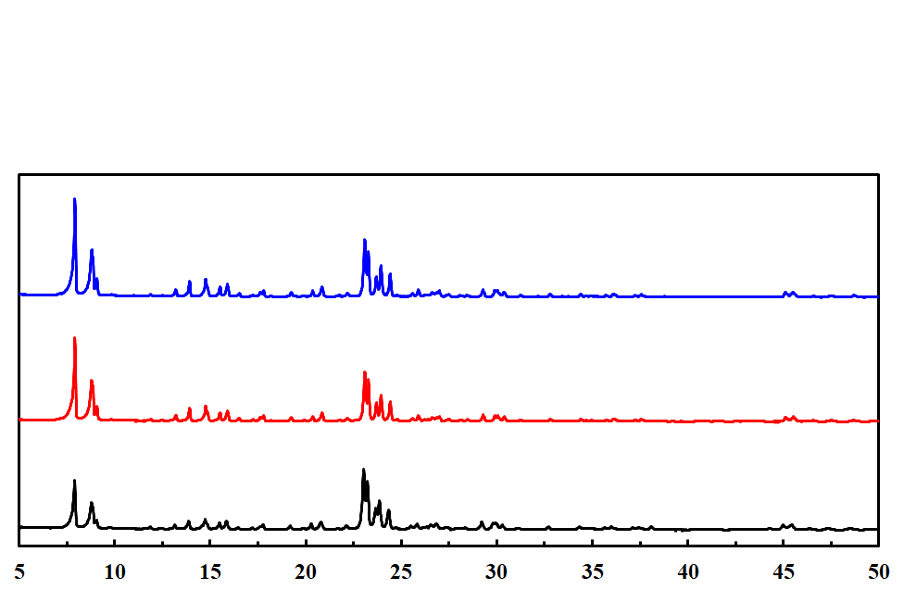

**Fe-Ga-Al-MFI zeolite**

**(Si/(Fe + Ga + Al) = 124.6)**

**Al-MFI zeolite**

**(Si/Al = 123.5)**

**Commercial Al-MFI zeolite**

**(Si/Al: ca. 20)**

*Figure 1: XRD patterns of synthesized MFI-type zeolites*

*Table 1: Elemental composition of synthesized MFI-type zeolites*

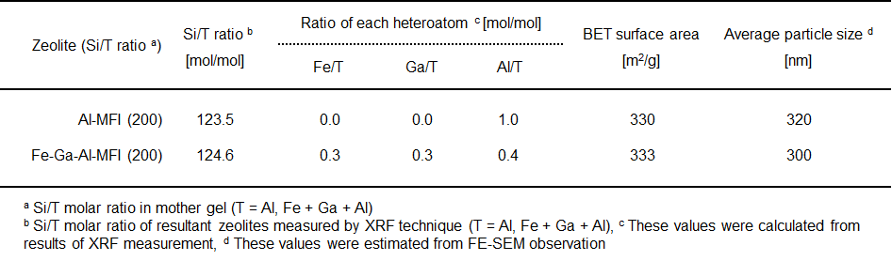

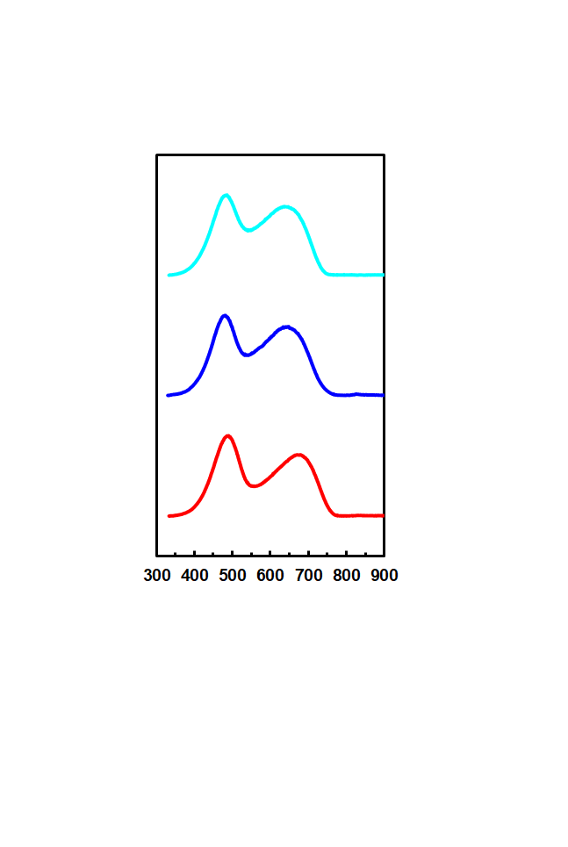

645 K

Normalized intensity [-]

Fe-Ga-Al-MFI/SiO2

Si/(Fe+Ga+Al) ratio: 124.6

Zeolite/SiO2 = 85/15 [wt%wt%]

Acid amount: 0.16 [mmol/g]

Fe-Ga-Al-MFI only

Si/(Fe+Ga+Al) ratio: 124.6

Acid amount: 0.18 [mmol/g]

Al-MFI only

Si/Al ratio: 123.5 [mol/mol]

Acid amount: 0.20 [mmol/g]

672 K

Temperature [K]

Measurement conditions; 2%-NH3/He 150 mL/min for 0.5 h,

Heating rate: 40 K/min

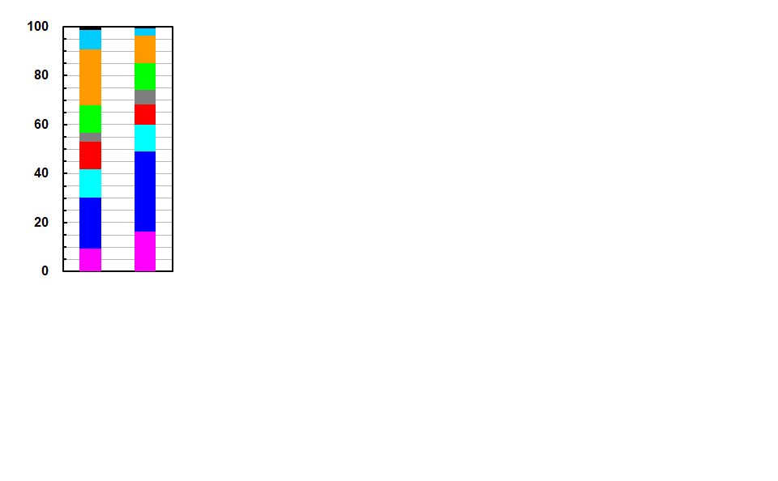

Overall yield [wt%]

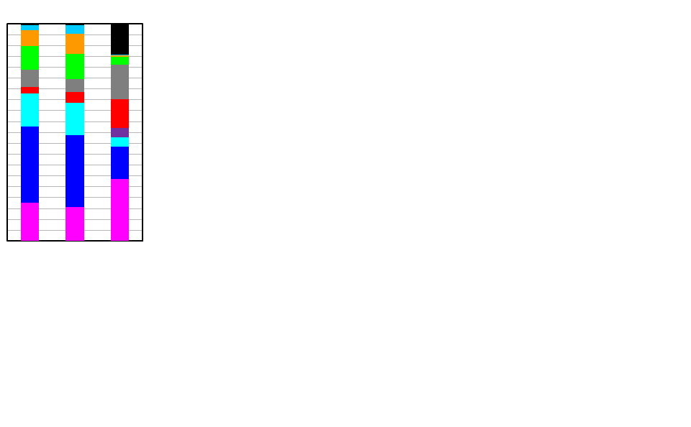

■ H2, C5+

■ C4o

■ C3o

■ C2o

■ CH4

■ BTX

■ C4= =

■ C4=

■ C3=

■ C2=

Cat. A: Al-MFI(85 wt%)/SiO2(15 wt%), Si/Al=122.9

Cat. B: Fe-Ga-Al-MFI(85 wt%)/SiO2(15 wt%), Si/(Fe+Ga+Al)=124.6

Cat. C: Fe-Ga-Al-MFI(60 wt%)/SiO2(40 wt%), Si/(Fe+Ga+Al)=124.6

Reaction conditions;

Feed: *n*-C6, (*n*-C5(32 wt%) + *n*-C6(33 wt%) + *n*-C7(35 wt%))

\*565oC/0.1 MPa/LHSV 6.0 h-1, \*\*565oC/0.15 MPa/LHSV 6.0 h-1,

\*\*\*615oC/0.15 MPa/LHSV 6.0 h-1,

\*\*\*\*Conventional thermal cracking of naphtha (850oC, 0.18 MPa)

82.5 80.8 53.8 53.4 100 One-pass conv.[wt%]

A\* B\*\* C\*\*\* C\*\*\* Thermal cracking\*\*\*\*

(*n*-C6) (*n*-C5+*n*-C6+*n*-C7)

*Figure 2: NH3-TPD profiles of prepared samples Figure 3: Initial product distribution in cracking*

*of light-naphtha fraction over composite samples*

* + 1. Evaluation of light-naphtha cracking process over Fe-Ga-Al-MFI/SiO2 composite for on-purpose propylene production in terms of chemical process engineering

To clarify the further advantages of the Fe-Ga-Al-MFI/SiO2 composite, catalytic cracking of light-naphtha over this composite as a promising method for on-purpose propylene production was compared to the conventional thermal cracking of light-naphtha for producing light olefins including propylene in terms of chemical process engineering. **Figure 4** shows a simplified block-flow diagram of the catalytic cracking process using the zeolite-based composite. This process mainly consists of the hot section for cracking light-naphtha and the cold section for separating and recovering products, where it should be noted that proven technologies developed for the thermal cracking could be applied. The hot section consists of the catalytic reactor, cooling unit for gas-liquid separation and extractive distillation unit for separating BTX. Both products and unconverted naphtha feed per pass are separated into gas and liquid components in the cooling unit. After separation of BTX from liquid components in the extractive distillation unit, both unconverted feed and higher olefinic hydrocarbons (C5+=), which are quite selectively converted into light olefins (Hodoshima, 2019, 2021), are recycled into the cracking reactor. The present catalytic cracking process was designed on the basis of recycling unconverted feedstock (incl. olefinic hydrocarbons) (Hodoshima, 2019), so that the productivity of the cracking process was estimated as the overall yield, which was defined as the ratio of each product yield to fresh feed. **Figure 5(A)** compares product distribution in the catalytic cracking and the thermal cracking. The catalytic cracking of model light-naphtha feed without dilution were performed under the following conditions: 650oC, 0.15 MPa and LHSV at 6 h-1. In this reaction test, the Fe-Ga-Al-MFI/SiO2 composite with excellent durability to coke formation were employed as the cracking catalyst. The overall yield of propylene higher than 30 wt% was obtained in the catalytic cracking of model light-naphtha feed under practical conditions and the sum of valuable product yields (ethylene, propylene, butenes and BTX) was higher than 70 wt%. It was confirmed on the experimental basis that the catalytic cracking was superior to the thermal cracking in terms of productivity.

Catalytic light-naphtha cracking in the absence of steam has advantages for preventing irreversible deactivation due to de-alumination of zeolites (Corma et al., 2012). However, cracking catalysts require excellent resistance to coke formation to maintain stable cracking reactions in fixed-bed mode, as catalytic cracking without steam easily causes polymerization of aromatics. The catalytic stability was investigated by performing a long-term reaction test. **Figure 5(B)** presents the time courses of one-pass conversions by the composite catalyst. The Fe-Ga-Al-MFI/SiO2 catalyst exhibited excellent stability during reaction. One-pass conversions of ca. 53% were stably maintained for longer than 700 h in despite quite severe conditions. The catalytic lifetime of the present zeolite-based composite is long enough for application to fixed-bed-type cracking reactors.

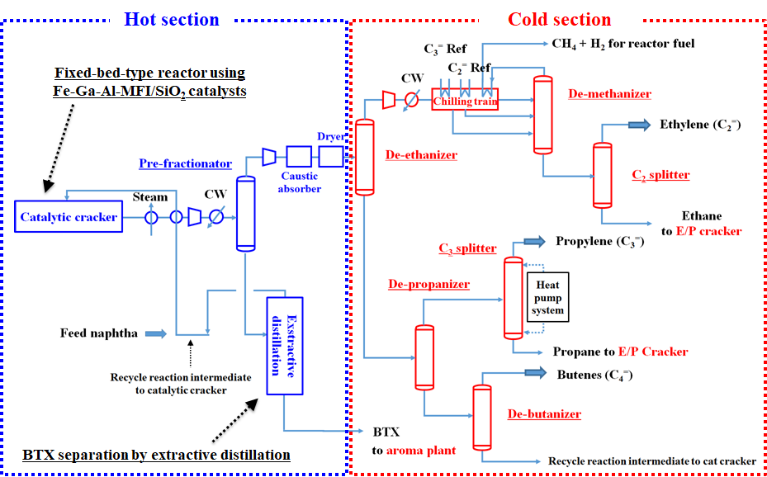

Figure 4: Simplified process flow for catalytic light-naphtha cracking over Fe-Ga-Al-MFI/SiO2

With respect to the catalytic cracking and the conventional thermal cracking, overall energy efficiency was estimated on the experimental basis (**Figure 6**). The overall energy efficiency was defined as the ratio of chemical energy of obtained valuable products (ethylene, propylene, butenes and BTX) to chemical energy of supplied light-naphtha feed. The overall energy efficiency in the catalytic cracking was calculated on the basis of the process flow diagram (**Figure 4**) and the testing result in **Figure 5(A)**. The overall energy efficiency in the thermal cracking was calculated according to the existing database (Sadrameli, 2015). The cracking reactor consumes a major part of energy required in overall process of both the thermal cracking and the catalytic cracking (Ren et al., 2006). To save energy in the reaction unit thus would reduce total energy consumption. As the thermal cracking of light-naphtha proceeds at higher than 800oC with steam diluent in the range of 30-40 wt%, the pyrolysis reactor requires a large input of thermal energy. In contrast, the catalytic cracking of light-naphtha over the zeolite-based composite proceeded at temperatures lower than 650oC without steam dilution. Energy consumption in the cracking reactor was thus suppressed due to the moderate reaction temperatures and no requirement for heating steam, so that the overall energy efficiency in the cracking process was improved from 73.4% to 86.7% (**Figure 6**).

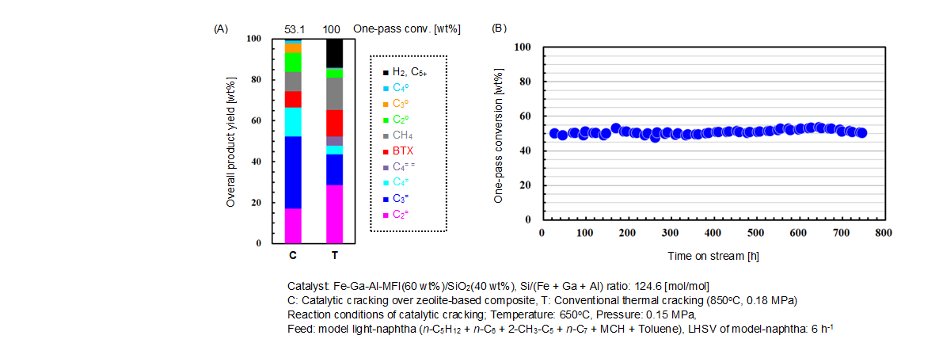 In either the thermal cracking or the catalytic cracking, light-naphtha acts as both feed and fuel, because byproducts such as methane generated in cracking are mainly utilized as fuels for driving endothermic cracking reactions. External input of fuel is thus not needed in principle unlike natural gas reforming. For this technical background, higher overall energy efficiency leads to lower amounts of naphtha feed and emitted carbon dioxide. In this study, both amount of light-naphtha required for producing valuable chemicals (ethylene, propylene, butenes and BTX) of unit weight and amount of emitted carbon dioxide were estimated from the results in **Figure 5(A)**. It was revealed that both amounts in the catalytic cracking could be reduced by ca. 15% compared to the thermal cracking (**Figure 6**). On the basis of a series of evaluation, the catalytic cracking of light-naphtha over zeolite-based composites in fixed-bed mode was confirmed to be advantageous in terms of propylene productivity, catalytic stability and energy consumption.

Figure 5: *Comparison of product distribution between catalytic cracking and thermal cracking (A) and*

*Time courses of catalytic activity for model-naphtha cracking over Fe-Ga-Al-MFI/SiO2 composite (B)*

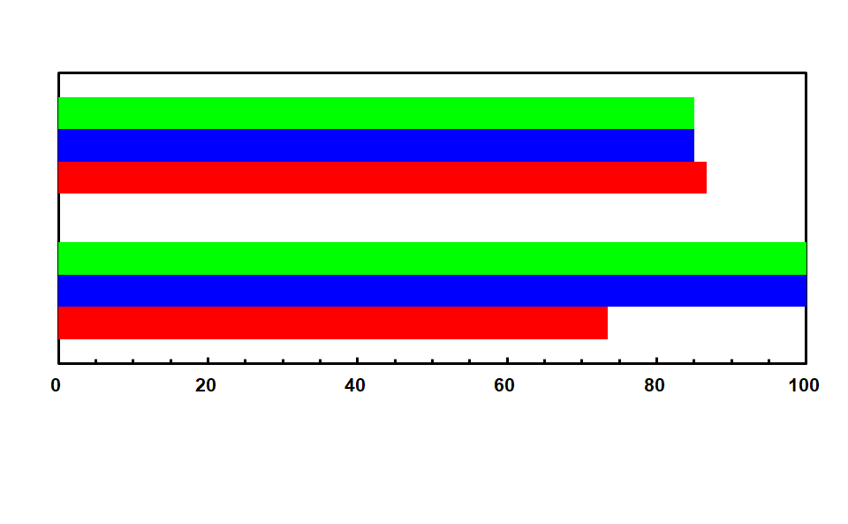

CO2 emission\*

Naphtha consumption\*\*

Overall energy efficiency

Catalytic cracking

\*Amount of carbon dioxide emitted in cracking process

\*\*Amount of naphtha feed required for producing valuable products (C2=, C3=, C4= and BTX)

CO2 emission\*

Thermal cracking

Naphtha consumption\*\*

Overall energy efficiency

Overall energy efficiency, naphtha consumption and CO2 emission

15% reduction

15% reduction

*Figure 6: E*nergetic evaluation of catalytic cracking and thermal cracking

* 1. Conclusions

The zeolite-based composite catalysts for on-purpose propylene production from light-naphtha feed was developed in the present study. The MFI-zeolites containing Fe, Ga and Al atoms incorporated in the zeolite framework at optimized ratio were employed as the matrix component. The Fe-Ga-Al-MFI zeolite showed overall acid strength suitable for selective generation of light olefins from light-naphtha as well as enhanced activity for alkane dehydrogenation compared to conventional ZSM-5 zeolite, resulting in higher selectivity to light olefins including propylene than the ZSM-5 zeolite. The Fe-Ga-Al-MFI zeolites combined with silicon-oxide binder (Fe-Ga-Al-MFI/SiO2) were prepared as practical cracking catalysts for industrial use and gave excellent performance for cracking of light naphtha. By use of silicon-oxide binder with neutral and inactive nature, the original acidity of the Fe-Ga-Al-MFI zeolite was maintained in the composite form, giving both high selectivity to light olefins and excellent stability.

Overall yield of propylene higher than 30 wt%, being ca. twice of that in the conventional thermal cracking of light-naphtha, was obtained in the catalytic cracking of model light-naphtha feed without dilution over the Fe-Ga-Al-MFI/SiO2 composite in the fixed-bed mode. Overall yield of valuable chemicals (ethylene, propylene, butenes and BTX) was higher than 70 wt%, indicating that the catalytic cracking is advantageous in terms of productivity. A long-term reaction test for evaluating catalytic stability showed longer lifetime than 700 h, being suitable for the fixed-bed reactor, due to the excellent resistance to coke formation. This composite catalyst thus exhibited both high selectivity to light olefins and excellent stability in catalytic cracking under practical conditions. From the energetic viewpoints, the catalytic cracking of light-naphtha over the composite was compared to the conventional thermal cracking. As catalytic cracking proceeds at lower temperatures than 650oC in the absence of steam, thermal energy required in cracking reactor was remarkably reduced, resulting in the improvement of overall energy efficiency. As a consequence, it was revealed that both amount of naphtha feed for producing valuable products of unit amount and amount of carbon dioxide emitted in cracking process were reduced by ca. 15%, respectively. Catalytic light-naphtha cracking over the present composite in fixed-bed mode has high potential for on-purpose propylene production from the viewpoints of productivity, catalytic stability and energy consumption.

Acknowledgments

A part of this study was financially supported by the New Energy and Industrial Technology Development Organization (NEDO). The author would like to express deep gratitude here. The author acknowledges Prof. Sachio Asaoka (The University of Kitakyushu) for guidance regarding zeolite synthesis.

References

Amghizar I., Vandewalle L. A., Van Geem K. M., Marin G. B., 2017, New trends in olefin production, Engineering, 3, 171-178.

Corma A., Mengual J., Miguel P. J., 2012, Stabilization of ZSM-5 zeolite catalysts for steam catalytic cracking of naphtha for production of propene and ethene, Appl. Catal. A; Gen., 421-422, 121-134.

Douri A. A., Sengupta D., Halwagi M. M. E., 2017, Shale gas monetization - A review of downstream processing to chemicals and fuels, J. Nat. Sci. Eng., 45, 436-455.

Hodoshima S., Motomiya A., Wakamatsu S., Kanai R., Yagi F., 2015, Catalytic cracking of light-naphtha over MFI-zeolite/metal-oxide composites for efficient propylene production, Res. Chem. Intermed., 41(12), 9615-9626.

Hodoshima S., Motomiya A., Wakamatsu S., Kanai R., Yagi F., 2016, Catalytic conversion of light hydrocarbons to propylene over MFI-zeolite/metal-oxide composites, Micropor. Mesopor. Mater., 233, 125-132.

Hodoshima S., 2019, Properties of zeolite-based composite catalysts and their application to catalytic naphtha-cracking process, Zeoraito (J. Jpn. Zeolite Assoc.), 36(1), 1-11.

Hodoshima S., 2021, Properties of zeolite-based composite catalysts and their application to catalytic naphtha-cracking process, J. Jpn. Petrol. Inst., 64(2), 37-50.

Kimura T., Sakashita K., Li X., Asaoka S., 2011, Catalytic roles of nano-sized oxides composed with zeolite for hydrocracking, catalytic cracking and reforming, Catal. Surv. Asia, 15(4), 259-266.

Ren T., Patel M., Blok K., 2006, Olefins from conventional and heavy feedstocks: Energy use in steam cracking and alternative processes, Energy, 31, 425-451.

Sadrameli S. M., 2015, Thermal/catalytic cracking of hydrocarbons for the production of olefins: A state-of-the-art review I: Thermal cracking review, Fuel, 140, 102-115.

Tanium A., TaniumG., Alasiri H., Aitani A., 2022, Catalytic cracking of crude oil: Mini review of catalyst formations for enhanced selectivity to light olefins, Energy Fuels, 36, 5152-5166.