|  |  |
| --- | --- |
| cetlogo ***CHEMICAL ENGINEERING TRANSACTIONS***  ***VOL. xxx, 2025*** | A publication of  aidiclogo_grande |
| The Italian Association  of Chemical Engineering  Online at www.cetjournal.it |
| Guest Editors: Fabrizio Bezzo, Flavio Manenti, Gabriele Pannocchia, Almerinda di Benedetto  Copyright © 2025, AIDIC Servizi S.r.l. **ISBN** 979-12-81206-17-5; **ISSN** 2283-9216 | |

Density and Surface-Tension Modeling of Binary Mixtures containing a Deep Eutectic Solvent

Daniela Méndez-Díaz & Ricardo Macías-Salinas\*

SEPI-ESIQIE, Departamento de Ingeniería Química, Instituto Politécnico Nacional, UPALM, Zacatenco, Ciudad de México 07738

dmendezd1500@alumno.ipn.mx / \*rms@ipn.mx

In this work, the Gibbs adsorption equation (GAE) coupled with a cubic equation of state (CEoS: Soave-Redlich-Kwong or Peng-Robinson) was applied to represent the surface tension of binary solutions consisting of a polar, associating substance (e.g. water, ethanol and acetonitrile) and a deep eutectic solvent (e.g. choline chloride/urea and tetraethylammonium bromide/ethylene glycol) over the whole composition range, at atmospheric pressure, and within a temperature range varying from 10 to 35 °C. As a matter of fact, the main thermodynamic potentials (fugacity coefficients in the bulk and surface liquid phases) present in the resulting GAE-based model were estimated via the use of the CEoS which also served to model the experimental mixture density data of the aforementioned mixtures using various volume translation and refitting techniques, thus obtaining highly satisfactory results.

* 1. Introduction

Density and surface tension are fundamental properties in mixtures involving associating fluids, such as deep eutectic solvents (DESs), playing a pivotal role in various industrial applications. Density provides critical insights into volumetric behavior and molecular interactions, facilitating the design and optimization of separation equipment, chemical reactors, and energy storage systems (Smith et al., 2005). Surface tension, on the other hand, governs interfacial phenomena, impacting phase stability, mass transfer, and heat transfer processes (Rosen and Kunjappu, 2012). These properties are indispensable in applications like liquid-liquid extraction, catalysis, distillation, and coatings, where precise control of interfacial behavior is essential (Shuler and Kargi, 2002).

In the context of DESs, density serves as an indicator of the molecular interactions between hydrogen bond donors (HBDs) and acceptors (HBAs), reflecting the structural organization of the fluid. Surface tension, meanwhile, influences the formation and stability of interfaces, which is critical in systems involving multi-phase equilibria or transfer processes (Smith et al., 2014). The accurate estimation of these properties is vital for the development and optimization of technologies that leverage the unique characteristics of DESs (Shahbaz et al., 2012), such as their low toxicity, high tunability, and biodegradability (Zhao et al., 2007).

To address the complexity of modeling such properties, this study focuses on the development of a robust thermodynamic framework capable of accurately predicting density and surface tension in binary mixtures containing DESs. The approach combines the Gibbs Adsorption Equation (GAE) with a cubic equation of state (CEoS), specifically Soave-Redlich-Kwong or Peng-Robinson, to model the thermophysical behavior of binary mixtures. These mixtures consist of a polar and associating component (e.g., water, ethanol, or acetonitrile) and a DES (e.g., choline chloride/urea or tetraethylammonium bromide/ethylene glycol), within a temperature range of 10 to 35 °C at atmospheric pressure (Wei et al., 2023).

The density model employs volume translation and parameter-fitting techniques to achieve high accuracy in reproducing experimental data. Simultaneously, the surface tension model uses mixing rules to incorporate compositional dependence into the attraction and repulsion parameters of the CEoS. This integration ensures a robust relationship between surface tension, temperature, and mixture composition.

The results demonstrate the model's ability to represent the complex behavior of DES-containing mixtures, offering a reliable tool for understanding and optimizing their thermophysical properties. These advancements are particularly relevant for sustainable processes and advanced engineering applications, such as green chemistry, solvent-based separations, and renewable energy systems.

* 1. Description of the Model

This work presents the development of a thermodynamic models to estimate fundamental properties such as density and surface tension in mixtures containing deep eutectic solvents (DESs), which are treated as a pseudopure compound. The density model is based on a Cubic Equation of State (CEoS), such as Soave-Redlich-Kwong or Peng-Robinson, employing classical Van der Waals mixing rules and volume translation techniques to fit experimental data. Meanwhile, the surface tension model uses the Gibbs Adsorption Equation (GAE) coupled with the CEoS, establishing a relationship between volumetric properties and fugacity coefficients to accurately estimate surface tension in binary mixtures composed of polar and associative components, such as water, ethanol, and acetonitrile.

2.1 Density Model

As previously mentioned, the proposed density model is developed using a cubic equation of state of the Peng-Robinson (PR) type, applied to both pure compounds and mixtures. To enhance the accuracy in representing the molar volume, a Péneloux-type volume correction factor is incorporated. Thus, the equation of state with the corrected volume is expressed as shown in Eq. (1).

|  |  |
| --- | --- |
| $$P=\frac{RT}{\left(V_{corr}+c-b\right)}-\frac{a}{(V_{corr}+c)\left(V_{corr}+c+b\right)+b(V_{corr}+c-b)}$$ | (1) |
| Where the volume corrected according to Péneloux et al. (1982) is defined as shown in Eq. (2). | |
| $$V_{corr}=V-c$$ | (2) |
| Where *V* is the molar volume obtained from the equation of state, and *c* is the volume correction factor, which has a constant value for the fluid. | |
| *a*, the parameter representing the attraction between molecules, is calculated based on the critical properties and depends on the temperature (accounted for in the parameter *α*) and the acentric factor (*ω*), as shown in Eqs. (3), (4), (5), (6), and (7). | |
| $$a=a_{c}α$$ $$a_{c}=0.45724\frac{R^{2}{Tc}^{2}}{Pc}$$ $$α={\left[1+m\left(1-\sqrt{Tr}\right)\right]}^{2}$$ $$m=0.37464+1.54226ω-0.269926ω^{2} ; ω<0.49$$ $$m=0.3796+1.485ω-0.1644ω^{2}+0.0167ω^{3} ; ω≥0.49$$ | (3)  (4)  (5)  (6)  (7) |
| *b*, known as the molecular repulsion parameter, is described based on the critical properties of the compound, as shown in Eq. (8). | |
| $$b=0.0778\frac{R Tc}{Pc}$$ | (8) |
| The previously described calculation algorithm allows for determining the molar property for pure compounds. However, to extrapolate it to mixtures, it is necessary to incorporate mixing rules, whose purpose is to adjust the interaction parameters between the molecules of different components in the mixture, such as the attraction and repulsion terms of the equation of state, to accurately model the behavior of the mixture under various conditions of pressure, temperature, and composition. In this work, classical mixing rules of the Van der Waals type will be used, which account for the parameters of both compounds as well as their molar fractions in the mixture, as shown in Eqs. (9), (10), and (11). | |
| $$a_{m}=\sum_{i=1}^{n}{\sum_{j=1}^{n}{x_{i}x_{j}\sqrt{a_{i}a_{j}}\left(1-k_{i,j}\right)}}$$ $$b_{m}=\sum_{i=1}^{n}{\sum_{j=1}^{n}{\left(\frac{b_{i}+b_{j}}{2}\right)\left(1-l_{i,j}\right)}}$$ $$c_{m}=\sum_{i=1}^{n}{x_{i}c_{i}}=x_{a}c_{a} ∴ c_{sep}=0$$ | (9)  (10)  (11) |
| Resulting in a PR-type CEoS modified for the mixture, as shown in Eq. (12). |  |
| $$P=\frac{RT}{\left(V_{corr,m}+c_{m}-b_{m}\right)}-\frac{a_{m}}{{(V}_{corr,m}+c_{m})\left(V_{corr,m}+c_{m}+b_{m}\right)+b_{m}(V_{corr,m}+c_{m}-b_{m})}$$ | (12) |

Solving iteratively using a minimization algorithm, which optimizes c for the organic solvent or water, Pc and Tc for the deep eutectic solvent, as well as the binary interaction parameters ki,j and li,j for the mixture.

2.2 Surface Tension Model

The surface tension model is based on the Gibbs Adsorption Equation (GAE), which is modified to use fugacity coefficients instead of activity coefficients (Eq. 13). This modification is justified as, in mixtures, both fugacity and activity describe the thermodynamic behavior of a component and are related through the chemical potential. Fugacity, which can be directly calculated using equations of state, represents an "effective pressure" and simplifies modeling in non-ideal systems by eliminating the need for additional empirical models for activity. This approach is particularly advantageous in systems where equations of state, such as Peng-Robinson, provide a reliable approximation of molecular interactions. The Peng-Robinson equation of state will be specifically used to calculate the fugacity coefficients required in this model.

|  |  |
| --- | --- |
| $$σ_{m}=σ_{i}+\frac{RT}{A_{i}}\ln{\frac{x_{i,s}{ϕ }_{i,s}}{x_{i,b} {ϕ }_{i,b}}}$$ | (13) |
| Let $σ_{i}$ ​ represent the surface tension of the pure compound, $T$ the temperature, $A_{i}$ ​ the molar surface area, $x_{i,s}$ ​ and $x_{i,b}$ the mole fractions of the compound in the surface and bulk phases, respectively, and $ϕ_{i,s}$ and $ϕ_{i,b}$ ​ the fugacity coefficients of the pure compound in the surface and bulk phases.  Considering a binary system composed of water or an organic solvent and a deep eutectic solvent treated as a pseudopure compound, the equation is specifically developed for both components. | |

It is important to highlight the relevance of the molar surface area in the implementation of the GAE. Firstly, the initial estimated value significantly influences the convergence of the minimization process. Additionally, surface areas have only been reported for organic solvents and water (Tojo-Suarez et al., 1989). Therefore, in the case of DESs, this value must be estimated using the Paquette method (Tojo-Suarez et al., 1989) as a starting point and optimized during the adjustment process.

* 1. Results and Discussion

The model validation process requires a comparison between the calculated and experimental values. For this purpose, the system is composed of tetraethylammonium bromide (TEAB) as a hydrogen bond acceptor and ethylene glycol (EG) as a hydrogen bond donor, in a 1:3 proportion [TEAB (1) : (3) EG], is validated in mixtures with water, ethanol, and acetonitrile. The experimental data used corresponds to those reported by Wei et al. (2023), under atmospheric pressure conditions, covering the entire composition range and a temperature range between 288.15 K and 318.15 K. For each system, the mean absolute deviation (%MAD), percentage bias (%BIAS), and maximum absolute percentage deviation (%MaxMAD) are evaluated as metrics for assessing the model's performance.

As described in the methodology, a significant portion of the calculations for the equation of state relies on the critical properties of pure compounds. For solvents, the values reported by NIST are used, while for DESs, a group contribution method of the Lee-Kesler type is employed, as reported and utilized by Boublia et al. (2024).

The figures presented in this document provide a visual comparison between the experimental data reported by Wei et al. and the predictions made by the proposed models. Markers represent the experimental data, while colored lines correspond to the model predictions, allowing a clear evaluation of the agreement between the two.

For the DES-water mixture, a notably non-ideal behavior is observed, primarily attributable to the nature of water. However, the model successfully captures this behavior, providing a satisfactory fit, as shown in Figure 1, with a mean absolute deviation (MAD) of 0.09%. Convergence values of $k_{i,j}$ =−0.318214 and $l_{i,j}$ =0.0142438l are obtained. In terms of surface tension, shown in Figure 2, the model achieves a MAD of 1.34%, with a maximum deviation of 2.86% at a DES mole fraction of 0.5. The optimized molar surface area for the DES is calculated as 6.23 x108 cm2/mol, while the value for water is kept constant at 0.723 x108 cm2/mol, as reported by Tojo-Suárez et al. (1989).

The DES-ethanol system exhibits an even better fit than the previous system, primarily due to its closer behavior to ideality. The density shows a MAD of 0.03%, with $k_{i,j}$ =−0.098143k and $l_{i,j}$ =0.00953823l, as illustrated in Figure 3. The surface tension of this mixture achieves a MAD of 1.24% and a maximum deviation of 3.76%, particularly evident at higher DES mole fractions (Figure 4). The molar surface area for ethanol remains constant at 8.052 x108 cm2/mol (Tojo-Suarez et al., 1989), while that for DES is optimized to 3.30 x108 cm2/mol.

Finally, the DES-acetonitrile system, like the DES-ethanol system, exhibits behavior closer to ideality, as shown in Figure 5. The density has a MAD of 0.15%, with the largest deviations observed at pure acetonitrile compositions at higher temperatures. The parameters obtained are $k_{i,j}$ =−0.058612 and $l_{i,j}$ =−0.00029625l. Regarding surface tension (Figure 6), the mean absolute deviation is 1.06%, with a maximum deviation of 3.06%, notably at low DES mole fractions at high temperatures and at high mole fractions at low temperatures. The molar surface area for DES is optimized to 3.84 x108 cm2/mol, while the value for acetonitrile is kept constant at 6.058 x108 cm2/mol (Tojo-Suarez et al., 1989).

Table 1 summarizes the previously detailed information on the mean absolute deviation (%MAD) of the three evaluated systems for both models, facilitating a quantitative comparison of their accuracy and performance.

Table 1: Comparison of the mean absolute deviation (%MAD) of the evaluated models.

|  |  |  |  |  |  |
| --- | --- | --- | --- | --- | --- |
| System | Number of points | Density (%MAD) | Surface Tension (%MAD) | | Figure |
| DES-Water | 70 | 0.09 | 1.34 | 1 and 2, respectively | |
| DES-Ethanol | 70 | 0.03 | 1.24 | 3 and 4, respectively | |
| DES-Acetonitrile | 70 | 0.15 | 1.06 | 5 and 6, respectively | |
| **OVERALL** |  | **0.09** | **1.213** |  | |

Among the findings, the model exhibited higher sensitivity to the molecular attraction parameter ($k_{i,j}$ ​) compared to the repulsion parameter ($l_{i,j}$ ​). This suggests that the model could be simplified by assuming a zero value for $l_{i,j}$ ​, with preliminary results indicating good accuracy.

Additionally, considering the non-ideal nature of the mixtures, primarily due to the presence of the solvents, it is proposed to quantify the agreement using excess properties, such as excess volume ($V_{EX}$ ​) and excess surface tension ($γ_{EX}$ ​). These properties can be useful for a more detailed evaluation of the agreement between experimental and calculated data, as well as for identifying potential areas for model improvement.

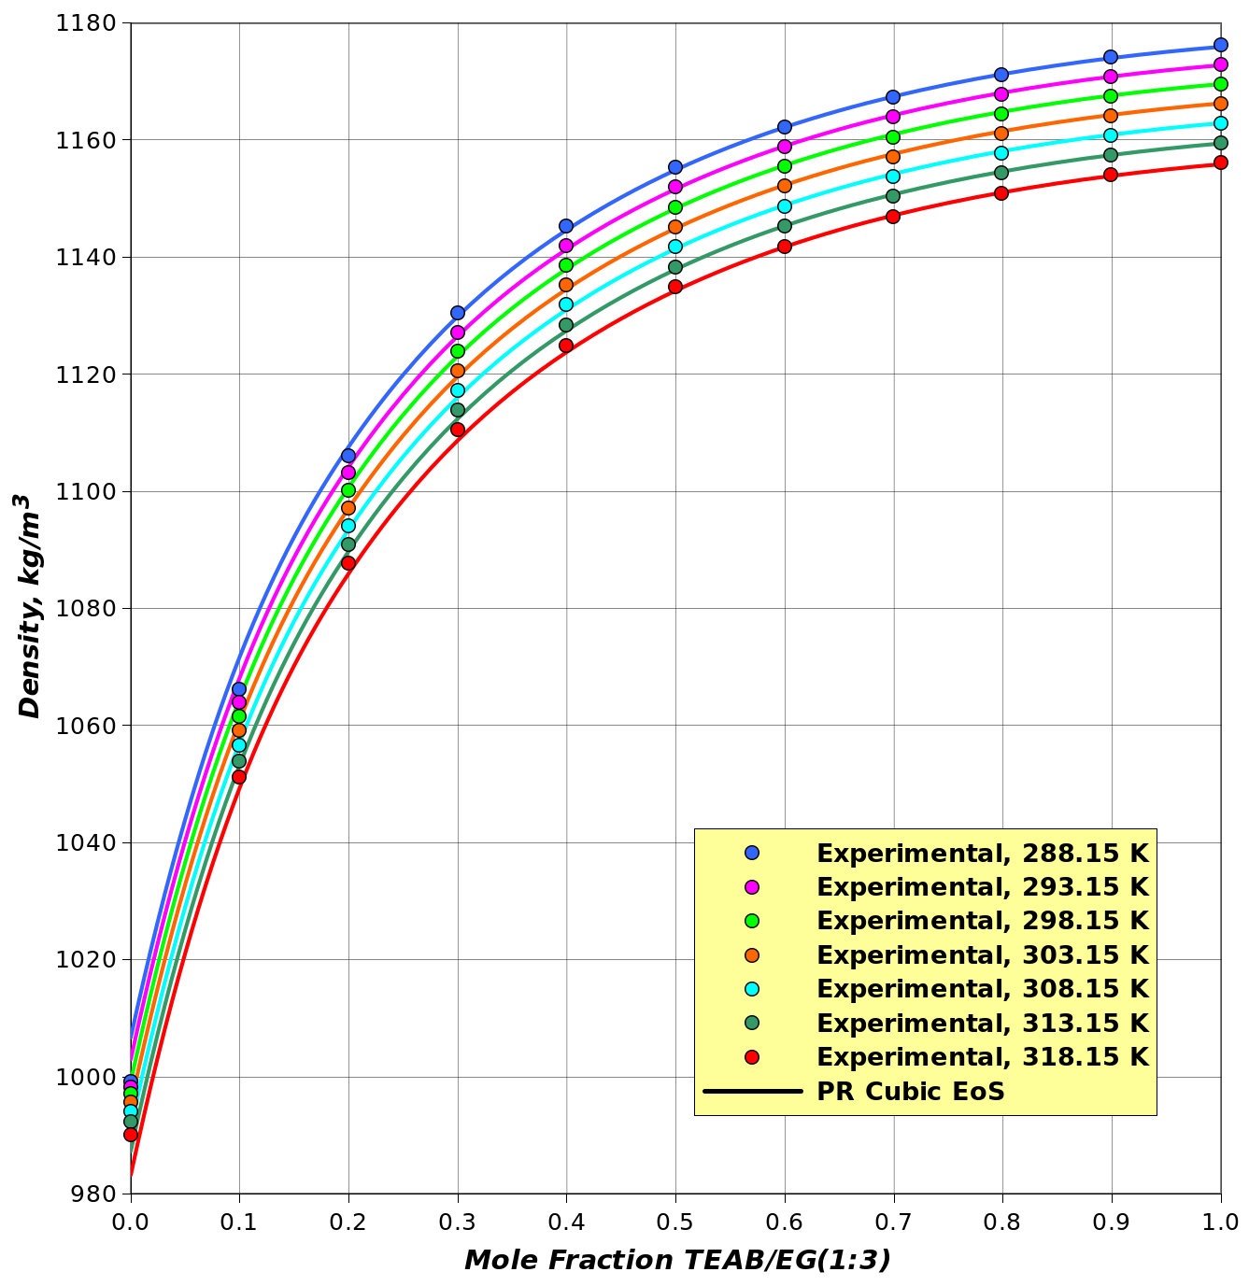

Figure 1: Density of DES-water mixture Figure 2: Surface tension of DES-water mixture

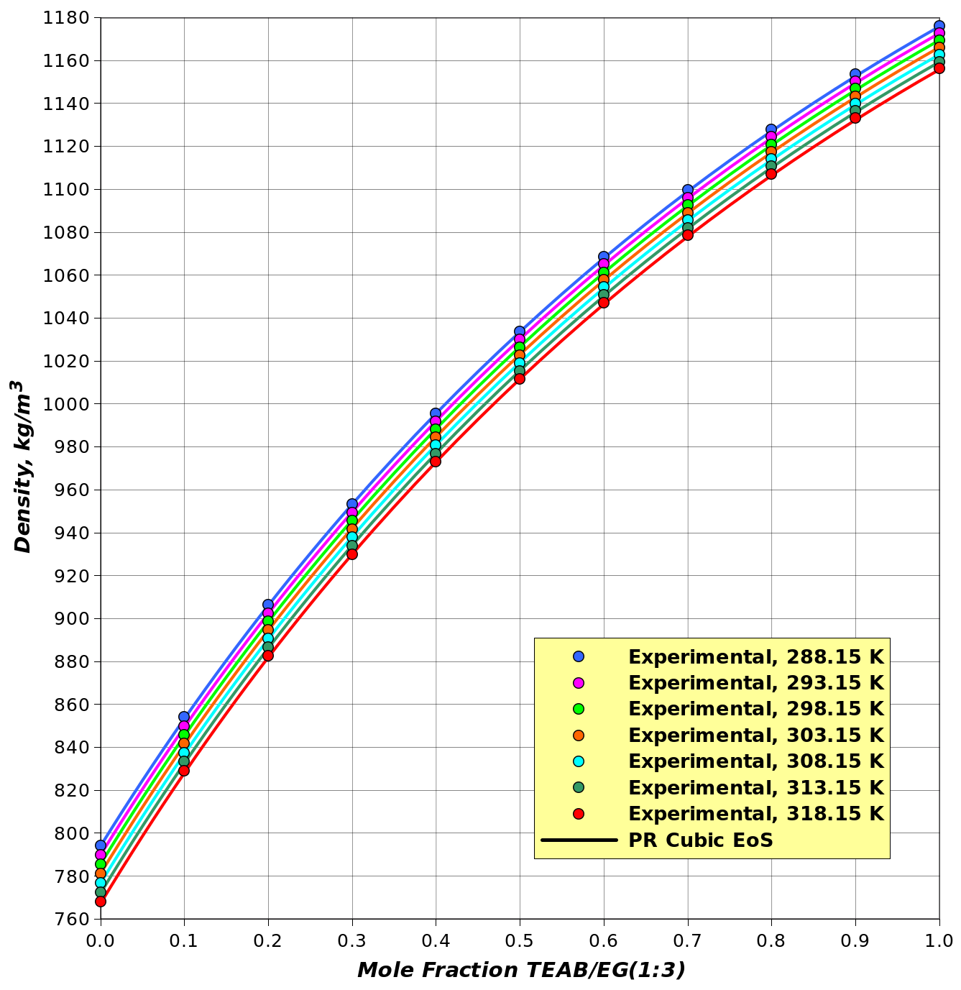

Figure 3: Density of DES-ethanol mixture Figure 4: Surface tension of DES-ethanol mixture

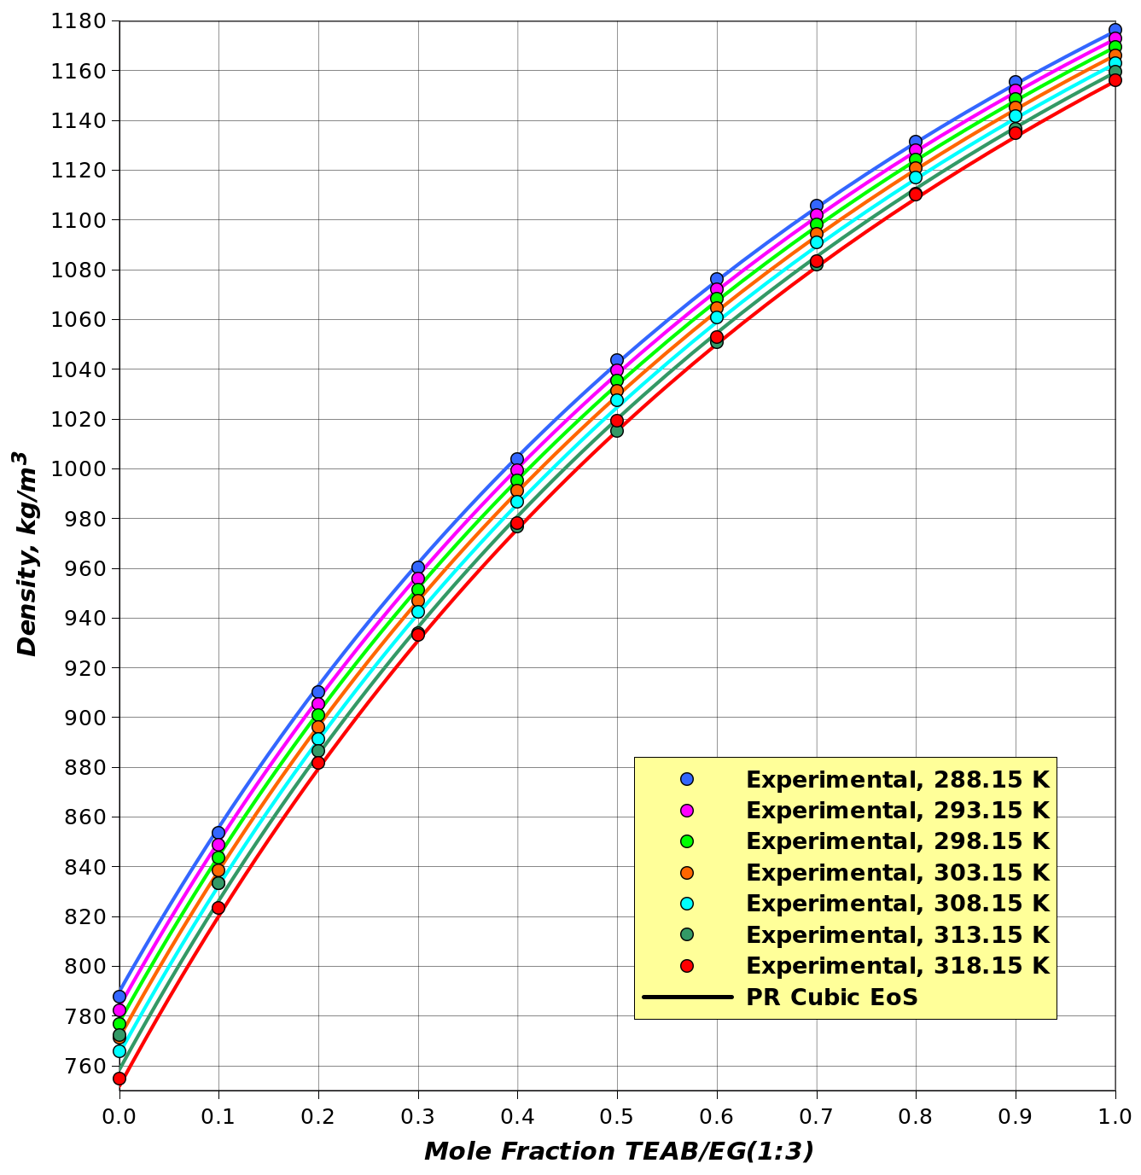

Figure 5: Density of DES-acetonitrile mixture Figure 6: Surface tension of DES-acetonitrile mixture

* 1. Conclusions

The proposed models for density and surface tension exhibit promising results, accurately capturing the thermophysical properties of binary systems containing deep eutectic solvents (DES) in mixtures with water, ethanol, and acetonitrile. Further validation is recommended to extend their applicability across a broader range of compositions and temperatures.

For pure compounds, the density model has shown high reliability, with minimal deviations. Notably, the DES-ethanol system achieved an absolute mean deviation of 0.03%, while the DES-water system, despite its strong non-ideality, had a %MAD of 0.09%, demonstrating the model’s ability to handle associative systems. The highest deviation, 0.15%, was observed for DES-acetonitrile.

The surface tension model also performed well, with molar surface area as a key optimization variable. The lowest deviation was observed for DES-acetonitrile (%MAD of 1.06%), while DES-water had the highest (1.34%), highlighting the influence of solvent interactions. The maximum error reached 3.76% for DES-ethanol at high DES mole fractions.

The model showed greater sensitivity to the attraction parameter ($k_{i,j}$ ​) than the repulsion parameter ($l_{i,j}$), suggesting that setting $l_{i,j}$ ​ to zero could simplify the model without compromising accuracy. Additionally, excess properties analysis revealed that negative $V_{EX}$ values indicate strong intermolecular attraction, reinforcing the predominance of $k_{i,j}$ ​ in capturing these interactions.

Despite its strong predictive capabilities, further refinement is needed. The limited availability of experimental data for DESs remains a challenge, restricting broader validation. Future work should focus on expanding experimental datasets and incorporating a temperature-dependent parameter to improve accuracy in highly non-ideal systems. Enhancing these aspects will strengthen the model’s relevance for sustainable processes and advanced engineering applications involving DESs.

* 1. References

1. Boublia, A., Lemaoui, T., Almustafa, G., Darwish, A. S., Benguerba, Y., Banat, F., & AlNashef, I. M. (2023). Critical properties of ternary deep eutectic solvents using group contribution with extended Lee–Kesler mixing rules. *ACS Omega, 8*(14), 13177-13191.

2. Péneloux, A., Rauzy, E., & Fréze, R. (1982). A consistent correction for Redlich-Kwong-Soave volumes. *Fluid Phase Equilibria, 8*, 7–23.

3. Prausnitz, J. M., Lichtenthaler, R. N., & de Azevedo, E. G. (1999). *Molecular Thermodynamics of Fluid-Phase Equilibria* (3rd ed.). Prentice Hall.

4. Rosen, M. J., & Kunjappu, J. T. (2012). *Surfactants and Interfacial Phenomena* (4th ed.). Wiley.

5. Shahbaz, K., Mjalli, F. S., Hashim, M. A., & AlNashef, I. M. (2012). Prediction of the surface tension of deep eutectic solvents. *Fluid Phase Equilibria, 319*, 48–54.

6. Shuler, M. L., & Kargi, F. (2002). *Bioprocess Engineering: Basic Concepts* (2nd ed.). Prentice Hall.

7. Smith, E. L., Abbott, A. P., & Ryder, K. S. (2014). Deep eutectic solvents (DESs) and their applications. *Chemical Reviews, 114*(21), 11060–11082.

8. Smith, J. M., Van Ness, H. C., & Abbott, M. M. (2005). *Introduction to Chemical Engineering Thermodynamics* (7th ed.). McGraw-Hill.

9. Tojo Suarez, J., Torres Marchal, C., & Rasmussen, P. (1989). Prediction of surface tension of nonelectrolyte solutions. *Chemical Engineering Science, 14*(3), 782–786.

10. Wei, J., Sun, X., Zhang, Y., Gao, P., Ren, C., Fang, D., & Li, L. (2023). Thermophysical properties of pseudo-binary mixtures of choline chloride-ethylene glycol-based deep eutectic solvent with acetonitrile, ethanol, and water. *Journal of Thermal Analysis and Calorimetry, 144*(1), 1234-1250.

11. Zhao, D., Liao, Y., & Zhang, Z. (2007). Ionic Liquids as Green Solvents: Applications in Green Chemistry. *Chemical Reviews, 107*(6), 2465–2514.