|  |  |
| --- | --- |
| cetlogo ***CHEMICAL ENGINEERING TRANSACTIONS***  ***VOL. , 2025*** | A publication of  aidiclogo_grande |
| The Italian Association  of Chemical Engineering  Online at www.cetjournal.it |
| Guest Editors: Fabrizio Bezzo, Gabriele Pannocchia, Almerinda di Benedetto  Copyright © 2025, AIDIC Servizi S.r.l.  ISBN 979-12-81206-17-5; ISSN 2283-9216 | |

Removal of Methylene Blue in Aqueous Solution with Modified Biomass from Forest Residues (*Quercus alba*)

Ángel Villabona-Ortiz a\*, Rodrigo Ortega-Toro b, Adriana Herrera-Barros c, Leidy Castillo-Solano a, Luis Sierra-Payares a

aProcess Design, and Biomass Utilization Research Group (IDAB), Chemical Engineering Department Universidad de Cartagena, Avenida del Consulado St. 30. Cartagena de Indias, Colombia, 130015.

bFood Engineering Department, Food Packaging and Shelf-Life Research Group (FP&SL), Universidad de Cartagena, Avenida del Consulado St. 30. Cartagena de Indias, Colombia, 130015.

cNanomaterials and Computer-Aided Process Engineering Research Group (NIPAC), Chemical Engineering Department, Universidad de Cartagena, Avenida del Consulado St. 30, Cartagena de Indias 130015, Colombia.

avillabonao@unicartagena.edu.co

Biochar is a product derived from the decomposition of biomass, and its physicochemical characteristics are closely linked to its source and the method of combustion employed. Key properties of biochar include its surface area, the development of macro and micropores, and the presence of various functional groups. This study aimed to synthesize activated carbons (AC) from Quercus alba sawdust, modified with phosphoric acid and urea at different concentrations (1, 3, and 6 M), identifying through physicochemical characterization its possible use as an adsorbent for the cationic dye methylene blue (MB). The prepared bio-based adsorbents were physiochemically characterized by Fourier-Transform Infrared Spectroscopy (FTIR), mechanical tests to determine porosity, pore distribution, and adsorption capacity by determining the methylene blue index. The biochar activated and functionalized with urea at a concentration of 6 M (C 6M) presented the best characteristics for the adsorption of dyes, the pH at the zero-loading point (pHpzc) was 6.1, and the methylene blue index corresponded to a qe of 16.77 mg/g. The FTIR spectra showed the changes that occur with increasing urea concentration. Based on their characteristics, it can be indicated that bioadsorbents prepared from Quercus alba sawdust can be used for the adsorption of azo dyes, obtaining a high percentage of removal.

* 1. Introduction

The huge amounts of synthetic dyes, in addition to the sulfates and nitrates thrown into the water bodies, cause a decrease in oxygen in aquatic ecosystems and, therefore, generates the deterioration of water quality, the degradation of the environment, and great health and economic impacts (Garcés et al., 2022). The large amounts of synthetic dyes, mainly from the azo group are characterized by the presence of one or more azo groups (–N=N–); they are considered the most significant chemical group currently in existence, for which these chemical compounds are the leading synthetic pigments released into the environment (Tamer et al., 2021). Within these dyes we can find, tartrazine, red 40, sunset yellow, brilliant black, amaranth and methylene blue (Hincapié et al., 2018). Specifically, methylene blue is a dye recognized as an organic pollutant that comes largely from the textile industry. Moreover, it has become a standard method to evaluate the adsorption capacity possessed by some synthesized materials because it is abundant, readily available, and easily colors any surface (Albis et al., 2017). As a result of the substantial impacts of industrial effluents contaminated with dyes, in recent decades, many investigations have been carried out to find effective removal of these pollutants, such as physical, chemical, and biological processes for removing dyes from wastewater. Nevertheless, these processes have economic and technical limitations; in consequence, many researchers have turned their attention to investigating wastewater treatment by applying adsorption techniques to remove toxic dyes because it is an effective and low-cost method. Activated carbon is one of the most common materials used in the removal of dyes, in which the use of lignocellulosic materials for its elaboration is being implemented since they present an adequate adsorption capacity; among the biomasses used for the preparation of activated carbon, we can mention the shells of various fruits, corn cob, banana peels, rice husks, as well as bamboo and wood sawdust, among many other biological materials (Présiga-López et al., 2020). For example: Ichipi et al., (2022) used sawdust residues to synthesize a biochar useful for the removal of methylene blue, their results showing an adsorption efficiency of up to 98.7% in 90 min, while Alvear-Alayon et al., (2022) created an adsorbent based on rice husk residues to remove nickel ions, obtaining a yield of up to 86%.

Considering the above, the present study prepared an *Quercus alba* -based activated carbons (AC), chemically modified with H3PO4, and functionalized with urea at different concentrations. The synthesized biocarbons were physiochemically characterized by FTIR and mechanical tests to determine porosity, pore distribution, and adsorption capacity by determining the methylene blue (MB) index. Thus, considering sawdust as a source of obtaining carbon, research into new materials such as dye adsorbents is promoted while taking advantage of an agro-industrial residue that is highly available in the region.

* 1. Materials and Methods
     1. Materials

Sawdust (*Quercus alba*) obtained from the residues of a sawmill in Cartagena, Colombia, phosphoric acid (H3PO4) and urea (CO(NH2)2) were used. Methylene blue (C16H18CIN3S) was used for adsorption tests supplied by Merck (M).

* + 1. Activated carbon synthesis

The raw sawdust was washed with water at 80 °C to remove impurities and not desired compounds. Subsequently, it was dried in an oven at 90 °C for 8 h. Then, 50 g of pretreated sawdust was placed in a muffle, with a heating rate of 5 °C/min until reaching 250 °C. Finished the process, the material was allowed to cool until the environment temperature. The carbonization conditions were established from trial-and-error testing, finding the temperature and time when an optimal carbonization process occurred without notable traces of ashes. Afterward, the biocarbon was chemically modified following the method proposed by Sajjadi et al., 2019 with some modifications, where physical ultrasound treatment was carried out for 1 min using 10 g of the synthesized biochar. Then, it was vacuum filtered and dried for 2 h at 100 °C. The chemical treatment with H3PO4 at 50 % was heated until 100 °C for 3 h at a ratio of 5 mL of solution by 1 g of carbon. The functionalization with urea as a nitrogen source was achieved using different urea concentrations (1, 3, and 6 M) with a ratio of 1 g of biochar for 5 mL of solution; the carbon was left in contact with the urea for 18 h under constant stirring at 200 rpm.

* + 1. Characterization of the bioadsorbents

The physical and chemical properties of the *Quercus alba* sawdust (OS), of the unmodified carbon (UOS), and the modified carbons with different concentrations of urea were determined through the following essays. The size distribution of the OS was analyzed employing granulometric essays according to ASTM C136-01. A mechanic sieve Ro-Tap type with seven mesh sizes was used: 0.106; 0.150; 0.212; 0.355; 0.5; 1 and 2 mm, these were subjected to vibration for 5 minutes, and a balance was used to determine the mass retained in each sieve. The porosity was measured to determine the void spaces and how the adsorbate passes toward the internal surface of the absorbents. For this, the material's apparent and real density were calculated. The real density was established using the pycnometer method; initially, an empty pycnometer was weighed, and the balance was tared; an amount between 2 and 4 g of the adsorbent was added to the pycnometer, and the pycnometer was subsequently filled with distilled water, and its weight was recorded again. Finally, the pycnometer was filled with distilled water up to its capacity, and its weight was recorded. Equation 1 was used for determining the real density.

|  |  |
| --- | --- |
| $$ρ_{real}=\frac{m_{a}×ρ_{l}}{m_{a}+m_{l}-m_{a,l}}$$ | (1) |

Where *ma* (g) is the mass of the adsorbent, *ρl* (g/cm3) is the density of the liquid, *ml* (g) is the mass of the liquid, and *ma,l* (g) is the mass of the wet adsorbent. The test tube method was used to calculate the apparent density of the bioadsorbents. A test tube was taken, and an amount of adsorbent was added to it until a certain volume was reached; then, the sample was placed in a container to record the weight of the volume occupied by the biomass in the test tube and finally the density was calculated as the result of the mass over the volume. porosity was determined as the difference of the real and apparent density between the real density multiplied by 100. In addition, FTIR analysis was performed to determine the functional groups of the adsorbents involved in the adsorption process and SEM to study the surface morphology of the materials. MB concentration was measured at a wavelength of 664 cm-1 using Biobase BK-UV 1600 UV-vis spectrophotometry (Shandong, China).

* 1. Results and discussion
     1. Activated carbon synthesis

The synthesis of the biochar was carried out following the established methodology, the carbonization process was performed at 250 °C for 1 h with a heating rate of 5 °C/min. From Table 1, the apparent densities of the bioadsorbents have similar values, except for the *Quercus alba* sawdust, which displayed a higher density. This is due to the increase in the porosity of the biomass after being carbonized. The above is due to the decrease in sawdust particle size after carbonization; likewise, the most significant number of components in the structure of the sawdust is associated with the presence of volatile compounds in the lignin, cellulose, and hemicellulose of the wood, which are released during carbonization (Wei & Li, 2021). It was also evidenced the enhancement of the real density compared to the apparent density; it was noticed that the porosity of the material proportionally with the urea concentration, being the carbon modified with a urea concentration of 6 M (C 6M) the one with the highest porosity of 79.3 %. The increase in the real density proportionally with the urea concentration is attributed to the increase in the mass of the biochar by incorporating the active nitrogenous centers into its structure.

Table 1. Porosity of Quercus alba sawdust (OS), unmodified carbon (UOS), modified carbon with different concentrations of urea (C 1M, C 3M, C 6M).

|  |  |  |  |  |
| --- | --- | --- | --- | --- |
| Sample | Apparent density (g/cm3) | Real density (g/cm3) | Porosity % | Sample |
| OS | 0.358 | 0.975 | 81.615 | OS |
| UOS | 0.214 | 0.964 | 77.787 | UOS |
| C 1M | 0.274 | 0.975 | 71.933 | C 1M |
| C 3M | 0.276 | 1.051 | 73.725 | C 3M |
| C 6M | 0.296 | 1.433 | 79.338 | C 6M |

The size and shape of the *Quercus alba* sawdust particles are important for handling and charring efficiency. The results of the screening of Quercus alba sawdust determined that 49.9% of the sample has a mean particle size of less than 0.428 mm, while the highest fraction retained has a value of 24.8% with a mean particle size of 0.75 mm, 23.5% of the sample has a mean particle size of 0.284 mm, and 25.3 % of the sample has a particle size smaller than 0.181 mm.

* + 1. FTIR spectrum

The identification of the characteristic functional groups in the adsorbent surface was studied by FTIR analysis (Figure 1). The OS sample shows a peak of around 3496 cm-1 and small broadband of nearly 3327 cm-1; these disturbances are attributed to the typical vibrations by stretching the O-H in the hydroxyl group, specifically in the polymeric molecules (Nguyen et al., 2019). In addition, bands located between 2901- 1422 cm-1 and 2359 cm-1 represent C-H and C≡C vibrations, respectively (Maia et al., 2021). The peak situated at 1594 cm−1 is caused by the stretching of the carboxyl group in aldehydes and ketones (El Nemr et al., 2021). The strong band ubicated at 1028 cm−1 can be associated with the stretching vibrations of the C-OH group, which can be present in aromatic rings and is also attributed to stretching in cellulose and hemicellulose (Khasri et al., 2018). On the other hand, in the spectrum of the UOS sample, it is observed the elimination of the peak corresponding to the group O-H; another significant change is the increase in the intensity of the peaks between 580 cm-1 and 537cm-1, which may be related to aromatic groups; in general, the bands that appear between the frequency 700 and 400 cm-1 are characteristic of the C–H group in cellulose, which indicates the fingerprint of the material (El Nemr et al., 2021).



Figure 1. FTIR analysis of the adsorbents under study before and after adsorption of methylene blue (MB).

Figure 1 also shows the spectrums of the functionalized AC at different urea concentrations before the MB adsorption process. From this characterization, it was possible to observe that the C 1M sample displayed a peak at 3302 cm-1, corresponding to the stretching vibrations of the O–H group (Zbair et al., 2018). Moreover, a decrease in the vibrations of this peak was observed in C 3M and C 6M samples due to an increase in the urea concentration. This behavior may be related to the interaction between the OH group and the urea molecules forming hydrogen bonds or the interaction between hydroxyl and carboxyl groups. Sajjadi et al., (2019) also observed this behavior. In that research, they determined peaks around 1590 cm-1 and 1207 cm-1 in three biocarbons samples, which were associated with C=C bonds related to the carboxyl group FTIR analysis was performed on the bioadsorbents after removing methylene blue (MB) to determine the functional groups involved in the adsorption of this dye. Figure 1 displays these results, observing a decrease in the intensity of the OH bands, which can be related to a possible interaction between the MB and the hydroxyl group. Another change observed is a peak around 880 cm-1 in all biochar samples after adsorption of the MB, attributed to the presence of this molecule on the surface of the adsorbents (Ovchinnikov et al., 2016). The attenuation or increase in the intensity of the peaks or in the displacement of the bands in a spectrum is evidence of a change in the functionality or distribution of electrons associated with a bond in the activated carbon (Jasper et al., 2020).

* + 1. Scanning Electron Microscopy – SEM

Figure 2a shows the SEM image for *Quercus alba* sawdust, which has a compact surface with defined pores concerning the unmodified *Quercus alba* biochar (Figure 2b). The UOS presents the distribution of some irregular cavities on the surface, which were rough and uneven, showing the changes that occurred with carbonization where some volatile compounds are released, and the percentage of carbon is increased. These results are similar to the obtained by Khasri et al., 2018, and Nguyen et al., 2019 when using carbon from Pentace species sawdust via microwave-induced KOH activation, and teak sawdust-hydro chars, respectively.



Figure 2. Scanning electron microscopy (SEM) of biochars functionalized with urea. **a)** Quercus alba sawdust, **b)** unmodified Quercus alba biochar, **c)** C 1M, d) C 3M, and **e)** C 6M.

In the SEM images of the modified biochar samples (Figure 2c to 2e), it was evidenced that the ultrasound treatment enhanced the cleaning of the biochar’s surface, increasing the presence of micropores. In addition, when the concentration of urea augments the porosity becomes more open and broader; In the C6M micrograph, traces of different sizes and shapes are evident, with an amorphous structure, since the molecules are randomly distributed. In addition, different investigations have shown that treatment with H3PO4 can improve properties such as the adsorption of dyes (Zbair et al., 2018). The results showed that the nitrogen source ratio significantly affected the evolution of biochar's pore structure. A higher urea addition ratio was beneficial to the development of pore structures (Jasper et al., 2020).

* + 1. Methylene blue adsorption tests

The best pH condition for adsorption essays was established. For this, 3 levels of variation were taken between pH 7, 8, and 9, above the pH-PZC. The adsorbent dose was fixed at 0.035 mg, and the initial methylene blue concentration at 40 mg/L. Figure 3 shows the results of the tests carried out. The pH that showed a better adsorption capacity in three of the four evaluated bioadsorbents was found to be pH 9, reaching an average experimental adsorption capacity of 11.11 mg/g. This result may be due to the cationic nature of methylene blue and to the fact that the surface of the biochars was acidic due to the modification with urea and phosphoric acid; therefore, a higher pH is necessary for sufficient electrostatic forces to occur, retaining the dye ions.

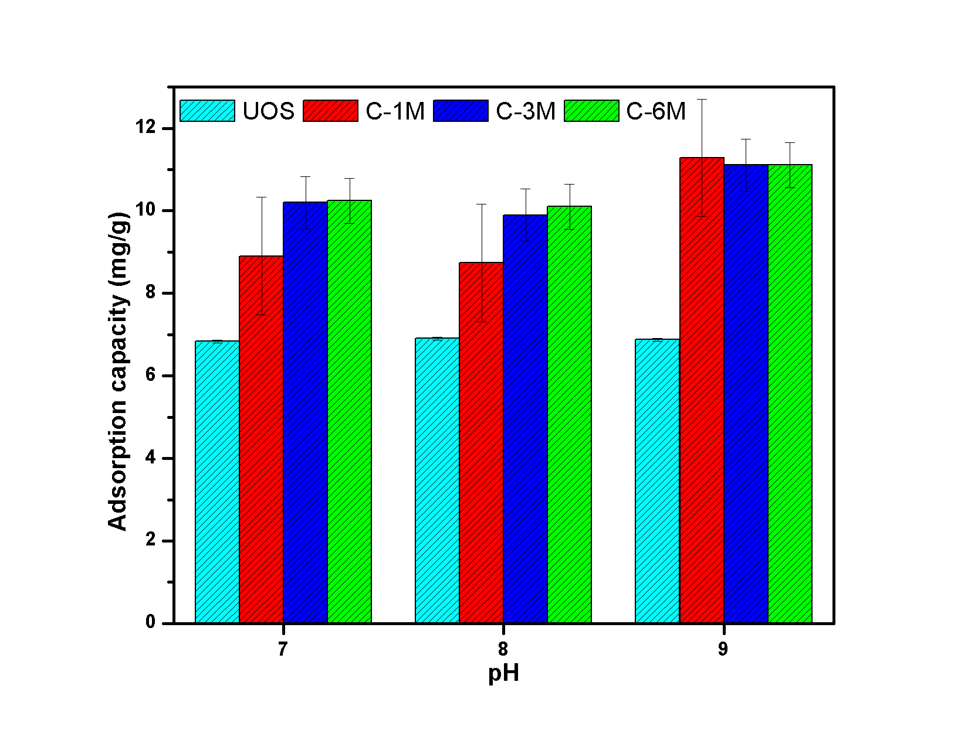

Figure 3. Effect of pH on the adsorption capacity of methylene blue

Subsequently, at the pH condition at which the highest adsorption capacity found was obtained, the equilibrium adsorption of methylene blue was evaluated using an adsorbent dose of 0.035 g and a methylene blue concentration of 60 ppm. As observed in Figure 4, C 6M was the one that presented the best performance, with an adsorption capacity of 16.768 mg/g and an average removal percentage of 97.8%; this result could be associated with the concentration of the urea solution used for the functionalization of the absorbent. Similar results were obtained in the research conducted by Yusop et al., (2022), where they synthesized an activated carbon from teak wood waste for the removal of MB dye achieving a removal yield of up to 97.5 % for an initial contaminant concentration of 25 mg/L, ratifying the potential of the biocarbon synthesized in our study for the removal of cationic dyes.

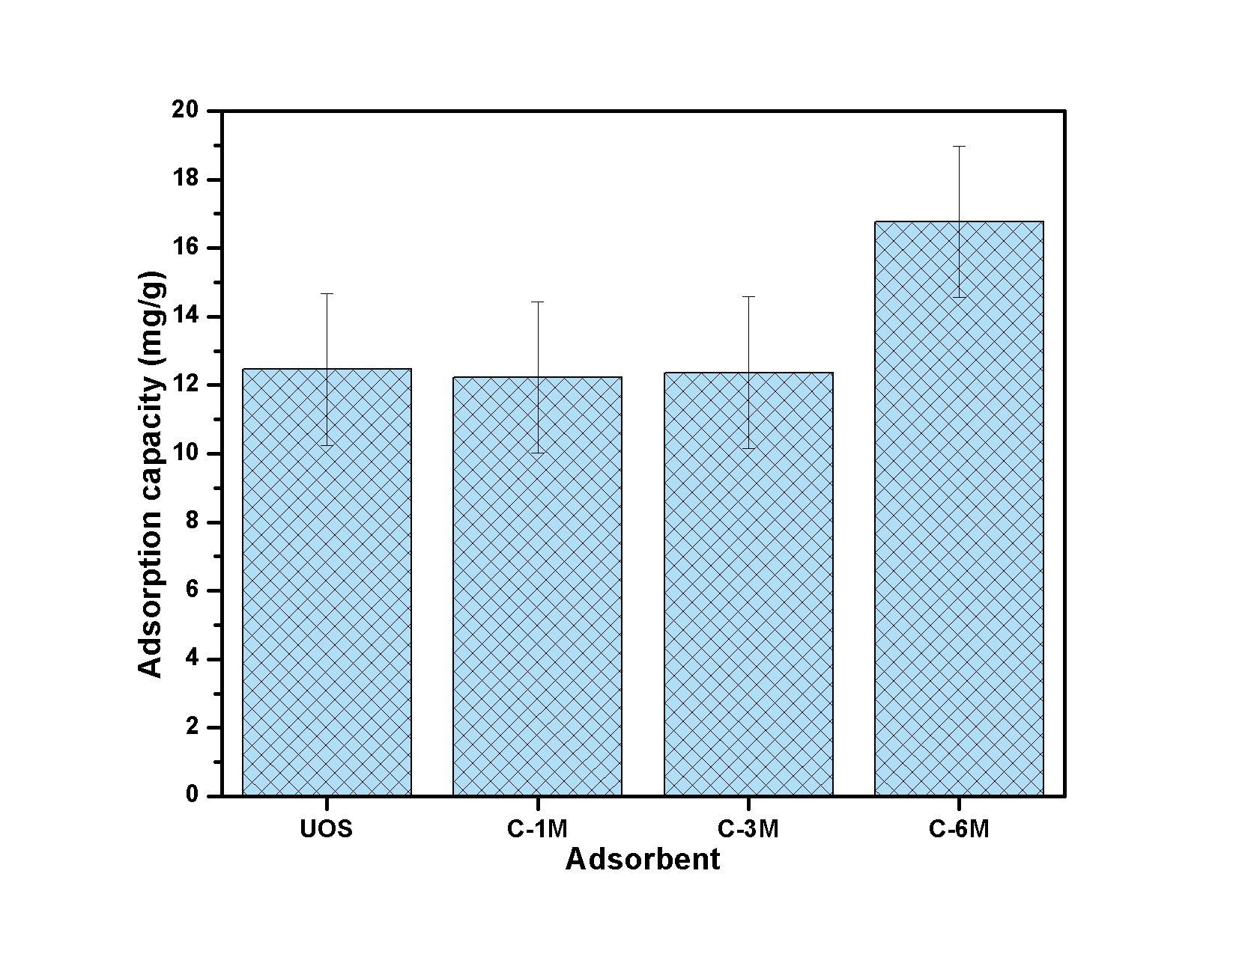

Figure 4. Evaluation of methylene blue adsorption capacity at pH 9

According to the results, nitrogen functionalization can effectively improve the adsorption capacity of biochars to methylene blue. The order of adsorption of methylene blue by the three biochars followed C 6M>C 3M>C 1M>UOS, which is consistent with Figure 3 and the FTIR spectrum. It has been noted that the adsorption of methylene blue primarily depends on the presence of surface functional groups. Specifically, the nitrogen groups play a crucial role, as the molecules of methylene blue can engage in Lewis acid-base interactions with them. In addition, methylene blue has an aromatic structure and can form a π-π interaction with Graphitic-N, further enhancing adsorption (Lian et al., 2016).

* 1. Conclusions

From the adsorption essays, it can be concluded that the carbon synthesized from *Quercus alba* sawdust, chemically activated with H3PO4 and functionalized with urea, has good properties for removing cationic dyes. From physical characterization, it was established that more than 49.9% of the biomass used is 0.428 mm in size, the apparent and real density of C 6M was 0.310 and 0.783 g/cm3, respectively, and the porosity was 79.3%. The increase in urea concentration gives better characteristics to the biochar; this was evidenced by obtaining a methylene blue index of 16.77 mg/g for the C 6M activated carbon, carrying out the tests at pH 9.

References

Albis, A. R., López, A. J., & Romero, M. C. (2017). Removal of methylene blue from aqueous solutions using cassava peel (Manihot esculenta) modified with phosphoric acid. *Prospectiva*, *15*(2), 60–73. https://doi.org/10.15665/RP.V15I2.777

Alvear-Alayon, M. R., Mallarino, L. P., Ramos, L. M., Arrieta, C. M., Guerra, J. D., Leones, J. L., & Tejeda, L. P. (2022). Adsorption of Nickel in a Continuous System Using Biochar Obtained from Pyrolysis of Rice Husk at Low Temperature. *Chemical Engineering Transactions*, *92*, 559–564. https://doi.org/10.3303/CET2292094

El Nemr, A., Shoaib, A. G. M., El Sikaily, A., Mohamed, A. E. D. A., & Hassan, A. F. (2021). Evaluation of Cationic Methylene Blue Dye Removal by High Surface Area Mesoporous Activated Carbon Derived from Ulva lactuca. *Environmental Processes*, *8*(1), 311–332. https://doi.org/10.1007/s40710-020-00487-8

Garcés, S., Pulido, C., Días, C., & Agudelo, R. (2022). Adsorción de sulfuros presentes en solución acuosa sobre carbón activado obtenido a partir de zuro de maíz. *Avances Investigación En Ingeniería*, *19*(1), 1–12. https://doi.org/10.18041/1794-4953/AVANCES.1.8394

Hincapié, G., Cuervo, S., & Ríos, L. (2018). Absorption thermodynamic study of azoic dye with by means of a lignocellulosic waste in aqueous medium. *Ingeniería y Desarrollo*, *36*(1), 97–118. https://doi.org/10.14482/INDE.36.1.10941

Ichipi, E. O., Tichapondwa, S. M., & Chirwa, E. M. N. (2022). Eco-friendly Removal of Methylene Blue from Aqueous Medium Using Low Cost Sawdust-biochar Adsorbent. *Chemical Engineering Transactions*, *96*, 361–366. https://doi.org/10.3303/CET2296061

Jasper, E. E., Ajibola, V. O., & Onwuka, J. C. (2020). Nonlinear regression analysis of the sorption of crystal violet and methylene blue from aqueous solutions onto an agro-waste derived activated carbon. *Applied Water Science*, *10*(6), 1–11. https://doi.org/10.1007/s13201-020-01218-y

Khasri, A., Bello, O. S., & Ahmad, M. A. (2018). Mesoporous activated carbon from Pentace species sawdust via microwave-induced KOH activation: optimization and methylene blue adsorption. *Research on Chemical Intermediates*, *44*(10), 5737–5757. https://doi.org/10.1007/s11164-018-3452-7

Lian, F., Cui, G., Liu, Z., Duo, L., Zhang, G., & Xing, B. (2016). One-step synthesis of a novel N-doped microporous biochar derived from crop straws with high dye adsorption capacity. *Journal of Environmental Management*, *176*, 61–68. https://doi.org/10.1016/J.JENVMAN.2016.03.043

Maia, L. S., Duizit, L. D., Pinhatio, F. R., & Mulinari, D. R. (2021). Valuation of banana peel waste for producing activated carbon via NaOH and pyrolysis for methylene blue removal. *Carbon Letters*, *31*(4), 749–762. https://doi.org/10.1007/s42823-021-00226-5

Nguyen, H. D., Tran, H. N., Chao, H. P., & Lin, C. C. (2019). Activated carbons derived from teak sawdust-hydrochars for efficient removal of methylene blue, copper, and cadmium from aqueous solution. *Water (Switzerland)*, *11*(12). https://doi.org/10.3390/w11122581

Ovchinnikov, O. V., Evtukhova, A. V., Kondratenko, T. S., Smirnov, M. S., Khokhlov, V. Y., & Erina, O. V. (2016). Manifestation of intermolecular interactions in FTIR spectra of methylene blue molecules. *Vibrational Spectroscopy*, *86*, 181–189. https://doi.org/10.1016/J.VIBSPEC.2016.06.016

Présiga-López, D., Rubio-Clemente, A., & Pérez, J. F. (2020). Uso del biocarbón como material alternativo para el tratamiento de aguas residuales contaminadas. *Revista UIS Ingenierías*, *20*(1), 121–134. https://doi.org/10.18273/revuin.v20n1-2021011

Sajjadi, B., Broome, J. W., Chen, W. Y., Mattern, D. L., Egiebor, N. O., Hammer, N., & Smith, C. L. (2019). Urea functionalization of ultrasound-treated biochar: A feasible strategy for enhancing heavy metal adsorption capacity. *Ultrasonics Sonochemistry*, *51*, 20–30. https://doi.org/10.1016/j.ultsonch.2018.09.015

Tamer, Y., Özeren, M. D., & Berber, H. (2021). High Adsorption Performance of Graphene Oxide Doped Double Network Hydrogels for Removal of Azo Dyes from Water and Their Kinetics. *Journal of Polymers and the Environment*, *29*(12), 4000–4016. https://doi.org/10.1007/s10924-021-02162-x

Wei, X., & Li, T. (2021). Wooden Activated Carbon Production for Dioxin Removal via a Two-Step Process of Carbonization Coupled with Steam Activation from Biomass Wastes. *ACS Omega*, *6*(8), 5607–5618. https://doi.org/10.1021/ACSOMEGA.0C06032/ASSET/IMAGES/LARGE/AO0C06032\_0009.JPEG

Yusop, M. F. M., Aziz, A., & Ahmad, M. A. (2022). Conversion of teak wood waste into microwave-irradiated activated carbon for cationic methylene blue dye removal: Optimization and batch studies. *Arabian Journal of Chemistry*, *15*(9), 104081. https://doi.org/10.1016/J.ARABJC.2022.104081

Zbair, M., Anfar, Z., Khallok, H., Ahsaine, H. A., Ezahri, M., & Elalem, N. (2018). Adsorption kinetics and surface modeling of aqueous methylene blue onto activated carbonaceous wood sawdust. *Fullerenes, Nanotubes and Carbon Nanostructures*, *26*(7), 433–442. https://doi.org/10.1080/1536383X.2018.1447564