|  |  |
| --- | --- |
| cetlogo ***CHEMICAL ENGINEERING TRANSACTIONS***  ***VOL., 2025*** | A publication of  aidiclogo_grande |
| The Italian Association  of Chemical Engineering  Online at www.cetjournal.it |
| Guest Editors: Fabrizio Bezzo, Flavio Manenti, Gabriele Pannocchia, Almerinda di Benedetto  Copyright © 2025, AIDIC Servizi S.r.l. **ISBN** 979-12-81206-17-5; **ISSN** 2283-9216 | |

Characterization and Properties of the Biosurfactant Produced by *Pantoea* sp.for Application in the Petroleum Industry

Fabíola Carolina G. Almeidaa, Leonie A. Sarubboa,b,\*

aInstituto Avançado de Tecnologia e Inovação (IATI), Rua Potyra, n. 31, Prado, Recife-PE, 50751-310, Brasil

bUniversidade Católica de Pernambuco (UNICAP), Rua do Príncipe, n. 526, Boa Vista, Recife-PE, 50050-900, Brasil

\*leonie.sarubbo@iati.org.br

The increase in environmental awareness and strict legislation has made the ecological compatibility of surfactants an essential factor in their application for various uses. Among natural surfactants, ones of microbial origin, so-called biosurfactants, have gained attention because of their biodegradability, low toxicity, ecological acceptability, and ability to be produced from renewable and less expensive substrates. Thus, the potential of an alkaliphilic bacterium *Pantoea* sp. to utilize a low-cost medium supplemented with vegetable fatty (25%), corn steep liquor (5%), and pineapple peels broth (2%) for biosurfactant production was evaluated. The kinetics of microorganism growth and biosurfactant production was carried out in a 5-L bioreactor at 30°C for 72 hours under 350 rpm and oxygenation at 0.5 vvm. The biosurfactant produced exhibited significantly low viscosity and a maximum reduction in surface tension of 30.0 mN/m. The biosurfactant production was detected at 36 hours, and the isolated biosurfactant corresponded to a concentration of 1.25 g/L after 60 hours of fermentation. A CMC of 1.0 g/L and a surface tension of 30 mN/m were obtained. The chemical characterization of the biosurfactant suggested its glycolipidic nature. The biosurfactant did not show toxicity against the microcrustacean *Artemia salina* and the cabbage (*Brassica oleracea*). Higher yield with cheaper raw materials, noteworthy stress tolerance of biosurfactant toward pH and salt, and nontoxic effects against marine and terrestrial indicators revealed its potential for application in bioremediation, as the removal of hydrocarbons (petroleum, diesel, kerosene, and motor oil) adsorbed in sand reached values higher than 87%.

* 1. Introduction

Biosurfactants are amphiphilic (with polar and non-polar moieties), comprised of glycolipids, phospholipids, lipopeptides, and polymeric compounds, and tend to separate at interfaces and reduce the surface tension (Sarubbo et al., 2022). They are produced by various microbes (fungi, bacterium, and yeast) from different environmental habitats and either adhere to the cell surface or are excreted out. Surfactants increase the aqueous solubility of hydrophilic molecules by reducing the surface tension at air–water, and water-oil interfaces. The monomers aggregate to form micelles as the interfacial tension is reduced and the aqueous surfactant concentration increases. The concentration at which micelles first begin to form is known as the critical micelle concentration (CMC). This concentration corresponds to the point at which the surfactant first shows a stable, low, surface tension value (Farias et al., 2021).

Biosurfactants have many biotechnological applications in areas such as dairy, food, beverage, cosmetics, detergent, textile, paint, mining, petroleum, paper pulp, and pharmaceutical industries. Biosurfactants are ecologically accepted, non-toxic, biodegradable, and effective in a wide range of extreme conditions, including temperature, pH, and salinity, as compared to chemical surfactants. Extreme environments are bioresources of potential microorganisms that secrete novel bioactive compounds and biosurfactants (Selva Filho et al., 2023).

At large scale, the production of biosurfactants is limited because of expensive raw materials, low production yield, complex downstream processes and high purification costs. The raw material (production medium) is estimated to account for 10–30% of the total production costs in most biotechnological processes. The primary factor limiting microbial biosurfactants' use is their production costs, principally due to high substrate costs. Several reports are available on the production of biosurfactants by using water-immiscible compounds, such as hydrocarbons, and water-soluble compounds, such as carbohydrates, as a carbon source. Carbon substrate is an important limiting factor, affecting the production of microbial surfactants by influencing its quality and quantity (Sarubbo et al., 2022). Several studies have been carried out to define the best ratio of carbon and nitrogen necessary to obtain high productivity. Several biosurfactants have been isolated and characterized. An understanding of the physiological roles of biosurfactants, as well as their interaction with the producer microbes, can help overcome the economic obstacles facing the commercialization of biosurfactants (Faccioli et al., 2024).

Thus, the aim of this study was to produce and characterize a new biosurfactant from the bacterium *Pantoea* sp. cultivated in a low-cost medium for application in the bioremediation of environments contaminated by oil.

# 2. Material and Methods

2.1. Microorganism and culture conditions

The studies used *Pantoea* sp. isolated from wastewater from textile industrial laundry machinery located in Toritama-PE, Brazil. The culture belongs to the Culture Collection of the Catholic University of Pernambuco and is recorded in the FCC-Federation Culture Collection. It was stored at -22ºC in BHI medium supplemented with 20% (v/v) glycerol solution

**2.2. Biosurfactant production**

The fermentation used a 5.0-L bench-top bioreactor (Bioflo 2000 New Brunswick Scientific) with a 3.5-L working volume. The corn steep liquor sample (Corn Steep Liquor®) was donated by the originating company Cabo de Santo Agustinho, Pernambuco, Brazil, and stored at 4 ◦C. The organic substrates 5% (v/v) corn steep liquor, 25.0% (v/v) broth pineapple peels, and 2.0% (v/v) vegetable fat were added in the preparation of medium production of the biosurfactant. The pineapple peels were collected in the commerce (Supply Central and Logistics of Pernambuco – CEASA). The vegetable fat post-frying was donated by commerce. The culture medium was inoculated with 106 CFU/mL, giving an initial optical density at 600 nm of 0.1. The fermentation was carried out at 30ºC for 72 hours, with agitation at 350 rpm and oxygenation at 0.5 vvm, without a chemical antifoaming agent. The pH was not controlled during the fermentation. The fermentative process was carried out in three independent replicates. Samples were taken periodically to analyze the concentrations of the bacterium biomass and surface tension.

The growth of the strain was observed by measuring the OD at 600 nm at 12 hours intervals for 72 hours using spectrophotometer UV. Also, the samples were submitted to serial dilutions in saline solution (0.85 %, w/v) and viable counts were performed by the spread plate technique. The results are expressed as colony-forming units per milliliter (CFU/mL). The pH of the culture was measured during the fermentation using a pH probe inserted into the broth.

**2.3. Isolation and purification of biosurfactant**

The cell-free supernatant obtained by centrifugation at 9000 × g for 10 minutes, was extracted three times with chloroform/methanol (3:2:1, vol/vol) mixture to obtain the biosurfactant. The organic fraction was evaporated to dryness under vacuum, and chilled acetone was added to recover the crude biosurfactant. This was dissolved in 10 mL of methanol and loaded onto a chromatography column (diameter 2.5 cm, height 30 cm) packed with silica gel 60 (230–400 mesh, Merck; Damstadt, Germany) equilibrated with methanol. The loaded column was washed with 10 volumes of methanol at a flow rate of 1 mL/min. Aliquots of volume 5 mL were collected and used to detect biosurfactant through reduced surface tension measurement. The solution, which contained active fractions of biosurfactant, was evaporated to dryness under vacuum.

**2.4. Surface tension and Critical micelle concentration (CMC) measurements**

Surface tension was determined on cell-free broth by centrifuging the cultures at 5000×g for 20 min using a Du Nouy Tensiometer model Sigma 700 (KSV Instruments LTD, Finland) at room temperature. Surface tension of distilled water and respective production media without inoculum, were taken as controls.

The CMC of the biosurfactant was determined for the concentration the purified biosurfactant (0.001–3% w/v) in distilled water and followed by the measurement of surface tension. The surface tension of each concentration was determined in triplicate. The maximum standard deviation associated with the surface activity measurements was ± 0.2 mN/m. The CMC of the biosurfactant was estimated from the constant value of surface tension.

**2.5. Characterization of biosurfactant**

Samples of the purified biosurfactant were then transferred to a decantation funnel and soaked in different ratios of chloroform and methanol. The extracted biosurfactant was then analyzed for total proteins, lipids, and carbohydrates. Proteins were determined using the Bradford method (1976). To determine the lipid content, 0.5 g of the isolated material was extracted with chloroform:methanol in different proportions (1:1 and 1:2 vol/vol). The organic extracts were then evaporated under vacuum and the lipid content determined by gravimetric estimation (Manocha et al., 1980). Carbohydrates were determined by the phenol– sulfuric acid procedure, using glucose as the standard (Dubois et al., 1956).

**2.6. Toxicity assays**

The toxicity assay was performed with the isolated biosurfactant using brine shrimp (the microcrustacean *Artemia salina*) as the toxicity indicator. Brine shrimp eggs were obtained from a local store and were used within 1 day of hatching. Following dilutions of a biosurfactant solution (0.1, 1.0, 10, 30 and 50 mg/mL) with saline water (33 mg/L), the assays were conducted in penicillin tubes of 10 mL capacity containing 10 brine shrimp larvae in 5 mL of saline water per tube. The tubes were observed for 24 h to calculate mortality. Each test was run in triplicate, and saline water was used as the control (Silva et al., 2010).

The phytotoxicity of the biosurfactant was evaluated in a static test by seed germination and root elongation of cabbage (*Brassica oleracea*) according to Tiquia et al. (1996). Solutions of the isolated biosurfactant were prepared with distilled water in concentrations of 0.1, 1.0, 10, 30 and 50 mg/mL. The toxicity was determined in sterilized Petri dishes (1 cm × 10 cm) containing Whatman N◦ 1 filter paper. The seeds were pre-treated with sodium hypochlorite and 10 seeds were introduced to each Petri dish, which was inoculated with 5 mL of the test solution at 27ºC. After 5 days of incubation in the dark, the seed germination, root elongation (≥ 5mm) and germination index (IG, a factor of relative seed germination and relative root elongation) were determined as follows:

Relative seed germination (%) = (number of seeds germinated in the extract/ number of seeds germinated in control) × 100

Relative root length (%) = (mean root length in the extract/mean root length in control) × 100

IG = [(% seed germination) × (% root growth)] / 100%

**2.7. Stability studies**

Stability studies were performed using the biosurfactant (10.0 mg/mL) heated at 50, 100 and 120 ºC for 30, 60, 100 and 160 minutes and cooled to room temperature, after which the surface tension was determined. The surface active properties of the biosurfactant were also determined after exposure to a low temperature (5°C). The pH of the biosurfactant was adjusted to different values (2 to 16) to determine stability regarding surface tension. The effect of adding NaCl (at concentrations of 2.0 to 50.0 %) was also determined. All assays were carried out in triplicate and did not vary by more than 5%.

**2.8. Application of the biosurfactant in hydrocarbon removal from contaminated sand**

The experiments were performed using 2 kg of sandy soil (sandy beach soil collected on the Boa Viagem beach, Recife/Brazil) contaminated in the laboratory with 200 mL of respective hydrocarbon motor oil, diesel oil, kerosene, and oil. Approximately 50 g of each contaminated soil was transferred to a 250 mL Erlenmeyer flask containing 100 mL of 1% (w/v) solution of the biosurfactant, along with controls containing 100 mL of distilled water. The soil was put into a rotary shaker at 150 rpm at 30ºC for 24 h. After the treatment period, the solution was centrifuged at 7000 rpm for 10 minutes to separate the aqueous phase containing the biosurfactant together with the oil. Any remaining oil was further extracted with hexane. The hexane was recovered using a rotary evaporator and the residual oil was measured gravimetrically.

3. Results and discussion

3.1. Biosurfactant production and characterization

*Pantoea sp.* produced a biosurfactant in a minimal medium containing 5% (v/v) of corn steep liquor, 2.0% (v/v) vegetable fat, 25.0% (v/v) pineapple peel residue. Figure 1 shows the average values of cell growth (CFU/mL), surface tension (mN/m), pH, and biosurfactant yield (g/L) over the course of the fermentation. The growth of *Pantoea sp.* was determined from culture medium samples collected from the fermenter vessel every 12 hours over a 72-hour period. The kinetics curves showed an almost parallel relationship between biosurfactant production, cell growth, and surface tension reduction, suggesting a growth-associated production. The microbial growth was characterized by a lag phase of 10 hours, followed by an exponential growth phase, complete after 48 h of incubation. The maximum growth rate occurred between 24 and 36 hours. The pH of the culture medium decreased from an initial value of 7.2±0.1 to a maximum of 6.8±0.18 after 48 hours of growth and remained stable during the remainder of the fermentation period (Figure 1). This decrease in pH is consistent with the observations of Silva et al. (2010), who reported a decrease in pH values from 6.0 to 6.5 for Pseudomonas species cultivated in a mineral medium containing different oils as the carbon source. The yield of biosurfactant reached a maximum value of 1.25 g/L at 60 hours (Figure 1). Maximum surfactant yield, therefore, corresponded to the maximum growth phase of the culture, demonstrating a growth-related production of surfactant. The surface tension of the culture broth at the beginning of the fermentation was 69.5±1.2 mN/m. However, the surface tension of the cell-free medium collected at 36 hours was 30.4±0.7 mN/m, demonstrating the presence of surfactants. The results obtained in this work are similar to those found for the biosurfactant produced by *Bacillus invictae* cultivated in frying oil using a 50-L bioreactor, which lowered the surface tension to 30 mN/m (Barata et al., 2025). The biosurfactant produced in a 1-L bioreactor by *Bacillus amyloliquefaciens* cultivated in olive oil reduced surface tension to 46 mN/m (Diez et al., 2022). The CMC was measured with various concentrations of the isolated biosurfactant. The biosurfactant reduced the surface tension of water from 72.5 mNm to 30.2 mN/m when the biosurfactant concentration was 1000 mg/L, evidencing its ability to reduce surface tension even at a very low concentration. The above result manifests the possibility of using this biosurfactant as a potential economic alternative to chemical surfactants in large-scale industrial applications. Any further increase in the concentration of the biosurfactant beyond this point (CMC) was not accompanied by a decrease in surface tension. The chemical composition analysis of the biosurfactant produced by *Pantoea* sp. suggested the presence of 62% lipids and 30% carbohydrates, suggesting the glycolipidc nature of the compound.

*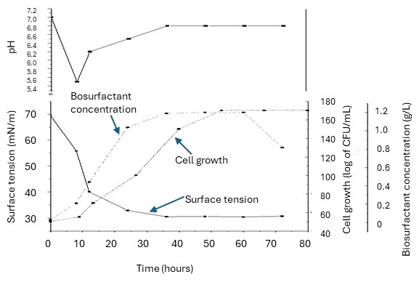*

*Figure 1:* Growth, pH, surface tension, biosurfactant concentration of Pantoea sp. cultivated in medium containing corn steep liquor, vegetable fat, and pineapple peel residue over 72 hours at 350 rpm and 30 ºC.

**3.2. Biosurfactant toxicity**

The biosurfactant from *Pantoea* sp*.* was tested for toxicity in a short-term bioassay using the microcrustacean *Artemia saline*, in which the biosurfactant did not cause lethality to the brine shrimp after 24 h, (Table 1). The acute toxicity tests of the surfactant JE1058BS produced by the bacterium *Gordonia sp*. against two species of marine larvae, *Mysidopsis bahia* (shrimp) and *Menidia beryllina* (fish), also showed low toxicity for this biosurfactant (Jian et al., 2011).

The germination index (IG), which combines relative seed germination and relative root elongation measures, was used to evaluate the toxicity of the biosurfactant on cabbage (*B. oleracea*). Considering that a GI value of 80% has been used as an indicator of the disappearance of phytotoxicity (Markandee et al., 2013), the results obtained indicated that the solutions tested did not show inhibitory effects on the seed germination and root elongation of cabbage (Table 1). In a similar study, ecotoxicological tests demonstrated the absence of toxicity of the detergent formulated with the biosurfactant from *Pseudomonas aeruginosa* ATCC 10145 (Soares da Silva et al., 2024).

Table 1: Toxicity of the isolated biosurfactant from Pantoea sp. on a microcrustacean bioindicator (Artemia salina) and on seeds of a cabbage (Brassica oleracea)

|  |  |  |  |  |  |
| --- | --- | --- | --- | --- | --- |
| Indicator | Solution of the isolated biosurfactant (mg/mL) | | | | |
| 0.100 | 1.0 | 10.0 | 30.0 | 50.0 |
| Lethality percentage of *A. salina* | 0 % | 0% | 0% | 0% | 0% |
| Germination Index (GI) of *B. oleracea* | 100% ± 0.3 | 99% ± 0.5 | 98% ± 0.5 | 90% ± 0.4 | 86% ± 0.6 |

**3.7. Stability of the biosurfactant**

The stability of the biosurfactant at various pH, temperatures, and NaCl concentrations was studied using measured changes in the surface tension. The biosurfactant showed sustained stability after 1 h of treatment at 5–121ºC (Figure 2A1, A2, A3 and A4). These results are in good agreement with the study from Portilla-Rivera et al. (2008), who reported that the biosurfactants produced by *L. pentosus* were stable after 24 h of exposure to 10, 25, and 40 ºC. Further, Ghojavand et al. (2012) investigated the stability of a biosurfactant from a *Bacillus subtilis* strain at 100 ºC at different exposure times. Similarly, within the salinity range of 2-15% (w/v) the biosurfactant demonstrated stability (Figure 2B). At the pH range of 6-8, the biosurfactant remained stable, showing no changes in surface tension (Figure 2C). In similar studies, other authors have shown that the surface activity of biosurfactants from *L. pentosus* is not negatively affected by pH values between 7.5 and 10.5, although their stability was reduced in acid pH values (Shavandi et al., 2012).

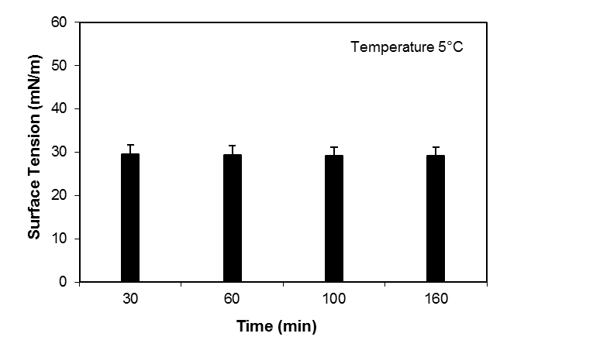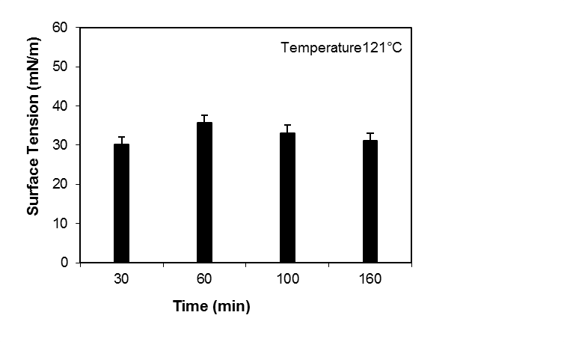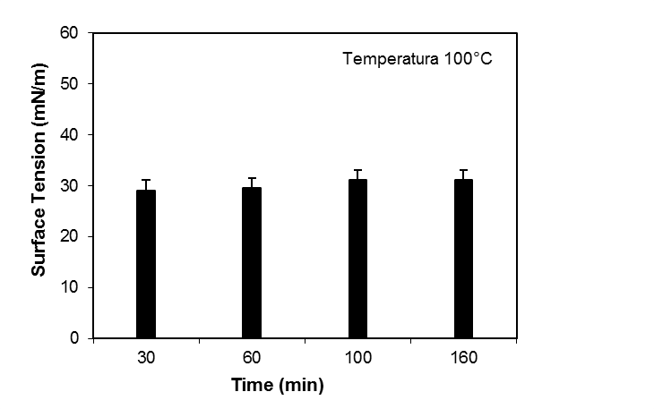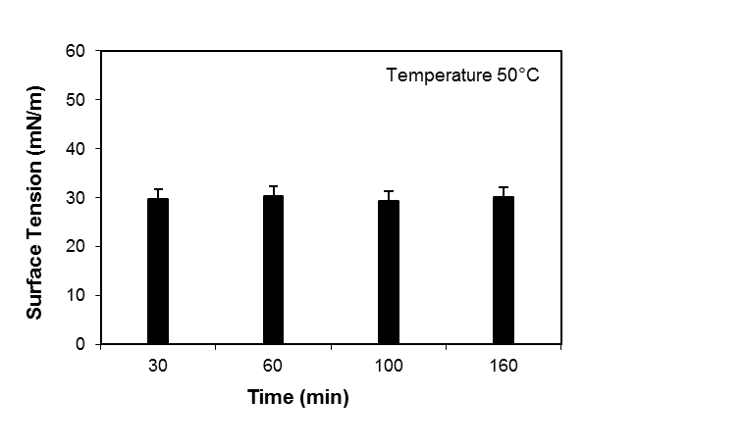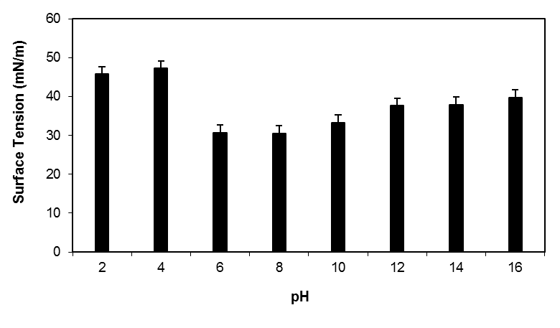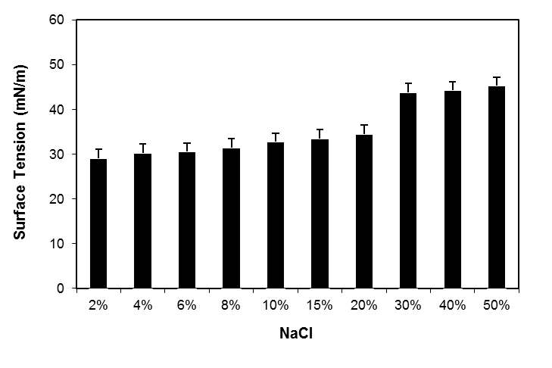

A2

C

B

A3

A 1

A4

*Figure 2:* Effect of temperature (A1-5ºC, A2-50ºC, A3-121ºC, A4-100ºC), NaCl concentration (B) and pH (C) on the surface tension of biosurfactant produced by Pantoea sp.

**3.3. Removal of hydrocarbons from contaminated sandy soil**

The application of biosurfactants in enhanced oil recovery is one of the most promising techniques to remove and recover a significant amount of residual oil. The results obtained demonstrated that the *Pantoea* sp. biosurfactant solution at its CMC was capable of removing 87% to 98% of the oils (motor oil, diesel oil, kerosene, and Petroleum) adsorbed in the sand (Table 2).

Table 2: Removal of petroleum, oil diesel, kerosene, and oil motor adsorbed in standard sand samples by the biosurfactant produced by Pantoea sp. and compared to distilled water (as the control).

|  |  |  |  |  |
| --- | --- | --- | --- | --- |
| Removal agent | Pollutant removal from sand (%) | | | |
| Diesel | Petroleum | Motor Oil | Kerosene |
| Solution of the isolated biosurfactant at the CMC | 95% ± 0.5 | 98% ± 0.9 | 87% ± 0.3 | 97% ± 0.8 |
| Control (distilled water) | 10% ± 0.5 | 1% ± 0.4 | 8% ± 0.6 | 11% ± 0.5 |

* 1. Conclusions

Petroleum hydrocarbon compounds bind to soil components and are difficult to remove and degrade. Biosurfactants can emulsify hydrocarbons, enhancing their water solubility, decreasing surface tension and increasing the displacement of oil substances from soil particles. The results obtained in this study demonstrated that the biosurfactant solution was capable of removing a large percentage of oil adsorbed in sand. The excellent surface tension reducing characteristics of the biosurfactant produced by *Pantoea* sp., grown in a low-cost medium, and its stability over a wide range of temperatures, pH, and salt concentrations suggest the possibility for the use of this new biosurfactant in commercial applications. These results indicate that the biosurfactant is suitable for use in the petroleum industry and in environmental applications, such as enhanced oil recovery, cleaning of oil reservoirs, reducing oil viscosity for crude oil transportation, and the decomposition of spilled oils in soil or marine environments.

Acknowledgments

This study was funded by the Brazilian fostering agency Conselho Nacional de Desenvolvimento Científico e Tecnológico (CNPq) and performed with support from the Advanced Institute of Technology and Innovation (IATI) and the Catholic University of Pernambuco (UNICAP).

References

Barata M.I.C., Souza C.M., Sales Da Silva I.G., Rufino R.D., Almeida F.C.G., Sarubbo L.A., 2025, Optimized production and properties of biosurfactant from *Bacillus invictae* UCP1617 and its performance in a detergent formulation for environmental applications, Journal of Surfactants and Detergents, 28, 155-169.

Bradford M.M., 1976, A rapid and sensitive method for the quantitation of microgram quantities of protein utilizing the principle of proteindye binding, Analytical Biochemistry, 72, 248–54.

Diez M.C., Llafquen C., Fincheira P., Lamilla C., Briceño G., Schalchli H., 2022, Biosurfactant production by *Bacillus amyloliquefaciens* C11 and *Streptomyces lavendulae* C27 isolated from a biopurification system for environmental applications, Microorganisms, 10, 1892.

Dubois M., Gilles K.A., Hamilton J.R., 1956, Colorimetric method for determination of sugar and related substances, Analytical Biochemistry, 28, 350–356.

Faccioli Y.E.d.S., de Oliveira K.W., Campos-Guerra J.M., Converti A., Soares da Silva R.d.C.F., Sarubbo L.A., 2024, Biosurfactants: Chemical properties, ecofriendly environmental applications, and uses in the industrial energy sector, Energies, 17, 5042.

Farias C.B.B., Almeida F.C.G., Silva I.A., Souza T.C., Meira H.M., Soares da Silva R.C.F., Sarubbo L.A., 2021, Production of green surfactants: market prospects, Electronic Journal of Biotechnology, 51, 28–39.

Ghojavand H., Vahabzadeh F., Shahraki K.A., 2012, Enhanced oil recovery from low permeability dolomite cores using biosurfactant produced by a *Bacillus mojavensis* (PTCC 1696) isolated from Masjed-I Soleyman Field, Journal of Petroleum Science and. Engineering, 81*,* 24–30.

Jian H.L., Liao X.X., Zhu L.W., Zhang W.M., Jiang J.X., 2011, Synergism and foaming properties in binary mixtures of a biosurfactant derived from *Camellia oleifera* Abel and synthetic surfactants, Journal of Colloid and Interface Science, 359, 487–492.

Manocha M.S., San-Blas G., Centeno S., 1980, Lipid composition of *Paracoccidioides brasilienses*: possible correlation with virulence of different strains, J General Microbiology, 177, 147–54.

Markandee A.R., Acharyab S.R., Nerurkara A.S., 2013, Physicochemical characterization of a thermostable glycoprotein bioemulsifier from Soli *Bacillus silvestris*, Process Biochemistry, 48, 1800–1808.

Portilla-Rivera O., Torrado A., Domínguez J.M., Moldes A.B., 2008, Stability and emulsifying capacity of biosurfactants obtained from lignocellulosic sources using *Lactobacillus pentosus*, Journal of Agricultural and Food Chemistry, 56, 8074–8080.

Sarubbo L.A., Silva M.G.C., Durval I.J.B., Bezerra K.G.O., Ribeiro B.G., Silva I.A., Twigg M.S., Banat I.M., 2022, Biosurfactants: production, properties, applications, trends, and general perspectives, Biochemistry and Engineering Journal, 181, 108377.

Selva Filho A.A.P., Converti A., Soares da Silva R.C.F., Sarubbo L.A., 2023, Biosurfactants as multifunctional remediation agents of environmental pollutants generated by the petroleum industry, Energies, 16, 1209.

Shavandi M., Mohebali G., Haddadi A., Shakarami H., Jain R.M., Mody K., Mishra A., Jha B., 2012, Isolation and structural characterization of biosurfactant produced by an alkaliphilic bacterium *Cronobacter sakazakii* isolated from oil contaminated wastewater, Carbohydrate Polymers, 87, 2320– 2326.

Silva S.N.R.L., Farias C.B.B., Rufino R.D., Luna J.M., Sarubbo L.A., 2010, Glycerol as substrate for the production of biosurfactant by *Pseudomonas aeruginosa* UCP0992, Colloids and Surfaces B: Biointerfaces, 79, 174–183.

Soares da Silva R.C.F., Farias C.B.B., Almeida F.C.G., Silva I.A., Sarubbo L.A., 2024, Comparative evaluation between a non-toxic biodetergent and a commercial degreaser for industrial use. Chemical Engineering Transactions, 110, 391-396.

Tiquia S.M., Tam N.F.T., Hodgkiss I.J., 1996, Effects of composting on phytotoxicity of spent pig-manure sawdust litter. Environmental Pollution, 93, 249–56.