|  |  |
| --- | --- |
| cetlogo ***CHEMICAL ENGINEERING TRANSACTIONS***  ***VOL. , 2025*** | A publication of  aidiclogo_grande |
| The Italian Association  of Chemical Engineering  Online at www.cetjournal.it |
| Guest Editors: Fabrizio Bezzo, Gabriele Pannocchia, Almerinda di Benedetto  Copyright © 2025, AIDIC Servizi S.r.l. **ISBN** 979-12-81206-17-5; **ISSN** 2283-9216 | |

Modeling of an Industrial-Scale Adsorption Column Packed with *Theobroma Cacao L.* for the Removal of Ni (II)

Candelaria N. Tejada-Tovara,\*, Angel Villabona-Ortíza, Angel D. González-Delgadob

aChemical Engineering Department, Process Design, and Biomass Utilization Research Group (IDAB), Universidad de Cartagena, Avenida del Consulado St. 30, Cartagena de Indias 130015, Colombia

bChemical Engineering Department, Nanomaterials and Computer-Aided Process Engineering Research Group (NIPAC), Universidad de Cartagena, Avenida del Consulado St. 30, Cartagena de Indias 130015, Colombia

ctejadat@unicartagena.edu.co

Nickel is a heavy metal used in different industries, such as electroplating, catalysis, electronics, pigments, and bacteria. It generates different harmful effects in the human body, such as in the cardiovascular or digestive system, when there is exposure in large amounts. The aim of this study is to use Computer Aided Process Engineering (CAPE) to model an industrial-scale operative column for Ni (II) adsorption in an aqueous solution, taking advantage of the biomass of *Theobroma cacao L*. For this reason, Aspen Adsorption software was used to carry out multiple simulations of an adsorption column using various industrial configurations to perform a parametric sensitivity analysis. The results show that the Langmuir II – Lumped Linear Resistance (LDF) model to simulate the adsorption column for Ni (II) removal yields efficiencies of up to 96.4%. The best conditions for simulation in the adsorption column were an input flow of 300 m3/day, a bed height of 5 m, and an initial concentration of 2000 mg/L. The present study is shown as a novel way of engineering prediction of the potential performance of adsorption columns packed with organic waste-based biomasses using computer-aided engineering.

* 1. Introduction

Due to the high demand for the implementation of water resources by industries and agricultural activities, among others, different sources of wastewater loaded with different pollutants have been generated (Yuan et al., 2024), which have been related to the generation of various diseases that are transmitted by water, negatively affecting the physical and mental health, being the most affected the older people because they are more susceptible to contracting any disease (Bochynska *et al.*, 2024). Among the pollutants in wastewater, we find heavy metals characterized by their high resistance to degradation and high toxicity levels. These pollutants generally accumulate rapidly in soil, water, and sediments due to different processes (adsorption, precipitation, or flocculation) (Zou *et al.*, 2024). Heavy metals are transmitted to water bodies through various natural processes and anthropogenic activities (Ahirvar *et al.*, 2023). Nickel is a heavy metal found in different parts of nature (soil, water, and air), is one of the most abundant elements, and is released into the atmosphere through various natural phenomena (Huang, He and Wu, 2022). Due to the growing importance and demand for Ni, it has been used in different commercial and industrial applications such as electroplating, catalysis, electronics, pigments, and batteries, among others (Begum *et al.*, 2022). Exposure to Ni (II) generates different harmful effects on health, affecting some cardiovascular and respiratory systems. According to the World Health Organization, the maximum permitted amount of Ni (II) in drinking water is 0.02 mg/L (Organization, 2023).

Adsorption is a technique for removing contaminants from water bodies that generates a layer of adsorbate on the surface of the adsorbent. It can be of two types: physisorption where adsorption occurs due to nonspecific van der Waals force and chemisorption which assumes that adsorption occurs by attractive forces formed by ionic or covalent bonds through chemical reactions (Raji *et al.*, 2023). Adsorption studies of heavy metals have mostly been conducted at the laboratory level, so ways to anticipate large-scale performance have been sought to evaluate how change affects the efficiency of the adsorbent material. Therefore, this study aimed to model an industrially operational packed column for the adsorption of Ni (II) on *Theobroma cacao L* as adsorbent using computational tools in combination with experimental data previously obtained by the authors and parametric studies. This study is presented as a technique for predicting the performance and behavior of a packed adsorption column on an industrial scale.

* 1. Methodology
     1. Assumptions and mathematical fundamentals

For the simulations of the packed adsorption column using Aspen adsorption, it was considered that the fluid passing through the column has no pressure drop or axial dispersion; the surface velocity and mass transfer coefficient are constant; the energy balance is isothermal; the physical properties to develop the adsorption process in Aspen Adsorption were determined using the non-random two-liquid solution model, with a correction for use in electrolytes (ELECNRTL); the adsorption isotherm was described by the Langmuir II model, which is described by Equations 1 and 2 (Shen *et al.*, 2018):

|  |  |
| --- | --- |
| $q^{*}=\frac{q_{m,i}b_{i}P_{i}}{1+b_{i}P_{i}}$ | (1) |
| $b_{i}=b_{0,i}\exp\left(-\frac{∆H}{R_{g}T_{S}}\right)$ | (2) |

The adsorption kinetics was described using the Lumped Linear Resistance (LDF) kinetic model, which is described by equation 3 (Ahmed *et al.*, 2020):

|  |  |
| --- | --- |
|  | (3) |

* + 1. Parametric study of the column

To evaluate the effect of inlet flow rate, initial concentration and bed height on adsorption performance, a parametric study was performed by varying these parameters and applying a breakthrough curve profile analysis. Table 1 shows the values of each parameter to be analyzed.

Table 1. Values of study parameters

|  |  |  |  |
| --- | --- | --- | --- |
| Parameters | Range of values | | |
| Bed height, m | 4 | 5 | 6 |
| Initial concentration, mg/L | 1000 | 2000 | 3000 |
| Flow rate, m3/day | 100 | 200 | 300 |

* + 1. Parameters required for column modeling

To perform the modeling of the packed adsorption column in the Aspen Adsorption software different parametric specifications are required, therefore, several studies of industrial scale heavy metal adsorption columns were taken into account as a reference for the scaling of the packed column for Ni (II) ion adsorption. The parameters of the industrial-scale packed column for this study are presented in Table 2.

Table 2. Adsorption column parameters for simulation

|  |  |
| --- | --- |
| Parameters | Values |
| Bed diameter, m | 1 |
| Bed porosity, m3 of vacuum / m3 of bed | 0.67 |
| Total vacuum, porosity m3 of vacuum / m3 of bed | 0.4 |
| Constant mass transfer coefficient, 1/s | 1.37x10-4 |
| Bulk density, g/cm3 | 0.0365 |

* 1. Results and discussions
     1. Data obtained from the simulation of a packed column for Ni (II) adsorption

Using Aspen Adsorption, different simulations of the adsorption column for Ni (II) removal were carried out, performing a parametric variation study of the inlet flow rate, bed height and initial contaminant concentration. Subsequent to the development of the multiple simulations, values of the time to rupture (T.R) and time to saturation (T.S) were obtained. The results are shown in Figure 1, where Figure 1.a represents the T.R and T.S values obtained for a concentration of 3000 mg/L, while Figure 1.b presents the T.R and T.S values obtained for a concentration of 2000 mg/L and finally, Figure 1.c shows the T.R and T.S values obtained for a concentration of 1000 mg/L. It should be noted that the figures show bars of different colors which represent a type of net flow configuration with bed height at that initial concentration.

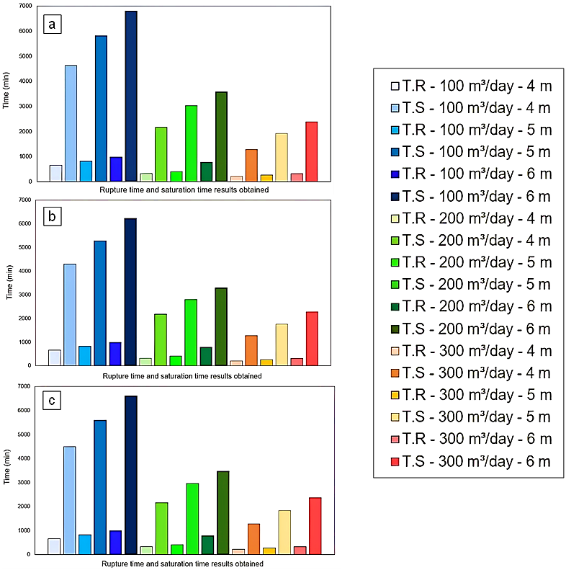

Figure 1. Results of rupture time (R.T) and saturation time (S.T) obtained from simulations for initial Cr (VI) concentrations of (a) 3000 mg/L, (b) 2000 mg/L and (c) 1000 mg/L, with a confidence interval of ± 72.66 for R.T values and ± 436.16 for S.T values.

* + 1. Parametric evaluation

Parametric evaluation for initial concentration

The impact generated by the variation of the initial concentration in the Ni (II) adsorption process in solution on a column was evaluated. The initial concentrations used were 1000 mg/L, 2000 mg/L and 3000 mg/L. Figure 2 shows that, by increasing the Ni (II) concentration, the saturation time increases, but the rupture time remains the same. This change is due to a greater presence of pollutants, which accelerates the adsorption equilibrium and decreases the number of active sites available over time, slowing down the adsorption process in its final stages. On the other hand, the process efficiency obtained for 1000 mg/L, 2000 mg/L and 3000 mg/L was 95.5% for all concentrations, showing that this parameter does not significantly affect the adsorption process. (Guan *et al.*, 2022).

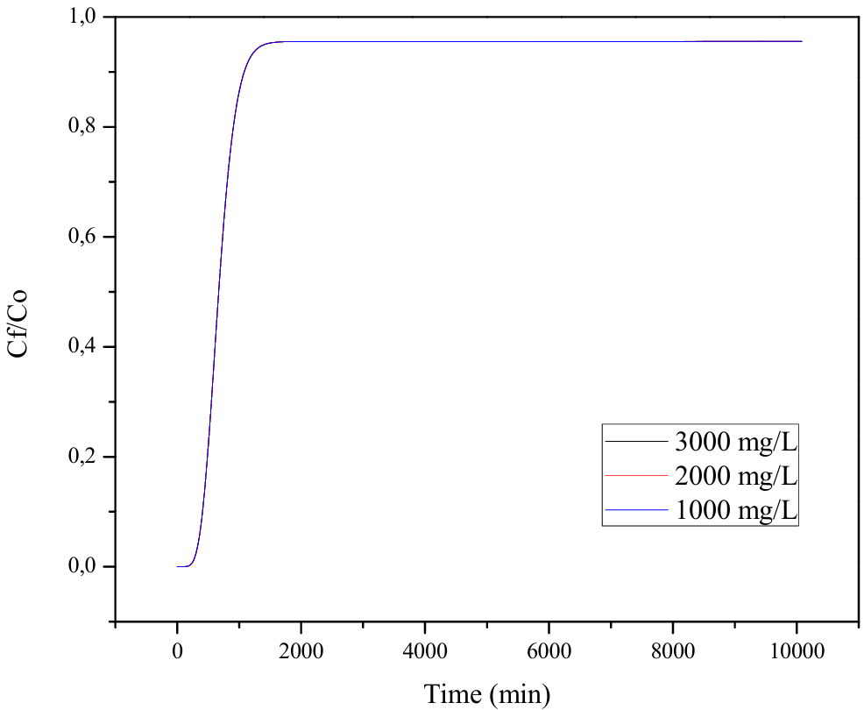

Figure 2. Rupture curves at different initial concentrations for Langmuir II - LDF.

Parametric evaluation for the inlet flow rate

It evaluated the impact generated by the variation of the inlet flow rate on the Ni (II) adsorption process in solution in an adsorption column. The inlet flow rates used were 100 m3/day, 200 m3/day and 300 m3/day. Figure 3 shows that when working with high flow rates, low rupture times and low saturation times were observed, while high rupture times and high saturation times were observed when using lower flow rates. The above is due to the increase in pollutants entering the column produced by the increase in flow rate, which increases the mass transfer of the system, resulting in a faster equilibrium at higher flow rates. The above is reflected in a decrease in the residence time in the biomass and, therefore, a reduction in the useful lifetime of the biomass, thus presenting lower values concerning the rupture and saturation times at higher flow rates. Similarly, the graph shows that a higher flow rate presents higher efficiencies, in this case: 95,5% for 300 m3/day, 93,4% for 200 m3/day and 87.3% for 100 m3/day (Zhang *et al.*, 2019).

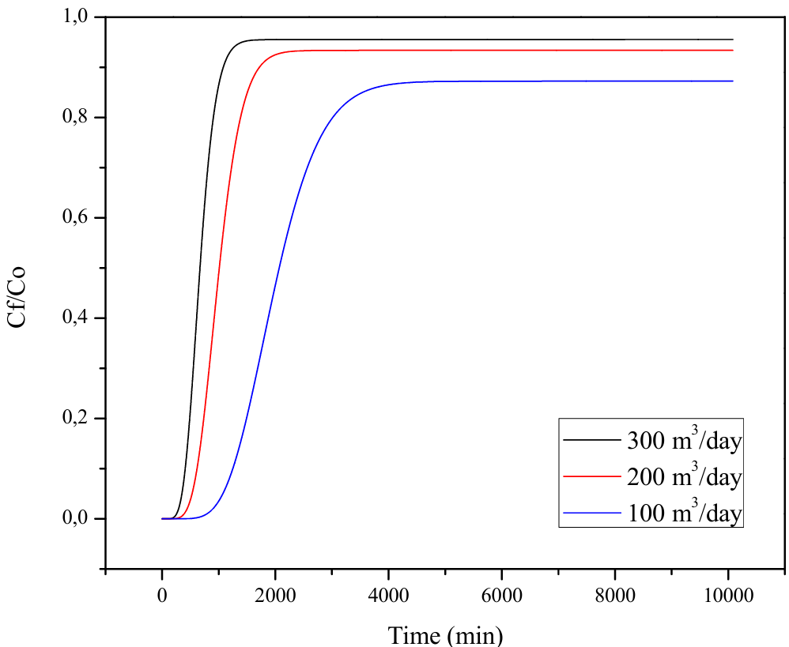

Figure 3. Rupture curves at different intel flow rates for Langmuir II - LDF.

Parametric evaluation for bed height.

The impact of bed height variation on the adsorption process of Ni (II) in solution on an adsorption column was evaluated. The bed heights used in this study were 4, 5 and 6 meters. It is observed in Figure 4 that when high heights are used, higher rupture times and saturation times are presented, while when working with low heights, rupture times and saturation times decrease. The above is because with an increase in bed height, there is an increase in the number of active sites available to adsorb the pollutant. Therefore, an increase in height allows a greater adsorption capacity of Ni (II) in the biomass-based on *Theobroma cacao L.* However, it is important to note that the efficiency tends to be lower at higher heights. Also, as shown in Figure 3, the efficiency is higher at lower heights, being 96.4% for 4 meters, 95.5% for 5 meters and 94.7% for 6 meters (Yildiz, 2017).

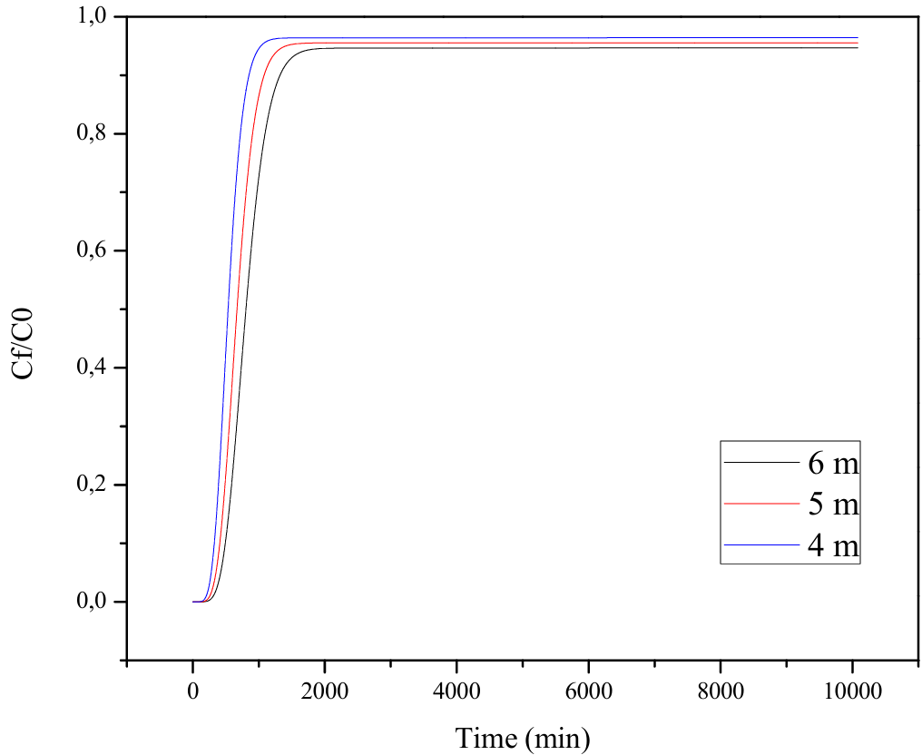

Figure 4. Rupture curves at different bed heights for Langmuir II - LDF.

These results allow observing how the variation of the parameters of the inlet flow rate, bed height and initial concentration of Ni (II) affects the adsorption process developed in an adsorption column packed with *Theobroma cacao L.,* being the parameter of the inlet flow rate the one that most affects the process, followed by the height of the column and finally the initial concentration.

* 1. Conclusions

Evaluating the effect caused by altering the inlet flow rate, bed height and initial concentration on Ni (II) adsorption using a parametric evaluation, it was found that, varying the inlet flow rate by 300, 200 and 100 m3/day, there was a reduction of R.T. and S.T. and an increase in the efficiency obtained by increasing the inlet flow rate. On the other hand, changing the bed height in magnitudes of 4, 5 and 6 meters, a prolongation of R.T. and S.T. was observed, but a decrease in efficiency with increasing height. Finally, altering the initial concentration in ranges of 3000, 2000 and 1000 mg/L did not significantly affect the efficiency of the process. This study presents a significant contribution in practical applications because it allows anticipating different conditions such as the useful life of the adsorbent biomaterial, reporting values such as the breakthrough time, which indicates the moment when the adsorbent begins to saturate, and the saturation time, which is when the adsorbent is completely saturated. In addition, they predict the possible behavior and allow determining the optimal packed bed conditions. Therefore, these results show a way to predict the possible performance of a packed column with *Theobroma Cacao* *L* residues to adsorb Ni (II) on an industrial scale.

Nomenclature

$b_{i}$ and $b_{0,i}$- Langmuir affinity constants (L/mg).

Cf/C0 - Efficiency.

- Isothermal heat of solution adsorption.

LDF - Kinetic model of Lumped Linear Resistance.

MTC - Global mass transfer coefficient (m/s).

- Gas constant.

- Adsorption capacity (mg/g).

- Maximum adsorption capacity (mg/g).

$T_{S}$: Solution temperature.

T.R. - Rupture Time (min).

S.T. - Saturation Time (min).

- Instantaneous equilibrium adsorbate loading on the adsorbent (mg/g).

Acknowledgments

The authors thank the Universidad de Cartagena for facilitating the development of this work

Reference

Ahirvar, B. P., Das, P., Srivastava, V., and Kumar, M. (2023) ‘Perspectives of heavy metal pollution indices for soil, sediment, and water pollution evaluation: An insight’, Total Environment Research Themes, 6(December 2022), p. 100039. Available at: https://doi.org/10.1016/j.totert.2023.100039.

Ahmed, S., Unar, I. N., Khan, H. A., Maitlo, G., Mahar, R. B., Jatoi, A. S., Memon, A. Q. and Shah, A. K. (2020) ‘Experimental study and dynamic simulation of melanoidin adsorption from distillery effluent’, Environmental Science and Pollution Research, 27(9), pp. 9619–9636. Available at: https://doi.org/10.1007/s11356-019-07441-8.

Begum, W., Rai, S., Banerjee, S., Bhattacharjee, S., Mondal, M. H., Bhattarai, A., and Saha, B. (2022) ‘A comprehensive review on the sources, essentiality and toxicological profile of nickel’, RSC Advances, 12(15), pp. 9139–9153. Available at: https://doi.org/10.1039/d2ra00378c.

Bochynska, S., Duszewska, A., Maciejewska-Jeske, M., Wrona, M., Szeliga, A., Budzik, M., Szczesnowicz, A., Bala, G., Trzcinski, M., Meczekalski, B. and Smolarczyk, R. (2024) ‘The impact of water pollution on the health of older people’, Maturitas, 185(March), p. 107981. Available at: https://doi.org/10.1016/j.maturitas.2024.107981.

Guan, Z., Guo, Y., Huang, Z., Liao, X., Chen, S., Ou, X., Sun, S., Liang, J., Cai, Y., Xie, W. and Xian, J. (2022) ‘Simultaneous and efficient removal of organic Ni and Cu complexes from electroless plating effluent using integrated catalytic ozonation and chelating precipitation process in a continuous pilot-scale system’, Chemical Engineering Journal, 428, p. 131250. Available at: https://doi.org/10.1016/J.CEJ.2021.131250.

Huang, L., He, F. and Wu, B. (2022) ‘Mechanism of effects of nickel or nickel compounds on intestinal mucosal barrier’, Chemosphere, 305(April), p. 135429. Available at: https://doi.org/10.1016/j.chemosphere.2022.135429.

Organization, W.H. (2023) Human health effects of benzene, arsenic, cadmium, nickel, lead and mercury.

Raji, Z., Karim, A., Karam, A., and Khalloufi, S. (2023) ‘Adsorption of Heavy Metals: Mechanisms, Kinetics, and Applications of Various Adsorbents in Wastewater Remediation—A Review’, Waste, 1(3), pp. 775–805. Available at: https://doi.org/10.3390/waste1030046.

Shen, Y., Shi, W., Zhang, D., Na, P., and Fu, B. (2018) ‘The removal and capture of CO2 from biogas by vacuum pressure swing process using silica gel’, Journal of CO2 Utilization, 27, pp. 259–271. Available at: https://doi.org/10.1016/j.jcou.2018.08.001.

Yildiz, S. (2017) ‘Artificial neural network (ANN) approach for modeling Zn(II) adsorption in batch process’, Korean Journal of Chemical Engineering, 34(9), pp. 2423–2434. Available at: https://doi.org/10.1007/s11814-017-0157-3.

Zhang, N., Xiao, J., Bénard, P., and Chahine, R. (2019) ‘Single- and double-bed pressure swing adsorption processes for H2/CO syngas separation’, International Journal of Hydrogen Energy, 44(48), pp. 26405–26418. Available at: https://doi.org/10.1016/j.ijhydene.2019.08.095.

Zou, Y., Lou, S., Zhang, Z., Liu, S., Zhou, X., Zhou, F., Radnaeva, L. D. Nikitina, E. and Fedorova, I. V. (2024) ‘Predictions of heavy metal concentrations by physiochemical water quality parameters in coastal areas of Yangtze River estuary’, Marine Pollution Bulletin, 199(November 2023), p. 115951. Available at: https://doi.org/10.1016/j.marpolbul.2023.115951.