|  |  |
| --- | --- |
| cetlogo ***CHEMICAL ENGINEERING TRANSACTIONS***  ***VOL. xxx, 2025*** | A publication of  aidiclogo_grande |
| The Italian Association  of Chemical Engineering  Online at www.cetjournal.it |
| Guest Editors: Fabrizio Bezzo, Flavio Manenti, Gabriele Pannocchia, Almerinda di Benedetto  Copyright © 2025, AIDIC Servizi S.r.l. **ISBN** 979-12-81206-17-5; **ISSN** 2283-9216 | |

Geopolymer-based adsorbents for pollutant removal: a tunable platform ranging from CO2 capture to Nitrogen/Phosphorus removal and recovery from wastewater

Walter Felix Cossio Guzmana,\*, Cristina Di Pietrob, Matteo Minellia, Valentina Medrib, Dario Frascaria, Davide Pinellia, Elettra Papab, Elena Landib, Francesco Micciob

aDepartment of Civil, Chemical, Environmental and Materials Engineering (DICAM) – Alma Mater Studiorum, University of Bologna, Via Terracini 28, 40131 Bologna – Italy

bNational Research Council - Institute of Science, Technology and Sustainability for Ceramics (CNR-ISSMC), Via Granarolo, 64, 48018 Faenza (RA) – Italy

walter.cossioguzman2@unibo.it

This study investigates the development and performance of geopolymer-based materials developed as solid sorbents for tunable applications, ranging from CO₂ capture to nitrogen and phosphorus removal and recovery from wastewater. Innovative material fabrication routes are used including Cold Sintering Process (CSP). The novel geopolymer-zeolite composites exhibited CO₂ adsorption capacities of up to 3 mmol/g at 1 bar, with CO₂/N₂ selectivity ranging from 50 to 300 at 0.1 bar, highlighting their potential for the separation of gas mixtures. For water treatment, composites showed maximum adsorption capacities of 32 mgN/g and 29 mgP/g for nitrogen and phosphorus pollutants, respectively. The findings demonstrate the tunability of these materials for different environmental applications, offering sustainable and efficient alternatives to conventional separation processes.

* 1. Introduction

Addressing increasing CO₂ and nutrient pollution demands scalable and sustainable solutions: adsorption technologies are versatile approaches that can be adapted to contaminants across phases (Maggetti et al., 2024). Adsorption is a versatile and effective approach for removing contaminants across different phases, offering adaptability to diverse applications. Geopolymers represent a flexible platform for the development of materials that can be used for the adsorption/removal of a wide range of pollutants of different nature, geopolymers have also been identified as effective ion exchangers, demonstrating remarkable potential in removing metal ions from aqueous solutions (El-Eswed, 2019). Geopolymer-based materials, with their tunable properties and eco-friendly synthesis, are thus promising candidates.

For CO₂ capture, post-combustion strategies focus on reducing emissions from stationary sources, geopolymers, with their customizable textural and chemical properties, emerge as a sustainable and robust alternative. Moreover, the cold sintering process (CSP) enables the low-energy production of geopolymer-based composite monoliths, enhancing the suitability and eco-friendliness of these materials for CO₂ capture. CSP further ensures scalability and sustainability in material fabrication (Hossain and Akhtar, 2023).

Geopolymer composites incorporating hydrotalcites effectively adsorb N and P pollutants, offering a sustainable alternative to conventional biological methods. The ability to adapt material properties, such as porosity and ion-exchange capacity, allows these sorbents to operate effectively under varying wastewater conditions, including real effluents from treatment plants and high-strength sludge streams.

This work investigates the dual application of geopolymer-based materials for both gas and water treatment, with a focus on optimizing performance through material design and the CSP method. For gas treatment, the study explores the synergistic interactions between geopolymer matrices and zeolite phases, highlighting their adsorption capacity and selectivity. For water treatment, the investigation centers on ammonium and phosphate adsorption, examining the role of effluent composition, material pre-treatments, and adsorption mechanisms. The findings provide critical insights into the potential of these materials for scalable, sustainable applications in industrial and environmental settings.

* 1. Materials and methods
     1. CSP-based adsorbents

Geopolymer matrices (K-G2 and Na-G1.2) were synthesized using metakaolin (Imerys, France) and potassium or sodium alkaline activating solutions. Na-G1.2 contains 81 vol.% NaA zeolite formed in situ, while commercial Na13X zeolite (Sigma-Aldrich) is added to the composite. Using CSP, these powders were compacted under 56 MPa at 40 °C and activated with 4 M alkali hydroxide solutions. After conditioning in distilled water and acetone, monoliths were ready for characterization. Sample codes denote their composition and are reported in Table 1 based on composition.

* + 1. Hydrotalcite-based adsorbents

Geopolymer-hydrocalcite composites for N and P removal were synthesized by blending geopolymer slurries with commercial hydrotalcite (HyT) powders featuring varying Mg:Al molar ratios. The geopolymer slurry was prepared by combining metakaolin with a potassium di-silicate solution (H₂O:K₂O = 13.5, SiO₂:K₂O = 2.0) under controlled mixing using a planetary centrifugal mixer. Commercial HyT powders, including Pural70, Pural61 (Sasol, Germany), and Sorbacid911 (Clariant, Germany), were added at a specific wt.% with optimized water content to ensure castable slurry consistency.

After thorough mixing and de-foaming, the slurries were cast into molds, cured at 80 °C for 24 hours, and calcined at 500 °C to transform the hydrotalcite phase into Mg:Al mixed solid oxides, optimizing adsorption efficiency. Reference pure KG2 and hydrocalcite samples were prepared for comparison. The final composites demonstrated enhanced structural and functional characteristics, enabling efficient adsorption of nitrogen and phosphorus from wastewater, as showed previously (Maggetti et al., 2024). The primary compositions of these adsorbents are summarized in Table 1.

* + 1. Characterization Techniques

Porosimetric characterization of the materials was conducted using Mercury Intrusion Porosimetry (MIP) (Thermo Finningan Pascal 140 and 240, Thermo Fisher Scientific, Waltham, MA, USA), covering a pore size range of 0.0058–100 μm. Specific surface areas were analyzed using BET measurements (Quantachrome Nova 2200e). Monoliths underwent pre-treatment at 200 °C under vacuum, as well as powdered samples for pristine zeolites tested for comparison.

The microstructure was examined using a ΣIGMA Field Emission Scanning Electron Microscope (FE-SEM, Zeiss, Germany) on gold-coated specimens (Quorum Q150T ES turbo-pumped sputter coater). X-Ray Diffraction (XRD) was carried out using a Bruker D8 Advance Powder Diffractometer with CuKα radiation (Karlsruhe, Germany). Compressive strength testing involved at least three specimens, performed on a Zwick Z050 Universal Testing Machine (GmbH, Ulm, Germany) at a cross-head speed of 1 mm/min.

* + 1. Adsorption Capacity Testing

2.4.1 Gas Phase isotherms

Adsorption isotherms for CO₂ and N₂ were obtained using a custom pressure-decay apparatus as illustrated previously (Minelli et al., 2018). The amount of gas adsorbed was evaluated by monitoring the pressure drop in a calibrated sample chamber containing the solid sorbent. All samples were tested as monoliths, except for pristine Na13X, which was also analyzed in powdered form for comparison. Samples were conditioned under vacuum at 200 °C for 16 hours to remove atmospheric gases and moisture. Adsorption experiments were conducted at 35 °C by introducing a known gas volume into the chamber and monitoring pressure until equilibrium was reached. Adsorption capacities were determined using the ideal gas law, with incremental pressure steps up to 1 bar enabling detailed isotherm construction.

2.4.2 Aqueous Phase isotherms

To identify optimal sorbents for nitrogen (N) and phosphorus (P) adsorption, multi-point screening tests were conducted in 100 mL bottles at various initial N and P concentrations. Tests were performed using floating sludge effluent and municipal wastewater treatment plant (WWTP) effluent. The adsorption tests were conducted using two distinct water matrices: floating sludge effluent, characterized by high pollutant concentrations (PO₄³⁻: 176 mgP/L, NH₄⁺: 564 mgN/L, TSS: 300 mg/L), and municipal wastewater treatment plant (WWTP) effluent with significantly lower pollutant levels (PO₄³⁻: 2 mgP/L, NH₄⁺: 4 mgN/L, TSS: 5 mg/L). Bottles were agitated at 200 rpm and 20–22 °C for 24 hours to achieve equilibrium. For high concentrations values, initial concentrations were adjusted using NH₄Cl (≥99%, Sigma-Aldrich) and K2HPO4/KH2PO4 (≥99%, Sigma-Aldrich) solutions. All sorbents were sieved to a particle size of <0.355 mm. Anion and cation analyses were conducted using an ion chromatograph (Thermo Fisher Scientific, Waltham, Massachusetts, USA).

* 1. Results and discussion
     1. Microstructural and porosimetric characterization

Cold Sintering Process (CSP) significantly impacted the microstructural and porosimetric properties of the tested materials, as shown in Table 1. Relative densities of the geopolymer-based samples approached 60%, surpassing those of their pristine matrices. This densification, particularly evident in zeolite-geopolymer composites like G2-X-90%-CSP (58%), correlated with a reduction in porosity observed via Mercury Intrusion Porosimetry (MIP). The measured porosities suggest that the MIP effectively captured most pores within the 0.0058–100 μm range.

Zeolite-containing samples exhibited bimodal pore distributions, with a peak at 0.005–0.1 μm , attributed to K-G2. These features improved the composites' porosity and pore volume, with G2-X-90%-CSP achieving the highest total pore volume.

In composites like G2-X-90%-CSP, Na13X grains were visibly integrated within the geopolymer matrix, maintaining structural integrity. XRD analysis confirmed a decrease in peak intensities associated with zeolite phases, likely due to structural rearrangements during CSP, further validating its impact on microstructural characteristics. These results underscore CSP's ability to enhance material properties, making geopolymer-zeolite composites effective candidates for CO₂ capture.

Concerning hydrotalcite-containing composites, hydrotalcites have different morphologies depending on the industrial production process: Pural61 is spherical with few small holes and Pural70 is shell like, while Sorbacid911 is nanometric. The relative density depends both on the type and amount of hydrotalcites, being G2-HyT70-35% the most porous as it contains the highest quantity of a porous filler with an irregular shape.

Table 1. Relative density, total porosity measured, total pore volume and average pore size of the tested samples.

|  |  |  |  |  |  |  |
| --- | --- | --- | --- | --- | --- | --- |
| Sample | Composition  (%) | Bulk density  (g cm-3) | Relative density  (%) | MIP | | Mechanical strength  (MPa) |
| Total porosity  (%) | Average pore size  (μm) |
| K-G2 pristine | K-G2 100% | 1.27 | 52 | 43 | 0.015 | 27 ± 3 |
| Na-G1.2 pristine | Na-G1,2 100% | 1.15 | 42 | 57 | 0.426 | 3 ± 1 |
| G2-CSP | K-G2 100% | 1.18 | 53 | 41 | 0.0343 | 8 ± 1 |
| G2-X-70%-CSP | K-G2 30%, Na13X 70% | 1.20 | 59 | 40 | 0.1145 | 4.6 ± 0.6 |
| G2-X-90%-CSP | K-G2 10%, Na13X 90% | 1.12 | 58 | 43 | 0.2490 | 4 ± 2 |
| X100%-CSP | Na13X 100% | 1.11 | 58 | 38 | 0.4725 | - |
| Na13X pristine | Na13X 100% | - | - | - | - | - |
| G2-HyT911-10% | K-G2 90%, Sorbacid911 10% | 1.18 | 53 | - | - | 7 ±1 |
| G2-HyT70-35% | K-G2 65%, Pural70 35% | 1.17 | 48 | - | - | 23±3 |
| G2-HyT61-10% | K-G2 90%, Pural61 10% | 1.24 | 55 | - | - | 22 ±1 |
| G1.2-HyT61-13% | Na-G1,2 87%, Pural61 13% | 1.24 | - | - | - | 21±1 |

* + 1. Mechanical characterization

The mechanical stability of geopolymer-based sorbents is critical for their application in industrial CO₂ capture systems. High compressive strength ensures durability during handling, packing, and extended operation. Table 1 reports compressive strength values, which align with medium-strength materials for industrial use, offering advantages over other geopolymer systems.

In Na13X-based composites, compressive strengths around 4 MPa were observed, sufficient for self-supporting monoliths, despite rising inhomogeneity in G2-X-90%-CSP due to packing flaws. These results underscore CSP's ability to balance strength and porosity for targeted adsorption applications.

In hydrotalcites-containing composites, mechanical strength depends both on HyT morphologies and final sample porosity, being close to the pristine geopolymer matrix. However, the low value obtained in G2-HyT911-10% (3 times less than in the other composites) is due to non-homogeneous distribution of the very fine hydrotalcite in this formulation, creating defects and increasing the data dispersion (relative error close to 14 %).

* 1. Gas Phase Capture

3.3.1 CO2 adsorption tests

CO₂ and N2 adsorption capacities of geopolymer-zeolite composites were evaluated at 35 °C using the pressure decay technique across a 0–1 bar range. To ensure reliability, isotherms were derived from at least two repeated tests, with experimental errors consistently below 10%. The Dual Site Langmuir (DSL) model was applied to analyze adsorption isotherms for CO2 and a simple linear regression for N2, effectively fitting and interpolating the data across the examined pressure range.

Figure 1 demonstrates superior performance of K-based geopolymer composites with zeolite Na13X over pure geopolymers, aligns with the findings of Boscherini et al. (2021), who also explored the thermal effects and adsorption behavior of geopolymer-zeolite composites. Pure Na13X exhibited the highest CO₂ capacity and saturation pressures among tested materials. However, the introduction of zeolite into the geopolymer matrix created composite materials with intermediate behavior, enhancing adsorption capacity due to the synergistic interaction between the two phases.

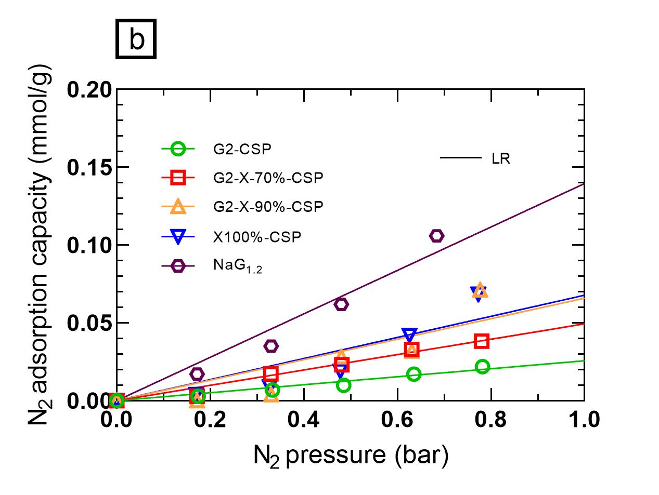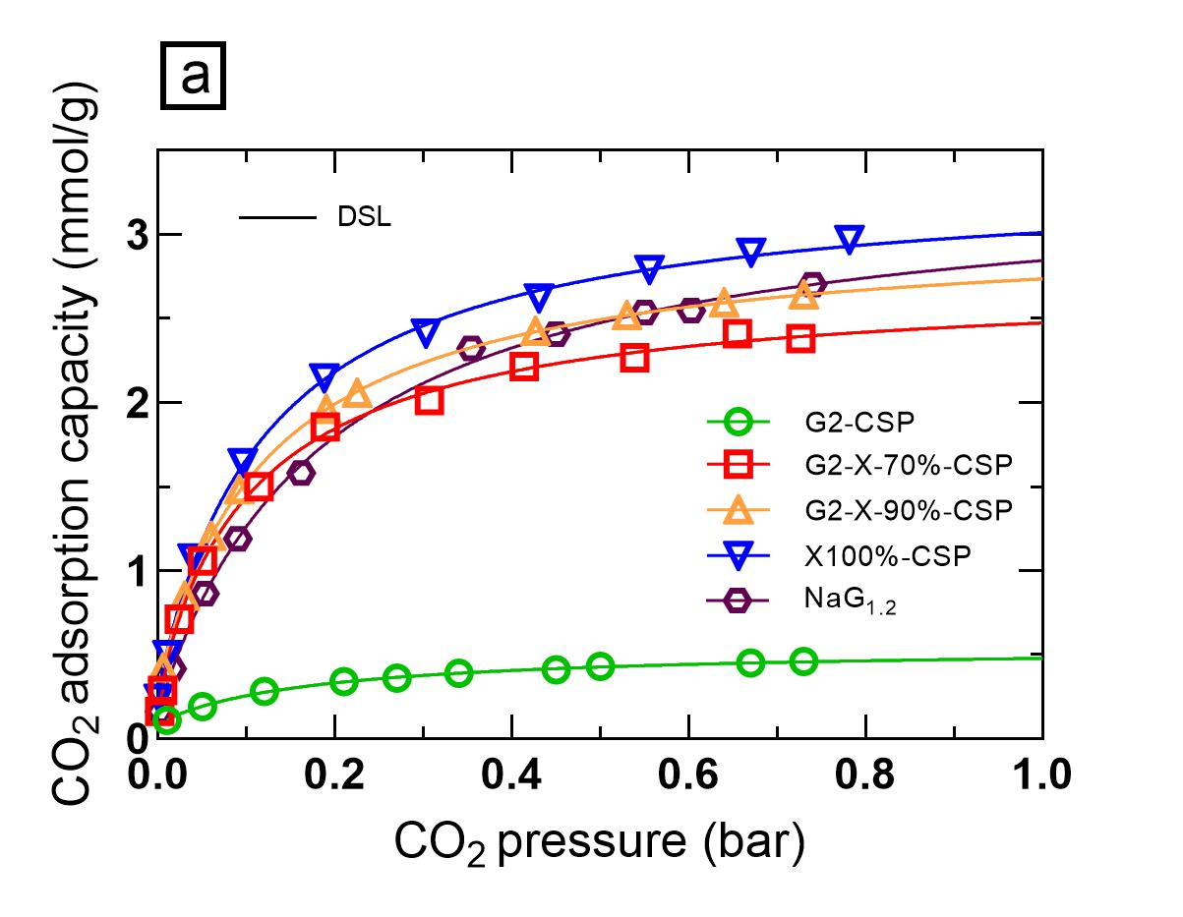

Figure 1: Tests conducted for composites and pure materials: (a) CO2 isotherms, (b) N2 isotherms. Experimental data and best-fitting model simulations.

3.3.2 Analysis of the gas separation performances

The CO₂/N₂ capacity selectivity (qCO2/qCH4) of the newly developed geopolymer-zeolite composites was evaluated to assess their potential as selective solid sorbents, based on data reported in Figure 1. The selectivity parameter was calculated from pure gas adsorption experiments, assuming a reference CO₂/N₂ ratio of 80/20 and without accounting for competitive effects. The dual-site Langmuir (DSL) adsorption equilibrium model was employed to interpolate the experimental curves, providing accurate descriptions of the adsorption behavior.

The CSP composites performance, summarized in Table 2 with reference data for K-G2, reveals that CSP-treated Na13X (X100%-CSP) had enhanced selectivity compared to its pristine (powder) form. This improvement likely results from CSP-induced densification, which reduced access to less selective pores. On the other hand, the K-based geopolymer (K-G2) showed minimal capacity reduction under the same conditions.

Interestingly, at lower CO₂ partial pressures, composites outperformed their individual components. This improvement can be attributed to enhanced interfacial bonding between the geopolymer and zeolite phases, which improves gas diffusion and increases accessible adsorption sites. The materials combined the zeolitic microporosity ideal for CO₂ capture with the mesoporosity of the geopolymer matrix, resulting in superior adsorption properties.

* 1. Water Phase: Nitrogen and Phosphorus removal

3.4.1 Wastewater and Synthetic Solutions

Adsorption studies were performed using two types of water matrices:

* + - 1. Secondary effluent from Bologna’s municipal wastewater treatment plant (WWTP), post-disinfection.
      2. Effluent rich in ammonium and phosphate from a sludge line process (FS).

The two wastewater effluents used in the experiments exhibited stark differences in N and P concentrations. The WWTP contained about 40 mg/L of nitrogen and 7 mg/L of phosphorus, whereas the floating sludge effluent had significantly higher levels, with about 600-800 mg/L of N and 150-200 mg/L of phosphorus. These variations highlight the need to tailor adsorption strategies for each effluent.

3.4.2 Adsorption Isotherms and Modelling

Table 2. Comparison of adsorption capacity and CO2/N2 selectivity at 35 °C for geopolymer based adsorbents samples analysed for liquid and gas adsorption.

|  |  |  |  |  |  |
| --- | --- | --- | --- | --- | --- |
| Material | Adsorption capacity (mmol CO2/g adsorbent) | | Selectivity CO2/N2 | Adsorption capacity (mg N-P/g adsorbent) | |
| 0.1 bar | 1bar | pCO2=0.1 bar | CL= 40 mgN/L | CL= 7 mgP/L |
| G2-X-70%-CSP | 1.44 | 2.47 | 291 | - | - |
| G2-X-90%-CSP | 1.53 | 2.73 | 232 | - | - |
| X100%-CSP | 1.66 | 3.01 | 245 | - | - |
| Na13X pristine | 2.28 | 3.50 | 110 | - | - |
| G2-CSP | 0.25 | 0.48 | 100 | - | - |
| Na-G1,2 pristine | 1.26 | 2.84 | 90 | 12.7 | - |
| G2-HyT911-10% | - | - | - | 11 | 28.9 |
| G2-HyT70-35% | - | - | - | 13.2 | 27.4 |
| G2-HyT61-10% | - | - | - | 9.04 | 28.4 |
| G1.2-HyT61-13% | - | - | - | 6.49 | 12.5 |
| K-G2 pristine (Minelli et al., 2018) | 0.27 | 0.58 | 130 | 6.6 | - |
| HyT911 pristine | - | - | - | - | 135 |

a K-G2: K-based geopolymer with Si:Al ratio = 2. Na-G1.2: Na-based geopolymer with Si:Al ratio = 1.2.

The results of the adsorption tests conducted with pure materials and composites are shown in Figure 2, in terms of liquid phase versus solid phase concentration. For composite sorbents, the solid phase concentration is referred to the fraction of total sorbent mass active towards ammonium (Fig. 2a) or phosphate (Fig. 2b). The results relative to the ammonium removal tests (Figure 2a) show in the first place that Na-G1.2 (Si:Al ratio = 1.2) performed better than K-G2 (Si:Al ratio = 2) over the entire concentration range. In addition, all the tested composited of G2 with a hydrotalcite performed better than the pure G2, indicating that the composite production process did not alter in any way the ammonium sorption performances of the G2 geopolymer. The maximum adsorption capacity for ammonium in equilibrium with 40 mgN/L (typical concentration in a municipal wastewater) resulted 13.2 mgN/gactive sorbent phase for the G2/Pural70 composite.

The results relative to the phosphate removal tests (Figure 2b) show that Sorbacid911 features a very high sorption capacity even at very low phosphate concentrations (40 mgP/gsorbent at 1 mgP/L in the liquid). However, Sorbacid911 resulted in significantly lower (but still interesting) P sorption capacities when it was mixed to G2. The composites of G2 with Sorbacid911, Pural 70 and Pural 61 resulted in about equal performances. For Pural 70 and Pural 61, the composites with G2 performed slightly better than the corresponding pure materials.

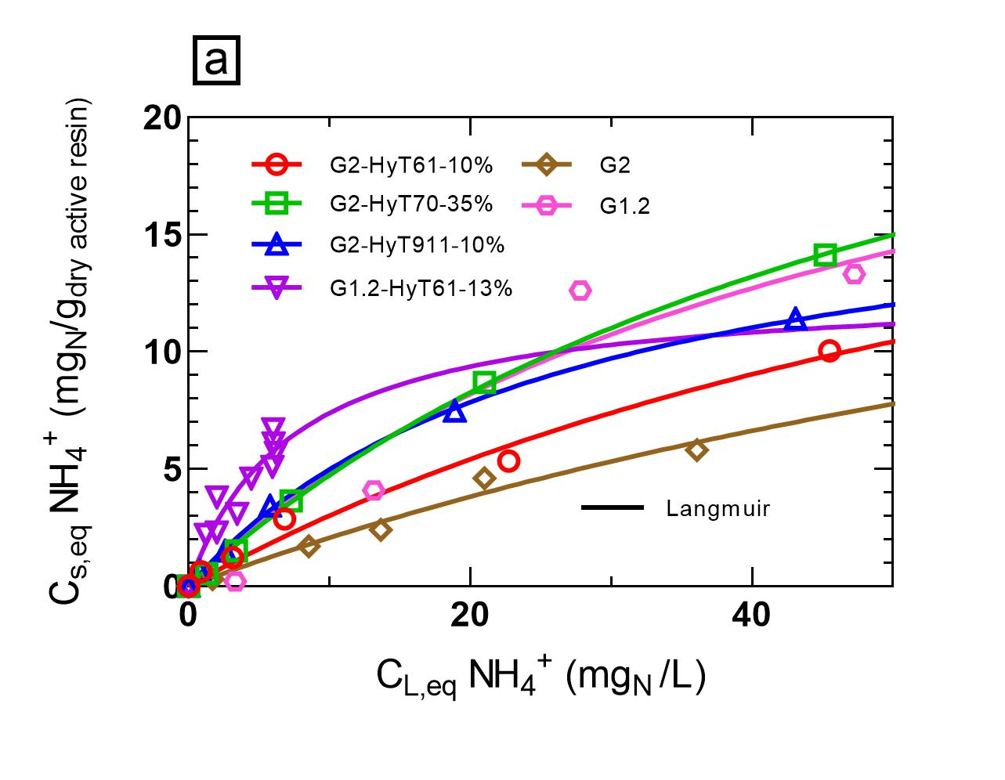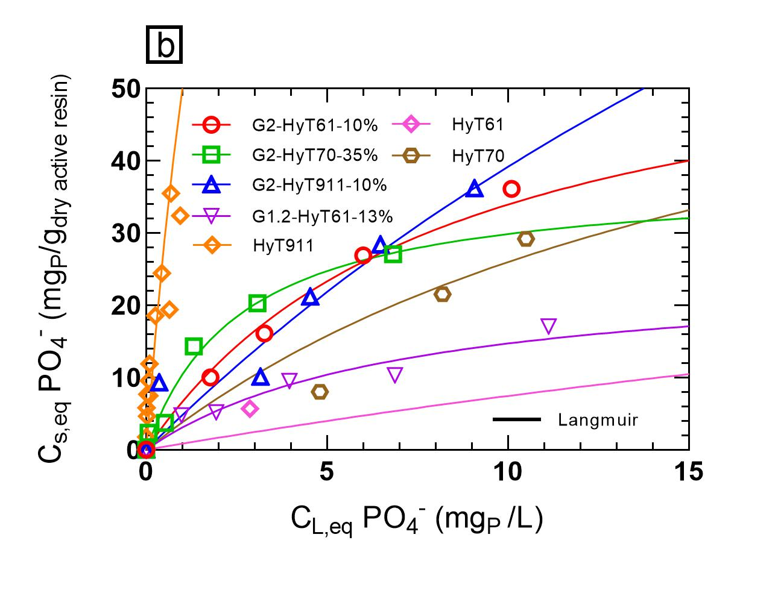

Figure 2: Isotherms conducted with Floating Sludge effluent diluted with Bologna WWTP effluent for composites and pure materials: (a) Nitrogen removal, (b) Phosphorus removal. Experimental data and best-fitting model simulations.

* 1. Conclusions

The geopolymer-based materials developed in this study demonstrated outstanding performance in both gas and aqueous applications, emphasizing their versatility and sustainability. Geopolymer-zeolite composites achieved up to 3 mmol/g CO₂ adsorption at 1 bar and CO2/N2 selectivity between 50–300 at 0.1 bar, demonstrating superior performance and synergy between their components. The cold sintering process (CSP) was instrumental in enhancing the structural integrity of the composites while maintaining high mesoporosity. This combination facilitated efficient mass transport and robust adsorption characteristics for industrial CO₂ capture applications, while also offering an energy-efficient and sustainable fabrication route.

In aqueous applications, the integration of hydrotalcite phases within the geopolymer matrix led to interesting performances in terms of simultaneous removal of ammonium and phosphate. The best results were obtained with the G2/Sorbacid911 and G2/Pural70 composites with ammonium capacities of 11-13 mgN/gactive sorbent phase at 40 mgN/L in the liquid, and phosphate capacities of 27 mgP/gactive sorbent phase at 7 mgP/L in the liquid. These results indicate the potential of such materials for dual-pollutant remediation, aligning with the growing demand for sustainable water treatment solutions. Overall, the study demonstrated that geopolymer-based composites offer a promising platform for addressing critical environmental challenges, combining customizable properties, high performance, and eco-friendly production methods.

Acknowledgments

This work received funding from the MUR PRIN 2022 grant No 20229THRM2 (GEA project) funded by the European Union – Next Generation EU.

References

Maggetti C., Pinelli D., Papa E., Medri V., Landi E., Frascari D., 2024. Development of an ion exchange process for ammonium removal and recovery from municipal wastewater based on a metakaolin K-based geopolymer. Chemosphere, 367:143559.

El-Eswed, B. I. (2019). Aluminosilicate inorganic polymers (geopolymers): emerging ion exchangers for removal of metal ions. Applications of Ion Exchange Materials in the Environment, 65-93.

Minelli M., Papa E., Medri V., Miccio F., Benito P., Doghieri F., Landi E., Characterization of novel geopolymer–zeolite composites as solid adsorbents for CO2 capture. Chem. Eng. J. 341 (2018) 505–515.

Boscherini M., Miccio F., Papa E., Medri V., Landi E., Doghieri F., Minelli M., 2021, CO2 Adsorption in a Geopolymer-zeolite Composite: Experimental Dynamic Tests and Modelling Insights on Related Thermal Effects, Chemical Engineering Transactions, 86, 1069-1074.

Hossain Sk S., Akhtar F., Recent progress of geopolymers for carbon dioxide capture, storage and conversion, J. CO2 Util., 78 (2023) 102631.