 CHEMICAL ENGINEERING TRANSACTIONS  VOL. xxx, 2025 | A publication of  
The Italian Association
of Chemical Engineering
Online at www.cetjournal.it

Guest Editors: Fabrizio Bezzo, Flavio Manenti, Gabriele Pannocchia, Almerinda di Benedetto
Copyright © 2025, AIDIC Servizi S.r.l.
ISBN 979-12-81206-17-5; ISSN 2283-9216

Innovative Supercritical Particle Formation for the Sustainable Manufacturing of Advanced Drug Delivery Systems
Daniele Sofia ^{a,c}, Massimo Moffa ª, Paolo Trucillo ^{a,b,*}
ªIodo, Corso Vittorio Emanuele, 143 – 84123 Salerno, Italy
^{b}Dipartimento di Ingegneria Chimica, dei Materiali e della Produzione Industriale, University of Naples Federico II, P.le V. Tecchio, 80, 80125, Napoli, Italy
^{c}Department of Computer Engineering, Modeling, Electronics and Systems, University of Calabria, Via P. Bucci cubo 44/a Rende (CS), 87036, ITALY

*paolo.trucillo@unina.it
The Supercritical Particle Formation (SPAF) process represents a significant advancement in the development of drug delivery systems for both pharmaceutical and nutraceutical applications. Traditional manufacturing methods often face challenges such as residual solvent contamination, low reproducibility, and limited versatility in bioactives encapsulation. On the contrary, SPAF exploits the benefits deriving from the use of supercritical fluids to remove solvent residue, thus resulting in a highly efficient, eco-friendly process, guaranteeing the coupling of several hydrophilic and lipophilic compounds with polymeric or lipidic carriers. This technique improves the yield at industrial level, without losing control over particle size distribution and morphology, release profile and cell bioavailability of active ingredients.
The improved stability of SPAF products is guaranteed by the addition of a process unit, made of several freeze-dryers working in parallel, to transform the liquid suspension of carriers into powder stable over 2 years. The synergy between supercritical particle formation and lyophilization offers a successful platform to produce high-quality, ready-to-market drug delivery systems with improved pharmacokinetic properties. This study highlights yield, profit and environmental benefits of SPAF, positioning it as a valid alternative to conventional production techniques nowadays utilized by companies.

  - Introduction
The growing demand for high-quality products in nutraceutical and pharmaceutical fields has highlighted the need for innovative technologies capable of overcoming the limitations of traditional manufacturing methods (Kailasapathy, 2009). Drug delivery systems, essential for ensuring effective bioavailability and targeted delivery of active ingredients, require solutions that combine efficiency, sustainability, and flexibility in handling complex bioactive compounds at nanometric level (Kucuk et al, 2023). Liposomes are known as biocompatible drug delivery systems, due to their affinity to human cell membranes. However, liposomes conventional production methods often face critical challenges that hinder their effectiveness and scalability. According to literature (Trucillo et al, 2020), the ethanol injection (EI) method forms liposomes by injecting a lipid-ethanol solution into water, but it leaves a high solvent residue, produces heterogeneous vesicles, and has low encapsulation efficiency, especially for hydrophilic compounds. The thin-layer hydration (TLH) method involves forming a lipid film, hydrating it, and spontaneously generating liposomes, but it results in large, irregular vesicles with low encapsulation efficiency, requiring further processing for size control.
Residual solvent contamination is a pervasive issue, particularly in methods that rely on organic solvents for encapsulation, such the conventional methods of thin-film hydration or ethanol injection (Gouda et al, 2021). These residual solvents not only compromise the safety and purity of the final product but also pose environmental and regulatory concerns, limiting their acceptability for massive use (Finotti Cordeiro et al., 2024). Moreover, low reproducibility remains a critical drawback. Conventional processes suffer from difficult control over particle size, morphology, and encapsulation efficiency, resulting in batch-to-batch variability (Lombardo & Kiselev, 2022). This inconsistency can significantly reduce the therapeutic efficacy of the drug delivery systems, with significant consequences to pass highly stringent quality control standards.
Additionally, the low versatility of these traditional methods is strictly related to the impossibility to successfully process different bioactive compounds. Encapsulation techniques often show a preference for either hydrophilic or lipophilic molecules, making it difficult to achieve efficient encapsulation for complex formulations that involve both types of compounds. This limitation reduces their applicability in multifunctional drug delivery systems, where the simultaneous delivery of various active ingredients may be required. Therefore, advanced manufacturing approaches must overcome these drawbacks while meeting the growing demands for sustainable, high-performance drug delivery systems.
Supercritical Particle Formation (SPAF) process represents a significant breakthrough, offering an innovative and eco-friendly alternative to current techniques (Sofia et al, 2025). By leveraging supercritical fluids, the SPAF process eliminates solvent residues, ensuring a clean and safe final product. Furthermore, this technique enables the coupling of hydrophilic and lipophilic compounds with polymeric or lipidic carriers while maintaining precise control over particle size distribution, morphology, release profiles, and the bioavailability of active ingredients. A further enhancement in the quality and stability of products obtained through SPAF is achieved by integrating a freeze-drying process unit. This step transforms liquid suspensions of carriers into powders that remain stable for over two years, ensuring long-term preservation and readiness for global market distribution. The synergy between supercritical particle formation and lyophilization not only improves the pharmacokinetic properties of delivery systems but also provides a scalable and sustainable production platform capable of meeting industrial demands.
Among the numerous molecules available in the market and currently lacking a significant bioavailability for humans, three specific molecules were selected for liposomes encapsulation using SPAF technology.
The first chosen molecule was vitamin B12, also known as cobalamin, is a water-soluble vitamin essential for various physiological functions, including DNA synthesis, red blood cell formation, and neurological health. Vitamin B12 is fundamental in the metabolism of every cell in the human body, particularly affecting the production of energy and the synthesis of fatty acids and amino acids. Being naturally found in animal-based foods such as meat, fish, eggs, and dairy products, it is used as a dietary supplement for vegetarians, vegans, and individuals with absorption issues. A deficiency in vitamin B12 can lead to anemia, fatigue, and neurological disorders, highlighting its importance for overall health and well-being (Marchianò et al, 2022).
A second molecule entrapped in liposomes in this work was melatonin, a naturally occurring hormone produced by the pineal gland in the brain, primarily responsible for regulating the sleep-wake cycle, also known as the circadian rhythm. Its production increases in response to darkness, promoting sleep, and decreases with exposure to light. Beyond its role in sleep regulation, melatonin is also a potent antioxidant and supports immune function. It is commonly used as a supplement to address sleep disorders, jet lag, and issues related to shift work. With its natural origins and wide range of benefits, melatonin plays a crucial role in maintaining overall health and well-being (Dubey et al, 2007).
A third very different molecule considered as an alternative to current iron dietary supplements is ferrous sulfate, commonly used as a dietary supplement to treat and prevent iron deficiency anemia. Iron is a vital mineral necessary to produce hemoglobin, a protein in red blood cells that carries oxygen throughout the body. Ferrous sulphate is known for its ability to restore iron levels in individuals with deficiencies caused by poor dietary intake, blood loss, or increased iron requirements, such as during pregnancy. It is typically available in tablet or liquid form and plays a crucial role in maintaining energy levels, cognitive function, and overall health (Kosaraju et al, 2006).
This study aims to evaluate the benefits of the SPAF process in terms of yield and environmental impact, demonstrating how this technology offers a viable alternative to conventional techniques currently employed by companies. By focusing on three distinct bioactive compounds, this work explores the versatility of the SPAF process in encapsulating both hydrophilic and lipophilic molecules within lipid-based carriers. Specifically, the study investigates how SPAF integrates precise particle engineering, encapsulation efficiency, and environmental sustainability into a scalable production framework.
The primary goals of this research are to assess the efficacy of SPAF in producing high-quality, stable powdered formulations with extended shelf-life, and to highlight its advantages over traditional methods in terms of reproducibility, product purity, and industrial scalability. Additionally, the study seeks to quantify the yield, profitability, and environmental benefits of SPAF, demonstrating its capacity to serve as a viable alternative for modern pharmaceutical and nutraceutical industries.

  - Materials and Methods
The Supercritical Particle Formation (SPAF) process is an advanced method for producing stable powdered drug delivery systems by combining supercritical CO₂ technology with drying techniques like freeze-drying and spray drying. It eliminates harmful organic solvents, enhances encapsulation efficiency (up to 94%), and ensures long-term stability of powdered formulations (more than 24 months). The process involves high-pressure mixing of active molecules and phospholipids (at 100 bar and 40°C) to form liposomes, followed by depressurization to remove CO₂-ethanol mixture, and drying to transform the suspension into a powder. SPAF is a scalable, green and versatile process, compliant with food-grade standards, making it suitable for nutraceutical applications. In detail, SPAF process operates through the following steps: a reactor is filled with water, ethanol, phospholipids, and the active compound. The reactor is sealed and heated to 40°C at 1 bar. Carbon dioxide is then introduced in the system up to a pressure of 100 bar. This environment creates a turbulent system where water forms droplets dispersed within the carbon dioxide. Ethanol, being miscible with CO₂, aids in dissolving phospholipids, by transferring them to water molecules. Phospholipids rearrange in a turbulent and aqueous environment, thus creating liquid suspensions of vesicles. The reactor is depressurized, releasing CO₂ and ethanol. This step leaves the liposomes suspended in the aqueous medium; subsequently, drying and stabilization occurs: the aqueous suspension is subjected to freeze-drying or spray-drying to remove residual water and convert the liposomes into a stable powdered form. Freeze-drying involves sublimating water under vacuum, while spray-drying uses heat to evaporate water quickly.
Encapsulation efficiency (EE), expressed in percentage, has been calculated as indicated in Eq. 1:

$EE, \%= \frac{amount of entrapped active ingredient}{total amount of acitive ingredient fed to the reactor}*100$ (1)

in which EE refers to the amount of the active molecule successfully entrapped in the inner core (for hydrophilic molecules) and in the double lipidic layer for the lipophilic active molecules, while the total amount of active ingredient is the mass of bioactive molecule dissolved in the preliminary ethanolic or aqueous solution fed to the system (Were et al., 2003), before pressurizing.
Granulometric analysis of liposome samples were performed using Fiji software directly on SEM micrographs.
  - Results
The SPAF process has been utilized for various applications in the nutraceutical field, effectively encapsulating both hydrophilic and lipophilic molecules. This study aims to demonstrate the effectiveness of the SPAF process for encapsulating diverse molecules, such as ferrous sulfate, vitamin B12, and melatonin.
Figure 1: micrograph of nanoliposomes entrapped in macroscopic phospholipidic aggregates
With this process, it is possible to produce nanoscale liposomes embedded within complex macroscopic structures (see Figure 1). This capability highlights the versatility of the SPAF (Supercritical Assisted Phase Separation) technique, which allows for the precise engineering of liposome size and distribution within intricate morphological frameworks. Such structures offer significant advantages in applications requiring controlled release, targeted delivery, or multifunctional systems, where the nanoscale properties of liposomes synergize with the structural complexity of the macroscopic matrix.
The micrograph demonstrates how these macroscale structures maintain integrity while housing nanoscale carriers, ensuring the stability of encapsulated agents and enhancing their delivery efficiency in biomedical or pharmaceutical contexts (de la Torre & de Pinho, 2015). The ability to achieve this dual-scale design is particularly promising for advanced drug delivery systems, tissue engineering scaffolds, or bioactive material development, where both structural complexity and precise nanoscale functionality are critical.
The following micrographs (Figures 2-4) represent studies of morphology performed on liposomes produced with SPAF technique and loaded with three different molecules.
(a) (b)
Figure 2: micrograph of melatonin loaded liposomes in powder form observed at different magnitude of 6000x (a) and 24000 (b) using scanning electron microscope
(a) (b)
Figure 3: micrograph of vitamin B12 loaded liposomes in powder form observed at different magnitude of 4000x (a) and 2000 (b) using scanning electron microscope
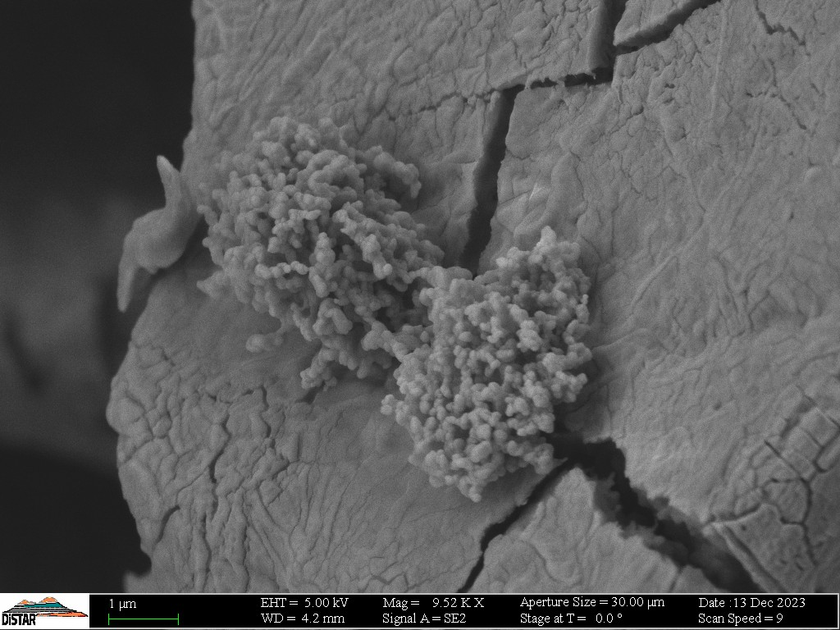(a) (b)
Figure 4 represents a micrograph of ferrous sulphate loaded liposomes in powder form observed at different magnitudes of 9500x (a) and 40500 (b) using scanning electron microscope.
In Figure 2, melatonin loaded liposomes are reported in uniform and almost homogeneous distribution, thus exhibiting the typical morphology of agglomerated liposomes. The phenomena of aggregation are typically due to the nature of phospholipids; however, this behavior can be attributed to interactions between the liposomes during drying or post-processing stages. Compared to conventional methods like ethanol injection or thin-film hydration, especially for this specific lipophilic molecule, SPAF technique demonstrates an improved control over liposome size and morphology. Melatonin, being a hydrophobic molecule, is well-suited for encapsulation using the SPAF technique, which optimizes the partitioning of hydrophobic substances into the lipid bilayer.
Figure 3 shows liposomal morphology suggesting the formation of large aggregates due to phospholipid agglomeration; in the inner sections and on the outer surfaces, vesicles of different shapes and roughness are observed. Moreover, the observed aggregation could be due to the absence or limited use of surfactants, but also to the fact that vitamin B12 has a larger molecular weight and requires more inner volume to be entrapped in a stable environment.
As shown in Figure 4, liposomes appear aggregated, possibly due to their high surface energy and interactions between particles during or after the drying process. Surface roughness and the presence of a distinct cluster-like structure indicate successful encapsulation of ferrous sulfate. Regarding structural integrity, the cracks visible in the substrate might indicate a post-processing effect, potentially arising during the drying or freezing steps. This does not directly compromise the functionality; however, the clustered aggregation could indicate high loading efficiency, which aligns with findings in similar supercritical-assisted processes.
As a general comment, SPAF process represents a significant advancement in drug delivery system manufacturing, enabling the production of a novel class of systems that merge compact macroscopic structures with nanometric environments. Specifically, SPAF technique facilitates the formation of lipid vesicles encapsulated within a macroscopically cohesive matrix. This duality is evident in the SEM micrographs, where the compact surface morphology at the macroscopic scale contrasts with the detailed vesicular nanostructures observed internally.
The successful encapsulation of compounds like melatonin, vitamin B12, and ferrous sulphate was also achieved despite the integration of drying steps to obtain the final powder, that did not compromise vesicles stability. As a general comment, this structural duality highlights that lipid vesicles enhance bioavailability through controlled release mechanisms, while the macroscopic compactness facilitates handling and industrial scalability. This innovative approach guarantees that SPAF offers versatile and highly efficient solutions for advanced drug delivery applications.
As reported in Table 1, mean size of melatonin loaded liposomes is 238 ± 79 nm, with a very high encapsulation efficiency. This molecule, being relatively small and lipophilic, integrates easily into the liposomal structure, explaining its high efficiency and compact size. Vitamin B12 loaded liposomes exhibit significantly larger dimensions (1198 ± 372 nm) with a slightly lower encapsulation efficiency (91 ± 5%). The larger size can be attributed to the hydrophilic nature and higher molecular weight of Vitamin B12, which requires a broader lipid structure for inclusion. Ferrous Sulfate loaded liposomes are the smallest ones (35 ± 11 nm), yet they maintain a high encapsulation efficiency (92 ± 2%). The reduced size could be due to the ionic nature of ferrous sulfate and its easy interaction with the lipid matrix, enabling a more compact organization.
Table 2 highlights the stability of liposomes and the absence of chemical contaminants. Stability varies across molecules: ferrous sulphate shows the highest stability (820 days), likely due to its simple chemical structure and compatibility with the lipid matrix, while melatonin and Vitamin B12 have stability of 760 and 540 days, respectively, with the latter influenced by its chemical complexity. Additionally, no heavy metals or pesticides were detected in any sample, confirming the high purity of liposomes produced with the SPAF technique.
Table 1: Mean size and encapsulation efficiency of liposomes produced using SPAF technique
Molecule | Molecule/Lipids, % | Mean dimensions, nm ± SD | Encapsulation Efficiency (EE), % ± SD
Melatonin | 1:1 | 238 ± 79 | 94 ± 3
Vitamin B12 | 1:1 | 1198 ± 372 | 91 ± 5
Ferrous sulphate | 1:1 | 35 ± 11 | 92 ± 2
Table 2: Stability of liposomes produced using SPAF technique
Molecule | Stability (S), days | Heavy Metals (HM), ppm | Pesticides (P), ppm
Melatonin | 760 | n.d. | n.d.
Vitamin B12 | 540 | n.d. | n.d.
Ferrous sulphate | 820 | n.d. | n.d.
  - Conclusions
Compared to traditional thin-film hydration or ethanol injection methods, the SPAF technique demonstrates superior performance by yielding particles with enhanced encapsulation efficiency and improved control over particle morphology. In details, this process overcomes common drawbacks because it eliminates residual solvents, ensuring higher product safety than conventional methods. Additionally, it enhances encapsulation efficiency (up to 94%) and enables long-term stability of liposomes in a dry powder form, overcoming storage and degradation issues associated with aqueous suspensions (Sofia et al, 2025). SEM micrographs from similar studies consistently highlight the rough, porous structures as distinctive features of liposomes produced using SPAF, particularly when encapsulating hydrophilic or ionic compounds. Additionally, aggregation is commonly observed in samples processed with minimal surfactant or stabilizing agents, which could explain the clustering observed in the current sample. Based on morphology, these liposomes could be suitable for controlled release applications and successful nutraceutical purposes.

Acknowledgements
The authors would like to express their gratitude to the entire team of IODO; in particular, special thanks go to Alessandro Liuzzi, Michela Ielpo, Stefania Ferrigno, and Damiana Pisaturo for their dedication, expertise, and collaborative efforts, which have been instrumental in the successful completion of this study.
References
de La Torre L. G. & de Pinho S. C., 2015, Lipid matrices for nanoencapsulation in food: liposomes and lipid nanoparticles, Food nanoscience and nanotechnology, 99-143.
Dubey V., Mishra D., Jain N. K., 2007, Melatonin loaded ethanolic liposomes: physicochemical characterization and enhanced transdermal delivery, European Journal of Pharmaceutics and Biopharmaceutics, 67, 398-405.
Finotti Cordeiro C., Lopardi Franco L., Teixeira Carvalho D., Bonfilio R., 2024, Impurities in Active Pharmaceutical Ingredients and Drug Products: A Critical Review, Critical Reviews in Analytical Chemistry, 1-21.
Gouda A., Sakr O. S., Nasr M., Sammour O., 2021, Ethanol injection technique for liposomes formulation: An insight into development, influencing factors, challenges and applications, Journal of Drug Delivery Science and Technology, 61, 102174.
Lombardo D., Kiselev M. A., 2022, Methods of liposomes preparation: formation and control factors of versatile nanocarriers for biomedical and nanomedicine application, Pharmaceutics, 14, 543.
Kailasapathy K., 2009, Encapsulation technologies for functional foods and nutraceutical product development. CABI Reviews, 1-19.
Kosaraju S. L., Tran C., Lawrence A., 2006, Liposomal delivery systems for encapsulation of ferrous sulfate: preparation and characterization, Journal of liposome research, 16, 347-358.
Kucuk N., Primozic M., Knez Z., Leitgeb M., 2023, Incorporation of Biologically Active Ingredient Gallic Acid Into Nano-scale Lipid Vesicles, Chemical Engineering Transactions, 100, 517-522.
Marchianò V., Matos M., Serrano E., Álvarez J. R., Marcet I., Blanco-López M. C., Gutiérrez G., 2022, Lyophilised nanovesicles loaded with vitamin B12, Journal of Molecular Liquids, 365, 120129.
Sofia D., Moffa M., Trucillo, P., 2025, Supercritical PArticle formation (SPAF) process for the versatile production of ready-to-market drug delivery systems, Chemical Engineering Science, 302, 120918.
Trucillo, P., Campardelli, R., Reverchon, E., 2020, Liposomes: From bangham to supercritical fluids, Processes, 8, 1022.
Were, L. M., Bruce, B. D., Davidson, P. M., & Weiss, J. (2003). Size, stability, and entrapment efficiency of phospholipid nanocapsules containing polypeptide antimicrobials. Journal of agricultural and food chemistry, 51(27), 8073-8079.

