 CHEMICAL ENGINEERING TRANSACTIONS  VOL. , 2025 | A publication of  
The Italian Association
Chemical Engineering
Online at www.cetjournal.it

Guest Editors: Fabrizio Bezzo, Flavio Manenti, Gabriele Pannocchia, Almerinda di Benedetto
Copyright © 2025, AIDIC Servizi S.r.l.
ISBN 979-12-81206-17-5; ISSN 2283-9216

Biochar From Wastewater Treatment Plant Sludge: Efficiency in the Removal of Hydrocarbons from Contaminated Soil
Julissa A. Diaz Agüeroª , María A. Pérez Pérezª , Danny Lizarzaburu-Aguinaga^{b}*, Elmer Benites-Alfaroª, Carlos Cabrera Carranza^{c}, Jorge Jave Nakayo^{c}, Guido Rene Suca-Apaza^{d}, Jose Freddy Atuncar Yrribari^{c}
ª Universidad César Vallejo, Av. Alfredo Mendiola 6232, Los Olivos, Lima – Perú
^{b} Universidad César Vallejo, Av. Argentina 1795, Callao – Perú
^{c} Universidad Nacional Mayor de San Marcos, Lima – Perú
^{d} Universidad César Vallejo, Carretera Central Km 8.2, Ate – Perú
* dlizarzaburu@ucv.edu.pe
Biochar is a carbonaceous material produced by pyrolysis of organic matter, such as wood, agricultural waste, or, in this case, sewage sludge. Biochar is very porous and has a large surface area, making it very efficient at absorbing and retaining contaminants in soil, including hydrocarbons. Using sewage sludge as biochar to remove hydrocarbons from the soil can be an exciting practice in environmental management and the remediation of contaminated soils. At the same time, it is a sustainable solution for managing these wastes, contributing to reducing environmental pollution. The research objective was to determine the efficiency of reducing total petroleum hydrocarbons from contaminated soil using 5, 10, and 20% biochar from sewage sludge. The results of hydrocarbon removal from the light fraction were 99.99%, the medium fraction 54.59%, and the heavy fraction 54.92% after 45 days. In addition, the physicochemical properties of the soil improved. Therefore, using sewage sludge as biochar to remove hydrocarbons from the soil is an effective strategy. Still, it must be carried out cautiously, and appropriate practices must be followed to ensure environmental safety and the highest remediation efficiency.
  - Introduction
On 15 January 2022, environmental alarms were raised in Peru due to an oil spill off the coast of Ventanilla; nearly twelve thousand barrels affected eleven thousand hectares in 97 sites, including 62 beaches and two protected natural areas (Defensoría del Pueblo, 2023). This accident generates the need to know the impacts on the environment such as water, soil, and ecosystems affected by the interaction of crude oil, causing adverse processes, mainly due to the wind, sea currents, and waves that transport the crude oil at high speed (Pulido Capurro et al., 2022), all these impacts lead us to think about treatments to eliminate hydrocarbons in the environment. Hence, the need arises to recognize different remediation mechanisms for soils impacted by these hydrocarbons, among them we have the use of native bacteria (Zafra et al., 2016), phytoremediation (Benítez et al., 2022), the use of biosludge (Lumia et al., 2020) and the use of biochar (Wei et al., 2024), the latter has been continuously used for the removal of hydrocarbons in the environment, the biochar used was formed by slow pyrolysis and adjusting the operating conditions of temperature (> 200 ºC) and residence time (+1 hour) improving the decomposition of volatile compounds and reducing the formation of tar (Solar et al., 2016). Consequently, it becomes necessary to address the following question to what extent can biochar reduce hydrocarbons in contaminated soils? Subsequently, the objective is to determine the reduction efficiency of total petroleum hydrocarbons in contaminated soils using biochar at 5, 10 and 20% from sludge from a wastewater treatment plant (WWTP); for this it will be necessary to determine the initial and final concentration of light, medium and heavy hydrocarbon fractions (MINAM, 2017) and determine whether the physicochemical properties of the soil contaminated by hydrocarbons improved with biochar treatment. Among the mechanisms to metabolize hydrocarbons are those mediated by microorganisms (Pseudomonas spp., Mycobacterium spp.) and specific enzymes (monooxygenases or dioxygenases) that will be used to reduce the complexity of the compound (Bridgwater, 2012).
  - Methodology
The research proposes a methodology developed in five stages: production of biochar from waste sludge from a wastewater treatment plant, extraction of soil samples, remediation of samples contaminated by hydrocarbons, analysis, interpretation, and data processing of the soil samples (see Figure 1).

Figure 1: Experimental procedure diagram.
    - Sewage sludge biochar preparation.
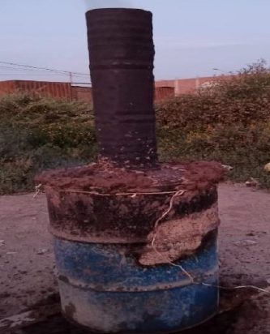
Figure 2: Pyrolysis oven heated with its chimney
Fifty kilograms were extracted from the last stage of the sludge drying process at the Santa Rosa wastewater treatment plant, Ancon, Lima. This material was dispersed on a polyethylene surface at room temperature (19 ºC) for seven days to ensure complete drying, reducing the moisture content from 85.90 % to 59.45 %. Subsequently, biochar was prepared by pyrolysis using an oven by adapting a 1 m³ metallic cylinder, with holes at the bottom and an airtight lid at the top (Condeña, 2017, pp. 66-70); this oven was designed in such a way that it limits incoming oxygen to generate the most significant amount of biochar.

The residual sludge was then poured into the furnace and dried Inga feuilleton (pacay) leaves were used as fuel. The cylinder was then covered with the top of the structure. After 60 minutes, the oven temperature was measured with a digital pyrometer that showed a reading of 305 ºC to confirm that the temperature was uniform throughout the oven the water jet technique was used (Quisquiche et al., 2022). When the indicated temperature was reached, the cylinder was fitted into a hole 50 cm in diameter and 15 cm deep, sealing around the furnace with mud to prevent gas exchange (Figure 2).

Finally, after 4 hours of cooking, the lid was removed and allowed to cool for 60 minutes, and then the sludge was removed for size by crushing and sieving with a #30 mesh stainless steel strainer.
    - Soil sampling
The soil sample contaminated with hydrocarbons was taken from an industrial area of 1000 m² located at kilometer 14.8 of the Huachipa district. The composite sampling technique was used following the guide for soil sampling of the Ministry of the Environment (MINAM, 2014), 25 extraction points were determined, duly referenced with their UTM coordinates, and the soil extraction was carried out through a “V”-shaped hole 10 cm deep (figure 3). All the collected samples were placed in a spread plastic for homogenization. From this, a sample of 20 kg was obtained for the soil remediation process (figure 4).

One kilogram of the sample was used as a “control sample.” All other samples were coded and transported following the protocol and chain of custody in a cooler at four ºC for the analysis of total hydrocarbon concentration, texture, cation exchange capacity (CEC), pH, organic matter (OM), nitrogen (N) and phosphorus (P).

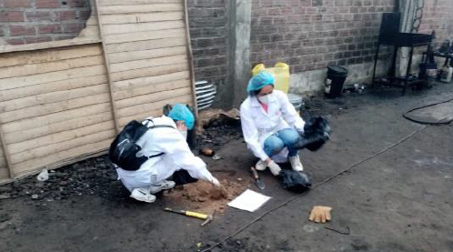  Figure 3: Sampling of contaminated soil. | 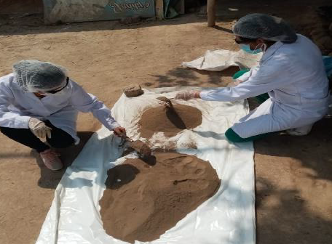  Figure 4: Homogenization of soil samples.
    - Soil remediation process
Ten buckets of 3 kg capacity were used for the treatment, each containing 2 kg of soil contaminated with hydrocarbons. Previously, the soil was sieved with a No. 10 mesh (2 mm ASTM 8”) to eliminate impurities (glass, concrete, plastic, etc.). The test consisted of adding three doses of biochar: 5% (100 gr), 10% (200 gr), and 20% (400 gr) to the contaminated soil. The experiment was carried out in triplicate for each dose, and one container served as a control; without adding biochar (Carlini et al., 2023), the experimental units were placed in a cool and dry place for 45 days.
    - Sample Analysis
Initially, an analysis of the hydrocarbon concentration of the control unit was performed. Then, the experimental units (09 units) were analyzed 20 and 45 days after adding WWTP biochar. The hydrocarbon concentration was determined using the EPA 8015 test method, established by the environmental quality standard. To find the efficiency of hydrocarbon concentration reduction, equation 1 was used.

$Reduction efficiency [hydrocarbons]= \frac{{\left[hidrocarbons\right]}_{Initial}-{\left[hidrocarbons\right]}_{Final}}{{\left[hidrocarbons\right]}_{Initial}} x 100$ (1)
    - Data processing
Data processing consisted of office work in which data was collected through registration forms. Then, the data were interpreted and coded (Table 1) to generate the results detailed in point 3. This will allow analyzing the efficiency of reducing the concentration of hydrocarbons in the samples and the improvement in the physicochemical parameters in the contaminated soils before and after treatment.
Table 1: Coding of samples according to treatment
Treatment | Fraction light | Middle Fraction | Fraction Heavy
5% Biochar | FLSB05 | FMSB05 | FPSB05
10% Biochar | FLSB10 | FMSB10 | FPSB10
20% Biochar | FLSB20 | FMSB20 | FPSB20
  - Results
The research also seeks to incorporate the concept of a circular economy by using common waste, such as sewage sludge from wastewater plants, to generate biochar. This biochar is then added to soils contaminated with hydrocarbons to evaluate its use as an effective treatment alternative. soil (Lin et al., 2022). The results are shown below.
    - Initial and final concentration of the light, medium, and heavy fractions of hydrocarbons in comparison to the ECA
The efficiency of the treatment using 5, 10, and 20% of biochar in soils contaminated with hydrocarbons is presented in Table 1. From the results shown, it is observed that after 45 days of treatment, the light fraction is reduced to 2.48, 1.03, and 0 .08 mg/kg. It is also determined that for the other hydrocarbon fractions (medium and heavy), there is also a decrease, although not very significant; it was also possible to verify that after 45 days, the three treatments show a reduction below the standards of the Peruvian environmental standard. The same table also shows the initial concentration of hydrocarbons in the soil and the results obtained for each treatment. It compares them with the environmental quality standard of the soil in Peru (MINAM, 2017).
Table 1: Concentration of hydrocarbons in the soil 20 and 45 days after starting the biochar treatment
Fraction of Hydrocarbons | ECA Soil (mg/kg) | Treatment code | sample (mg/kg) | Sample after 20 days (mg/kg) | Sample at 45 days (mg/kg) | Total reduction | % Efficiency in hydrocarbon reduction
Light fraction of hydrocarbons (C6-C10) | 500 | FLSB05 | 795.01 | 272.8 | 2.48 | 792.53 | 99.69%
 |  | FLSB10 |  | 206.53 | 1.03 | 793.98 | 99.87%
 |  | FLSB20 |  | 158.87 | 0.08 | 794.93 | 99.99%
Medium fraction of hydrocarbons (>C10-C28) | 5000 | FMSB05 | 7096.00 | 5582.11 | 4624.57 | 2471.43 | 34.83%
 |  | FMSB10 |  | 4862.03 | 4023.77 | 3072.23 | 43.30%
 |  | FMSB20 |  | 4027.57 | 3222.40 | 3873.60 | 54.59%
Heavy fraction of hydrocarbons (>C28-C40) | 6000 | FPSB05 | 8980.00 | 7280.70 | 6841.47 | 2138.53 | 23.81%
 |  | FPSB10 |  | 6685.17 | 5412.33 | 3567.67 | 39.73%
 |  | FPSB20 |  | 5847.00 | 4048.33 | 4931.67 | 54.92%
The table shows that the light fraction of hydrocarbons results in 99% regardless of the treatment. Furthermore, for the medium and heavy fractions of hydrocarbons, the treatment with 20% biocarbon is above 50%.
    - Efficiency of reduction of hydrocarbon fractions in contaminated soils using various doses of biochar
Figure 5 shows the percentage reduction in the concentration of the light, medium, and heavy fractions of hydrocarbons in the soil samples during 45 days of treatment. It is confirmed that the light fraction reduces up to 99.99% of its concentration, and the heavy fraction is the one that obtains the least reduction. This is because biochar improves soil porosity, reducing apparent density and evapotranspiration. The efficiency is greater since the light fraction is less dense (Gul et al., 2015). Furthermore, biochar efficiently facilitates the elimination of polycyclic aromatic hydrocarbons (PAHs), stating once again that the porous structure of biochar is essential for absorption (Isaeva et al., 2021).

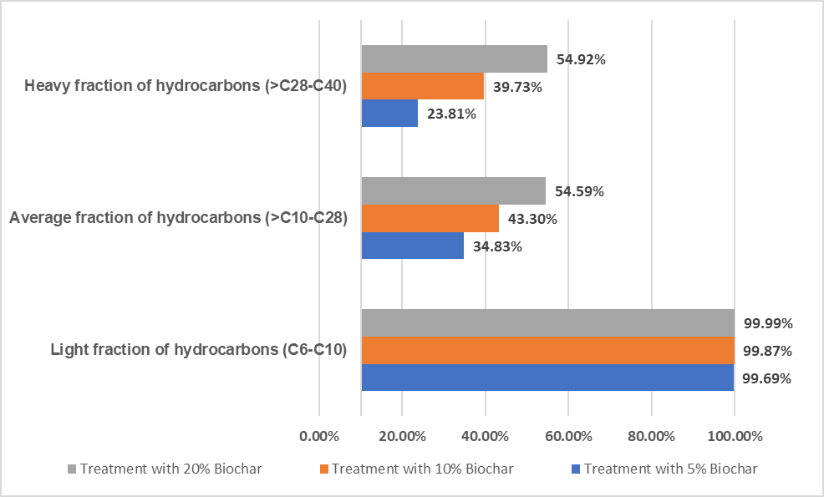
Figure 5: Percentage of efficiency according to treatment for each type of hydrocarbon fraction.
    - Physicochemical properties of contaminated soil after treatment with biochar
Table 2 shows the changes that each treatment (5%, 10%, and 20%) exerts on the physicochemical parameters after 20 and 45 days of homogenizing the soil contaminated with biochar.
Table 2: Physicochemical parameters of the soil before and after treatment at 20 and 45 days.
Parameters physicochemical |  | Sample Control | Treatment results after 20 days |  |  | Treatment results after 45 days
 |  |  | SB05 | SB10 | SB20 | SB05 | SB10 | SB20
Organic material (%) |  | 2.36 | 3.90 | 4.19 | 4.74 | 3.99 | 4.64 | 5.10
pH (1-14) |  | 5.40 | 6.73 | 6.80 | 6.73 | 6.80 | 7.03 | 7.17
Nitrogen (mg/kg) |  | 53.60 | 68.93 | 70.87 | 72.60 | 70.07 | 72.17 | 73.90
Phosphorus (mg/kg) |  | 105.30 | 199.67 | 201.07 | 203.80 | 201.80 | 205.03 | 207.90
CIC ( meq /100gr) |  | 29.50 | 45.90 | 47.20 | 46.40 | 46.63 | 52.07 | 52.60
Texture | Sand | 93.00 | 89.00 | 84.67 | 80.00 | 88.73 | 83.45 | 79.92
 | Silt | 4.00 | 8.67 | 11.67 | 16.00 | 8.69 | 11.90 | 16.50
 | Clay | 2.00 | 2.33 | 3.67 | 3.33 | 2.45 | 3.85 | 3.79
Note: SB05= Soil with 5% Biochar, SB10= Soil with 10% Biochar, and SB20= Soil with 20% Biochar

It is established that the most significant change occurred in the treatment with 20% biochar in 45 days. In the case of organic matter, it increased progressively due to the porous characteristic of biochar, with the proliferation of microbiota present in the soil. The increase in pH until reaching 7.17, with more significant nitrogen and phosphorus fixation up to 73.90 and 207.90 mg/kg, respectively, was due to biochar (Allohverdi et al., 2021), the cation exchange capacity also shows a continuous increase until reaching 52.60 meq /100 g corresponding to the control sample. All these values demonstrate that the soil is healthy and fertile (Freitez & Villanueva, 2019). Therefore, incorporating biochar into the soil can generate changes in physical and chemical properties (Puentes & Rodríguez, 2021). Finally, the texture varies with a decrease in sandiness and an increase in silt. However, more studies are still required to help conclude the benefits of biochar. (Reyes Pallazhco et al., 2023).

Biocarbon turns out to have an advantage due to its molecular structure and physical architecture when applied to soil. The high pyrolysis temperature allows generating a very effective biocarbon for the absorption of organic contaminants by increasing the surface area, hydrophobicity, and microporosity (Qiu et al., 2022).
  - Conclusions
The biochar obtained from the residual sludge managed to significantly reduce the hydrocarbon concentration by 99.99% in the light fraction (C6-C10), 54.59% in the medium fraction ( > C10 – C28), and 54.92% in the heavy fraction ( > C 28 – C40), obtaining excellent efficiency that allows compliance with soil environmental quality standards. ; Likewise, it improves the physicochemical properties, such as the impact of the presence of biochar by giving it porosity, increasing the percentage of organic matter, stabilizing the pH around 7.17, and increasing nitrogen, phosphorus, and cation exchange. Therefore, using biochar obtained under the circular economy concept constitutes an environmentally sustainable method for treating soils contaminated by hydrocarbons.
Acknowledgments
The authors and GIGATRE thank “Investiga UCV” of César Vallejo University for funding the publication of this research.
References
Allohverdi T., Mohanty A., Roy P., and Misra M., (2021). A review on current status of biochar uses in agriculture. Molecules, 26(18). <doi.org/10.3390/molecules26185584> accessed 11.01.2024.
Benítez L., Miranda L., and Castro., C., 2022, Phytoremediation to Remove Pollutants from Water, Leachates and Soils. Chemical Engineering Transactions, 92(April), 553–558. <doi.org/10.3303/CET2292093> accessed 07.01.2024.
Bridgwater A. V., 2012, Review of fast pyrolysis of biomass and product upgrading. Biomass and Bioenergy, 38, 68–94. <doi.org/https://doi.org/10.1016/j.biombioe.2011.01.048˃ accessed 19.01.2025.
Carlini C., Chaudhuri S., Mann O., Tomsik D., Hüffer T., Greggio N., Marazza D., Hofmann T., and Sigmund G., (2023). Benchmarking biochar with activated carbon for immobilizing leachable PAH and heterocyclic PAH in contaminated soils. Environmental Pollution, 325(December 2022), 121417. <doi.org/10.1016/j.envpol.2023.121417˃ accessed 09.01.2024.
Defensoría del Pueblo, (2023). Oil spill in Ventanilla: One year report on the environmental and social disaster on our coast (Spanish).
Freitez N., and Villanueva S., (2019). Dissemination article: Biocarbon, an alternative to contaminated soils. Science in Revolution Magazine, 5, 97–100 (Spanish).
Gul S., Whalen J. K., Thomas B. W., Sachdeva V., and Deng H., (2015). Physico-chemical properties and microbial responses in biochar-amended soils: Mechanisms and future directions. Agriculture, Ecosystems and Environment, 206, 46–59. <doi.org/10.1016/j.agee.2015.03.015˃ accessed 11.01.2024.
Isaeva V. I., Vedenyapina M. D., Kurmysheva A. Y., Weichgrebe D., Nair R. R., Nguyen N. P. T., and Kustov L. M., 2021, Modern carbon–based materials for adsorptive removal of organic and inorganic pollutants from water and wastewater. Molecules, 26(21), 1–95. <doi.org/10.3390/molecules26216628> accessed 04.03.2024.
Lin H., Yang Y., Shang Z., Li Q., Niu X., Ma Y., and Liu A., 2022, Study on the Enhanced Remediation of Petroleum-Contaminated Soil by Biochar/g-C3N4 Composites. International Journal of Environmental Research and Public Health, 19(14). <doi.org/10.3390/ijerph19148290˃ accessed 09.01.2024.
Lumia L., Rabbeni G., Giustra M., Giumento S., Gallo G., and Di Bella G., 2020, Treatment of contaminated sediments by bio-slurry reactors: Study on the effect of erythromycin antibiotic. Chemical Engineering Transactions, 79(September 2019), 391–396. <doi.org/10.3303/CET2079066> accessed 07.01.2024.
MINAM. (2017). Supreme Decree No 011-2017-MINAM. The Peruvian, 1–4 (Spanish).
MINAM, (2014). R. M. No 085-2014-MINAM. Guide for Soil Sampling and Guide for the Preparation of Soil Decontamination Plans, Vol. 2, (Spanish).
Pulido Capurro V, Escobar-Mamani F, Arana Bustamante C, and Olivera Carhuaz, E, 2022, Effects of the oil spill at the La Pampilla Refinery on the coast of the marine coast, Lima (Peru). Magazine of Investigations Altoandinas, 24(1), 5-8. Epub February 21, 2022, <doi.org/10.18271/ria.2022.411˃ accessed 06.01.2024.
Pulido V., Cruz J., Arana C., and Olivera E., 2022, Environmental damage to the Peruvian marine littoral caused by the oil spill (January 2022) at the La Pampilla refinery. Manglar, 19(1), 67–75. <doi.org/10.17268/manglar.2022.009> accessed 06.01.2024 (Spanish).
Qiu M., Liu L., Ling Q., Cai Y., Yu S., Wang S., Fu D., Hu B., and Wang X., 2022, Biochar for the removal of contaminants from soil and water: a review. Biochar, 4(1), 1–25. <doi.org/10.1007/s42773-022-00146-1˃ accessed 09.03.2024.
Quisquiche Morales D., Lizarzaburu Aguinaga D., Castañeda C., and Benites-Alfaro E., 2022, Solid Biofuel Spheres for the use of Residual Biomass from Polylepis (Quenual) in Rural Areas. Chemical Engineering Transactions, 92(March), 157–162. <doi.org/10.3303/CET2292027˃ accessed 09.01.2024.
Reyes Pallazhco J. M., Leon Cabrera P., and Barrezueta Unda S., 2023, Banana crop response to different proportions of microorganisms and biochar in two soil textures. Manglar, 20(2), 109–115. <doi.org/10.57188/manglar.2023.012> accessed 10.01.2024 (Spanish).
Solar J., de Marco I., Caballero B. M., Lopez-Urionabarrenechea A., Rodriguez N., Agirre I., and Adrados A., 2016, Influence of temperature and residence time in the pyrolysis of woody biomass waste in a continuous screw reactor. Biomass and Bioenergy, 95, 416–423. <doi.org/10.1016/j.biombioe.2016.07.004˃ accessed 19.01.2025.
Wei Z., Wei Y., Liu Y., Niu S., Xu Y., Park J. H., and Wang J., 2024, Biochar-based materials as remediation strategy in petroleum hydrocarbon-contaminated soil and water: Performances, mechanisms, and environmental impact. Journal of Environmental Sciences (China), 138, 350–372. <doi.org/10.1016/j.jes.2023.04.008˃ accessed 07.01.2024.
Zafra G., Regino R., Agualimpia B., and Aguilar F., 2016, Molecular characterization and evaluation of oil-degrading native bacteria isolated from automotive service station oilcontaminated soils. Chemical Engineering Transactions, 49, 511–516. <doi.org/10.3303/CET1649086> accessed 07.01.2024.

