|  |  |
| --- | --- |
| cetlogo ***CHEMICAL ENGINEERING TRANSACTIONS***  ***VOL. xxx, 2025*** | A publication of  aidiclogo_grande |
| The Italian Association  of Chemical Engineering  Online at www.cetjournal.it |
| Guest Editors: Fabrizio Bezzo, Flavio Manenti, Gabriele Pannocchia, Almerinda di Benedetto  Copyright © 2025, AIDIC Servizi S.r.l. **ISBN** 979-12-81206-17-5; **ISSN** 2283-9216 | |

Design of Multi Stage Reverse Osmosis Process for Reuse of Textile Wastewater

M.Tanvir Sowgath\*a, Nahid Sarkerb, I.M. Mujtabac

aDepartment of Chemical Engineering, Bangladesh University of Engineering and Technology. Dhaka, Bangladesh

bDepartment of Chemical and Biological Engineering, South Dakota School of Mines & Technology, Rapid City, USA

cDepartment of Chemical Engineering, Faculty of Engineering and Informatics, University of Bradford, Bradford, UK

\*mstanvir@che.buet.ac.bd

Textile sector contribution in country’s Gross Domestic Product (GDP) is noteworthy but produces environmental issues from wastewater. The government encourages advanced water treatment technologies to improve water reuse and address freshwater scarcity. In recent years, a combination of like Membrane Bioreactor (MBR) and Reverse Osmosis (RO) is being used effectively in textile to achieve zero liquid discharge. This work examines a multistage RO model for multicomponent system of the MBR-RO wastewater treatment plant at Nice Cotton Limited, Bangladesh, using Aspen Custom Modeler. After estimating the membrane parameters, RO plant model was developed and validated against operational data and found good agreement. Increasing pressure and the number of stages improves the removal of organic dissolved contaminants. Moreover, feed pressure and feed dissolved solids affect the removal of dye color.

* 1. Introduction

Water and energy are dependent on each other; reducing the energy costs of fresh water supply will influence energy usage across different sectors (Cohen et al., 2017). In the coming years, Bangladesh will experience frequent shortages of water supplies in different cities. The textile sector has played a considerable role in Bangladesh's GDP in recent decades (Humayra et al., 2023). Unplanned urbanization and industrialization in Bangladesh are critical problems that cause water pollution in cities like Dhaka and nearby cities particularly regarding water usage for fabric preparation, dyeing, printing, finishing, and machine cleaning of textile industry. Reusing treated water will decrease potential water shortages, reduce industrial pollution, safeguards human health in Dhaka City, and conserve valuable surface water and underground water (Ahmad et al., 2021).

The researchers show that Membrane Bioreactor (MBR) produces high-quality effluent and has a smaller footprint than conventional treatment methods, making it suitable for the textile industry (Rahman et al., 2023). Whereas membrane-based Reverse osmosis (RO) process (Lu et al., 2010) was cost-effectively to achieve zero effluent discharge. MBR as a pretreatment step for RO helps remove larger particles, suspended solids, and dissolved organic matter, and remove macromolecules and ions from textile discharge by RO. In recent days, zero liquid discharge several textile industries in uses cost-effective MBR-RO combination achieves zero liquid discharge (Zahraa and Gzar, 2019) in Bangladesh (DOE,2020).

This work considers the multistage RO process model (Sassi, 2013) for MBR-RO combination wastewater treatment plant (Figure 1) of Nice Cotton Limited, Bangladesh, within Aspen Custom Modeler. The membrane characteristic parameters and operating conditions are based on the Spiral wound RO membrane TML20D-400 manual. At first, based on the membrane characteristic parameters, the salt rejection%, water recovery%, and operating conditions of the Spiral wound RO membrane TML20D-400, as outlined in the technical manual, different membrane parameters are estimated using parameter estimation. Following this, the results of the two-stage RO model developed are verified against the operational data of the Industrial two-stage RO unit data from a Nice Cotton Limited textile factory in Bangladesh. Afterward, removal efficiency of different dissolved organic components similar to textile wastewater was studied. Finally, the analysis further studies the effects of varying operational parameters, including pH levels and the total dissolved solids (TDS) present in textile wastewater, on the overall efficiency of dye color removal.

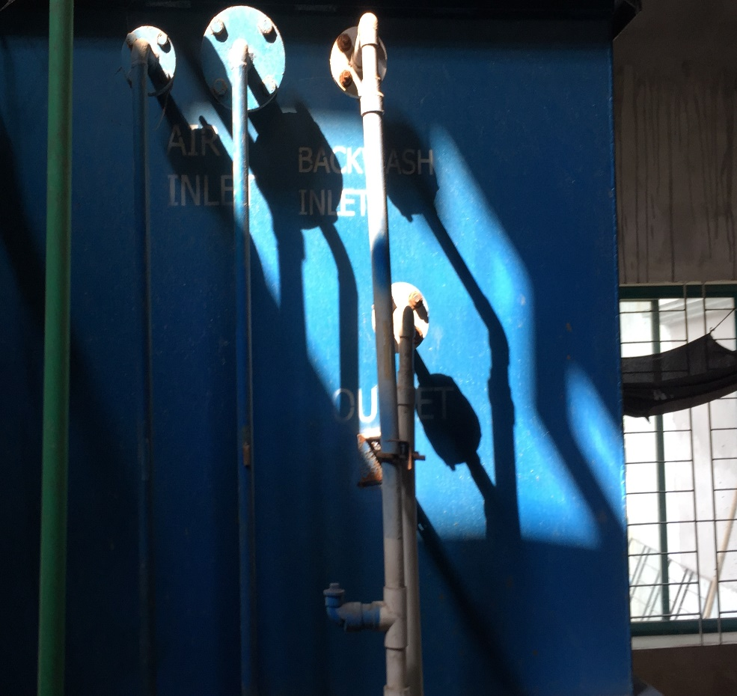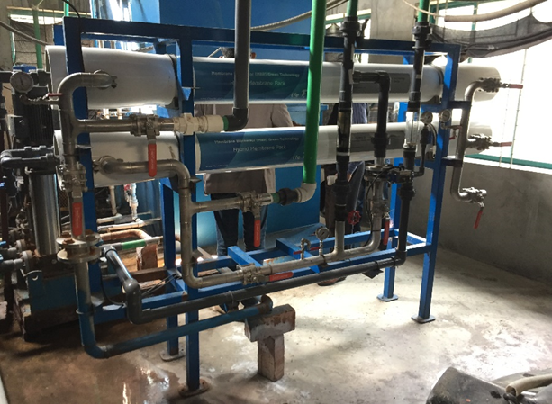

*Figure 1: Industrial MBR-RO Textile Wastewater* Treatment Plant at Gazipur, Bangladesh

* + 1. Current Scenario in Bangladesh

Several researchers identified several rivers in Dhaka, Bangladesh, that are severely polluted by textile effluent discharge. The Burigonga, Turag, and Shitalakkhya rivers, located near major industrial areas, have suffered significant ecological damage due to this pollution (Rampley et al., 2020). The Turag River, for example, exhibits a dark color and strong odor, indicating the presence of high concentrations of pollutants. Studies have shown that the water quality in these rivers often exceeds permissible limits for key parameters such as pH, electrical conductivity (EC), total dissolved solids (TDS), and biochemical oxygen demand (BOD5), all of which point to high levels of pollution. Textile operation (Figure 2 and Table 1) discharges effluent containing high levels of pollutants into inland surface water bodies, exceeding Department of Environment standards for various parameters. This makes the textile industry’s (Figure 2) water footprint significant.

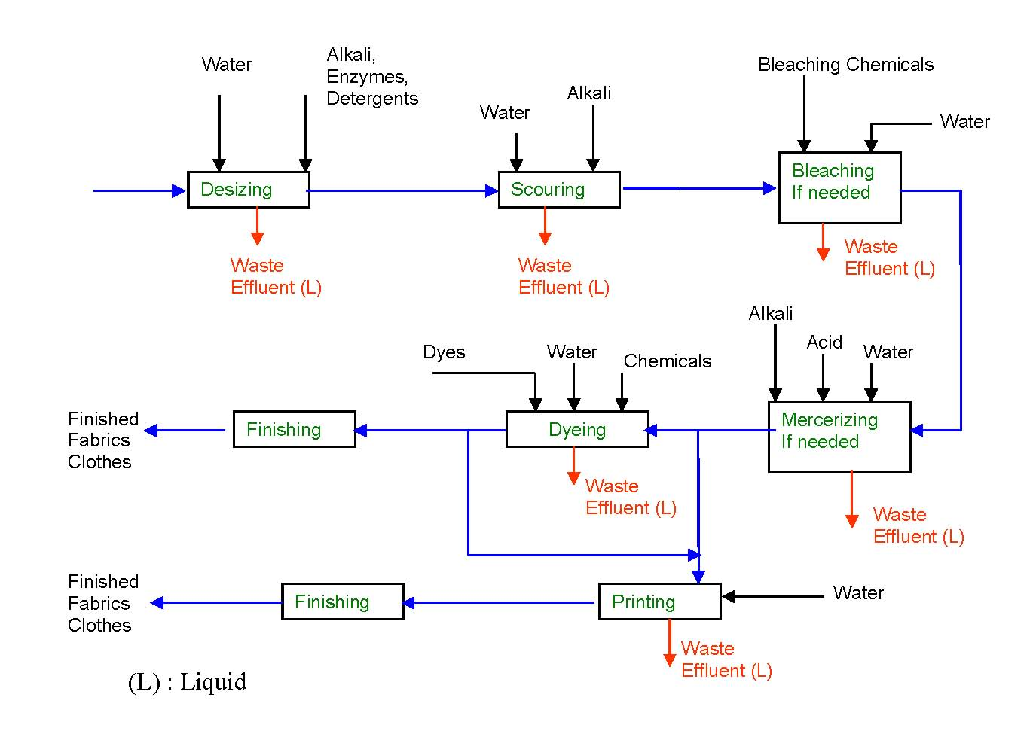

Figure 2: Typical steps of textile process.

Table 1: Typical Characteristics. of Textile. Wastewater (Ahmad et al., 2021).

|  |  |  |  |  |  |  |
| --- | --- | --- | --- | --- | --- | --- |
| Source |  | TSS | TDS | Colour | BOD5 | COD |
|  |  | (mg/l) | (mg/l) | (Pt-Co) | (mg/l) | (mg/l) |
| Knit Dying #1 |  | 279 | 2340 | 3575 | 376 | 1208 |
| Knit Dying #2 |  | 39 | 555 | 733 | 4104 | 11383 |
| WD#1 |  | 1481 | 3520 | 5006 | 2412 | 8364 |
| WD#2 |  | 70 | 1036 | 996 | 2668 | 8618 |
| DW#1 |  | 52 | 219 | 209 | 798 | 1812 |
| DW#2 |  | 38 | 587 | 3350 | 603 | 1440 |

* + 1. Current Studies of RO base textile waste treatment

Local textile factories rely on underground water, causing its depletion. Contaminated water from spills poses public health risks. Considering the situation, the Government of Bangladesh and international importer are encouraging to reclaim textile effluents (Sowgath and Mujtaba, 2017) and adoption the ZLD (Zero Liquid Discharge) and BAT (Best Available Technology) option in the upcoming years (Ahmad, 2021). The color removal efficiency of ETPs, except for Reverse osmosis base, is minimal. Conventional activated sludge plants often fail to meet regulatory standards for textile wastewater. While challenges and costs are associated with these advanced treatment methods, advocating for many industries shift towards more sustainable advanced wastewater treatment MBR-RO combinations to achieve cost-effective reuse/recycle and ZLD.

Over the past decade, Reverse osmosis (RO) has emerged as leading membrane-based solution due to its ability to produce high-quality water while removing dissolved solids and contaminants (Heavy Metals) instead of conventional wastewater treatment to reduce water consumption in textile processing. RO serves as the main purification stage in the advanced treatment system of MBR-RO combinations wastewater treatment. It is responsible for removing the remaining dissolved salts and other contaminants from the pretreatment step, producing high-quality water suitable for reuse within the textile manufacturing process. Membrane Bioreactors (MBRs) act as pre-treatment step to reduce the membrane fouling of RO. MBRs combine biological treatment with membrane filtration, which effectively removes suspended solids and can improve the removal of other pollutants. MBR technology to overcome limitations of conventional processes. The MBR system demonstrated stable effluent quality despite fluctuating feed conditions, a significant advantage over the conventional treatment plant. Due to high fouling and scaling potential while dealing with textile wastewater, single stage RO face limitations in recovery efficiency and operation sustainability. Feed spacers are components within RO modules that promote turbulence and enhance mass transfer, influencing system performance. Membrane characteristics like water permeability and salt permeability directly affect the water and solute fluxes, influencing overall performance. Different membrane types exhibit varying performance levels. The type and pore size of the RO membrane, separation mechanism such as molecular interaction, solution diffusion and other factors influences the overall.

* 1. Evaluation of the process performance via simulation
     1. Model Development

The work uses Aspen Custom Modeler (ACM) v10 software to simulate and optimize the process parameters for different RO wastewater systems. ACM allows the creation of customized models for process equipment and has the flexibility to easily integrate these models for various steady-state and optimization studies in ACM and other Aspen products. In this work RO process model developed by Sowgath and Mujtaba (2017) have been used to investigate the performance of the system. Each element (Figure 3) is modelled which is described in Table 2. Details of physical property correlations and different geometric correlations are in Sassi (2013).

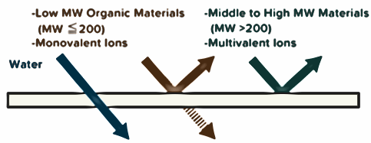

Figure 3: Schematic diagram of structure of element reverse osmosis process.

Table 2: Model equations

|  |  |  |  |  |
| --- | --- | --- | --- | --- |
|  |  |  |  |  |
| Water and Salt mass balance respectively: |  |  |  |  |
| Water and Salt flux respectively |  |  |  |  |
| Concentration polarization |  |  |  |  |
| Mass transfer coefficient and Reynolds No respectively |  |  |  |  |
| Average bulk flow and Average velocity in feed side |  |  |  |  |
| Recovery % and Salt rejection % respectively |  |  |  |  |
| Pressure drop and Specific energy |  |  |  |  |

* 1. Evaluation of the process performance via simulation
     1. RO Membrane Model Parameter Estimation

Firstly, the simulation model of an individual RO model of a vessel (Figure 4) Sowgath and Mujtaba (2017) is validated against experimental data from the manufacturing document. Membrane parameters and spacer characteristics and feed operating conditions of the model (Shown in Table 3) are taken from Manufactured document except *hsp* (Reported by Sassi) and *Lf* (Reported by Sassi). The data on water recovery and salt rejection found in a manufactured document is compared with those predicted by this work is shown in Table 4. Different design parameters such as *Aw* and *As* estimated also shown in Table 4 based on the Table 3 data.

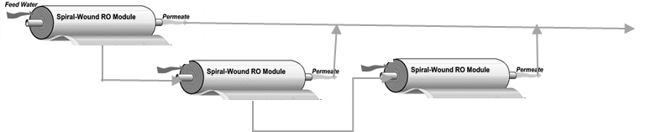

Figure 4: Schematic diagram of structure of series reverse osmosis process.

Table 3: The characteristics of spiral wound membranes Manufacturer Document

|  |  |
| --- | --- |
| Parameter | Element type |
| TML20D-400 Low fouling |
| Diameter of the element (m) | 0.201 |
| Membrane module area (m2) | 37 |
| Module Feed flow range (m3/d) | 31.8-39.7 |
| Maximum operating pressure (bar) | 41 |
| Salt Rejection | 99.65-99.8 |
| Water Recovery | 15 |
| Salt permeability (m/s) | 5.65×10-8 |

Table 4: Membrane parameters and spacer characteristics and feed operating conditions

|  |  |  |  |  |  |  |  |  |  |  |
| --- | --- | --- | --- | --- | --- | --- | --- | --- | --- | --- |
| TML20D-400 Spiral wound RO Membrane parameters and spacer characteristics | | | | | | | | | |  |
| Parameter | *hsp*(m) | | *dh*(m) | | *A* (m2) | *Lf* (m) | | *L* (m) | | *w* (m) |
| Value | 5.93×10-4 | | 8.126×10-4 | | 37 | 2.77×10-3 | | 1.0 | | 37. |
| Feed operating conditions | | | | | | | | | | |
| Parameter | | *Qf*(m3/h) | | *Cf* (ppm) | | | *Pf* (psi) | | *To*(°C) | |
| Value | | 30 | | 2000 | | | 225 | | 25 | |
| Rejection | | | | | | | | | | |
| Parameter | | Input Data | | Parameter | | | Water permeability | | Salt permeability | |
| Water recovery % | | 15 | | Value Predicted | | | *Aw*(m/bar s) | | *As*(m/ s) | |
| Salt rejection % | | 99.97 | | By Parameter Estimation | | | 9.08×10-5 | | 1.1834×10-9 | |

Operating condition of NaCl in the manufactured document of TML20D-400 were used to obtain parameters using parameter estimation technique. These estimated parameters were used for the prediction of separation data as shown in Table 4 and compared with the experimental values obtained earlier (Table 3).

* + 1. Pant Model Validation

Single stage RO face limitations in recovery efficiency and operation sustainability. MBR-RO textile treatment performance operation data shown in Table 4. Table 4 shows that because RO treatment reduces the salt contain by 90% and 85% color removed whereas MBR reduces the RO membrane fouling by reducing organic pollutant (Suspended solid, Larger Molecular weight organic). The performance test data shows that RO unit produce high-quality water from MBR effluent that is suitable for reuse in textile process. MBR with RO successfully processes the textile wastewater within the reuse specification, which aligns with the findings from literatures (Zahraa and Gzar, 2019). Theplant data NICE Cotton Limited, Gazipur Table 5 shows that textile dyes need additional treatment beyond MBR.RO act as polishing steps to further remove residual colour after MBR removal.

Table 5: Water Parameters of MBR-RO Plant

|  |  |  |  |  |  |
| --- | --- | --- | --- | --- | --- |
| Parameter | Untreated Wastewater | MBR Treated Water | Feed RO | Permeate from RO | Rejection from RO |
|  |  |  |  |  |  |
| TDS (mg/L) | 2200 | 2041 | 2041 | 18 | 3064 |
| TSS (mg/L) | 180 | 3 | 3 | 0 | 3 |
| Color (Pt-Co) | 2500 | 300 | 300 | BDL | 550 |
| BOD (mg/L) | 350 | 7 | 7 | 2 | 9 |
| COD (mg/L) | 1178 | 51 | 51 | 5 | 55 |
| pH | 11 | 8 | 8 | 7.5 | 7.8 |

The fundamentals of RO process configuration are challenged by the difficulties in managing RO concentrate, membrane fouling, scaling, and feed pretreatment (Cohen et al., 2017).

Design patterns have been developed as two stage RO module arranged in series stages of RO Plant at NICE Cotton Limited is assumed where 3 elements in series in each stage, where the permeate stream of the first stage is the feed of the s subsequent stage, and this continues onward. The model has been validated against the operational data and a good agreement was observed and are shown in Table 6.

Table 6: Comparison between RO Plant Data at NICE Cotton Limited, Gazipur and this work results

|  |  |  |  |  |
| --- | --- | --- | --- | --- |
| Parameter |  | Plant Data |  | This work |
| Water recovery % |  | 70 |  | 70 |
| Salt rejection % |  | 73 |  | 73 |

Textile wastewater typically contains a high proportion of non-ionic surfactants and other organic and non-organic compounds. For simpler case, RO process in relation to different compound removal efficiency of textile wastewater expressed as derivatives of similar compound to those of (Al-Obaidi, 2023) shown in Table 7 due to scarcity of experimental data related to textile process. The same parameters are used for further study. The rejection abilities of the membrane WR and SR for multi component are shown in the Table 8.

Table 7: Multi component

|  |  |
| --- | --- |
| Textile Chemicals | Similar Components for which RO data available |
| Glauber’s salt, Dye, surfactant | Sulfate |
| Azo based Dye | N-Nitrosodimethyamine |
| Prussian blue iron, cyanide compound | Cyanide |
| Aniline Dye, methylene green | Aniline |
| Dye Solvent | Ammonium |
| Acid Dye, Direct dye Natural Dye | Phenol group |
| Synthetic Dye | Chlorophenol |

Table 8: Comparison operational data with and this work results

|  |  |  |  |  |  |  |  |  |
| --- | --- | --- | --- | --- | --- | --- | --- | --- |
| Source/Parameter As(m/ s) | TDS/NaCl | Cyanide | Aniline | Ammonium | Phenol | Dimethylphenol | | Sulphate |
| Mudhar As(m/ s) | 1.749×10-8 | 2.186×10-6 | 4.19×10-6 | 1.169×10-6 | 6.536×10-7 | 2.225×10-8 | | 3.987×10-8 |
| This Work As(m/ s) | 1.183×10-9 | 1.479×10-7 | 2.835×10-7 | 7.910×10-8 | 4.422×10-8 | 8.468×10-8 | | 2.698×10-9 |
| Case :Prediction for WR 70% (Permeate to Reject ratio 70:30) composition S | | | | | | | | |
| SR % @ 29.25 bar | 98.87% | 98.87% | 98.87% | 98.87% | 98.87% | | 98.87% | 98.87% |
| SR % @ 31.17 bar | 99..99% | 99..99% | 99..99% | 99..99% | 99..99% | | 99..99% | 99..99% |

Textile wastewater contains a variety of complex organic dyes that can significantly alter the color of the effluent, even at low concentrations. Consequently, investigating dye color removal is critical following the assessment of dissolved organic removal addressed earlier. To this end, the current model is further incorporated to simulate red dye (Lancron) for 50 ppm concentration, where a power law formula is developed for removing acid dye by Abid (2012), and results are presented in Table 9. Dye color removal efficiency depends on various parameters, notably pH, pressure, initial dye concentration, and TDS. The RO process reaches near-optimal dye removal efficiency (greater than 99%) at pressures between 26.37 and 27.65 bar. Interestingly, excessive pressure, higher initial dye concentration, and other dissolved solids can lead to issues like concentration polarization or membrane fouling, which can reduce efficiency locally. Moreover, trace dye concentrations (~0.006 ppm) show almost complete removal. Dye removal is effective at lower TDS levels but becomes inconsistent at higher TDS concentrations.

Table 9: Comparison operational data with and this work results

|  |  |  |  |  |  |  |  |  |  |  |  |  |  |  |  |
| --- | --- | --- | --- | --- | --- | --- | --- | --- | --- | --- | --- | --- | --- | --- | --- |
| Parameter | | | | TDS/NaCl | | | | | | | Acid Red Dye | | | | |
| SR % | | | | 98.87% | | | | | | | 95.17% | | | | |
| Correlation parameters Equation by Abid, (2012) | | | | | | a0 67.6889 | | a1 0.0316 | | a2 0.0563 | | | a3 0.0336 | | a4-0.0002 |
| P | 29.26 | 29.26 | 26.95 | | 28.42 | | 26.37 | | 27.65 | | | 25.83 | | 26.95 | |
| C | 25.000 | 0.928 | 0.186 | | 0.051 | | 0.016 | | 0.006 | | | 0.002 | | 0.001 | |
| pH | 7 | 7 | 7 | | 7 | | 7 | | 7 | | | 7 | | 7 | |
| TDS | 2000 | 3133.91 | 2208.34 | | 3626.94 | | 2456.83 | | 4285.96 | | | 2758.74 | | 5212.57 | |
| F | 96.29 | 79.93 | 72.81 | | 67.75 | | 63.41 | | 59.99 | | | 56.85 | | 54.28 | |

* 1. Conclusions

Substantial wastewater generation from textile sector leads to environmental concerns. This study explores a multi-stage RO process model integrated into an MBR-RO treatment system at Nice Cotton Limited, Bangladesh, using the Aspen Custom Modeler. Model validation shows good agreement with industrial data, proving the reliability of multi-stage RO for water reuse. The findings indicated that increasing pressure and the number of stages improves organic dissolved contaminant removal. Moreover, optimum dye color removal is influenced by factors like pH and feed dissolved solid concentration. Operational data and model prediction MBR-RO demonstrate a cost-effective and scalable solution for reusing textile wastewater and reducing freshwater dependency.

References

Ahmad M., Abir M. A., Khan M. S., 2021, Technical and Economic Aspects of Reusing Textile Effluent as Process Water: A Case Study of Denim Washing Factory, Chemical Engineering Research Bulletin, 22, 127.

Abid M.F., Zablouk M.A., Abid-Alameer A.M., 2012, Experimental study of dye removal from industrial wastewater by membrane technologies of reverse osmosis and nanofiltration, J Environ Health Sci Engineer 9, 17.

Ahmad M., 2021, Study of Ultrafiltration and Reverse Osmosis Membrane Processes for Advanced Treatment and Recycling of Textile Effluent in Bangladesh, MSc Thesis, Department of Chemical Engineering, Bangladesh University of Engineering and Technology (BUET), Dhaka, Bangladesh.

Al-Obaidi M.A., 2023, Towards improved removal of multicomponent from wastewater using a predefined multistage direct pass of reverse osmosis, Korean Journal of Chemical Engineering, 40, 1731–1745.

Cohen Y., Semiat R., Rahardianto A., 2017, A perspective on reverse osmosis water desalination: Quest for sustainability, AIChE J., 63: 1771-1784.

DoE, 2020, Performance Evaluation of Zero Liquid Discharge-Effluent Treatment Plants (ZLD-ETPs) in Textile Industries of Bangladesh, Department of Environment, Bangladesh < https://doe.portal.gov.bd/ > accessed 04.02.2025.

Humayra S., Hossain L., Hasan S. R., Khan M. S., 2023, Water Footprint Calculation, Effluent Characteristics and Pollution Impact Assessment of Leather Industry in Bangladesh, Water, 15, 378.

Islam M. R., Mostafa M. G., 2019, Textile Dyeing Effluents and Environment Concerns - A Review. Journal of Environmental Science and Natural Resources, 11, 131-144.

Lu X., Liu L., Liu R., Chen J. 2010, Textile wastewater reuse as an alternative water source for dyeing and finishing processes: A case study. Desalination, 258, 229-232.

Rahman T. U., Roy H., Islam M. R., Tahmid M., Fariha A., Mazumder A., Tasnim N., Pervez M. N., Cai Y., Naddeo V., Islam, M. S., 2023, The Advancement in Membrane Bioreactor (MBR) Technology toward Sustainable Industrial Wastewater Management. Membranes, 13, 181.

Rampley C. P. N., Whitehead P. G., Softley L., Hossain M. A., Jin L., David J., Shawal S., Das P., Thompson I. P., Huang W. E., Peters R., Holdship P., Hope R. and Alabaster G., 2020, River toxicity assessment using molecular biosensors: Heavy metal contamination in the Turag-Balu-Buriganga river systems, Dhaka, Bangladesh, Science of The Total Environment, 703, 134760.

Sassi K. M., 2013, Optimal scheduling, design, operation and control of reverse osmosis desalination. Prediction of RO membrane performance under different design and operating conditions, synthesis of RO networks using MINLP optimization framework involving fouling, boron removal, variable seawater temperature and variable fresh water demand, PhD Thesis, University of Bradford, Bradford, UK.

Sowgath M. T., Mujtaba, I. M., 2017, Design of Reverse Osmosis Process for the Purification of River Water in the Southern Belt of Bangladesh. Chemical Engineering Transactions*,* 61**,** 1159-1164.

Zahraa S. H., Gzar, H. A., 2019, Evaluation of the Performance of MBR-RO Technology for Treatment of Textile Wastewater and Reuse. IOP Conference Series: Materials Science and Engineering, 584, 012049.