 CHEMICAL ENGINEERING TRANSACTIONS  VOL. xxx, 2025 | A publication of  
The Italian Association
of Chemical Engineering
Online at www.cetjournal.it

Guest Editors: Fabrizio Bezzo, Flavio Manenti, Gabriele Pannocchia, Almerinda di Benedetto
Copyright © 2025, AIDIC Servizi S.r.l.
ISBN 979-12-81206-17-5; ISSN 2283-9216

Surface-Tension Modelling of Pure Fluids Using the Gradient Theory Coupled with a Cubic EoS
Ricardo Macías-Salinas^{a,}*, Obed A. Solis-González^{b}
ªSEPI-ESIQIE, Departamento de Ingeniería Química, Instituto Politécnico Nacional, Zacatenco, Ciudad de México 07738, MEXICO
^{b}Departamento de Ingeniería Química y Bioquímica, Instituto Tecnológico de La Piedad, La Piedad, Michoacán 59370,
MEXICO
*rms@ipn.mx

The well-known Gradient Theory of Fluid Interfaces (GTFI) was coupled with a simple cubic equation of state (CEoS) to accurately calculate the surface tension of non-polar, polar, and associating fluids over a wide temperature range, from the triple point to the critical region. For most of the pure fluids studied, a remarkably accurate representation of experimental surface tensions was obtained near their critical points, even though the homogeneous fluid portion of the GTFI was modelled using a simple CEoS, which typically fails to accurately describe fluid phase behavior near the critical point. To mitigate this limitation of the CEoS within the GTFI framework, a new scaling function for the influence parameter of the inhomogeneous fluid was introduced. The proposed expression for the influence parameter, which carries information about the molecular structure of the interface, proved highly satisfactory when combined with the Soave-Redlich-Kwong or Peng-Robinson CEoS in representing the experimental surface tensions of various pure fluids, including normal paraffins, aromatics, CO₂, SF₆, alcohols, water, acetone, and others.

  - Introduction
Surface tension plays a key role in various areas of industry, such as the development of paints, detergents, agrochemicals, and particularly in the oil industry. In the latter, specifically during the oil extraction process, surface tension predominantly governs the dynamics of oil flow through the capillary channels present in fractured reservoirs. In general, surface tension has a direct effect on the mass- and heat-transfer rates across a liquid-vapor interface. Therefore, a reliable thermodynamic model is required to accurately estimate the behaviour of surface tension for various substances (non-polar, polar, and associating) over a wide temperature range: from the triple point up to the critical point. According to the open literature, one of the most widely used techniques for modelling the surface tension of pure fluids is the so-called Gradient Theory for Fluid Interfaces (GTFI). Several researchers have successfully applied GTFI to represent gas-liquid interfacial tensions for a wide variety of pure fluids, mostly non-polar substances, over moderate temperature ranges (Carey et al., 1978; Guerrero and Davies, 1980; Cornelisse et al., 1996; Zu and Stenby, 1997; Miqueu et al., 2003; Sher et al., 2005). Based on the above, we presently developed a mathematical model based on GTFI for the accurate correlation of experimental surface tension data for non-polar, polar and associating fluids over a wide temperature range, including the region near the critical point. An attractive feature of the model developed here lies in the fact that the homogeneous fluid portion within the GTFI formalism was estimated using a simple cubic equation of state (EoS), such as the formulations proposed by Soave-Redlich-Kwong (1972) and Peng-Robinson (1976).

  - Description of the Model
The GTFI, also known as the van der Waals theory for non-homogeneous fluids, was revisited and modified by Bongiorno and Davies (1975). The modification proposed by these authors is based on the general van der Waals fluid model for rigid spheres with attractive forces. Bongiorno and Davies (1975) proposed the following relationship between the thermodynamic potential and the density gradient:

$\frac{d}{dx}\left[\frac{1}{2}m{\left(\frac{dρ}{dx}\right)}^{2}\right]=\frac{dΩ}{dρ}$ (1)

where x is the coordinate perpendicular to the interface, m is the influence parameter, ρ is the fluid density, and Ω is the thermodynamic potential defined as follows:

$Ω=A−ρ⋅μ$ (2)

here, A and μ represent the Helmholtz free energy and the chemical potential, respectively. The boundary conditions necessary to solve the differential equation given by Eq. (1) are:

$ρ\left(x→−∞\right)=ρ_{V}$ (3)
$ρ\left(x→∞\right)=ρ_{L}$ (4)

where the subscripts refer to the saturated vapor (V) and liquid (L) phases. Accordingly, the surface tension of a pure fluid across a planar vapor-liquid interface is expressed as follows:

$\text{σ=}\int_{ρ_{V}}^{ρ_{L}}{{\left[−2m\left(ρ\right)W\left(ρ\right)\right]}^{1/2}dρ}$ (5)

where the function -W(ρ) represents the negative of an excess pressure and the influence parameter m represents the contribution of molecular interactions to the energy required to form a gradient in density or concentration. Within the GTFI formalism, -W(ρ) is expressed as follows:

$−W\left(ρ\right)=P−ρ⋅μ\left({T,ρ}_{V,L}\right)+ψ\left(T,ρ\right)$ (6)

where P corresponds to the saturation pressure (acting within the bulk phase when the interface is considered planar), while $μ\left({T,ρ}_{V,L}\right)$ is the chemical potential of the global fluid along the saturation line, obtained as follows:

$μ\left({T,ρ}_{V,L}\right)={\left(\frac{∂ψ\left(T,ρ\right)}{∂ρ}\right)}_{T}$ (7)

Above, $ψ\left(T,ρ\right)$ defines a local free energy density within the two-phase region: $ρ_{V}≤ρ≤ρ_{L}$. A convenient way to calculate the thermodynamic properties involved in the GTFI formalism is through the use of a cubic equation of state (CEoS). However, it remains to define the function i$ψ\left(T,ρ\right)$ in terms of thermodynamic properties that can be easily calculated from a CEoS; this function has units of pressure and is given by,

$ψ\left(T,ρ\right)=ρ⋅A^{r}\left(T,ρ\right)$ (8)

where A^{r} is the residual Helmholtz energy for a pure fluid. Additionally, the chemical potential can also be expressed in terms of A^{r}. From Eq. (7), we have:

$μ\left({T,ρ}_{V,L}\right)=\frac{P}{ρ_{V,L}}{+A}^{r}\left({T,ρ}_{V,L}\right)$ (9)

Therefore, all thermodynamic potentials present in the GTFI formalism (P, ρ, and A^{r} at saturation) were readily estimated using an EoS (Soave-Redlich-Kwong SRK or Peng-Robinson PR). Returning to Eq. (5) and assuming that the influence parameter m is independent of the density, the surface tension can be estimated as follows:

$\text{σ=}\sqrt{2m}⋅\int_{ρ_{V}}^{ρ_{L}}{{\left[−W\left(ρ\right)\right]}^{1/2}dρ}$ (10)

where the integral on the right-hand side of the equation (representing the homogeneous fluid within the GTFI) was numerically evaluated using the Gauss-Konrod quadrature. On the other hand, the functionality of the influence parameter m (representing the non-homogeneous fluid with the GTFI) plays a key role in the correct representation of the experimental surface-tension data. In general, from available experimental surface tensions, back-calculated m values indicate that the influence parameter varies almost linearly from the triple point up to the boiling point, however, in the vicinity of the critical point, there is a pronounced exponential growth of the influence parameter with respect to temperature. Accordingly, we found that the following expression captures rather well the variation of m with the reduced temperature (T_{r}) from the triple point up to the critical point:

$m=C_{0}+{C_{1}⋅\sqrt{T_{r}}⋅ρ_{c}}/{\left(ρ_{L}−ρ_{c}\right)}$ (11)

where ρ_{L} and ρ_{c} are the liquid and the critical densities, respectively, yielded by the CEoS, whereas C₀ and C₁ are two parameters that should be fitted to experimental surface tensions of the pure fluid of interest. In the specific case of water and alcohols, which are typical hydrogen-bond formers due to their hydroxyl groups, a slightly modified version of Eq. (11) yielded better results, as shown below:

$m=C_{0}⋅T_{r}+{C_{1}⋅\sqrt{T_{r}}⋅ρ_{c}}/{\left(ρ_{L}−ρ_{c}\right)}$ (12)

3. Results and Discussion
The present modeling approach (Eqs. 6 and 10 to 12) was applied to the correlation of experimental surface tension of selected pure fluids which included four linear alkanes, CO₂, two aromatics, one sulfur-based compound (SF₆), water, two alkanols, H₂S, ammonia, acetone, and dimethyl ether. A least-square fit based on the differential-evolution global optimization method was then performed to obtain the model parameters, namely C₀ and C₁. The minimization of the following objective function served for such a purpose:

$\text{min }f=\sum_{\text{j=}1}^{N}{{\left[1−{σ_{j}^{\text{cal}}}/{σ_{j}^{\text{exp}}}\right]}^{2}}$ (13)

where N is the number of experimental points, whereas σ^{exp} and σ^{cal} stand for the observed and calculated surface tensions, respectively. Table 1 lists the pure fluids considered here along with their temperature ranges, the proximity to their critical temperatures (T_{c}) and the sources of their experimental surface-tension data. As seen in this table, the experimental surface tensions cover nearly the entire saturation line, from the triple point to just below the critical point of the pure fluid of interest, with T_{c} proximities close to one in most cases. Prior to the application of the present GT-based surface-tension model, critical pressures and temperatures as well as acentric factors of each fluid should be available as inputs needed by both CEoS. These properties are listed in Table 2. On the other hand, Table 3 summarizes the optimized C₀ and C₁ parameters for each fluid, along with the correlation results in terms of absolute average relative deviations between the experimental and calculated surface tensions (AAD values) yielded by the present GT-based model, which was coupled with the SRK and PR CEoS. Table 3 reveals that the ability of the present GT modeling approach in representing the experimental data was remarkably good with overall AAD values of 1.67% using the SRK CEoS, and 1.78% using the PR CEoS based on a total of 523 data points.
Table 1: Experimental reference data for the 15 fluids considered here
Component | N | T, K | T_{c} Proximity | Source
Methane | 23 | 90.69 – 190.56 | 0.993 | NIST Webbook (2024)
Propane | 32 | 88.52 – 369.89 | 0.998 | NIST Webbook (2024)
n-Pentane | 36 | 143.47 – 469.75 | 0.999 | NIST Webbook (2024)
n-Decane | 41 | 243.5 – 617.75 | 0.996 | NIST Webbook (2024)
CO₂ | 21 | 216.59 – 304.13 | 0.997 | NIST Webbook (2024)
Cyclohexane | 32 | 279.86 – 553.65 | 0.999 | NIST Webbook (2024)
Toluene | 46 | 178 – 591.75 | 0.996 | NIST Webbook (2024)
SF₆ | 24 | 223.55 – 318.72 | 0.995 | NIST Webbook (2024)
Water | 47 | 273.16 – 647.1 | 0.999 | NIST Webbook (2024)
Methanol | 36 | 175.61 – 512.65 | 0.981 | NIST Webbook (2024)
Ethanol | 35 | 180.12 – 514.71 | 0.978 | NIST REFPROP (2024)
H₂S | 40 | 187.7 – 373.15 | 0.997 | NIST Webbook (2024)
Ammonia | 44 | 195.49 – 405.56 | 0.997 | NIST Webbook (2024)
Acetone | 36 | 178.5 – 508.1 | 0.990 | NIST REFPROP (2024)
Dimethyl Ether | 30 | 131.66 – 400.38 | 0.994 | NIST REFPROP (2024)

Table 2: Pure-component physical properties needed as model inputs
Component | M, g/mol | P_{c}, bar | T_{c}, K | ω
Methane | 16.0425 | 45.992 | 190.564 | 0.01142
Propane | 44.0956 | 42.512 | 369.89 | 0.1521
n-Pentane | 72.1488 | 33.765 | 469.75 | 0.251
n-Decane | 142.2817 | 21.03 | 617.75 | 0.4884
CO₂ | 44.0095 | 73.773 | 304.1282 | 0.22394
Cyclohexane | 86.161 | 40.805 | 553.65 | 0.2096
Toluene | 92.1384 | 41.263 | 591.75 | 0.2657
SF₆ | 146.055 | 37.54984 | 318.7232 | 0.218
Water | 18.0153 | 220.64 | 647.096 | 0.3443
Methanol | 32.0419 | 81.035 | 512.65 | 0.5625
Ethanol | 46.068 | 62.68 | 514.71 | 0.646
H₂S | 34.081 | 90.0 | 373.15 | 0.1005
Ammonia | 17.0305 | 113.634 | 405.56 | 0.256
Acetone | 58.079 | 46.924 | 508.1 | 0.3071
Dimethyl Ether | 46.068 | 53.368 | 400.38 | 0.196
C₀ and C₁ in dyne²-cm⁴/bar-mol²

Table 3: Optimized parameters & model performance in terms of AAD values
Component | N | GT Regressed Parameters  C₀-SRK C₁-SRK C₀-PR C₁-PR | GT Model Performance  % AAD SRK % AAD PR
Methane | 23 | 1.2309 2.4996 0.9415 1.7272 | 1.13 1.12
Propane | 32 | 6.4250 19.752 4.9551 13.621 | 1.84 1.89
n-Pentane | 36 | 28.866 29.697 21.271 19.659 | 0.41 0.42
n-Decane | 41 | 147.39 103.10 107.70 66.891 | 2.54 2.94
CO₂ | 21 | 1.7427 3.8461 1.3029 2.6268 | 0.91 1.02
Cyclohexane | 32 | 30.066 43.020 22.209 29.010 | 1.46 1.66
Toluene | 46 | 38.999 32.824 28.554 21.406 | 2.22 2.61
SF₆ | 24 | 9.9616 8.7468 7.1440 5.8481 | 1.74 1.58
Water | 47 | 1.0233 5.0148 0.9149 3.4095 | 0.45 0.48
Methanol | 36 | -5.6468 19.412 -3.5117 13.683 | 1.49 1.66
Ethanol | 35 | -9.9785 35.745 -6.3050 25.379 | 1.48 1.49
H₂S | 40 | 1.6037 6.0590 1.2570 4.2137 | 1.99 2.01
Ammonia | 44 | 1.2076 4.3283 0.9338 2.9920 | 1.80 1.86
Acetone | 36 | 9.6804 44.523 7.5830 31.005 | 3.14 3.12
Dimethyl Ether | 30 | 7.3024 9.7036 5.4176 6.5025 | 1.99 2.22
OVERALL | 523 |  | 1.67 1.78
These encouraging results demonstrate the suitability of the mathematical expressions (Eqs. 11 and 12) used to represent the influence parameter. Despite the fact that the PR CEoS provides density data with higher accuracy compared to the SRK CEoS, surprisingly, the latter produced better surface-tension correlation results, with lower AAD values both globally and individually (in most cases), as shown in Table 3. This result very likely suggests that the density functionality provided by the SRK CEoS is better suited for integration within the present GT formalism than that of the PR CEoS. Example correlating results are graphically shown for four non-polar fluids using GT-SRK approach (Figure 1) and also for four polar and associating fluids using the GT-PR approach (Figure 2).
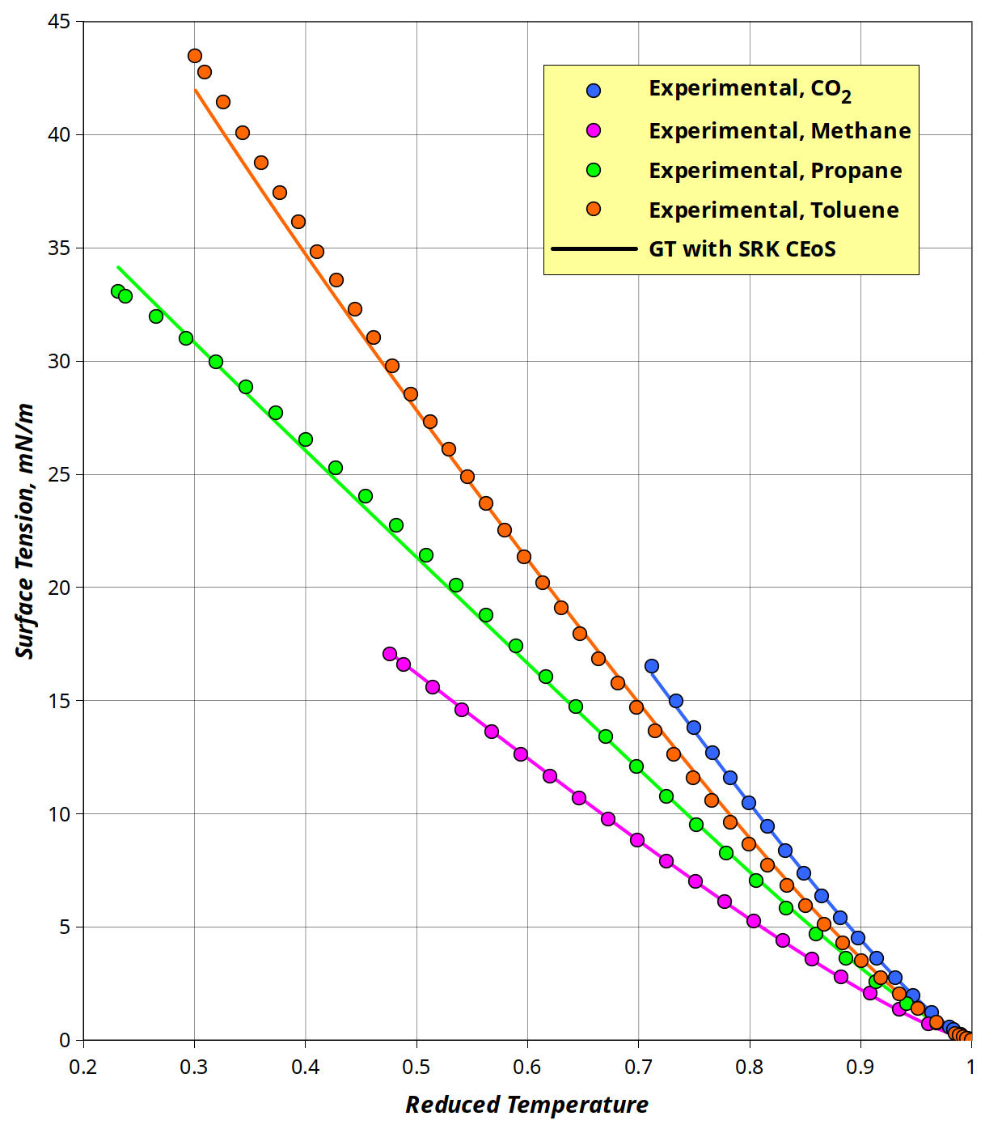  Figure 1: Model performance in correlating the surface tension of  four non-polar substances | 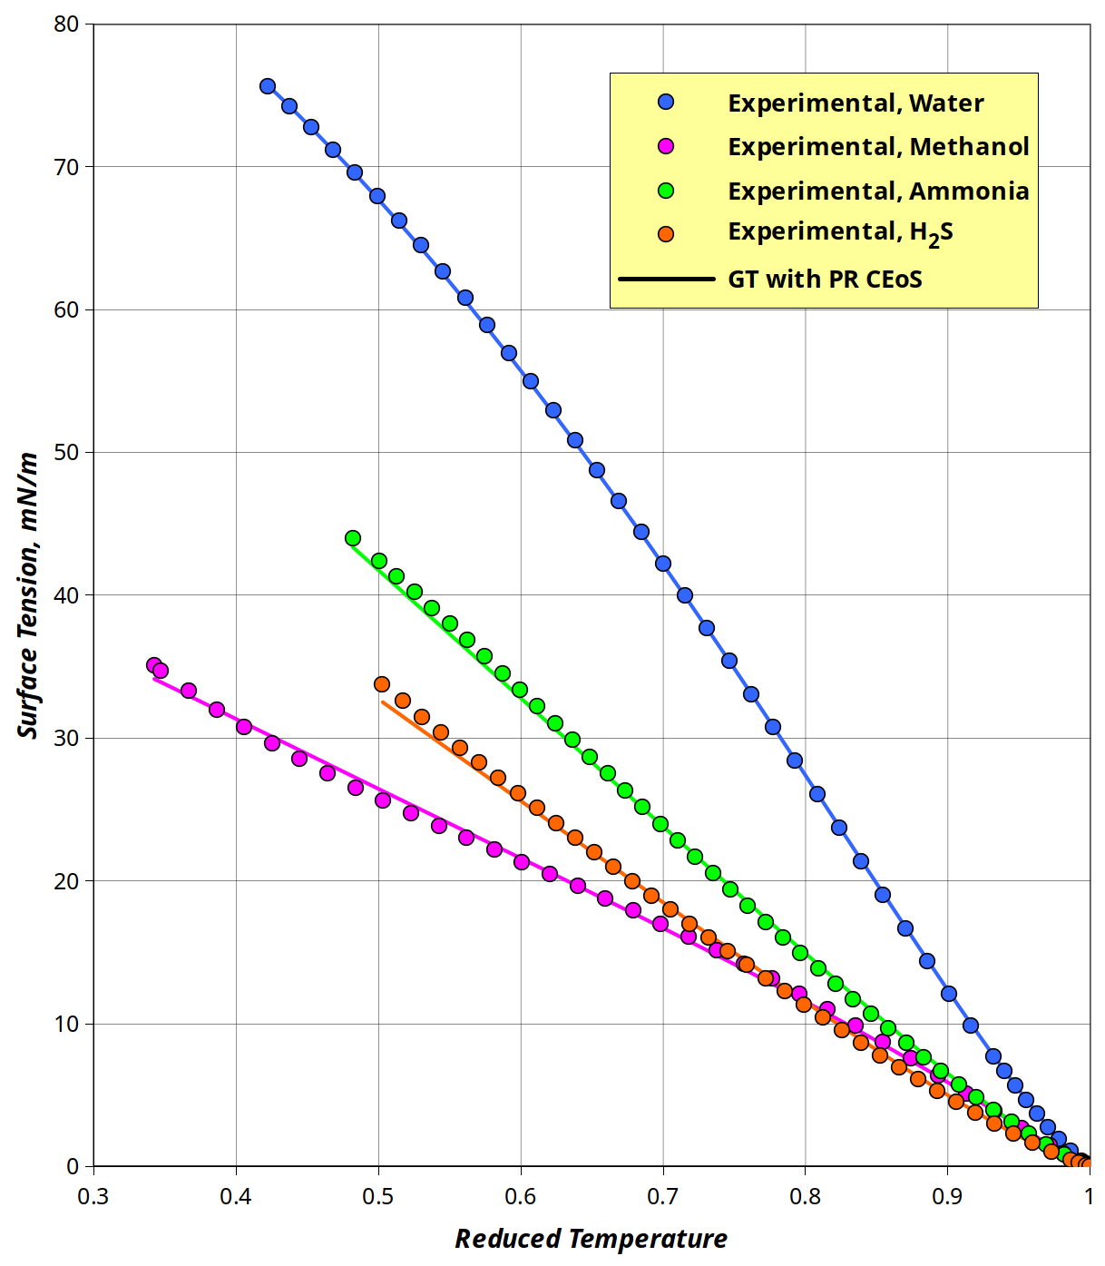  Figure 2: Model performance in correlating the surface tension of  four polar & associating substances
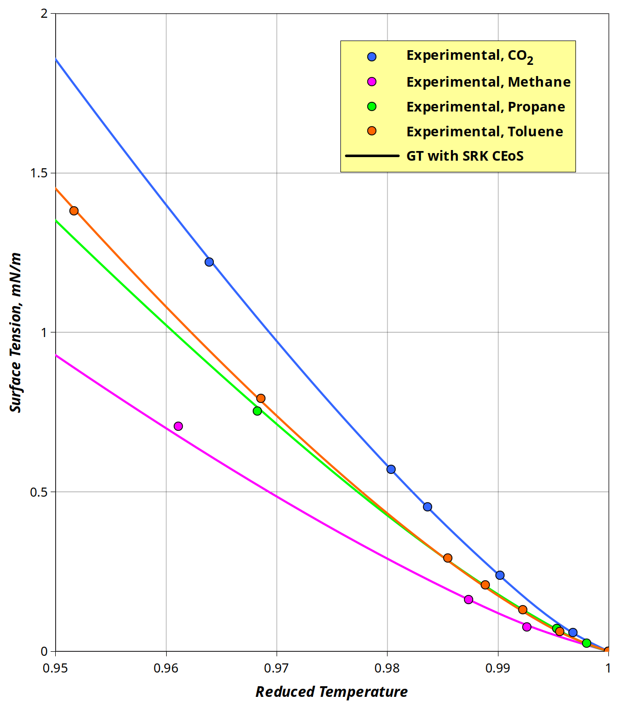  Figure 3: Model performance in representing the surface tension of  four non-polar substances near their critical points | 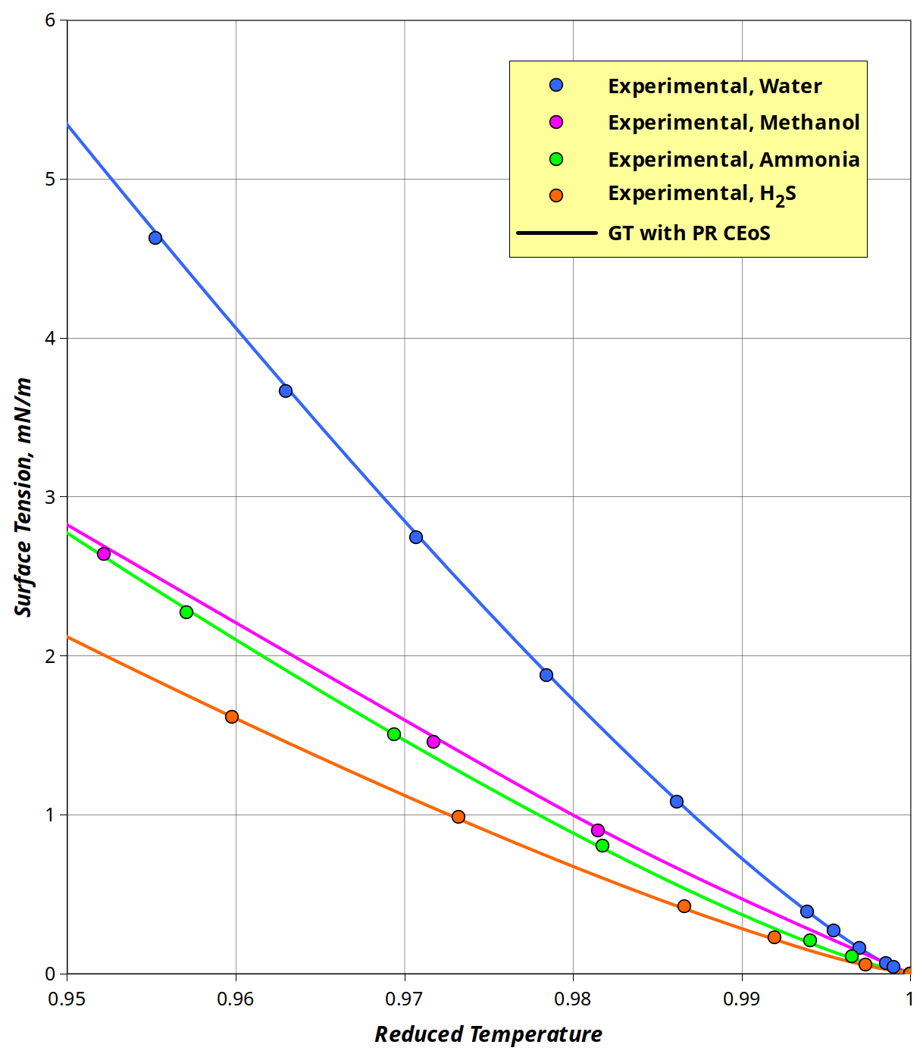  Figure 4: Model performance in representing the surface tension of  four polar & associating substances near their critical  points
As shown by these figures, the present GT-based model represents remarkably well the experimental surface tensions of the eight fluids along their entire saturation lines: from their triple points up to their critical points where surface tension vanishes. As a matter of fact, as seen in Figures 1 and 2, the present model tends to either underestimate or overestimate the experimental surface tensions for most fluids as their triple points are approached, except in the cases of toluene and water, this finding may be attributed to the limitation of the Soave alpha function (used by both CEoS) in yielding vapor pressure data of good accuracy near the triple point of the fluid. Furthermore, the present model makes a pretty good job in representing with good accuracy the low experimental surface tensions exhibited by the eight fluids very near their critical points as depicted by Figures 3 and 4 within a 0.95 proximity to T_{c}. These results again demonstrate the suitability of the proposed expressions to properly capture the variation of the influence parameter with temperature.

Conclusions
A simple yet theoretically sound surface-tension model, using the gradient theory with new expressions for the influence parameter and coupled with a simple cubic equation of state, is presented here for the improved surface tension representation of pure fluids along their entire saturation lines. The performance of the present modeling approach was highly satisfactory during the representation of experimental surface-tension data of several fluids varying in polarity and associating abilities from low to high molar masses. In the particular case of those highly polar and associating substances (such as water, methanol and ethanol) the present GT model yielded a significantly improved surface-tension representations.

References
Bongiorno V., Davies H.T., 1975, Modified Van der Waals theory of fluid interfaces. Phys. Rev. A, 12, 2213.
Carey B.S, Scriven L.E, Davis H.T., 1978, Semiempirical theory of surface tensions of pure normal alkanes
and alcohols. AIChE J., 24, 1076.
Cornelisse P.M.W, Peters C.J, Arons J.S., 1993, Application of the Peng-Robinson equation of state to
calculate interfacial tensions and profiles at vapour-liquid interfaces. Fluid Phase Equilibria, 82, 119.
Guerrero M.I., Davies H.T., 1980. Gradient theory of surface tension of water. Ind. Eng. Chem. Res., 19, 309.
Miqueu C., Mendiboure B., Graciaa A., Lachaise J., 2003, Modelling of the surface tension of pure
components with the gradient theory of fluid interfaces: a simple and accurate expression for the influence
parameters. Fluid Phase Equilibria, 207, 225.
Sher I., Haber S., Hetsroni G., 2005, A new state model of liquid–vapor interfaces—to yield analytical
expression for surface tension. Chem. Eng. Sci., 60, 711.
Soave G., 1972, Equilibrium constants from a modified Redlich-Kwong equation of state. Chem. Eng. Sci., 27,
1197.
Peng D,Y,, Robinson D.B., 1976, A new two-constant equation of state. Ind. Eng. Chem. Fundam., 15, 59.
Zu Y.X., Stenby E.H., 1997, Calculation of interfacial tensions with gradient theory. Fluid Phase Equilibria,
132, 139.

