 CHEMICAL ENGINEERING TRANSACTIONS  VOL. xxx, 2025 | A publication of  
The Italian Association
of Chemical Engineering
Online at www.cetjournal.it

Guest Editors: Fabrizio Bezzo, Flavio Manenti, Gabriele Pannocchia, Almerinda di Benedetto
Copyright © 2025, AIDIC Servizi S.r.l.
ISBN 979-12-81206-17-5; ISSN 2283-9216

Applying the Clausius Equation of State to Model the P-V-T Behaviour of Quantum Helium-4
Valeria Alejandra Villegas-Peñaª, Ricardo Macías-Salinas^{b,*}
ESIQIE-Departamento de Ingeniería Química, Instituto Politécnico Nacional, Zacatenco, México, D.F. 07738
*rms@ipn.mx
The present study focuses on the application of the Clausius cubic state equation (CEoS) to accurately represent the Pressure-Volume-Temperature (PVT) behaviour of quantum Helium-4. The Clausius CEoS was chosen as it is among the few PVT expressions capable of performing well at very low temperatures, where Helium-4 exhibits quantum fluid or superfluid behaviour. To make it more effective, the Clausius CEoS was modified by introducing a more suitable alpha function to better represent the cohesion energy between molecules. Additionally, a volume-shifted Clausius CEoS was considered in an attempt to incorporate the quantum effects of Helium-4 into the co-volume parameter (b). The resulting modified Clausius CEoS was then applied to correlate the binodal curve (the gas-liquid coexisting curve), compressed liquid, dense gas, and the vicinity to the critical point of Helium-4. The modified Clausius CEoS was also tested in predicting the saturated pressures, vapour and liquid densities below the lambda transition temperature (2.17 K) down to 0.65 K. The final modelling results were compared with those previously obtained by Aasen et al. (2020) who applied a modified Peng-Robinson CEoS to Helium-4.
  - Introduction
In classical mechanics, a fluid is characterized by the interactions between its particles, such as van der Waals forces or dipole interactions, whereas these interactions are absent in an ideal gas. In quantum mechanics, quantum fluids represent a special case, exhibiting large-scale quantum behaviour involving multiple particles. These substances display unique features, such as state superposition and quantum entanglement, influencing their macroscopic properties. Quantum fluid modelling combines quantum mechanics with fluid dynamics to understand and predict their behaviour under extreme conditions, such as temperatures near absolute zero.

Helium-4, a notable quantum fluid, has been extensively studied at saturated vapour pressures. However, the limited experimental data available requires the development of thermodynamic models capable of accurately representing its properties. Traditional cubic equations of state have demonstrated limitations, underscoring the need for improved approaches to describe properties at very low temperatures and near the critical point.

This work focuses on developing a thermodynamic model based on cubic equations of state to describe the saturated properties (pressure, liquid density, and vapour density) of Helium-4 along its saturation line from 0.65 K to the critical point (5.1953 K). The Clausius cubic equation of state was modified with a new alpha function to more accurately represent the cohesive energy between molecules and a volume translation was also employed to account for quantum effects in the co-volume parameter. This model was applied to calculate the binodal curve and the liquid and gas phases, with the results compared to previous studies including those of Aasen et al. (2020). This research contributes to advanced and accurate modelling of quantum fluids, offering valuable insights into fundamental phenomena.

  - Model Description
A thermodynamic model capable of accurately representing the phase equilibrium of quantum fluids at extremely low temperatures requires exploring equations of state that effectively account for molecular interactions and temperature dependencies. This study introduces the Clausius CEoS as an adaptation of the original van der Waals model and initially designed for cryogenic fluids (Gow, 1993). This approach makes it a suitable tool for modelling quantum systems such as Helium-4, whose behaviour at very low temperatures exemplifies the distinctive properties of quantum fluids.
    - Proposed Equation of State
The Peng-Robinson (Peng and Robinson, 1976) equation is among the most widely used CEoS, renowned for its popularity in predicting thermodynamic properties. However, lesser-known equations, such as the Clausius CEoS, offer intriguing approaches to modelling thermodynamic systems. Proposed by Clausius (1880) this equation marked a significant step forward in understanding real gases by incorporating a temperature dependence into the attractive term. Clausius identified that intermolecular forces vary with temperature and postulated that, at low temperatures, molecules tend to cluster together, thereby intensifying attractive forces compared to states with higher thermal energy. This concept was integrated into the attractive term, distinguishing it from the original van der Waals formulation, where the attractive term remained constant. Furthermore, Clausius highlighted the importance of adapting thermodynamic models to the specific characteristics of each substance and emphasised the need to consider temperature and other variables in predicting macroscopic properties. The Clausius equation is given by:
$$P=\frac{RT}{V-b}-\frac{a\left(T\right)}{{(V+c)}^{2}}$$ | (1)
with,
$$a\left(T\right)={27R^{2}T_{c}^{2}}/{64P_{c}}$$ | (2)
$$b=\left(1-\frac{1}{4Z_{c}}\right)V_{c}$$ | (3)
$$c=\left(\frac{3}{8Z_{c}}-1\right)V_{c}$$ | (4)
$T_{c}$, $P_{c}$, $V_{c}$ and $Z_{c}$ correspond to the critical temperature (K), critical pressure (bar), critical molar volume $\left({{\text{cm}}^{\text{3}}}/{\text{mol}}\right)$ and compressibility factor of the pure component, respectively.

The cubic form of the Clausius equation effectively represents both attractive and repulsive interactions whilst preserving the mathematical simplicity characteristic of cubic equations of state. Its flexibility is further enhanced by including temperature-dependent alpha functions, improving its capacity to predict thermodynamic properties and phase transitions in complex systems.
    - The Melhem and Stryjek-Vera alpha $\left(α\right)$ functions
This work considered two specific alpha functions: the one proposed by Stryjek-Vera (Stryjek and Vera, 1986) and the other introduced by Melhem (Melhem et al., 1989).

The alpha function proposed by authors R. Stryjek and Juan H. Vera modifies Soave's original alpha (Soave, 1972) by adding a correction based on two adjustable parameters.
$α={\left[1+κ\left(1-T_{R}^{0.5}\right)\right]}^{2}$ ; $T_{R}=\frac{T}{T_{c}}$ | (5)
$κ$ is a function of the acentric factor $\left(ω\right)$ and $T_{R}$ corresponds to the reduced temperature.

Stryjek-Vera (SV) adjusted the independent term $κ$, and with this correction, they improved the vapour pressure estimates from the triple point to the normal boiling point. The expression they proposed is as follows:
$κ=κ_{0}+κ_{1}\left(1-T_{R}^{0.5}\right)\left(0.7-T_{R}\right)$ | (6)

being,
$$κ_{0}=0.378893+1.4897153ω-0.17131848ω^{2}+0.0196554ω^{3}$$ | (7)
and $κ_{1}$ an adjustable parameter that varies for each pure compound.

Melhem et al. (1989) also developed a temperature-dependent, two-parameter alpha equation for the Peng-Robinson (PR) cubic equation of state, enabling more accurate equilibrium calculations in mixtures containing one or more supercritical components.
$$α=\text{exp}\left[M\left(1-T_{R}\right)+N{\left(1-\sqrt{T_{R}}\right)}^{2}\right]$$ | (8)
$M$ and $N$ are adjustable parameters that can be determined through the regression of experimental data for each specific pure compound.
  - Results and Discussion
    - Binodal Curve Modelling
The modified CEoS was applied to correlate phase equilibria in Helium-4, focusing on the binodal (liquid-vapour) curve as well as liquid and vapour densities, both in the subcritical temperature range (starting from the triple point) and near the critical point. The alpha function parameters were optimised using a least-squares fitting approach based on the Nelder-Mead method. Additionally, the Mathias (Mathias et al., 1989) volume translation, which includes two adjustable parameters $\left(χ_{0},χ_{1}\right)$, was incorporated into the analysis. For the PR-SV model, only a single parameter ($\left(κ_{1}\right)$ was adjusted.

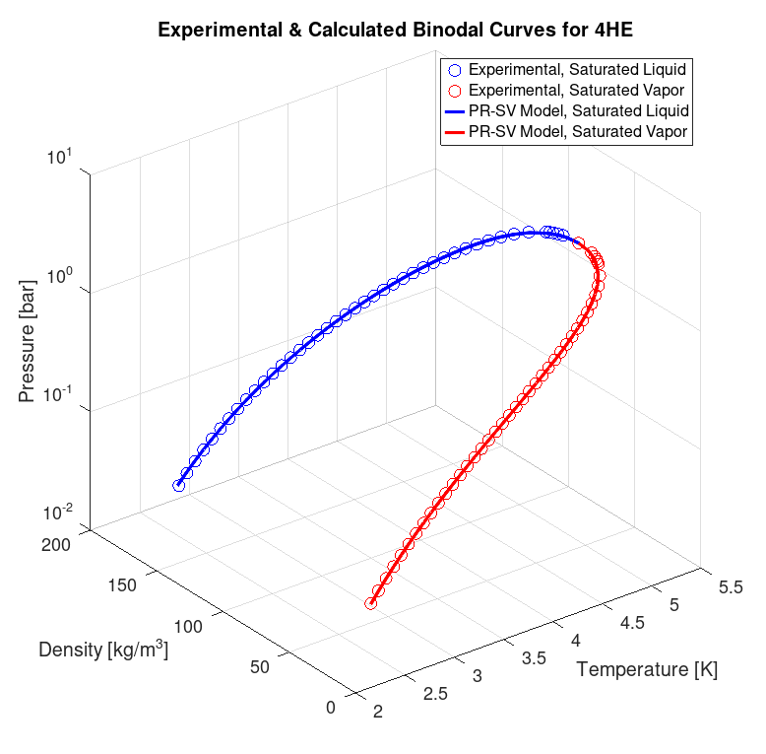

Figure 1: Experimental and calculated binodal curve for Helium-4, PR-SV model

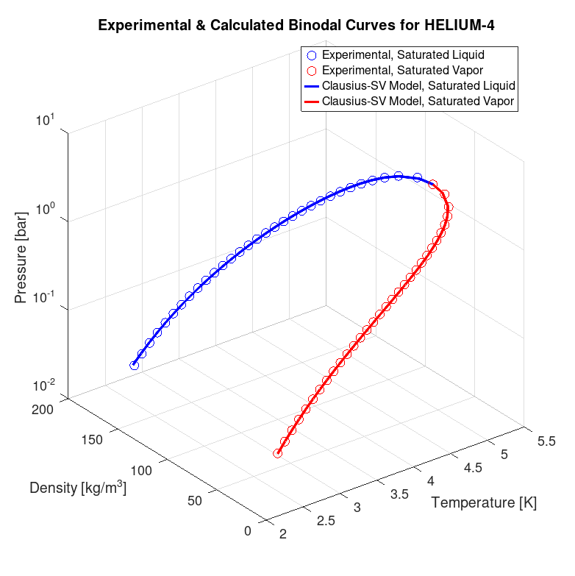

Figure 2: Experimental and calculated binodal curve for Helium-4, Clausius-SV model

Table 1: Adjusted parameters for each alpha function including the Mathias translation volume for the binodal curve modelling
CEoS | $$α$$ | $$κ_{0}$$ | $$κ_{1}$$ | $$M$$ | $$N$$ | $$χ_{0}$$ | $$χ_{1}$$
PR | Stryjek and Vera (1986) | ̶ | -0.140831 | ̶ | ̶ | 0.0556068 | -0.0233716
 | Melhem et al. (1989) | ̶ | ̶ | -0.149649 | -1.015300 | 0.0558869 | -0.0238071
Clausius | Stryjek and Vera (1986) | -0.140291 | -0.186449 | ̶ | ̶ | 0.0753654 | -0.0201718
 | Melhem et al. (1989) | ̶ | ̶ | -0.059403 | -1.078170 | 0.0761387 | -0.0215796

Table 2: Comparison between the present work and previous studies for Helium-4 vapour-liquid equilibrium modelling
CEoS | $$α$$ | AAD (%)
PR | Stryjek and Vera (1986) | 0.23
 | Melhem et al. (1989) | 0.22
Clausius | Stryjek and Vera (1986) | 0.17
 | Melhem et al. (1989) | 0.32
PR  (Aasen et al., 2020) | Twu et al. (1991) | 1.94
 |  | 2.52
The Stryjek-Vera alpha function, with its adjustable parameters, proved most effective in accurately capturing thermal dependence, particularly near the critical point. The Mathias volume translation was crucial for improving the representation of liquid phase density. The combination of the Clausius equation, Stryjek-Vera alpha function, and Mathias translation delivered the best fit, outperforming Peng-Robinson and Melhem’s alpha factor. Whilst Peng-Robinson showed limitations near the critical point, the Stryjek-Vera alpha function improved the fit, especially for the liquid phase. The Clausius equation, though less commonly used, provided better accuracy in certain temperature ranges due to an additional parameter that adjusts the attractive forces. These results are consistent with those obtained by Aasen et al. (2020), but the Clausius equation offers a promising alternative, enhancing the prediction of Helium-4’s thermodynamic properties.
    - Predictions Below 2.17 K (Lambda Transition Point)
Following the optimisation of the parameters of the two alpha functions (for both Clausius and PR), the alpha function that most accurately reproduced the equilibrium data was selected for each CEoS. Using this alpha function and its optimised parameters, its extrapolative and predictive capability to represent saturation pressure, liquid density, and vapour density in the superfluid region, where Helium-4 exhibits quantum fluid behaviour, was evaluated. The experimental data necessary for this analysis were reported by Donnelly (Donnelly and Barenghi, 1998) and McCarty (Arp and McCarty, 1989).

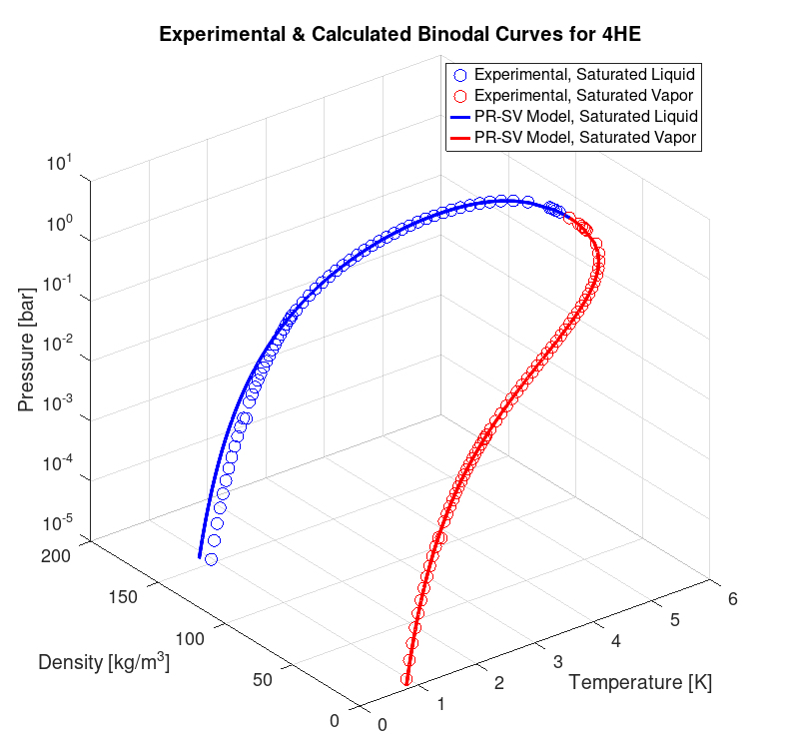

Figure 3: Experimental and calculated data for Helium-4 below 2.17 K (superfluid region); PR-SV model. McCarty experimental data

Table 3: Average absolute deviations for predictions below 2.17 K (within the superfluidity region) for Helium-4
CEoS | $$α$$ | Source | AAD (%)
PR | Stryjek and Vera (1986) | Donelly and Barenghi (1998) | 6.64
Clausius |  |  | 7.08
PR |  | Arp and McCarty (1989) | 5.00
Clausius |  |  | 5.35
The pressure and density modelling of Helium-4 using the Peng-Robinson and Clausius equations highlighted notable differences in their representation of the fluid's thermodynamic behaviour. The accuracy of the models was strongly influenced by the choice of the alpha function. Whilst the Peng-Robinson equation performed slightly better below 2.17 K, both approaches ultimately yielded similar results.
  - Conclusions
The models used were capable of adequately capturing phase transitions and critical behaviour. However, some deviations were noted in pressure predictions at temperatures near the triple point (transition temperature for superfluidity). This work shows that combining the Clausius equation with the Stryjek-Vera alpha function and volume translation can account for the quantum effects present in helium-4, slightly outperforming the approach proposed by Aasen et al. (2020), who incorporate these effects into the co-volume.
Nomenclature
CEoS – Cubic Equation of State
PR – Peng-Robinson
SV – Stryjek-Vera
AAD – Average Absolute Deviation
$α$ – Alpha function
$κ_{0}, κ_{1}$ – Adjustable parameters in the Stryjek-Vera alpha function
$M, N$ – Adjustable parameters in the Melhem alpha function
$χ_{0}, χ_{1}$ – Adjustable parameters in the Mathias volume translation equation
$T_{c}$ – Critical temperature, K
$P_{c}$ – Critical pressure, bar
$V_{c}$ – Critical molar volume, ${{\text{cm}}^{\text{3}}}/{\text{mol}}$
$Z_{c}$ – Compressibility factor, -
$T_{R}$ – Reduced temperature, -
$ω$ – Acentric factor, -
References
Aasen A., Hammer M., Lasala S., Jaubert J.-N., Wilhelmsen Ø., 2020, Accurate Quantum-Corrected Cubic Equations of State for Helium, Neon, Hydrogen, Deuterium and Their Mixtures, Fluid Phase Equilibria, 524, 112790.
Arp V., McCarty R., 1989, Thermophysical Properties of Helium-4 from 0.8 to 1500 K with Pressures to 2000 MPa, United States.
Clausius R., 1880, On the Behaviour of Carbonic Acid in Relation to Pressure, Volume and Temperature, Annalen Der Physik Und Chemie, 245(3), 337–357. (in German)
Donnelly R.J., Barenghi, C.F., 1998, The Observed Properties of Liquid Helium at the Saturated Vapor Pressure. Journal of Physical and Chemical Reference Data, 27(6), 1217–1274.
Gow A.S., 1993, A Modified Clausius Equation of State for Calculation of Multicomponent Refrigerant Vapor-Liquid Equilibria, Fluid Phase Equilibria, 90, 219–249.
Mathias P.M., Naheiri T., Oh E.M., 1989, A Density Correction for the Peng-Robinson Equation of State, Fluid Phase Equilibria, 47, 77–87.
Melhem G.A., Saini R., Goodwin B.M., 1989, A Modified Peng-Robinson Equation of State, Fluid Phase Equilibria, 47(2-3), 189–237.
Peng D.Y., Robinson D.B., 1976, A New Two-Constant Equation of State, Industrial and Engineering Chemistry Fundamentals, 15, 59–64.
Soave G., 1972, Equilibrium Constants from a Modified Redlich-Kwong Equation of State, Chemical Engineering Science, 27, 1197–1203.
Stryjek R., Vera J.H., 1986, PRSV: An Improved Peng-Robinson Equation of State for Pure Compounds and Mixtures, The Canadian Journal of Chemical Engineering, 64, 323–333.
Twu C.H., Bluck D., Cunningham J.R., Coon J.E., 1991, A Cubic Equation of State with a New Alpha Function and a New Mixing Rule, Fluid Phase Equilibria, 69, 33–50.

