 CHEMICAL ENGINEERING TRANSACTIONS  VOL. xxx, 2025 | A publication of  
The Italian Association
of Chemical Engineering
Online at www.cetjournal.it

Guest Editors: Fabrizio Bezzo, Flavio Manenti, Gabriele Pannocchia, Almerinda di Benedetto
Copyright © 2025, AIDIC Servizi S.r.l.
ISBN 979-12-81206-17-5; ISSN 2283-9216

Entropy Scaled Viscosities of Water and Some Alkanols Using a Cubic EoS
Donaldo Pereda-Cruz, Ricardo Macias-Salinas*
SEPI-ESIQIE, Departamento de Ingeniería Química, Instituto Politécnico Nacional, UPALM, Zacatenco, Ciudad de México 07738
*rms@ipn.mx
The present modelling work introduces the application of the residual-entropy scaling approach to adequately represent the dynamic viscosity of water and some alkanols (methanol, ethanol, 1-propanol and 1-butanol) over wide temperature and density ranges. Both unreduced and reduced viscosity forms (total viscosity, Rosenfeld and dilute gas) were examined and compared. A cubic equation of state (Soave-Redlich-Kwong or Peng-Robinson or Peng-Robinson-Stryjek-Vera) was used to estimate sufficiently accurate residual entropy data needed by the present scaling procedure. The resulting modelling approach was successfully validated during the representation of experimental dynamic viscosities of the aforementioned pure fluids covering wide ranges of temperature (from the triple the triple point of the fluid up to 1,000 K) and pressures (from 0.1 up to 1,000 bar).
  - Introduction
Dynamic viscosity plays a crucial role in the design and optimization of industrial processes. However, experimental data for transport properties are often scarce or restricted to narrow ranges of pressure, temperature, and composition, particularly for complex systems. To address these limitations, various predictive approaches have been developed, including corresponding states principles (Ely et al., 1981), free volume theory (Burgess et al., 2012), friction theory (Quiñones et al., 2000), and thermodynamic scaling based on density (Pensado et al., 2008).
Residual-entropy scaling (Rosenfeld, 1977) has proven especially effective in correlating transport properties, such as viscosity, with the residual entropy of the system, reducing the dependence on pressure and temperature. While this approach has been extensively applied with SAFT-type equations of state (Melfi et al., 2024), studies by Dehlouz et al. (2024) and Macías-Salinas et al. (2023) have also demonstrated its applicability with cubic equations of state for liquid-phase systems, including ionic liquids and deep eutectic solvents.
This work builds on these findings by extending residual-entropy scaling with cubic equations of state (SRK, PR, and PRSV) to a diverse range of substances, including water, methanol, ethanol, 1-butanol, and 1-propanol, evaluating its performance across broad pressure and temperature ranges.
  - Description of the Model
First introduced by Rosenfeld (1977), residual-entropy scaling reduces the dependence of transport properties, such as viscosity, diffusion constant and thermal conductivity, from two variables (pressure and temperature) to a single variable: the residual entropy. Pressure and temperature are implicitly accounted for through the residual-entropy. Consequently, an accurate equation of state is required to calculate the residual entropy with sufficient precision, ensuring proper scaling. As mentioned previously, various authors have applied this modeling approach using SAFT-type equations of state, such as PC-SAFT, SAFT VR-Mie, PCP-SAFT, and ePC-SAFT, for a wide range of pure substances and their mixtures, achieving satisfactory results. However, one of the objectives of this work is to demonstrate that this scaling can be successfully performed using simple, practical, and widely adopted cubic equations of state in the industry, specifically SRK, PR and PRSV. Residual entropy (or departure entropy) is the difference between the entropy of the system and the entropy of the ideal gas at the same temperature and density:
$$S^{res}\left(ρ,T\right)=S\left(ρ,T\right)-S^{id}(ρ,T)$$ | (1)
For a cubic equation of state explicit in pressure, such as SRK, PR and PRSV, it can be obtained using the following expression:
$$S^{res}\left(ρ,T\right)=\int_{∞}^{v}{\left[{\left(\frac{∂P}{∂T}\right)}_{v}-\frac{R}{v}\right]dv}$$ | (2)
$$S^{res}\left(ρ,T\right)=-\frac{da}{dT}\frac{1}{b\left(δ_{1}-δ_{2}\right)}\ln\left(\frac{1+bρδ_{2}}{1+bρδ_{1}}\right)-R\ln\left(\frac{1}{1-bρ}\right)$$ | (3)
Where $ρ$ is the molar density, $T$ is the temperature, $\frac{da}{dT}$ is the derivative of the attractive parameter, $b$ is the van der Waals co-volume, $R$ is the gas constant, $δ_{1}=1+\sqrt{2}$, $δ_{2}=1-\sqrt{2}$ for PR and PRSV and $δ_{1}=1$, $δ_{2}=0$ for SRK.
    - Reference Viscosity
The residual-entropy scaling for the dynamic viscosity of fluids can be described by the following equation:
$$\frac{η\left(ρ,T\right)}{η^{ref}}=f\left(-\frac{S^{res}\left(ρ,T\right)}{R}\right)$$ | (4)
Where $η^{ref}$ is a reference viscosity, $f$ refers to a scaling function, and $η\left(ρ,T\right)$ and $S^{res}\left(ρ,T\right)$ are the calculated viscosity and residual entropy at the absolute temperature $T$ and molar density $ρ$ of interest, respectively. Formally, the residual-entropy scaling uses macroscopically reduced units (Dyre, 2018), as presented in the original paper by Rosenfeld through the following equation:
$$η^{ref}=η_{Rosenfeld}=ρ_{N}^{2/3}\sqrt{mk_{B}T}$$ | (5)
Where $m$ is the molecular mass, $k_{B}$ is the Boltzmann constant, $T$ is the absolute temperature and $ρ_{N}$ is the number density calculated from the molar density $ρ$, using the equation of state. If $ρ$ is expressed in units of $mol/cm^{3}$, then:
$$m=\frac{M_{w}N_{A}}{{10}^{3}}$$ | (6)
$$ρ_{N}={10}^{6}ρN_{A}$$ | (7)
$η_{Rosenfeld} \left[mPa⋅s\right]={10}^{3}ρ_{N}^{2/3}\sqrt{mk_{B}T}$ | (8)
Where $M_{W}$ is the molecular weight in g/mol and $N_{A}$ is Avogadro’s number, $k_{B}$ is the Boltzmann constant in J/K and $T$ is the absolute temperature in K.
Some authors (Lötgering-Lin et al., 2018) have proposed using the Chapman-Enskog equation to improve scaling within the gas-like region. In this work, the specific modification proposed by Chung et al. (1988) will also be analyzed:
$$η^{ref}=η_{CE}\left[mPa⋅s\right]=40.785⋅{10}^{-4}\frac{F_{c}\sqrt{M_{w}T}}{v_{c}^{2/3}Ω^{*}}$$ | (9)
$$Ω^{*}=\frac{1.16145}{{T^{*}}^{0.14874}}+\frac{0.52487}{\exp{(0.77320T^{*})}}+\frac{2.16178}{\exp{(2.43787T^{*})}}-6.43⋅{10}^{-4}{T^{*}}^{0.14874}\sin{(18.0323{T^{*}}^{-0.76830}-7.27371)}$$ | (10)
$$T^{*}=1.2594\frac{T}{T_{c}}$$ | (11)
$$F_{c}=1-0.2756ω+0.0590035μ_{r}^{4}+κ$$ | (12)
Where $M_{w}$ is the molecular weight in g/mol, $T$ is the absolute temperature in K, $v_{c}$ is the critical temperature in cm³/mol, $Ω^{*}$ is the Neufeld’s collision integral, $T^{*}$ is a reduced temperature, $T_{c}$ is the critical temperature in K, $F_{c}$ is a correction factor that accounts for the nonsphericity, polarity, and hydrogen bonding of the substance, $ω$ is the acentric factor, $μ_{r}$ is the dimensionless dipole moment and $κ$ is a substance-specific constant as reported by Chung et al. (1988). In this work, $F_{c}$ is assumed to be unity.
Lastly, the third reference viscosity, as performed by Melfi et al. (2024) and Macías-Salinas et al. (2023), will be unity, meaning that the scaling will be performed using the total dynamic viscosity directly.
    - Scaling function
As previously mentioned, the present modeling approach reduces the viscosity dependence to be solely a function of residual entropy. Therefore, a mathematical expression $f$ is required to best describe this relationship. In this work, a third-degree polynomial within an exponential function is used:
$$f\left(-\frac{S^{res}\left(ρ,T\right)}{R}\right)=\exp\left(A+B\left(-\frac{S^{res}\left(ρ,T\right)}{R}\right)+C{\left(-\frac{S^{res}\left(ρ,T\right)}{R}\right)}^{2}+D{\left(-\frac{S^{res}\left(ρ,T\right)}{R}\right)}^{3}\right)$$ | (13)
Where $A$, $B$, $C$, and $D$ are the model parameters specific to each component and model variation (combination of cubic equation of state, alpha function, and reference viscosity)
  - Results and discussion
In order to evaluate the model's performance, dynamic viscosity data for water, methanol, ethanol, 1-butanol, and 1-propanol were used within a pressure range up to 1,000 bar (up to 3,000 bar for water) and a temperature range up to 1,000 K. The specific range, number of data points, and sources for each component are detailed in Table 1.
Table 1: Experimental reference data for the fluids examined in this work
Component | N | T, K | P, bar | Source
Water | 799 | 273.16 – 1073.1 | 0.0061165 – 3,000 | NIST Webbook (2019)
Methanol | 217 | 180 – 620 | 0.1 – 1,000 | NIST Webbook (2023)
Ethanol | 1252 | 268.1 – 612.2 | 0.8150 – 980.66 | Dortmund Data Bank
1-butanol | 1297 | 186.15 – 473.15 | 0.8150 – 980.66 | Dortmund Data Bank
1-propanol | 1042 | 153.15 – 546.15 | 0.8150 – 982 | Dortmund Data Bank

The input parameters required for this work are provided in Table 2. Additionally, the model fitting is performed using the following minimization procedure:
$$\min{f_{obj}}=\sum_{i=1}^{i=N}{{\left(\ln\left(\frac{η_{i}^{exp}}{η_{i}^{ref}}\right)-\ln\left(\frac{η_{i}\left(ρ_{i},T_{i}\right)}{η_{i}^{ref}}\right)\right)}^{2}}=\sum_{i=1}^{i=N}{{\left(\ln\left(\frac{η_{i}^{exp}}{η_{i}^{ref}}\right)-\left(A+Bx_{i}+Cx_{i}^{2}+Dx_{i}^{3}\right)\right)}^{2}}$$ | (14)
Where $f_{obj}$ is the objective function, $η^{exp}$ represents the experimental dynamic viscosity, and $x$ denotes the scaling potential $-S^{res}(ρ,T)/R$.
Table 2: Single-component physical properties required as inputs for the model
Component | M_{w}, g/mol | T_{c}, K | P_{c}, bar | v_{c}, cm³/mol | $$ω$$ | $$κ$$
Water | 18.0153 | 647.096 | 220.64 | 55.9481 | 0.3443 | -0.6635
Methanol | 32.0419 | 512.6 | 81.035 | 116.2791 | 0.5625 | -0.16816
Ethanol | 46.069 | 516.2 | 63.8348 | 168 | 0.635 | -0.03374
1-butanol | 74.1228 | 562.9 | 44.1777 | 274 | 0.59 | 0.33431
1-propanol | 60.0959 | 536.7 | 51.6758 | 218 | 0.624 | 0.21419

The model's performance was evaluated using the Average Absolute Deviation (AAD):
$$AAD\%=\frac{100}{N}\sum_{i=1}^{i=N}{\left(1-\frac{η_{i}(ρ_{i},T_{i})}{η_{i}^{exp}}\right)}$$ | (15)
A summary of the results obtained, in terms of AAD, for the different variations of the present model is provided in Table 3.
Table 3: Results Overview
Component | Reference Viscosity | SRK AAD% | PR AAD% | PRSV AAD%
Water | Unity, $η^{ref}=1$ | 14.02 | 13.776 | 13.546
 | Rosenfeld, Eq(5) | 49.887 | 49.728 | 47.629
 | CE, Eq(9) | 6.9122 | 6.6587 | 7.3969
Methanol | Unity, $η^{ref}=1$ | 8.5280 | 8.8439 | 6.9747
 | Rosenfeld, Eq(5) | 43.648 | 43.536 | 37.312
 | CE, Eq(9) | 5.4527 | 5.7645 | 4.2624
Ethanol | Unity, $η^{ref}=1$ | 3.0369 | 3.3217 | 3.1593
 | Rosenfeld, Eq(5) | 3.2598 | 3.5067 | 3.2383
 | CE, Eq(9) | 2.2279 | 2.5320 | 2.3584
1-butanol | Unity, $η^{ref}=1$ | 3.2406 | 3.7136 | 6.1769
 | Rosenfeld, Eq(5) | 2.2883 | 2.7127 | 5.1587
 | CE, Eq(9) | 2.2915 | 2.7359 | 5.3514
1-propanol | Unity, $η^{ref}=1$ | 4.1912 | 4.6589 | 6.1878
 | Rosenfeld, Eq(5) | 4.8669 | 5.0316 | 6.6678
 | CE, Eq(9) | 3.2895 | 3.6725 | 5.2945

Table 3 highlights, in bold, the best model variations in terms of AAD for each studied compound. Figures 1–6 present the $η$ vs $P$ vs $T$ surfaces obtained from the model and experimental data (a), along with the scaling curve and scaled experimental viscosities (b), for the best variations of water, methanol, ethanol, 1-butanol, and propanol, respectively.
Both the AAD values and graphical representations demonstrate that the present modeling approach accurately represents the dynamic viscosity of the studied compounds, with some exceptions for water and 1-butanol, which are discussed later. The best results were generally obtained using the SRK cubic equation of state and the CE reference viscosity. Conversely, the viscosity scaling originally proposed by Rosenfeld yielded the poorest results, except for 1-butanol, where it provided the best AAD value. However, it is important to note that the scaling curve observed for 1-butanol (Figure 5b) deviates from typical trends seen in other compounds. This is also reflected in the calculated saturated viscosities (Figure 5a), which exhibit an atypical pronounced drop. Therefore, while Rosenfeld's approach yields the best numerical results for 1-butanol, the use of the CE reference viscosity is still recommended. The PR and PRSV equations of state rarely showed significant improvements over SRK.

a)  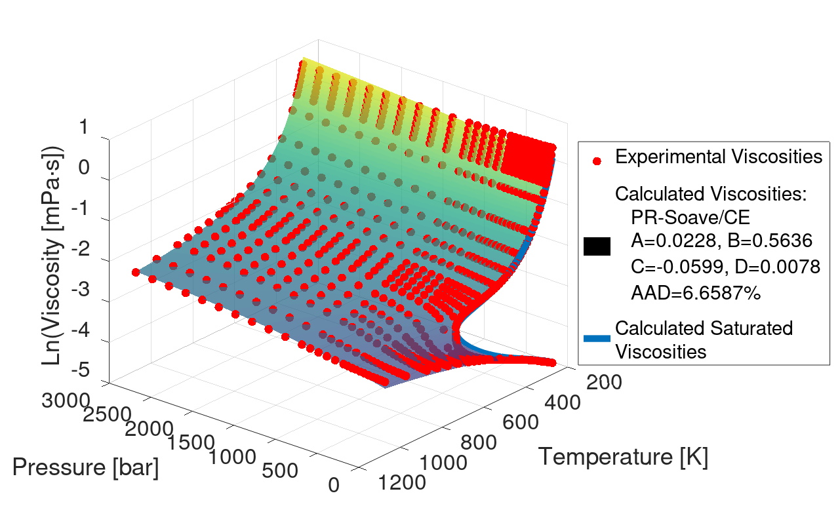 | b)  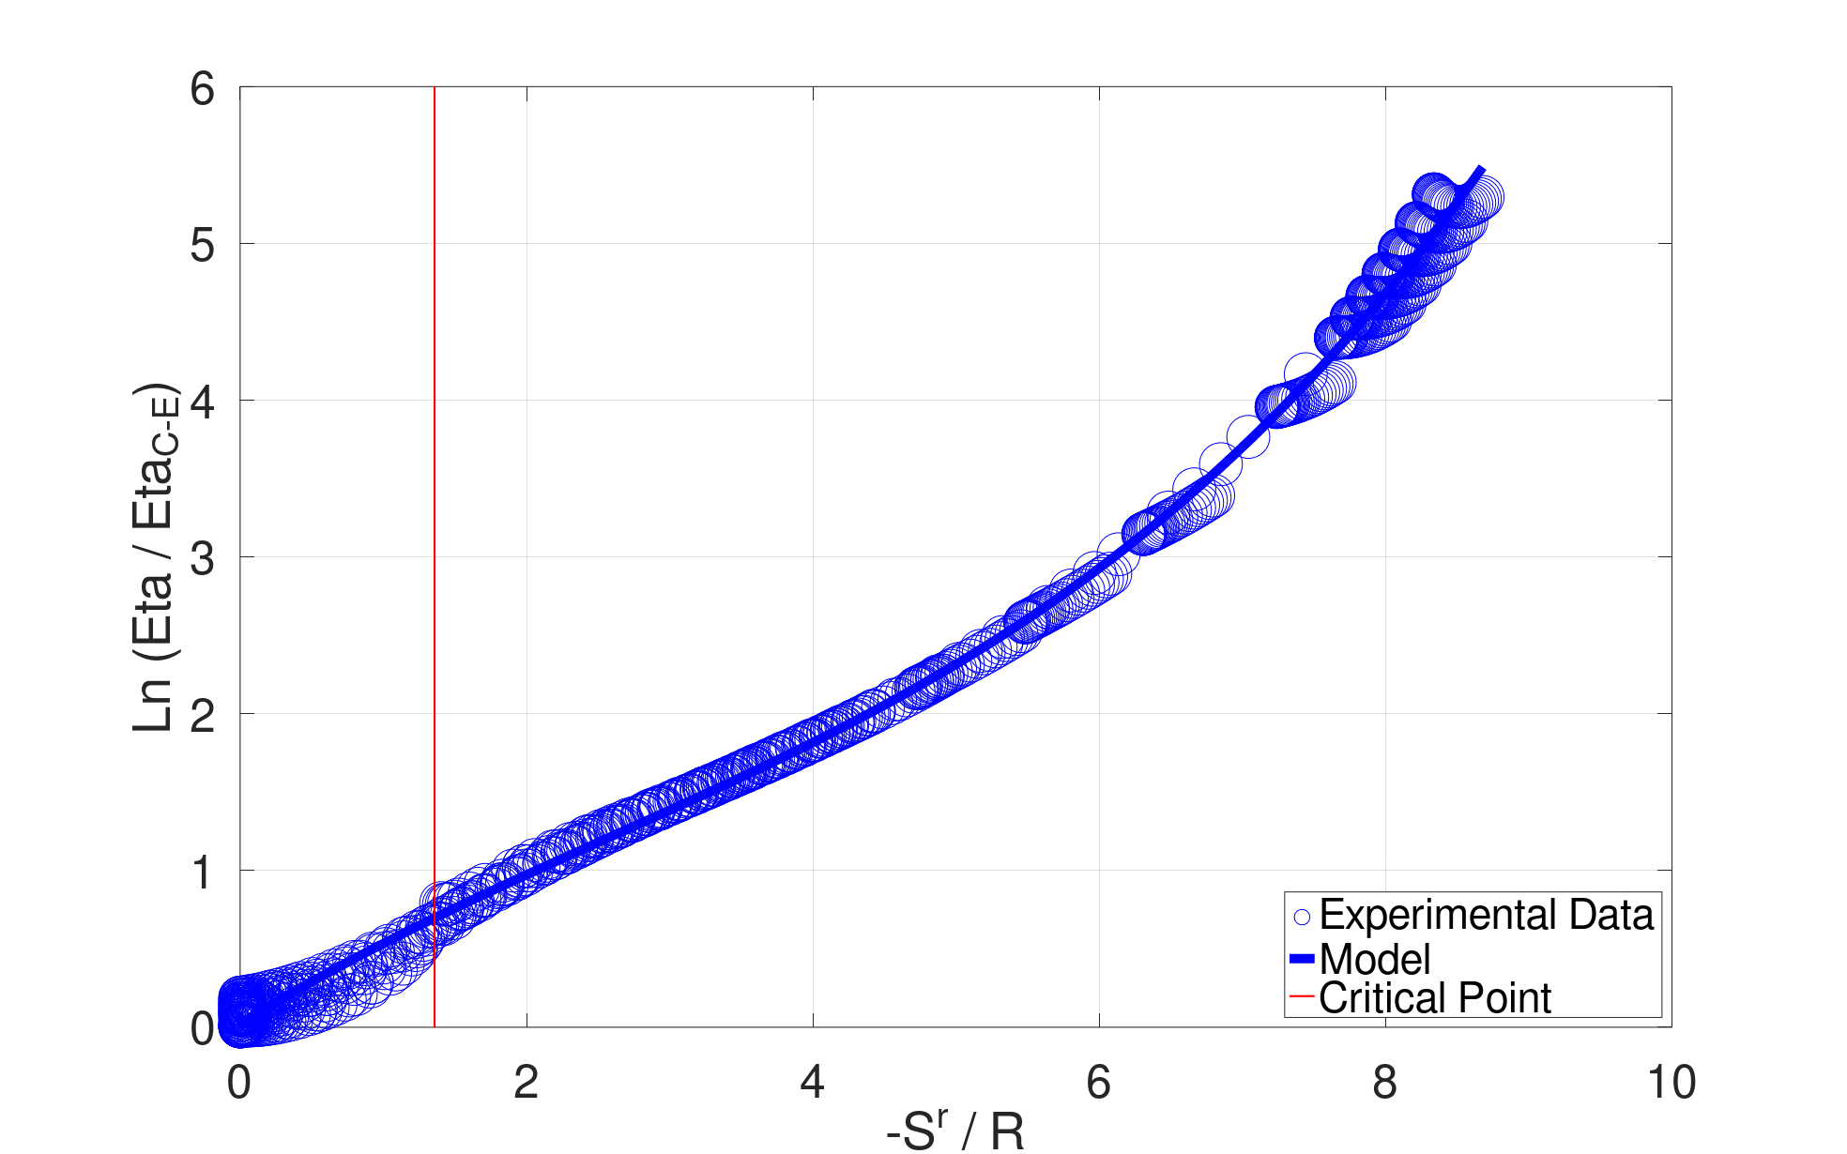
Figure 1: a) Experimental & calculated viscosities vs T & P for Water. b) Scaled experimental viscosities & resulting scaling for Water.

a)  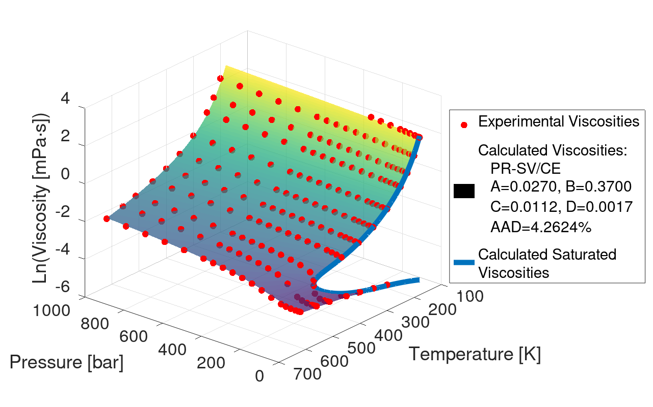 | b)  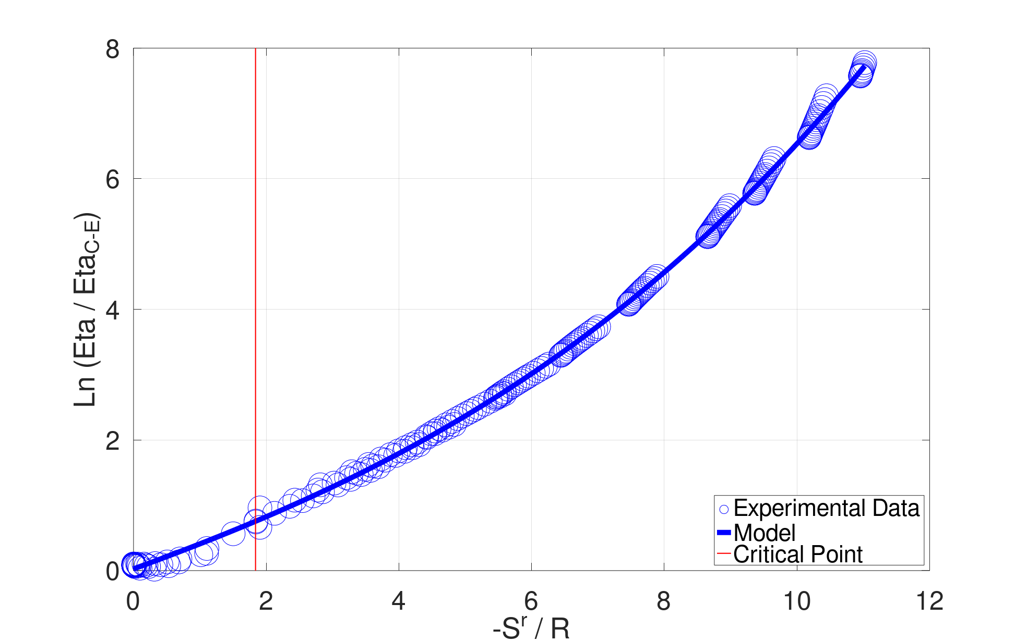
Figure 2: a) Experimental & calculated viscosities vs T & P for Methanol. b) Scaled experimental viscosities & resulting scaling for Methanol.

a)  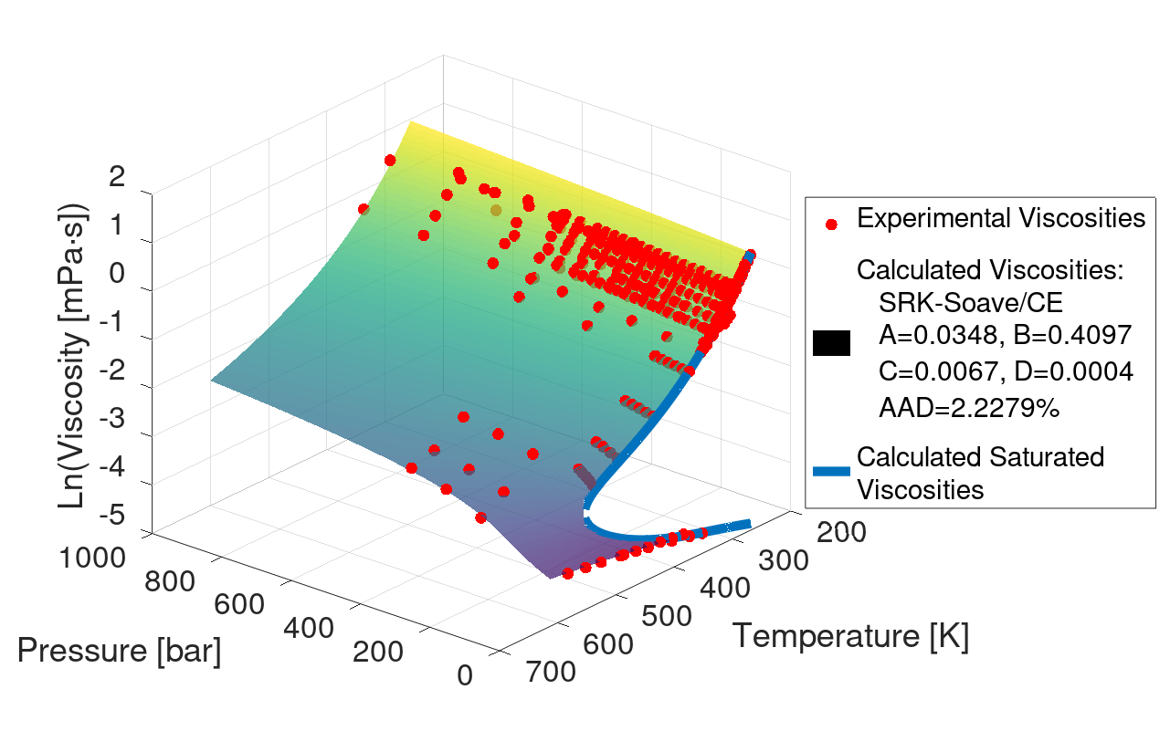 | b)  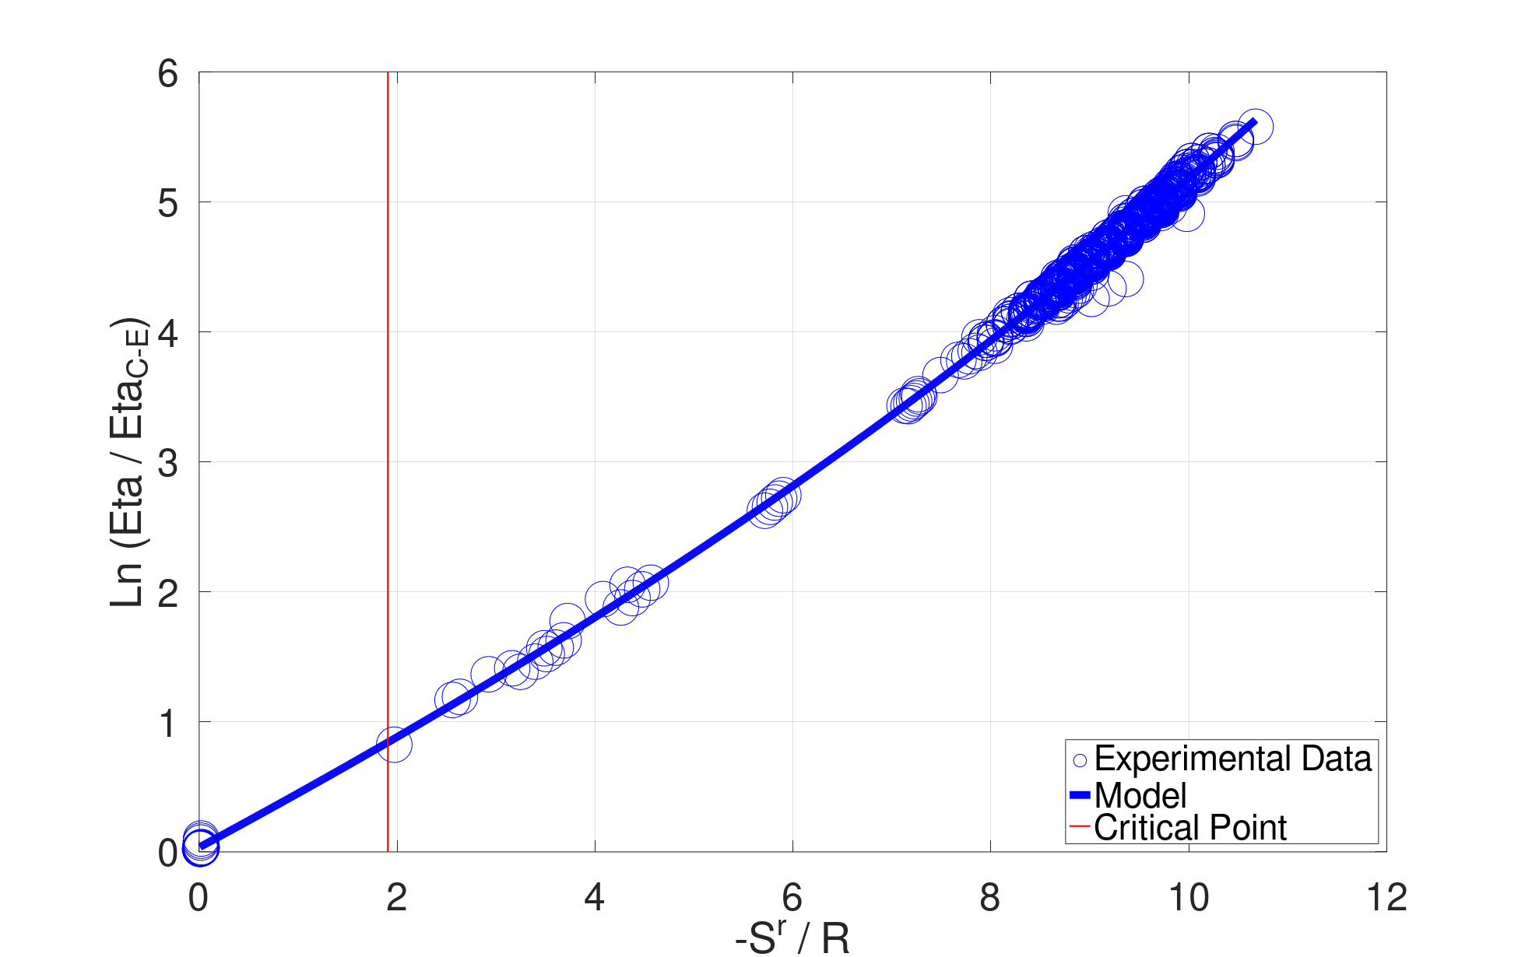
Figure 3: a) Experimental & calculated viscosities vs T & P for Ethanol. b) Scaled experimental viscosities & resulting scaling for Ethanol.
a)  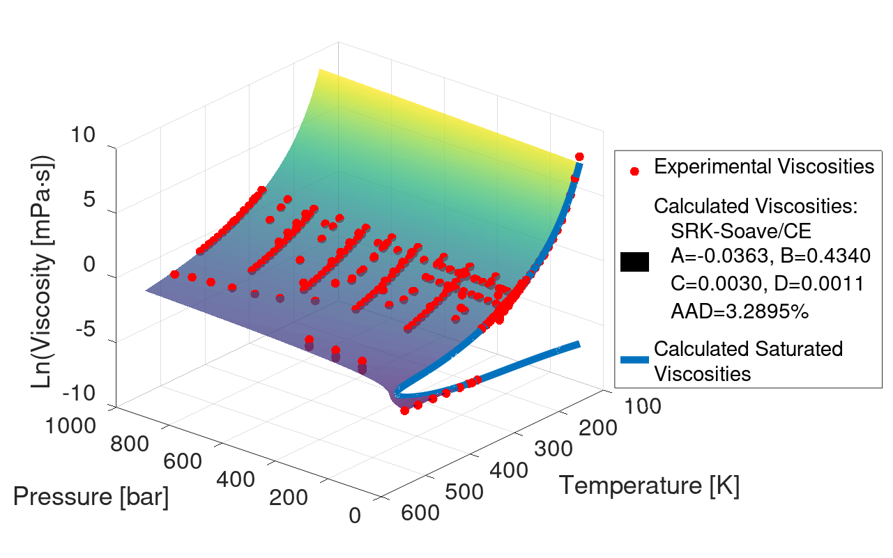 | b)  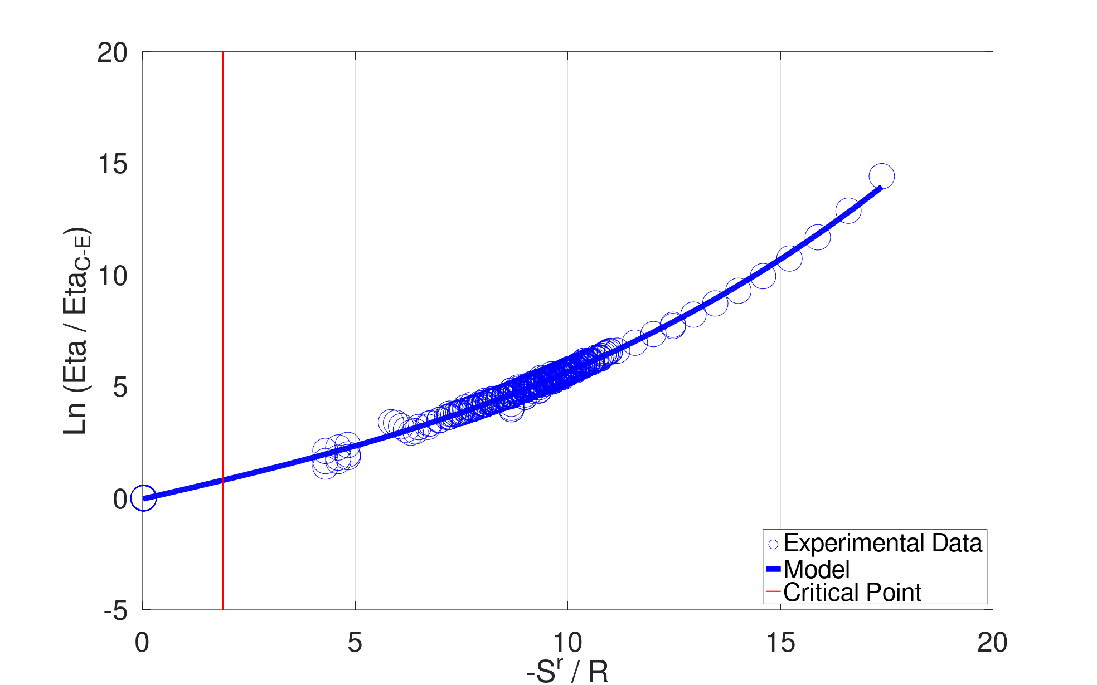
Figure 4: a) Experimental & calculated viscosities vs T & P for 1-Propanol. b) Scaled experimental viscosities & resulting scaling for 1-Propanol.
a)  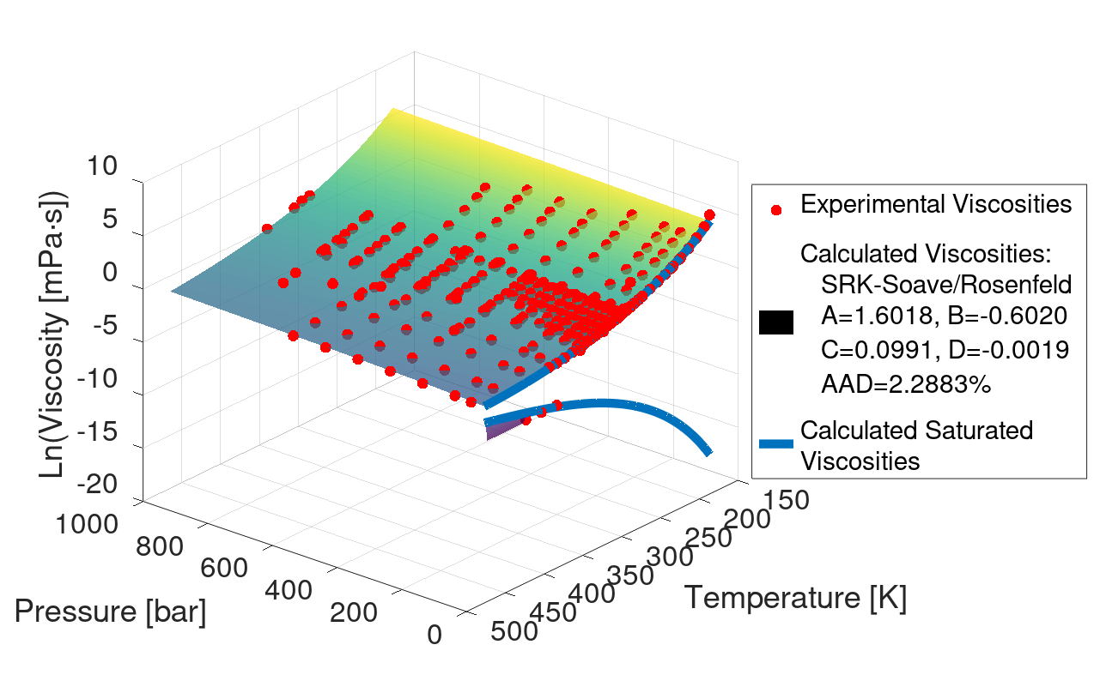 | b)  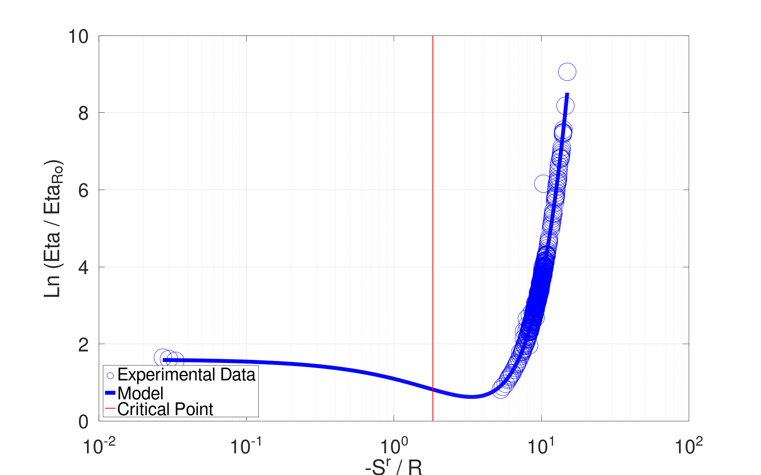
Figure 5: a) Experimental & calculated viscosities vs T & P for 1-Butanol. b) Scaled experimental viscosities & resulting scaling for 1-Butanol.
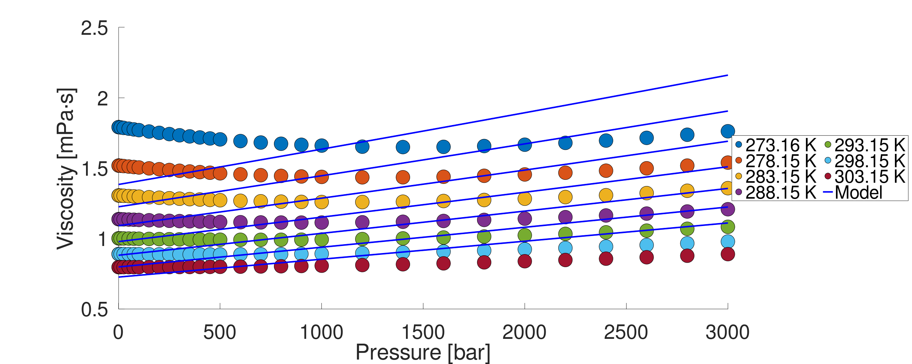
Figure 6: Model (SRK-Soave/CE) limitation in capturing the viscosity minimum of water at high pressures (0.1 – 3000 bar) and low temperatures (273.15 – 303.15 K).

Moreover, Figure 1b shows that the scaled experimental viscosities exhibit atypical behavior, forming multiple U-shaped curves in the high residual-entropy region (highlighted by the red circle). This phenomenon corresponds to the so-called anomalous region of water. Within this region, spanning approximately from 0 to 30 °C, viscosity exhibits a minimum as pressure increases from 0.1 to 3,000 bar. Figure 6 illustrates that this anomalous region could not be adequately represented by the present model. None of the model variations successfully capture this behavior.
  - Conclusions
This work demonstrates that residual-entropy scaling, originally proposed by Rosenfeld, can be effectively applied using simple and widely adopted cubic equations of state, such as SRK, PR, and PRSV. Among them, SRK provided the most accurate results, making it the preferred choice for viscosity modeling. Additionally, the CE reference viscosity function proved to be the most reliable, offering superior performance compared to Rosenfeld's original scaling. These equations of state, while less complex than SAFT-type models, provide satisfactory results for modeling dynamic viscosity across various compounds, offering a practical and efficient tool for industrial applications.
References
Burgess W.A., Tapriyal D., Gamwo I.K., Morreale B.D., McHugh M.A., Enick R.M., 2012, Viscosity Models Based on the Free Volume and Frictional Theories for Systems at Pressures to 276 MPa and Temperatures to 533 K. Ind. Eng. Chem. Res., 51, 16721.
Chung T.-H., Ajlan M., Lee L.L., Starling K.E., 1988, Generalized Multiparameter Correlation for Nonpolar and Polar Fluid Transport Properties. Ind. Eng. Chem. Res., 27, 671.
Dehlouz, A., Privat, R., Jaubert, J., 2024, Coupling cubic equations of state with the concept of entropy scaling to model the viscosity of ionic liquids. Fluid Phase Equilibria, 589, 114261.
Dyre J. C., 2018, Perspective: Excess-entropy scaling. The Journal of Chemical Physics, 149(21), 210901
Ely, J. F., Hanley, H. J. M., 1981, Prediction of transport properties. Viscosity of fluids and mixtures. Industrial & Engineering Chemistry Fundamentals, 20(4), 323–332.
Lötgering-Lin, O., Fischer, M., Hopp, M., Gross, J., 2018, Pure substance and mixture viscosities based on entropy scaling and an analytic equation of state. Industrial & Engineering Chemistry Research, 57(11), 4095–4114.
Macías-Salinas, R., Pereda-Cruz, D., 2023, Entropy scaled viscosities of choline-chloride-based deep eutectic solvents using a cubic EoS with volume translation. Fluid Phase Equilibria, 572, 113849.
Melfi, D. T., Scurto, A. M., 2024, Viscosity of imidazolium ionic liquids and mixtures of ILs from entropy scaling using the PC-SAFT and ePC-SAFT equations of state. Journal of Molecular Liquids, 401, 124500.
Pensado A.S., Pádua A.A.H., Comuñas M.J.P., Fernández J., 2008, Relationship Between Viscosity Coefficients and Volumetric Properties Using a Scaling Concept for Molecular and Ionic Liquids. J. Phys. Chem. B, 112, 5563.
Quiñones-Cisneros S. E., Zéberg-Mikkelsen C. K., Stenby E. H., 2000, The Friction Theory (f-theory) for Viscosity Modeling. Fluid Phase Equilib., 169, 249.
Rosenfeld Y., 1977, Relation between the transport coefficients and the internal entropy of Simple Systems. Physical Review A, 15(6), 2545–2549.

