|  |  |
| --- | --- |
| cetlogo ***CHEMICAL ENGINEERING TRANSACTIONS***  ***VOL. xxx, 2025*** | A publication of  aidiclogo_grande |
| The Italian Association  of Chemical Engineering  Online at www.cetjournal.it |
| Guest Editors: Fabrizio Bezzo, Flavio Manenti, Gabriele Pannocchia, Almerinda di Benedetto  Copyright © 2025, AIDIC Servizi S.r.l. **ISBN** 979-12-81206-17-5; **ISSN** 2283-9216 | |

Viscosity Modelling of Water Over Wide Temperature and Pressure Ranges (Including its Anomalous Region) Using the Friction Theory

Ines Maria Romero-Rueda, Ricardo Macias-Salinas\*

SEPI-ESIQIE-Departamento de Ingeniería Química, Instituto Politécnico Nacional, Zacatenco, México, City. 07738

\*rms@ipn.mx, [iromeror2000@alumno.ipn.mx](mailto:iromeror2000@alumno.ipn.mx)

This works introduces the use of a modified friction-theory model coupled with a cubic equation of state (Peng-Robinson-Stryjek-Vera) to accurately represent the dynamic viscosity of water over wide temperature and pressure ranges. In doing so, new functionalities of the friction coefficients appearing in the repulsive and attractive terms were introduced within the framework of the friction theory. The resulting modelling approach was successfully applied during the representation of water viscosity encompassing the vapor-liquid coexisting curve, the compressed liquid, the dense gas and the region near the critical point. Moreover, the present viscosity model captures remarkably well the so-called “anomalous region” of water where the viscosity isotherms of this highly associating substance exhibit a minimum with pressure at temperatures ranging from -17.5 to 35°C and pressures varying between 0.1 and 3000 bar.

* 1. Introduction

Water is one of the most studied and fundamental substances in science due to its crucial role in industrial processes and nature. Despite its apparent simplicity, it exhibits complex physical and thermodynamic properties, particularly under extreme temperature and pressure conditions. Among these properties, dynamic viscosity plays an essential role in describing processes and molecular interactions in liquid and gaseous media.

Accurately modelling water’s viscosity across wide ranges of temperature and pressure is challenging due to the presence of anomalous regions, such as those where viscosity isotherms exhibit unusual behaviour, including minima with respect to pressure. This behaviour is particularly evident at low temperatures (0–35°C) and high pressures (up to 3000 bar), making water an exceptionally difficult substance to describe using conventional methods. Several mathematical models have been proposed to describe the viscosity of water; however, it is difficult to accurately capture its anomalous behaviour across broad temperature and pressure ranges. One of the most notable attempts is the empirical equation proposed by Watson et al. (1980), which remains one of the most comprehensive efforts for modelling the dynamic viscosity of water. This model includes 23 specific parameters and is originally valid for a temperature range between 0 and 800°C and pressures from 1 to 1000 bar. While this equation provides a robust framework, its complexity and empirical nature highlight the need for alternative approaches that can better capture the peculiar physics of water’s viscosity behaviour, particularly in anomalous regions. In this context, friction theory-based models have emerged as promising tools for representing fluid viscosity, as they incorporate attractive and repulsive molecular effects in a more physical manner. However, existing models often require additional tuning or are limited in their ability to capture the complexity of water’s behaviour in its anomalous regions. The present work addresses this issue by developing a modified model based on friction theory, combined with a cubic equation of state (Peng-Robinson-Stryjek-Vera). This approach not only accurately captures the dynamic viscosity of water under normal conditions but also describes its behaviour in critical and anomalous regions with a high degree of precision.

* 1. Modelling Approach

Modelling the viscosity of water under wide pressure and temperature conditions requires integrating both macroscopic effects and specific molecular interactions. This work adopts a modified friction theory, coupled with the Peng-Robinson-Stryjek-Vera (PRSV) cubic equation of state [R. Stryjek and J. H. Vera, 1986], to describe its viscosity behaviour in vapor, compressed liquid, dense gas phases, and critical regions. For the dilute gas contribution, the equation by Chung et al. is employed, which accurately represents viscosity in the low-density limit. Friction Theory, based on the equation $η=η_{0}+η_{f}$ ​ [Quiñones-Cisneros, 2000], allows for viscosity estimation by explicitly integrating molecular effects such as hydrogen bonding, tetrahedral structure, and the critical and anomalous behaviour of water, providing an effective tool to predict its total viscosity under various conditions, using the equation:

|  |  |
| --- | --- |
| $$η=η_{0}+η_{f}$$ | (1) |

To calculate the dilute gas viscosity ($η_{0}$), the model of Chung et al. (1984), which is applicable for predicting the dilute gas boundary of both non-polar and polar fluids over wide temperature ranges, will be used.

|  |  |
| --- | --- |
| $$η_{0}=\frac{40.785\sqrt{MW.T}}{V_{C}^{2/3}Ω^{*}}F_{c}$$ | (2) |

The integral collision parameter $Ω^{*}$ and $F_{c}$ (the correction factor) are estimated using the following equations:

|  |  |
| --- | --- |
| $$Ω^{*}=\frac{1.16145}{T^{*0.14874}}+\frac{0.52487}{exp\left(0.7732T^{*}\right)}+\frac{2.16178}{exp\left(2.43787T^{*}\right)}-6.435×{10}^{-4}{\left(T^{*}\right) }^{0.14874} \\ \sin\left[18.0323{\left(T^{*}\right) }^{-0.7683}-7.27371\right]$$ | (3) |
| $$F_{c}=1-0.275ω+0.059035μ_{r}^{4}+κ$$ | (4) |

$$T^{*}=\frac{1.2593T}{T_{c}}$$

$$μ_{r}=131.3\frac{μ}{\sqrt{V_{c}T_{c}}}$$

**Where: $κ$** is the association factor (-.06635)

**2.1 Dense-state contribution $η_{f}$**

To calculate the dense-state viscosity contribution ($η_{f}$), the modified friction theory model is applied (eq. 5), which incorporates temperature-dependent friction coefficients ($κ_{r}, κ_{a}, κ_{rr})$, repulsive pressure ($P_{r}$), attractive pressure ($P_{a}$) and second-order repulsive pressure ($P_{rr}$). These coefficients, together with the cubic equations of state (EOS), allow for the consideration of the non-ideal behaviour of water in dense phases. The equation estimates $η_{f}$ by accounting for the molecular interactions that become significant at high pressures and near the critical point.

|  |  |
| --- | --- |
| $$η_{f}=κ_{r}P_{r}+κ_{a}P_{a}+κ_{rr}P_{r}^{2}$$ | (5) |

The expressions $κ_{i}$ appearing in equation (5), originally based on the FT are defined as:

|  |  |
| --- | --- |
| $$κ_{r}=a_{1}Ψ_{1}+a_{2}Ψ_{2}+a_{3}Ψ_{3}$$ | (6) |
| $$κ_{a}=b_{1}Ψ_{1}+b_{2}Ψ_{2}+b_{3}Ψ_{3}$$ | (7) |
| $$κ_{rr}=c_{2}Ψ_{2}+c_{3}Ψ_{3}+c_{3}Ψ_{3}$$ | $$(8)$$ |

where:

|  |  |
| --- | --- |
| $$Ψ_{i}=exp\left(2i∙Γ^{i/4}\right)$$ | (9) |

and:

|  |  |
| --- | --- |
| $$Γ= \frac{Tc}{T}$$ | (10) |

**3**. **Results and Discussion**

To validate the model, water data over a wide range of temperatures and pressures were used, comparing the viscosity predictions of the proposed model with experimental data and those obtained using the parameters proposed by Quiñones-Cisneros & Dieters (2006). Figure 1 shows the binodal curve, illustrating the model's ability to describe phase boundaries and transitions in water. The proposed model produces results significantly closer to the data reported in the literature, demonstrating greater accuracy in describing viscosity gradients near the critical point compared to other models. As shown in Table 1, the comparison of the optimized parameters in terms of verage absolute relative deviation (AAD), the BIAS and the Maximum Deviation (MaxDev) further highlights the improved performance of the proposed model relative to that of Quiñones-Cisneros & Dieters (2006).

*Figure 1: Binodal curve obtained using experimental data reported by NIST (2019).*

*Table 1: Comparison of the optimized parameters and average absolute deviation (AAD) of the proposed model and the model by Quiñones-Cisneros & Dieters (2006).*

|  |  |  |  |  |  |  |  |  |  |
| --- | --- | --- | --- | --- | --- | --- | --- | --- | --- |
| **Optimized Parameters** | | | | **MS24** | | | **QC&D** | | |
| **MS24** | | **QC&D** | | **AAD** | **BIAS** | **MaxDev** | **AAD** | **BIAS** | **MaxDev** |
| A1 [cP/bar] | 1.6774726e-06 | A0 [cP/bar] | 1.3780144e-05 | 4.7448 | -0.9207 | 16.3871 | 5.6685 | -1.7056 | 16.9297 |
| A2 [cP/bar] | -1.9898139e-07 | A1 [cP/bar] | -5.1074980e-06 |
| A3 [cP/bar] | -1.5251179e-08 | A2 [cP/bar] | -2.7677247e-06 |
| B1 [cP/bar] | -1.2293960e-06 | B0 [cP/bar] | -2.5713629e-06 |
| B2 [cP/bar] | -4.2049431e-08 | B1 [cP/bar] | -2.3970112e-06 |
| B3 [cP/bar] | -1.0585434e-08 | B2 [cP/bar] | -1.8532642e-06 |
| C1 [cP/bar2] | -1.2989191e-10 | C0 [cP/bar2] | -1.6856881e-10 |
| C2 [cP/bar2] | 1.6593108e-11 | C1 [cP/bar2] | 1.4197836e-10 |
| C3 [cP/bar2] | 3.1949235e-13 | C2 [cP/bar2] | 7.9922911e-12 |

The viscosities were modelled for three important isotherms that encompass key regions of water behaviour: 623.15 K, representing the compressed liquid region; 647.15 K, corresponding to the critical point where density fluctuations are prominent; and 673.15 K, exploring the dense gas region above the critical point. Figure 2 shows that the model successfully captures the viscosity trends as pressure increases, with a combined average absolute deviation percentage (%AAD) of 1.8896 for the three isotherms.

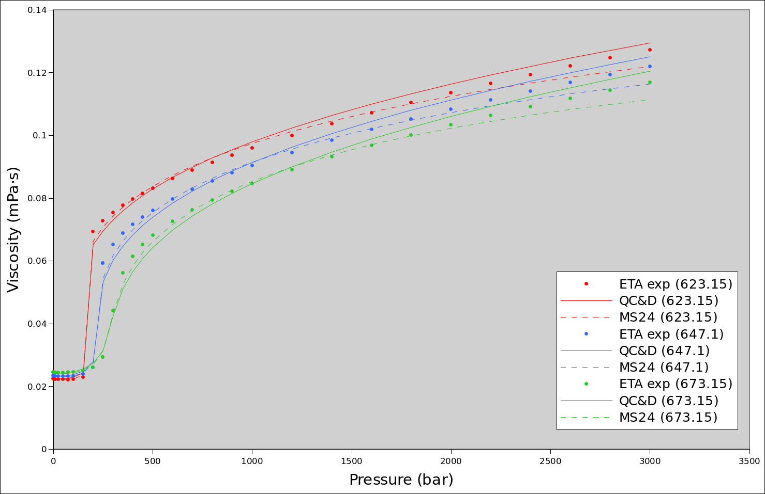

*Figure 2: Two models compared in representing reference data of NIST.*

**3.1 Representation of the Anomalous Region**

The efficacy of the model was evaluated in the anomalous region of water, characterized by minima in viscosity isotherms with respect to pressure, a behaviour observed at low temperatures (0°C to -35°C) and pressures of up to 3000 bar. This behaviour is attributed to the effects of hydrogen bonding and the unique tetrahedral structure of water.

The model satisfactorily reproduces the minima observed in experimental isotherms, with an average absolute deviation percentage (%AAD-ETA) of 1.5195 for the data reported by Först et al. (2000). Figure 3 presents these isotherms, covering a temperature range of 260.15 K to 293.15 K and pressures from 1 to 7000 bar. The results show a significant improvement compared to the data obtained by Quiñones-Cisneros & Dieters (2006), particularly in the interval from 273.15 K to 293.15 K.

*Figure 3: Viscosity isotherms for the temperature range of 260.15 K to 293.15 K and pressures from 1 to 7000 bar, according to Först et al.*

The viscosity isotherms presented in Figures 4 and 5 illustrate the model's performance under different conditions. Figure 4 shows the experimental data reported by DeFries & Jones (1977), covering a temperature range from 258.15 to 283.15 K, demonstrating how the model satisfactorily captures viscosity changes. Meanwhile, Figure 5 includes isotherms provided by Kenneth R. Harris et al. (2004), focusing on critical conditions. It is observed that the model successfully captures this region, particularly in the range of 273.15 to 298.15 K, showcasing its ability to describe complex phenomena such as density fluctuations and phase transitions, achieving an %AAD of 2.002.

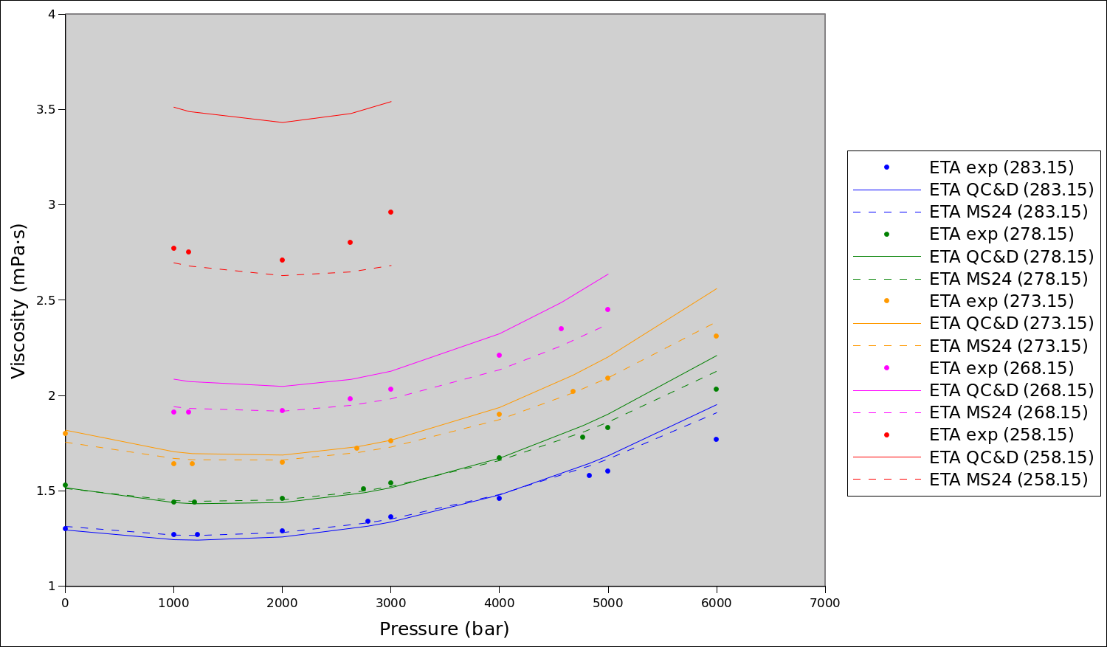

*Figure 4: Critical and subcritical isotherms from Defries et al., comparing experimental data and the proposed model (258.15–283.15 K, 1000–6000 bar).*

*Figure 5: Comparison of isotherms from Harris et al. with the proposed model (255.65 K to 298.15 K, 1 to 3000 bar).*

4. Conclusions

The proposed model, based on FT and combined with the Peng-Robinson-Stryjek-Vera EOS, demonstrated remarkable accuracy in representing the dynamic viscosity of water over wide ranges of temperature and pressure, including critical and anomalous regions. Furthermore, it successfully predicts the viscosity minima within the anomalous region, especially at low temperatures (0–35 °C) and pressures up to 3000 bar, at least, qualitatively. Compared to models such as those by Quiñones-Cisneros and Dieters, this approach shows a lower average percentage deviation, standing out for its higher accuracy in describing phase transitions and density fluctuations near the critical point. The success of the present model is mainly due to the new functionalities introduced to the friction factors (eq. 9) which prove to be a suitable temperature functionality in the particular case of water.

**Nomenclature**

AAD – Average Absolute Deviation

F𝑐 – Correction factor

$T_{c}$– Critical temperature, K

$T^{*}$– Reduced temperature, -

𝑉𝑐 – Critical molar volume, ${{cm}^{3}}/{mol}$

$η$– Viscosity, mPa\*s

$η_{0}$– Dilute gas viscosity, mPa\*s

$η_{f}$– Dense-state viscosity, mPa\*s

$Ω^{*}$– Reduced collision integral

𝜔 – Acentric factor, -

References

Chung, T.H., Ajlan, M., Lee, L.L., Starling, K.E. (1988). Generalized multiparameter correlation for nonpolar and polar fluid transport properties. Industrial & Engineering Chemistry Research, 27, 671-679.

DeFries, T., Jonas, J. (1977). Pressure dependence of NMR proton spin–lattice relaxation times and shear viscosity in liquid water in the temperature range −15–10 °C. Journal of Chemical Physics, 66, 896-901.

Forst, P., Wemer, F., Delgado, A. (2000). The viscosity of water at high pressures - especially at subzero degrees centigrade. Springer-Verlag, 39, 566-573.

Harris, K.R., Woolf, L.A. (2004). Temperature and volume dependence of the viscosity of water and heavy water at low temperatures. Journal of Chemical & Engineering, 9, 1064-1069.

Macías-Salinas, R. (2023). "A Viscosity Model Based on a Modified Free Volume Theory for Pure Fluids". Chemical Engineering Transactions, 100, 229-234.

Quinones-Cisneros, S.C., Stenby, E. (2000). The friction theory (f-theory) for viscosity modelling. Fluid Phase Equilibria, 169, 249-258.

Quiñones-Cisneros, S., Deiters, U.K. (2006). Generalization of the friction theory for viscosity modelling. Journal of Physical Chemistry B, 10, 12820-12834.

Romero-Rueda, I.M., Macías-Salinas, R. (2023). "A Viscosity Model for Deep Eutectic Solvents Based on the Friction Theory". Chemical Engineering Transactions, 100, 493-498

Stryjek, R., Vera, J.H. (1986). PRSV: An improved Peng-Robinson equation of state for pure compounds and mixtures. The Canadian Journal of Chemical Engineering, 64 (April), 100-110.