|  |  |
| --- | --- |
| cetlogo ***CHEMICAL ENGINEERING TRANSACTIONS***  ***VOL. , 2025*** | A publication of  aidiclogo_grande |
| The Italian Association  of Chemical Engineering  Online at www.cetjournal.it |
| Guest Editors: Fabrizio Bezzo, Flavio Manenti, Gabriele Pannocchia, Almerinda di Benedetto  Copyright © 2025, AIDIC Servizi S.r.l. **ISBN** 979-12-81206-17-5; **ISSN** 2283-9216 | |

Computer-Aided simulation of the hydrogen production process from palm rachis in María La Baja

Tamy C. Herrera-Rodrígueza, Paola A. Acevedo Pabónb, Ángel D. González-Delgadoa\*

aNanomaterials and Computer Aided Process Engineering Research Group (NIPAC), Chemical Engineering Department,

Faculty of Engineering, University of Cartagena, Av. del Consulado Calle 30 No. 48-152, Cartagena, Colombia.

bChemical Engineering Department, Faculty of Engineering, EAN University, Carrera 11 78-47, Bogotá, Colombia.

agonzalezd1@unicartagena.edu.co

In the world, 20 million palm rachis are produced annually; this is a fibrous residue resulting from the use of the palm fruit. In Colombia, approximately 400,000 tons of empty fruit bunches (palm rachis) are generated each year, so the expansion of this crop has generated concerns due to the deforestation of land used for palm plantations. In addition, palm oil production generates a large amount of waste, such as the rachis, which is often not adequately utilized, contributing to waste management problems and greenhouse gas emissions; however, the rachis can be used for the generation of value-added products or energy, because it is a biomass rich in lignocellulosic material and fiber. According to the above, it is proposed to use the palm rachis cultivated in María la Baja, located in the department of Bolívar, to obtain hydrogen, to stop burning this biomass and obtain a product that can be used mainly as fuel or energy. In this study, the modeling and simulation of the hydrogen synthesis process from palm rachis produced in María la Baja, Bolívar, were conducted using Aspen Plus. According to the results, the thermodynamic model used allows predicting the behavior of the process in an efficient way, since the properties of the validated substances fit the data reported in the literature. The process simulation helped to evaluate the technical feasibility of the assembly of a hydrogen production plant from rachis, allowing decision making for the improvement of the process not only at a technical level, but also at an economic, energetic and environmental level, optimizing the operative conditions such as temperature and pressure, minimizing the production of undesired substances and maximizing the synthesis of the product of interest. According to the simulation, hydrogen with properties exceeding 95% accuracy is obtained, which indicates that it is possible to produce this product through indirect gasification of palm residues at a temperature of 900 °C. This process indicates that it is possible to obtain 5,056 kg/h of hydrogen from 85,557 kg/h of empty fruit bunches (EFB).

**1. Introduction**

The transition to energy systems based on renewable sources is an alternative to improve environmental sustainability by harnessing solar, wind, or biomass energy, such as agro-industrial waste. The goal is to stop using fossil fuel-based energy sources, which generate large amounts of substances that contribute to pollution and the greenhouse effect (Qamaruzzaman, 2025; Barragán et al., 2025). Some of the sources correspond to residual biomass, which can be seeds, shells, and all waste containing usable lignocellulosic material. The cultivation of oil palm is a significant activity in Colombia, used for extracting crude palm oil (CPO), which is widely used in the food industry. However, this process produces waste such as fiber, kernel, rachis, or empty fruit bunches (EFB), palm oil mill effluent (POME), primarily (Zhang and Lim, 2024; Rajakal et al., 2024). These wastes were initially accumulated, leading to the presence of insects in the deposit areas and leachates. Another form of utilization is the burning of this biomass for energy production in boilers (Reyes et al., 2009). As an alternative for biomass valorization, hydrogen can be obtained through different techniques, including gasification and pyrolysis. The production of biofuels from this raw material allows the decarbonization of industries and the reduction of pollution in the regions (Zhang et al., 2025).

To identify the sustainability and economic feasibility of these processes, it is necessary to design and simulate their behavior using computer-aided tools, representing in a simplified or detailed manner each of the stages of the process of interest, considering pressure, temperature, and stream composition conditions (González et al., 2022). This research develops the computer-aided simulation of the hydrogen production process from palm rachis produced in María La Baja (Bolívar). A hydrogen synthesis process was modeled based on the gasification of rachis (waste from crude palm oil extraction). Aspen Plus software was used, considering data from literature and experimental results to represent the actual conditions of the palm waste valorization process. The goal is to contribute to the development of sustainable solutions in the region by leveraging the potential of agricultural waste for energy generation and reducing environmental impacts through hydrogen production from palm cultivation waste.

**2. Materials and methods**

**2.1 Process description**

The simulation was developed using the Aspen Plus process simulation software, for which it was necessary to define temperature and pressure conditions for the area (María La Baja), compositions, among others. Figure 1 shows the schematic representation of the hydrogen synthesis process from palm rachis. The process begins with the reception of the palm rachis after extracting the crude palm oil (CPO). It is then sent to a mill to reduce its size and facilitate drying. Once the biomass is broken into smaller pieces, it is dried at a temperature of 101 °C to remove the moisture content of the rachis, which exceeds 45 %. Subsequently, the dehydrated biomass is sent to a reactor where indirect gasification occurs in the absence of oxygen at a temperature of 400 to 600 °C. At this stage, the rachis releases its light components as volatile gases, and a solid residue known as biochar is obtained. The produced biochar is then sent to the gasification reactor to be mixed with steam to generate certain gases, such as hydrogen (H2), carbon dioxide (CO2), carbon monoxide (CO), and methane (CH4).

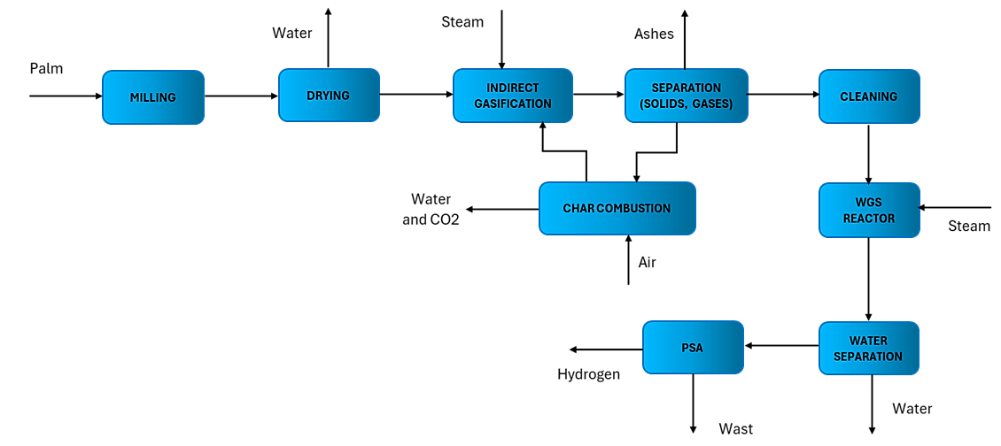*Figure 1: Process Flow Diagram for Hydrogen Production from Palm Rachis*

Then, the gas mixture is cleaned to remove impurities or unwanted solids. Carbon monoxide (CO) is converted into hydrogen through a Water Gas Shift (WGS) reactor, where CO reacts with steam to produce additional hydrogen. In the next stage, water is removed, and the gas mixture is sent to a Pressure Swing Adsorption (PSA) unit, where hydrogen is purified by eliminating impurities such as CO₂, CH₄, and N₂. This purification process can achieve hydrogen purity levels of up to 99.99% (Kalman et al., 2022). As a result, hydrogen is obtained as the main product, while impurities are considered as waste. Figure 1 shows the process flow diagram.

**2.2 Biomass characterization**

To determine the constituent compounds of the palm rachis, the biomass samples were characterized by proximate and ultimate analysis. Proximate analysis allows the identification of moisture content, ash, volatile material and fixed carbon present in the ash content. These techniques allow the composition of hydrogen, carbon, oxygen, sulfur and carbon to be determined by elemental or proximate and final analysis, making it possible to identify the chemical properties of a compound (Racero-Galaraga et al., 2024) and assessing how suitable raw material is to produce the desired product, in this case, hydrogen. Table 1 shows the content of C, H, O, N, and S in a sample of rachis or empty fruit bunch (EFB) analyzed at an external laboratory. Likewise, it shows a moisture content above 50%, which must be removed before gasification.

*Table 1: Chemical composition of the palm rachis from María la Baja, Bolívar.*

|  |  |
| --- | --- |
| Parameter | Rachis |
| Moisture | 59.13 % |
| Total solids | 40.87 % |
| Proximate analysis (dry basis) | |
| Volatile matter | 82.56 % |
| Fixed carbon | 7.85 % |
| Ash | 9.58 % |
| Ultimate analysis (dry basis) | |
| Carbon | 49.73 % |
| Hydrogen | 5.72 % |
| Oxygen | 34.06 % |
| Nitrogen | 0.90 % |
| Sulfur | 0.05 % |

With this characterization and additional information obtained from the literature, it is possible to feed the Aspen Plus software with the biomass composition, allowing for a better simulation of the properties of the rachis used, in this case, the one resulting from the crude palm oil extraction process in the department of Bolívar, Colombia, specifically in María la Baja.

**3. Results and discussion**

Below are the results of the hydrogen production simulation from palm rachis through indirect gasification, using computer-aided process engineering (CAPE), which allows for the optimization of resources and time by considering thermodynamic and molecular phenomena. This makes it possible to develop processes at a pilot or industrial scale (González et al., 2022). To carry out the simulation, the thermodynamic package was initially selected. According to the Aspen manual and the processes reported in the literature, the most suitable model is the Peng-Robinson model, as it tends to be more accurate when studying processes with hydrocarbon mixtures (Al-Ali, 2021) and allows estimating physical properties of the components that are mainly produced in gasification (Galiano et al., 2017). Additionally, the chemical substances, temperature and pressure conditions, and required equipment were specified to adequately represent the process.

**3.1 Simulation**

For the production of hydrogen through indirect gasification of palm rachis produced in María la Baja, Bolívar, several considerations were made, including the use of different equipment to best represent the behavior of each stage. Likewise, substances and solution models were considered with the same objective. Figure 2 shows the simulation diagram in Aspen Plus, where the equipment, inputs, and outputs of the hydrogen production process are displayed. The process began with the reception of the palm rachis (EFB), which was sent to a ball mill (MILL/CRUSHER) to reduce its size and facilitate drying in a DRYER, where moisture was removed, generating a steam stream. The dehydrated biomass was then sent to a gasification train consisting of two reactors (INDIRECT GASIFICATION/R-GIBBS), where the palm rachis was converted into a gas mixture, known as syngas, at a temperature of 900°C. Generally, the gasification process occurs at temperatures ranging from 800 to 1200°C in the presence of steam, air, or oxygen, involving both exothermic and endothermic reactions (Rajabi et al., 2019). To ensure higher hydrogen production, steam was used as the gasifying agent, as it is one of the most efficient methodologies for obtaining hydrogen from biomass (Basu and Kaushal, 2024; Parthasarathy and Narayanan, 2014). The resulting stream (stream 9) from gasification passes through a cyclone separator (CYC SEP/SSPLIT), where impurities or ash are separated from the gaseous stream containing the product of interest. The latter then undergoes a washing process (CLEANER/FLASH) to remove any remaining ash and unwanted material (Neubauer, 2013), producing a residual stream (16).

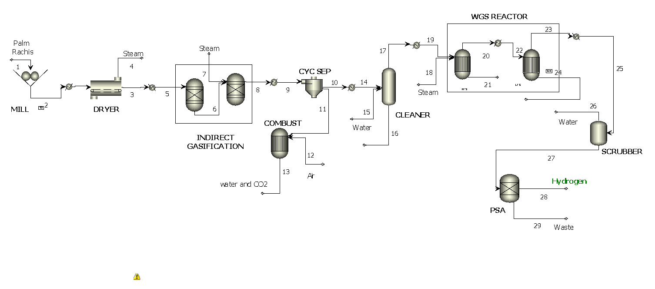Figure 2: Process Flow Diagram for Hydrogen Production from Palm Rachis in the Maria la Baja

The syngas-rich stream (stream 17) is then sent to a WGS reactor, where hydrogen production is increased through the reaction between steam and carbon monoxide, forming H₂ and CO₂. This reactor operates in two stages: one at high temperature and another at low temperature, as lower temperatures favor hydrogen production due to the exothermic nature of the reaction (Ghasemzadeh et al., 2017). Next, a SCRUBBER removes any remaining water vapor before the gas enters the PSA unit. The hydrogen-rich stream is purified in an absorption column or PSA (Pressure Swing Adsorption), obtaining a high-purity product. Based on this process, from 85,557 kg/h of feedstock, 5,056 kg/h of hydrogen is obtained. Table 2 shows the compositions of the main process streams and their operating conditions.

*Table 2: Chemical compositions of the hydrogen production process from palm rachis*

|  |  |  |  |  |  |  |  |  |  |
| --- | --- | --- | --- | --- | --- | --- | --- | --- | --- |
| T (°C) | 30 | 900 | 450 | 600 | 30 | 30 | 10 | 40 | 40 |
| P (bar) | 1 | 60 | 10 | 60 | 1 | 1 | 60 | 45 | 45 |
| Flow (kg/h) | 85,557 | 85,557 | 20,833 | 95,974 | 250,000 | 288,942 | 72,961 | 5,056 | 37,626 |
| Stream | 1 | 6 | 7 | 9 | 12 | 13 | 15 | 28 | 29 |
| CO | 0.000 | 0.000 | 0.000 | 0.225 | 0.000 | 0.000 | 0.000 | 0.000 | 0.050 |
| O2 | 0.000 | 0.288 | 0.000 | 3.0x10-5 | 0.258 | 0.029 | 0.000 | 0.000 | 0.000 |
| H2O | 0.000 | 0.000 | 1.000 | 0.115 | 0.000 | 0.000 | 1.000 | 0.000 | 0.002 |
| H2 | 0.000 | 0.043 | 0.000 | 0.022 | 0.000 | 0.000 | 0.000 | 1.000 | 0.000 |
| CH4 | 0.000 | 0.000 | 0.000 | 0.061 | 0.000 | 0.000 | 0.000 | 0.000 | 0.011 |
| C | 0.000 | 0.618 | 0.000 | 0.365 | 0.000 | 0.048 | 0.000 | 0.000 | 0.000 |
| Ash | 0.000 | 0.046 | 0.000 | 0.041 | 0.000 | 0.013 | 0.000 | 0.000 | 0.000 |
| SO2 | 0.000 | 0.000 | 0.000 | 0.008 | 0.000 | 0.000 | 0.000 | 0.000 | 0.000 |
| Rachis | 1.000 | 0.000 | 0.000 | 0.000 | 0.000 | 0.000 | 0.000 | 0.000 | 0.000 |
| CO2 | 0.000 | 0.000 | 0.000 | 0.163 | 0.000 | 0.267 | 0.000 | 0.000 | 0.936 |
| S | 0.000 | 0.005 | 0.000 | 3.8x10-5 | 0.742 | 0.000 | 0.000 | 0.000 | 0.000 |
| N2 | 0.000 | 0.000 | 0.000 | 0.000 | 0.000 | 0.642 | 0.000 | 0.000 | 0.000 |
| Char | 0.000 | 0.000 | 0.000 | 0.000 | 0.000 | 0.000 | 0.000 | 0.000 | 0.000 |
| Total | 1.000 | 1.000 | 1.000 | 1.000 | 1.000 | 1.000 | 1.000 | 1.000 | 1.000 |

**3.2 Validation**

After simulating the hydrogen production process from oil palm rachis under the conditions of María la Baja, the results were validated by comparing some properties of the target product. For hydrogen (stream 28), a molecular weight of 2.0158 kg/mol was observed. Table 3 presents some properties of hydrogen to validate whether the decisions made during the simulation were appropriate.

In the previous table, two important properties for evaluating the energy behavior of the obtained hydrogen are observed: thermal conductivity and heat capacity. According to these data, the evaluated properties show an approximation above 95%. Specifically, thermal conductivity achieved an approximation of 96.13%, while heat capacity reached 98.81%. These values indicate that the considerations made allow for obtaining hydrogen with characteristics similar to those reported in other studies. It is worth noting that the properties evaluated by Kliche et al. (2011) were measured at a temperature of 25°C and a pressure of 1 bar, whereas the present study was conducted under the conditions of the Bolívar department, considering 30°C and 1 bar. Validating these properties is necessary, as they help determine the efficiency with which hydrogen can transfer heat and how much energy is required to change the gas temperature.

*Table 3: Validation of Hydrogen Properties from Oil Palm Rachis*

|  |  |  |  |
| --- | --- | --- | --- |
| Properties | This work | Kliche et al. (2011) | Accuracy (%) |
| Heat capacity (Kj/kg.K) | 14.45 | 14.29 | 98.81 |
| Thermal conductivity (W/m.K) | 0.188 | 0.181 | 96.13 |

Various types of biomass with elemental compositions similar to that of palm rachis have been reported in the literature. Rabea et al. (2023) conducted hydrogen production from wood chips via gasification, where the ultimate analysis revealed a comparable composition of carbon, hydrogen, and sulfur, owing to the organic nature and similar characteristics of the materials. Several studies have demonstrated the significance of incorporating syngas cleaning processes, which contribute to improved system performance. Méramo et al. (2020) developed a model of the gasification process of cassava and rice for hydrogen production, including gas cleaning and CO₂ capture stages to purify the desired product. Likewise, Bach et al. (2019) performed steam gasification of wood, also integrating a CO₂ capture stage to obtain hydrogen with higher concentration and calorific value.

The present study focuses solely on the design and simulation of the hydrogen production process from palm rachis; however, various process evaluation methods are currently under development. One such method is Life Cycle Assessment (LCA), which involves the evaluation of different environmental indicators, considering the use of various energy sources and their contributions to overall process-related pollution. It is important to note that LCA enables the assessment of environmental implications across the entire process chain, from raw material reception and product synthesis to final use. Future work aims to evaluate hydrogen production using different methodologies that support the assessment of the process’s sustainability. In this context, a techno-economic sensitivity analysis is proposed, involving variations in raw material costs, operating expenses, processing capacity, and other factors to identify how the process responds to such changes. Additionally, future research should consider comparing different hydrogen production methodologies from an economic perspective.

**4. Conclusions**

The computer-aided simulation of the hydrogen production process from palm rachis in María La Baja allowed for the evaluation of the technical and energy viability of this alternative within the context of regional bioeconomy. Through computational modeling, key parameters influencing the process efficiency were identified, optimizing operational conditions to maximize biomass conversion into hydrogen. The results highlight the potential of palm rachis as a renewable resource for hydrogen generation, contributing to energy diversification and the valorization of agro-industrial waste in the region. Moreover, the use of simulation tools facilitates informed decision-making for the design and scaling of such processes. Finally, this study emphasizes the importance of continuing experimental research and techno-economic analysis to validate the developed models and assess the long-term sustainability of hydrogen production from biomass in rural settings.

The production of hydrogen is an alternative for utilizing waste from the palm cultivation and the crude palm oil extraction process. In this way, part of the pollution generated in these processes is eliminated, and biomass that is typically burned for energy generation within the same system is valorized.

**Nomenclature**

CPO – Crude Palm Oil

PSA – Pressure Swing Adsorption

CO – Carbon monoxide

CO₂ – Carbon Dioxide

CH₄ – Methane

N₂ – Nitrogen

H₂ – Hydrogen

EFB – Empty Fruit Bunch

POME – Palm Oil Mill Effluent

CAPE – Computer-aided Process Engineering

T – Temperature

P – Pressure

WGS – Water gas shift

**Acknowledgments**

The authors gratefully acknowledge the financial support provided by the Universidad de Cartagena and the Colombian Ministry of Science, Technology, and Innovation (MINCIENCIAS) for this research. This work was funded under the project “Development and implementation of a methodology to evaluate social, technical, economic, and environmental aspects of hydrogen production from palm rachis in Sabana de Torres and María La Baja,” with project code SIGP 100495.

**References**

Al-Ali H., 2021, Process simulation for crude oil stabilization by using Aspen Hysys, Upstream Oil and Gas Technology, 7, 100039.

Bach Q.V., Gye H., Song D., Lee C., 2019, High Quality Product Gas from Biomass Steam Gasification Combined with Torrefaction and Carbon Dioxide Capture Processes. International Journal Hydrogen Energy, 44, 14387-14394.

Barragán-Ocaña A., Cecilio-Ayala E., Silva-Borjas P., Cortés-Ruiz J. A., Hernández E.-Y., 2025, Policies and sustainable energy transition in the global environment: Challenges for Latin America, Heliyon, 11, e42295.

Basu P., Kaushal P., 2024, Biomass Gasification, Pyrolysis, and Torrefaction: Practical Design, Theory, and Climate Change Mitigation. 4th edn. Chapter 11 - Hydrogen production and fuel cells, Elsevier, 397-430.

Gagliano A., Nocera F., Bruno M., Cardillo G., 2017, Development of an equilibrium-based model of gasification of biomass by Aspen Plus, Energy Procedia, 111, 1010–1019.

Ghasemzadeh K., Zeynali R., Basile A., Iulianelli A., 2017, CFD analysis of a hybrid sorption-enhanced membrane reactor for hydrogen production during WGS reaction, International Journal of Hydrogen Energy, 42(43), 26914-26923.

González-Delgado Á. D., Moreno-Sader K. A., Martínez-Consuegra J. D., 2022, Biorrefinación sostenible del camarón: Desarrollos desde la ingeniería de procesos asistida por computador, Corporación Universitaria Minuto de Dios-UNIMINUTO.

Kalman V., Voigt J., Jordan C., Harasek M., 2022, Hydrogen Purification by Pressure Swing Adsorption: High-Pressure PSA Performance in Recovery from Seasonal Storage, Sustainability, 14(21), 14037.

Kliche K., Billat S., Hedrich F., Ziegler C., Zengerle R., 2011, Sensor for gas analysis based on thermal conductivity, specific heat capacity and thermal diffusivity, IEEE 24th International Conference on Micro Electromechanical Systems, 769-772.

Meramo S., Puello P., Cabarcas A., 2020, Process Analysis of Hydrogen Production via Biomass Gasification under Computer-Aided Safety and Environmental Assessments, ACS Omega, 5 , 19667-19681.

Neubauer Y., 2013, Biomass gasification, in Biomass Combustion Science, Technology and Engineering. Woodhead Publishing Series in Energy. Woodhead Publishing, 106-129.

Parthasarathy P., Narayanan K.S., 2014, Hydrogen production from steam gasification of biomass: Influence of process parameters on hydrogen yield – A review, Renewable Energy, 66, 570-579.

Qamaruzzaman M., 2025, Driving energy transition in BRI nations: The role of education, globalization, trade liberalization, and financial deepening – A comprehensive linear and nonlinear approach, Energy Strategy Reviews, 57, 101620.

Rabea K., Michailos S., Hughes K.J., Ingham D., Pourkashanian M., 2023, Comprehensive process simulation of a biomass-based hydrogen production system through gasification within the BECCS concept in a commercial two-stage fixed bed gasifier, Energy Conversion and Management, 298, 117812.

Racero-Galaraga D., Rhenals-Julio J.D., Sofan-German S., Mendoza J.M., Bula-Silvera A., 2024, Proximate analysis in biomass: Standards, applications and key characteristics, Results in Chemistry, 12, 101886.

Rajabi M., Mehrpooya M., Haibo Z., Huang Z., 2019, Chemical looping technology in CHP (combined heat and power) and CCHP (combined cooling heating and power) systems: A critical review, Applied Energy, 253, 113544.

Rajakal J.P., How B.S., Andiappan V., Ng L.Y., Ng D., 2024, Evaluation of Decarbonisation Pathways for Palm Oil Mills Integrated with Carbon Capture and Storage, Chemical Engineering Transactions, 114, 445-450.

Reyes Ortiz, S. P., Ortiz García, J. A., Barbosa, N. P., 2009, Aprovechamiento de los residuos de la palma africana - Utilization of waste from oil palm. Universidad Cooperativa de Colombia, Facultad de Ingenierías, Sede Villavicencio.

Zhang J.T.Z., Lim J.S., 2024, Optimisation of Crystallisation Recipe for Varied Cloud Points Characteristics in Palm Oil Fractions, Chemical Engineering Transactions, 114, 529-534.

Zhang Y., Hou D., Sun X., Zhu X., Yan B., Chen G., 2025, Different pretreatment of biomass for gasification: A critical review, Journal of the Energy Institute, 119, 101992.