|  |  |
| --- | --- |
| cetlogo ***CHEMICAL ENGINEERING TRANSACTIONS***  ***VOL. , 2025*** | A publication of  aidiclogo_grande |
| The Italian Association  of Chemical Engineering  Online at www.cetjournal.it |
| Guest Editors: Fabrizio Bezzo, Flavio Manenti, Gabriele Pannocchia, Almerinda di Benedetto  Copyright © 2025, AIDIC Servizi S.r.l. **ISBN** 979-12-81206-17-5; **ISSN** 2283-9216 | |

Exergetic Evaluation of an avocado (*Laurus Persea L*.) Biorefinery in Northern Colombia

Tamy C. Herrera-Rodríguez, Vianny Parejo-Palacio, Ángel D. González-Delgado\*

Nanomaterials and Computer Aided Process Engineering Research Group (NIPAC), Chemical Engineering Department,

Faculty of Engineering, University of Cartagena, Av. del Consulado Calle 30 No. 48-152, Cartagena, Colombia.

agonzalezd1@unicartagena.edu.co

In Colombia, avocado cultivation is prominent in departments such as Bolívar, Antioquia, Tolima, Cesar, Caldas, Valle del Cauca, Quindío, and Santander, covering 86% of the planted area. In Bolívar, particularly in the Montes de María, avocados damaged by fungi, poor marketing, and deteriorated roads pose a challenge. This study proposes a biorefinery approach to valorize these wastes by producing oil, chlorophyll, biochar, fat-free pulp, and fertilizer. The research evaluates the overall exergy efficiency and identifies key thermodynamic irreversibilities in an avocado (*Laurus Persea L*) biorefinery in northern Colombia. Exergy, which measures energy quality and work potential, is used to assess process efficiency and sustainability. Results show that stages 8 (oil distillation, condensation, and refrigeration), 12 (pyrolysis and by-product separation), and 16 (chlorophyll extract distillation, condensation, and refrigeration) have the highest exergy destruction, accounting for 23.90 %, 33.27 %, and 7.84 %, respectively. The peel washing stage demonstrated high exergetic efficiency (97.32 %) due to its contribution to chlorophyll-rich extract and fertilizer production. However, stage 12 had significant exergy loss (2,438.52 MJ/h) because the volatile gases produced during pyrolysis were not utilized as biorefinery products. The highest irreversibilities were observed in stages 8 and 12. The overall exergy efficiency of the process was 46.26 %, higher than systems that use only avocado pulp, as this biorefinery integrates seeds and peels into its processes, reducing waste generation. This study highlights the potential of avocado crop residues for value-added production and emphasizes the need to optimize processes to enhance energy efficiency and sustainability.

**1. Introduction**

Avocado biorefineries, especially in regions with significant production of this crop, represent a promising opportunity to improve environmental and economic conditions. Avocado production has increased by approximately 7% over the last 10 years (Campos et al., 2024). Consequently, the avocado industry generates large amounts of seed and peel waste, accounting for 21–30% of the fruit. These residues contain proteins, carbohydrates, lipids, minerals, and polyphenols that can be utilized to produce various products (Del-Castillo et al., 2023).

To implement these processes, it is essential to determine how energy is used and how it can be optimized. Therefore, exergy analyses are conducted to quantify energy losses and process efficiency, with the aim of proposing improvements that yield both energetic and economic benefits. Previous studies have reported exergy assessments of the linear avocado value chain, focusing on pulp utilization for oil extraction, revealing that the process had an overall exergy efficiency of approximately 31% (Herrera et al., 2022). Pezara et al. (2024) developed an avocado biorefinery to determine the energy potential of the seed, finding that it has a high energy production capacity through transformation; however, the process efficiency was not assessed through an exergy analysis. Based on the above, it can be observed that the literature reports avocado biorefineries that have been evaluated mainly from energetic, economic, and environmental perspectives, but few have been assessed in terms of exergy. As a result, data for comparing the present study with others is very limited. Other types of processes involving different biomasses have indeed been analyzed from an exergy perspective. For instance, Zalazar et al. (2022) conducted an exergy evaluation of the pumpkin seed drying process, obtaining an efficiency of 41.77%. Determining this value is important because it allows for the identification of exergy losses, thereby enabling the implementation of improvements that help reduce process emissions. This study presents an exergetic assessment of an avocado-based biorefinery located in the Montes de María region, designed to produce oil, chlorophyll, biochar, fertilizer, and defatted pulp. Oil extraction was performed using the Soxhlet method, while biochar was generated through pyrolysis. The potential for converting various agricultural residues into biofuels via pyrolysis has been well established (Lim et al., 2024). Exergy losses at each stage of the process, along with overall exergetic performance indicators, were quantified to enhance energy efficiency and reduce environmental impacts.

**2. Materials and methods**

**2.1 Process description**

The evaluated avocado biorefinery involves the use of two solvents, hexane and ethanol, primarily required for oil extraction and chlorophyll-rich extract production. To facilitate the exergetic analysis, the process was divided into 16 stages, which are described as follows:

**Stage 1 (Avocado Washing):** This stage involves washing the fruit with a NaClO solution (stream 2) to remove impurities and contaminants from the avocado. The output consists of clean fruit (stream 3) and waste, which is a mixture of water and impurities (stream 4). **Stage 2 (Pulp Separation):** The pulp of the avocado is separated from the peel and seed, which are collected as streams 6 and 8, respectively. **Stage 3 (Seed Washing):** The seed separated from the pulp is sent to a washing stage to remove any remaining pulp. A seed free of pulp is obtained in stream 11. **Stage 4 (Peel Washing):** The peel separated from the pulp during the peeling process is sent to a washing stage to remove any remaining pulp. A peel-free pulp is obtained in stream 14. **Stage 5 (Water Separation):** The water resulting from the washing of the seed and peel is sent to a centrifugation process to separate the pulp (stream 17) from the water (stream 16).

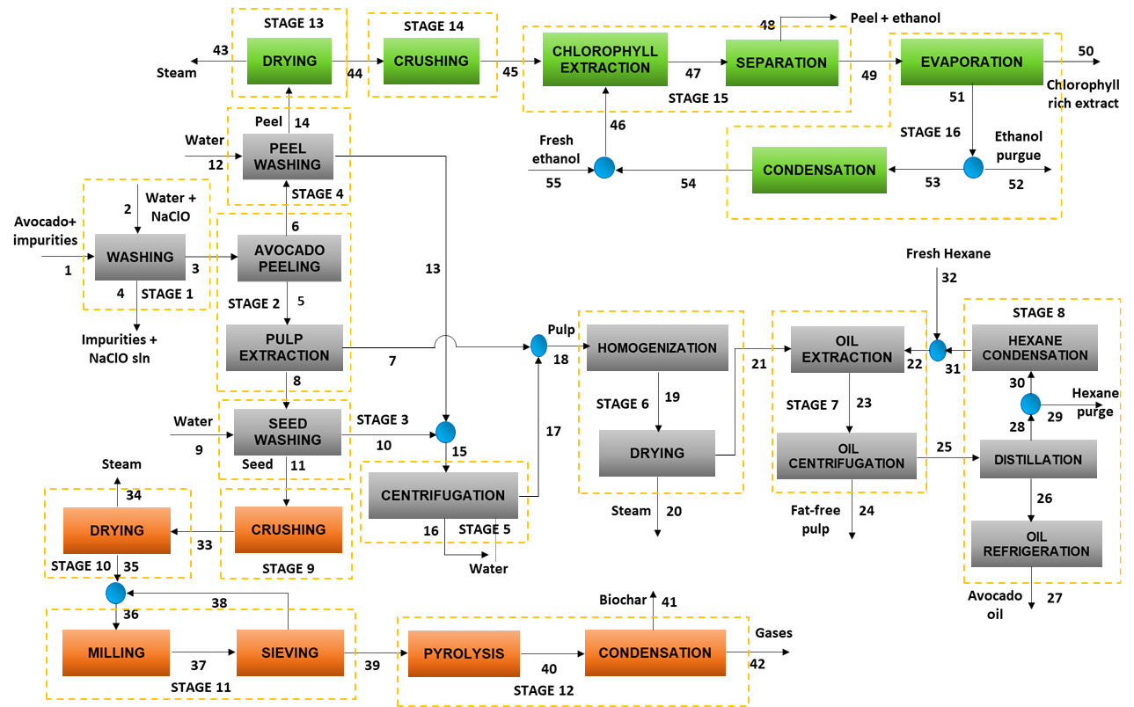

*Figure 1: Process flow diagram of avocado oil extraction.*

**Stage 6 (Homogenization and Drying):** The pulp obtained in Stage 2 (stream 7) is mixed with stream 17 (pulp from stage 5). After forming an avocado pulp paste, it is dried at 70 °C and 1 bar to remove the water content, producing vapor as stream 20. This process is carried out under these temperature and pressure conditions to prevent degradation or oxidation of the pulp and preserve the properties of the oil contained in it (Ariza et al., 2011). **Stage 7 (Oil Extraction and Centrifugation):** The dehydrated pulp is sent to the extraction stage, where it is mixed with hexane, producing an oil-hexane-pulp mixture (stream 23). The mixture is then sent to a centrifuge, where the solid part (stream 24) is separated from the liquid part (stream 25). The solid part corresponds to fat-free pulp, while the liquid part consists of the oil-solvent mixture. **Stage 8 (Hexane Distillation and Condensation):** To obtain avocado oil, the hexane-oil mixture is distilled at 70 °C, recovering hexane as stream 28 and cooled oil as stream 27. Part of the recovered hexane is recirculated to Stage 7.

**Stage 9 (Seed Crushing):** The clean seed is sent to a crushing stage to reduce its size, facilitating the removal of moisture. **Stage 10 (Seed Drying):** The seed is dried using an air stream heated to 110 °C (Xue et al., 2018), resulting in dehydrated seed in stream 35. **Stage 11 (Seed Milling and Sieving):** The dried seed is milled and passed through a sieve. Biomass that does not meet the desired size is sent back to the milling stage. **Stage 12 (Pyrolysis and Condensation):** Stream 39, resulting from the sieving stage, enters the pyrolysis reactor, maintained at a temperature of 400 °C. This temperature facilitates the conversion of biomass into biochar without the use of a catalyst, with nitrogen fed to ensure an inert atmosphere. Biochar is obtained in stream 41, and a gas mixture is collected in stream 42 (Durak and Aysu, 2014).

**Stage 13 (Peel Drying):** The clean peel is dried at 60 °C to prevent pigment degradation (Weemaes, 1999). Vapor is obtained in stream 43 during this stage. **Stage 14 (Peel Crushing):** After drying, the peel is crushed to reduce its size, facilitating the extraction of the chlorophyll-rich extract. **Stage 15 (Chlorophyll Extraction and Centrifugation):** The crushed peel is mixed with ethanol, resulting in a mixture of ethanol, peel, and chlorophyll-rich extract. The mixture is centrifuged to separate the solid part from the liquid, yielding peel with ethanol traces in stream 48 and the chlorophyll-rich extract in the solvent as stream 49. **Stage 16 (Ethanol Distillation and Condensation):** To separate the solvent from the chlorophyll, the mixture is distilled, producing the extract in stream 50 and ethanol in stream 51, which is recirculated back into the extraction process.

**2.2 Exergy assessment**

Exergy analysis is a methodology used to evaluate energy and efficiency in processes by applying the principles of the first and second laws of thermodynamics, providing information on areas where energy is lost and sources of irreversibilities (Mtogo and Mizsey, 2024). Through this type of analysis, it is possible to identify the location, magnitude, and sources of thermodynamic inefficiencies in an energy conversion system; this information can be used to improve the efficiency of the evaluated system. Exergy is defined as the maximum theoretical useful work that can be obtained from an energy conversion system as the system is brought to a complete thermodynamic equilibrium with the environment (Barragán et al., 2018). Total exergy consists of four main components: physical, chemical, potential, and kinetic. However, in most engineering applications, only physical and chemical exergies need to be considered (Duk et al., 2018). The total exergy losses can be determined by Eq (1), which in consideration the net exergies for work, heat and mass, Eq (2), (3) and (4), respectively. These equations are shown below:

|  |  |
| --- | --- |
| $$Ex_{loss}=Ex_{mass}+Ex_{heat}+Ex_{work}$$ | (1) |
| $$Ex_{work}=W$$ | (2) |
| $$Ex_{heat}=\sum{\left(1-\frac{T_{0}}{T}\right)Q}$$ | (3) |
| $$Ex_{mass}=Ex_{ch}+Ex_{phy}$$ | (4) |

The physical exergy of an ideal gas with constant specific heat is determined based on temperature, pressure, and the universal gas constant (R). For streams in a solid or liquid state, also assuming constant specific heat, physical exergy is calculated using temperature, pressure, and stoichiometric coefficients. Chemical exergies of the substances are computed using Eq (5), which considers the standard Gibbs free energy of formation, stoichiometric coefficients, and standard chemical exergy values. Irreversibilities are identified and quantified using Eq (6), which considers the total exergy input and the exergy output of the products. The total input exergy is defined as the sum of the exergies of all mass flows entering the system, as well as the exergy associated with the required industrial utilities. Conversely, the total output exergy is the sum of the exergy of the final products and the exergy of the waste streams. To calculate the percentage of exergy destroyed, Eq (7) is applied. Finally, the overall exergy efficiency of the process is determined using Eq (8), which accounts for the destroyed exergy and the total exergy input (González et al., 2022).

|  |  |
| --- | --- |
| $$Ex_{ch}=∆G_{f}^{0}+\sum{v_{j} {Ex}_{ch-j}^{0}}$$ | (5) |
| $$Ex_{total loss }=Ex_{total in}-\sum{Ex_{total out }}$$ | (6) |
| $$\%Ex_{destroyed}=\left(\frac{{Ex}_{destroyed}}{Ex_{total destroyed}}\right)*100\%$$ | (7) |
| $$η_{ex}=1-\left(\frac{{Ex}_{loss}}{Ex_{total in}}\right)$$ | (8) |

**3. Results and discussion**

**3.1 Exergy evaluation of the biorefinery**

To quantify the exergy of the streams involved in the evaluated biorefinery topology, it was necessary to determine the chemical exergy of the substances, which was obtained from the literature (Singh et al., 2019). Additional data required for the evaluation, such as stream compositions, temperatures, pressures, and energy demands, were obtained through process simulation using Aspen Plus software.

*Table 1: Exergy for work and heat calculated for the stages of the avocado biorefinery.*

|  |  |  |  |
| --- | --- | --- | --- |
| Name | Exergy of work (MJ/h) | Exergy of heat (MJ/h) | Unavoidable exergy losses (MJ/h) |
| Avocado washing | 14.40 | 0.00 | 18.59 |
| Pulp separation | 93.60 | 0.00 | 76.74 |
| Seed washing | 14.40 | 0.00 | 10.71 |
| Peel washing | 14.40 | 0.00 | 72.61 |
| Water separation | 79.20 | 0.00 | 73.32 |
| Homogenization and drying | 378.00 | 196.94 | 21.71 |
| Oil extraction and centrifugation | 414.00 | 0.00 | 420.81 |
| Hexane distillation, condensation, and cooling | 2,181.60 | 32.58 | 2,207.4 |
| Seed crushing | 360.00 | 0.00 | 360.00 |
| Seed drying | 572.40 | 12.67 | 570.73 |
| Seed crushing and sieving | 439.20 | 0.00 | 439.78 |
| pyrolysis and by-product separation | 540.00 | 791.22 | 1,385.37 |
| Peel drying | 108.00 | 0.00 | 22.33 |
| Peel crushing | 360.00 | 0.00 | 360.0 |
| Chlorophyll extraction and centrifugation | 684.00 | 0.00 | 685.36 |
| Ethanol distillation and condensation | 306.00 | 52.70 | 356.69 |

The exergy analysis carried out allowed for the quantification of the main causes of thermodynamic irreversibilities in the biorefinery topology for the integrated use of avocado. To achieve this, calculations of exergy due to heat, work, and inevitable losses were developed as indicated in Table 1.

*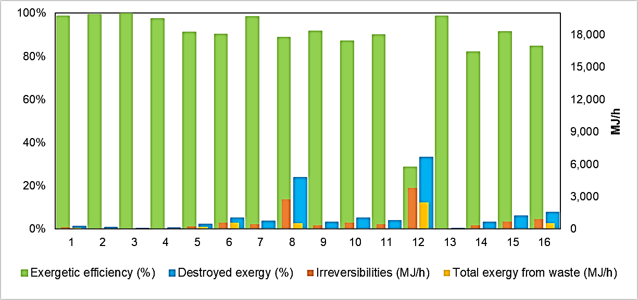*

*Figure 2: Exergy parameters by stage for avocado (Laurus Persea L.) biorefinery.*

The exergy by work for the biorefinery increased by 205.64% (6.559 MJ/h) compared to the total exergy of the linear chain; meanwhile, the exergy by heat increased by 467.68% (1.073 MJ/h). This is due to the fact that the greatest destruction of input exergy by heat occurs in the pyrolysis stage during biochar production, where high temperatures are involved. The contribution of each stage (16 in total) to the irreversibilities of the process is shown in Figure 2.

The avocado biorefinery shows a higher percentage of exergy destruction in stages 8, 12, and 16, corresponding to the distillation, condensation, and refrigeration of oil (23.90%), pyrolysis and separation of by-products (33.27%), and the distillation, condensation, and refrigeration of chlorophyll-rich extract (7.84%). Continuing from this, for the biorefinery topology, the exergy efficiency of stage 4 significantly increases compared to the linear chain, from 40.00% to 97.32%, thanks to the fact that avocado peel is no longer considered waste and is utilized to produce fertilizer and chlorophyll-rich extract. In the case of stage 12, corresponding to pyrolysis and the separation of solid phase (biochar) and volatiles, the latter are not utilized in the biorefinery, resulting in exergy from waste of 2,438.52 MJ/h in this stage. For the setup of the biorefinery, 8 processing stages were added to the linear chain, so exergy from waste is lower, but energy consumption increases due to the higher amount of equipment required for the transformation of avocado pulp, seed, and peel.

**3.2 Global exergy parameters**

The global analysis of the exergy behavior of the processes is shown in Figure 3. The exergy per service for the topology is 7645.30 MJ/h, doubling its value with respect to the linear chain; this significant increase corresponds to the implementation of service streams for the drying and pyrolysis stages at high temperature (400°C). This indicates that the modeled process requires a high demand for industrial services for its operation. The irreversibilities for the topology also increased, with a destroyed value of 11,495 MJ/h.

*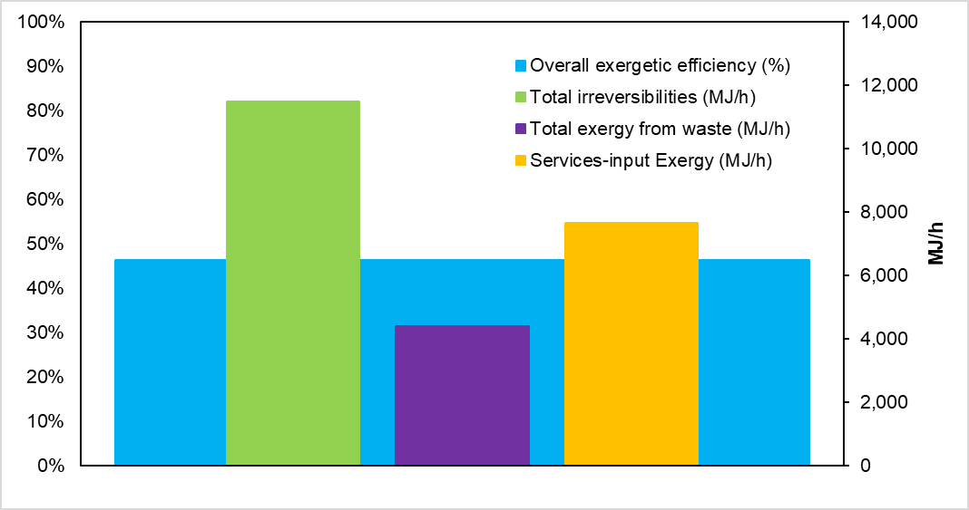*

*Figure 3: Global exergy parameters for the avocado (Laurus Persea L.) biorefinery.*

According to Figure 3, the overall exergy efficiency for the avocado biorefinery was 46.26% higher than that obtained for the linear chain (Herrera et al., 2022), which is due to the use of residues such as peel and defatted pulp, which reduces the exergy from process residues. Ebrahimi and Houshfar (2022) reported a total exergy efficiency of 27.60% for the process of obtaining oil and biochar by means of simple pyrolysis, where the thermodynamic analysis and optimization of pyrolysis for biomass is studied, working the process at 500°C. Ocampo et al. (2022) evaluated an oil palm-cane biorefinery annexed to a lignocellulosic biomethanol plant, with an overall energy efficiency of 51.04 %. The difference is due to the use of feedstock with different composition and moisture content, amount of equipment in the different process stages, as well as the energy requirements of the processes.

**4. Conclusions**

The exergetic evaluation of the biorefinery topology for the use of avocado produced in the Montes de María region allowed determining global exergetic indicators and the individual contributions of each of the stages considered (16 stages). This biorefinery uses avocado pulp to obtain oil (1,000 t/y) and fat-free pulp (798.15 t/y), biochar (504.78 t/y) from the seed and an extract rich in chlorophyll (31.32 t/y) and fertilizer (1,237.59 t/y) from the peel. According to the results, it was possible to identify an overall exergy efficiency of 46.26 %, much higher than that reported for other avocado valorization processes. Likewise, a lower exergy per residue of 4,413 MJ/h was observed in comparison with the linear avocado chain, due to the transformation of residues such as the seed and peel into value-added products such as biochar, chlorophyll-rich extract and compost. On the contrary, the exergy for services increased behavior that is considered normal because it includes more processing stages to obtain the different products.

**Nomenclature**

$Ex_{loss}$– Exergy loss

$Ex_{work}$– Exergy by work

$Ex_{heat}$– Exergy by heat

$Ex_{ch}$– Chemical exergy

$Ex_{phy}$– Physical exergy

$Ex_{total loss }$–Process irreversibilities

$Ex_{mass}$– Exergy by mass

$η_{ex}$– Exergy efficiency

$T_{0}$– Reference temperature

$T$– Temperature

$W$– Work

$Q$– Heat

$R$– Gas constant

$∆G_{f}^{0}$– Standard Gibbs free energy of formation

${Ex}_{ch}^{0} –$ Standard chemical exergy

$v_{j}$– Stoichiometric coefficient

**Acknowledgments**

The authors thank the Universidad Cartagena for funding this research presented in the ninth call for visible research groups (categorized or recognized) on the Scienti platform of the Ministry of Science, Technology, and Innovation approved by Resolution 02007 of 2018 and commitment act No. 090 of 2018.

**References**

Ariza J., Lopez F., Coyotl J., Ramos M., Diaz J., Martinez A., 2011, Effect of different extraction methods on the fatty acid profile in the avocado (Persea americana Mill. var. Hass) oil, Revista Venezolana de Ciencia y Tecnología de Alimentos, 2(2).

Barragán D., Morales S., Kafarov V., 2018, Exergetic Analysis of Combustion Processes of Variable Mixtures of Refinery Residual Gas: Effect of Propane, Chemical Engineering Transactions, 70, 1183-1188.

Campos N., Gómez J., Cerón A., Ozuna C., Saldaña A., Sáyago S., 2024, Valorization of avocado (Persea americana) residual paste: Microwave-assisted extraction, optimization and addition to an artisanal pork ham, Journal of food, 22, 1-11.

Del-Castillo A., Rodríguez F., Rodríguez B., Mallo A., Del-Río P., Gullón B., 2023, Valorization of avocado seed wastes for antioxidant phenolics and carbohydrates recovery using deep eutectic solvents (DES), Antioxidants, 12(6), 1156.

Durak H., Aysu T., 2014, Effect of pyrolysis temperature and catalyst on production of bio-oil and biochar from avocado seeds, Research on Chemical Intermediates, 41(11), 8067-8097.

Ebrahimi A., Houshfar E., 2022, Thermodynamic analysis and optimization of the integrated system of pyrolysis and anaerobic digestion, Process Safety and Environmental Protection, 164, 582-594.

González Á., Moreno K., Martínez J., 2022, Biorrefinación sostenible del camarón: Desarrollos desde la ingeniería de procesos asistida por computador, Corporación Universitaria Minuto de Dios-UNIMINUTO.

Herrera T., Parejo V., González-Delgado A., 2022, Quality of Energy Conservation in an Avocado Oil Extraction Process via Exergy Analysis, Chemical Engineering Transactions, 91, 241-246.

Mtogo J., Mizsey P., 2024, Efficiency Ranking through Exergy Analysis in Azeotropic Distillation Systems, Chemical Engineering Transactions, 114, 25-30.

Lim H., Goh B., Chai P., Ang C., Chong C., 2024, Assessing the Energy Profitability of Biofuels Generated from Coffee Waste via Microwave Pyrolysis, Chemical Engineering Transactions, 112, 271-276.

Ocampo E., Victoriano A., Castillo Y., Escobar J., Da Costa E., Horta L., Vinicius M., Dias X., Martínez A., 2022, Brazilian integrated oil palm-sugarcane biorefinery: An energetic, exergetic, economic, and environmental (4E) assessment, Energy Conversion and Management, 268, 116066.

Peraza K., Valdez J., Juárez, M., Ambriz D., Santos D., 2024, Energetic biorefinery from waste avocado seed (Persea americana cv. ‘Hass’), Revista de Ciencias Químico Biológicas, (II), 23–34.

Singh G., Singh P., Tyagi V., Barnwal P., Pandey A., 2019, Exergy and thermo-economic analysis of ghee production plant in dairy industry, Energy, 167, 602–618.

Weemaes C., Ooms V., Van Loey A., Hendrickx M., 1999, Kinetics of Chlorophyll Degradation and Color Loss in Heated Broccoli Juice, Journal of Agricultural and Food Chemistry, 47(6), 2404-2409.

Xue J., Chellappa T., Ceylan S., Goldfarb J., 2018, Enhancing biomass+coal Co-firing scenarios via biomass torrefaction and carbonization: Case study of avocado pit biomass and Illinois No. 6 coal, Renewable Energy, 122, 152-162.

Zalazar D., Román M., Fernández A., Asensio D., Zhang X., Fabani M., Rodríguez R., Mazza G., 2022, Exergy, energy, and sustainability assessments applied to RSM optimization of integrated convective air-drying with pretreatments to improve the nutritional quality of pumpkin seeds, Sustainable Energy Technologies and Assessments, 49, 101763.