|  |  |
| --- | --- |
| cetlogo ***CHEMICAL ENGINEERING TRANSACTIONS***  ***VOL. , 2023*** | A publication of  aidiclogo_grande |
| The Italian Association  of Chemical Engineering  Online at www.cetjournal.it |
| Guest Editors: Sauro Pierucci, Jiří Jaromír Klemeš  Copyright © 2023, AIDIC Servizi S.r.l. **ISBN** 978-88-95608-98-3; **ISSN** 2283-9216 | |

**POLYMERIC SEPARATOR SYNTHESIS FOR LITHIUM-AIR BATTERIES**

Elda X. S. Silveiraa,\*, Martim C. Policanob, André N. Mirandaa, Maria Ingrid R. B. Schiavona, Gustavo Doubeka, Rubens Maciel Filhoa

aUniversity of Campinas, School of Chemical Engineering, Av. Albert Einstein, 500. Campinas, SP, Brazil, 13083-852

bUniversity of Twente, Faculty of Science and Technology, MESA+ Institute for Nanotechnology, Catalytic Processes and Materials Group, 7500 AE Enschede, The Netherlands

elda.silveira1@gmail.com

Battery electricity storage has been one of the main strategies to reach a sustainable energy network. They are adequate to store energy and release it later, supporting a high volume of variable renewable electricity. In this context, lithium-air batteries (LABs) have the potential to be a high-capacity battery option, with theoretical energy densities higher than currently available lithium-ion ones. However, they are still commercially unfeasible. In the last few decades, there has been immense progress in LABs technology with the development of stable electrolytes, porous cathodes, and catalysts. Nonetheless, minor attention has been given to the protection of the lithium metal electrode, especially against reactive substances present in the atmospheric air, such as water and oxygen. In this work, a protective membrane was synthesized to protect the metallic lithium anode against water. The synthesis was carried out using polytetramethylene glycol (PTMEG), 4,4-diphenylmethane diisocyanate (MDI), and a blend of 1,4 butanediol with glycerine as a chain extender. The synthesized membrane was tested using an aprotic lithium-oxygen (Li-O2)battery assembled with carbon paper as the cathode, metallic lithium as the anode, and 0.1 mol.L-1 lithium perchlorate (LiClO4) in dimethyl sulfoxide (DMSO) with 550 ppm of water concentration as electrolyte. Furthermore, the cyclability of the batteries with the novel polymeric membrane was compared with the standard glass microfiber separator. The results showed a higher cyclability of the batteries assembled with the polymeric separator over the glass microfiber separator.

* 1. Introduction

To reach decarbonization of the global energy system, a higher share of renewable sources is required. Renewable energy from solar and wind are good candidates for electricity generation, but they are variable and uncertain energy sources (Ram et al., 2022), since they are dependent upon the weather conditions. Battery electricity storage has been considered one of the main strategies to support high levels of variable renewable electricity and contribute to energetic transition (Lach et al., 2018). The lithium-air batteries (LABs) have theoretical energy densities higher than the currently available lithium-ion batteries, nevertheless, many challenges need to be overcome to turn them commercially viable (Bi et al., 2020).

Metallic lithium is considered a good choice for anode material due to its super high specific energy, low redox potential, and low mass density. Nevertheless, problems like the crossover of oxidative species such as (O2−, LiO2−, etc.), H2O, and other substances can accelerate Li loss, resulting in a reduced life cycle (Luo et al., 2020).

Some strategies have been investigated to solve this problem, such as the solid-electrolyte interface (SEI) layer and alternative Li alloys instead of pure Li as the anode (Song et al., 2017). However, the SEI layer on the surface of lithium can cause volume fluctuations, resulting in dendritic growth of Li crystals and short circuits (Luo et al., 2018), and there is a potential decrease in discharge in the Li alloy anodes (Liang et al., 2020).

The addition of water directly in the electrolyte contributes to the increase in the discharge capacity of Li-O2 battery due to changes in the reaction mechanism, resulting in alterations in the morphology of the discharge product (Policano et al., 2022). However, the addition of H2O in Li-O2 batteries also shortens the battery life because Li metal is very reactive with water, which causes the metallic lithium anode to degrade after some time (Dai et al., 2019). Therefore, the protection of lithium becomes a key point for the intended success of the use of Li-O2 batteries.

Ion-selective separators have been one of the desired strategies to protect the metallic lithium from attack by oxidative species and obtain stability in the charge and discharge cycles of high-energy and state-of-the-art rechargeable batteries (Huang et al., 2020). The commercially available separators most common for lithium battery applications are polyolefin-based, such as polyethylene (PE) and polypropylene (PP) (Saal et al., 2021). Polyurethane is a class of polymer used in insulators, foams, elastomers, synthetic skins, coatings, adhesives and recently has been investigated in the literature for use as separator in batteries, mainly as composite nanofibrous separator using the electrospinning method (Pan et al., 2017; Cheng et al., 2022).

Polyurethane (PU) is considered a versatile polymer material because of the adaptation characteristic of its molecular structures to attend to specific property demands and it is synthesized by a reaction of polyol, isocyanate, and chain extender (Vlad et al., 2009). Its mechanical behavior depends on the synthesis method employed, conforming to the type of preparation (bulk, solution, water) and sequence of added reactants (one-step or prepolymer synthesis) (Prisacariu, 2011). PU structure is composed of soft segments (polyether or polyester) and hard segments (urethane) along the polymer conferring a microphase-separated morphology due to different polarity and chemical nature between the segments (Vlad & Oprea, 2008).

In this context, a PU polymer separator was synthesized with the purpose to protect the metallic lithium anode against water in aprotic Li-O2 batteries. In this separator, polyurethane (PU) is prepared by the bulk polymerization method and deposited on a cellulose substrate using the spin coating technique. The cellulose is a natural polymer and due to its excellent performance characteristics, such as good reproducibility, high dielectric constant and excellent chemical and thermal stability it has been considered a good candidate for use in battery separators (Zhang et al., 2014; Liu et al., 2016; Luo et al., 2021). The cellulose fibers can be woven into meshes and this results in many pores with high surface area that contribute with ion diffusion for charge/discharge operations (Lizundia et al., 2020; Muddasar et al., 2022). The analyses carried out showed an increase in the cyclability of the batteries using the novel membrane compared to the commercially available microfiber glass separator.

* 1. Method

*Synthesis of polymeric separator*: Polyurethane was synthesized by bulk polymerization under an inert atmosphere of nitrogen, using 4,4-diphenylmethane diisocyanate (MDI) as isocyanate, polytetramethylene glycol (PTMEG) as polyol and a blend of 1,4-butanediol (BD) and glycerine (Gly), 60% and 40% respectively as chain extender at a molar ratio of 2:1:1. Firstly, PTMEG with molecular mass M 1000 was dried (70 °C in vacuum) after MDI was added and stirred at 80°C for 1 hour to generate a prepolymer, followed by the addition of BD and Gly stirred at 80°C for 30 minutes. Next, the polyurethane synthesized was applied on a cellulose substrate (70 mm diameter, 80 g) at 5.000 rpm using Spin Coater (Chemat Technology, KW-4A) to get the polymeric separator.

*Li-O2 battery assembly and electrochemical test*: Carbon paper (Toray TGP-H-060) with 16 mm diameter was used as air-cathode, metallic lithium (Tob Machine, 99.99%) as the anode, 100 µl of 0.1 mol.L-1 lithium perchlorate (LiClO4) in dimethyl sulfoxide (DMSO) with 550 ppm of water concentration as the electrolyte, polymeric separator with 20 mm diameter as protective membrane and 3 bar of O2 on a closed battery. The charge and discharge electrochemical tests of Li-O2batteries were conducted at a current of 0.05 mA in the range of 2.2 a 4.7 V and the deep discharge tests at a current of 0.1 mA using LBT21084 Arbin battery test system.

The same parameters were used for the batteries assembled with the standard glass microfiber separator.

*In situ FT-IR spectroscopy:* Carbon paper (Toray TGP-H-060) with 14 mm diameter was used as air-cathode, 8 mm metallic lithium (Tob Machine, 99.99%) with a 5 mm hole in the middle as the anode, 40 µl of 0.1 mol.L-1 lithium perchlorate (LiClO4) in dimethyl sulfoxide (DMSO) with 550 ppm of water concentration as electrolyte, 10 mm polymeric separator with a 4 mm hole in the middle as protective membrane and pressure of 0,5 bar of O2 on a closed battery. *In situ* FT-IR spectra were acquired using an Agilent Cary 620 spectrometer in the mid-IR range (4000 to 1500 cm-1) using a Globar source, with 16 cm-1 spectral resolution and 256 scans accumulated by a DLATGS detector. The cell was analyzed in transmission mode by adapting the battery case with two ZnSe windows. The cell was connected to a VersaSTAT potentiostat from AMETEK. It was realized a discharge from open circuit potential (OCP, 2,9 V) to 2.2 V with a 50 µA current.

*Characterization of polymeric separator and electrodes*: The batteries were disassembled in an argon-filled glove box for the characterization. The morphology of the air-cathodes, metallic lithium anodes, and separators were analyzed using SEM (Quattro ESEM, Thermo Fischer Scientific), and the separators were sputtered with Au particles in the surface to improve the resolution of the images using Sputter (Emitech K350, England). The chemical characterization of the polymeric separator was analyzed using ATR FTIR (Vertex 70V, Bruker, USA). For the analysis of the contact angle with water was used Attention Theta Flex optical tensiometer (Biolin, Scientific AB, Sweden) and the angle was taken at the first instant the water dropped.

* 1. Results and Discussion

The chemical characterization of the polymeric separator by ATR FTIR is shown in Figure 1 (a). The presence of groups N-H (3320 cm-1) and C=O (1730 cm-1) is characteristic of the (NHCOO) urethane group formation present in polyurethane (PU). The morphology of the polymeric separator (PU) deposited on cellulose substrate was compared with the commercial glass fiber (GF) separator, as shown in Figure 2. The scanning electron microscopy (SEM) images showed different morphology between them. While there are pores in the GF separator, the PU separator presents itself as a poreless surface.

The water contact angle was measured to verify the hydrophobic/hydrophilic characteristics of the GF and PU separators. Figure 3 shows the superior hydrophobicity of the PU separator with a contact angle of ~75º versus ~25º of the GF separator.

Figure 1: (a) FT-IR spectrum of the polymeric separator (b) prepared polyurethane polymerization reaction.

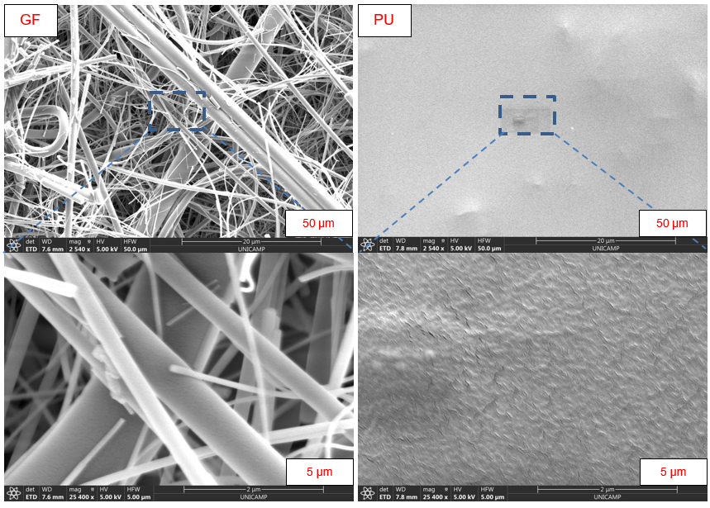

Figure 2: SEM images of the glass microfiber (left) and synthesized PU (right) separators at low (upper) and high (lower) magnifications.

Figure 3: Water contact angle of the glass microfiber (left) and synthesized PU (right) separators.

The electrochemical performance of the synthesized PU separator was compared with GF separator in aprotic Li-O2batteries at the same conditions. As shown in Figure 4a, the battery with the novel membrane presented a discharge capacity that was more than 70 % higher (164 mAh/m2BET) than GF battery (48 mAh/m2BET) and the Figure 4b shows an increase of 45 % in PU batteries cyclability (39 and 40 cycles) when compared with GF batteries (19 and 23 cycles) with a fixed capacity of 11 mAh.m-². The higher performance of the PU batteries indicates that the PU separator can reduce the passivation of the metallic lithium anode, increasing the Li-O2batteries' lifespan.

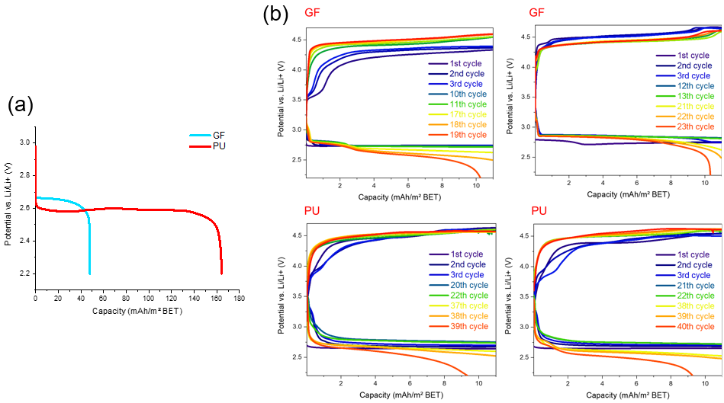

Figure 4: (a) Deep discharge profiles (b) charge and discharge profiles of the batteries assembled with GF and PU separators with a fixed capacity of 11 mAh.m-².

The SEM images of the air-cathode after deep discharge revealed a higher density of discharge product in the battery assembled with PU separator than in the battery assembled with GF separator (Figure 5). This is in accordance with Figure 4 (a) which showed a higher deep discharge capacity for batteries using the synthesized membrane, emphasizing that the PU separator has good permeability to lithium ions and can protect anode passivation against reactive compounds like water.

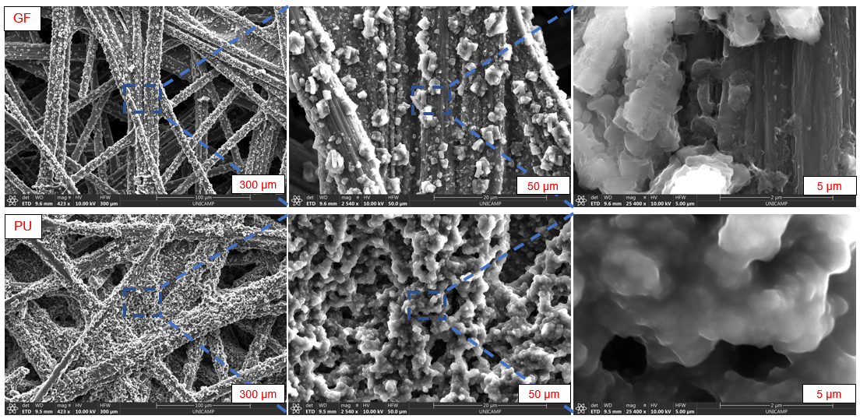

Figure 5: SEM images of the air-cathode after deep discharge of battery assembled with GF (upper) and PU (bottom) separators.

The *in situ* FTIR experiments, presented in Figure 6, show a 6 h discharge step of two different batteries, one using GF separator (left) and the other using a PU separator (right). In the spectra, two DMSO bands were found at 2000 and 2100 cm-1, related to weak vibrations of the C-S-C and C-S=O groups (NIST, 2021). Typical bands of PU can be seen at 1535, 1608, and 1720 cm-1, respectively representative of C=C, C-N, and C=O bond vibrations (Wong & Badri, 2012). At 2350 cm-1, the characteristic band of CO2 can be observed (*i.e.*, O=C=O vibration). When the battery with the GF membrane was discharged (Figure 6, left) it is noticed over time a decrease in the DMSO bands and simultaneously an increase in the CO2 band. This effect could indicate that the discharge step leads to partial decomposition of the electrolyte (Nepel et al., 2021). On the other hand, when the PU membrane is used (Figure 6, right) there are no changes in the DMSO bands and the CO2 band remains constant over time. Therefore, the PU separator not only protects the metallic lithium from water, but also avoids side reactions that can induce the electrolyte toward decomposition.

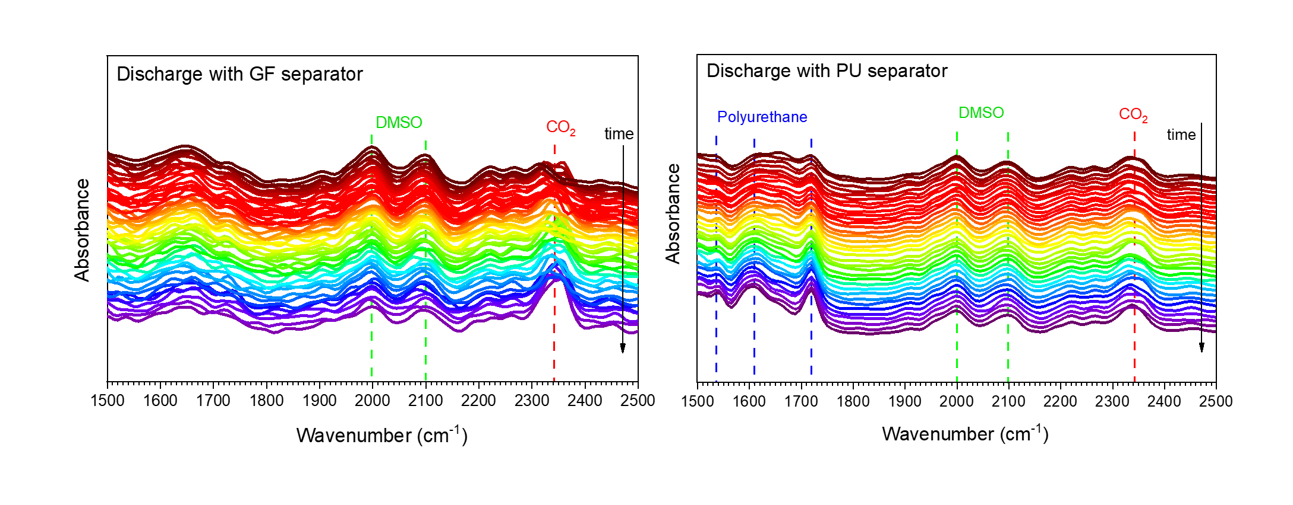 Figure 6: In situ FTIR spectroscopy characterization of battery assembled with GF separator (left) and with PU separator (right).

* 1. Conclusion

The feasibility of Li-O2 batteries depends on their component’s stability. To contribute to metallic lithium anode protection, a hydrophobic polymeric separator was synthesized. The electrochemical tests showed that the use of this separator improved by 45 % the battery’s cyclability. The characterizations revealed that this increase in cyclability is related to good permeability to lithium ions combined with high hydrophobicity, protecting water to passivate the metallic lithium anode. Moreover, the in situ FTIR results showed that the novel membrane also protects the electrolyte against decomposition. The application of the novel separator in Li-O2 batteries proved to be beneficial, especially considering real applications where atmospheric air ought to be used, carrying water into the system. However, applications are not limited only to Li-O2 batteries, as the PU membrane can be implemented in other applications in which ionic conductive is a requirement and water protection is needed.

Acknowledgments

The authors gratefully the support from grant #2015/20630-4 and grant #2017/11958-1 São Paulo Research Foundation (FAPESP), the Brazilian National Council for Scientific and Technological Development (Conselho Nacional de Desenvolvimento Científico e Tecnológico - CNPq), Shell, and the Imbuia-micro beamline staff from CNPEM, Brazil, for the assistance with the in situ FTIR.

**References**

Bi, X., Amine, K., & Lu, J. (2020). The importance of anode protection towards lithium oxygen batteries. In *Journal of Materials Chemistry A* (Vol. 8, Issue 7, pp. 3563–3573).

Cheng, C., Liu, H., Ouyang, C., Hu, N., Zha, G., Hou, H. (2022). A high-temperature stable composite polyurethane separator coated Al2O3 particles for lithium ion battery. *Composites Communications*, 33.

Dai, A., Li, Q., Liu, T., Amine, K., & Lu, J. (2019). Fundamental Understanding of Water-Induced Mechanisms in Li–O2 Batteries: Recent Developments and Perspectives. *Advanced Materials*, 31(31).

Huang, X., He, R., Li, M., Chee, M. O. L., Dong, P., & Lu, J. (2020). Functionalized separator for next-generation batteries. In *Materials Today* (Vol. 41, pp. 143–155). Elsevier B.V.

Lach, J., Wróbel, K., Wróbel, J., Podsadni, P., Czerwiński, A., & Commission, E. (2018). Towards the battery of the future. In *Journal of Solid State Electrochemistry* (Vol. 23, Issue March).

Liang, D., Bian, T., Han, Q., Wang, H., Song, X., Hu, B., He, J., Zhao, Y. (2020). Inhibiting the shuttle effect using artificial membranes with high lithium-ion content for enhancing the stability of the lithium anode. *Journal of Materials Chemistry A* (28), 14062–14070.

Liu, K., Liu, M., Cheng, J., Dong, S., Wang, C., Wang, Q., Zhou, X., Sun, H., Chen, X., & Cui, G. (2016). Novel cellulose/polyurethane composite gel polymer electrolyte for high performance lithium batteries. *Electrochimica Acta*, *215*, 261–266.

Lizundia, E., Costa, C. M., Alves, R., & Lanceros-Méndez, S. (2020). Cellulose and its derivatives for lithium ion battery separators: A review on the processing methods and properties. In *Carbohydrate Polymer Technologies and Applications* (Vol. 1). Elsevier Ltd.

Luo, Z., Zhu, G., Yin, L., Li, F., bin Xu, B., Dala, L., Liu, X., & Luo, K. (2020). A Facile Surface Preservation Strategy for the Lithium Anode for High-Performance Li–O2 Batteries. *ACS Applied Materials & Interfaces*, *12*(24), 27316–27326.

Luo, K., Zhu, G., Zhao, Y., Luo, Z., Liu, X., Zhang, K., Li, Y., Scott, K. (2018). Enhanced cycling stability of Li-O2 batteries by using a polyurethane/SiO2/glass fiber nanocomposite separator. *Journal of Materials Chemistry A* (17), 7770–7776.

Luo, W., Cheng, S., Wu, M., Zhang, X., Yang, D., & Rui, X. (2021). A review of advanced separators for rechargeable batteries. *Journal of Power Sources*, *509*.

Muddasar, M., Beaucamp, A., Culebras, M., & Collins, M. N. (2022). Cellulose: Characteristics and applications for rechargeable batteries. In *International Journal of Biological Macromolecules* (Vol. 219, pp. 788–803). Elsevier B.V.

Nepel, T. C. M., Anchieta, C. G., Cremasco, L. F., Sousa, B. P., Miranda, A. N., Oliveira, L. C. C. B., Francisco, B. A. B., Júlio, J. P. de O., Maia, F. C. B., Freitas, R. O., Rodella, C. B., Filho, R. M., & Doubek, G. (2021). In Situ Infrared Micro and Nanospectroscopy for Discharge Chemical Composition Investigation of Non-Aqueous Lithium–Air Cells. *Advanced Energy Materials*, *11*(45).

NIST (2021), Dimethyl Sulfoxide. *NIST Standard Reference Database 69: NIST Chemistry WebBook.*

Pan, Y., Chou, S., Liu, H. K., & Dou, S. X. (2017). Functional membrane separators for next-generation high-energy rechargeable batteries. *National Science Review*, *4*(6), 917–933.

Policano, M. C., Anchieta, C. G., Nepel, T. C. M., Filho, R. M., & Doubek, G. (2022). Water in Aprotic Li-O2 Batteries: A Critical Review. In *ACS Applied Energy Materials* (Vol. 5, Issue 8, pp. 9228–9240). American Chemical Society.

Prisacariu, C. (2011). *Polyurethane Elastomers*. From Morphology to Mechanical Aspects. Springer, Vienna.

Ram, M., Bogdanov, D., Aghahosseini, A., Gulagi, A., Oyewo, A. S., Odai Mensah, T. N., Child, M., Caldera, U., Sadovskaia, K., Barbosa, L. D. S. N. S., Fasihi, M., Khalili, S., Traber, T., & Breyer, C. (2022). Global energy transition to 100% renewables by 2050: Not fiction, but much needed impetus for developing economies to leapfrog into a sustainable future. In *Energy* (Vol. 246). Elsevier Ltd.

Saal, A., Hagemann, T., &#38; Schubert, U. S. (2021). Polymers for Battery Applications—Active Materials, Membranes, and Binders. In *Advanced Energy Materials* (Vol. 11, Issue 43). John Wiley and Sons Inc.

Song, H., Deng, H., Li, C., Feng, N., He, P., Zhou, H. (2017). Advances in Lithium-Containing Anodes of Aprotic Li–O2 Batteries: Challenges and Strategies for Improvements. In Small Methods (Vol. 1, Issue 8). John Wiley and Sons Inc.

Vlad, S., & Oprea, S. (2008). Chain extender and diisocyanate amount effects on the thermal, mechanical and wettability properties of some polyurethane elastomers. *E-Polymers*.

Vlad, S., Spiridon, I., Grigoras, C. V., Drobota, M., & Nistor, A. (2009). *Thermal, mechanical and wettability properties of some branched polyetherurethane elastomers*. *004*.

Wong, C. S., & Badri, K. H. (2012). Chemical Analyses of Palm Kernel Oil-Based Polyurethane Prepolymer. *Materials Sciences and Applications*, *03*(02), 78–86.

Zhang, J., Yue, L., Kong, Q., Liu, Z., Zhou, X., Zhang, C., Xu, Q., Zhang, B., Ding, G., Qin, B., Duan, Y., Wang, Q., Yao, J., Cui, G., & Chen, L. (2014). Sustainable, heat-resistant and flame-retardant cellulose-based composite separator for high-performance lithium ion battery. *Scientific Reports*, *4*.