|  |  |
| --- | --- |
| cetlogo ***CHEMICAL ENGINEERING TRANSACTIONS***  ***VOL. 76, 2019*** | A publication of  aidiclogo_grande |
| The Italian Association  of Chemical Engineering  Online at www.cetjournal.it |
| Guest Editors: Sauro Pierucci, Jiří Jaromír Klemeš, Laura Piazza  Copyright © 2019, AIDIC Servizi S.r.l. **ISBN** 978-88-95608-73-0; **ISSN** 2283-9216 | |

An experimental and numerical procedure for energetic and acoustic optimization of dry-ice blasting processes

David Muckenhaupt, Thomas-A. Zitzmann, Arthur Rudek\* and Gerald Russ

Hochschule Darmstadt, University of Applied Sciences, Haardtring 100, 64295 Darmstadt, Germany

\*Corresponding Author: arthur.rudek@h-da.de

Conventional CO2 dry-ice blasting is widely used in maintenance for non-destructive cleaning of sensitive industrial components. In dry-ice blasting systems, dry-ice particles serve as cleaning agent. They are accelerated with pressurized air flows through convergent-divergent nozzles. These supersonic flows make the particles impinge and defoul variously fouled targets. The main disadvantages of such systems are high energy consumption by compressed air and massive aeroacoustic emissions, which make them usable under consideration of certain safety restrictions only.

This paper describes an all-encompassing approach to minimize the energy consumption of an automatic cleaning system used to defoul car-tire moulds and to assess and improve this systems aeroacoustic emission. Experiments are made utilizing a high speed camera (HSC) to assess the amount of energy necessary to remove typical fouling layers. Further experiments are conducted with a HSC to measure particle sizes and velocities at the nozzle outlet and the experimental investigation is completed by detailed aeroacoustic emission measurements at the aeroacoustic test-rig. The particle acceleration process is numerically simulated with an Euler-Lagrange approach. Particle outlet velocities, impact properties and mean aeroacoustic emissions of the process are predicted by means of this validated simulation strategy. The simulations are partially compared to experimental measurements where possible.

All these results are used to map and to improve the process for the dry-ice blasting system considered. This is put into practice by adjusting the process parameters and by design and applications of new system-specific silencers. Significant reductions of aeroacoustic emissions and energy consumption are achievable. The study shows that the system can be operated with enhanced energy efficiency and decreased acoustic emissions. The cleaning efficiency is decreased but it is shown that it is still possible to certainly clean the car-tire moulds.

* 1. Introduction

In dry-ice blasting applications, such as car-tire mould cleaning, dry-ice particles are accelerated by compressed air though convergent-divergent nozzles. These particles are made impacting the fouled target and defoul certain proportions of the target by erosion. The schematic from Figure 1 shows a typical setup of this process. It consists of the compressor (1) and the dry ice blasting machine (2). Here, the particles (3) are introduced into the compressed air flow via a rotating disc system. There is a 5 m long flexible connecting tube (4) linking the blasting machine (2) with the nozzle (5), where the particles are accelerated.

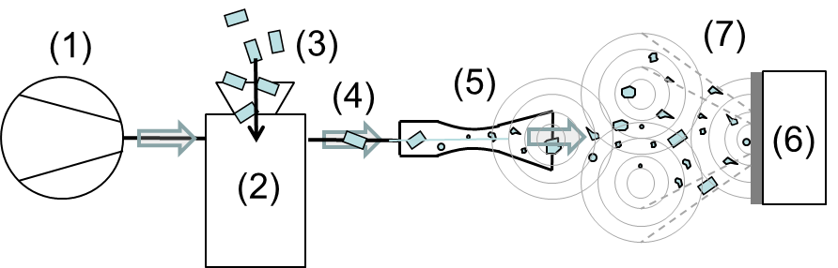

Figure 1: Schematic of a typical direct dry-ice blasting scenario with acoustic field indication.

All given pressure values in this work are referred to as system pressure, which is preselected at (2). The dry-ice particles impact and defoul the target (6). The resulting acoustic field (7) consists of aeroacoustic sources with various polarity and these are triggered by particle-wall contacts, particle disintegration, high speed air flow expansion, pressure fluctuations and free-jet pulsation, turbulent structures and shear-stress phenomena in the shear layer. An all-encompassing approach is chosen in this study to lower the energy consumption and the aeroacoustic emissions of such systems in which the particle laden flow-field is surveyed in conjunction with the fouled cleaning target. Lower energy consumption and lower acoustic emissions lead to less operational cost, a more environmentally friendly process and lower aeroacoustic stresses for operators and the environment. It widens the field of application for such systems, because they can be used in safety restricted areas.

* 1. State of the art

Aeroacoustic optimization of nozzle-like geometries and fundamental understanding of jet noise has been studied by a number of researchers and most of the work is experimental or numerical. Typical experimental methods are the application of Schlieren imaging and acoustic field survey by microphone arrays in anechoic chambers. Widely used numerical methods are detailed turbulence modelling techniques, such as LES or DES in the near-field formulations. These are often coupled with acoustic-analogy far-field formulations to assess and predict acoustic field metrics. Typical applications of such optimized geometries are aeroderivative engines, rocket propulsion systems, process engineering applications such as pneumatic transportation systems, fluidized-bed control systems, cold spraying or combustor design. There are only few publications known dealing with particle laden supersonic flows such as these typically used in dry-ice blasting applications.

Viswanathan, 2004, published an extensive experimental aeroacoustic analysis of cold and hot jets which is widely used for validation in numerical simulations. The results for a cold jet with a nozzle exit Mach number of 0.9 are used to validate the aeroacoustic simulations applied in this work.

Du and Morris, 2011, published a study in which hot jet simulations from baseline and chevron nozzles at off-design operating conditions are compared to experiments. The authors coupled detached eddy simulations (DES) with a far-field solver based on the modified Lighthill acoustic analogy theory (Lighthill, 1952 &1954) presented by Ffowcs-Williams and Hawkings, 1969. They reported a disagreement between experimental and numerical results of 3 dB(A) for the predictions of the far-field overall sound pressure level (OASPL) for lower frequencies and reported more significant differences for mid to high frequencies.

Meier et al., 1990, presented an experimental study to reduce jet noise from supersonic nozzles by adjustment of simple silencer geometries in conjunction with pressure ratio adjustments. They found peaks and valleys in the OASPL for all combinations considered and proposed an optimization procedure for applied noise reduction in such systems.

Zoppleari and Juve, 1994, experimentally investigated the effect of water droplet injection into hot supersonic jets to reduce jet noise. They reported a significant reduction of the OASPL as high as 10 to 20 dB based on near- and far-field experiments for the nozzle operated at Mach Numbers of 1.6 and 2.0.

Kweon et al., 2006, applied a wire device to lower jet noise in a range of experiments. It was placed at various positions downstream from the nozzle exit and it was intended to reduce the OASPL by influencing the jet pattern. The authors reported that the OASPL can be significantly influenced by the wire device; however the effect, which can decrease or increase the OASPL, is strongly dependent on the downstream position of the wires and on the nozzle pressure ratio applied. Almost no effect was found for high pressure rations (i.e. for under-expanded jets).

Morris et al., 2013, used fluidic inserts in a number of experimental studies to reduce supersonic jet noise. With these inserts the area ratio of the nozzle was locally changed and turbulent structures were intentionally triggered. This helped decreasing the aeroacoustic emissions up to 5 dB but it was shown that these improvements are strongly dependent on the polar measurement position of the sound pressure level and on the nozzle pressure ratio.

* 1. Optimization procedure description
     1. Identification of main contributing parameters

The main goal of this study is to lower the aerodynamic noise intensity of the dry-ice particle laden cleaning flow which impinges the cleaning target (in this work car-tire moulds) as shown in Figure 1. The aerodynamic noise intensity

 (1)

is described as a function of the transient pressure field p(t) and the sound-velocity u(t)s. The noise level LI is used as a measure of noise intensity with I0 being the lower bound reference intensity:



(2)

There are three types of phenomenological noise-sources included in particle laden supersonic flows. These are monopole, dipole and quadrupole sources and they are basically related to the flow Mach number Ma, the fluid density ρf and the flow velocity uf:



(3)

These source-types can be matched to the corresponding noise-sources by the applied exponent to the Mach number j: pressure-gradient related noise-sources trigger monopole sources (i.e. j=1), particle-wall interaction triggers dipole sources (i.e. j=3), and turbulence and shear-layer related phenomena trigger quadrupole sources (i.e. j=5). The appropriate exponent for the Mach number in Equation (3) is:



(4)

The strength of the sources of noise production in the particle-laden high-speed cleaning jets are highly dependent on the Mach number and hence on the energy content in the flow. It is desired to minimize this energy content to reduce noise in the first step of this study. The system pressure is parametrized for this reason and the most important process variable is the nozzle outlet Mach number which contains the fluids speed of sound af:



(5)

If a further energy reduction is not possible, the sound pressure level trends can be shifted in frequency domain, for example by geometrical modifications of an applied silencer which can trigger desired flow features such as turbulent structures with specific frequencies. The process variable to assess this is the Strouhal number



(6)

and it incorporates the frequency f and a characteristic length l\* of the system.

Finally it must be ensured that the dry-ice particles are sufficiently accelerated by the optimized and modified nozzle system to certainly clean the target. These particle properties are derived from basic experiments introducing the fouling threshold energy (see Rudek et al., 2018, for details). The mean Stokes number is monitored for this reason. It is related to the particle-wall contact and contains the particles density ρP, its diameter dP and velocity vP as well as the fluids dynamic viscosity ηf:



(7)

* + 1. Threshold energy survey and system energy optimization

The fouling specific threshold energy is derived with an energy-based experiment in the first step of the optimization procedure. This experiment is described in detail in a previous communication by the authors (see Rudek et al., 2018). A number of particles made from reference material and from dry-ice are made to impact originally fouled targets (here: car-tire moulds). These impacts are recorded with HSCs and the surfaces of the car-tire moulds are recorded by digital cameras before and after the particle impacts. Fouling specific energy values are derived from the particle restitution process observed. These energy values and the defouled areas are correlated as functions of either particle impact velocity or Stokes number (i.e. dependent on the fouling material). For the original fouling which is typically found in car-tire moulds the Stokes number correlation is used. Main results from this experimental procedure are shown in Figures 2a & b.

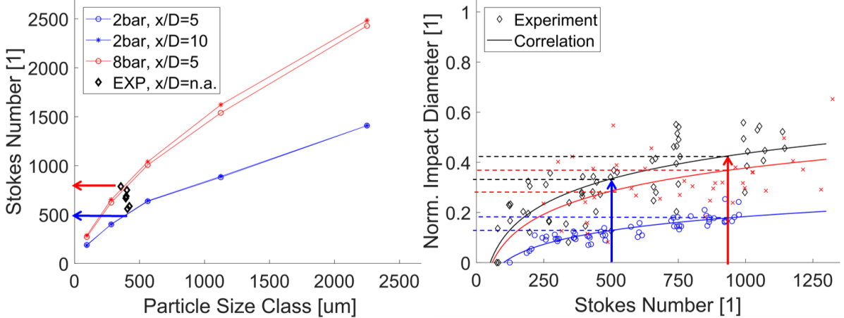

*Figure 2: Simulated and experimental results of defouling related Stokes number (see Equation (7)) as function of particle size, system pressure and target distance (Figure 2a, left); experimental data and correlated results for defouling impact diameters as function of the Stokes number (Figure 2b, right).*

The left hand diagram compares numerical to experimental Stokes numbers of the particles before they impact the target. The experimental dataset contains only mean Stokes numbers (i.e. derived from mean particle size and velocity). These numerical Stokes numbers are predicted with validated methods presented in Rudek et al., 2016. The system pressure is varied from 2 to 8 bar and there are two distances between the nozzle outlet and the target considered, i.e. x/D =  5 and x/D = 10. The HSC experiment was applied to the free jet without target (i.e. x/D = n.a.). The numerical and the experimental results are comparable in the range of mean particle sizes and the mean Stokes numbers range from 500 to 900 and these are mainly dependent on the nozzle pressure. There is no significant influence of the target distance upon the Stokes number.

These Stokes number results characterize the dry-ice jet. They are compared to the fouling characteristics which are derived from the threshold energy experiment and this is shown in Figure 2b (right). The diagram shows the dimensionless impact diameter (i.e. normalized by the impacting particles diameter) as a function of the Stokes number. Single particle impacts upon originally fouled car-tire moulds are shown and three different mould modules were investigated (various markers and colours in Figure 2b). A minimum number of 100 single particles of various size and impact velocity are considered per module. The trends shown are logarithmic correlations of the experimental data and the corresponding coefficients of determination range from 0.6 to 0.7. In all cases both, the lower and the upper mean Stokes number values are sufficiently high to certainly clean the car-tire moulds. This is indicated by the arrows in both diagrams. The impact diameters decrease with decreasing Stokes numbers. It is concluded that the nozzle pressure can be lowered from 8 to 2 bar to lower the systems energy consumption; however the cleaning efficiency is also lowered in this case.

* + 1. Aeroacoustic silencer design and emission survey

The aeroacoustic field is surveyed numerically and experimentally and this is done in the second step of the optimization procedure. Based on this survey new silencer prototypes are designed and tested. The cleaning efficiency of the modified system and its aeroacoustic emissions are summarized in final nozzle specific diagrams. The numerical simulations were conducted with Ansys CFX 17.0.

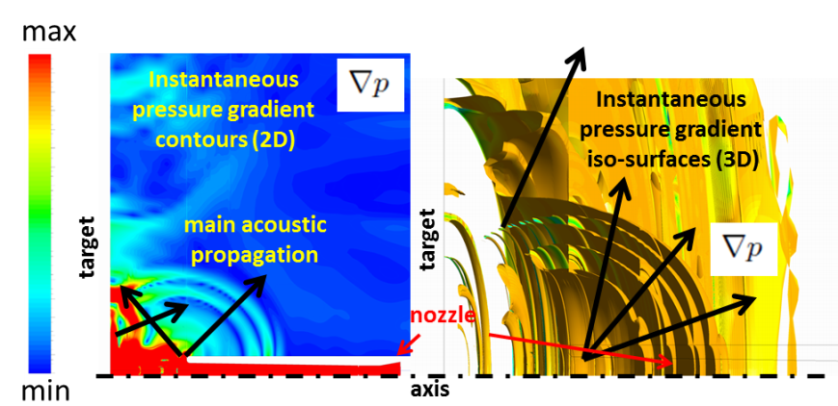

*Figure 3: Instantaneous acoustic field visualized by pressure gradient contours (left) and pressure gradient iso-surfaces (right) for a typical dry-ice blasting scenario as considered in this work.*

Table 1: Parameters tested in the experimental aeroacoustic field survey.

|  |  |  |  |
| --- | --- | --- | --- |
| Parameter | Range tested |  |  |
| System pressure | 2, 4, 6 and 8 bar |  |  |
| Target distances (normalized by nozzle diameter D) | x/D = 5 and 10 |
| Measurement angles | α = 30°, 60°, 90° |  |  |
| Measurement positions (normalized by nozzle radius R) | r/R = 8, 16, 24 |  |  |
| Particle mass loading | 0, 20, 100 kg/h |  |  |

An unsteady Euler-Lagrange URANS formulation is used solving mass-, momentum-, total-energy and particle transport equations in a 2-way coupled numerical procedure. It is intended to visualize the main flow features with this procedure and Figure 3 shows typical results such as the instantaneous pressure gradient as contour plot (left display) and pressure gradient iso-surfaces in 3D (right display). These results help to identify the main distribution direction of strong aeroacoustic waves and the information is used for the main experimental setup and for basic silencer design. The aeroacoustic experiment was conducted in a specially designed anechoic test-rig and this is shown in Figure 4a (left display). The dry-ice blasting nozzle was positioned perpendicularly to the car-tire mould and the microphone (shown in the Figure) and microphone arrays (not shown in the Figure) were positioned as displayed in the right hand scheme. All parameters are listed in Table 1 as varied in the experiments.

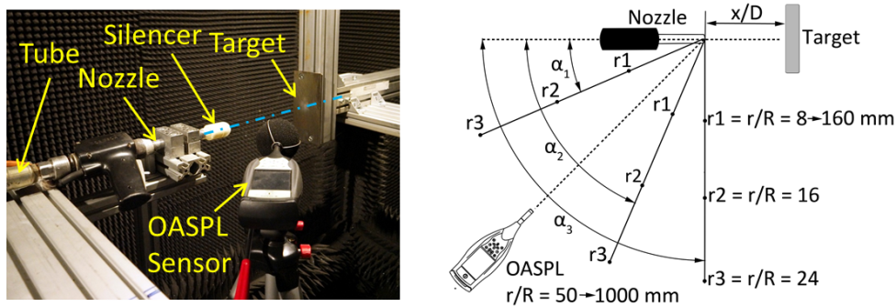

*Figure 4: Acoustic test-setup (Figure 4a, left) and schematic of the acoustic field surveyed (Figure 4b, right).*

Based on this procedure a total of 55 silencer geometries were designed, additively manufactured and tested in the anechoic chamber. The best prototypes (i.e. most noise reducing) were surveyed for their cleaning efficiency. The main results from both experiments are shown in Figure 5. The cleaning efficiency (normalized to 1) is plotted against the OASPL. The Figure contains these trends for the original nozzle (red) and the three best silencer prototypes developed (green, blue and black). The universal variant (green trend) lowers the OASPL from 95.7 to 88.3 dB(A) at 2 bar and from 122.9 to 114.1 dB(A) at 8 bar. It is possible to achieve 87.1 dB(A) in the low pressure range (i.e. 2 bar) with the lwr-variant (black trend) and 113.2 dB(A) at 8 bar system pressure with the upr-variant (blue trend). Decreasing the system pressure decreases the cleaning efficiency. This finding is independent from the type of silencer used.

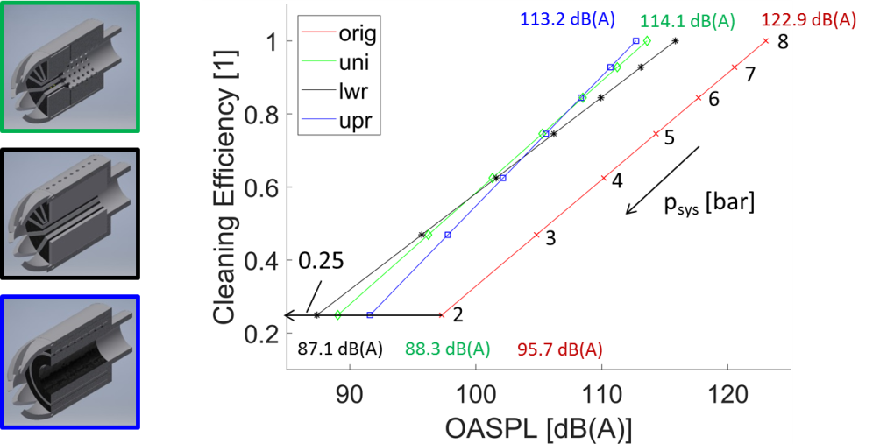

*Figure 5: Final silencer prototypes for universal usage (uni, green), low-pressure applications (lwr, black) and high-pressure applications (upr, blue) and final process diagram relating cleaning efficiency to OASPL with system pressure as parameter.*

The cleaning efficiency is 100% at 8 bar and it decreases to approximately 25% at 2 bar. Therefore the cleaning process must be prolonged when the system energy is lowered to achieve comparable final cleaning effects. However it is still significant cleaning possible with lower energy and the system can be operated more energy efficient with significantly lowered aeroacoustic emissions. No comparable studies dealing with the cleaning efficiency of a dry-ice blasting system and its aerodynamic noise reduction are known to date; therefore no additional comparison can be provided for the results achieved here with data already published.

* 1. Conclusions

Numerical and experimental methods are combined to a specific solution design in this work to energetically and aeroacoustically optimize a dry-ice blasting system used in car-tire mould cleaning applications. An all-encompassing approach is presented considering the whole system including the particle laden flow field and the fouled cleaning target. All system specific geometrical and operational limitations are considered.

Firstly the threshold energy experiment is used to assess the energy necessary to certainly defoul the moulds. The near-wall Stokes number contains this information and it ranges from 500 to 900. This requirement is matched with the particle behaviour which is numerically and experimentally derived for the nozzle investigated. The mean Stokes numbers of the jets investigated turn out to fit the energetic requirements for defouling. It is shown that lower Stokes numbers, achieved with lower system pressure, decrease the single particle cleaning efficiency by approximately 30%. However, there is still a significant cleaning effect visible.

Secondly numerical URANS simulations of the particle laden flow are applied to visualize the main aeroacoustic emissivity of the nozzle without silencer. The results are used to set-up an experiment and to design the main geometry of specific silencers for the nozzle. There are three prototypes identified leading to most significant noise reduction. The lowest OASPL achieved for 8 bar is 113.2 dB(A), which means a decrease of 9.7 dB(A) compared to the non-silenced system and this for 2 bar is 87.1 dB(A) which describes a decrease of 8.6 dB(A). The cleaning efficiency achievable remains constant in both cases; it is found to be independent from the silencer type used. If the whole process is optimized, i.e. pressure change and silencer application, a decrease of the OASPL as high as 35.8 dB(A) is possible. However a lowered cleaning efficiency by 75% must be taken into account in this case.

Further investigations are planned by the authors into the development of a new nozzle geometry. It is intended to find a new energetic and aeroacoustic efficient nozzle design. This nozzle will deliver a modified particle laden flow pattern to increase the cleaning efficiency at lower OASP levels and system pressures.

Acknowledgments

The authors would like to thank Winfried Peschke and Dennis Kreher from enotech GmbH for their support of this work. The study was funded by the German LOEWE Hessen Agentur.

References

Du, Y. and Morris, P.J., 2011, Noise simulations of supersonic hot jets for chevron nozzles, 32nd AIAA Aeroacoustics Conference, Portland, Oregon, USA, pp. 1-18

Ffowcs Williams, J. E., and Hawkings, D. L., 1969, Sound Generated by Turbulence and Surfaces in Arbitrary Motion, Philosophical Transactions of the Royal Society, 264 (1151), pp. 321-342

Kweon, Y.-H., Miyazato, Y., Aoki, T., Kim, H.-D. and Setoguchi, T., 2006, Control of supersonic jet noise using a wire device, Journal of Sound and Vibration, 297, pp. 167-182

Lighthill, M.J., 1952, On sound generated aerodynamically - Part I - General theory, Proceedings of the Royal Society, 211 (1107), pp. 564-587

Lighthill, M.J., 1954, On sound generated aerodynamically - Part II - Turbulence as a source of sound, Proceedings of the Royal Society, 222 (1148), pp. 1-32

Meier, G.E.A., Selerowicz, W.C. and Szumowski, A.P., 1990, A nozzle generating low jet noise, Journal of Sound and Vibration, 136 (1), pp. 65-73

Morris, P.J., McLaughlin, D.K. and Kuo, C.-W., 2013, Noise reduction in supersonic jets by nozzle fluidic inserts, Journal of Sound and Vibration, 332, pp. 3992-4008

Rudek, A., Russ, G. and Duignan, B., 2016, Particle laden flow investigations in special purpose dry-ice blasting applications, Journal of Computational Methods and Experimental Measurements: Advances in Fluid Mechanics, 4 (4), pp. 393-402

Rudek, A., Zitzmann, T.-A., Russ, G. and Duignan, B., 2018, An energy based approach to assess and predict erosive airfoil defouling, Journal of Computational Methods and Experimental Measurements: Materials Characterization, 6 (3), pp. 476-486

Viswanathan, K., 2004, Aeroacoustics of hot jets, Journal of Fluid Mechanics, 516, pp. 39-82

Zoppelari, E. and Juve, D., 1998, Reduction of hot supersonic jet noise by water injection, 4th AIAA/CEAS Aeroacoustics Conference, Toulouse, France, pp. 35-45