CHEMICAL ENGINEERING TRANSACTIONS  VOL. 76, 2019 | A publication of
The Italian Association
of Chemical Engineering
Online at www.aidic.it/cet
Guest Editors: Sauro Pierucci, Jiří Jaromír Klemeš, Laura Piazza
Copyright © 2019, AIDIC Servizi S.r.l.
ISBN 978-88-95608-73-0; ISSN 2283-9216

Synthesis and Characterisation of Potential Visible-light Photocatalyst and its Photocatalytic Activity in the Decomposition of Phenol
Dorcas O. Adenuga*, Shepherd M. Tichapondwa, Evans M. N. Chirwa
Water Utilisation and Environmental Engineering Division, Department of Chemical Engineeering, University Of Pretoria, Pretoria 0002, South Africa.
dorcasadenuga@yahoo.co.uk
This work involves the in-situ synthesis and application of a visible-light activated composite catalyst. The photocatalytic activity of the synthesised photocatalyst was investigated by tracking the degradation of phenol under ultraviolet (UV) and visible light irradiation using a batch reactor set-up. The change in concentration of phenol was determined using a High Performance Liquid Chromatograph (HPLC). The synthesised Ag/AgCl/BiOCl particles were characterised using X-ray diffraction (XRD), scanning electron microscopy (SEM), transmission electron microscopy (TEM) and Brunauer–Emmett–Teller (BET). The particles had a flower-like morphology and the XRD confirmed the presence of AgCl and BiOCl phases. A color change from white to purple during the synthesis of the composite catalyst indicated the formation of elemental Ag in the composite. The BET surface area was 6.64 m²g⁻¹. Degradation studies indicated that the Ag/AgCl/BiOCl composite synthesised can be activated by visible light resulting in 52% degradation after 4.5 h at a 0.83 gL⁻¹ catalyst loading.
  - Introduction
There has been an increase in the environmental pollution caused by gases, oil products and organic matter due to a rise in industrialisation (Chen et al., 2016). Consequently, this has led to the ever growing research in the remediation of a range of pollutants especially those associated with air and water. Phenol, which is one of the products of petroleum and plastics industries, is the environmental pollutant that causes critical health damage to humans such as liver damage and respiratory disorders and has possible carcinogenic risks (Tshuto et al., 2017). Photocatalysis is one of the catalytic approaches to environmental remediation that has been very attractive because of its effectiveness and high potential for removal of recalcitrant environmental pollutants using light and catalyst. This is a reduction-oxidation technology that enables toxic pollutants to be degraded into non-toxic and non-hazardous compounds such as water, carbon dioxide and other small molecules (Li et al., 2017). Semiconductor photocatalysis is a type of Advanced Oxidation Processes (AOPs) that has attracted increased attention due to its ability for practical implementation in solving water and air purification problems. It is referred to as a ‘green’ technology in the degradation of toxic water pollutants (Jay and Chirwa, 2018). It has shown immense advantages in the destruction of bacteria and virus, cancer cells inactivation, odour mitigation, water photo splitting and oil spillage clean-ups (Hoffmann et al., 1995). Common semiconductor catalysts are grouped as oxides, sulfides, oxysulfides, nitrides and oxynitrides (Wang et al., 2014). Titanium based photocatalysts have been widely used due to their relatively low cost and stability (Xiao et al., 2016). However, they have high electron-hole recombination rates, low quantum yields and their wide band gap energy that render them unsuitable for visible light activation and only viable for the UV light region (Chen et al., 2016). Visible light represents 45 % of the solar spectrum and it has been revealed that a visible light activated catalyst makes use of solar energy for photocatalysis (Manassero et al., 2013).
In order to improve photocatalytic activity under visible light, there has been continuous investigation into potential visible light catalyst. An example of catalysts being investigated in recent years are bismuth based oxyhalides. This is due to their uncommon properties of layered structures and its application in catalysis, nanodevice and nanosensor development and its eco-friendly pigments (Wang et al., 2014). Bismuth oxychloride (BiOCl) is one of the bismuth oxyhalides which has attracted vast attention due to its high photocatalytic activity in the degradation of cationic dyes such as methylene blue and rhodamine B (Chen et al., 2016). BiOCl has a higher degradation activity potential in comparison to TiO₂ photocatalysts under UV irradiation due to its special layered structure (Chen et al., 2016). This layered structure provides a large enough space for the atoms and orbitals to be polarized thereby separating the electron-hole pair effectively and reducing recombination of the generated electron hole pairs (Wang et al., 2014). The synthesis technique of BiOCl is a major factor in its photodegradation potential (Cheng et al., 2014).
Different synthesis techniques could lead to the formation of BiOCl in the form of nanoflowers, nanorods, nanosheets, nanobelts, thin films, which all have different morphology and surface area, consequently affecting the band gaps (Kumar et al., 2018). While research continues into improving the visible light responsiveness of BiOCl, some good materials were discovered for this purpose, one of which is the AgX (X = Cl, Br, I) group. AgX has a wide band gap of 3.25 eV that cannot be photo excited under visible light irradiation (ʎ = 420 nm) (Zhou et al., 2014), however it improves the visible light responsiveness of some large band gap semiconductors (Ao et al., 2014).
Previous work has shown that Ag/AgX/BiOX has shown good photodegradation activity in the degradation of dyes and organism sterilization (Chen et al., 2016). Herein, we attempted the synthesis of the flower-like Ag/AgCl/BIOCl composite particles for potential visible light degradation. The obtained particles were characterised and were tested for photodegradation of phenol under UV and visible light irradiation.
  - Materials and methods
2.1. Chemical and reagents
Hexadecyltrimethylammonium chloride (CTAC) and bismuth (III) nitrate pentahydrate (Bi(NO₃)₃.5H₂O) were purchased from Sigma-Aldrich (St Louis, MO, USA). Silver nitrate (AgNO₃) and glacial acetic acid (CH₃COOH) were purchased from Glassworld (Johannesburg, South Africa). Phenol and HPLC grade acetonitrile were purchased from Merck, South Africa. All these were used as received and without any further purification. Ultrapure water from a Purelab Flex 3 water was used throughout the study.
2.2. Synthesis
The synthesis method of the Ag/AgCl/BiOCl composite was adapted from (Hong et al., 2017). A solution of CTAC was prepared by dissolving 6.4 g of CTAC in 30 mL ultrapure water. 30 mL of ultrapure water, 15 mL of glacial acetic acid and 9.7 g of Bi(NO₃)₃.5H₂O were placed in a separate beaker. The mixture was stirred using a magnetic stirrer until the solution became clear and transparent. This solution was then added to the prepared CTAC solution to form BiOCl particles. The mixture was stirred for 1 h. 1.7 g of AgNO₃ was dissolved in 925 mL of ultrapure water in a 1000 mL Erlenmeyer volumetric flask. The “BiOCl” solution was added to the aqueous AgNO₃ solution to form AgCl/BiOCl suspension and this was stirred for another 6 h. The precipitate was obtained by centrifuging the solution at 9000 rpm for 10 min at 25$℃$. The collected precipitate was re-dispersed in 1000 mL of ultrapure water before being irradiated in visible light for 1 h to give Ag/AgCl/BiOCl suspension. The resultant particles were collected by centrifuging the suspension for 10 min at 9000 rpm and 25 ºC. The particles were then washed thoroughly three times with ethanol and subsequently five times with ultrapure water. Each washing step was followed by centrifuging to collect the particles. The washed particles were collected and dried at 80 ºC for 8 h.
2.3. Physicochemical properties
XRD was conducted using a PANalytical X’Pert Pro powder diffractometer in θ–θ configuration with an X’Celerator detector and variable divergence and fixed receiving slits with Fe filtered Co-Kα radiation (ʎ =1.789 Å). The mineralogy was determined by selecting the best–fitting pattern from the ICSD database to the measured diffraction pattern, using X’Pert Highscore plus software. SEM images were captured on a Zeiss Ultra PLUS FEG SEM. Transmission electron microscopy images were captured on a JOEL JEM 2100F TEM. Specific surface area was determined using a BET surface area system with a liquid nitrogen temperature of 77.350 K on Micrometrics Tristar II. The sample was dried overnight prior to the BET analysis under pure nitrogen flow at 100 ºC so as to eliminate all water molecules.
2.4. Degradation study
A proof of concept study was carried out on the degradation of phenol under both UV and visible light irradiation. The reactor set up consisted of a light source and a 400 mL glass beaker placed on a magnetic stirrer. All these were contained in a box which prevented the effect of natural light. The UV light had a power rating of 36 W and light intensity of 30.66 Wm⁻² (measured using a Goldilux radiometer/photometer GRP-1 with a UVB probe). The experimental sequence involved 30 min stirring in the dark followed by 4 h with irradiation. 10 mgL⁻¹ of phenol and a catalyst concentration of 0.83 gL⁻¹ was prepared for each experiment. Due to low wattage of the light, there was no significant increase in temperature of the experiments, therefore temperature was kept at room temperature. The visible light setup consists of six Osram L 36W 77 G13 Fluora lamps arranged with two lamps at the top, two lamps to the left and two lamps to the right of the beaker (the intensity was 6860 lux measured by a RS PRO ILM01 light meter).
  - Analytical procedure
Phenol concentration and degradation were monitored on a HPLC (Waters 2695 separation module with a Waters 2998 photo diode array (PDA) detector). Phenol was separated on a Waters PAH C18 (4.6 x 250 mm, 5 µm) column. The mobile phase consisted of two solvents, of 1 % acetic acid in water and 1 % acetic acid in acetonitrile. Phenol elution was done at 30 % and 70 % of the solvents respectively. A flowrate of 1.2 mLmin⁻¹, injection volume of 5 µL, temperature of 30 $℃$ and wavelength of 280 nm. Phenol concentration was determined from calibration curves of prepared standards. Data was collected and analysed using Empower software.
- Results and discussion
3.1. Synthesis
The synthesis procedure for BiOCl can be summarized by the stoichiometric Eq(1) to Eq(3) as illustrated by (Li et al., 2017).
 | $$Bi\left(NO_{3}\right)→ {Bi}^{3+}+3N{O^{-}}_{3}$$ | (1)
 | $${Bi}^{3+}+ C_{16}H_{33}({CH_{3})}_{3}N-Cl →C_{16}H_{33}{\left(CH_{3}\right)}_{3}N-Cl-{Bi}^{3+}$$ | (2)
 | $C_{16}H_{33}({CH_{3})}_{3}N-Cl-{Bi}^{3+}+ H_{2}O → BiOCl$ +$C_{16}H_{33}(C{H_{3})}_{3}N^{+}+2H^{+}$ | (3)
Eq(1) shows the dissociation of the Bismuth nitrate ions. Eq(2) illustrates the reaction between the dissolved Bi³⁺ and CTAC to form a complex which consequently begins to nucleate and grow into BiOCl as seen in Eq(3) during stirring. Other synthesis routes utilises NaCl, BiCl₃ etc. as chlorine source, but CTAC in this experiment serves as both the chlorine source and a surfactant (Zhang et al., 2013).
3.2. Characterisation
XRD
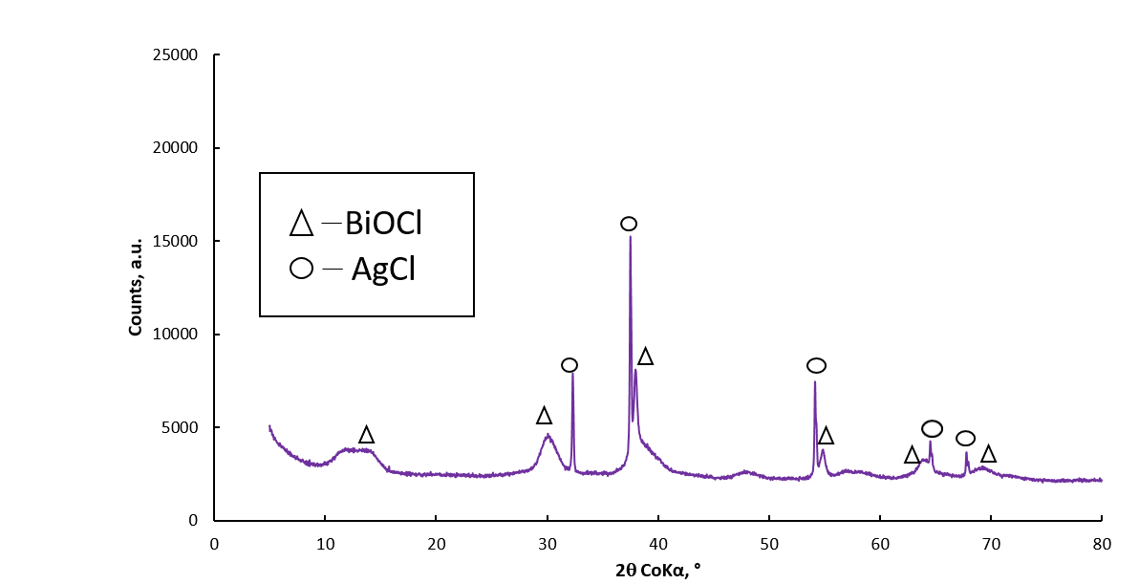
Figure 1: Powder XRD spectrum showing a match with Ag/AgCl/BiOCl

Figure 1 shows the XRD patterns of the prepared Ag/AgCl/BiOCl. Two distinct peaks detected were AgCl and BiOCl. This illustrates the purity of the synthesised particles. The sharp diffraction peaks suggests that the materials were well crystalised. The XRD could not verify the presence of Ag in the synthesised materials. This could be as a result of its low composition. However, the change of colour from white to purple (Figure 2) observed after irradiation confirms the presence of Ag in the composite catalyst (Hong et al., 2017) which is as a result of the surface Plasmon resonance (SPR) of Ag nanoparticles(Ao et al., 2014).

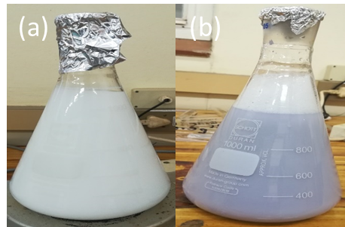
Figure 2: Colour change before (a) and after (b) irradiation

SEM and TEM
Aliquots of samples were taken during synthesis after the formation of BiOCl. These samples were taken before the addition of AgNO₃ in order to characterise the BiOCl formed. Figure 3(a) and 3(b) show the SEM images of the prepared BiOCl. The BiOCl looks like flat nanosheets consisting of tiny rod-like materials. Stephenson et al. (2018) describes the BiOCl particles as having a flat-like morphology with a few particles that look like spikes. Figure 3(d) and 3(e) show SEM images of synthesized Ag/AgCl/BiOCl. The particles have a flower-like morphology. Figure 3(c) and 3(f) shows the TEM images of the prepared BiOCl and Ag/AgCl/BiOCl, respectively. They resemble square-like nanosheets.

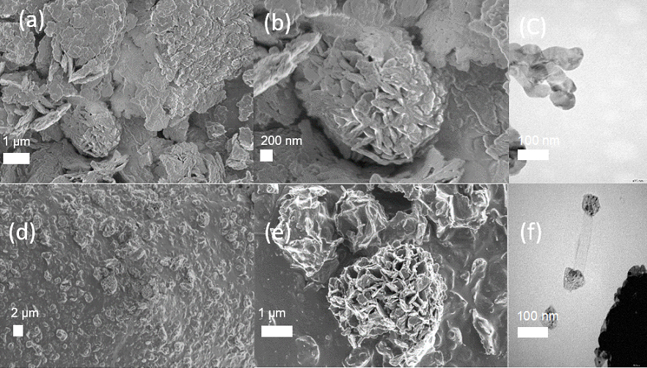

Figure 3: (a) Area SEM image of BiOCl. (b) Zoomed in SEM image of BiOCl. (c) TEM image of BiOCl. (d) Area SEM image of Ag/AgCl/BiOCl. (e) Zoomed in SEM image of Ag/AgCl/BiOCl. (f) TEM image of Ag/AgCl/BiOCl.

BET Surface Area
The BET surface area was measured as 6.64 m²g⁻¹ which is relatively lower in comparison to the surface area of commonly used Degussa. Theoretically, it is known that photocatalysis especially that of phenol happens on the surface of a catalyst and therefore a high surface area is usually required.

3.3. Degradation studies
The UV and visible light activity of prepared Ag/AgCl/BiOCl photocatalyst were evaluated for the degradation of 10 mgL⁻¹ phenol solution using 0.83 gL⁻¹ catalyst loading. A control experiment testing for the effect of visible light and adsorption on the phenol was carried out. The photolysis experiment where the phenol is degraded without catalyst to illustrate the effect of only visible light shows that degradation is not detectable in visible light without the presence of a catalyst. Likewise, a catalysis experiment without any light irradiation source showed a degradation extent of 20 % in 4.5 h which could be as a result of adsorption-desorption equilibrium in the dark. Figure 4 shows a degradation of 52 % in 4.5 h under visible light.

Figure 4: Visible light irradiation

Figure 5 illustrates the degradation activity of Ag/AgCl/BiOCl in both UV and visible light. In UV irradiation, phenol degraded by 60 % in 4.5 h as compared to 52 % degradation in the visible light. This shows a higher catalyst activity in UV light than visible light.

Figure 5: Phenol degradation under UV and Visible light irradiation using Ag/AgCl/BiOCl

A further experiment was carried out in the visible light irradiation which showed a total disappearance of phenol after 24 h. This shows the catalyst is capable of complete degradation of phenol at an extended period of time under visible light irradiation.
4. Conclusions
The Ag/AgCl/BiOCl photocatalyst was prepared and showed reasonable photocatalytic activities under UV and visible light irradiation. The XRD confirms the presence of AgCl and BiOCl in the prepared catalyst and the SEM illustrated a flower-like morphology. The photodegradation tests showed that the interaction between the catalyst and light is required for degradation to occur. The Ag/AgCl/BiOCl is activated by both UV and visible light irradiation. This study indicates the potential of using visible light for remediation of phenol in the environment.
Acknowledgments
This work was supported financially by the National Research Foundation (NRF), South Africa Competitive Programme for Rated Researchers Grant No. CSUR180215313534 awarded to Prof Evans Chirwa and National Research Foundation (NRF) Masters Innovation scholarship awarded to the co-author, Dorcas Adenuga.
References
Ao Y., Tang H., Wang P., Wang C., 2014, Deposition of Ag@AgCl onto two dimensional square-like BiOCl nanoplates for high visible-light photocatalytic activity, Materials Letters, 131, 74-77.
Chen Y., Zhu G., Liu Y., Gao J., Wang C., Zhu R., Liu P, 2016, Preparation of hollow Ag/AgCl/BiOCl microspheres with enhanced photocatalytic activity for methyl orange under LED light irradiation, Journal of Materials Science: Materials in Electronics, 28, 2859-2866.
Cheng H., Huang B., Dai Y, 2014, Engineering BiOX (X = Cl, Br, I) nanostructures for highly efficient photocatalytic applications, Nanoscale, 6, 2009-2026.
Hoffmann M.R., Martin S.T., Choi W. & Bahnemann, D.W, 1995, Environmental Applications of Semiconductor Photocatalysis, Chemical Reviews, 95, 28.
Hong S., Ratpukdi T., Sivaguru J., Khan E., 2017, Glutaraldehyde Removal from produced Waters Using Visible Light Driven Photocatalysis, Water Environment Federation, 5312-5331.
Jay L., Chirwa, E.M.N, 2018, Pathway Analysis of Phenol Degradation by UV/TiO₂ photocatalysis utilising the C-13 Isotopic Labelling Technique, Chemical Engineering Transactions 70, 181-186.
Kumar A., Thakur P.R., Sharma G., Naushad M., Rana A., Mola G.T., Stadler F.J., 2018, Carbon nitride, metal nitrides, phosphides, chalcogenides, perovskites and carbides nanophotocatalysts for environmental applications, Environmental Chemistry Letters.
Li X., Zhu C., Song Y., Du D., Lin Y., 2017, Solvent co-mediated synthesis of ultrathin BiOCl nanosheets with highly efficient visible-light photocatalytic activity, RSC Advances, 7, 10235-10241.
Manassero A., Satuf M.L., Alfano O.M., 2013, Evaluation of UV and visible light activity of TiO₂ catalysts for water remediation, Chemical Engineering Journal, 225, 378-386.
Stephenson J., Celorrio V., Tiwari D., Hall S.R., Green D.C., Fermín D.J, 2018, Photoelectrochemical properties of BiOCl microplatelets, Journal of Electroanalytical Chemistry, 819, 171-177.
Tshuto T.T., Kitoto E.O., Ranamane L.K., Chirwa E.M.N., 2017, Simultaneous Degradation of Phenol and Reduction of Chromium (VI) Using UV/TiO2 Photocatalysis, Chemical Engineering Transactions, 57, 895 -900.
Wang Q., Hui J., Huang Y., Ding Y., Cai Y., Yin S., Li Z., Su B., 2014, The preparation of BiOCl photocatalyst and its performance of photodegradation on dyes, Materials Science in Semiconductor Processing, 17, 87-93.
Xiao S., Wan D., Zhang K., Qu H., Peng J., 2016, Enhanced photoelectrocatalytic degradation of ammonia by in situ photoelectrogenerated active chlorine on TiO₂ nanotube electrodes, Journal of Environmental Science (China), 50, 103-108.
Zhang L.S., Long T.F., Yan C.Q., H X.C., Cheng M.L., Zhong S., 2013, Synthesis of AgCl/BiOCl Composite Photocatalyst and its Photocatalytic Activity under Visible-Light Irradiation, Advanced Materials Research, 662, 372-378.
Zhou P., Yu J., Jaroniec M., 2014, All-solid-state Z-scheme photocatalytic systems, Advanced Materials, 26, 4920-4935

