|  |  |
| --- | --- |
| cetlogo ***CHEMICAL ENGINEERING TRANSACTIONS***  ***VOL. 76, 2019*** | A publication of  aidiclogo_grande |
| The Italian Association  of Chemical Engineering  Online at www.cetjournal.it |
| Guest Editors: Sauro Pierucci, Jiří Jaromír Klemeš, Laura Piazza  Copyright © 2019, AIDIC Servizi S.r.l. **ISBN** 978-88-95608-73-0; **ISSN** 2283-9216 | |

High-Temperature Extraction of Lignocellulosic Bio-Crude by Supercritical Carbon Dioxide

Nikolaos Montesantosa, Thomas H. Pedersenb, Rudi P. Nielsena, Lasse A. Rosendahlb, Marco Maschiettia\*

aDepartment of Chemistry and Bioscience, Aalborg University, Niels Bohrs Vej 8A, 6700 Esbjerg, Denmark

bDepartment of Energy Technology, Aalborg University, Pontoppidanstræde 111, 9220 Aalborg Øst, Denmark

marco@bio.aau.dk

Supercritical carbon dioxide extraction was utilized for the fractionation of a pinewood derived hydrothermal liquefaction bio-crude. The experiments were performed at temperature 120 ºC and at pressure levels that correspond to CO2 density of 500, 615 and 730 kg/m3. Extraction yields of 34 to 49 % were achieved, which increased with increasing solvent density. Density was reduced for all extracts (2-10 %) while the H/C atomic ratio increased when compared to the bio-crude. Low boiling point components such as ketones, 1-ring aromatic hydrocarbons and low molecular weight fatty acids were extracted preferentially (K-values up to 11). 1-ring phenols and benzenediols were enriched in the extracts as well (K-values 1-3). Heavy hydrocarbons and long chain fatty acids were extracted at the later stages of extraction when the lighter components were depleted.

* 1. Introduction

Bio-crudes that are produced by conversion of biomass through thermochemical processes, such as hydrothermal liquefaction (HTL) and pyrolysis, have been recognized as potential alternatives to petroleum, for the production of liquid fuels as well as commercial chemicals (Baloch et al., 2018). Especially HTL of the so-called second-generation lignocellulosic biomass, which includes non-food material (e.g. forestry, sewage, industrial residues), can be a low cost and environmentally friendly source of the above. Wood (Pedersen et al., 2016) and industrial residues, such as pulp mill excess lignin (Nguyen et al., 2014) are a few examples of second-generation lignocellulosic biomass that have successfully been converted to liquid HTL bio-crudes with promising fuel properties such as higher heating values up to 35 MJ/kg. Development of HTL has already reached demonstration scale, even though there are a few obstacles to overcome with regard to downstream fuel upgrading (Castello et al., 2018). High viscosity (e.g. 2000 mPa·s), density (e.g. over 1000 kg/m3) (Haarlemmer et al., 2016) and oxygen content (e.g. 15 %) (Pedersen et al., 2017) are quality issues of HTL bio-crudes, which need to be upgraded in order to be compatible with the conventional fuel infrastructure. Catalytic hydrotreatment is the state-of-the-art upgrading process, which can bring the bio-crude to drop-in quality, with however considerable cost due to hydrogen consumption and high operating temperature (e.g. above 350 ºC) (Castello et al., 2018). In addition to the fuel perspective, HTL bio-crudes contain a large number of chemical species that range from ketones and 1-ring phenols to long-chain fatty acids and polyaromatic hydrocarbons (Pedersen et al., 2016), indicating the possibility of producing chemicals. However, the high number of components, the high boiling points of a large fraction of the bio-crude, as well as its high viscosity render the separation into fractions a complicated task. In particular, distillation needs very high temperatures even if operated under vacuum, and it is thus characterized by high operating costs. In addition, the high temperature involved may lead to uncontrolled cracking reactions resulting to equipment fouling. Conventional liquid-liquid extraction, which may have the advantage of viscosity reduction induced by the solvent dissolution in the oil, has the disadvantage of requiring the use of organic solvents, which are often petroleum-derived, that need to be regenerated by distillation (Maqbool et al., 2017).

As typical when dealing with high boiling point and viscous liquid feeds to be separated, the extraction by means of supercritical carbon dioxide (sCO2) is an environmentally friendly process with the potential of competing with conventional separation processes. In the case of pyrolysis lignocellulosic oils, the possibility of producing extracts enriched in valuable components, such as phenolics, ketones and acids, was shown (Feng and Meier, 2017). In addition, Feng and Meier (2017) observed that relatively high temperatures (e.g. 80 ºC) enhances the extraction efficiency, especially when combined with high CO2 density. In a previous work, carried out at Aalborg University and focused on HTL lignocellulosic bio-crude, the positive effect of the extraction temperature on the process operability and efficiency for these types of feed was highlighted. As a matter of fact, process operability and the extraction efficiency were dramatically enhanced for extraction temperatures increasing from 40 to 120 ºC (Montesantos et al., 2019). In line with these preliminary findings, the aim of this work is to investigate the potential of sCO2 extraction of HTL lignocellulosic bio-crude at 120 ºC, for different pressures.

* 1. Materials and methods
     1. Feed and chemicals

The bio-crude used in this work was produced by HTL of pinewood, in a pilot unit located at Aalborg University (Pedersen et al., 2016). The HTL product was demineralized and dehydrated as described by Jensen (2018). The final feed bio-crude used for the sCO2 extractions was a black highly viscous liquid (Figure 1a).

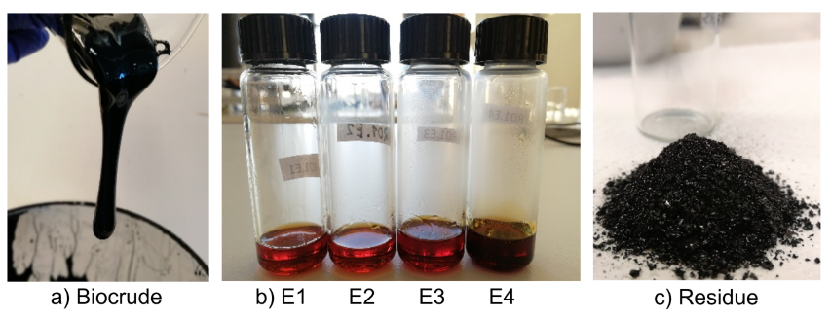

Figure 1: a) Bio-crude, b) Extracts (yield 34 %) and c) residue. Experimental run at 120 ºC and 247 bar.

Carbon dioxide (CO2, 99.8 %) from AGA was used for the extractions. Tetrahydrofuran (THF, 99 %), methyl ethyl ketone (MEK, 99 %) and methyl isobutyl ketone (MIBK, 99 %) from VWR were used as solvents for density measurements. For the GC-MS analysis, diethyl ether (DEE, 99 %) from VWR and pyridine (ACS grade) from Hach were used as solvents, n-heptadecane (C17, 99 %) from Acros and 4-bromophenol (99 %) from Merck as internal standards, and N,O-Bis(trimethylsilyl)trifluoroacetamide (BSTFA, 98.5 %) from Sigma Aldrich as derivatisation agent. A PerkinElmer Cystine 4G powder was used for the calibration of elemental analysis.

* + 1. Supercritical extractions

sCO2 extractions were performed utilizing a supercritical extraction system described in detail by Montesantos et al. (2019). The system comprises a high pressure vessel with a basket insert (178 cm3), in which a feed of approximately 30 g was charged prior to an extraction. The basket was filled up to 1/3 height with soda-lime glass beads to ensure bio-crude dispersion and an adequate contact area with the solvent. CO2 was chilled to 5 ºC by a heat exchanger and fed to the bottom of the extractor by a pneumatic pump. The extraction pressure (247 to 448 bar) and the CO2 flow rate (4.8 to 5.9 g/min) were maintained by manually regulating the air supply of the pump and the opening of a heated micrometering valve downstream the extractor. Before starting to flow sCO2, the feed and the supercritical solvent were kept at the extraction pressure and temperature for 30 minutes under static mode. A drum-type gas meter was used to measure the CO2 volumetric flow at ambient conditions, downstream a series of washing bottles comprising a cold trap (2-5 ºC). The extract was collected in the cold trap in interchangeable sampling vials. After the end of each extraction, the system was depressurized, the basket dismounted, and the residue retrieved by washing the basket and the glass beads with THF and removing the solvent by rotary vacuum evaporation.

* + 1. Analytical characterization

The feed and extracts where characterized in terms of density, elemental composition and component identification and quantitation by gas chromatography – mass spectrometry (GC-MS), while the residue was subjected to elemental analysis (EA). Because of the high viscosity, the density of the bio-crude feed was estimated by diluting it 1:1 (w/w) in three solvents (i.e. MEK, MIBK, THF). The densities of the mixture and of the pure solvent were measured with an Anton Parr DMA 35 Ex, and the density of the bio-crude was calculated assuming a linear relation between the measured density and its mass fraction. Due to the small quantity of the extracts, their density was measured by weighing the mass of a volume of sample displaced by a calibrated positive displacement precision pipette. EA was performed in a PerkinElmer 2400 Series II CHNS/O analyser. Carbon, hydrogen, nitrogen and sulphur were measured, whereas oxygen was calculated by difference. GC-MS analysis of bio-crude and extracts was performed by injecting 1 μl of sample in a PerkinElmer Clarus 680 GC coupled with a PerkinElmer Clarus SQ 8T MS. The analytes were separated in a PerkinElmer Elite 5 column (30 m, 0.25 mm ID, 0.1 μm). The temperature program of the GC was: 70 °C initial temperature for 1 min; 15 °C/min up to 250 °C; hold for 7 min. All identified components except the acids were quantified by means of the internal standard (IS) method, diluting the samples in DEE (15:1) spiked with a known amount of C17 (IS). The identification and quantitation of the acids were carried out by derivatizing the samples with BSTFA, using pyridine as solvent (1:1:1 (w/w)) and applying a heat treatment at 60 °C for 20 min. Pyridine contained a known amount of 4-bromophenol (IS). The derivatised samples were diluted in DEE (25:1). The identified compounds were approximately quantitated assuming proportionality between their mass fraction and the chromatographic area (Nguyen et al., 2014). All analysis (i.e. density, EA, GC-MS) were performed in triplicate.

* 1. Results and discussion
     1. Extraction yields and vapour phase loading (VPL)

The operating conditions and experimental data of all extractions are reported in Table 1. The extraction temperature (T) for all runs was set to 120 ºC while pressure (P) was set to different values in order to achieve CO2 densities (ρ) in the range of 500 to 730 kg/m3. Pressure and temperature were maintained for the whole duration of each extraction with average standard deviations (SD) of 3 bar and 0.4 ºC, respectively. In addition, the average flow rate (Q) is reported (SD 0.8 g/min). Extractions lasted approximately 4 hours and 4-5 extracts were collected for each run (E1, E2, …, E5). The extracts appeared remarkably less viscous than the bio-crude feed while the residue was a dry solid (Figure 1b and 1c). Extraction yields at time $t$ were calculated as the ratio of the mass extracted from the beginning of the flow mode of operation $(t=0)$ until time $t$ and the mass of the feed (F). Total extraction yields (YT) refer to the time of the last extract. They were observed to range from 34 to 49 %. The mass of the residue (RS), the cumulative solvent-to-feed ratio (S/F) and the mass balance closures (MB) are also reported in Table 1. The mass balance closure discrepancy is in line with the extracted material remaining in the dead volume of piping (estimated 6.2 ml) after the end of an extraction.

Table 1: Operating conditions and experimental results of all extractions.

|  |  |  |  |  |  |  |  |  |  |  |  |  |  |  |
| --- | --- | --- | --- | --- | --- | --- | --- | --- | --- | --- | --- | --- | --- | --- |
| Run | T  (°C) | P  (bar) | ρ  (kg/m3)a | Q  (g/min) | F  (g) | E1  (g) | E2  (g) | E3  (g) | E4  (g) | E5  (g) | RS  (g) | MB  (%) | S/F  (g/g) | YT  (%) |
| A | 120 | 247 | 500 | 6.9 | 30.8 | 2.3 | 2.1 | 3.0 | 3.0 | - | 16.6 | 87.6 | 50.9 | 33.9 |
| B | 120 | 323 | 615 | 5.8 | 30.0 | 2.7 | 2.6 | 2.5 | 4.2 | - | 13.9 | 89.9 | 42.0 | 41.9 |
| C | 120 | 448 | 730 | 4.8 | 28.0 | 2.5 | 2.4 | 2.7 | 2.7 | 3.4 | 11.6 | 90.4 | 40.6 | 48.9 |

a Taken from NIST

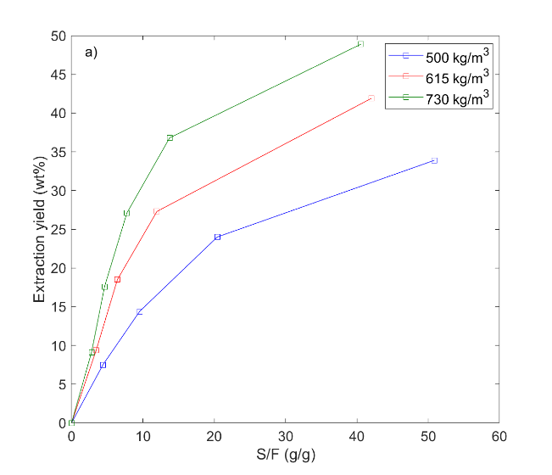 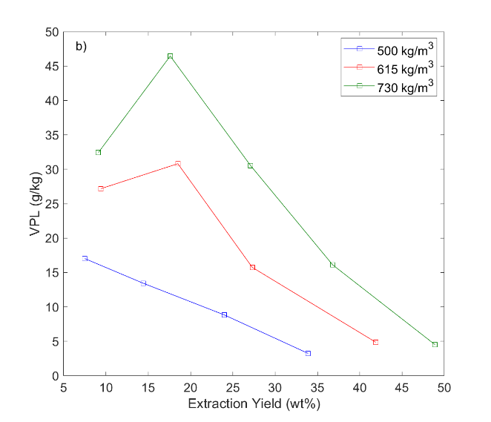

Figure 2: a) Extraction yield vs. solvent to feed ratio (S/F) and b) vapour phase loading (VPL) vs. extraction yield for different solvent densities, at 120 ºC.

In Figure 2a, the extraction yield is plotted against S/F for all solvent densities. As expected, at the given temperature, the extraction yield for a given S/F increases with solvent density. In other words, a given extraction yield can be achieved with less solvent as solvent density increases. In Figure 2b, the Vapour Phase Loading (VPL) is plotted against the extraction yield. VPL, typically reported in g/kg, is defined as the mass extracted in a specific time interval, divided by the mass of solvent flowed through the extractor in the same interval. The figure shows an expected improvement of VPL with increasing solvent density, due to the increased solubility of the bio-crude in sCO2. VPL is decreasing while the extraction proceeds since the feed remaining in the extractor becomes heavier and thus less soluble in sCO2. The irregular increase shown for runs at 615 and 730 kg/m3 between the first and second extract is most likely due to unsaturated solvent at the beginning of the flow mode of operation and it is a feature often seen in supercritical extractions. VPL in this work ranges from 46 g/kg for the early stages at the highest pressure to values as low as 3 g/kg at the final stages of the extractions. These results demonstrate average VPL values above 10 g/kg, which can be considered as a rule-of-thumb value for industrial application feasibility (Maschietti, 2014), at yields up to 49 %. In addition, at the high pressure and temperature values applied in this work, VPL values in line with those obtained for other types of oils (11 to 40 g/kg), for which the sCO2 extraction was proved feasible (Gironi and Maschietti, 2006; Gironi and Maschietti, 2007; Riha and Brunner 2009), are found.

* + 1. Physical and chemical characterization

The density of the bio-crude was found to be 1064 kg/m3 ± 15 kg/m3, whereas values in the range 957 kg/m3 ± 30 kg/m3 to 1044 kg/m3 ± 26 kg/m3 were measured for the extracts. Extract density values are in line with density of marine fuels, which ranges from 890 to 1010 kg/m3 as defined by ISO 8217 2017. The density of the extracts was found to increase during the extraction, which is in line with increased extraction of heavier components. The H/C atomic ratio of the extracts was observed in the range 1.40 to 1.69, which is higher than the feed (1.21), with these values being similar to typical bitumen values (i.e. 1.5) (Speight, 2014). The residues had the lowest H/C (range 1.03 to 1.14), which is in line with the respective increase in the extracts. The O/C atomic ratio was relatively unchanged in all extracts (range 0.08 to 0.10) compared to the bio-crude (i.e. 0.10). The standard uncertainty of H/C and O/C was 0.04 and 0.004, respectively. Similar lack of definite trends in oxygen distribution have been found in literature where lignocellulosic bio-crude was fractionated by vacuum distillation (Pedersen et al. 2017) or liquid-liquid extraction using pentane (Bjelic et al. 2018). This O/C is an order of magnitude higher than that of conventional crude oil. However, the near absence of other heteroatoms (i.e. S, N), shown by EA, makes a 1:10 blending for refinery vacuum distillation possible. The O/C ratio in the residues of all runs was 0.12, which indicates that high boiling point oxygenated compounds remain in the residue and a robust hydrotreatment/cracking process would be needed to upgrade it for fuel purposes.

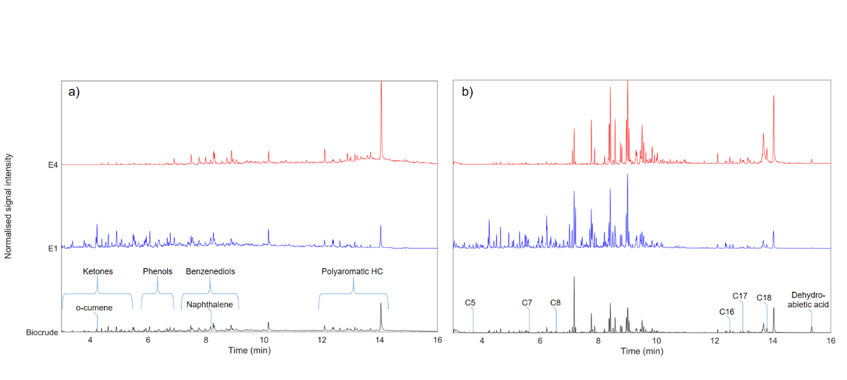

Figure 3: Example chromatogram of extraction A (i.e. 120 ºC, 500 kg/m3): a) without derivatisation, b) acid identification after derivatisation.

Chemical species belonging to the following 8 distinct classes were identified by means of GC-MS analysis of the bio-crude and extracts: 1) cyclic aliphatic (C6-C9) saturated or monounsaturated ketones (ketones); 2) o-cumene; 3) phenol, 1-ring alkylphenols and 1-ring guaiacols (phenols); 4) benzenediols and alkylbenzenediols, with either methyl or ethyl side groups (benzenediols); 5) 2-ring and 3-ring aromatic hydrocarbons (polyaromatic HC); 6) short-chain fatty acids (C5-C8); 7) long-chain fatty acids (C16-C18); 8) dehydroabietic acid. The chromatograms of bio-crude, together with extracts E1 and E4 of extraction A are shown in Figure 3a, whereas Figure 3b shows the corresponding chromatograms of the derivatised samples that served for identifying and 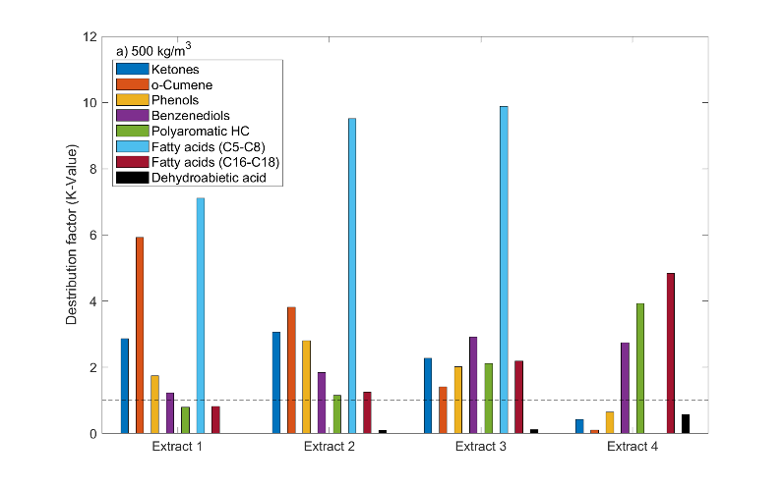 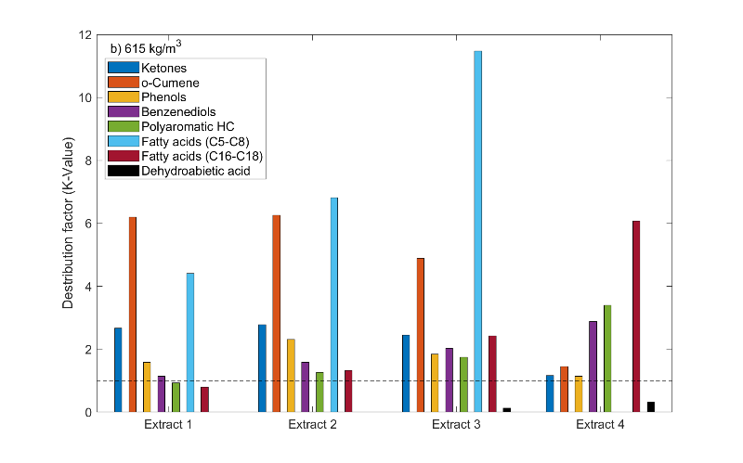 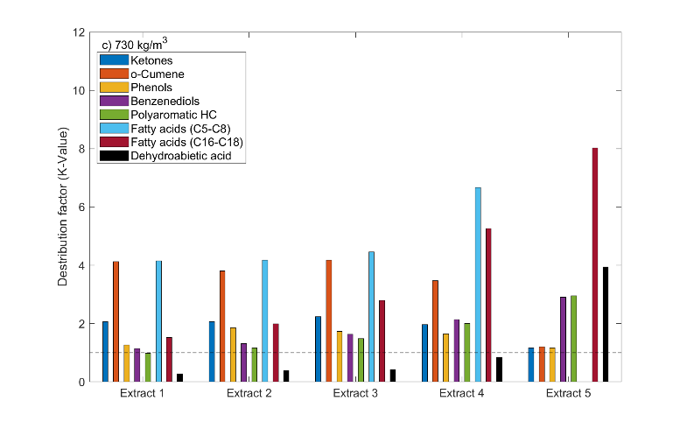 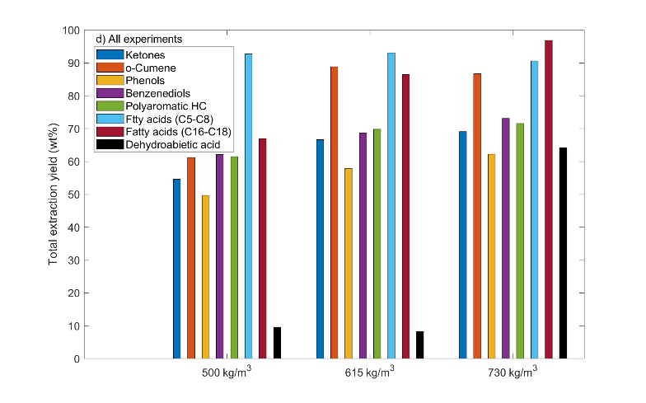

Figure 4: a, b, c: Distribution factors of identified classes at 500, 615 and 730 kg/m3 respectively; d: Total extraction yield of identified classes for all experiments.

quantitating the acids. The boiling points of the identified extracted components varied from approximately 150 ºC for the lighter components up to higher than 400 ºC for the heavier acids, with a consistent match with increasing retention rimes.

Figures 4a to 4c show the distribution factors (K-values) of the identified classes of components, whereas Figure 4d shows the total extraction yield of each class. The K-values ${(K}_{ik})$ were calculated, in a CO2-free basis, as:

|  |  |
| --- | --- |
| $$K_{ik}=\frac{y_{ik}}{\frac{z_{i,k-1}+z_{ik}}{2}}$$ | (1) |

where $y_{ik}$ is the mass fraction of each class $i$ in an extract $k$ and $\left(\frac{z_{i,k-1}+z_{ik}}{2}\right)$ is an estimation of the average mass fraction of class $i$ in the extractor during the period of collection of the extract $k$. The total extraction yield $Y_{T,i}$ for each class $i$ was defined as:

|  |  |
| --- | --- |
| $$Y_{T,i}=\frac{\sum_{1}^{N}{E_{k}y_{ik}}}{Fz_{i}}∙100$$ | (2) |

where $E_{k}$ is the mass of extract $k$, $y_{ik}$ and $F$ were defined above, and $z_{i}$ is the mass fraction of the class $i$ in the bio-crude feed. As can be seen from Figure 4, the lighter components (i.e ketones, o-cumene, short-chain fatty acids) are enriched in the extracts, owning the highest K-values in the initial period (up to 7) of each extraction. Phenols and benzenediols are also enriched in the first extracts, albeit with lower K-values (below 3). A noteworthy increase in the K-value for the polyaromatic hydrocarbons and the long-chain fatty acids is observed as the extraction progresses, with values close or below 1 at early extraction stages and up to 4 and 9, respectively, at the last stages. Another interesting observation is the considerably higher K-value of dehydroabietic acid at 730 kg/m3 compared to the respective values at the lower solvent densities. At the highest solvent density, an extraction yield of this component over 60 % was achieved. This difference shows the remarkable tuneability of the sCO2 extraction process by varying the solvent density. A general trend of K-values decreasing as boiling point increases was observed. The total extraction yield of the component classes follows the increase of the extraction yields, which increases with solvent density. The only exception is the fatty acids (C5-C8) that seem to be preferentially extracted in all cases and end up to yields close to 100 %. With regard to K-value ratios (i.e. selectivity between the identified classes), values between 1.1 and 13 were found, with the majority being above 2. These selectivities indicate that multistage sCO2 extraction units can separate the above-mentioned classes of chemicals in a downstream process.

* 1. Conclusion

The present work proves the feasibility of sCO2 extraction of lignocellulosic HTL bio-crude at 120 ºC. Extraction yields as high as 49 % were achieved for solvent density of 730 kg/m3, which is comparable to vacuum distillation of a similar bio-crude (e.g. 52 %, Pedersen et al., 2017). The extracts exhibit lower density values (956 – 1044 kg/m3) compared to the feed (1064 kg/m3), which are in line with the density of marine fuels. The oxygen content of the extracts is however an order of magnitude higher than crude oil. Nevertheless, the reduced viscosity and density, as well as the enrichment of high boiling point oxygenated compounds in the residue, suggests the possibility of a milder and less problematic hydrotreatment of the extracts, with respect to direct hydrotreatment of the whole HTL bio-crude. This, on the other hand, would require extensive cracking/hydroxydeoxygenation to be carried out on the residue. With focus to chemical composition, distinct chemical classes such as ketones, phenols, aromatic hydrocarbons and fatty acids were identified and quantitated. These classes can be extracted with yields from 50 % up to values approaching 100 %, depending on the operating conditions. In addition, the selectivity of sCO2 towards the separation of couples of classes of components shows values between 1.1 and 13, with average values around 2. This means that a downstream separation by multistage sCO2 extraction is feasible, thus rendering HTL bio-crude an alternative source for the production of chemicals.

References

Baloch H.A., Nizamuddin S., Siddiqui M.T.H., Riaz S., Jatoi A.S., Dumbre D.K., Mubarak N.M., Srinivasan M.P., Griffin G.J., 2018, Recent advances in production and upgrading of bio-oil from biomass: A critical review, Journal of Environmental Chemical Engineering, 6, 5101-5118.

Bjelic S., Yu J., Iversen B.B., Glasius M., Biller P., 2018, Detailed investigation into the asphaltene fraction of hydrothermal liquefaction derived biocrude and hydrotreated biocrudes, Energy and Fuels, 32, 3579-3587.

Castello D., Pedersen T., Rosendahl L., 2018, Continuous hydrothermal liquefaction of biomass: A critical review, Energies, 11, 3165.

Feng Y., Meier D., 2017, Supercritical carbon dioxide extraction of fast pyrolysis oil from softwood, Journal of Supercritical Fluids, 128, 6-17.

Gironi F., Maschietti M., 2007, Continuous countercurrent deterpenation of lemon essential oil by means of supercritical carbon dioxide: Experimental data and process modelling, Chemical Engineering Science, 63, 651–661.

Gironi F., Maschietti M., 2006, Separation of fish oils ethyl esters by means of supercritical carbon dioxide: Thermodynamic analysis and process modelling, Chemical Engineering Science, 61, 5114–5126.

Haarlemmer G., Guizani C., Anouti S., Déniel M., Roubaud A., Valin S., 2016, Analysis and comparison of bio-oils obtained by hydrothermal liquefaction and fast pyrolysis of beech wood, Fuel, 174, 180-188.

Jensen C.U., 2018, PIUS – Hydrofaction TM Platform with Integrated Upgrading Step, PhD Thesis, Aalborg University, Department of Energy Technology, Aalborg, Denmark.

Maqbool W., Hobson P., Dunn K., Doherty W., 2017, Supercritical carbon dioxide separation of carboxylic acids and phenolics from bio-oil of lignocellulosic origin: Understanding bio-oil compositions, compound solubilities, and their fractionation, Industrial & Engineering Chemistry Research, 56, 3129-3144.

Maschietti M.,2014, Separation of oils using supercritical carbon dioxide, Chapter in: J. Osborne (Ed.), Handbook of Supercritical Fluids, Nova Science Publishers Incorporated, New York, USA, 57-78.

Montesantos N., Pedersen T.H., Nielsen R.P., Rosendahl L., Maschietti M., 2019, Supercritical carbon dioxide fractionation of bio-crude produced by hydrothermal liquefaction of pinewood, Journal of Supercritical Fluids, Article in Press, DOI 10.1016/j.supflu.2019.04.001.

Nguyen T.D.H., Maschietti M., Belkheiri T., Åmand L.E., Theliander H., Vamling L., Olausson L., Andersson S.I., 2014, Catalytic depolymerisation and conversion of Kraft Lignin into liquid products using near-critical water, Journal of Supercritical Fluids, 86, 67-75.

Pedersen T.H., Grigoras I.F., Hoffmann J., Toor S.S., Daraban I.M. Jensen C.U., Iversen S.B., Madsen R.B., Glasius M.,Arturi K.R., Nielsen R.P., Søgaard E.G., Rosendahl L.A., 2016, Continuous hydrothermal co-liquefaction of Aspen wood and glycerol with water phase recirculation, Applied Energy, 162, 1034-1041.

Pedersen T.H., Jensen C.U., Sandström L., Rosendahl L.A., 2017, Full characterization of compounds obtained from fractional distillation and upgrading of a HTL biocrude, Applied Energy, 202, 408-419.

Riha V., Bunner G., 2000, Separation of fish oil ethyl esters with supercritical carbon dioxide, Journal of Supercritical Fluids,17, 55–64.

Speight J.G., 2014, Chemical composition, Chapter in: Chemistry and Technology of Petroleum, Taylor & Francis, Boca Raton, USA, 212-236.