|  |  |
| --- | --- |
| cetlogo ***CHEMICAL ENGINEERING TRANSACTIONS***  ***VOL. 76, 2019*** | A publication of  aidiclogo_grande |
| The Italian Association  of Chemical Engineering  Online at www.aidic.it/cet |
| Guest Editors: Sauro Pierucci, Jiří Jaromír Klemeš, Laura Piazza  Copyright © 2019, AIDIC Servizi S.r.l. **ISBN** 978-88-95608-73-0; **ISSN** 2283-9216 | |

Diffusion-controlled, size-based separation of narrowly distributed suspensions in pressure-driven flows through microfluidic bumper arrays

Stefano Cerbelli

Dipartimento di Ingegneria Chimica Materiali Ambiente - Sapienza Università di Roma - Via Eudossiana 18 - 00184 Roma

E-mail: [stefano.cerbelli@uniroma1.it](mailto:stefano.cerbelli@uniroma1.it)

Microfluidic bumper arrays (also referred to as Deterministic Lateral Displacement devices, DLD) have been proposed in the last fifteen years as a simple and effective mean to implement the label-free, size-based separation of a suspension of micrometric-sized particles. The separation resolution in these devices resolution is significantly higher than that associated with more traditional separation techniques such as, e.g., SEC columns. In DLD devices, the suspended particles are dragged by a pressure-driven flow through a periodic array of obstacles, typically hosted in a channel with rectangular cross-section. Experiments have proven that if a focused current entraining a suspension of particles of different size is continuously introduced upstream the obstacle array, size-sorted populations of particles can be collected at different locations of the device outlet. This is because, as a consequence of the fluid drag and of the hydrodynamics-mediated collisions with the obstacles, particles of different size follow on the average differentmigration pathts, which are at an angle with respect to the average direction of the carrier flow. Based on the DLD separation mechanism, prototypes have been constructed and used for sorting and isolating suspensions of clinical and biological interest, ranging from the size of red blood and circulating tumor cells, down the nanometric scale of exosomes. Recently, a novel chromatographic use of DLD devices has been proposed, where the suspension is separated in time and space coordinates by exploiting the dependence on particle mobility on particle size. By investigating particle transport in a idealized setting (associated with point-sized obstacles), it has been argued that the separation-enhancing effect due to mobility should allow, in principle, to effectively separate particles suspensions characterized by a narrow size distribution to very high degrees of resolution. In this contribution, the possibility of reproducing the same phenomenon in a classical pressure-driven flow in the presence of finite-sized obstacles is explored. Specifically, it is shown that (ideal) conditions similar to the type of particle motion predicted for point-size obstacles can be obtained even in the presence of obstacles of finite dimension, provided that the obstacle shape near the collision point is accurately tuned to obtain a diffusion-controlled behavior of particle dynamics.

* 1. Introduction

There are numerous examples of engineering applications where the interaction between deterministic (i.e. convective) transport and diffusive Brownian motion at lengthscale much smaller than the size of the equipment plays a key role in determining the overall performance of the process, from micromixing technology (Garofalo et Al, 2010) to chromatographic separations (Adrover et Al, 2009).

In the context of microfluidics-assisted separations, periodic arrays of micrometric obstacles - also referred to as Deterministic Lateral Displacement (DLD) devices - have been attracting increasing attention in the last fifteen years (McGrath et Al, 2014) as a simple and effective tool to implement the label-free, size-based sorting of a suspension of micrometer-sized particles with a resolution that finds no correspondence in more traditional separation techniques such as, e.g., SEC columns (see, e.g., Sun et Al, 2004). In DLD devices, the suspended particles are dragged by a pressure-driven flow through a planar spatially-periodic array of obstacles embedded in a channel with rectangular cross-section. Experiments have proven (Huang et Al, 2004) that if a focused current entraining a suspension of particles of different size is continuously fed at a point upstream the obstacle array, size-sorted sub-populations of particles can be collected at different zones of the device outlet. This property results from the fact that, as a consequence of the fluid drag and of the hydrodynamics-mediated collisions with the obstacles, particles of different size follow on the average different trajectories characterized by different migration angles with respect to the average direction of the carrier flow (see Section 2). Based on the DLD separation mechanism, prototypes have been constructed and used for sorting and isolating suspensions of clinical (Loutherback et Al, 2012; Holm et Al, 2011) and biological interest, ranging from the size of red blood and circulating tumor cells down the nanometric scale of exosomes and viruses (Wunsch et Al, 2016). Here, a novel chromatographic use of DLD devices is proposed, where the suspension is separated in time and space coordinates by exploiting the dependence of particle mobility on particle size. By investigating a theoretical model of particle transport accounting for the action of the deterministic drag of the suspending fluid and Brownian fluctuations, it is shown that the separation-enhancing effect due to mobility should allow, in principle, to effectively separate particles suspensions characterized by a narrow size distribution to a very high degree of resolution. Specifically, the possibility of reproducing these conditions in a classical pressure-driven flow in the presence of finite-sized obstacles is explored.

* 1. System geometry and transport model

Figure 1-(a) depicts a typical geometry of a stretched obstacle lattice hosted in the microfluidic separator. The Cartesian lattice of obstacles is defined by the vectors $e_{1}$ and $e_{2}$. The angle $θ_{l}$ between the vector $e_{2}$ and the direction of the lateral walls of the channel is referred to as the lattice angle. Coordinates are next made dimensionless by taking the cell edge, say $ℓ$ = $||e_{2}||$, as a reference length. The carrier fluid suspending the particles is pushed by a pressure drop through the obstacle lattice. Because of the small dimension of the periodic cell ( $ℓ$ is of the order of few $μm$), and since the average flow velocity is well below the *mm/sec* range, the flow regime is strictly laminar (${10}^{-3}≤Re≤1$), so that the (unperturbed) single-phase flow of the carrier fluid can be computed by solving the linear Stokes problem in place of the Navier-Stokes equations. Also, as a further consequence of the low value of the Reynolds number, the perturbation induced by the presence of the lateral walls of the channel decays swiftly when moving towards the core of the channel, so that the flow is spatially periodic onto the same lattice defined by $e_{1}$ and $e_{2}$. By this property, the solution of the Stokes flow through the structure can be obtained by taking the basic unit cell as reference domain and imposing periodic boundary conditions for the velocity components at corresponding points of the opposite edges. Panels -(b) and -(c) of Figure 1 show the flow structure for two different values of the obstacle diameter for a pressure gradient directed along the device walls. Note that, because of the presence of these lateral walls, a global constraint imposing a vanishing average value of the $y$ velocity component must be enforced (Cerbelli, 2012). The black lines depict the structure of the flow streamlines. The contour plot represents the local velocity magnitude, normalized with respect to the cell-averaged value of the flow velocity. Note how the bigger-sized obstacle depicted in Panel -(b) of the figure induces large velocities in the gap between adjacent obstacles, whereas the flow structure is almost uniform both as regards the streamline structure and the velocity magnitude in the case of the tiny obstacle.

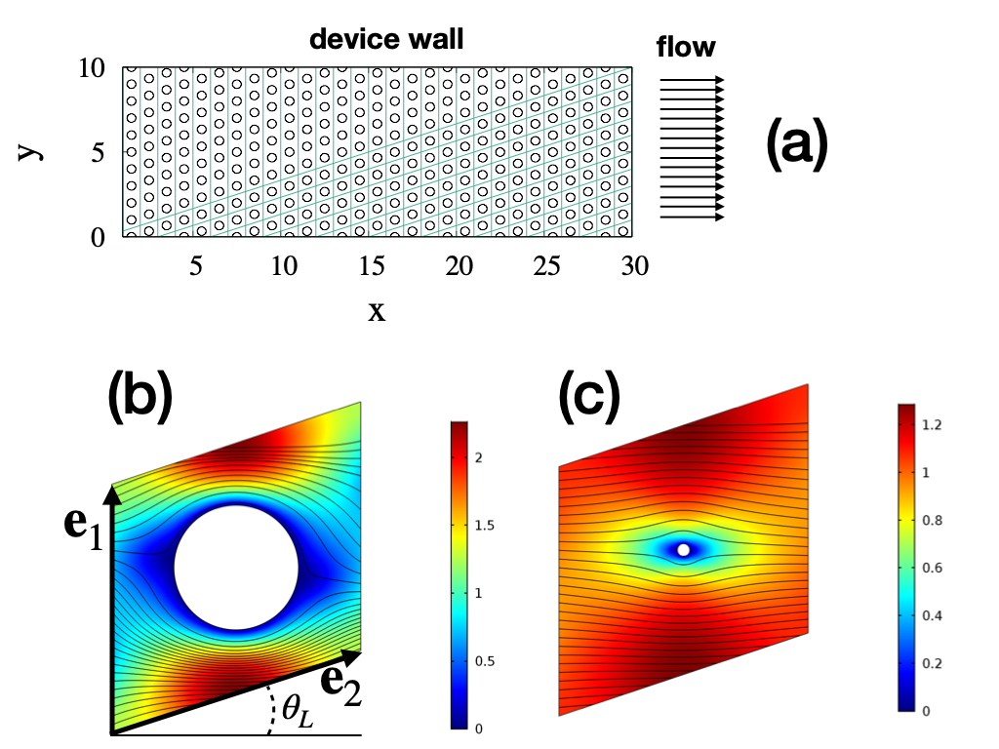

Figure 1: (a) Typical obstacle lattice geometry of a DLD microseparator. (b) and (c): unperturbed laminar flow in the periodic cell of the structure for different size of the obstacle.

This much established for the structure of the single-phase flow of the carrier fluid, the transport features of the suspended particles can be tackled by enforcing some simplifying assumptions (see Cerbelli et Al., 2013)

* The suspension is diluted, so that particle-particle interactions can be neglected
* Overdamped regime applies, so that the particle velocity in the bulk of the fluid is equal to the velocity of the unperturbed flow at the particle center-of-mass.
* A hard-wall repulsive model is considered to account for the hydrodynamic interactions occurring during the fluid-mediated collisions between the particles and obstacles. Specifically, it is assumed that no interaction occurs until the surfaces come into contact with each other. At the particle-obstacle contact, it is assumed that the obstacle annihilates the velocity component normal to the touching surfaces, while leaving the tangential velocity unaltered.

Thus, for a particle of assigned size, the trajectory through the obstacle lattice is composed by a piecewise alternated sequence of flow streamlines and arc of circles, whose radius is equal to the radius of the physical obstacle plus the particle radius. Figure 2 shows the implementation of this transport model under the assumption that Brownian motion due to thermal fluctuations can be neglected (deterministic motion) for particles of different size. Two qualitatively different transport modes can be observed. The smaller particle displays a “zig-zag” type of motion, whose average direction is aligned with the average flow direction. The bigger particle is instead systematically displaced by the collisions with the obstacles, so that its average direction is collinear with the lattice vector $e_{2}$. Between these particle dimensions, there exists a particle size (referred to as *critical*) such that the particle will approach the obstacle in the direction exactly orthogonal to the touching surfaces. According to the simplified model described above, the particle of critical size comes to a complete stop, and only the presence of fluctuations can cause the particle to depart from this (unstable) equilibrium position. 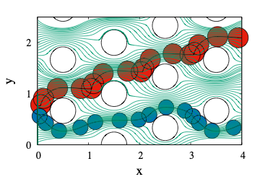

Figure 2: Qualitatively different trajectories of particles of different size according to the deterministic transport model. The smaller (blue) particle undergoes a “zig-zag” motion, whereas the bigger (red) particle is systematically deflected at each obstacle collision. The green thin lines depict the underlying streamline structure of the unperturbed flow of the suspending fluid (see main text for details).

However simple in its formulation, the deterministic transport model described above accounts for the mechanism that constitutes the driving force for the size-based (label-free) separation of multi-dispersed particle suspensions enforced in DLD-based microseparators (Cerbelli et Al., 2015). Here, the particle suspension is continuously introduced through a focused stream at the device inlet, and two sub-populations of particles are collected at different locations at the device outlet, each containing particles of size above and below the critical particle size, respectively. It is worth underlining that the critical particle parameter is ultimately defined by the geometry of the unperturbed single-phase flow of the carrier fluid, and thus, by the obstacle lattice geometry.

The purely deterministic model described above, which was first proposed in a qualitative framework in (Huang et al, 2004), has been generalized in a series of articles to include the action of particle diffusion, whose effects had been experimentally observed. The results of these theoretical body of work can be summarized by stating that at lengthscales larger that the characteristic cell size, the collective behavior of the suspended particles can be accurately described by an *effective advection-diffusion equation*,

|  |  |
| --- | --- |
| $$\frac{∂Φ}{∂t}+W⋅∇Φ=∇⋅(D⋅∇Φ)$$ | (1) |

where $Φ$ is the large-scale particle number density (i.e. averaged over a sufficiently large number of elementary cells), $W$ is the large-scale effective particle velocity, and where $D$ is the effective dispersion tensor. Here, both the transport parameters $W$ and $D$ depend on the flow structure as well as *on the particle size.* It is worth observing that these parameters can be computed by the cascade solution of a scalar and a vector-valued elliptic boundary value problem defined on the elementary cell of the domain (Cerbelli et al., 2013). Alternatively, the same quantities can be derived by considering ensemble averages of advecting-diffusing particles which evolve according to the stochastic differential equation

|  |  |
| --- | --- |
| $$dx_{p}=u_{f}(x_{p})dt+\sqrt{2D}dξ$$ | (2) |

where $x_{p}$ is the position of the center of mass of the particle, $u_{f}$ is the velocity of the single-phase flow of the suspending fluid, $D$ is the particle diffusion coefficient, and where $dξ$ represents the (vector-valued) increment of a Wiener process characterized by zero mean and variance proportional to $\sqrt{dt}$. Equation (2) is complemented by reflecting conditions at the boundary of the solid obstacles (see Cerbelli, 2012, for a detailed discussion). Based on the transport parameters $W$ and $D$, the separation performance and the separation resolution associated with the standard (i.e. continuous steady-state) implementation of DLD in microfluidic bumper arrays can be predicted (Cerbelli, 2015). In steady-state continuous separations, the parameter controlling separation efficiency is the ratio ${W_{⊥}}/{W_{∥}}$, where $W_{⊥}$ and $W_{∥}$ are to components of the average particle velocity normal, and parallel to, the device walls, respectively. This ratio defines the average migration angle of the particle current with respect to the average direction of the carrier flow. Because $W$ markedly depends upon the particle diameter, size-based separation can be realized, since a generic size-dispersed current of particles naturally separates into different streams, each characterized by a specific range of particle sizes. Besides, the excluded volume model for particle transport described above also predicts that the *magnitude $W=∥W∥$* , also referred to as *particle mobility*, depends sensitively on the particle size. This effect can be exploited whenever transient conditions in place of a steady-state setting for the separation process are enforced. The idea of performing a transient separation in a DLD device has recently been suggested in the simplified context where the velocity field $u_{f}$ driving the particle in the overdamped regime is uniform (e.g. this condition could be considered as an approximation of a body-volume force driving the particle in a quiescent viscous fluid filling the gaps between the obstacles). In what follows, we explore whether this effect can be observed even in the presence of pressure-driven flows, which constitute the most common, straightforward, and flexible implementation of DLD based separation processes.

* 1. Results and discussion

As a case study, consider the obstacle lattice represented in Fig. 1-(b), defined by an obstacle diameter equal to half of the cell width, and to a lattice angle $θ_{l}=\tan^{-1}(1/3)$. For this specific geometry, the critical radius corresponding to the structure of the laminar flow through the periodic array (computed by analyzing the behavior of particles of increasing size and determining the particle diameter marking the transition between the qualitative paths depicted in Fig. 2) falls in the interval $0.189<r_{p}^{c}/ℓ<1.90$, $ℓ$ being the length of the cell edge. In place of the commonly used continuous feeding of the particle suspension, we here consider the

Figure 3: Migration of particles of different size in a DLD lattice under transient conditions. Particles of different characteristic size are initially placed in a circular clump at the origin of the coordinate axes and their positions recorded at fixed times (see main text for details).

situation where a certain number of particles, say $N_{p}$, are initially placed in a circular area of radius $R_{0}$ within the lattice. Starting from this initial condition, the suspending fluid is set in motion by a pressure drop and particles are dragged by the surrounding fluid through the lattice of obstacles. Assuming that the cell size is in the order of 10 $μm$, and that the average velocity of the carrier flow is in the order of tens of $μm/s$, we computed the particle diffusivity appearing in Eq. (2) by taking the particle Péclet number equal to ${10}^{3}$ for the particle possessing critical size. In these conditions, we set the initial size of the circular particle clump equal to $10ℓ$, and placed an equal number $N_{p}={10}^{3}$ of particles of dimensionless size $r_{p}/ℓ=0.17;0.18;0.186$ (represented as purple, green and blue dots, respectively) randomly distributed within the circular area centered at the origin of the coordinate axes. Figure 3 shows the evolution of the particle ensemble at different times. Here lengths and times are made dimensionless by taking the cell edge $ℓ$ as reference length and the characteristic time $τ=ℓ/U$ as reference time. The initial clump of particles of different dimensions separates into three swarms, each characterized by a specific particle size. The center of mass of each particle swarm moves with an effective velocity $W$ which depends on the particle size both as regards its direction and its magnitude. The data clearly show that a complete separation of particles whose relative size differs by less than 10% is achieved after order ${10}^{3}$ rows of obstacles (compare the relative positions of the particles ensembles at t=1400). It is worth observing that in a corresponding continuous operation, where only the direction of the effective velocity provides the driving mechanism causing the size-based separation of the suspended particles, particles of size $r_{p}/ℓ=0.17$ (purple) and $r_{p}/ℓ=0.18$ would exit a device composed of ${10}^{3}$ obstacle rows still unresolved. Thus, the data suggest that using DLD microseparators under transient in place of continuous (steady-state) conditions could improve the separation performance in that both the direction and the mobility dependence of the effective particle velocity is exploited.

The phenomenon illustrated in Fig. 3 is generic, meaning that for each assigned lattice there is a range of particle dimensions where the dependence of particle mobility on size becomes sensitive. This range typically brackets the critical particle size and extends to radii values that depend on the specific geometry of the lattice. Thus, running DLD devices under transient conditions fully exploits the size dependence of the effective velocity on particle size, meaning that particles that share similar migration angles can be separated by their different response in terms of residence time. An immediate consequence of the results suggested by the transport model proposed in this article is the potential use of DLD arrays to identify the Particle Size Distribution of a multi-dispersed suspension. This could be accomplished by running a chromatographic experiment on a suspension characterized by a particle mixture possessing a known particle size distribution, and using the dispersion structure as standard baseline to determine the peaks of particle concentration at assigned times.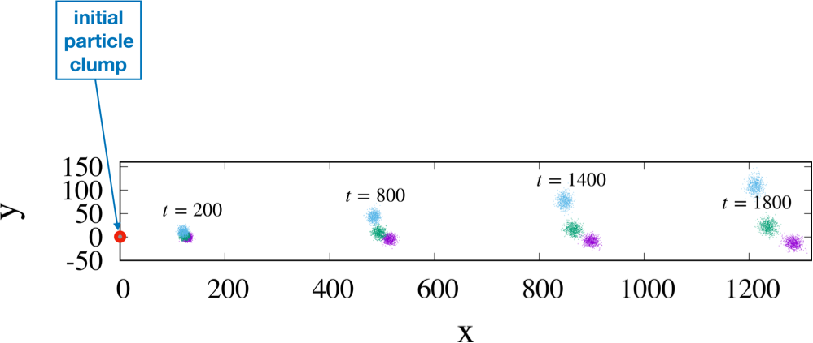

* 1. Conclusions

DLD arrays are currently being used for the continuous separation of size-dispersed population of particles, by running the process under steady-state conditions. A theoretical model enforcing overdamped regime for the fluid-particle interaction and a simple hard-wall repulsion for the particle-obstacle collisions predicts that not only the particle migration angle, but also particle mobility depends markedly on particle size. Based on this observation, a proof-of-concept for the potential use of DLD arrays under transient conditions has been proposed, which shows that separation resolution could be significantly improved using the same device geometries that are designed for the time-continuous operating conditions.

References

Adrover, A, Cerbelli, S., Garofalo, F., Giona, M., 2009, Convection-dominated dispersion regime in wide-bore chromatography: A transport-based approach to assess the occurrence of slip flows in microchannel, Analytical Chemistry, 81(19) 8009-8014.

Cerbelli, S., 2012, Separation of polydisperse particle mixtures by deterministic lateral displacement. The impact of particle diffusivity on separation efficiency. Asia‐Pacific Journal of Chemical Engineering, 7, S356-S371.

Cerbelli, S., Giona, M., & Garofalo, F., 2013, Quantifying dispersion of finite-sized particles in deterministic lateral displacement microflow separators through Brenner’s macrotransport paradigm. Microfluidics and Nanofluidics, *15*(4), 431-449.

Cerbelli, S., Garofalo, F., & Giona, M., 2015, Effective dispersion and separation resolution in continuous particle fractionation. Microfluidics and Nanofluidics, 19(5), 1035-1046.

Garofalo, F., Adrover, A., Cerbelli, S., Giona, M., 2010, Spectral characterization of static mixers. The S-shaped micromixer as a case study, AIChE Journal, 56(2), 318-335.

Huang, L. R., Cox, E. C., Austin, R. H., & Sturm, J. C., 2004, Continuous particle separation through deterministic lateral displacement. Science, 304(5673), 987-990.

Holm, S. H., Beech, J. P., Barrett, M. P., & Tegenfeldt, J. O., 2011, Separation of parasites from human blood using deterministic lateral displacement. Lab on a Chip, 11(7), 1326-1332.

Loutherback, K., D'Silva, J., Liu, L., Wu, A., Austin, R. H., & Sturm, J. C., 2012, Deterministic separation of cancer cells from blood at 10 mL/min. *AIP advances*, *2*(4), 042107.

McGrath, J., Jimenez, M., & Bridle, H., 2014, Deterministic lateral displacement for particle separation: a review. Lab on a Chip, 14(21), 4139-4158.

Sun, T., Chance, R. R., Graessley, W. W., & Lohse, D. J., 2004, A study of the separation principle in size exclusion chromatography. Macromolecules, 37(11), 4304-4312..

Wunsch, B. H., Smith, J. T., Gifford, S. M., Wang, C., Brink, M., Bruce, R. L., ... & Astier, Y., 2016, Nanoscale lateral displacement arrays for the separation of exosomes and colloids down to 20 nm. Nature nanotechnology, 11(11), 936.