CHEMICAL ENGINEERING TRANSACTIONS  VOL. 76, 2019 | A publication of
The Italian Association
of Chemical Engineering
Online at www.cetjournal.it
Guest Editors: Sauro Pierucci, Jiří Jaromír Klemeš, Laura Piazza
Copyright © 2019, AIDIC Servizi S.r.l.
ISBN 978-88-95608-73-0; ISSN 2283-9216

Surfactant Activity of Artocarpus heterophyllus Fruit Extract and Application in Oil Removal of Solid Surface
Fabíola C. G. de Almeida^{*a,b,,} Nathália M. da Rocha e Silva^{b,c,} Thaís C. de Souzaª, Darne G. de Almeida^{a,b}, Juliana M. de Luna^{a,b}, Charles B. B. Farias^{b,c} Raquel D. Rufinoª, Leonie A. Sarubbo^{a,b}

ª Centre of Science and Technology, Catholic University of Pernambuco, Rua do Príncipe, n. 526, Boa Vista, Cep: 50050 900, Recife-Pernambuco, Brazil
^{b} Advanced Institute of Technology and Innovation – IATI, Rua Carlos Porto Carreiro, n. 70, Boa Vista, CEP: 50070-090, Recife, Pernambuco, Brazil
^{c} Northeast Biothecnoloby Network, Federal Rural University of Pernambuco, Rua Dom Manoel de Medeiros, s/n, Dois Irmãos, CEP: 52171-900, Recife, Pernambuco, Brazil
fabiolacgalmeida@ hotmail.com

The commercial importance of natural surfactants is evidenced from the increasing trends in their production and the number of industrial applications due to its potential physicochemical properties. Currently, these compounds are moving several industries in the food, chemical and pharmaceutical sectors in which they demand the development of technologies in the industrial and environmental areas. The objectives of the present study were to evaluate the surfactant properties of the Artocarpus heterophyllus plant extract and its application in oil removal of solid surface. Studies on the surfactant properties analyses performed were the surface tension, emulsification activity using different hydrocarbons and vegetable oils, the haemolytic activity, the surface tension stability in different temperatures, pH and addition of salt, test of dispersion, toxicity test, the critical micelle concentration and the ion charges. To evaluate the capacity of this surfactant on oil removal in engine parts, small-scale tests conducted using steel nuts of different sizes. The results showed that this surfactant of vegetable origin obtained from fruit extract exhibited surfactant properties due to the presence of the haemolytic activity and the reduction of the surface tension of water from 72.00 ± 0.14 mN / m to 26.90 ± 0.20 mN / m, with the critical micelle concentration of 0.050 g / L with the increase values of the emulsification activity ranging from 42 ± 0.12 % and 100 ± 0.05 % on all hydrophobic compounds (corn oil, sunflower oil, soybean oil, petroleum, n-hexadecane, diesel and motor oil). The results also showed a considerable stability of these biosurfactants derived from fruit extract submitted to different temperature (stability of 26.11 ± 0.23), pH (stability of 25.63 ± 0.21) and the salt concentrations (stability of 25.79 ± 0.08). And in the result of oil displacement test demonstrated that the biosurfactant vegetable could remove 1.872 cm² the motor oil. With the characteristic of low toxicity (germination index with values of 100 at 98 %) of biosurfactant and the efficient oil removal on a solid surface between 82.6 ± 0.5 a 78.4 ± 0.6 %, can be considered new perspectives with potential to be marketed and replace the application of chemical surfactants.

  - Introduction
Biosurfactants and have a wide range of biotechnological applications in areas such as dairy, food, beverage, cosmetics, detergent, textile, paint, mining, petroleum, paper pulp and pharmaceutical industries. Biosurfactants are ecologically accepted, non-toxic, biodegradable and effective in a wide range of extreme conditions including temperature, pH and salinity, as compared to chemical surfactants (Sarubbo et al., 2016; Luna et al., 2016). They are produced by fungi, bacterium, yeast and plants. Due to their ability to concentrate at the air–water interface, they are commonly used to separate oily materials from a given medium. Surfactants increase the aqueous solubility of hydrophilic molecules by reducing the surface tension at air–water and water–oil interfaces (Souza et al., 2014; Santos et al., 2017). The Natural surfactants of vegetable origin are classified as phospholipids, proteins or protein hydrolysates and saponins. And they are surfactants which have emulsifying and foaming properties. Some studies have shown that vegetables biosurfactant (saponins) can effectively remove heavy metals or oils from contaminated soils due to efficiency coupled with characteristics such as biodegradability, low toxicity and easy to obtain (Zhou et al., 2013). Global research in the field of surfactants has been intensifying as a function of the properties of these compounds, since the amphipathic nature of their structures allows numerous industrial applications. On the other hand, the need for replacement of these agents, derived from petroleum, has motivated the development of innovative alternatives with low environmental impact. The presence work describes the properties physico-chemical along with environmental application of the biosurfactants produced by Artocarpus heterophyllus.

2. Material and methods
2.1 Format Collect and preparation of vegetables
The fruits Artocarpus heterophyllus (Jaca) purchased commercially (Central Supply and Logistics of Pernambuco - CEASA). After collection, the fruits taken to the laboratory for the washing process under water. Samples placed in the oven for 48 h at a temperature of 50 ° C for dehydration. After dehydration, the samples were ground to a fine powder.
2.2 Hemolytic activity test
Hemolytic activity observed from the mixture of the plant extract in soy tripticasein Agar (TSA-BBL) plus 5% sheep defibrinated blood in Petri dishes. Petri dishes incubated at 37 ° C for 24-48 hours (Nagao et al., 2000).

2.3 Obtaining the extractive solution vegetable

Powdered vegetable matter (50 g) from Artocarpus heterophyllus were transferred separately to Becker and 100 ml of 1% aqueous sodium hydroxide solution was added and subjected to heating 60 ° C for 30 minutes under constant stirring. The extractive solution filtered under reduced pressure using Whatman n°1 filter paper. Then the filtered solution acidified with citric acid slowly added and with constant stirring until the solution reached pH 2. The acid solution placed in a separation funnel for the extraction of the biosurfactant using ethyl acetate in a ratio of 1: 2 (v / v). The procedure epeated until the ethyl acetate became colourless. The extractive solution was frozen at -4 ° C and lyophilized. The vegetable extract lyophilized containing the biosurfactant submitted to analysis.

2.4 Surface activity
The surface tension of the vegetable extract was looking using a Du Nouy Tensiometer model Sigma 70 (KSV Instruments LTD, Finland) at room temperature. The surface measurement carried out at 25 ± 1 ºC after dipping the platinum ring in the solution for a while to attain equilibrium conditions. The measurement repeated three times and an average value was obtained.

2.5 Emulsification activity
The emulsification index measured using the method described by Copper and Goldenberg (1987). An aliquot of 3 ml hydrocarbon was added to 2 ml vegetable extract in a glass test tube separately and vortexed at high speed (2300 rpm) for 2 min. The stability of the emulsion was determined after 24 h and emulsification index (E24) calculated by dividing the measured height of the emulsion layer in the test tube by the total height of the mixture and multiplying by 100.

2.6 Determination of critical micelle concentration (CMC)
The CMC of the extracts vegetable containing the biosurfactant was determined for the concentration 0.01–3 % (w / v) in distilled water and followed by the measurement of surface tension. The surface tension of each concentration was determined in triplicate. The maximum standard deviation associated with the surface activity measurements was ± 0.2 mN / m. The CMC of the extracts brute vegetable estimated from constant value of surface tension.

2.7 Stability studies
To determine the stability of the vegetable extract containing the biosurfactant, the extract was maintained at different conditions of temperature (5 - 100 °C) for 15 min, in different values of pH (2 - 12) using 1 N NaOH or 1 N HCl. Different concentration of NaCl (2.5 - 40 %). The stability of the biosurfactant of vegetable extract investigated by analysis of surface tension. All assays carried out in triplicate and did not vary by more than 5 %.

2.8 Totoxicity (germination test)
The phytotoxicity test performed according to Tiquia et al. (1996), using seeds of cabbage (Brassica oleracea var. Capitata L.). Each petri dish placed on filter paper moistened with water (as positive control), diesel (as negative control) and concentration of vegetable extract in 1.0, 0.05 and 0.025 g / L. They were then placed 10 cabbage seeds per plate and incubated in bacteriological oven at a temperature of 28 ° C for 120 hours. After this period counted germinated seeds, evaluating the length of the roots of the transition point between the hypocotyl to the root end and the calculation of germination. Assays performed in triplicate. The results were expressed percentage of germination (% G), average growth of the root (CR %) and germination index (GI %), by the formula: (average of seed germination test x 100) on seed germination media control; (mean root growth of the seed test x 100), on the average growth of the root control seeds, (% germination of seed growth of the roots) of 100.

2.9 Oil displacement test
The oil displacement test is a method used to measure the diameter of the clear zone, which occurs after dropping a surfactant-containing solution on an oil-water interphase. The binomial diameter allows an evaluation of the surface tension reduction efficiency of a given biosurfactant contained in the vegetable extract. The oil displacement test done by adding 20 ml of distilled water to a petri dish with a diameter of 15 cm. After that 20 μl moto oil was dropped onto the surface of the water, followed by the addition of 10 μl of solution of extract vegetable of 0.05 g / L. The diameter and the clear halo visualized under visible light measured after 30 s (Rodrigues et al., 2006).
2.10 Surface oil removal test
Surface testing performed using 2 cm diameter metal nuts that had their area contaminated uniformly with 500 μL of motor oil. Then the metal nuts submerged in the solutions containing the plant extract in different concentrations (1.0, 0.05, 0.025 g / L) under constant stirring for 5 minutes. The results observed visually and the ratio between the volume of oil removed and not removed by the vegetable extract was determined after extraction with hexane, and expressed as a percentage.
  - Results and Discussion
The structural diversity of the plant biosurfactant is reflected in its physical-chemical properties (foaming, emulsification, solubilization, sweetening, bitterness) and biological (hemolytic, antimicrobial and insecticide), which are exploited in several applications in the industries. They are widely distributed in the plant kingdom and include a diverse group of compounds characterized by their structure containing a steroidal or triterpenoid aglycone, attached to one or more sugar molecules. In the present study, the surfactant properties of the crude extract vegetable of Artocarpus heterophyllus investigated. The analyze of haemolytic activity has shown the evidence presence of biosurfactant by present of a halo colourless it around of vegetable extract, as shows in figure 1.

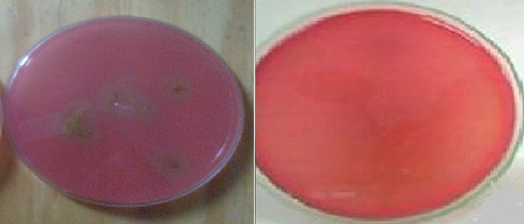

Figure 1: Haemolytic activity test

The ability of the vegetable biosurfactant in reduce the surface tension of distilled water and the capacity of oil dispersion on the surface of water was observed (Table 1). The vegetable extract of Artocarpus heterophyllus reduced the surface tension of distilled water to a minimum value of 26.92 mN/m in a value of critical micelle concentration of 0.050 g / L. And the procedure of extraction of vegetable biosurfactant in ethyl acetate presented an yield gross of 2.5 g to each 1K g of plant material. On the oil displacement test was observed than crude vegetable biosurfactant had a higher displacement activity presents the zones of clearing on the oil surface. These results are in accordance with previously reported data of literature (Sarubbo et al., 2015; Banat, 2010), where it was reported biossurfactant production by microorganisms with surface tension between 37 at 25 mN/m.
Table 1: Physicochemical properties of vegetables biosurfactants produced by Artocarpus heterophyllus.
Samples | Surface tension  (mN/m) | CMC  (g/L) |  | Oil displacement  (cm²)
Biosurfactant  A. heterophyllus | 26.90 ± 0.20 | 0,050 |  | 1.872
Control (water) | 72.00 ± 0.14 | - |  | -

The emulsification activity of biosurfactants can be clearly understood through determination of the emulsification index. Once the emulsification index is determined, this information can be applied to estimate the emulsifiers property of biosurfactant to be utilized by environmental pollution treatment (Sarubbo et al., 2012). The biosurfactant vegetable exhibited emulsification effects on all hydrophobic compounds, and the emulsification index reached 42 – 100 % (Figure 2).

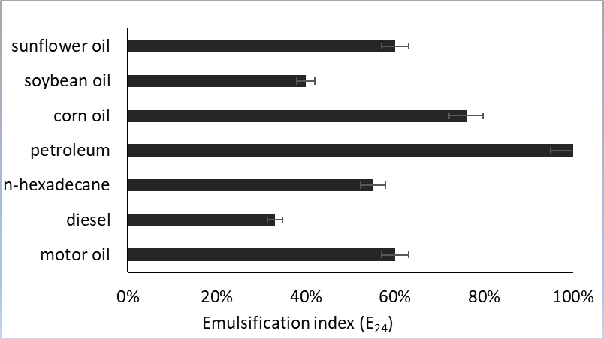
Figure 2: Emulsification activity (E₂₄) of the crude biosurfactants vegetables produced by Artocarpus heterophyllus towards different hydrophobic substrates

Many biosurfactants can be used under extreme conditions, which include high temperatures, pH values and salinity (Luna et al., 2016). The stability tests of vegetable biosurfactant at various pH, temperature and NaCl concentrations studied using surface tension measurements. The surface tension of the vegetable extract containing the biosurfactant remained stable during exposure to a wide range of temperatures of 5 - 100 ° C, pH of 2 - 10 and salt 2.5 - 40 %, end it presents no great variations in its surface tension (Table 2).

Table 2: Results of effect of temperature, NaCl concentration and pH on the surface tension of vegetable biosurfactants
NaCl concentration  (%) | Surface tension  (mN/m) | pH |  | Surface tension  (mN/m) | Temperature  (° C) | Surface tension  (mN/m)
2.5 | 25,94 ± 0.14 | 2 |  | 26,59 ± 0.24 | 5 | 26,02 ± 0.12
5.0 | 25,82 ± 0.16 | 4 |  | 26,61 ± 0.41 | 30 | 26,12 ± 0.08
10.0 | 25,84 ± 0.04 | 6 |  | 26,63 ± 0.15 | 60 | 26,09 ± 0.17
15.0 | 25,93 ± 0.10 | 7 |  | 26,62 ± 0.05 | 90 | 26,10 ± 0.14
20.0 | 25,92 ± 0.12 | 8 |  | 25,62 ± 0.12 | 100 | 26,11 ± 0.23
25.0 | 25,96 ± 0.14 | 10 |  | 25,61 ± 0.16
30.0 | 25,85 ± 0.15 | 12 |  | 25,63 ± 0.21
40.0 | 25,79 ± 0.08

The germination index (IG), which combines measures of relative seed germination and relative root elongation, was used to evaluate the toxicity of the vegetable biosurfactant on cabbage (B. oleracea). Considering that a GI value of 80% has been used as an indicator of the disappearance of phytotoxicity (Markandea et al., 2013). The results obtained indicated that the solutions tested did not show inhibitory effects on the seed germination and root elongation of cabbage. GI values of 100 at 98 % were found for biosurfactant vegetable extract solutions containing of 1.0, 0.05 and 0.025 g /L, respectively (Table 2).

Table 2: Observation of the toxicity of the vegetable biosurfactant using seeds of B. oleracea
Solution of the vegetable biosurfactant of Artocarpus heterophyllus (g / L) | Germination Index (IG)
1.0 |  |  | 98 ± 0.2 %
0.05 |  |  | 99 ± 0.5 %
0.025 |  |  | 100 ± 0.2 %
water |  |  | 100 ± 0.3 %

The application of biosurfactants is one of the most promising techniques to remove and recover a significant amount of the residual oil in environment (Sarubbo et al., 2012; Brasileiro et al., 2016). The results of test of washing demonstrated that the biosurfactant vegetable could remove 82 % and 78 % the motor oil, while the distilled water (control) not removed (Table 3). And therefore, the biological surfactants have advantages over chemical surfactant by being more efficient, effective and ecofriendly, by they remove oil of superface contaminants (Figure 3).

Table 3: Removal of surface motor oil by vegetable biosurfactant produced by Artocarpus heterophyllus

Removal agent | Recovery (%)
Solution of the vegetable biosurfactant at a concentration CMC (0.05 g / L) |  |  | 82.6 ± 0.5
Solution of the vegetable biosurfactant at a concentration ½ CMC (0.025 g / L) |  |  | 78.4 ± 0.6
Control (distilled water) |  |  | -

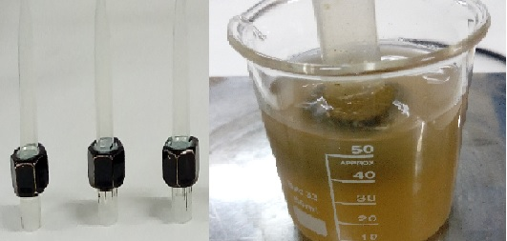

Figure 3: Illustration of motor oil removal test on solid surface
  - Conclusions
The biosurfactants produced by Artocarpus heterophyllus can be considered an potential alternatives to be applied in the industry of hygiene to remediation of environments contaminated by oil and oil products. The physicochemical characteristics of the biosurfactant obtained confirmed their tensoactive and emulsifying properties, and consequently their potential for use in formulation of natural detergent for industrial and environmental applications.
Acknowledgments
This study was funded by the Foundation for the Support of Science and Technology of the State of Pernambuco (FACEPE), the Research and Development Program from National Agency of Electrical Energy (ANEEL) and Electrical Central of Paraíba (EPASA), the National Council for Scientific and Technological Development (CNPq), and the Coordination for the Improvement of Higher Level Education Personnel (CAPES). The authors are grateful to the laboratories of the Centre for Sciences and Technology of the Universidade Católica de Pernambuco, Brazil.
Reference
Banat, I. M., 2010, Microbial biosurfactants production, applications, Appl. Microbiol. Biotechnol. 87, 427- 444.
Brasileiro, P.P.F., Meira, H.M., Luna, J.M., Rufino, R.D., Santos, V.A., Sarubbo, L.A., 2016, Oil Bioremoval Prototype Controlled by Arduino Utilizing the Biosurfactant Produced by Candida Guilliermondii, Chemical Engineering Transactions, 49, 505 - 510, DOI: 10.3303/CET1649085.
Luna J.M., Santos Filho A., Rufino R.D., Sarubbo L.A., 2016, Production of a biosurfactant from cândida bombicola URM 3718 for environmental applications, Chemical Engineering Transactions, 49, 583-588.
Markandea, A. R., Acharyab, S. R., Nerurkara, A. S., 2013, Physicochemical characterization of a thermostable glycoprotein bioemulsifier from Soli bacillus silvestris. Process Biochemistry, 48, 1800 - 1808.
Nagao E., Yamamoto A., Igarashi T., Goto N., Sasa R., 2000, Two distinct hemolysins in Trichomonas tenasx ATCC 30207. Oral Microbiol Immunol, 15, .355 - 359.
Cooper, D. G. and Goldenberg, B. G., 1987, Surface active agents from two Bacillus species. Appl Environ Microbiology, 53, 224 - 229.
Tiquia, S. M., Tam, N. F. Y., Hodgkiss, I. J., 1996, Effects os composting on phytotoxicity of spent pig-manure sawdust litter. Envir Pollution, 3, 249 - 256.
Rodrigues, L., Banat, M. I., Teixera, J and Oliveira, R., 2006, Biosurfactants: potential applications in medicine. J of Antimicro Chemoth, 57, 609 - 618.
Sarubbo L. A., Luna J. M., Rufino R. D., Farias C. B. B., Santos V. A., 2012, Production of Biosurfactants for Application in the Removal of Hydrophobic Contaminants Originated by the Petroleum Industry. Chemical Engineering Transactions, 27, 7 - 12, DOI: 10.3303/CET1227002
Sarubbo L., Luna J., Rufino R., 2015, Application of a biosurfactant produced in low-cost substrates in the removal of hydrophobic contaminants, Chemical Engineering Transactions, 43, 295 - 300, DOI: 10.3303/CET1543050
Sarubbo, L. A, Luna, J. M., Rufino, R. D., Brasileiro, P. P. F., 2016, Production of a Low-cost Biosurfactant for Application in the Remediation of Sea water Contaminated with Petroleum Derivates. Chemical Engineering Transactions, 49, 523 - 528.
Santos, Danyelle Khadydja F., Meira, Hugo M., Rufino, Raquel D., Luna, Juliana M., Sarubbo, Leonie A., 2017, Biosurfactant production from Candida lipolytica in bioreactor and evaluation of its toxicity for application as a bioremediation agent. Process Biochemistry, 54, 20 - 27, 2017.
Souza, C. E., Vessoni-Penna, T. C., Oliveira, S. P. R., 2014, Biosurfactant-enhanced hydrocarbon bioremediation: An overview International Biodeterioration & Biodegradation, 89, 88 - 94.
Zhou, W., Wang, X., Chen, C., Zhu, L. Enhanced soil washing of phenanthrene by a plant-derived natural biosurfactant, Sapindus saponin. Colloids and Surfaces A: Physicochemcal and Engineering Aspects, 425, 122– 128, 2013.

