CHEMICAL ENGINEERING TRANSACTIONS  VOL. 76, 2019 | A publication of
The Italian Association
of Chemical Engineering
Online at www.aidic.it/cet
Guest Editors: Sauro Pierucci, Jiří Jaromír Klemeš, Laura Piazza
Copyright © 2019, AIDIC Servizi S.r.l.
ISBN 978-88-95608-73-0; ISSN 2283-9216

Energy integration of steam-assisted gravity drainage facilities with carbon capture
Omid Ashrafi*, Philippe Navarri, Orsen Zamor
ªNatural Resources Canada, CanmetENERGY, 1615 Lionel-Boulet, Varennes, Quebec, J3X 1S6, Canada
omid.ashrafi@canada.ca
The in-situ extraction of bitumen is one of the most energy-intensive processes and a large natural gas consumer in the Canadian oil sands industry, contributing significantly to Canada’s anthropogenic GHG emissions. In this regard, industry and technology developers are constantly looking for ways to reduce CO₂ emissions from their operations through process improvements and more efficient heat production and utilisation. Post-combustion carbon capture (PCC) is one of the solutions available to achieve significant GHG reductions. This work focuses on improving the energy performance of integrated steam-assisted gravity drainage (SAGD) processes with PCC technologies. Three typical SAGD configurations have been selected, all with different water treatment and steam generation systems that are representative of active facilities, and simulated using Aspen HYSYS®. Analysis of the selected SAGD configurations revealed that significant energy savings and GHG reductions could be achieved through optimised heat recovery. The proposed retrofit projects could decrease natural gas consumption for steam generation by up to 10%. Then, several PCC technologies were considered to analyse the systems aspect when integrated into SAGD facilities, with a view to maximising the synergies between the two processes from an energy and water standpoint. The results revealed that the SAGD process configuration, the type of PCC technology, and the level of heat integration within the SAGD plant have a direct impact on the amount of CO₂ that can be captured.
  - Introduction
The accumulation of GHG emissions has grown rapidly (approximately 2% per year (Migueza et al., 2018)) over the previous decades due to the utilisation of fossil fuels in several sectors, including industrial processes. Process industries consume approximately 37% of global energy and contribute to 25% of global direct GHG emissions (Fitzpatrick and Dooley, 2017). The oil sands are Canada’s fastest growing source of GHG emissions, projected to reach over 100 Mt GHG emissions by 2030 (Government of Canada, 2017). In steam assisted gravity drainage (SAGD) processes, steam is generated by combusting large quantities of natural gas. The combustion process, therefore, results in huge GHG emissions that industries must reduce. Because in-situ facilities are both energy and water-intensive and among the largest Canadian GHG emitting industrial facilities, the oil sands industry and process developers are seeking ways to reduce the environmental footprint of their processes. Various approaches are considered to mitigate GHG emissions, including (Migueza et al., 2018):
- Improved energy efficiencies (heat recovery; steam generation efficiencies);
- Energy generation (new technologies for steam generation; combined heat and power; renewables);
- New and cleaner technologies for process;
- Carbon capture, utilisation and storage.
Among these approaches, a comprehensive heat integration that maximises heat recovery and minimises natural gas use will simultaneously reduce GHG generation and plant’s operating cost. Additionally, less natural gas combusted will generate lower volumes of flue gas that will require smaller units for carbon capture. However, since numerous streams need to be heated up and cooled down in these facilities, optimising heat recovery systems requires the use of a facility-wide approach for heat management. Due to conservative approaches often used in the design of in-situ processes to minimise operational risks, oil sands operators do not take full advantage of most recent advances in heat integration and potential for improving plants performance remains unexploited (Jacobs, 2009). Process Integration (PI) is a powerful approach among different heat management techniques that is used in several industrial processes to improve the energy efficiency and to optimise the use of heat in the process (Ashrafi et al., 2016). Among the PI techniques, Pinch Analysis is very effective to optimise heat recovery systems that minimises the use of thermal energy in a process by proposing the best design options (Gadalla, 2015).
Carbon capture is a key technology to control and mitigate the rise of GHG emissions in industry (IEA, 2013) since CO₂ alone has contributed to about 76% of the global GHG (Rudin et al., 2017). The international energy agency (IEA) revealed that the potential for carbon capture from industry and power plants is approximately 19% of the total reduction potential (Berstad et al., 2013). In general, existing carbon capture technologies are post-combustion, pre-combustion, oxy-fuel combustion and chemical looping combustion (Rudin et al., 2017). A typical solvent-based post-combustion carbon capture (PCC) unit is comprised of an absorber where the CO₂ in the flue gas is absorbed into a solvent, and a stripping column to regenerate the solvent. The desorbed CO₂ is recovered for further use, for example in enhanced oil recovery or other industry utilisations, or for conversion into value-added products. Commercially available technologies using solvents can achieve high CO₂ capture rates. However, significant amounts of high-grade heat and high capital costs are needed to process the large volume of flue gas from SAGD processes.
Carbon capture has been actively investigated for decades in various countries (e.g. Kessler et al., 2018, Laribi et al., 2018; Li et al., 2018) and most of the work currently performed by research teams and technology providers is directed towards reducing both operating and capital costs. However, most of these works consider the carbon capture unit stand-alone and do not fully exploit the opportunities for heat integration to maximise synergies between the in-situ plant and the capture unit to further reduce costs. In this study, heat recovery systems in typical SAGD facilities are analysed and optimised, the energy penalty associated with PCC is reduced, and the overall efficiency of the combined operations (SAGD + PCC) is improved. Three SAGD facility configurations, representing the majority of existing plants in operation in Canada, and three PCC technologies that are best suited to in-situ plants have been selected in collaboration with our industry partners. This analysis focuses on energy and GHG aspects of SAGD process with PCC and capital cost was not considered. Subsequently, modelling and extensive facility-wide heat integration is performed to optimise the energy use of the typical SAGD configurations, in two scenarios: with and without PCC. First, energy-efficient designs that reduce energy use and GHG emissions related to steam production in the in-situ typical processes without carbon capture is developed. Then, selected carbon capture technologies are optimally integrated within the in-situ plants to maximise synergies that improve the overall efficiency of the combined operations. Impact analysis is performed for the different scenarios, to evaluate the energy and environmental benefits associated with the optimal integration of in-situ facilities, with and without carbon capture.
  - Process and technology assessment
    - SAGD configurations
In SAGD process, large amounts of high pressure (HP) steam are produced in the central processing facility (CPF) and injected through several wells into the reservoir to extract bitumen (Jacobs, 2009). More details about the SAGD process can be found in (Jacobs, 2012). In this work, three SAGD configurations that are representative of typical plants currently in operation are considered, as follows (COSIA, 2018):
- Configuration 1: Mechanical lift with Warm lime softening and 6 once-through steam generators (OTSG) with 77% steam quality;
- Configuration 2: Mechanical lift with Evaporator and 5 Drum boilers with 98% steam quality;
- Configuration 3: Mechanical lift with Evaporator, 4 Drum boilers, and 1 Cogeneration unit with 98% steam quality.
Since SAGD plants are energy-intensive and often has limited access to water, the process is designed for energy efficiency and water conservation. In the three configurations analysed, besides direct heat exchangers, a large glycol circuit is also employed to transfer heat throughout the plant where heat in the hot process streams is used to preheat cold process streams, mostly boiler feedwater (BFW). Although the use of glycol as heat transfer medium in SAGD processes is common due to the flexibility in operation, glycol systems introduce inefficiencies from a heat recovery standpoint. Glycol heat recovery loops transfer heat several times that tends to lower the heat quality and reduce the heat recovery potential (Suncor Energy and Jacobs, 2012). However, in conservative design practices, the use of a heat transfer loop finds its rationale as an intermediate means for heat transfer. In this study, the efforts are to maximise direct heat recovery to keep process streams as hot as possible and to reduce the use of glycol in the process. Figure 1 represents the simplified process flow diagram of the SAGD process (Configuration 1) that includes major equipment, process streams, and heat recovery system within the CPF.

Figure 1: Simplified flow diagram of the Base Case SAGD process – Configuration 1
    - Carbon capture technologies
Carbon capture is considered an important option to dramatically reduce GHG emissions from large industrial combustion systems such as SAGD. In this work, three PCC technologies are optimally integrated with the in-situ plants to maximise synergies that will improve the overall efficiency of the combined operations. The selected PCC technologies are:
- Enzyme-enabled solvent (absorber + stripper); regeneration energy: hot water (CC 1)
- Physical sorption; regeneration energy: LP steam (CC 2)
- State-of-the-art amine-based solvent (absorber + stripper); regeneration energy: LP steam (CC 3)
In all selected technologies, 655,220 kg/h SAGD flue gas (195 °C) with 8.5% CO₂ (wet basis) is treated with a targeted capture rate of 90%. The captured CO₂ is compressed and dehydrated to 157 bars in a multi-stage compressor and intercooling system. The compressed CO₂ can be pipelined for further use, for example in enhanced oil recovery applications (EOR), for use in greenhouses or the food and beverage industry, or for conversion to value-added products (chemicals and fuels). In the capture plant, some water contained in the flue gas is condensed and can be reused in the SAGD process as make-up water. This study showed that the condensed water recovered in the carbon capture plant could significantly reduce the SAGD plant make-up water, by 25% to 100%, depending on the SAGD configuration and the required amount of make-up water. The cleaned flue gas is then released into the atmosphere.
  - Process optimisation
The three selected SAGD configurations were simulated using Aspen HYSYS®. Then, CanmetENERGY’s INTEGRATION and COGEN software were used to analyse the existing heat recovery system, identify energy use inefficiencies in the process and develop design solutions to improve heat recovery (NRCan, 2015).
    - Heat recovery optimisation in SAGD process
Pinch Analysis was used to improve the energy integration of the three SAGD plants. For each configuration, process data (i.e. flowrates, temperatures, and enthalpy) were collected, and energy and material balances were performed for the existing heat exchangers networks. The flue gas from OTSGs, drum boilers, and cogeneration systems, rejected into the atmosphere at high temperature in the base case designs, was considered as a source with high-quality energy for heat recovery. In order to avoid overestimating the available energy for heat recovery, it was assumed that the flue gas temperature is always 25 °C above the boiler feedwater inlet temperature. It was also assumed that the OTSG and drum boiler combustion air could be heated up to 175 °C with no negative effect on NO_{X} emissions. It is worth saying that the improved heat recovery not only identified opportunities to reduce natural gas use for steam generation but also found ways to reduce the glycol usage in the plant. Opportunities for increasing energy efficiency in the three cases are presented in Table 1. A detailed heat integration of the SAGD process Configuration 1 is presented in Ashrafi et al. (2016).
Table 1: Results of the Pinch Analysis on the three SAGD configurations
Parameter | Unit | Configuration 1 | Configuration 2 | Configuration 3
Boiler feedwater temperature  Base Case  Heat integrated | °C  °C | 170  194 | 184  200 | 160  166
Combustion air temperature  Base Case  Heat integrated | °C  °C | 53  128 | 53  150 | 53  130
Boiler flue gas temperature  Base Case  Heat integrated | °C  °C | 195  130 | 209  143 | 185  130
Natural gas consumption reduction | % | 8 | 6 | 2

    - Heat recovery optimisation in SAGD process with carbon capture
In this section, producing part of the regeneration energy using excess heat from the PCC unit and the SAGD process was investigated for various heat integration levels of the SAGD facility. Figure 2 shows the simplified flow diagram of the SAGD process with carbon capture and compression.

Figure 2: Simplified flow diagram of the SAGD process with carbon capture and compression
The enzyme-enabled PCC technology is using hot water as regeneration energy while the other two technologies use low pressure (LP) steam. These technologies already consider some heat recovery measures in their design. For example, CC 1 uses the energy in the flue gas and the compression train as a part of the regeneration energy. However, the recovered energy is insufficient and another source of energy is needed to provide the regeneration energy. In most carbon capture technologies, this is done using a dedicated natural gas auxiliary boiler. However, excess heat from SAGD can be used to provide part of the energy required for regeneration. Table 2 summarises available heat sources in the three selected SAGD configurations that can be used for the carbon capture units.
Table 2: Heat sources in SAGD useful for regeneration energy
Heat source | Configuration 1 | Configuration 2 | Configuration 3
Flue gas (FG) from OTSG/DB | Y | Y | Y
Flue gas (FG) from COGEN | - | - | Y
Glycol system | - | Y | -
Produced water (PW) | - | Y | -
Dilbit | Y | Y | Y

In addition to the SAGD heat sources, several other strategies were considered to provide the regeneration energy, including: the use of heat pumps, stripper overhead compression (SOC), and the use of part of the process steam or a dedicated auxiliary boiler. Figure 3 shows a comparison of CO₂ emissions for the three PCC technologies integrated with the SAGD configuration 1 (Mechanical lift, Warm lime softening and OTSG). In this figure, direct and indirect CO₂ emissions due to natural gas combustion and electricity consumption, respectively, are presented for the plant with no PCC and for the plant with PCC having different energy integration levels.
The energy analysis showed that the excess heat available in the SAGD plant is insufficient to provide all the required regeneration energy for any of the three selected PCC technologies. As expected, a larger portion of the regeneration energy can be provided using excess heat for the enzyme-enabled capture technology since the process uses a lower temperature for solvent regeneration. This is also the technology where the regeneration heat can be provided using stripper overhead compression but the power consumption and indirect GHG emissions would be increased. In addition, if the SAGD flue gas energy is used for internal heat recovery, less energy would be available for the PCC unit and more natural gas would be burned in the auxiliary boiler to provide the regeneration energy. This is the case for the three SAGD configurations studied. Again, the impact is lower for the enzyme-enabled capture technology that uses a lower temperature regeneration energy.

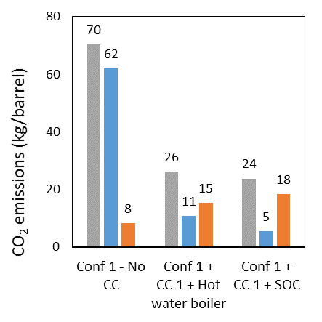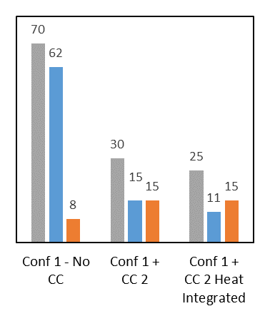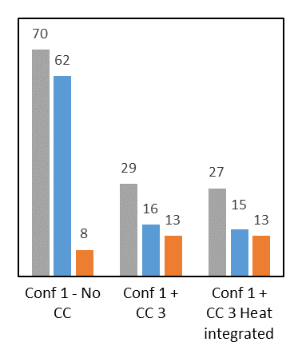
Figure 3: Integration of CC units within SAGD Configuration 1 (Base Case)
As shown in Figure 3, the impact of indirect CO₂ emission associated with electricity consumption on total emissions is significant. In this study, we also analysed the potential benefits of using a cogeneration unit instead of an auxiliary boiler to produce the regeneration energy. In this case, the cogeneration unit can also meet all of the SAGD facility, carbon capture, and compression’s power demands. It can also generate excess power that can be exported to the grid and therefore considered as a GHG credit considering the grid power GHG intensity (i.e. 0.635 t-CO₂/MWh in this study). As an example, Figure 4 illustrates the use of a cogeneration unit for carbon capture technology CC 3. The figure shows a negative value for indirect emission due to power export that results in less overall CO₂ emissions compared to the scenario with auxiliary boiler (see Figure 3). However, using cogeneration increases the natural gas consumption and direct GHG emissions, as well as capital cost. This is the case for all PCC technologies studied.

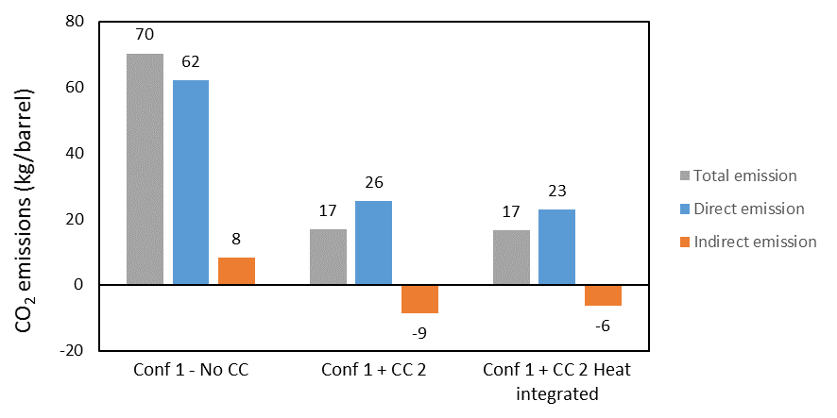
Figure 4: Integration of CC 3 unit with a cogeneration unit within SAGD Configuration 1 (Base Case)
  - Conclusions
Lowering the carbon dioxide emissions in various industrial sectors is necessary to meet GHG emission targets established in international agreements. Consequently, the Canadian oil sands industry needs to significantly reduce its GHG emissions to comply with federal/provincial regulations and to improve international acceptance. Carbon capture is considered as an efficient path for decarbonisation in energy intensive industries. In this study, energy integration aspects for SAGD facilities with PCC are analysed in order to maximise the use of waste heat and decrease the use of natural gas to produce the PCC regeneration energy. Among all studied options, the technologies that use a low-grade heat as regeneration energy benefit more from waste heat and rely less on natural gas. In addition, PCC with a cogeneration unit simultaneously producing heat and power appears to be attractive in terms of overall GHG reductions and new revenues from power export. However, direct emissions and capital investment would be higher than with a conventional boiler. Further, this work did not consider capital cost that could significantly affect the overall capture cost. The economic analysis of SAGD processes with PCC will be studied in the next phase of this work. In all cases, synergies between SAGD process and PCC were exploited from an energy and environment perspective. The results revealed that the SAGD configuration, its heat integration level and the type of PCC technology affect the amount of waste heat that can be used as regeneration energy, as well as the overall energy demand, and GHG emission reduction.
Acknowledgments
The Energy Innovation Program (EIP) at Natural Resources Canada for the funding of this research work, COSIA Joint Industry Project members CNOOC International, Canadian Natural, and Suncor Energy for providing valuable input to the project, CO₂ Solutions Inc. and Mitsubishi Heavy Industries America for providing data for their carbon capture technologies.
References
Ashrafi O., Navarri P., Hughes R., Lu D., 2016, Heat recovery optimization in a steam-assisted gravity drainage (SAGD) plant, Energy, 111, 981–990.
Berstad D., Anantharaman R., Neksa P., 2013, Low-temperature CO2 capture technologies – Applications and potential, International Journal of Refrigeration, 36, 1403–1416.
COSIA, 2018, SAGD Reference Facilities Report, https://www.cosia.ca/node/38, accessed 17/01/2019.
Fitzpatrick J.J, Dooley P., 2017, Holistic view of CO₂ reduction potential from energy use by an individual processing company, Renewable and Sustainable Energy Reviews, 77, 336–343.
Gadalla M.A., 2015, A new graphical method for pinch analysis application: heat exchanger network retrofit and energy integration, Energy, 81, 159–174.
IEA, 2013, Technology Roadmap: Carbon Capture and Storage, Energy Technologies Perspective, France.
Jacobs Consultancy, 2009, SAGD Energy Efficiency Study, Canada.
Jacobs Consultancy, 2012, Thermal in situ water conservation study – A summary report, Canada.
Kessler E., Schäfer L.N., Willy B., Schneider R., Irfan M., Rolker J., von Harbou E., Hasse H., 2018, Structure-property relationships for new amines for reactive CO₂ absorption, Chemical Engineering Transactions, 69, 109–114.
Laribi S., Dubois L., Weireld G.D., Thomas D., 2018, Simultaneous absorption of SO₂ and CO₂ from conventional and partial Oxy-fuel cement plant flue gases, Chemical Engineering Transactions, 69, 121–126.
Li K., Feron P.H.M., Jiang K., Jones T.W., Bennett R.D., 2018, Hollenkamp A.F., Pearson P., Reaction enthalpy conversion in amine based post-combustion CO₂ capture, Chemical Engineering Transactions, 69, 139–144.
Migueza J.L., Porteiroa J., Pérez-Orozcoa R., Patiñoa D., Rodríguez S., 2018, Evolution of CO2 capture technology between 2007 and 2017 through the study of patent activity, Applied Energy, 211, 1282–1296.
NRCan (Natural Resources Canada), 2015, INTEGRATION Software: A Unique Tool for Identifying and Assessing Energy Saving Projects, https://www.nrcan.gc.ca/energy/efficiency/industry/processes/systems-optimization/process-integration/products-services/5529, accessed 29/01/2019.
Government of Canada, 2017, Canada's 2016 greenhouse gas emissions reference case, https://www.canada.ca/en/environment-climate-change/services/climate-change/publications/2016-greenhouse-gas-emissions-case/chapter-2.html#tab6, accessed 29/01/2019.
Rudin S.N.F.M., Muis Z., Hashim H., Ho W.S., 2017, Overview of carbon reduction, capture, utilization and storage: Development of new framework, Chemical Engineering Transactions, 57, 649–654.
Suncor Energy and Jacobs Consultancy, 2012, A greenhouse gas reduction – Roadmap for oil sands, Canada.

