|  |  |
| --- | --- |
| cetlogo ***CHEMICAL ENGINEERING TRANSACTIONS***  ***VOL. 76, 2019*** | A publication of  aidiclogo_grande |
| The Italian Association  of Chemical Engineering  Online at www.cetjournal.it |
| Guest Editors: Sauro Pierucci, Jiří Jaromír Klemeš, Laura Piazza  Copyright © 2019, AIDIC Servizi S.r.l. **ISBN** 978-88-95608-73-0; **ISSN** 2283-9216 | |

Agglomeration Phenomena During Fluidized Bed Combustion/Gasification of Biomass Fuels

Francesco Miccioa,\*, Annalisa Natali Murria, Valentina Medria, Elena Landia

aIstituto di Scienza e Tecnologia dei Materiali Ceramici CNR, via Granarolo 64 Faenza I

francesco.miccio@cnr.it

The objective of this research is to investigate the occurrence of agglomeration phenomena during fluidized bed processing of biomass fuels. These are to be ascribed to the alkali content in biomass materials that gives rise to low melting compounds in combination with SiO2, normally present in bed materials. The results obtained in a lab scale facility under operating conditions of gasification highlight that other materials may be adopted (e.g. olivine and chromite), despite they have higher density with respect to silica sand, affecting the bed fluid-dynamics. As alternative the addition of metakaolin is effective in order to delay the occurrence of bed agglomeration, as demonstrated by experiments carried out in alumina crucible at 900 °C and complemented by electronic scanning microscopy (SEM) and x-ray diffraction (XRD) analyses. The results are reported and discussed in the article, with the sake of providing further insights for contrasting the undesired agglomeration behavior in practical applications.

* 1. Introduction

The utilization of fluidized beds (FB) is highly advised for accomplishing thermochemical processes, such as combustion and gasification, in presence of difficult fuels. In fact, fluidized beds can easily face problems arising from coarse or irregular particle size (Werther et al., 2000) or high moisture/ash content in the fuel (Miccio et al., 2016). Nevertheless, agglomeration phenomena in fluidized bed can be experienced, when biomass fuels are processed, even at moderately high temperature, owing to the alkali content that can be substantially high for certain classes of biomass (Werther et al., 2000). For instance, experiences of bed agglomeration are reported for straw gasification (Ergundler and Ghaly, 1993), pine-seed combustion (Chirone et al., 2006), gasification of giant reed and sweet sorghum (Fryda et al., 2008).

The bed agglomeration is very detrimental because leads to plant malfunction with the need of shut-down for maintenance. The agglomeration temperature strongly depends on the fuel characteristics as well as on the chemical composition of the bed material. The combination of straw or giant reed as fuel and quartz sand as bed material gives rise to defluidization even at temperature of around 800°C (Ergundler and Ghaly, 1993). The utilization of other bed materials, e.g. olivine, alumina (Mettanant et al., 2009), or chromite (Miccio et al., 2014), significantly increases the agglomeration temperature, i.e. in excess of 900 °C.

It is reported in literature that biomass blends (Surjosatyo et al., 2017) or coal-biomass mixtures (Svoboda et al., 2000) can prevent agglomeration phenomena, because of the ash composition of the added fuel. In fact, kaolinite and derived minerals act as “alkali getters”, suppressing the agglomeration of fluidized particles (Öhman M. and Nordin A., 2000), by formation of K2O-SiO2-Al2O3 ternary compounds. Concerning the effect of Ca, also abundant in coal and biomass ashes, the Ca/(K+Na) ratio of the fuel was proposed as an useful indicator for predicting the propensity to give rise to bed agglomeration (Mettanant et al., 2009), a higher value reducing the probability of this event. During gasification, the higher temperature needed for improving the reaction kinetics and the lower equivalence ratio are both critical factors in order to increase the probability of bed agglomeration and defluidization.

In this regard, the present article reports insights into detecting, understanding and contrasting agglomeration phenomena during fluidized bed process of biomass fuels, with particular focus on gasification. The results of experiments carried out in a small scale fluidized bed gasifier and complemented with laboratory deepening are presented and discussed in the article.

* 1. Experimental description
     1. Biomass

An agro-industrial residual biomass was considered for this study, namely olive husk (OH), produced in the south of Italy during the olive oil extraction. Before use, the biomass was oven dried and grinded in a cutting mill equipped with a 2 mm sieve (Fritsch Pulverisette 15). The residual moisture content was around 6% wt. The milled samples were alternatively pelletized (6 mm diameter and 20-30 mm length) or sieved in 1.0-2.0 mm size fraction. The main properties of OH are reported in Table 1, along with those of a German brown coal (BC) that was added for preparation of some pellet batches. Three different formulations were adopted: 100%, 70% and 50% wt. in olive husk. The alkali (K+Na) content determined by ICP in OH ash was around 36% wt., whilst it is less than 10% wt. for BC. The Ca/(K+Na) ratio is equal to 6.95 and 0.35 for OH and BC, respectively.

Table 1: Physical and chemical properties of the fuels on dry basis

|  |  |  |  |  |  |  |  |  |  |  |  |
| --- | --- | --- | --- | --- | --- | --- | --- | --- | --- | --- | --- |
|  | Particle size  mm | density  g/mL |  | C  % | H  % | N  % | O  % | Char  % | Vol.  % | Ash  % | LHV  MJ/kg |
| Olive Husk | 1.0-2.0 | 1.35 |  | 54.4 | 6.8 | 0.8 | 35.3 | 18.9 | 78.4 | 2.7 | 22.5 |
| Brown coal | 0.1-2.0 | 0.86 |  | 65.4 | 4.9 | 0.8 | 24.8 | 45.0 | 51.3 | 3.7 | 24.1 |

* + 1. Inorganic materials

Different materials were investigated during agglomeration tests in the experimental facilities (see below): quartz sand (0.2-0.4 mm size, 2.6 g/mL density), olivine sand (0.2-0.6 mm size, 3.2 g/mL density), and chromite sand (0.2-0.3 mm size, 4.2 g/mL density). The Si content is 85%, 40% and 1.0% wt. for quartzite, olivine and chromite, respectively. Accordingly, the major mineral phases of the different bed materials are indicated in Figure 1, which highlights the high content of silica in the quartzite sand, being olivine and chromite mainly constituted by magnesium silicate and iron chromium oxide, respectively.

As additives, commercial kaolin (BS4, AGS Mineraux: 95% <100 m, SiO2= 40.9%, Al2O3= 41.0%, K2O+Na2O= 0.4%) and metakaolin (Argical M1000, Imerys: 95% <80 m, SiO2= 55.59%, Al2O3= 40.0%, K2O+Na2O= 0.8%) powders have been used in certain experiments.

C:\Users\Annalisa\Documents\Annalisa\Dati\_PROGETTI\Fluidized Bed Combustion\XRD\crom-quarz-oliv 900 (2).tif

Figure 1: Phase distribution of as given bed materials

* + 1. Experimental setup

Transient agglomeration tests were carried out in a lab-scale fluidized bed reactor made in AISI 316 stainless steel (78 mm inner diameter, 500 mm height) with opened bottom side, as shown in Figure 2-A. A rotameter was used for measuring the air flow rate supplied to the bottom of the reactor throughout a multi-holes nozzle. A K-type thermocouple (T) was immersed in the bed for temperature measurement. The fluidization column was externally heated by a couple of electric ceramic furnaces and controlled by an electronic device, driven by the bed thermocouple. A screw feeder dosed the granular fuel from the top side of the fluidization column at constant rate. The pressure (P) at the bottom of the fluidization column was monitored by means of an electronic device (Druck PTX, 0-100 mbar, 1 kHz). The reactor was operated at temperature of 850 and 900 °C, fluidization velocity of 0.20-0.25 m/s, and equivalence ratio of 0.4-0.5.

Batch tests of agglomeration have been carried out with fixed amount of bed materials (2 g), with addition of olive husk at different mass ratios. An alumina crucible holding the sample was inserted in an electric tubular furnace (CARBOLITE 1200) from the bottom end, as shown in Figure 2-B, and kept for 1 hour at the operating temperature. Afterwards the crucible was extracted from the furnace and visually inspected.

Qualitative crystallographic analysis of the samples have been carried out by X-ray diffraction (XRD, Bruker D8 Advance powder diffractometer with Cu Ka radiation, Karlsruhe D) to assess the possible formation of new phases upon reaction of the fuel with bed material and/or the used additives. The morphological characterization of the samples was done by scanning electronic microscopy (SEM) using a field emission gun-scanning electron microscope (FEG-SEM, ΣIGMA Zeiss) equipped with energy dispersion spectroscopy (EDS-Oxford Instruments), in order to identify any agglomeration effect among the bed particles.

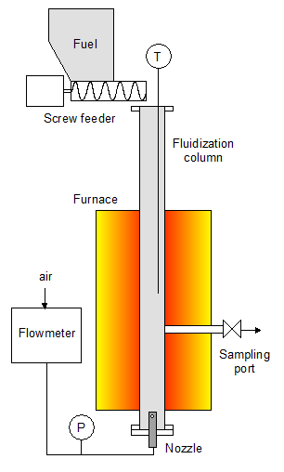 A 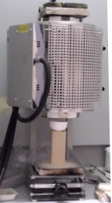 B

Figure 2: Schematics of the experimental setup for FB agglomeration tests (A) and photograph of the batch apparatus for characterization of bed materials (B)

* 1. Experimental results
     1. Fluidized bed experiments

The temperature and pressure profiles of a FB test carried out with quartzite sand at 900 °C are shown in Figure 3. The occurrence of bed agglomeration is well evident, as marked by the vertical line drawn at t=5230 s, thanks to the abrupt change of both T and P signals. In fact, the agglomeration caused bed defluidization with formation of an anomalous reactor behavior, with hot spots and irregular gas flow.

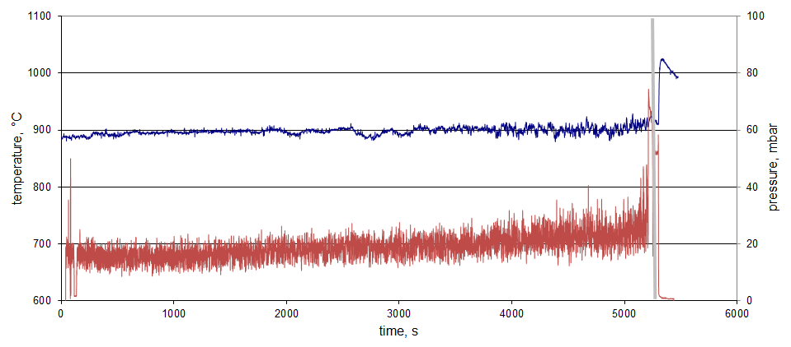

Figure 3: Temperature and pressure profiles during an agglomeration test. The vertical line at t=5230 s marks the onset of agglomeration

The photograph of sand agglomerates (quartzite) extracted from the reactor are displayed in Figure 4. Besides the presence of small and fragile agglomerates formed by a limited number of sand particles (Figure 4-A), big agglomerates with size comparable to the fluidization column diameter were also found (Figure 4-B) under certain conditions, when the experiment was not promptly stopped and the build-up of large and compact agglomerates was favored by the anomalous bed function. Figure 4-C shows the fuel to bed-inventory ratio , or equivalently test duration, needed for achieving agglomeration with quartz sand. The effect of the bed temperature and of the olive husk content in fuel pellets (Y) is well evident: the higher T or Y, the lower is the fuel to bed-inventory ratio needed for agglomeration. In particular, comparing the first and third bars, the increase of 50 °C only in T had a dramatic effect, speeding up the agglomeration phenomena at 900 °C that occurred at fuel/bed ratio 0.3 times lower with respect to 850 °C. Looking at the effect of the fuel blend, the presence of BC is beneficial in order to delay the occurrence of agglomeration, although no synergistic effects ascribed to the coal ashes can be evidenced and quite linear behavior appears.

FB tests confirmed that quartz sand is very prone to give rise to agglomeration, the tests carried out at both temperature of 850 and 900 °C always being terminated with defluidization in rather short time (around 1 h). In contrast, the olivine sand exhibited a good resistance to agglomeration, no phenomena being noted even at 900°C for a long test with a total duration in the excess of 10 h. This is an obvious consequence of the different silicon content in the bed materials, as reported in experimental description.

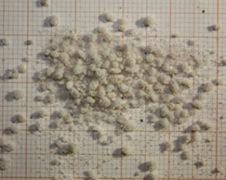 A 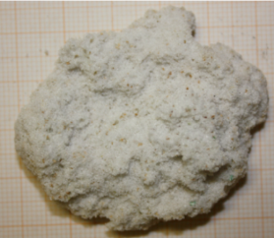 BC

*Figure 4: Photographs of small (A) and big (B) agglomerates retrieved in fluidized bed. Fuel to bed-inventory ratio at agglomeration as function of olive husk content in the fuel pellets (C)*

* + 1. Tests in alumina crucible

The tests carried out in the alumina crucible are summarized in Table 2. It appears that the quartz sand gave rise to agglomeration at 900 °C (test Q-2) for equal amounts of fuel and sample (2.0/2.0), but no agglomeration was observed at T=800 °C (test Q-1) even with higher fuel to sample ratio (4.0/2.0). Chromite and olivine were both resistant to agglomeration (tests CH-1 and OL-1) under same severe conditions of test Q-2. The addition of either kaolin or metakaolin prevented agglomeration (tests Q-3 and Q-4). It is worth noting that at the operating conditions of the tests the kaolin should be fully converted to metakaolin, losing the hydroxide groups (Sperinck et al., 2000). The tests Q-5 to Q-8 were executed at decreasing addition of kaolin until agglomeration was achieved. This event occurred when 22 mg of additive was used (Q-8).

Table 2: Tests carried out in alumina crucible with different bed materials and olive husk

|  |  |  |  |  |  |  |  |
| --- | --- | --- | --- | --- | --- | --- | --- |
|  | bed material | temperature  °C | mass  g | additive | mass  mg | olive husk  g | agglomeration |
| Q-1 | quartz sand | 800 | 2.0 |  |  | 4.0 | NO |
| Q-2 | quartz sand | 900 | 2.0 |  |  | 2.0 | YES |
| Q-3 | quartz sand | 900 | 2.0 | kaolin | 200 | 2.0 | NO |
| Q-4 | quartz sand | 900 | 2.0 | metakaolin | 200 | 2.0 | NO |
| Q-5 | quartz sand | 900 | 2.0 | kaolin | 100 | 2.0 | NO |
| Q-6 | quartz sand | 900 | 2.0 | kaolin | 50 | 2.0 | NO |
| Q-7 | quartz sand | 900 | 2.0 | kaolin | 28 | 2.0 | NO |
| Q-8 | quartz sand | 900 | 2.0 | kaolin | 22 | 2.0 | YES |
| CH-1 | chromite sand | 900 | 2.0 |  |  | 2.0 | NO |
| OL-1 | olivine sand | 900 | 2.0 |  |  | 2.0 | NO |

The mechanism of alkali neutralization by metakaolin (Al2O32SiO2) can be ascribed to the formation of K2OAl2O32SiO2 compound (Brown, 1995). Since the OH sample (2.0 g) contains around 19 mg of K, or equivalently 0.24 mmol of K2O, the stoichiometric amount of metakaolin turns out to be 53 mg, that is double than the threshold value between tests Q-7 and Q-8. However, it is likely that certain amount of potassium escaped the reactor during fuel volatiles release, as consequence of the fast heating of the sample, lowering the amount to be fixed by metakaolin.

* + 1. Sample characterization by SEM and XRD

Figure 5 reports the morphology of samples obtained from Q-2, Q-3, and Q-4 tests, where the effect of the additive in preventing the agglomeration of quartz sand is clearly visible. Such effect could be evidenced for both kaolin and metakaolin powders, the latter being more effective in alkali neutralization through the formation of mixed alkali-aluminosilicates, as could be noticed from the slightly higher increment in K+ concentration in the residual powder after the test (Figure 6).

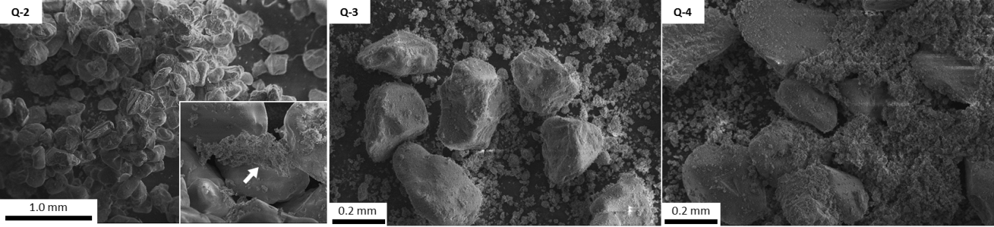

*Figure 5: SEM images of quartzite-based samples Q-2, Q-3, Q-4 (from left to right)*

The greater effectiveness of metakaolin might be due to its higher reactivity in terms of amorphous content and smaller particle size. As can be noticed, Q-2 sample was characterized by large irregular clusters of bed materials, with quartz grain stuck together through the formation of K-enriched necks between the particles (Figure 5). The use of aluminosilicate additives resulted in an enrichment of K species in the amorphous kaolinite/metakaolinite powders, leaving the quartz grains clearly loose, without any neck formation among the particles. The elemental map distribution for Si, K and Al of the three samples (Figure 6) confirms how the addition of the amorphous aluminosilicate powders triggers a preferential reaction between the alkali, originating from the biomass at high temperature, and the kaolin/metakaolin. However, the formation of compounds with K2O: Al2O3: SiO2 ratios equal to 1: 1: 2 could not be verified; indeed, different reaction products consisting of Si-, Al-, and K-oxides in varying ratios have been identified on the resulting kaolinite and metakaolinite powders, both clearly showing the inclusion of K-species.

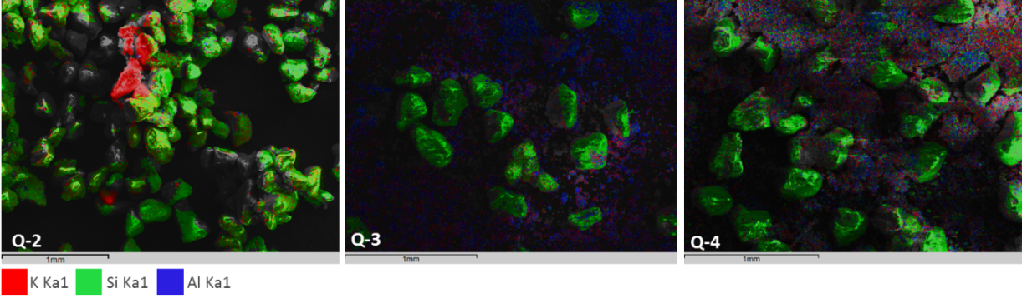

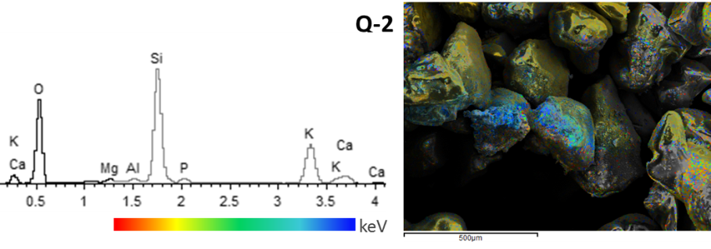

*Figure 6: Si, Al, K elemental distribution in samples Q-2, Q-3, Q-4 (upper panel) and detail of K concentration on agglomerated grains in Q-2 sample*

The average relative amounts of Si, K and Al in Q-3 and Q-4 samples likely suggest the formation of aluminosilicate phases with K2O: Al2O3: SiO2 ratios between about 0.1: 1: 2 and 0.4: 1: 2 for kaolin and metakaolin powders, respectively. Conversely, as expected, samples CH-1 and OL-1 did not show any agglomeration effect, having olivine and chromite materials a considerably lower amount of silica.

In accordance with Ohman and Nordin (2000), no newly formed crystalline phases could be found from XRD analysis of Q-3 and Q-4 samples, suggesting that the process temperatures were not high enough to promote the crystallization of the alkali alumino-silicate formed species. Indeed, no other phases than silica from the bed material could be spotted out (data not shown).

* 1. Conclusions

The bed agglomeration has been systematically experienced with a quartzite bed at temperature in excess of 800 °C, when a alkali rich fuel (olive husk) was gasified in fluidized bed. Different bed materials, i.e. olivine and chromite, prove to be resistant to agglomeration but have larger density than silica sand with negative impact on bed fluid-dynamics. Using a coal/biomass blend was also beneficial to delay agglomeration.

In alternative the addition of metakaolin can be very effective in order to prevent the occurrence of bed agglomeration. The metakaolin is highly reactive thanks to the amorphous content and small particle size. SEM images showed the presence of large irregular clusters of bed materials, with quartz grain stuck together through the formation of K-enriched necks between the particles. The use of aluminosilicate additives resulted in an enrichment of K species in the amorphous kaolinite/metakaolinite powders, leaving the quartz grains clearly loose, without any neck formation among the particles

The studied measures to prevent bed agglomeration, i.e. adoption of low silica materials or kaolin addition, would have limited economic impact at full-scale, being based on easily available natural materials. To this aim, the scale-up implementation will be argument of future research, also considering the impact on fluid-dynamics.

Acknowledgments

Mr. E. Marinò is gratefully acknowledged for the setup of the FB facility and the production of fuel pellets.

Reference

Brown J.J., The use of phase diagrams to predict alkali oxide corrosion of ceramics, in Phase Diagrams in Advanced Ceramics, Alper A.M. (Ed.), Academic Press, 1995, Pages 43-cp1.

Chirone R., Miccio F., Scala F., 2006, Mechanism and prediction of bed agglomeration during fluidized bed combustion of a biomass fuel: effect of the reactor scale, Chemical Engineering Journal 123, 71-80.

Ergudenler A., Ghaly A.E., 1993, Agglomeration of alumina sand in a fluidized bed straw gasifier at elevated temperatures, Bioresource Technology 43, 259-268.

Fryda L.E., Panopoulos K.D., Kakaras E., 2008, Agglomeration in fluidised bed gasification of biomass, Powder Technology 181, 307-320.

Mettanant V., Basu P., Butler J., 2009, Agglomeration of biomass fired fluidized bed gasifier and combustor, Canadian Journal of Chemical Engineering 87, 656-684.

Miccio F., Ruoppolo G., Russo S., Urciuolo M., De Riccardis A., 2014, Fluidized bed combustion of wet biomass fuel (olive husks), Chem. Eng. Trans. 37, 1-6.

Miccio F., Solimene R., Urciuolo M., Brachi P., Miccio M., 2016, Fluidized bed combustion of a lignin-based slurry, Chem. Eng. Trans. 50, 271-276.

Öhman M., Nordin A., 2000, The role of kaolin in prevention of bed agglomeration during fluidized bed combustion of biomass fuels, Energy & Fuels 14, 618-624.

Sperinck S., Raiteri P., Marks N., Wright K., 2011, Dehydroxylation of kaolinite to metakaolin—a molecular dynamics study, Journal of Materials Chemistry 21, 2118-2125.

Surjosatyo A., Muammara, Dafiqurrohmana H., 2017, Prevention study of sand agglomeration on fluidised bed combustor with co-combustion method, Chem. Eng. Trans. 56, 1273-1278.

Svoboda K., Čermák J., Hartman M., Pohořelý M., 2000, Possible ways of suppression of agglomeration of particles in fluidized bed combustion of selected waste biomass, Energy Forum 2000, Program, p. 115, September 17-19, Varna, Bulgaria.

Werther J., Saenger M., Hartge E.-U., Ogada T., Siagi Z., 2000, Combustion of agricultural residues, Progress in Energy and Combustion Science 26, 1-27.