CHEMICAL ENGINEERING TRANSACTIONS  VOL. 76, 2019 | A publication of
The Italian Association
of Chemical Engineering
Online at www.cetjournal.it
Guest Editors: Sauro Pierucci, Jiří Jaromír Klemeš, Laura Piazza
Copyright © 2019, AIDIC Servizi S.r.l.
ISBN 978-88-95608-73-0; ISSN 2283-9216

Experimental and Simulated Operation of Absorption Column for the Removal of VOC from Air
C. Pirola
ª Università di Milano, Dipartimento di Chimica, Via Golgi, 13 – 20133 Milano, Italy
carlo.pirola@unimi.it
Separation processes represent one of the most important operation in chemical industry. The most used techniques are distillation and absorption. The Industrial Chemistry Bachelor’s Degree program at the University of Milano, Chemistry Department, includes a third-year course titled “Industrial Plants with Laboratory”. This laboratory (six university credits course) is devoted to separation processes with an average annual attendance of about 80 people. An experience concerning the use of an absorption column is proposed to the students. A 1 m height column with an internal diameter of 0.044 m, filled with Sulzer-type structural bodies is used for data collection in steady state conditions. Water purifies a mixture of a VOC (acetone) and air in counter current. With the collected data, students check the material balance on the column and, knowing the height of the column, determine the global diffusion coefficients. Moreover, the software PRO II 9.3 by AVEVA is used for the simulation of the plant. The comparison between experimental and simulated data is a key aspect of the laboratory and guarantees a cross-check of both activities. Students evaluation of the course is strongly positive.
  - Introduction
Separation and purification processes are largely present in chemical plants, both for raw materials and final products separation and purification. Learning the basic knowledge of these largely diffuse and complex technologies is a basic prerequisite for all the Chemical Engineering and Industrial Chemistry courses. Students characteristics are strongly not homogeneous, in fact modern theories on education suggest some are more confident with theoretical lessons and others with practical experiences (Felder and Brent, 2005). Consequently, it is important to propose courses in which both abstract and concrete concepts are presented and explained. As example, in Brazil a Chemical Engineering undergraduate course was provided, in which a strong integration with pulp industry was proposed to give to the students the possibility to apply the theoretical concepts concerning distillation and absorption in a real industrial case-study (Fregolente et al, 2018). Alternatively, it is possible to propose courses in which experimental activities are proposed together to theoretical lessons, always for topic related to diffusional transfer unit operations. For example, Narang et al. (Narang et al., 2012) described a laboratory experience for the analysis and optimization of a distillation column. In this work, the students were engaged in using a distillation column to optimize its performance, changing variables such as the feed flow rate, the reflux ratio and the steam flow to the reboiler. Clearly, all these possibilities required the basic theoretical knowledge explained in the theoretical lessons. Another important possibility to increase students' learning and interest is also to introduce process simulation software. The use of simulation is largely diffused in modern chemical engineering companies for optimization, scale up and control. Simulation studies can be developed in static and dynamic conditions. Static simulation corresponds to the plant in steady-state conditions and it is useful for the design and optimization of the plant, while dynamic simulation is required for the start up and showdown operations, for the plant control strategies and for operator training by plant virtualization (Yang et al., 2001). Dynamic simulation, in which the time dependency is introduced, is more complex respect static simulation. For this reason the suggested approach for the Bachelor students is static simulation. The use of static simulation software in the Chemical Engineering undergraduate course was positively introduced for example in the School of Chemical Science, Department of Chemical Engineering, in Madrid (Spain) (Calvo and Prieto, 2016) within a fourth year course of the Chemical Engineers degree, for the production of MTBE by reactive distillation.
Summarizing, by mixing theoretical lessons, experimental activities and simulation software applications, it is possible to establish with students a creative environment that allows integration and synergy of different education approaches, together with the positive effects of a team work among students (Fregolente, 2018).
It is also important to make a suitable selection of laboratory equipment proposed in chemistry education. This selection can be based on the following most important factors, namely: safety, the effectiveness of learning process, ease of use, the accuracy level of equipment, and cost (Irwansyah et al., 2018).
The Industrial Chemistry bachelor Degree program at the University of Milano, Chemistry Department, includes a third-year course titled “Industrial Plants with Laboratory”. This laboratory (six University Credits, UC) is devoted to separation processes with 16 hours of theoretical lessons and 80 hours of experimental work. It consists of two main parts, the first dedicated to the rectification columns and the second to the absorption columns. This paper will describe the laboratory experience devoted to absorption column, 1 m height with an internal diameter of 0.044 m, filled with Sulzer-type structural bodies "Laboratory Pack" (diameter equal to the internal diameter of the column and specific surface a = 900 m²/m³). A mixture of a VOC (acetone) and air is obtained by evaporation from the acetone tank and fed in the bottom of the plant. Pure water is fed from the head of the column. Students during the experience measure the flowrate of all the streams using different instruments (rotameters, mass flow, magnetic inductive flow meter etc.), the temperature, the pressure and the pressure drop of the column and determine the concentration of acetone in air and water by gas-cromatograph and UV-vis analysis. With the collected data, they can check the material balance on the column and, knowing the height of the column, determine the global diffusion coefficients. Moreover, the software PRO II 9.3 by AVEVA is used by the students for the simulation of the plant. The comparison between experimental and simulated data is a key aspect of the laboratory and guarantees a cross-check of the two activities. In fact, the analysis and optimization of these processes involve material and energy balances together with phase equilibrium relationship and can be satisfactory only if the experimental data are consistent and the thermodynamic relationship inserted in the software suitable for a meaningful representation of the system.
Finally, the opinions of the students at the end of the course will presented and discussed.
  - Methodology
In this paragraph the structure and the theoretical program of the course, the experimental set up, the laboratory activities and the simulation procedures will be described.
    - Format course structure
The course “Industrial Plant with Laboratory” is a mandatory twelve-credit course for the third year students of the Bachelor Degree of Industrial Chemistry. The average number of students per year is about 80 people. The course is divided in two sub-courses of six credits: the theory part (6 UC for 48 h) and the laboratory part, 6 UC with 16 hours of theoretical lessons and 80 hours of experimental work. This paper is entirely devoted to the laboratory part, devoted to separation processes. In the theoretical lessons of the laboratory (16 h) the topics are the theoretical introduction of the laboratory experiences, the explanation of the experimental plants, the explanation for the elaboration of experimental data, a tutorial for the general use of the simulation software PRO II and for its use for the simulation of the laboratory experiences. The laboratory work is formed by four stations: 1) determination of vapor pressure of two different liquid at different temperatures; 2) determination of the vapor liquid equilibria (T, x, y) for a binary mixture at different pressure; 3) the conduction of a multistage continuous distillation column; 4) the conduction of an absorption column, that is the topic of the present paper.
Each student works in group of 3/4 peoples and the lab attendance is mandatory. The student learning is evaluated through the final reports in which the description of experimental plant, the collected data, the elaboration by classical equations and by simulation are requested and a final oral examination. The reports are prepared by the students of each group in team, while the oral examination is made individually. The students, before this course, have attended the preparatory courses of physical-chemistry and transport phenomena.
    - Absorption column experimental setup
The molar fractions concerning the gas phase are presented with the letter y while the one of the liquid phase with the letter x. The same molar fractions but referred to the inert flow, i.e. moles of acetone/moles of air and moles of acetone/moles of water are indicated as Y and X, respectively. If the compositions are referred to the bottom of the column, the subscript 1 is used while for the top of the column the subscript 2 is used. The bench scale plant used for the experimental determinations is schematically represented in Figure 1.

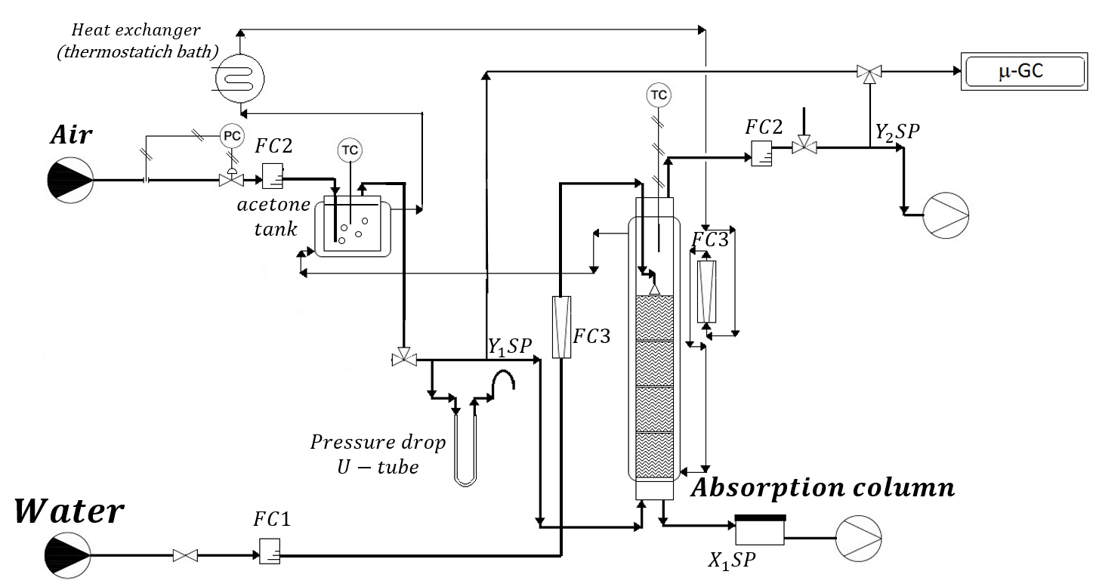
Fig. 1: Simplified set-up of the experimental absorption column: FC1: magnetic induction flowmeter; FC2: thermal mass flow; FC3: rotameter; SP: Sampling Point.
A 43 mm internal diameter jacketed cylindrical glass column was used. The column was filled with Sulzer DX structured packing for a height of 700 mm, (diameter equal to the internal diameter of the column and specific surface a = 900 m²/m³). One mass flowmeter, FC2, is used to control and measure the flowrate of air. A mixture of a VOC (acetone) and air is obtained by evaporation from the acetone tank and fed in the bottom of the plant. The measurement of the compositions was performed by sending either the inlet or the outlet gas to the micro-GC by automatic sampling. The gas was pumped in the sampling loop of the micro-GC for 2 minutes, to stabilize the gas composition.
A manometer filled with silicone oil, with an end connected to the tube in which the gas flows and the other end open is used for the measurement of the pressure drop, using the equivalence 1.33 mbar = 13 mm oil. The use of silicone oil allows to measure very low pressure drop in the column. As displayed from Figure 1 the column and the acetone tank are jacketed to maintain a constant temperature, lower respect the external room temperature, to avoid condensation phenomena in the whole plant.
Municipal water, coming from the city network, is pre-treated in a softener to remove the calcium. Subsequently it is sent to a valve and a magnetic induction flowmeter, FC1, to carefully set and measure the flow of liquid entering the column.
Once the column temperature is reached, the air and water flowrates were regulated and the acetone composition in the inlet of the column (Y₁) was measured until a constant value is determined, in steady-state condition. Each group of students works with a specific set of operative parameters, i.e. fixed temperature, air flowrate and water flowrate. Students must check steady-state condition, by verifying the stability of all the operative parameters and the composition of gas exiting from the column. Then, they must measure and register all the instrumental temperatures, flows, pressure drop and the concentrations of acetone in all the entering and exiting streams of the column.
    - Simulation
The solubility of a gas in a liquid can be expressed by the Henry law, in which the molar fraction of the gas in the liquid (x) is proportional to its partial pressure (P) by means of the Henry coefficients, dependent on temperature. For the simulation the database Henry coefficient for the system air-acetone-water was used. Gas –phase was considered as ideal and the pure compounds as perfect gas. Differently, liquid phase was considered as non ideal and the activities coefficients were calculated by NRTL model.
The experimental runs were simulated using PRO/II software version 9.1 by AVEVA, using the SURE VLE algorithm. The HEPT (Height Equivalent Theoretical Plates) for the DX Sultzer bodies at the operating coniditons used is about 40 mm, in the simulation a 10 theoretical trays column was simulated.
  - Experimental results and interpretation by classical equations
As example, the experimental data obtained by a team of students in the course of the last year (spring 2018) are reported in Table 1.

Table 1: Experimental data collected in laboratory experience
Water flow  L_{S}  $$\left(\frac{kmol}{h m^{2}}\right)$$ | Air flow  G_{S}  $$\left(\frac{kmol}{h m^{2}}\right)$$ | $$Y_{1}$$  $$\left(\frac{kmol acetone}{kmol air}\right)$$ | $$Y_{2}$$  $$\left(\frac{kmol acetone}{kmol air}\right)$$ | $$X_{1}$$  $$\left(\frac{kmol acetone}{kmol water}\right)$$ | $$X_{2}$$  $$\left(\frac{kmol acetone}{kmol water}\right)$$ | T  (°C) | P  (Pa)
37.43 | 2.66 | 0.1964 | 0.0036 | 0.0144 | 0 | 16.8 | 1.007x10⁵

Air and water flowrates can be considered as constant in the column. The flowrates of air and water were collected by instruments (mass flow for air and magnetic flowmeter for water) in l/h. These values can be easily transformed in kmol/h and then referred to the internal diameter of the column, obtaining the values reported in Table 1. The column temperature was determined by a thermocouple inserted in the middle of the column, while the pressure is an average value between the head of the column, at atmospheric pressure, and the bottom. The pressure in the bottom is calculated by adding the pressure drop, experimentally measured to the value of the top of the column. Acetone is highly soluble in water, and consequently its removal from air using the absorption tower is quite fully (98.2 % of acetone removed comparing the entering and exiting concentration in air, at the reported experimental conditions). The choice of acetone, as VOC model, can be explained considering the efficiency of the process and its low cost and toxicity.
The total molar balance on the column, referred to acetone, can be verified by Equation (1):
$$L_{S}X_{1}+G_{S}Y_{2}=L_{S}X_{2}+G_{S}Y_{1} (1)$$
This balance is verified if the parameter R, calculated by Equation (2), is equal to one.
$$R=\frac{L_{S}\left(X_{1}-X_{2}\right)}{G_{S}\left(Y_{1}-Y_{2}\right)} (2)$$
As example, using the data reported in Table 1, R=1.051. After the mass balance check, the students can calculate the global mass transfer coefficients for the gas phase (K_{G}) and liquid phase (K_{L}), multiplied for the specific interface surface, a, using equations (3) and (4) respectively (Treybal, 1981).
$$K_{G}∙a=\left[\frac{G_{S}}{Z∙\overline{P}}\right]∙\int_{y_{2}}^{y_{1}}{\frac{1}{\left[\left(y-y^{*}\right)∙{\left(1-y\right)}^{2}\right]}}dy (3)$$
$$K_{L}∙a=\left[\frac{G_{S}}{Z∙\overline{C}}\right]∙\int_{x_{2}=0}^{x_{1}}{\frac{1}{\left[\left(x^{*}-x\right)∙{\left(1-x\right)}^{2}\right]}dx} (4)$$
where Z is the height of the Sulzer package inside the column, x and y are the molar fractions of acetone in water and air, $\overline{P}$ is the average pressure in the column, $\overline{C}$ is the average molar concentration of the liquid expressed as (kmoles of water and acetone)/(m³ of water and acetone) and $x^{*}$ and $y^{*}$ are the equilibrium concentrations. These equilibrium concentrations can be calculated using the Henry Law x* = y/m (or y* = mx). The Henry coefficient m can be calculated by considering the water-acetone mixture as non ideal, by the equation (5):
$$m=\frac{y}{x}=\frac{γ\left(x,T\right)p^{0}(T)}{\overline{P}} (5)$$
where $p^{0}(T)$ is the vapor pressure of acetone at the temperature column, that can be calculated using the following Antoine equation:
$$Log\left(p°\right)=7.23967 – \left(\frac{1279.870}{T\left(°C\right)+237.500}\right) (6)$$
The activity coefficients for the water (1)-acetone (2) mixture can be calculated using, for example, the NRTL equation:
$$lnγ_{1}=x_{2}^{2}\left(τ_{21}\frac{exp\left(-2α_{12}τ_{21}\right)}{{\left[x_{1}+x_{2}exp\left(-α_{12}τ_{21}\right)\right]}^{2}}+τ_{12}\frac{exp\left(-α_{12}τ_{12}\right)}{{\left[x_{2}+x_{1}exp\left(-α_{12}τ_{12}\right)\right]}^{2}}\right) (7)$$
where $τ_{21}=\frac{C_{12}}{RT};τ_{21}=\frac{C_{21}}{RT}$ and $C_{12}=C_{12}^{C}+C_{12}^{T}\left(T-273.15\right);C_{21}=C_{21}^{C}+C_{21}^{T}\left(T-273.15\right); α_{12}=α_{21}=α_{12}^{C}+α_{12}^{T}\left(T-273.15\right)$. The numerical values for the system water-acetone are $C_{12}^{C}=564; C_{21}^{C}=475;C_{12}^{T}=-11.71; C_{21}^{T}=19.27;α_{12}^{C}=0.1676;α_{12}^{T}=-0.000409$ (Renon, 1971). The solution of Equations (3) and (4) require a numerical integration. Different software (for example Matlab, Microsoft Excel) or methods (for example the easy method of trapezoids) can be suggested to the students. The integration must be performed between the concentrations entering and exiting from the columns. It is possible to consider the concentration range $x_{1}-x_{2}$ or $y_{1}-y_{2}$ and to divide it in 100 step for numerical integration. It is important to emphasize to students the importance of the good use of units of measure in these calculations. $K_{G}a$ can be expressed in $\frac{kmoli}{h∙atm∙m^{3}}$ and $K_{L}∙a$ in $\frac{1}{h}$. As example, using the experimental data reported in Table 1, we obtain $K_{G}a$=270 $\frac{kmoli}{h∙atm∙m^{3}}$ and $K_{L}a=6.5\frac{1}{h}$, if we consider as actual height of the tower the one in which the great part (>95%) of absorption occurs, i.e. the initial 5 cm from the bottom. These values are similar to the corresponding ones reported in (Yu, Shao, 2002) and (Biard, 2018). We determined the height of the Sulzer bodies in which 95% of absorption occurs (5 cm) by the results of computer simulation described in the following paragraph.
  - Simulation
The simulation of the absorption plant can be performed using a flash and an absorption column. The flash unit is useful for the simulation of the enrichment of the initial air stream with acetone by evaporation from the acetone tank. Clearly, in this way an equilibrium condition is simulated. The experimental values are very near to this hypothesis. The thermodynamic approach previously discussed is inserted in the simulation file. The scheme of the plant, as inserted in the software is reported in figure 2.
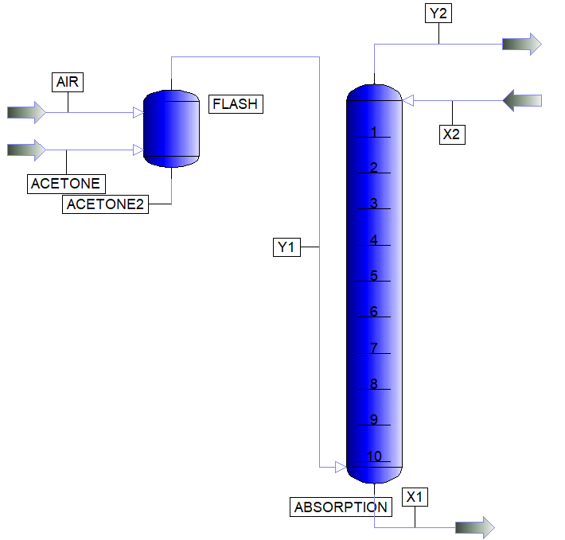
Fig. 2: simulation flow-sheet of the experimental plant.

The calculated values for all the streams give an average error lower than 2% respect the experimental ones.
  - Student evaluation and learning
Figure 3 presents the results of the survey, made at end of the course in 2018, taken from the official data of Università degli Studi di Milano. The questions are: 1) were the preliminary learnings sufficient for understanding the topics set out in the examination syllabus?; 2) did the course reflect the learning objectives set out in the Degree Programme?; 3) was the course load proportionate to the credits assigned, also in relation to the examination syllabus?; 4) do you believe the amount of lesson time scheduled was proportionate to the topics
covered in the examination syllabus?; 5) were any additional learning activities integrated into the teacher's lessons (exercises, seminars, laboratories, etc...) useful for learning the subject matter?; 6) were you satisfied, on the whole, with this course?; 7) are you interested in the topics dealt with during the course?. The general strongly positive of the students is clear, both for the topics covered in the course and for the educational approach. All the students (100%) are satisfied with the course. The great part of negative answer is connected with the preliminary learnings, the course load and the amount of lesson time, but they are given by a very small part of the students.
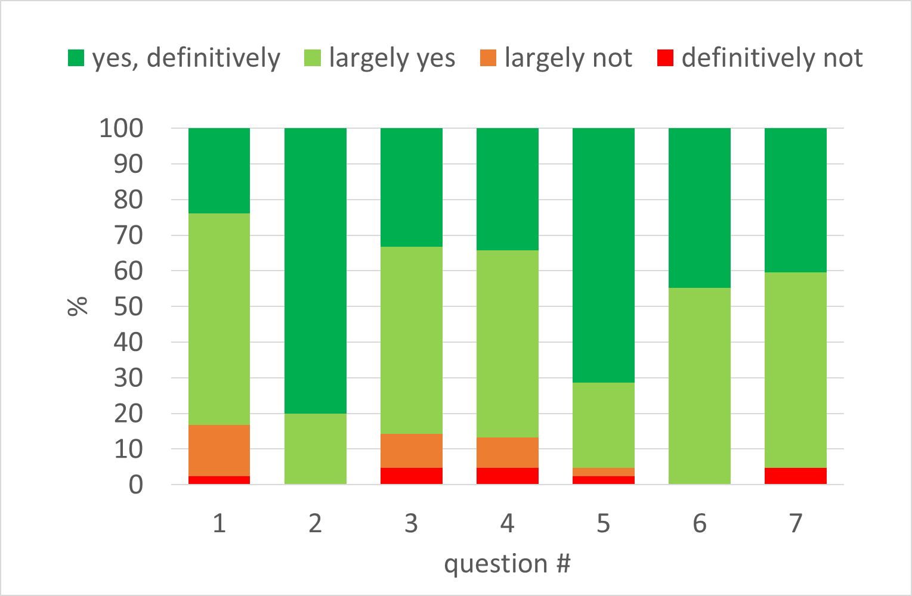
Fig. 3: Statistical analysis to the 2018 questionnaire for students in industrial chemistry.
  - Conclusions
An experimental absorption column, 1 m height filled with Sulzer DX structured packing, was proposed and described for educational activity. Data collected during the laboratory exercise were reported, as example, and analysed to verify the mass balance on the column. Moreover, the global mass transfer coefficients for the system air-water-acetone were determined. A simulation study was proposed obtaining results according with the experimental ones. The final evaluation of the students after the 2018 course was strongly positive.
Acknowledgments
The author thank the “Dipartimento di Chimica” at “Università degli Studi di Milano”, prof. Silvia Ardizzone in particular, for the support and the funding of the activities. Dr. Federico Galli is friendly thanked for helpful discussions, SimSci byAVEVA for the academic license concession of the software PRO/II and Dr. Cristina Peretti for the technical support in the simulations. Prof. Vittorio Ragaini is warmly thanked for the foundation of the Laboratory of Chemical Plant.
References
Biard P. F., Couvert A., Giraudet S., 2018, Volatile organic compounds absorption in packed column: theoretical assessment of water, DEHA and PDMS 5’ as absorbents, Journal of Industrial and Engineering Chemistry, 50, 70-78.
Calvo L., Prieto C., 2016, The Teaching of Enhanced Distillation Processes using a Commercial Simulator and a Project-based Learning Approach, Education for Chemical Engineers, 17, 65-74.
Chen Y. S., Liu H. S., 2002, Absorption of VOCs in a Rotating Pached Bed, Industrial Engineering Chemistry Research, 41, 1583-1588.
Felder R. M., Brent R., 2005, Understanding Students Differences, Journal of Engineering Education, 94, 57-72.
Fregolente L. V., Venturelli H. C. de A., Rodrigues J., da Silva E. M., Diniz I. S., Maciel M. R. W., 2018, Project-Based Learning Applied to Distillation and Absorption Education: Integration Between Industry and a Chemical Engineering Undergraduate Course, Chemical Engineering Transactions, 69, 427-432.
Irwansyah F. S., Slamet C., Ramdhani M. A., 2018, The Analysis of Determinant Factor in Selecting Laboratory Equipment in Chemistry Education Experiment, Chemical Engineering Transactions, 63, 793-798.
Narang A., Ben-Zvi A., Afacan A., Sharp D., Shah S. L., Huang B., 2012, Undergraduate design of experiment laboratory on analysis and optimization of distillation column, Education for Chemical Engineers, 7, e187-e195.
Pirola C., Galli F., Bianchi C. L., Manenti f., 2015, Biogas to Biomethane Upgrading by Water Absorption Column at Low Pressure and Temperature, Technology, 03, 1-5.
Pirola C., Galli F., Manenti F., Bianchi C. L., 2015, Biogas Upgrading by Physical Water Washing in a Micro-Pilot Absorption Column Conducted at Low Temperature and Pressure, Chemical Engineering Transactions, 43, 1207-1212.
Renon H. (Ed.), 1971), Calcul sur Ordinateur des Equilibres Liquido-Vapeur et Liquide-Liquide, Technip, Paris.
Treybal R. E. (Ed.), 1981, Mass-Transfer Operations, McGraw-Hill, Singapore.
Yang S. H., Yang L., He C. H., 2001, Improve Safety of Industrial Process using Dynamic Operator Training Simulators, Trans IChemE, 79 (B), 329-338.

