Pollutants removal from municipal sewage by means of microalgae
Serena Limaª, Valeria Villanovaª, Monica Richiusaª, Franco Grisafiª, Francesca Scargialiª, Alberto Brucatoª
ªUniversità degli Studi di Palermo, Dipartimento di Ingegneria DII, Viale delle Scienze Ed. 6, Palermo, Italy.
serena.lima@unipa.it

Microalgae are microorganisms able to photosynthesize, namely transforming inorganic substrates and sun light into organic compounds and chemical energy. The industry of microalgae has expanded in the last decades and several applications are now developed, making their biomass interesting under an economic perspective. Nannochlopsis gaditana is one of the most interesting species already employed in industry because of its high content in lipids that could be employed as source for biodiesel synthesis but also in other fields such as cosmetic and pharmaceutic. One of the most promising application is the exploitation of microalgal grow for bioremediating wastewaters polluted with inorganic nutrients such as nitrates and phosphates that microalgae are able to employ as nutrients. Bio-treatment of wastewaters by using microalgae has the advantage to reclassify the water and preserve it from wasting while producing a valuable biomass. In this work, a microalgal strain, Nannochloropsis gaditana, was employed for testing its performance in the bioremediation of municipal sewages. The wastewater was taken from a municipal plant, after the primary treatment, and the algae processing was aimed at replacing the secondary treatment. Algal growth in its growth medium and in the sewage was compared and algal biomass was characterized. Biochemical Oxygen Demand (BOD), Chemical Oxygen Demand (COD), total nitrogen and total phosphorous levels of the sewage before and after algae treatment were also determined in order to evaluate the efficiency of this microalgal strain on wastewater bioremediation. Our results showed that N. gaditana grows better in wastewater than in the control growth medium and it is able to efficiently remove nutrients from the sewage. However, COD and BOD values did not decrease after algal treatment. These results suggest that the use of selected bacteria and/or yeast strains (together with microalgae) could improve the efficiency of wastewater treatments decreasing BOD and COD values.
  - Introduction
Since ’80s worldwide there has been the problem of remediating wastewaters because of the increasing size of population and of the spreading of industries. There are, for these reasons, several methods and techniques already developed in order to remove nutrients from wastewaters (Tchobanoglous et al., 1978)
The overall goal of wastewater treatment is to remove the pollutants in order to be able to re-employ the treated water by integration into the environment. The wastewater treatment is divided in several level (i.e. primary, secondary, tertiary and quaternary), and involved the combination of physical, chemical, and biological processes. The primary treatment (i.e. the removal of organic and inorganic sediments) is usually, followed by the secondary treatment that involved the use of a consortia of microorganisms, naturally developed in the treatment plant, for the biological removal of organic matter. Microorganisms, in fact, are able to employ nutrients present into the sewage and use them as nutrition source. Heterotroph bacteria are able to process carbon compounds, but usually they are limited by the oxygen level inside the treatment tank; in fact these bacteria need oxygen to degrade nutrients.
By contrast, photosynthetic microalgae in presence of a light source are able to treat inorganic pollutants such as ammonia NH₄⁺, nitrates NO₃ and phosphates PO₄ and, in some cases, also organic pollutants producing molecular oxygen that can be used by heterotrophic bacteria, creating an example of symbiosis. The ability of microalgae bioremediating wastewater and their importance for helping the develop of a microalgae industry is assessed by Delrue et al. (2016). The use of microalgae in wastewater treatment has two main advantages: in one hand the removal of nutrients from sewage and in the other hand the production of a high value molecules contained in microalgal biomass. In fact, as well known, microalgae biomass has been of increasing economic interest in the last tens of years, because of its possible applications in nutraceutical, cosmetic, pharmaceutical fields but also in emerging field such as production of biodiesel and recombinant proteins. Microalgae can be cultivated in raceway ponds (Kumar et al., 2015) or in photobioreactors (Marotta et al., 2017) and wastewater treatment could be employed in both kinds of cultivation. Bioremediation of wastewater using microalgae has been largely addressed by recent research. The use of Chlorella vulgaris was tested on the treatment of both winery (Casazza et al., 2016) and municipal wastewater (Dvoretsky et al. (2018). Finally, Blanco-Suarez et al. (2016) tested the effect on treatment of immobilized cultures of the same microalgal strain.
The scientific interest of this topic underlines the potential that this application has in the development of efficient methods for valuating resources, in this case water and biomass. Beside its great relevance in literature, there is shortage of works in which municipal sewage is used as only medium for microalgal growth. One of the best examples is found in the work of Dong et al. (2014). Several works employ as growth medium an artificial sewage that in one hand guarantees the control of the composition of the growth medium, but on the other hand brings to conclusions hard to employ in real treatment plants (Feng et al., 2011).
This work tested a strain of algae rich of lipids for its ability in removing nutrients from municipal sewage that already was treated with primary treatment. The study is realized with real wastewater used as only medium for microalgal growth, coming from a municipal treatment plant, and the method adopted was aimed to imitate a real treatment plant because of no CO₂-supplemented air insufflation. This makes the results of this study reliable and transferable into real applications. Microalgal biomass was also characterized, in particular the lipid fraction, in order to evaluate the industrial potential of this species.
  - Materials and Methods
    - Microalgal growth and experimental set up
Nannochloropsis gaditana was grown in a modified version of Guillard’s medium (Guillard, 1975), supplied with 6 times the original nitrate and phosphate concentration and made in artificial sea water. The microalgae was kept in liquid medium as stock culture at r.t. and refreshed once a month. From the stock culture, a preculture was generated by inoculating 100 ml of fresh medium with 10 % of stock culture. The preculture was grown until late exponential phase (10 days) was reached and, then, used to inoculate both control medium and sewage. In order to acclimate the algae to the sewage it was inoculated from the preculture to a mixed medium made with 50 % of sewage and 50 % of medium; then it was inoculated to the first cultivation series, with the volume of 400 ml. The cells grown in the first cultivation series were inoculated into the second cultivation series, with the volume of 1 L. Cultivations in original medium, first cultivation series and second one were compared. The growth was daily monitored by counting manually at a light microscope in a Burker Chamber for 15 days. Values were taken in triplicate and an average is retained.
    - Preparing the samples
At the end of the cultivation, the cell suspensions were filtered (0.45 μm) and the filtrate was frozen at -20°C for further analysis. The filtered biomass was freeze-dried (FreeZone 2.5L, LABCONCO, US) and stored at r.t. for further analysis.
    - Sewage analysis
The sewage employed in this study was taken from the municipal treatment plant AMAP Acqua dei Corsari, located in Via Messina Marine, 592, 90121 Palermo PA. This batch was analysed for COD, BOD, total phosphorous and total nitrogen and then stored at -20°C until it was used to inoculate microalgae. The same analysis were repeated after the treatment with microalgae, following a microfiltration (0,45 μm). A batch of the sewage was treated in the same way (frozen and microfiltered) and used as a control. The COD analysis was done following the APAT/CNR Method, IRSA Manuals 117/2014 - Method 513; BOD5 followed OXITOP method, compliant to UNI EN ISO 1899-1:2001; total nitrogen was analysed according to disintegration ISO 11905-1; ISO 7890-1:1986 while total phosphorous with EPA method 365.2.

    - Total lipids extraction and fatty acids characterization
About 20 mg of lyophilized biomass were weighted and transferred in a mortar together with 5 ml of Chl/MeOH 2:1 and 1 ml of NaCl 1 %. The mixture was vigorously mixed and chloroform phase was transferred in a pre-weighted tube and evaporated in a nitrogen stream by heating below 50°C. By weighting the tubes after evaporation total lipid content was determined. The lipid mixture was then transesterificated by adding 1 ml of sodium metoxide (1 g NaOH in 100 ml MeOH) and 1 ml of hexane. The upper phase (hexane) was then transferred in GC vials and analyzed by gas chromatographic analysis. For the fatty acid analysis, a GC 7890B System (Sigma-Aldrich, US) was used supplied with a FID detector and a capillary column Omegawax 250 (Sigma- Aldrich, US). Initial temperature was 50 °C, increased to 220°C as working temperature. Total analytic time was 79.5 minutes and argon was used as transfer gas. Samples’ chromatograms were compared to the standard’s one. As standard, Supelco 37- Component FAME Mix (Sigma-Aldrich, US) was used.
  - Results and discussion
    - Growth curves
The growth curves of the algae grown in three different cultivations were obtained. The growth medium cultivation control (volume of 150 ml) is compared with the first (volume of 400 ml) and second (volume of 1 L) cultivation in the sewage. As shown in Figure 1, for the first ten days of cultivation, the cells grown faster in the first cultivation comparing with the other two conditions. However, in the control medium, the cells continued to grow also after day fifteen, when the cells in the others conditions reached the stationary phase. The different growth in the tested conditions can be explained on the differential nutrient concentration in the control medium and in the sewage. The sewage probably contains some nutrients (that are missed in the control medium) that stimulate the growth of N. gaditana in the first phase of cultivation. By contrast, the sewage could be limited by some others nutrients that are instead present in the control medium and are important in the second phase of cultivation. The difference between first and second cultivation, instead, can be explained because the inoculum for the second cultivation comes from the first cultivation, so it may be possible that some micronutrients are diluted and become limiting in this cultivation.
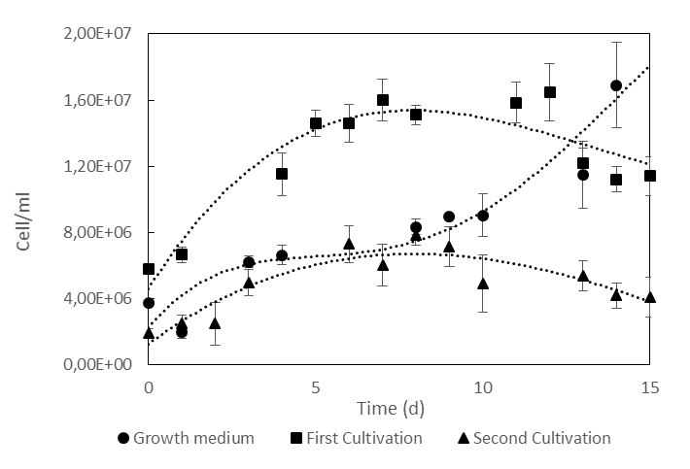

Figure 1: Growth curves of the microalgae N. gaditana. The cells were grown in Growth Medium (●) as a control and then in the sewage in two cultivation series, the first one ( ) and second cultivation series (▲).

    - Total Lipids content

The dry biomass of the microalgae grown in the growth medium and in the second cultivation in the sewage was analysed for the total lipids. The percentage of lipids is the same, so the treatment in the sewage did not significantly influence the lipids quantity, as shown in Figure 2.

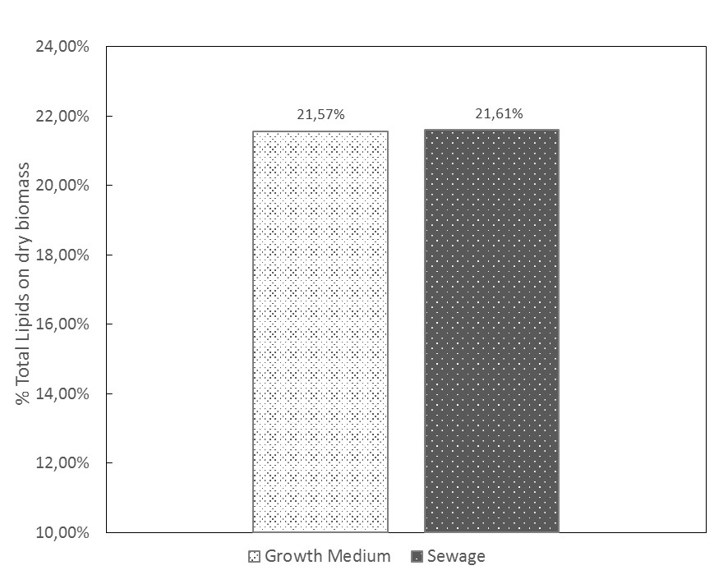

Figure 2: Total Lipid content in the microalgae N. gaditana grown in the control growth medium and in the sewage. The treatment did not influence the quantity of lipids.
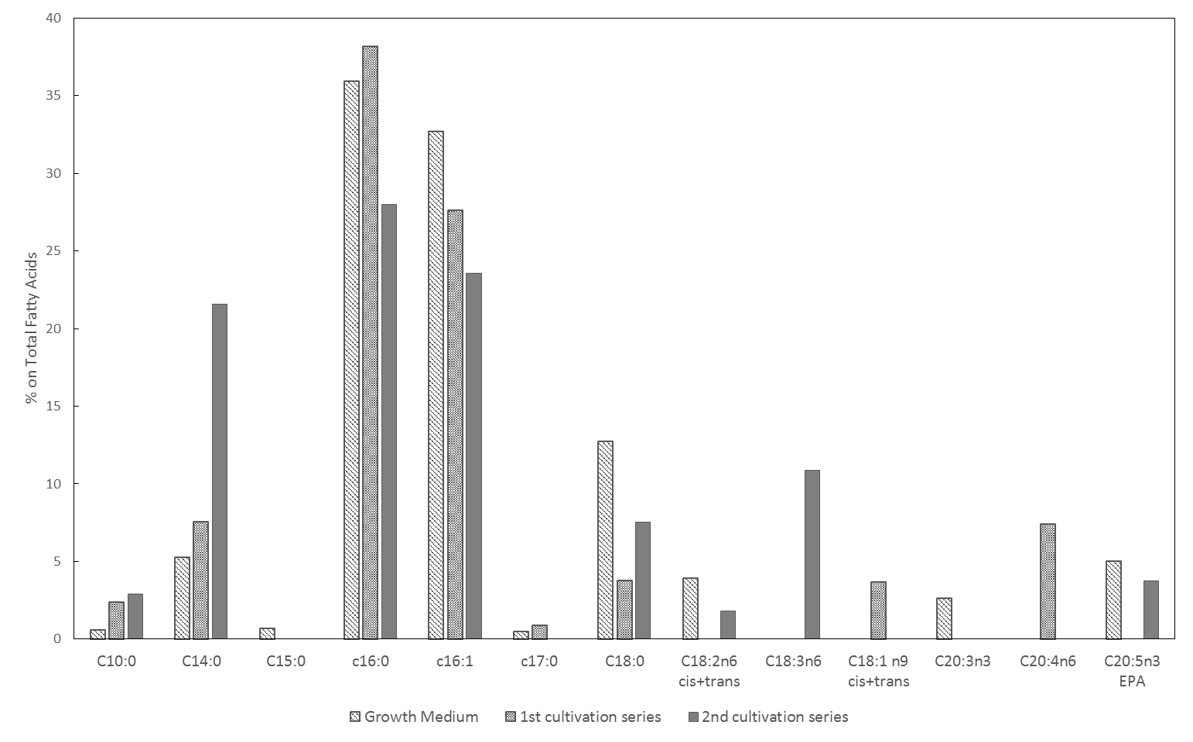
    - Fatty acids characterization
Figure 3: Characterization of fatty acids in the biomass of N. gaditana grown in three different cultures: Growth Medium ( ), first sewage cultivation series ( ), second sewage cultivation series ( ).

Figure 3 shows the percentage fatty acids composition in the biomass of the microalgae N. gaditana grown in the three conditions. Our results showed that the most abundant fatty acids in N. gaditana is C16:0 and C16:1 confirming previous findings (Ma et al., 2016). The tested conditions showed a difference on fatty acid composition. In particular, in the second cultivation there was a decrease of C16:0 and C16:1 in favour of both short chain (i.e. C10 and C14) and long chain fatty acid (i.e. C18:3n6). Another minor differences were detected in the first cultivation such as decrease of C18 and increase C18:1n9 C20:4 n6 comparing with the control. The change on fatty acid profile can be explained by the activation of different metabolic pathways under stress conditions (e.g. nutrient limitation) (Simionato et al. 2013). Interestingly, unsaturated fatty acids of the series C18:3 and C20:5n3 (Eicosapentaenoic acid, EPA) are present in moderate amounts, with an increased added-value of the obtained biomass because of the good economic value of these compounds as shown by Van der Voort et al. (2017).

    - Chemical Analysis
The treated sewage with microalgae was frozen and microfiltered and, then, analysed for the determination of COD, BOD, total nitrogen and total phosphorous. Procedures of freezing and microfiltering were repeated in untreated sewage in order to check if the process could influence the results. As shown in Figure 4 a), the treatment has no effect on the BOD (Biological Oxygen Demand) and a negative effect on the COD (Chemical Oxygen Demand). This may be explained because microalgae grown in autotrophic way do not participate to the decrease of the oxygen level needed to biologically degrade the organic compounds in the matrix but probably produce some compounds, such as cellulose or hemicellulose, that causes the increase of the chemical oxygen demand. COD level decreases from the first to the second cultivation because in the second one there is a minor cell concentration, as shown by growth curves in Figure 1. This result is in contrast with literature, according to which community of microalgae and other microorganisms (yeast and bacteria) can reduce COD and BOD up to 98 % and 87 % (Wang et al., 2010). This probably means that the selection of bacteria and yeasts present in the culture used in this study is not able to cooperate in order to decrease the COD and BOD levels. The treatment has though a positive effect on the removal of nutrients, both on nitrates and phosphates levels (Figure 4 a) and b) ). The level of nutrients was, in fact, almost totally shot down. N. gaditana is, therefore, a suitable microalgae for the removal of nutrients from sewage. This result is in accordance with other studies, such as the one of Lau et al. (2010), that showed how Chlorella vulgaris has a nutrient removal efficiency of 86 % for inorganic N and 78 % for inorganic P.
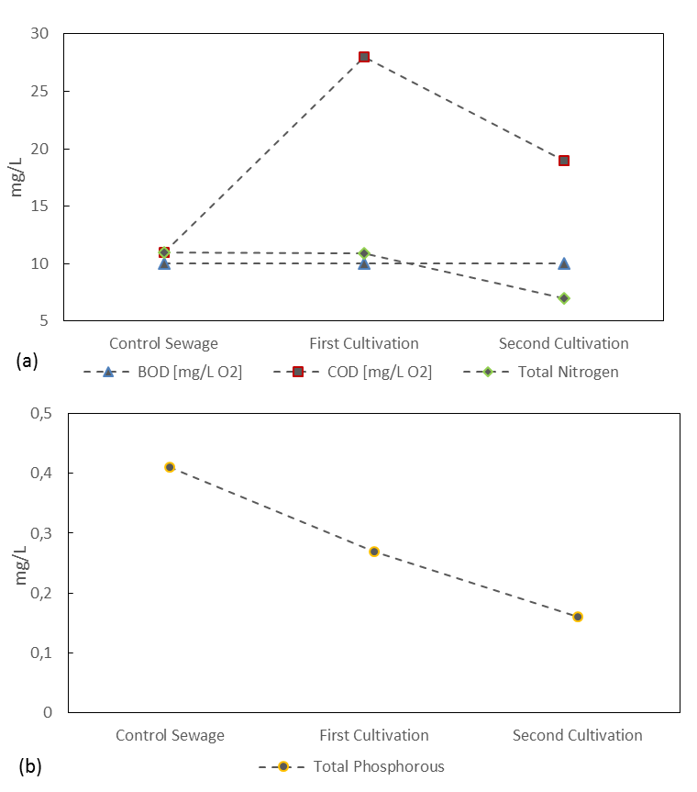

Figure 4: Chemical analysis on the microalgae treated sewage and the control sewage. a) shows BOD ( ), COD ( ), total nitrogen ( ) and b) shows total phosphorous ( )
  - Conclusions
This is a proof-of-concept study that allowed to assess the capabilities of a strain of microalgae, N. gaditana, in reducing nutrients present in municipal wastewaters. The employed sewage was coming from a municipal treatment plant in order to assess the response of the algae to a real treatment. This makes the results of this study applicable to a real treatment plant. The sewage was used to growth the microalgae as only nutrient source and the growth was studied by checking the cell number. N. gaditana supports well the growth into the sewage, showing a faster growing comparing with control medium. The biomass of N. gaditana was analyzed to check if there are changing in the biomass composition that potentially could make it more attractive economically. The percentage of lipids on dry weight is though the same between control and treatment. The composition of fatty acids is slightly changed and some interesting PUFAs are produced (especially of the EPA series). Minor differences were also detected in the first cultivation such as decrease of C18 and increase of C18:1n9 and C20:4 n6 comparing with the control. The treatment has resulted very effective in the removal of nutrients such as nitrates and phosphates. However, COD values were increased after the treatment, probably for the production of organic compounds by the microalgae. To solve this issue, the microalgal treatment could be coupled with the use of a consortia of yeasts and heterotrophic bacteria that are able to degrade organic matter and, hence, reduce efficiently COD and BOD values.

References
Blanco-Suarez, V. E., Villamizar-Sanchez, S. S., Peralta-Ruiz, Y. Y., González-Delgado, A. D., Barajas-Solano, A. F., & Ardila-Alvarez, A. M., 2016, Passive microalgae immobilization for wastewater treatment: Study of residual glycerol consumption. Chemical Engineering Transactions, 47, 463–468.
Casazza, A. A., Ferrari, P. F., Aliakbarian, B., Comotto, M., & Perego, P., 2016, Microalgae growth using winery wastewater for energetic and environmental purposes. Chemical Engineering Transactions, 49, 565–570.
Delrue, F., Álvarez-Díaz, P. D., Fon-Sing, S., Fleury, G., & Sassi, J. F., 2016, . The environmental biorefinery: Using microalgae to remediate wastewater, a win-win paradigm. Energies, 9(3), 1–19.
Dong, B., Ho, N., Ogden, K. L., & Arnold, R. G., 2014, Ecotoxicology and Environmental Safety Cultivation of Nannochloropsis salina in municipal wastewater or digester centrate. Ecotoxicology and Environmental Safety, 103, 45–53.
Dvoretsky, D., Dvoretsky, S., Temnov, M., Markin, I., Bushkovskaya, A., & Ustinskaya, Y., 2018, Technology of Wastewater Use For L-Lactic Acid Biosynthesis, 64, 577–582.
Feng, Y., Li, C., & Zhang, D., 2011, Lipid production of Chlorella vulgaris cultured in artificial wastewater medium. Bioresource Technology, 102(1), 101–105.
Guillard, R. R. L., 1975, Culture of Phytoplankton for Feeding Marine Invertebrates. In W. L. Smith & M. H. Chanley (Eds.), Culture of Marine Invertebrate Animals: Proceedings --- 1st Conference on Culture of Marine Invertebrate Animals Greenport (pp. 29–60). Boston, MA: Springer US.
Kumar, K., Mishra, S. K., Shrivastav, A., Park, M. S., & Yang, J. W., 2015, Recent trends in the mass cultivation of algae in raceway ponds. Renewable and Sustainable Energy Reviews, 51, 875–885.
Lau, P. S., Tam, N. F. Y., & Wong, Y. S., 2010, Wastewater Nutrients Removal by Chlorella Vulgaris : Optimization Through Acclimation, Environmental Technology, 17(2), 183-189.
Ma, X.-N., Chen, T.-P., Yang, B., Liu, J., & Chen, F., 2016, Lipid Production from Nannochloropsis. Marine Drugs, 14(4).
Marcel P.J. van der Voort, Joanneke Spruijt, Jorieke Potters, Pieter L. de Wolf, Hellen J.H. Elissen, 2017, Socio-economic assessment of Algae-based PUFA production, Public Output report of the PUFA Chain project, Göttingen, 79 pp.
Marotta, G., Scargiali, F., Lima, S., Caputo, G., Grisafi, F., & Brucato, A., 2017, Vacuum air-lift bioreactor for microalgae production. Chemical Engineering Transactions, 57, 925–930.
Simionato, D., Block, M. A., La Rocca, N., Jouhet, J., Maréchal, E., Finazzi, G., & Morosinotto, T., 2013, The response of Nannochloropsis gaditana to nitrogen starvation includes de novo biosynthesis of triacylglycerols, a decrease of chloroplast galactolipids, and reorganization of the photosynthetic apparatus. Eukaryotic cell, 12(5), 665–676.
Wang, L., Min, M., Li, Y., Chen, P., Chen, Y., Liu, Wang, Y., Ruan, R., 2010, Cultivation of Green Algae Chlorella sp . in Different Wastewaters from Municipal Wastewater Treatment Plant, Applied Biochemical Biotechnology, 162(4),1174-86.

